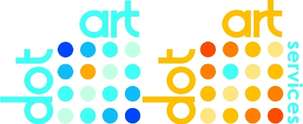
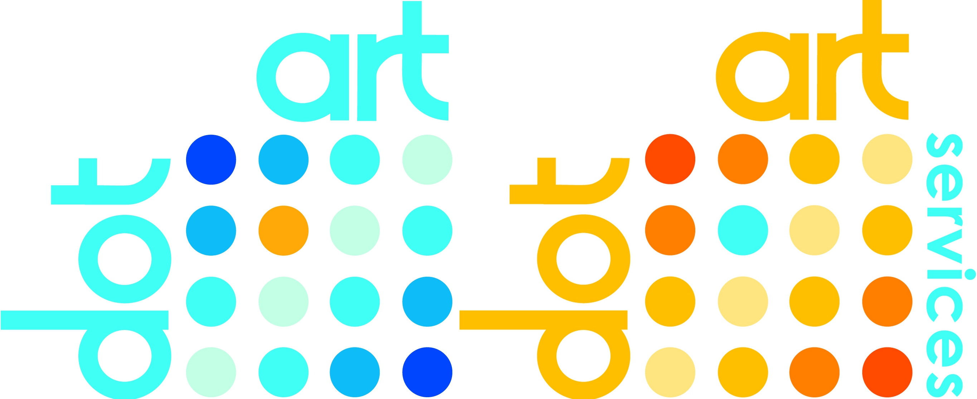

dot-art Schools
An Interactive Online Gallery Program for Primary School Art Students.

The Concept:

Students in Year 6 are given a public platform to display their art work, the chance enter into friendly inter-school competition, and an insight into the way the art world works. This provides a fantastic way of celebrating the art work created by students and the school's commitment to arts education, and demonstrates the quality of art produced to parents, families, local authorities and the wider community.

During the Autumn and Spring terms, each school creates and selects 25 pieces of student work which they feel best represent the talents of their students. These art works are submitted to their dot-art Schools page by February Half Term, then put on display to the world via the dot-art Schools website. Students from all the schools in the program, as well as the general public, will be able to vote for their favourite piece of art. During the Summer term, the top rated pieces of work from across all participating schools will then be displayed on the home page of the dot-art Schools site and an exhibition will be held showcasing the top works from each participating school, in Liverpool city centre.

This annual program will encourage healthy competition between students and schools, as well as driving traffic to the site and therefore increasing the audience for the students' work and the profile of the school. The final exhibition will also provide a wonderful opportunity for the successful students to show their work in a public setting. Finally the program can help participating schools meet many of the KS2 National Curriculum requirements for Art and Design, the criteria outlined in the OFSTED evaluation framework, as well as providing a valuable tool for schools working towards Artsmark status. (See separate documents for details.)

“Pupils benefited greatly from the feedback received when their work was shared locally or more widely...”

“Schools should... build sustained partnerships with art galleries and creative practitioners.”

“Good or outstanding lessons in primary schools were characterised by... reviews of practical work, supported by inspiring examples by other pupils or creative practitioners”

“The public exhibition of students’ work was highly effective in strengthening links between schools and the local community, including diverse community groups, different generations and those living in contrasting socio-economic circumstances.”

Extracts from: Ofsted Report - Making a mark: art, craft and design education, 2008/11

How it Works:

- Each participating school will have it's own portfolio page created by dot-art, eg: schools.dot-art.com/school-name
- A teacher will be nominated as dot-art liaison.
- Each school will decide how the work to be shown on the dot-art Schools site will be selected, whether it be by internal competition or any other suitable filtering process.
(N.B. We can also help with this process and the production of art work by bringing in professional artists and craftspeople to work alongside students and enrich the learning and creation process – please call 0845 017 6660 for details)
- The liaison staff member will then photograph the selected art work and email the images and relevant details (all information regarding format, details needed etc will be supplied by dot-art) to dot-art. Full support will be provided where necessary.
- dot-art will use this information to create the online portfolio for the school.
- Once the school's page is live, schools and students will publicise their dot-art Schools page and encourage friends, family, staff and the general public to vote for their favourite pieces.
- In the Summer term, the winners will be announced, and their work displayed on the dot-art Schools homepage schools.dot-art.com for the rest of the year.
- At the end of the Summer term an exhibition of the top pieces of work from each participating school will take place.
- Steps 3-7 repeat on an annual basis.
- In addition, participating schools can submit news of arts projects, community art initiatives, or similar related activities, to be added to the dot-art Schools website, providing a fantastic marketing platform for the school to publicise their work and successes.

Cost:

dot-art Schools Program Annual Fee: £150.

Background:

The dot-art Schools program has been developed by dot-art, a Liverpool based arts organisation which has been supporting artists and developing innovative and creative visual arts projects and initiatives since 2005.

We are now using our skills, experience and expertise to give the young people of the region access to an exciting new public platform for their creative output, and a taste of the way the art world works.

dot-art is made up of two arms:

dot-art Ltd is an art gallery and consultancy based in Liverpool city centre, specialising in affordable, high quality, locally sourced art, on a sale, commission and rental basis, as well as offering a range of complementary services including; art consultancy, exhibition planning and implementation, bespoke framing, art valuation and restoration and artist sourcing.
dot-art Services CIC is a not-for-profit organisation which exists to support North-West based visual artists, both emerging and established, through a range of services and activities designed to help them develop their careers and gain exposure and promotion for their work. A Social Enterprise with artists at its heart, dot-art Services CIC functions in a unique fashion, operating a membership system which gives artists a range of benefits including their own web page, access to exhibition, career development and promotional opportunities, as well as help and advice, networking events and discounts on art supplies and framing

This project is supported using public funding by the National Lottery through Arts Council England.

Contact:

Lucy Byrne
Director, dot-art
lucy.byrne@dot-art.com
0845 017 6660 / 07976 72379

