Affinity push/s3pull see “man mpstat”

Number of page replacement cycles

Total number of network packets passed through interfaces

% page space used (there’s a bug here – the warning triangle is often shown when it shouldn’t be)

Number of threads redispatched in affinity domains see man mpstat” green = sd0, through to red =sd5

Paging Space Free (in MB)

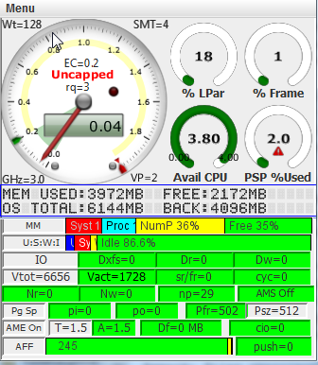

Available (free) CPU’s in the shared processor pool

% of Frames CPU’s being used by LPar

% of LPar’s entitled CPU (EC) being used