Take note that there is no build script available for building the release. We are using the Eclipse export jar functionality. It will be much more convenient if there is an ANT script.

The following illustrate the build process for **gtas-sftpclient-X.jar**.

1. Right Click the Extensions Project and select Export > Java > JAR file
2. Select the appropriate SRC folder for export as below

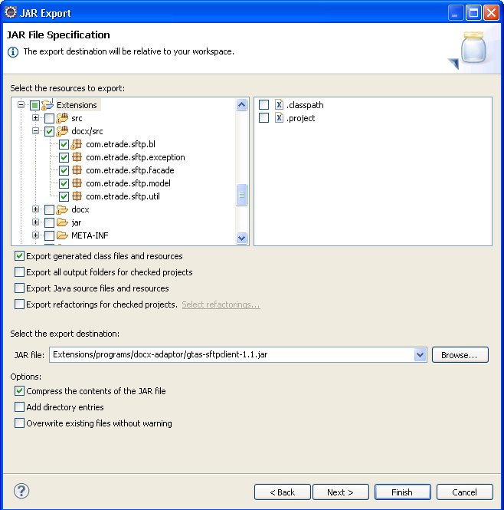

1. Select the java manifest file as below

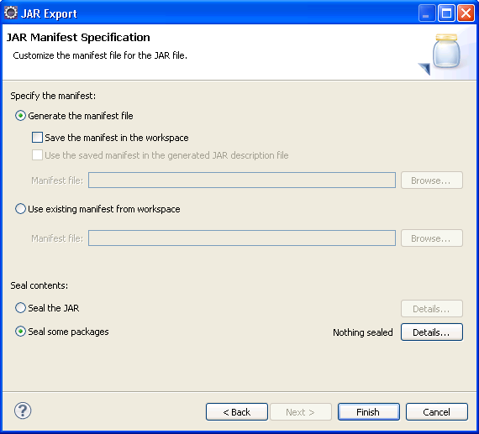

1. Package the java class files below into **gtas-sftpclient-X.jar**.
   1. <VIEW_HOME>\GTAS\Customers\Extensions\programs\docx-adaptor\lib\commons-vfs-1.0.jar
   2. <VIEW_HOME>\GTAS\Customers\Extensions\programs\docx-adaptor\lib\gtvan-util.jar
   3. <VIEW_HOME>\GTAS\Customers\Extensions\programs\docx-adaptor\lib\jsch-0.1.42.jar
   4. <VIEW_HOME>\GTAS\Customers\Extensions\classes\com\gridnode\ext\util\DocumentUtil.class
2. Refer to the previous release of the gtas-sftpclient jar to exclude the unused java class from the java folder com\gridnode\util\.