Take note that there is no build script available for building the release. We are using the Eclipse export jar functionality. It will be much more convenient if there is an ANT script.

The following illustrate the build process for **gt-ftp-pull-X.jar**. Perform the similar steps for **startScheduleFTPPull.jar**.

1. Right Click the Extensions Project and select Export > Java > JAR file
2. Select the appropriate SRC folder for export as below

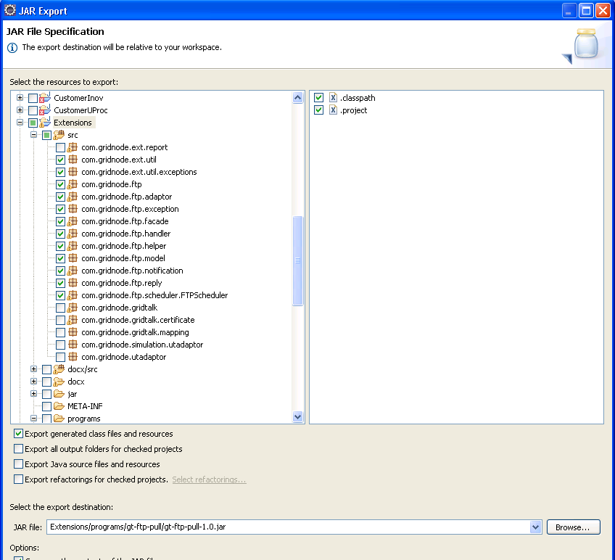

1. Select the java manifest file as below

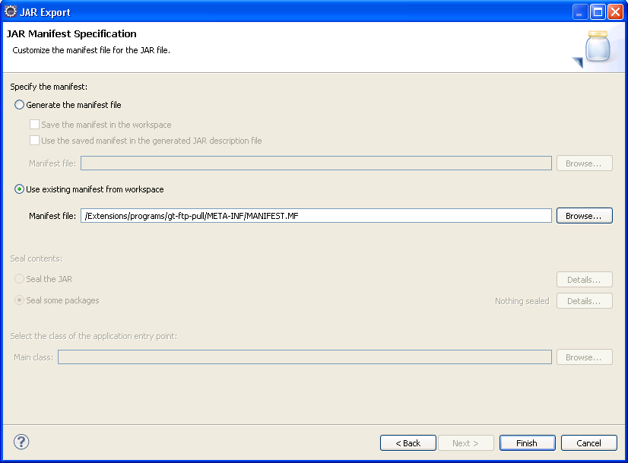

1. Refer to the previous release of the gt-ftp-pull jar to exclude the unused java class from the jar. For the folder com.gridnode.ftp, it will only contain FTPPull.class only.

