Framework Component
Revision History
Date | Version | Description | Author
8 – April - 2008 | 1.0 | Initial draft | Tam Wei Xiang

Introduction

Purpose
This document contains the key services for the Framework Component.

Context
The Framework Component provide the most common use services to the application

References
\\raven\sd_doc\Project Document\GTAS\2.0\ GridTalk 2.0 Software Design Document.doc

Key Functionality

Configuration Service
All the loading of the application properties has to be making use of this service.

ConfigurationManager
This class provides the method to load the properties file from external store. It can be associated to more than one instance of Configuration.

Configuration
This class contains a set of Property object which basically represents the key-value pair. Each configuration object being instantiated is representing a properties file in the application.

Lookup Service
This component provides the lookup service to the application. It help to locate the J2EE resource which includes the Session Bean, Entity Bean, DataSource, JMS Destination etc.

ServiceLocator
The ServiceLocator will base on the given context name to determine the appropriate lookup properties (eg JMS destination can be on remote server, and we need to use remote lookup properties). It makes use of the JNDIFinder to locate the J2EE resource. It also provides caching for EJB home interface to avoid expensive JNDI lookup.

JNDIFinder
A wrapper class on the InitialContext which perform the actual JNDI Lookup.

ConfigurationManager
It will load the JNDI Lookup properties from the configuration file.

GT Persistence Framework

Most of the entity being use in the GT application has adopted the GT Persistence Framework. The framework reliefs the burden of the developer to hand code the SQL statements, making the future maintenance easily.

The persistence type use in the framework is the Bean Managed Persistence (BMP). It delegates the SQL statement generation responsibility to the application. The reason we acquire it instead of the Container Manage Persistence (CMP) will be explain in the following section.

The framework has adopted the DAO design pattern which hides the underlying DB access logic from the client.
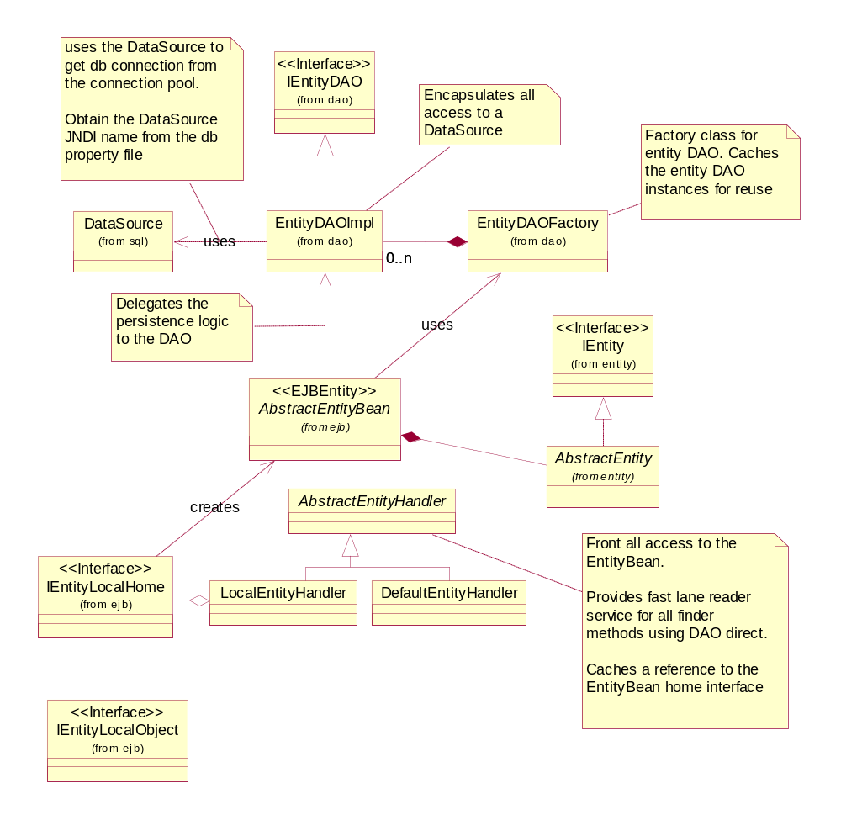
DirectDAOEntityHandler (NOT IN THE DIAGRAM)
The super class of the AbstractEntityHandler. It provides direct data access for an entity. Meaning the retrieval of the entities is directly via JDBC call without involving the EJB call to the entity bean. Only retrieval operation is permitted.

TODO: include that in the diagram. It will also has a link to the “EntityDAOFactory” same as “AbstractEntityBean”.

AbstractEntityHandler
This abstract class acts as a proxy to the entity bean. It provides the method to create, delete, update, and retrieve the entity. (The create, delete, update and retrieve method on the Entity Home Interface will be constructed using reflection during the initialization of the AbstractEntityHandler).

LocalEntityHandler
This class retrieves the JNDI name of the entity bean from the subclass and look up the Home Interface of the entity using local context.

DefaultEntityHandler
This class retrieves the JNDI name of the entity bean from the entity-ejb-map.properties file. The look up of the Home Interface can be under Client Context or local context.

AbstractEntityBean
The abstract class of the Entity Bean class use under the GT Persistent framework. It provides all the life cycle method needed in the BMP Entity bean. Subclass is not needed to provide any coding on those life cycle method and neither the CRUD query.

AbstractEntity
The abstract class of the Value Object of the Entity Bean class use under the GT Persistent framework. It provides the useful functionality to the Value Object for example the conversion of the Value Object to the HashMap representation.

IEntity
This interface defines the basic functionality of a data entity.

DataObject
A general data object implementation. It provides the XML serialize/de-serialize capability for its subclass.

TODO: AbstractEntity is extend from this class.

IDataObject
A basic data object interface.

TODO: DataObject implement this interface.

EntityDAOFactory
This class produces the concrete DAO for a particular entity. At any one time only one instance will be produced.

EntityDAOImpl
This class contain the actual logic to perform the create, delete, update, retrieve service. It gets the DB Connection from the DataSource.

IEntityDAO
This interface defines the method that will be called by the EJB.

EntityMetaInfo (EMI) & FieldMetaInfo (FMI)

For the EntityDAOImpl to generically handle all type of entity CRUD operation (if we adopted the CMP, we can’t achieve that), it intensively makes use of the EntityMetainInfo and FieldMetaInfo to achieve the goal.

For each entity that make use of the GT Persistent framework, it will need to define the EntityMetaInfo. The EMI basically capture the table name in the DB and the entity class name.

For each field (the instance variable) in the entity, they will be represented by the FMI. The FMI capture info for example the field corresponding column name in the DB.

Usage include

- Generate the SQL STATEMENT for example INSERT
- Get the value from the result set and initialize a particular entity.

1)

- We will get the EMI base on the given entity name, and using the EMI to load the corresponding list of FMI.
- From the FMI, we can get the field corresponding SQL column name and generate the template for insert statement. EG INSERT INTO Partner (partnerName, partnerType) VALUES (?, ?);
- Given the template, we can use the FMI again to get a particular field value from the entity and set that value into the preparedstatement of that insert query.

2)

- We will initialize an instance of the entity via Reflection by using the class name we define in the FMI.
- We will use appropriate getter method provided by the ResultSet to retrieve the value.
- We will set the value we got from the result set into the instance of the entity via Reflection.

The retrieval of record from different Datasource
The Persistence framework will base on the propertities file “db.properties” under %GRIDTALK_HOME%/jboss4.0.2/bin/conf\server\default\pdip\framework\ to determine which datasource a particular table reside in.

Limitation of the GT Persistence Framework
It was not DB vendor independent meaning if we change the underlying DB the corresponding SQL statement generates logic may need to be altered.

The FMI info corresponding SQL column name is also need to be modified for example while we change to Oracle DB, we need to include the “” in the SQL column name.

Exception Service
TODO: CLASS DIAGRAM

NestingException
This is the superclass of all the exception define in GT

TypedException
This class tag a “type” to the exception.

ApplicationException
This class signal a business logic related exception

SystemException
This class indicates a problem related with the services that support the application.

File Access Service
TODO: CLASS DIAGRAM

FileUtil
This class provides the common file services to the application. All the file operations have to be passed through this class.

FileAccess
This class perform the actual file operation if the operation context is “LocalContext” (Local File System). Otherwise, it will delegate the file operation request to FileMgrBean to handle.

FileMgrBean
This class make use of the Apache Webdav to provide the file operation on a remote server.

