GridTalk 4.0.1, ensure that the below patch is implemented.
4 - GNDB00027615 (10 Aug 2006)
This fixes the problem of XML splitting not performing as expected when the required xpath contains multiple occurrences in the parent level elements.

- Sample File before Splitting
The diagram below shows a sample of a data which contain multiple PO documents. If there should be any business process specification that dictates that per PO message can only contain 1 PO, it is necessary to split the consolidated file.
It is necessary to ensure that the xpath value for splitting is unique.

Xpath = /ConsolidatedPO/PO/PO_DocID
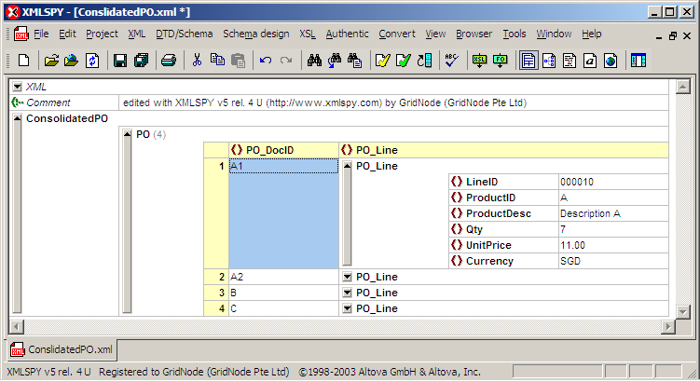

- XSL for splitting
<?xml version="1.0" encoding="UTF-8"?>
<xsl:stylesheet version="1.0" xmlns:xsl="http://www.w3.org/1999/XSL/Transform">
<xsl:output method="xml" indent="yes"/>
<xsl:param name="ONE"/> ➔ the parameter “ONE” will store all the unique values from
an xpath specified in GridTalk. From the above sample,
GridTalk will store 4 unique values into the parameter.

<xsl:template match="/">
<xsl:for-each select="/ConsolidatedPO/PO"> ➔ set looping to grab value
from multiple PO messages

<xsl:if test="string(PO_DocID)=$ONE"> ➔ in each of the loop, check that
the value “PO_DocID” is the same as
value specified in the parameter

<PO>
<xsl:copy-of select="*"/> ➔ if the “PO_DocID=$ONE” this statement will
perform a copy, and bring over all the
elements within the PO element.
</PO>
</xsl:if>
</xsl:for-each>
</xsl:template>
</xsl:stylesheet>

- Create XSL for splitting
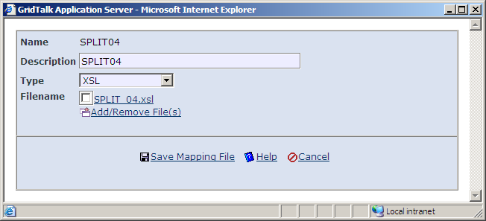

- Create Mapping Rule for Splitting
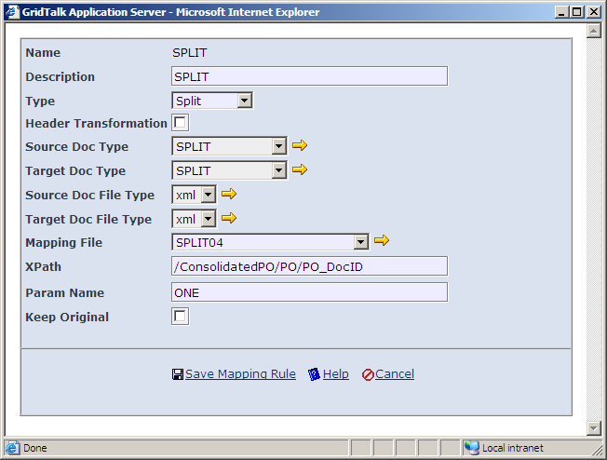
Extract data from this xpath.
Only unique values extracted would be store into the parameter.
The “Param Name” must be the same as <xsl:param name="ONE"/> stated in the xsl file.

- Sample Partner Function Configuration for Splitting
