HeaderMapping

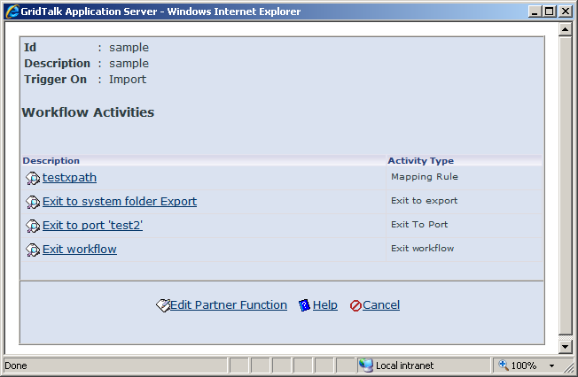

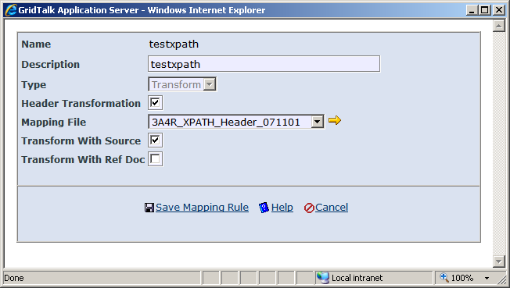

XSL File
<xsl:stylesheet xmlns:xsl="http://www.w3.org/1999/XSL/Transform" version="1.0">
<xsl:output method="xml" indent="yes" />

<xsl:param name="UDOC" />

<xsl:template match="GridDocument">
<GridDocument>
<xsl:apply-templates />
</GridDocument>
</xsl:template>

<xsl:variable name="test1">
<xsl:value-of select="document($UDOC)/Pip3A4PurchaseOrderRequest/GlobalDocumentFunctionCode" />
</xsl:variable>

<xsl:variable name="test2">
<xsl:value-of select="document($UDOC)/Pip3A4PurchaseOrderRequest/PurchaseOrder/DocumentReference/ProprietaryDocumentIdentifier" />
</xsl:variable>

<!-- -->
<xsl:template match="Custom1">
<Custom1>
<xsl:value-of select="$test1" />
</Custom1>
</xsl:template>

<!-- -->
<xsl:template match="Custom2">
<Custom2>
<xsl:value-of select="$test2" />
</Custom2>
</xsl:template>

<!-- -->
<xsl:template match="Custom3">
<Custom3>
<xsl:value-of select="document($UDOC)/Pip3A4PurchaseOrderRequest/PurchaseOrder/DocumentReference/ProprietaryDocumentIdentifier" />
</Custom3>
</xsl:template>

<!-- -->
<xsl:template match="Custom4">
<Custom4>
<xsl:value-of select="document($UDOC)/Pip3A4PurchaseOrderRequest/PurchaseOrder/DocumentReference[GlobalDocumentReferenceTypeCode ='Purchase Order']/ProprietaryDocumentIdentifier" />
</Custom4>
</xsl:template>

<!-- -->
<xsl:template match="Custom5">
<Custom5>
<xsl:value-of select="concat( $test1, '**', $test2, '**', document($UDOC)/Pip3A4PurchaseOrderRequest/PurchaseOrder/ProprietaryDocumentIdentifier, '**', document($UDOC)/Pip3A4PurchaseOrderRequest/PurchaseOrder[DocumentReference ='Purchase Order']/ProprietaryDocumentIdentifier )" />
</Custom5>
</xsl:template>

<xsl:template match="*">
<xsl:copy-of select="." />
</xsl:template>
</xsl:stylesheet>

Output GDOC (using saxon)
<?xml version="1.0" encoding="utf-8"?>
<GridDocument>
<GdocId>5994</GdocId>
<GdocFilename>null-2128-IB-5994.xml</GdocFilename>
<Folder>Inbound</Folder>
<SenderPartnerId>Samsung</SenderPartnerId>
<UdocNum/>
<RefUdocNum/>
<UdocFilename>UnPackage3032630333.xml</UdocFilename>
<UdocVersion>0</UdocVersion>
<UdocDocType>SAM_3A4</UdocDocType>
<UdocFileType/>
<SrcFolder/>
<NotifyUserEmail/>
<UdocFileSize>26</UdocFileSize>
<isExported>false</isExported>
<isViewAckReq>false</isViewAckReq>
<isExportAckReq>false</isExportAckReq>
<isReceiveAckReq>false</isReceiveAckReq>
<isViewed>false</isViewed>
<isSent>false</isSent>
<isLocalPending>false</isLocalPending>
<isExpired>false</isExpired>
<isRecAckProcessed>false</isRecAckProcessed>
<isRejected>false</isRejected>
<CreateBy/>
<SenderRoute/>
<SenderPartnerFunction/>
<SenderUserId/>
<SenderUserName/>
<SenderBizEntityId>SAM</SenderBizEntityId>
<SenderBizEntityUuid/>
<SenderRegistryQueryUrl/>
<SenderPartnerType>KU</SenderPartnerType>
<SenderPartnerGroup>AP</SenderPartnerGroup>
<SenderPartnerName>Samsung</SenderPartnerName>
<RefGdocId>0</RefGdocId>
<RefUdocFilename/>
<RecipientNodeId>2128</RecipientNodeId>
<RecipientPartnerId/>
<RecipientPartnerFunction/>
<EncryptionLevel>64</EncryptionLevel>
<RecipientPartnerType/>
<RecipientPartnerGroup/>
<RecipientPartnerName/>
<RecipientBizEntityId>DEF</RecipientBizEntityId>
<RecipientBizEntityUuid/>
<RecipientRegistryQueryUrl/>
<RecipientChannelName/>
<RecipientChannelProtocol/>
<PortName/>
<DateTimeCreate>2007-10-31T21:43:58.158-05:00</DateTimeCreate>
<DateTimeSendEnd>2007-10-31T21:43:57.533-05:00</DateTimeSendEnd>
<DateTimeReceiveEnd>2007-10-31T21:43:57.533-05:00</DateTimeReceiveEnd>
<DateTimeReceiveStart>2007-10-31T21:43:57.533-05:00</DateTimeReceiveStart>
<Activity>
<ActivityType>Exit to System Folder</ActivityType>
<Description>Exit to System Folder Inbound</Description>
<DateTime>2007-10-31T21:43:58.142-05:00</DateTime>
</Activity>
<PartnerFunction/>
<ActionCode/>
<RnProfileUid>15156</RnProfileUid>
<ProcessDefId>3A4_RequestPurchaseOrder_V02_00_00</ProcessDefId>
<isRequest>false</isRequest>
<hasAttachment>false</hasAttachment>
<isAttachmentLinkUpdated>true</isAttachmentLinkUpdated>
<UniqueDocIdentifier/>
<UdocFullPath>E:\Gridnode\GridTalk\jboss-4.0.2\bin\gtas\data\doc\udoc\Inbound\UnPackage3032630333.xml</UdocFullPath>
<ExportedUdocFullPath/>
<Custom1>Request</Custom1>
<Custom2>PurchaseOrderA</Custom2>
<Custom3>PurchaseOrderA</Custom3>
<Custom4>PurchaseOrderA</Custom4>
<Custom5>Request**PurchaseOrderA****</Custom5>
<Custom6/>
<Custom7/>
<Custom8/>
<Custom9/>
<Custom10/>
<ProcessInstanceUid>20752</ProcessInstanceUid>
<ProcessInstanceID>d3bd4d8af70d80950014987c</ProcessInstanceID>
<UserTrackingID>7500242152</UserTrackingID>
<DocTransStatus/>
<MessageDigest/>
<AuditFileName>UnPackage30326_1.tmp</AuditFileName>
<ReceiptAuditFileName/>
</GridDocument>

Output GDOC (using GridTalk)
<?xml version="1.0" encoding="UTF-8"?>
<GridDocument>
<GdocId>992</GdocId>
<GdocFilename>2129-0-EP-992.xml</GdocFilename>
<Folder>Export</Folder>
<SenderPartnerId></SenderPartnerId>
<UdocNum></UdocNum>
<RefUdocNum></RefUdocNum>
<UdocFilename>WPI_3A4R.xml</UdocFilename>
<UdocVersion>1</UdocVersion>
<UdocDocType>TRIAL</UdocDocType>
<UdocFileType>xml</UdocFileType>
<SrcFolder>Import</SrcFolder>
<NotifyUserEmail></NotifyUserEmail>
<UdocFileSize>4</UdocFileSize>
<isExported>false</isExported>
<isViewAckReq>false</isViewAckReq>
<isExportAckReq>false</isExportAckReq>
<isReceiveAckReq>false</isReceiveAckReq>
<isViewed>false</isViewed>
<isSent>false</isSent>
<isLocalPending>true</isLocalPending>
<isExpired>false</isExpired>
<isRecAckProcessed>false</isRecAckProcessed>
<isRejected>false</isRejected>
<CreateBy></CreateBy>
<SenderNodeId>2129</SenderNodeId>
<SenderGdocId>0</SenderGdocId>
<SenderRoute></SenderRoute>
<SenderPartnerFunction></SenderPartnerFunction>
<SenderUserId>kliauw</SenderUserId>
<SenderUserName>Karen Liauw</SenderUserName>
<SenderBizEntityId>DEF</SenderBizEntityId>
<SenderBizEntityUuid></SenderBizEntityUuid>
<SenderRegistryQueryUrl></SenderRegistryQueryUrl>
<SenderPartnerType></SenderPartnerType>
<SenderPartnerGroup></SenderPartnerGroup>
<SenderPartnerName></SenderPartnerName>
<RefGdocId>619</RefGdocId>
<RefUdocFilename>WPI_3A4R.xml</RefUdocFilename>
<RecipientNodeId>0</RecipientNodeId>
<RecipientPartnerId>Intel Corp</RecipientPartnerId>
<RecipientPartnerFunction></RecipientPartnerFunction>
<EncryptionLevel>64</EncryptionLevel>
<RecipientPartnerType>KU</RecipientPartnerType>
<RecipientPartnerGroup>AP</RecipientPartnerGroup>
<RecipientPartnerName>Intel Corp</RecipientPartnerName>
<RecipientBizEntityId>INTC</RecipientBizEntityId>
<RecipientBizEntityUuid></RecipientBizEntityUuid>
<RecipientRegistryQueryUrl></RecipientRegistryQueryUrl>
<RecipientGdocId>0</RecipientGdocId>
<RecipientChannelUid>0</RecipientChannelUid>
<RecipientChannelName></RecipientChannelName>
<RecipientChannelProtocol></RecipientChannelProtocol>
<PortUid>18</PortUid>
<PortName>test2</PortName>
<DateTimeCreate>2007-11-20T08:16:30.097-05:00</DateTimeCreate>
<DateTimeImport>2007-11-20T08:16:30.035-05:00</DateTimeImport>
<Activity>
<ActivityType>Exit to System Folder</ActivityType>
<Description>Exit to System Folder Import</Description>
<DateTime>2007-11-20T08:16:30.050-05:00</DateTime>
</Activity>
<Activity>
<ActivityType>Exit from System Folder</ActivityType>
<Description>Exit from System Folder Import</Description>
<DateTime>2007-11-20T08:16:30.722-05:00</DateTime>
</Activity>
<Activity>
<ActivityType>Exit to System Folder</ActivityType>
<Description>Exit to System Folder Export</Description>
<DateTime>2007-11-20T08:16:30.785-05:00</DateTime>
</Activity>
<PartnerFunction>sample</PartnerFunction>
<ActionCode></ActionCode>
<RnProfileUid>0</RnProfileUid>
<ProcessDefId></ProcessDefId>
<isRequest>false</isRequest>
<hasAttachment>false</hasAttachment>
<isAttachmentLinkUpdated>true</isAttachmentLinkUpdated>
<UniqueDocIdentifier></UniqueDocIdentifier>
<UdocFullPath>E:\Gridnode\GridTalk\jboss-4.0.2\bin\gtas\data\doc\udoc\Export\WPI_3A4R.xml</UdocFullPath>
<ExportedUdocFullPath></ExportedUdocFullPath>
<Custom1>Request</Custom1>
<Custom2></Custom2>
<Custom3></Custom3>
<Custom4></Custom4>
<Custom5>Request******</Custom5>
<Custom6></Custom6>
<Custom7></Custom7>
<Custom8></Custom8>
<Custom9></Custom9>
<Custom10></Custom10>
<DocTransStatus></DocTransStatus>
<MessageDigest></MessageDigest>
<AuditFileName></AuditFileName>
<ReceiptAuditFileName></ReceiptAuditFileName>
</GridDocument>

