RN Design Document

Revision Log
Date | Version | Description | Author
11 – April - 2008 | 1.0 | Initial draft | Tam Wei Xiang
26 – April – 2008 | 1.1 | Include the sequence diagram for sending the request message, and receiving the response message, signal | Tam Wei Xiang
11 Sept 2008 | 1.2 | 1) Include Double Action PIP receiving of response message and sending out response message. 2) Add sequence diagram for OB Signal | Tam WeiXiang

Table of Contents

1Introduction 4
1.1Purpose 4
1.2Reference 4
2Component Diagram 5
2.1Component Diagram For Inbound RN DOC 5
2.2Component Diagram For OB RN Doc 6
3Logical Model 7
3.1Receive of RN Message via HTTP Protocol 7
3.2The Processing of the incoming RN Request Message (Part 1 + Part 2) 11
3.3The Processing of the incoming RN Response Message 14
3.4The Processing of incoming Signal Message 15
3.5Initiate Send Req Doc Process 17
3.6Send RN Messages 18
3.7OB Req Message 20
3.7.1Process OB Req Message 20
3.8OB Response Message 21
3.8.1Process outgoing Response Document 21
3.9Prepare Send Request/Response Document 22
3.10Perform a particular signal action after processed request/response message 23
3.10.1Perform SendAckAction (RN_ACK) 26
3.11Delegate OB RN MSG to Transport Layer 27
3.12Send RN Message 28
3.13HTTP Connection to TP 30
3.14Feedback Sent Status 31
3.15Checking of ACK Status for Request Message (Initiating Role) & Response Message (Responding Role, Double Action PIP) 32

Introduction

Purpose
The purpose of this document is to describe the design model of the RN module in GTAS.

Reference
- GTAS 4.2 source code

Component Diagram
The following diagram show the relationship between the available components in GTAS.

Component Diagram For Inbound RN DOC
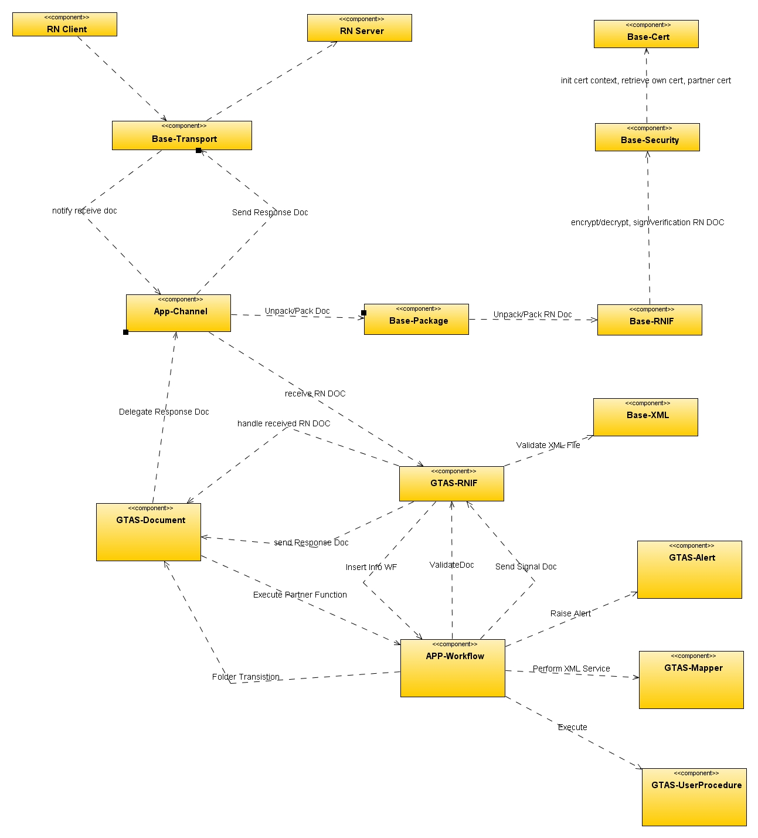
Figure 1 IB RN Doc Component Diagram

Component Diagram For OB RN Doc

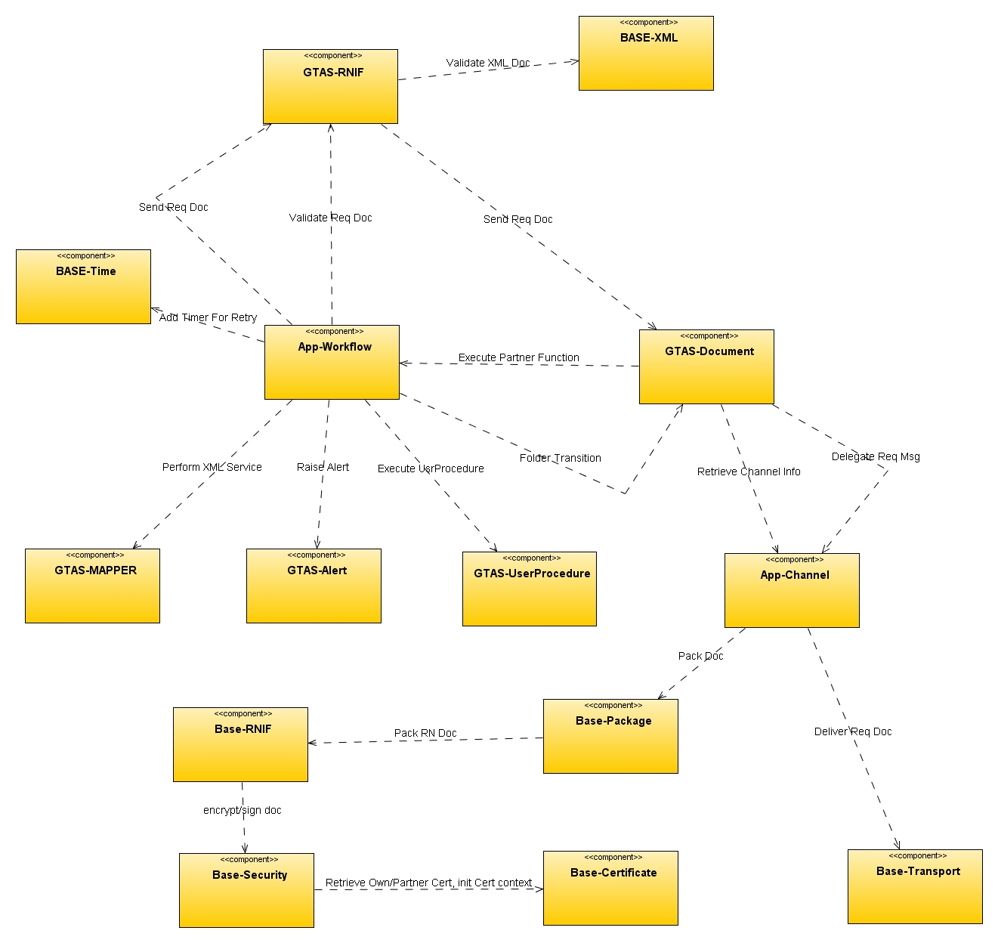
Figure 2 OB RN DOC Component Diagram

Logical Model
The following section will show the sequence diagram when GTAS handling incoming and outgoing Rosettanet Message.

Receive of RN Message via HTTP Protocol
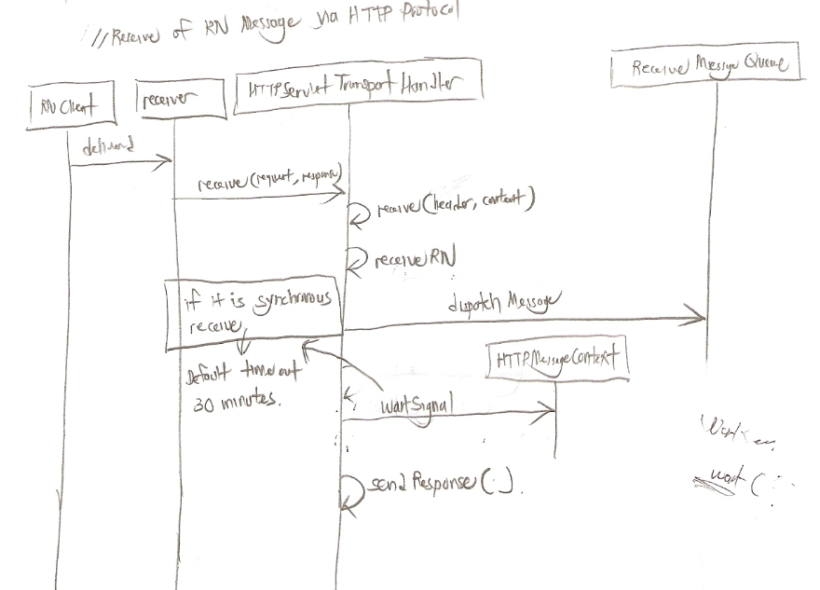

The receiving of the RN Message can be asynchronous or synchronous depending on the trading partner agreement. If synchronous option is indicated, the signal message will be sent back to the TP using the same HTTP connection. If not, the signal message will be delivered using a new HTTP connection.

Receive RN Message Part1
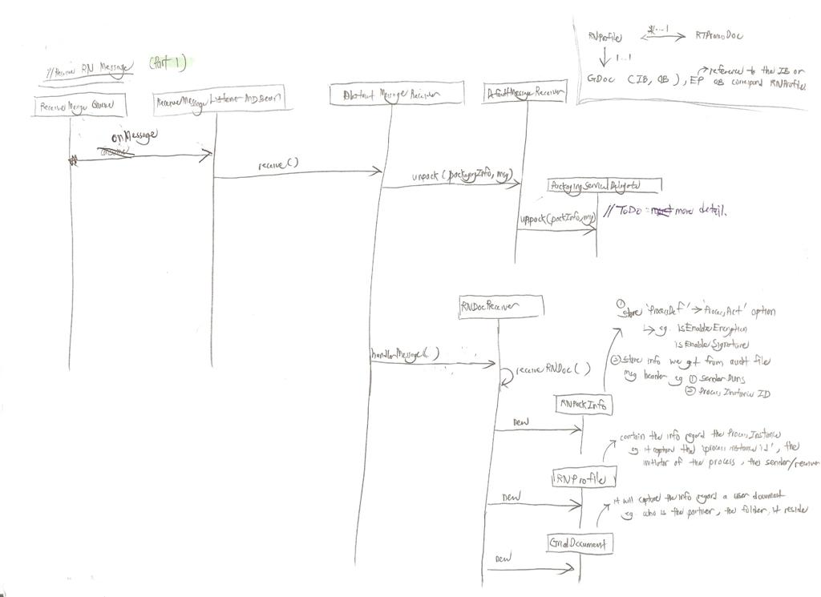

After the receiving the RN Message, appropriate un-package process has been acted on the RN Message. After the message has been un-packaged, the sender info, process related info (eg the RNIF Version, PIP Code, Role Type etc) will be stored in RNProfile. GridDocument will store the info regard a user document.

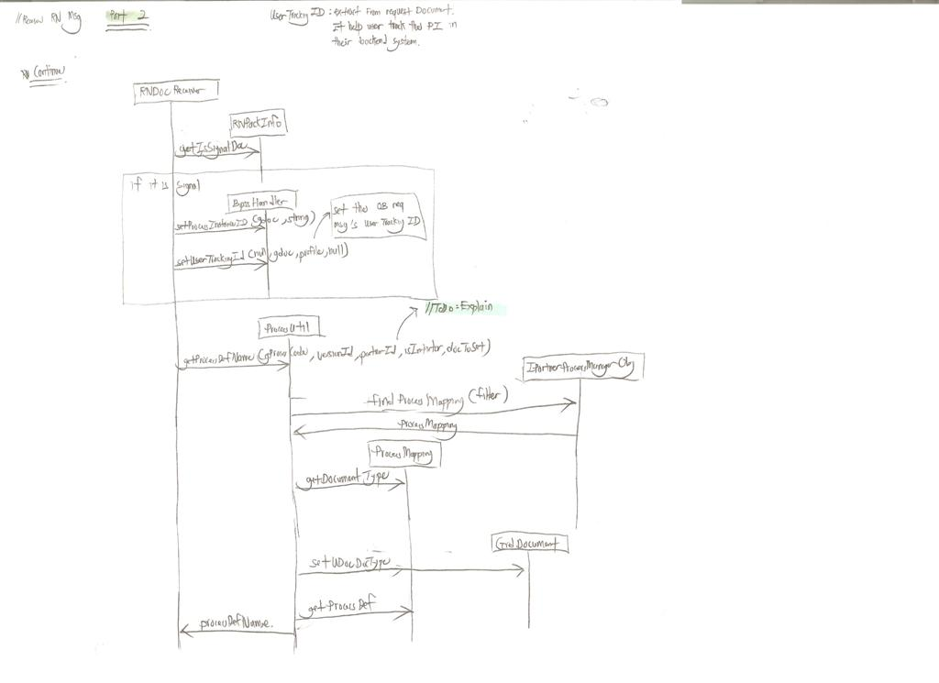
Receive RN Message Part2

Receive RN Message Part3

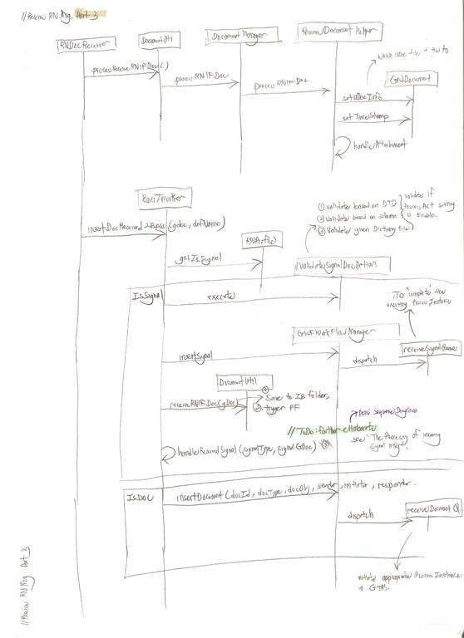
Base on the PIP code, PIP version, Partner ID and the Role Type (Initiator or responseder), we can retrieve the Process Mapping. This is how we know the corresponding Process Def we define in GTAS and also the corresponding UDoc Doc Type to be used.

The Processing of the incoming RN Request Message (Part 1 + Part 2)

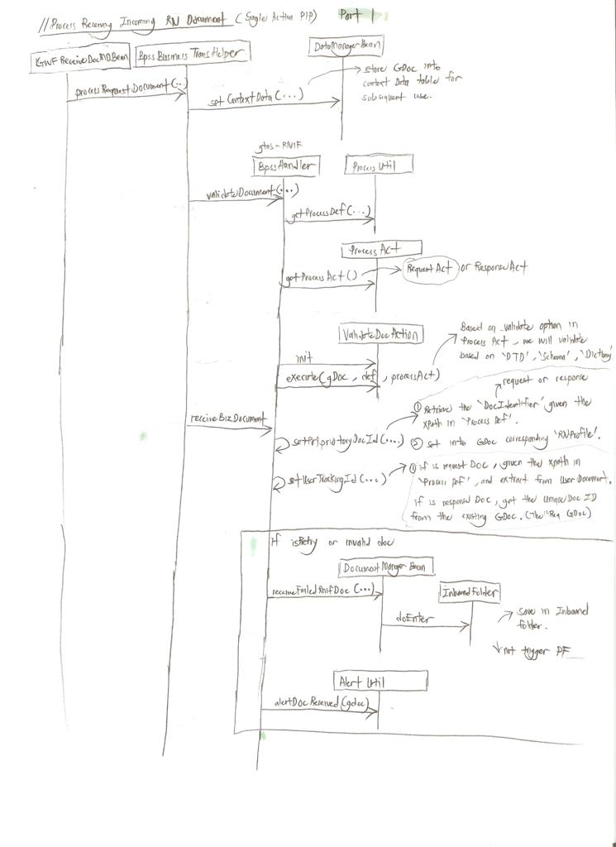

Part2, Conitnue the Processing of the incoming RN Request Message
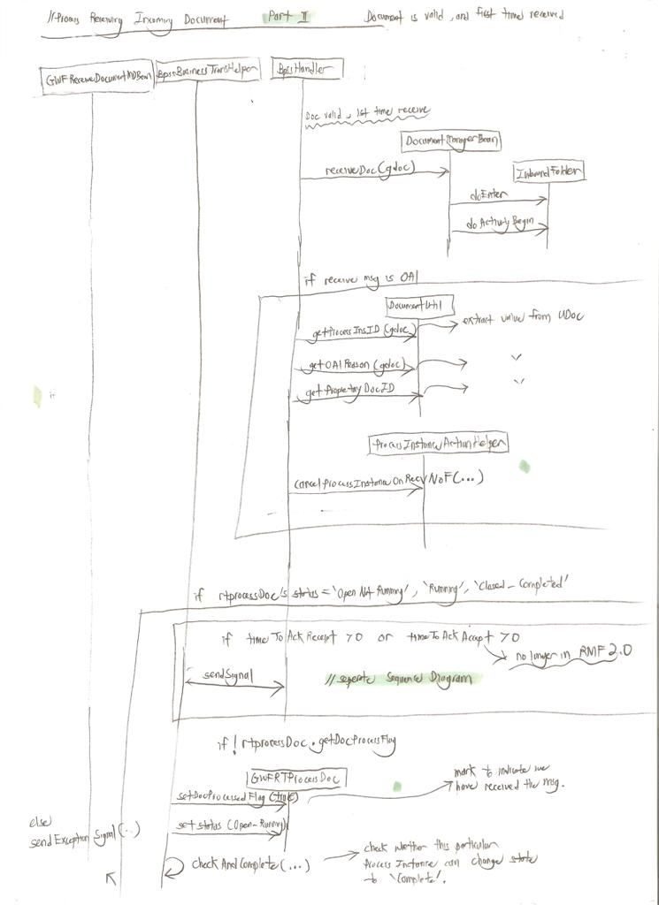

For the incoming request message we received, we will perform validation on it if the ProcessAct has enabled the xml validation. If the validation is failed or the received document is a retry message from TP, the document will be saved into IB folder and no partner function will be triggered.

After the request message has been received successfully, we will send back the RN_ACK to notify the partner the completion of the process instance.

If the request message is a 0A1 message, we will cancel the process instance that related to the “ProcessInstanceID”.

If we failed to receive the request message due to some internal system error, we will trigger 0A1 or send back the EXCEPTION_CANCEL signal.

It is worth to note that the multiple request message can be delivered from TP while the first message received still being processing (Maybe due to the retry interval is set to low). Thus the document ID (formed by “Process Instance ID” and “RoleType”) of the first received request message will be cached. If the document id exist in the cache, we will also cache the request message so that GT can process them sequentially.

See BpssBusinessTransHelper.addConcurrentRequest(..) for more detail.

The Processing of the incoming RN Response Message

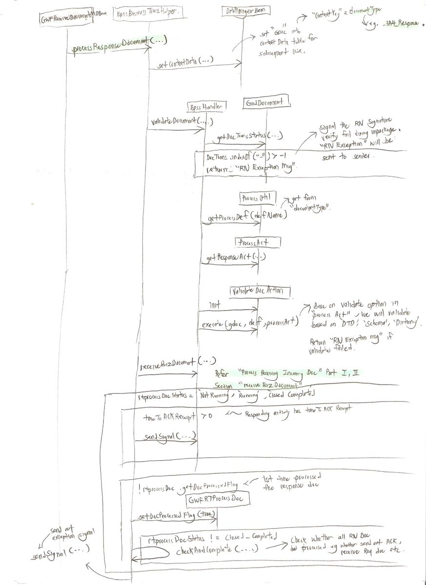

The receiving of the response document from TP is quite similar to the flow of processing an incoming RN Request message from TP.

The Processing of incoming Signal Message

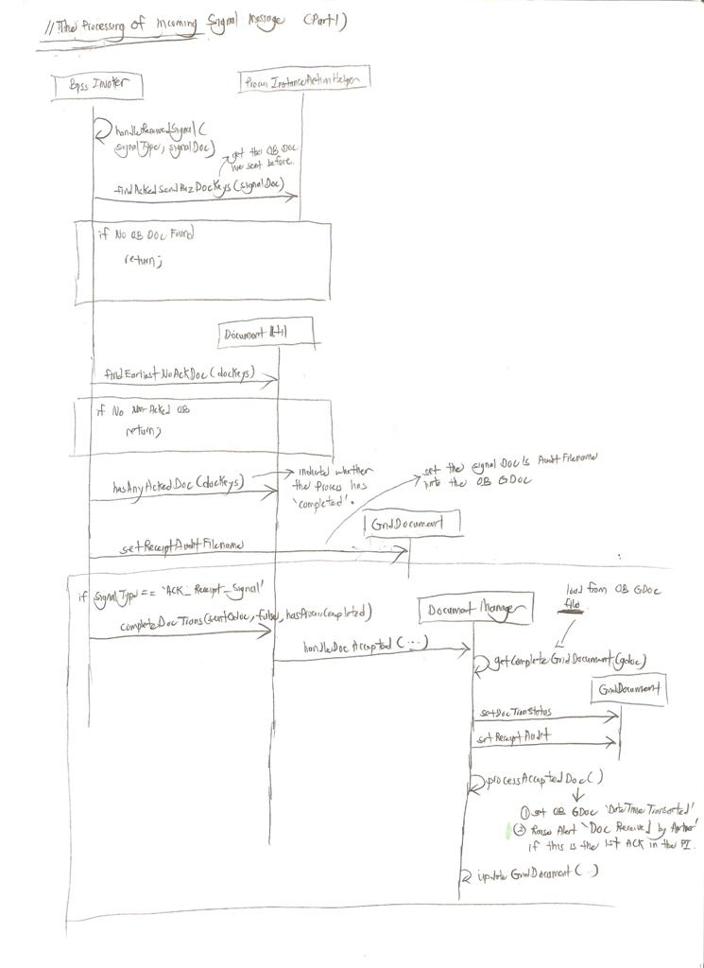
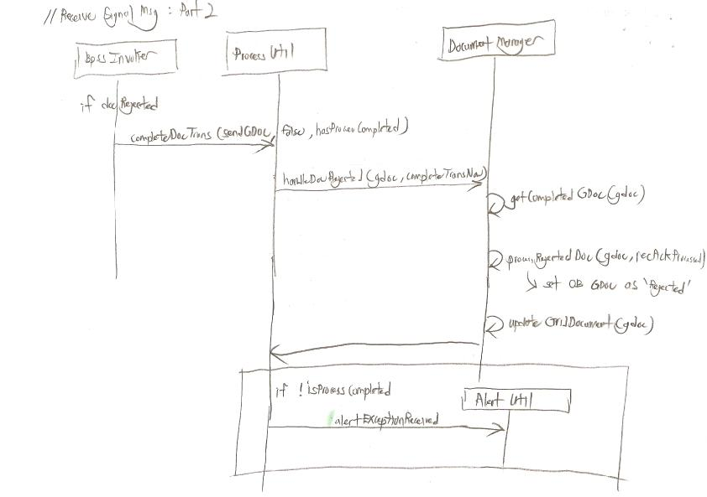
Upon receipt the signal message, we will locate the OB GDOC that has not acked before.

If the signal type is “AcknowledgeReceiptSignal”, we will update the OB GDOC’s DateTimeTransacted field. The Alert “Doc Received By Partner” will also be raised.

If the signal type is other than “AcknowledgeReceiptSignal”, we will update the OB GDOC as “rejected”, and the alert “Exception Received” will be raised.

Initiate Send Req Doc Process

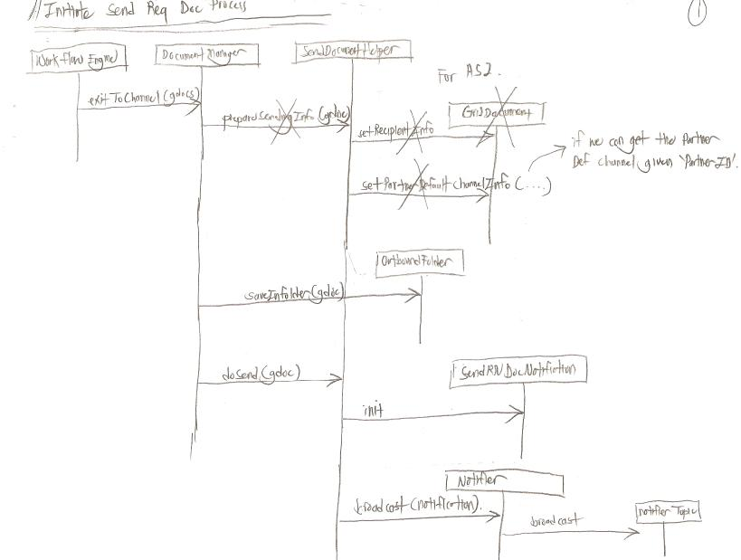

When we reached the PartnerFunction activity “Exit To Channel”, the OB GDOC will be persisted into OB Folder.

Send RN Messages

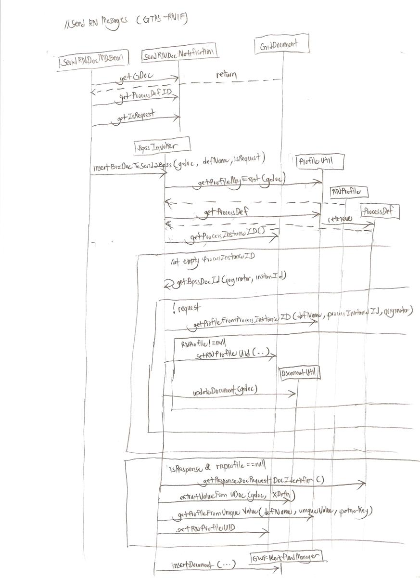

The above handling for both the Request message (act as an initiating role) and Response message (act as an responding role) by importing them into the Bpss Workflow engine which will be kicked start the RN processing.

For a response message, it can be linked to an existing Process Instance via a few option. For example 1) the extraction of “ResponseDocRequestDocIdentifier” from the response User document which can be configured under Process Def 2) by specifying the IB RNProfile in the backend sender 3) by specifying the Process Instance ID in the backend sender.

For a request message, the process instance ID can also be specified in the backend sender.

OB Req Message

Process OB Req Message

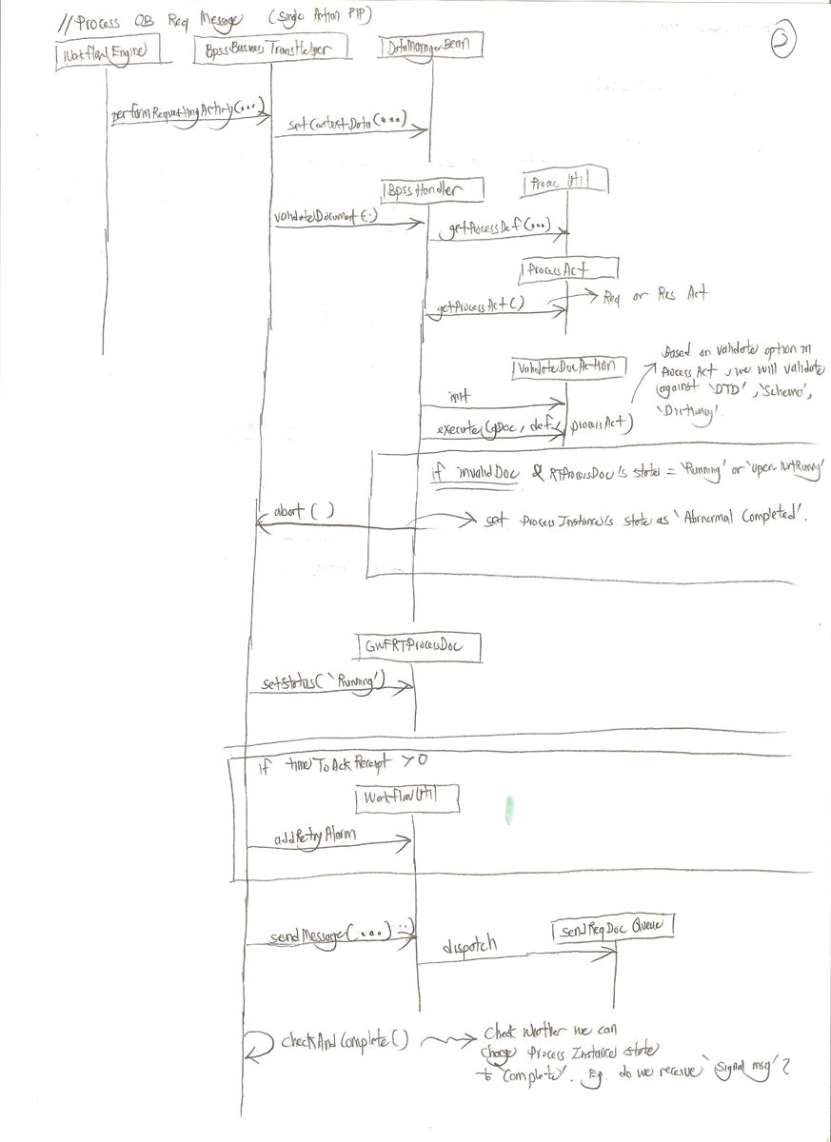

After the Process Instance has been created by the Workflow engine, we will start processing the OB request message base on the setting we define in the ProcessAct for example the validation on the request message, the time for resend, and the initiating of resending the request message if no signal message coming back given the configuration time.

OB Response Message

Process outgoing Response Document

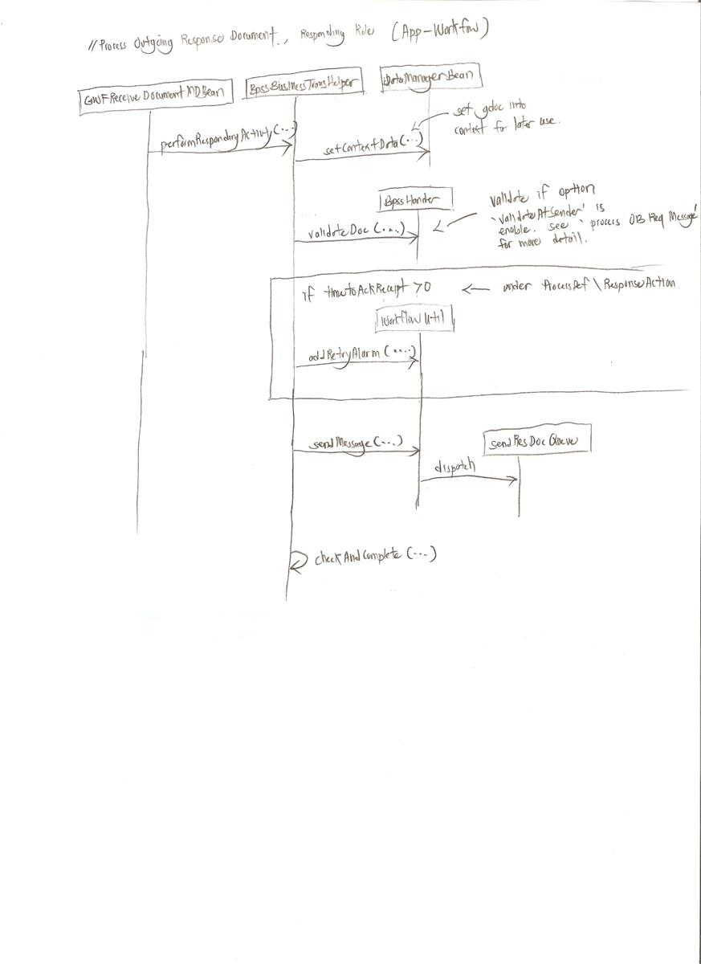

We will process the outgoing response document only if the corresponding GWFRTProcessState is “Running”. Such a checking is necessary since there is no point for us to do the sending again if the process instance state is already “Complete”, “Abnormal Complete” etc.

Same as the sending out of the request message, we will start processing the OB response message base on the setting we define in the “ResponseProcessAct” for example the validation on the response message, the time for resend if no signal message coming back given the configuration time.

Prepare Send Request/Response Document

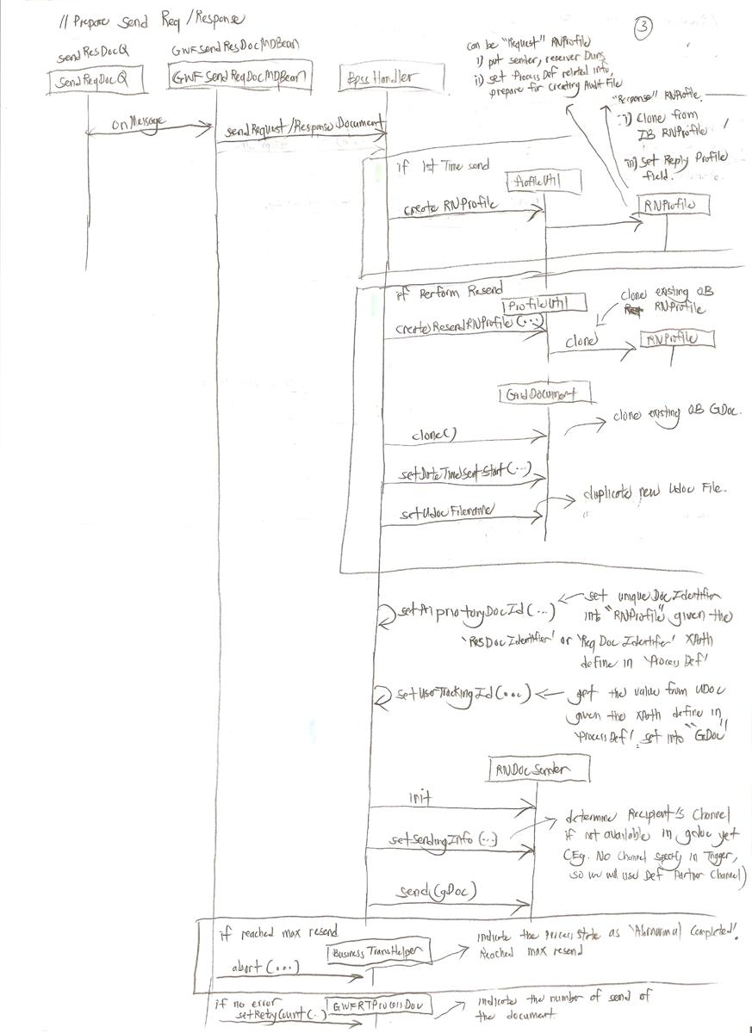

The above diagram show the necessary preparation for sending out request message (we as the initiating role) or sending out response message (we as the responding role, 3A4 confirmation).

For the information being specified in the “RNProfile” for example “ProcessDef” related info (GlobalUsageCode, PIPGlobalProcessCode), and Duns number of sender and receiver will be retrieved when we package the RN Audit File (for DeliveryHeader, ServiceHeader).

We will perform checking on the number of time the document has been sent. If we exceed the number of retry, the state of that particular ProcessInstance will be set as “Abnormally Completed” and with a message “Cannot sendBizDocument: Exceeds maximum retry numbers!”.

Perform a particular signal action after processed request/response message
Perform Signal Action Part1

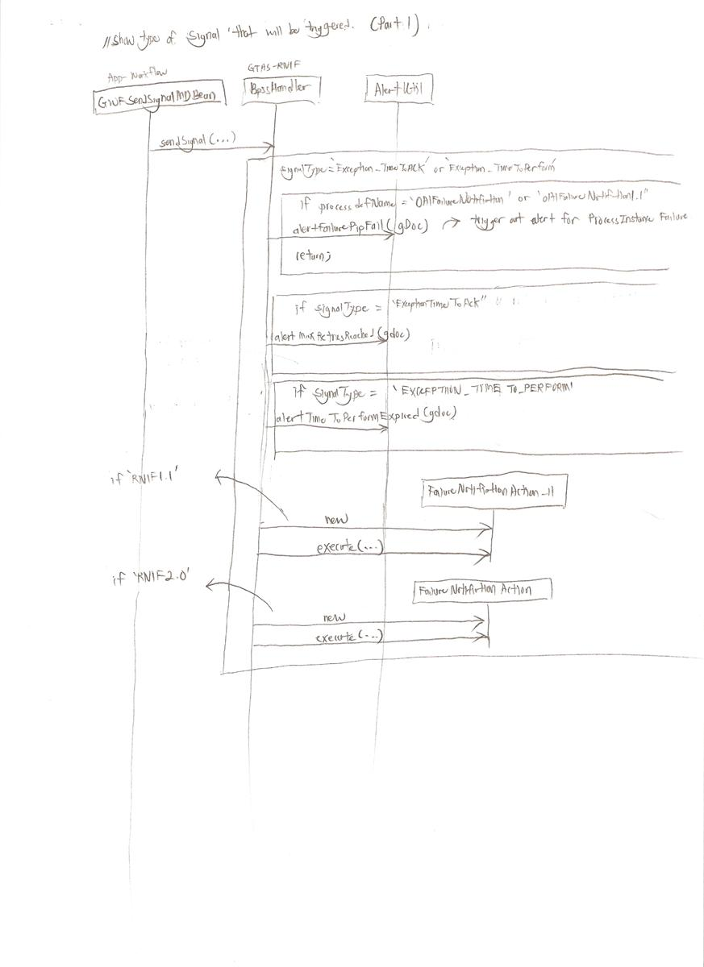

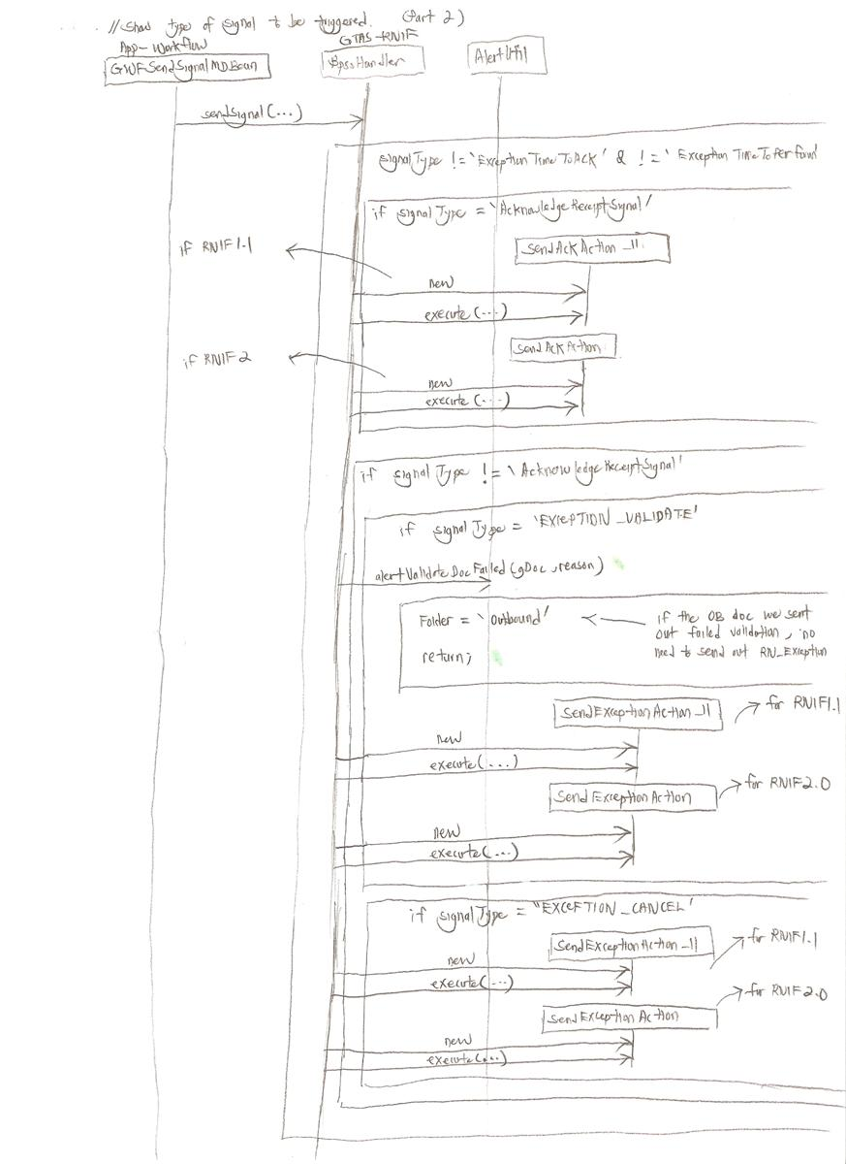
Perform Signal Action Part2 Continue
Given the signal type, appropriate signal action will be performed. For example, the FailureNotificationAction (new 0A1 process instance will be created), SendAckAction (send back the RN_ACK), SendExceptionAction (send back the RN_EXCEPTION due to the failure in processing the incoming request message of a DoubleAction PIP or due to the invalid content in the request/response message).

Perform SendAckAction (RN_ACK)

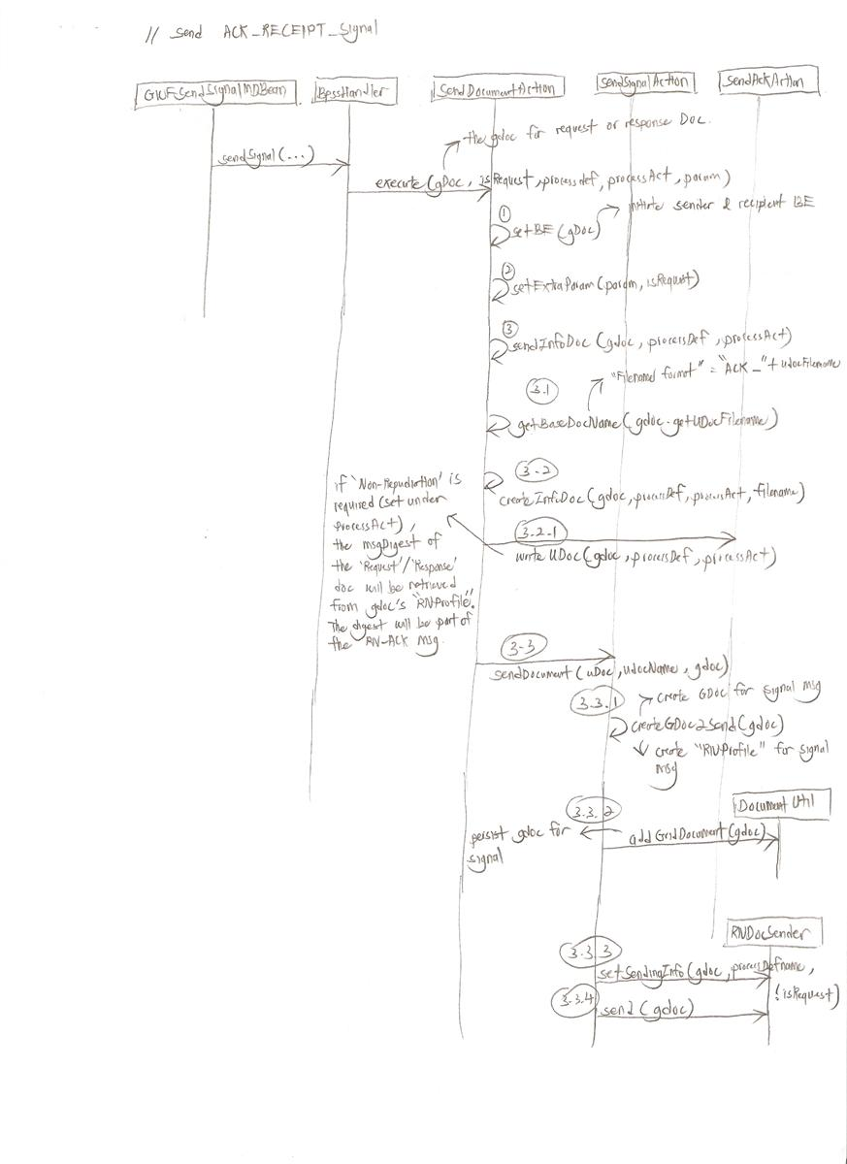

After the type of signal action has been determined, we will prepare the content of the signal message and send to the recipient.

The above show how the “ACK_RECEIPT_SIGNAL” being generated and deliver to the channel.

If the option “Non-Repudiation” is enabled in “ProcessAction”, the message digest of the doc being acked will be retrieved and as part of the content for the signal msg. This is the RN's Non-Repudiation of receipt.

The GDOC and RNProfile for the signal message will also be created.

Delegate OB RN MSG to Transport Layer

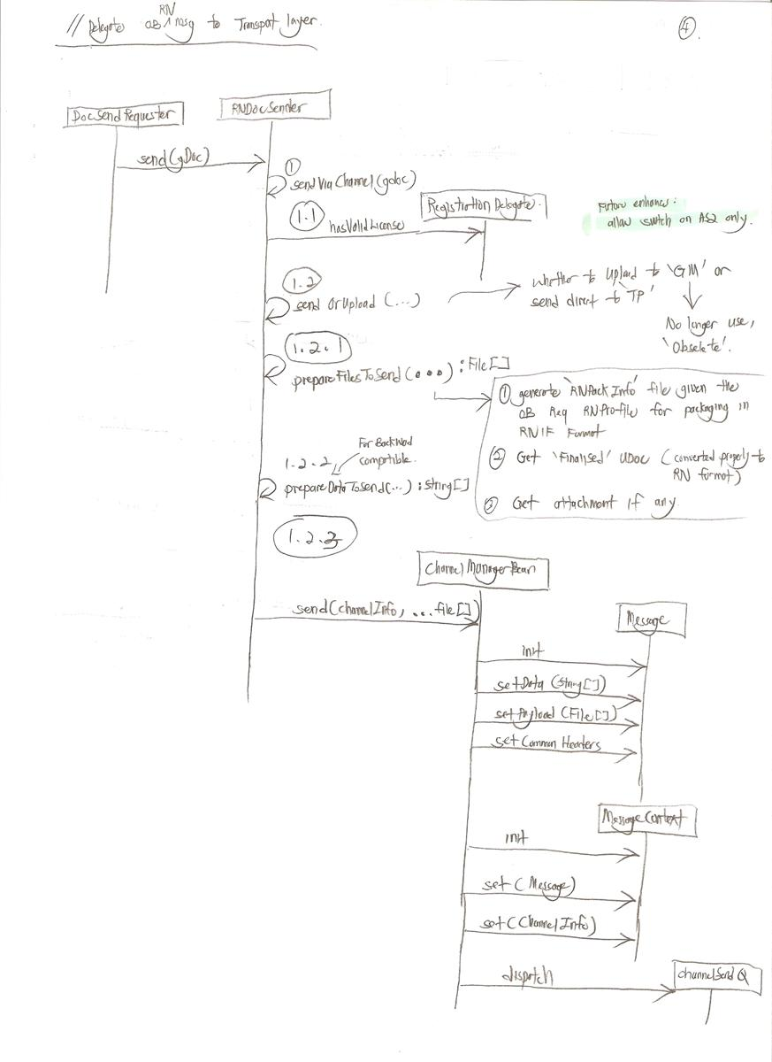

- Check whether the GTAS contain valid license
- Gather all the file that need to be send to TP
- Package all info into type Message and send to Transport layer for further processing.

Send RN Message (From Channel To Transport)

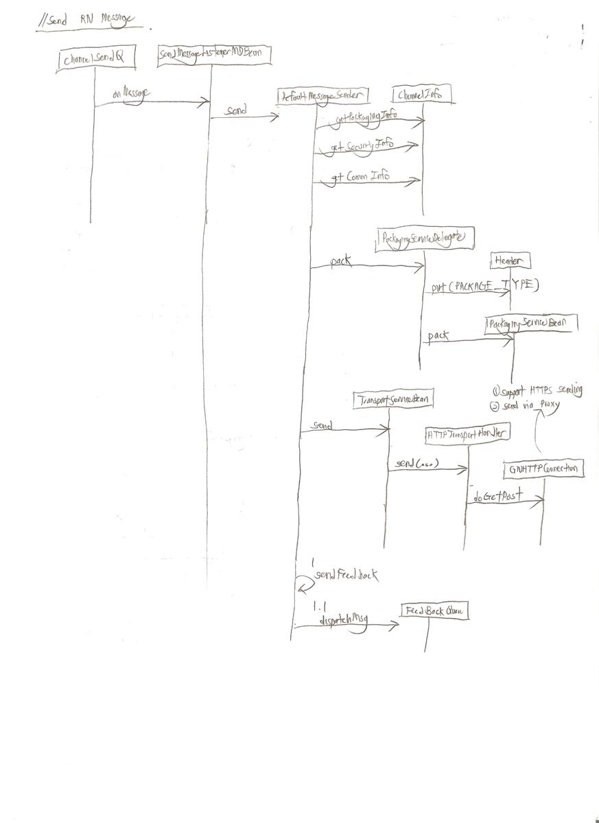

Based on the ChannelInfo, we can determine the Packaging info, SecurityInfo, and the CommInfo.

The PackagingServiceBean will package the user document content into the appropriate RN format given the RNIF version we defined in the Packaging info. Audit file will be generated as well.

The TransportServiceBean will deliver the audit file (RN Message) to the destination given the communication URL we defined in the CommInfo.

After the audit file file has been delivered, the sent status will be feedback to the “Feedback” queue.

HTTP Connection to TP

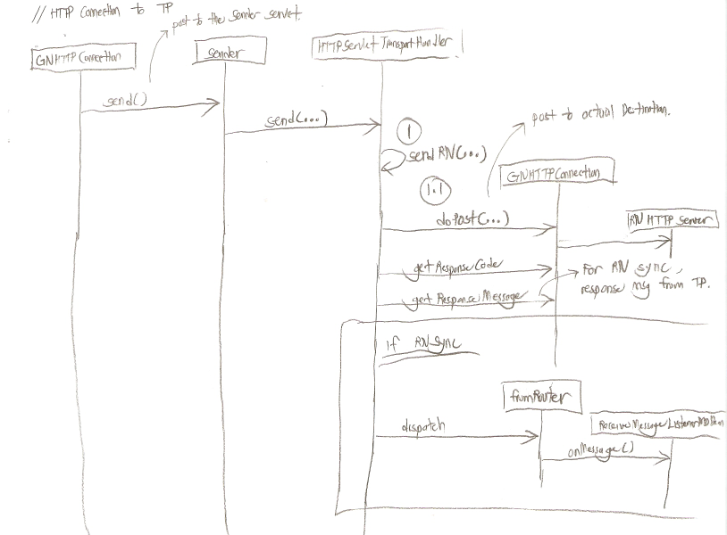

For the HTTP sending, we actually post the HTTP request to the internal servlet (http://localhost:8080/gridtalk/b2bi/rosettanet/sender) for performing the actual connection to the HTTP destination.

The GNHTTPConnection can support the HTTPS connection, and send via proxy server.

HTTP response code will be extracted to notify the upper layer regard the HTTP send status.

If the RN connectivity has been configured as “Sync”, the GNHTTPConnection will wait for the reply message from TP using the existing connection. The default wait timeout is configured as 30000s.

The returned reply message from TP will be dispatched to the “ReceiveMessageListenerMDBean” for further processing.

Feedback Sent Status

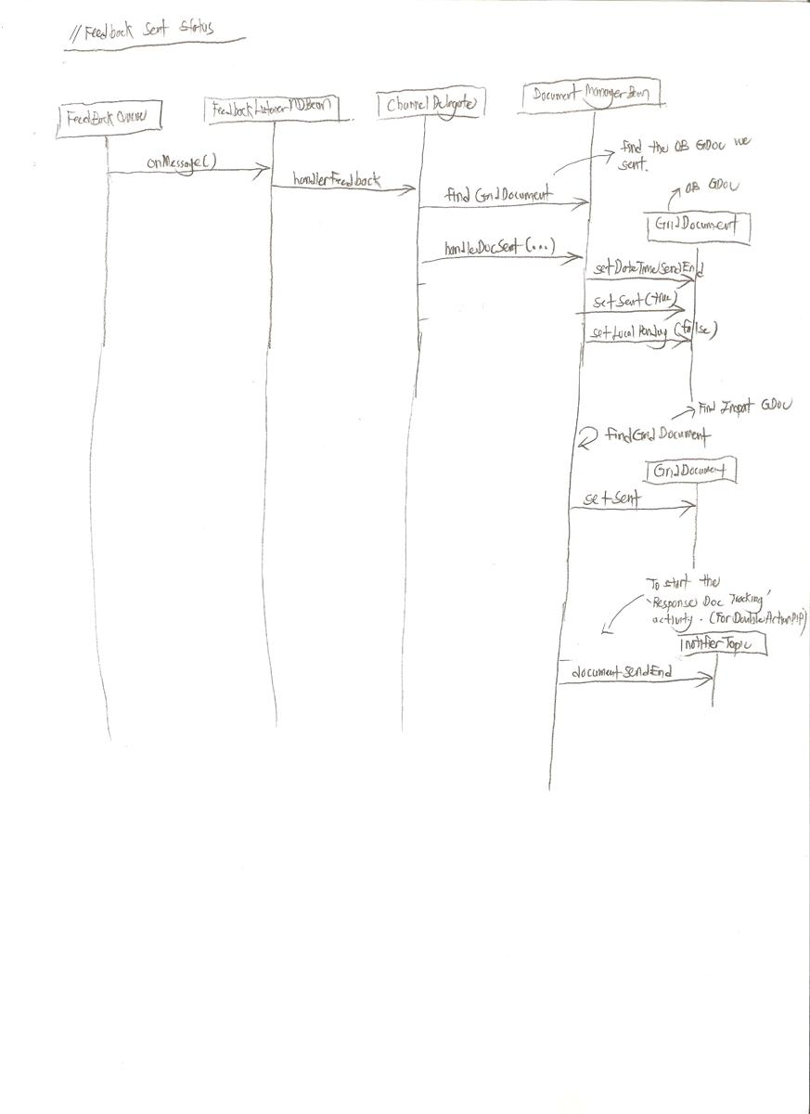

The transport layer will feedback the sent status of the OB document we sent out.

If the sent status is successful, it just indicates that the document has reached TP server, but it does not guarantee the document can be processed by the TP without issue (eg content validation error). The “DateTimeSent” field of OB GDOC will be updated with the timestamp when we received the feedback.

If the sent status is failed, we will trigger the Partner function failure alert to indicate the OB message we sent is not successful.

Checking of ACK Status for Request Message (Initiating Role) & Response Message (Responding Role, Double Action PIP)

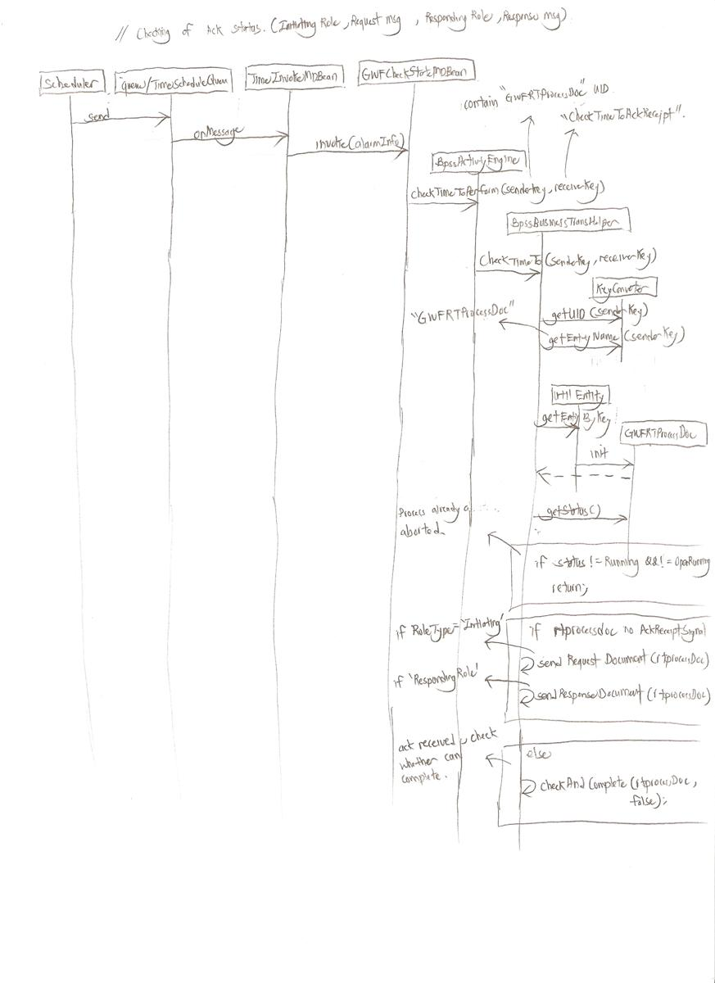

If there is no signal message be acked on the Request message or Response message, there will be a resend of the request/response message

There is some limitation on identifying the Process Def based on the PIP code, PIP version, Partner ID, and Role Type if the customer needs to use RNIF 1 and RNIF 2 for the same Process Def. A possible enhancement is to include the RNIF version as additional search criteria.
We will send the EXCEPTION_CANCEL signal if the Process Instance is a double-action PIP, and the receive msg is not the last message in the PIP. Otherwise, we will trigger 0A1. The signal or 0A1 is to notify the TP GTAS is having problem in processing the received msg due to some internal error.
Currently the implementing of the caching mechanism will not work under Cluster environment due to the fact that the request message can be concurrent processed by the other nodes. Enhancement is needed to tackle this in cluster environment; So far, no customer has reported such issue.
Maybe for the future enhancement, we can have the option to specifically switch off a particular medium of transport eg The AS2 transport can be disable. Currently, as long as customer have the valid license, he/she can use all the medium of transport supported in GTAS.
We have such a design so that we can support the DMZ setup as describe in the document “GridTalk Deploy Env.doc”. Refer to http://trac.vpn1.gridnode.com/trac/gtas/browser/branches/4.2.x_dev/Doc/misc/GridTalk%20Deploy%20Env.doc

