This document provides an overview of how a user request gets processed within the GT from presentation tier to business tier.

Error: Reference source not found1 illustrates the typical message flows that happen in the presentation tier when the client sent a request from the Client tier.

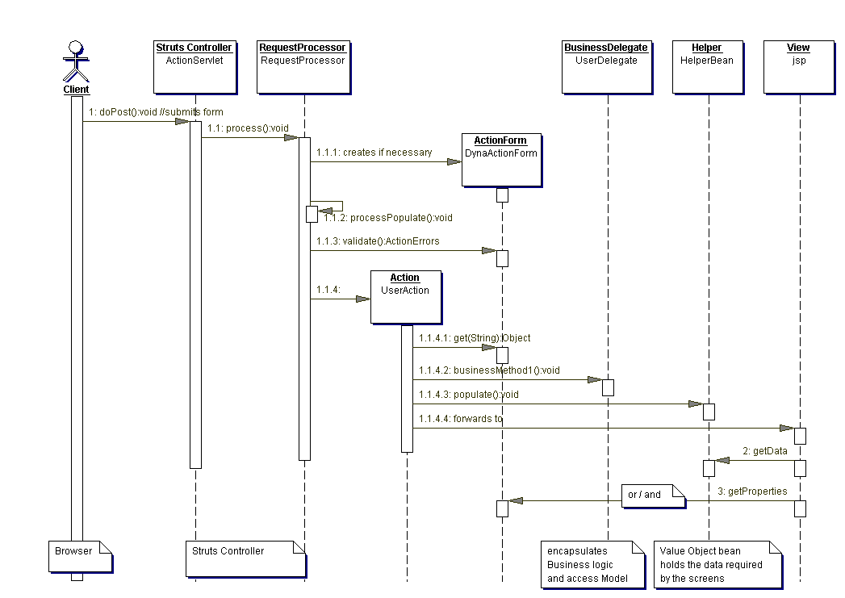
Figure 1 Message Flows in the Presentation Tier

- The ActionServlet class is at the core of the struts framework. It implements the Front Controller pattern by providing a centralized access point to intercept all users’ requests. It is an HTTPServlet that receives requests from the browser and forwards it to the RequestProcessor class.
- Depending on the struts configuration file, the RequestProcessor shall invoke the appropriate concrete Action helper class to handle the request.
- The concrete Action class collaborates with one or more helper classes to provide the necessary logic to handle the specific request.
- Most request handling sequences span across tiers. The WebClientController sits between the Presentation tier and the Business Tier, acting as a bridge to the EJBClientController in the Business Tier. It implements the Business Delegate pattern by hiding the underlying implementation details of the business services, such as JNDI lookup to the business service bean components. A single instance of this exists for every client’s session. It caches a reference to the EJBClientController object to avoid the expensive JNDI lookup.

Business Tier
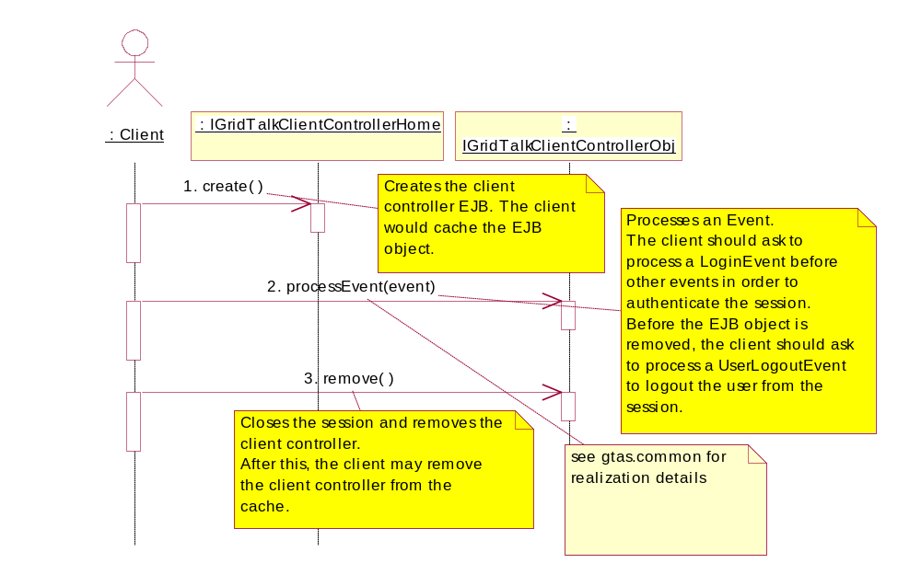
Figure 2 Client Session Life Cycle

- Similar to the Presentation Tier, the Business Tier adopts a single point of entry to all available business services via the EJBClientController object. The EJBClientController object implements the Front Controller pattern by intercepting all Event objects flowing from the presentation tier and routing them to the appropriate EventAction object.
- The EventAction object encapsulates the business logic required to handle the event. It does so by delegating to the appropriate business components in the business tier for processing. Typically, it acts as a mediator that coordinates the activities among these business components.
- The business components are usually realized by the Session Beans. These Session Beans implements the Session Façade pattern. They hide the complex interaction that occurs beneath the subsystem and exposes only a set of uniform coarse-grained services.
The following diagram Figure 3 illustrates how the StateMachine handle the event receive from GridTalkClientController.

Based on the event, the StateMachine will instantiate the appropriate EventAction
addEvent : CreateAlertEvent
: StateMachine
: CreateAlertAction
: Alert
:
IAlertManagerObj
: AlertAction
CreateAlertEvent class
entitiesFieldIds =
AlertEntityFieldID.getEntityFieldID()
encapEntities = null
4. perform(event)
4.1. doProcess(event)
4.1.1. createEntity(event)
4.1.1.1. prepareCreationData(event)
4.1.1.2. createEntity(entity)
4.1.1.3. retrieveEntity(key)
4.1.2. constructEventResponse(errorCode, params, ex)
4.1.2.1. convertToMap(entity)
4.1.3. constructErrorResponse(event, ex)
4.1.3.1. getErrorMessageParams(event)
4.1.3.2. constructEventResponse(errorCode, params, ex)
1. init(sm)
2. doStart( )
3. validateEvent(event)
5. doEnd( )
3.1. getExpectedEventClass( )
3.2. doSemanticValidation(event)
4.1.2.1.1. convertToMap(entity, entitiesFieldIds, encapEntities)
4.1.1.1.1. getName( )
4.1.1.1.2. setAlertType(typeUid)
4.1.1.2.1. createAlert(alert)
Set the following properties:
Name = addEvent.getName()
AlertType = addEvent.getType()
BindActions = addEvent.getActions()
Descr = addEvent.getDescription()
4.1.1.2.2. setAlertUid(alertUid)
4.1.1.2.3. setActionUid(actionUid)
4.1.1.2.4. createAlertAction(alertAction)
4.1.1.3.1. getAlertByAlertUId(alertUId)
For each Action bind
to the Alert, create an
AlertAction.
Figure 3 Sample on how State machine handle event from GridTalkClientCtrl

