
GridNode
GridTalk

GridTalk enables your collaborative value chain to exchange business documents, automate workflows and synchronize shared data directly with multiple business partners in real-time, reliably, efficiently, and securely.
GridTalk provides end-to-end delivery of business documents so that you can enjoy the following benefits:
- Ownership and control over your data.
- Faster and unhampered access to your data as data resides locally within your company rather than with a third-party. You do not have to be connected to the outside world just to view/process your business documents.
- Enables real-time integration with your back-end system thus allowing you to deal with a single-unified interface i.e. your back-end system.
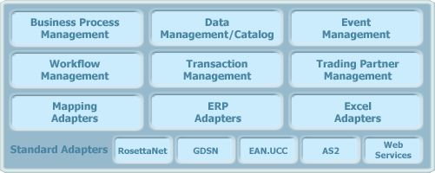
Features: Scalable networking of business nodes for communication and collaboration
Support for Web Service provision and consumption

Security with RSA PKI certificates and 3DES and RC2 strong encryption

Audit trail, transaction tracking and non-repudiation support

Connectivity to Enterprise Resource Planning (ERP) and Collaborative Planning Forecast and Replenishment (CFPR) systems for end-to-end integration

XML-enabled technology allowing flexible adoption of business document standards

Certified for plug-and-trade with leading messaging and payload standards such as RosettaNet RNIF 1.1 and 2.0, AS2, CIDX etc...

Data transformation and conversion

Workflow engine using BPSS and XPDL standards

Platform independent - Windows 2000, XP pro, Server 2003, Linux and Solaris 10

Web browser interface eliminates the need to install software on multiple desktops

GridTalk™ Connects ERP to Internet for B2B

GridTalk can communicate with any RosettaNet compliant B2B gateway
The GridTalk RosettaNet Gateway enables full business-to-business (B2B) process integration
Securely exchange e-business documents
(PIP®)
across
the
Internet

GridTalk™

RosettaNet
Gateway
(RNIF)

GridTalk™

RosettaNet
Gateway
(RNIF)
Data
Mapping
Data
Mapping
Trading Partner B

Trading Partner A
Enterprise
Resource
Planning
System

(ERP)

Manages
Private
Business

Processes

Enterprise
Resource
Planning
System

(ERP)

Manages
Private
Business
Processes

