
GRIDNODE PTE LTD

GRIDTALK ™ TXMR
Admin Guide

Release version 1.11.0

Copyright

© Copyright 2007 GRIDNODE PTE LTD. All rights reserved.

No part of this GRIDTALK™ TXMR administration and user guide may be reproduced or transmitted in any form or for any purpose without the express permission of GRIDNODE PTE LTD. The information contained herein may be changed without prior notice.

GRIDNODE PTE LTD further does not warrant the accuracy or completeness of the information, text, graphics, links, or other items contained within these materials. GRIDNODE PTE LTD shall not be liable for any special, indirect, incidental, or consequential damages, including without limitation, lost revenues or lost profits, which may result from the use of these materials. The information in this documentation is subject to change without notice and does not represent a commitment on the part of GRIDNODE PTE LTD for the future.

Some software products marketed by GRIDNODE PTE LTD and its distributors contain proprietary software components of other software vendors.

Names of all products herein are used for identification purposes only and are trademarks and/or registered trademarks of their respective owners.

GRIDTALK™ and GridNode™ are registered or unregistered trademarks of GRIDNODE PTE LTD.

All rights reserved.

GRIDTALK™
Transaction Monitoring & Reporting Admin Guide

Contents

Chapter Page

1 About the Guide 1
1.1 Terminology 1
2 Getting Started with TXMR 2
2.1 Accessing TXMR 2
2.2 Overview of TXMR User Interface 3
3 Web Admin Tasks 5
3.1 Managing User Groups & Accounts 5
3.1.1 Groups Management 5
3.1.1.1 Adding a new Group 6
3.1.1.2 Deleting an existing Group 7
3.1.2 User Management 8
3.1.2.1 Adding a new user 8
3.1.2.2 Editing a user account 10
3.1.2.3 Deleting a user account 11
3.2 Transaction Document and Event Tracking 12
3.3 Report Generation 13
3.3.1 Scheduling Report Generations 13
3.3.2 Managing Generated Reports 15
3.3.2.1 Report Housekeeping Schedule 15
3.3.2.2 Changing the Report Housekeeping Schedule 16
3.3.3 Supported Report Types 18
3.3.3.1 Certificate Status Report 18
3.4 Transaction Archival and Restore 20
3.4.1 Scheduling Transaction Archival 20
3.4.1.1 Creating a new Archive Schedule 21
3.4.1.2 Editing an Archive Schedule 23
3.4.2 Archiving Transactions on Ad-hoc Basis 25
3.4.3 Overview of Archival Process 27
3.4.3.1 Email Notifications 28
3.4.3.2 Outputs from Archival 30
3.4.3.3 Concurrent Archival Requests 30
3.4.4 Restoring Transaction Archives 31
3.4.4.1 Downloading a Transaction Archive Summary File 32
3.4.4.2 Restoring a Transaction Archive 33
3.5 Configuring Web Settings 34
3.5.1 Web Session Idle Time 34
3.5.1.1 Changing the Web Session Idle Time 34
3.5.2 Miscellaneous Web Configurations 35
3.5.2.1 Changing Web Configurations 35
3.6 Viewing User Action Logs 37
3.6.1 Action Logs 39
4 Appendix 40
4.1 Computation of Next Run Date/Time 40
4.1.1 Frequency: Daily 40
4.1.2 Frequency: Weekly 40
4.1.3 Frequency: Monthly 41
4.2 Computation of Archive Date Range 42
4.2.1 Frequency: Daily 42
4.2.2 Frequency: Weekly 42
4.2.3 Frequency: Monthly 42
4.3 Archival Email Notification Samples 43
4.3.1 At Start Archival 43
4.3.2 At the start of Archive by Process 43
4.3.3 At the start of Archive by Document 44
4.3.4 At the start of Archive Monitored Data 44
4.3.5 At the completion of Archive by Process 45
4.3.6 At the completion of Archive by Document 45
4.3.7 At the completion of Archive Monitored Data 46
4.3.8 At the completion of entire archival 46
4.3.9 On error during Archive by Process 47
4.3.10 On error during Archive by Document 47
4.3.11 On error during Archive Monitored Data 48
4.3.12 On failure of entire archival 48
4.4 Archive Restore Email Notification Samples 49
4.4.1 Restore of Processes and Transactions Completed 49
4.4.2 Restore of Processes and Transactions Failed 49
4.4.3 Restore of Monitored Data Completed 49
4.4.4 Restore of Monitored Data Failed 49

Figures
Figure 1: TXMR Login Screen 2
Figure 2: Admin Page Navigation Bar 3
Figure 3: Admin Menu 3
Figure 4: Main Page Navigation Bar 3
Figure 5: Groups Management Page 6
Figure 6: User Management Page 8
Figure 7: Register User Page 9
Figure 8: User Edit Page 10
Figure 9: RosettaNet Transaction Search Page 12
Figure 10: List Of Schedule Page 13
Figure 11: Add Schedule Report Page 14
Figure 12: Update Schedule Report Page 14
Figure 13: Run Report Now Page 14
Figure 14: List Of Report Page – With Housekeep Report link 15
Figure 15: Housekeep Report Page – View mode 16
Figure 16: Housekeep Report Page – Edit mode 16
Figure 17: Housekeep Report Page – with update status 17
Figure 18: Archive Schedule List Page 20
Figure 19: Add Schedule Archive Page 23
Figure 20: Edit Schedule Archive Page 24
Figure 21: Archive Transaction Page 25
Figure 22: Archival Process Overview 27
Figure 23: Email Template for Stage 1 28
Figure 24: Email Template for Stage 4 28
Figure 25: Email Template for Stage 7 29
Figure 26: Email Template for Stage 8 29
Figure 27: Email Template for Stage 11 29
Figure 28: Email Template for Stage 12 29
Figure 29: List Archived Page – With Data 31
Figure 30: List Archived Page – Without Data 32
Figure 31: Sample Transaction Archive Summary File 32
Figure 23: Email Template for Restore Completed 33
Figure 24: Email Template for Restore Failed 33
Figure 32: Web Idle Setting Page 34
Figure 33: Web Configuration Page 36
Figure 34: Show Log Page 37
Figure 35: Show Log Search Result 38

About the Guide

This Transaction Monitoring Admin Guide is especially designed for the web administrator. The guide contains the step-by-step instructions and visual screens to enable you to perform the simple tasks while you are getting acquainted with the features in the GridTalk 4.1 TXMR application. This admin guide is applicable for the Web Admin only, whereas Group Admin and Group User should refer to the user guide.

As a Web Admin, not only can you perform transaction monitoring and some simple administrative tasks as can be a Group User or a Group Admin respectively, you can also perform more intensive administrative tasks as well as generation of higher authority reports. Therefore, this admin guide covers mainly the features which are not found in the user guide, such as:

- Web Administration
Provide instructions on how to administer user accounts from all groups, to set idling time, to perform web configuration, to administer all existing groups, to track log files, and to manage archive transaction and restore transaction.

- Report Generation
Provide instructions on how to generate higher authority reports and scheduling of housekeep of generated reports.

Terminology

This document uses some terms or abbreviations extensively that you may not be familiar with. The following explains the terms and abbreviations used throughout the document.

Term/Abbreviation | What it stands for
Certificate | In this context, it refers to a digital certificate that is used for secured data exchange over internet.
GridTalk | An application providing RosettaNet message processing capabilities.
Process instance | An instance of a business process defined between two partners and may consist of one or more business action messages exchanged between the partners.
Transaction | A business action message exchanged between two partners, e.g. Purchase Order Request
TXMR | An application providing Transaction Monitoring and Report Generation capabilities for the transactions exchanged between the customers and their trading partners using GridTalk.

Getting Started with TXMR

Accessing TXMR

- Launch a web browser and navigate to the login page by entering the TXMR URL. After a few moments, the following login screen will be shown.

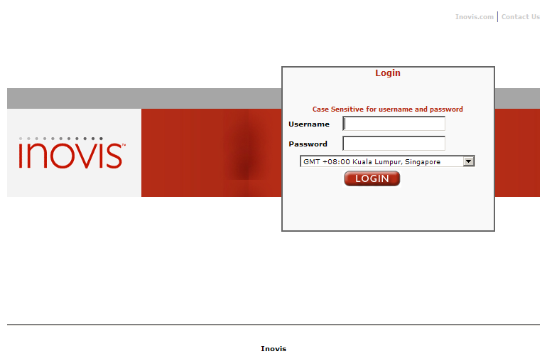
Figure 1: TXMR Login Screen

- Enter the username.

- Enter the password.

- Select the time zone that matches your area.

- Click on the ‘Login’ button.

- After successfully login, the ‘User Management’ page will be displayed.

TIP: If you lose your password, you can ask other web administrators (if any) to reset your password. Otherwise, you would need to contact your GridNode support.

Overview of TXMR User Interface

The user interface displayed for a Web Admin.

The following screen is applicable when you just login:
Links

Links
Login Username

Page Name

Figure 2: Admin Page Navigation Bar

The following screen is applicable when you roll your mouse over the menu:

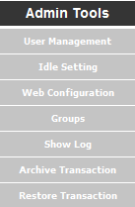
Links

Figure 3: Admin Menu

The following screen is applicable when you clicked on the link:
Links

Links
Login Username
Figure 4: Main Page Navigation Bar

The table below summarizes the use of each link on the navigation bar:

Link | Comment
 | This link is applicable for Web Admin to access the main functionalities of the TXMR – Transaction Document & Event Tracking, and Report Generation.
 | This link is used to direct you to manage your own account in the TXMR.
 | This link is used to end the session and to direct you to the login page.
 | This link is used to direct you to the Admin page when you first login.
 | This link is used to direct you to the Transaction Search page.
 | This link is used to direct you to the Report Generation page.
 | This link is used to direct you to the User Management page.
 | This link is used to direct you to the Idle Setting page.
 | This link is used to direct you to the Web Configuration page.

The table below summarizes the use of each link on the admin menu:

Link | Comment
 | This link is used to direct you to the User Management page.
 | This link is used to direct you to the Idle Setting page.
 | This link is used to direct you to the Web Configuration page.
 | This link is used to direct you to the Groups page.
 | This link is used to direct you to the Show Log page.
 | This link is used to direct you to the Archive Transaction page.
 | This link is used to direct you to the Restore Transaction page.

Web Admin Tasks

As a Web Admin, you are able to identify an Admin Tools menu ( ) at the left-hand side of the screen when you first login. This Admin Tools allow you to perform administrative tasks such as the following:

- Managing All User Groups & Accounts
- Transaction Archival and Restore
- Configuring Web Settings
- Viewing User Action Logs

In addition, you would be able to perform the following tasks on the Main Page:

- Transaction Document and Event Tracking for all Groups
- Report Generation for all Groups

The following sub-sections describe the various tasks that you may perform.

Managing User Groups & Accounts

As a Web Admin, you are authorized to administer user Groups as well as all user accounts in all Groups.

Groups Management

This feature allows you to administer all user Groups of the TXMR application.

To access the Groups Management feature,

- Go to Admin Page by clicking on the Control Panel link at the top right-hand corner of the TXMR UI.

- Click link at the Admin Tools menu. The Groups Management page is displayed, as shown in Figure 5: Groups Management Page.

Each row in the list identifies a Group. The column header shows the following fields:

ID:
This indicates an identifier that uniquely identifies a Group in TXMR.

Group Name:
This indicates the name of the Group.

CE ID:
This indicates the Customer Entity ID. This would tally with the Business Entity ID of the same customer, as configured in GridTalk application.

Delete:
This link allows delete of the Group.

The following functionalities are available on the Groups Management page:

- Adding a new Group representing a customer organization
- Deleting an existing Group

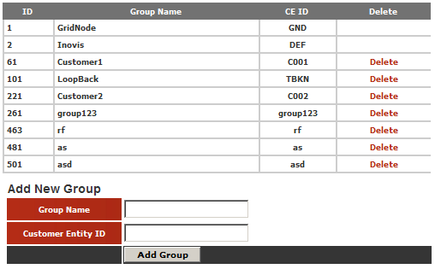
Figure 5: Groups Management Page

Adding a new Group

A new Group must be added for each new customer that GridTalk is to support. To do so,

- On the Groups Management Page, enter the following fields:

Group Name:
This indicates the name of the Group.

Customer Entity ID:
This is the unique identification of the customer, as configured as Business Entity ID in GridTalk application.

- To confirm the entries, click on the Add Group button.

If creation is successful, the newly created Group will appeared last in the list in the Group Management page. Otherwise, you will see the error message displayed on the right of the Add Group button.

NOTE:

The Group Name field and Customer Entity ID field are unique identifiers. Therefore, no duplicates are allowed.

TIP: To change the Group Name of Customer Entity ID, of an existing group, you have to delete it first, and then re-create it again.

Deleting an existing Group

- On the Groups Management Page, click on the Delete button of the Group you wish to delete. You will be prompted to confirm the deletion.

- To confirm the deletion, click YES.

- To cancel the deletion, click NO.

NOTE:

Deletion of a Group also deletes all user accounts which currently belong to that group.

User Management

The figure below shows the Administrator page after login to TXMR or when the link is clicked or when the link is clicked.

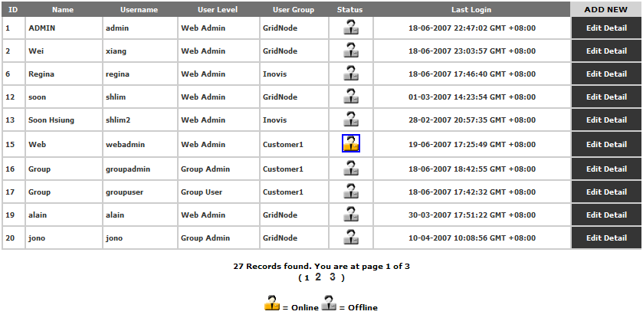
Figure 6: User Management Page

You will be able to view and edit details of all listed user accounts from all existing Groups in TXMR, as well as delete unwanted user accounts.

Adding a new user

You may add new Web Admins, Group Admins or Group Users for different organizations to access TXMR.

- Go to Admin Page by clicking on the Control Panel link at the top right-hand corner of the TXMR UI.

- On the User Management page, click button. This directs you to the Register User page to register a new user, as displayed in Figure 7: Register User Page.

- Enter the following fields (all fields with * are mandatory):

First Name:
Set the first name of the new user.

Last Name:
Set the last name of the new user.

Email Address:
Set the email address of the new user. The login information will be mailed to this email address.

Username:
Set the login name of the new user for TXMR.

Password:
Set the initial password for the new user to login to TXMR.

Confirm Password:
Set the same as initial password. This is required to check the consistency against the first entered password.

User Level:
Select whether the new user belongs to Web Admin, Group Admin or Group User. This is to grant the user rights for the new user.

User Group:
Select the group that the new user belongs to in TXMR.

User Info:
Set any additional description you may like for the new user.

Activate:
Select Yes or No to activate the new user at the point of registration. If the account status set to ‘No’, the account will not be granted access to login, even with correct user name and password.

Sign Up Date/Time:
This identifies the date/time of which the registration page was displayed. This field is not editable.

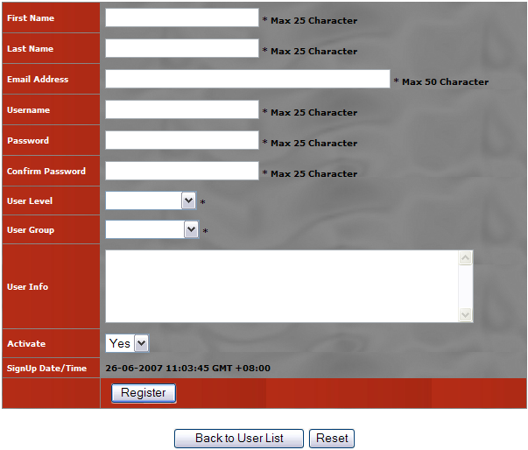
Figure 7: Register User Page

- To abort the registration, click Back to User List button.

- To reset the entries, click Reset button.

- To confirm the entries, click Register button. After a few moments, the status of registering the new user will be shown beside the Register button, e.g.  for successful status.

Editing a user account

Similar to adding new user account, you may edit any of the listed user accounts in your User Management page.

- On the User Management page, click at the end of a user record. The User Edit page will be displayed as shown in Figure 8: User Edit Page.

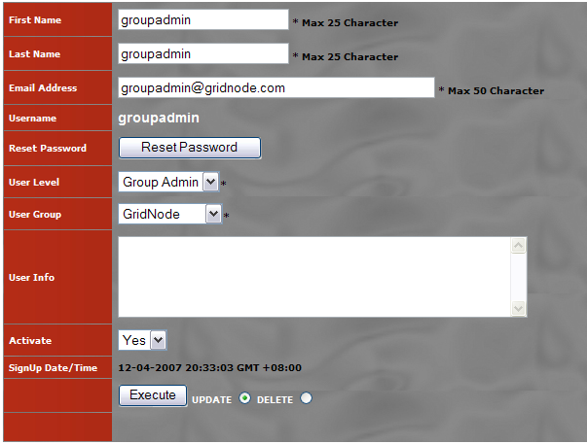
Figure 8: User Edit Page

- You may make changes to the First Name, Last Name, Email Address, User Level, User Group, User Info, and Activate fields.

TIP: Changing the Activate field to ‘No’ will freeze the user account. Upon saving the change, the user will not be able to login to TXMR even with correct login credentials. Similarly, to allow the user to login again, change the Activate field back to ‘Yes’.

- Upon making the necessary changes, select UPDATE option () beside the button.

- To confirm the changes, click the Execute button. All changes will be persisted after the button is clicked. The status of the changes will be displayed below the button.

- To just reset the password of the user instead of changing the details, click on the Reset Password button.

A new password will be randomly generated and mailed to the email address of the user.

Deleting a user account

You may delete an existing user account from the application database totally if the account is no longer required.

- On the User Management page, click at the end of a user record. The User Edit page will be displayed as shown in Figure 8: User Edit Page.

- Select DELETE option beside the Execute button.

- To confirm the deletion, click the Execute button.

The user account will be removed from the database. The user details will be cleared from the page, and the status of the delete will be displayed below the Execute button.

Transaction Document and Event Tracking

As a Web Admin, you are entitled to search and monitor transactions belonging to any Group in TXMR. This is different from Group Admin or User who is constrained to transactions belonging to his or her own Group.

As with a normal user, two options are provided for searching the transactions:
- Search By Processes
- Search By Event

However, for the Search By Processes option, there are additional field inputs that allow you to perform searches for a particular Group:

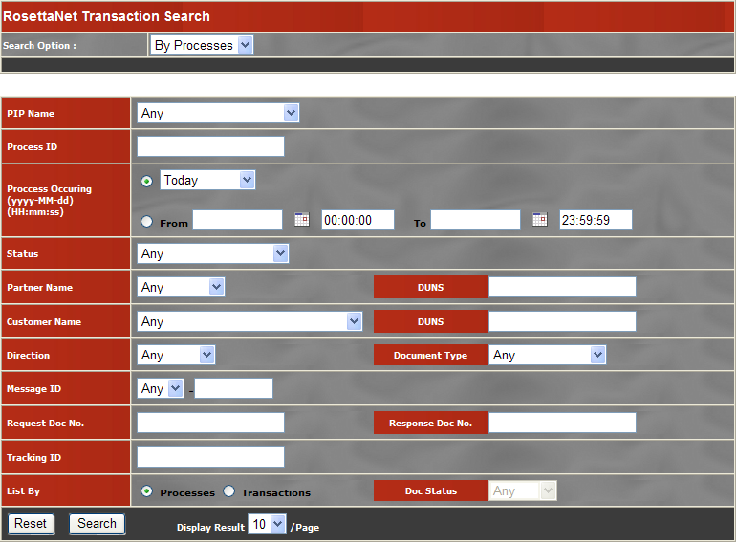
Figure 9: RosettaNet Transaction Search Page

Customer Name
This shows a list of Groups (customers) who has some transactions captured in TXMR. Select a Group from the list to filter the search for that customer.

DUNS
Enter the DUNS number of the customer that you want to search transactions for.

Report Generation

As a Web Admin, you may access the following Report Generation functionalities:

- Manage schedules for report generation
- Generate report for online viewing or email
- Manage generated reports
- Manage report housekeeping schedule (only available for Web Admin)

The following report type(s) are available for generation:

- Transaction Status Report
- Generate Certificate Status Report (only available for Web Admin)

To access the Report Generation feature,

- Go to Main Page by clicking on the Main Page link at the top right-hand corner of the TXMR UI.

- Click at the top left-hand corner of the screen. The Report Generation page is displayed, defaulting to the List Of Schedule page.

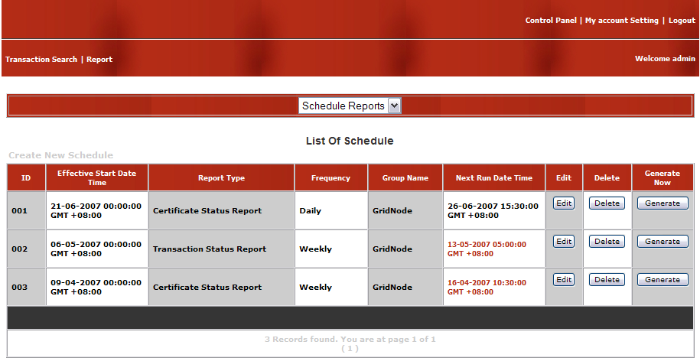
Figure 10: List Of Schedule Page

The following options are available on the Report Generation page:

- Schedule Reports
- Run Reports Now
- List of Report

Scheduling Report Generations

This functionality is the same as detailed in TXMR User Guide Section 6.2.1 with only one difference – you are able to select the Group(s) for whom you wish to generate report.

As shown in the following figures, there is an additional Generate For field which indicates the Group(s) for whom you wish to generate reports. Multiple selections are possible.

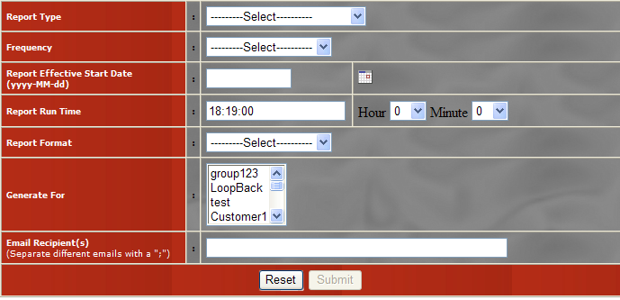
Figure 11: Add Schedule Report Page
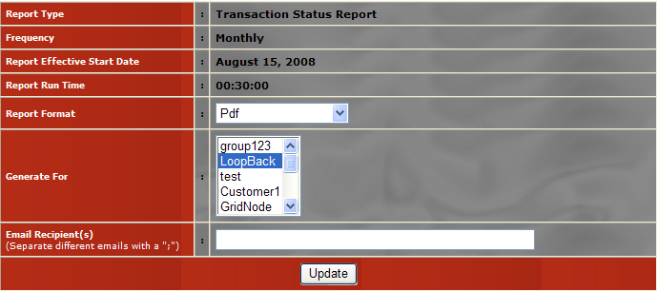
Figure 12: Update Schedule Report Page

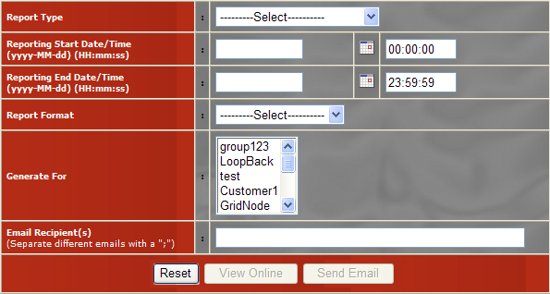
Figure 13: Run Report Now Page

Managing Generated Reports

This functionality is the same as detailed in TXMR User Guide Section 6.2.3, with the following addition:

- View and edit report housekeeping schedule

Report Housekeeping Schedule

Reports generated regularly will get obsolete as time goes by. As such, you would not want to keep those reports any more. You may retrieve the list of generated of reports and delete them one by one, but it may be a hassle if there are a lot of obsolete reports.

Therefore, TXMR provides a way for you to housekeep the obsolete reports in batch regularly. You may change the housekeeping schedule freely to suit your need.

To access the housekeeping schedule,

- Go to List Of Report page by selecting the List Of Report option on the Report Generation page.

Notice there is an additional link above the list of reports table as compared to what is displayed for a Group Admin, as shown in figure below:

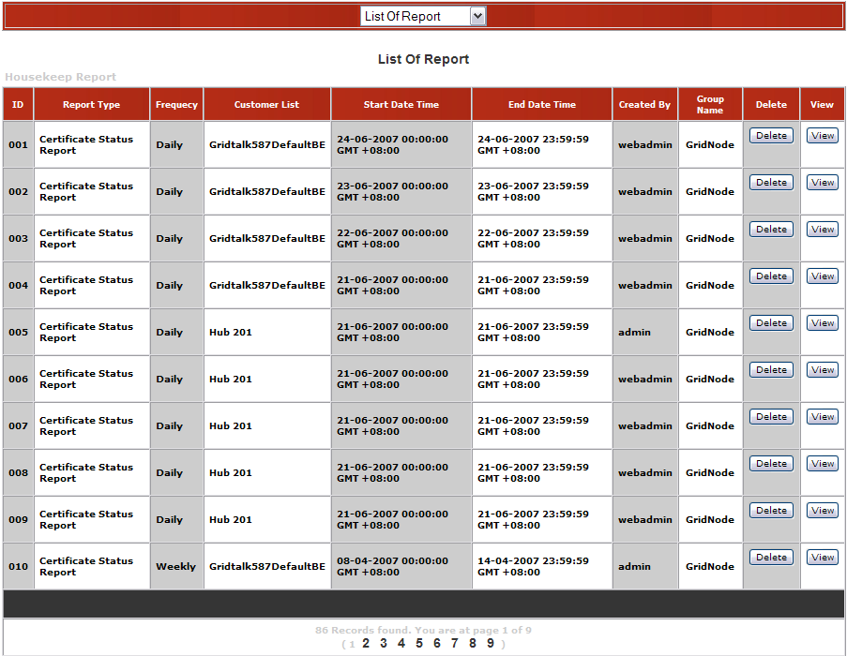
Figure 14: List Of Report Page – With Housekeep Report link

- Click on the link.

The Housekeep Report page will be displayed with the following fields:

Current Schedule:
This indicates the current housekeeping schedule – “Once”, “Daily”, “Weekly” or “Monthly”.

Next Delete Date:
This indicates the next date on which obsolete reports which will be purged.

Deleting Reports more than x days:
This indicates the minimum age of reports since generation before it is considered obsolete. Any reports which were generated more than x number of days ago, at the time of housekeeping, will be deleted.

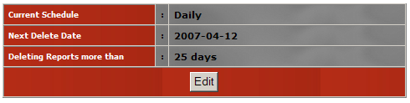
Figure 15: Housekeep Report Page – View mode

Changing the Report Housekeeping Schedule

To change the report housekeeping schedule,

- On the Housekeep Report page, click the Edit button.

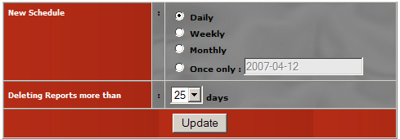
Figure 16: Housekeep Report Page – Edit mode

- The Housekeep Report page will change to edit mode with the following fields:

New Schedule:
Select the new frequency for the schedule.

If the “Once only” option is selected, the field next to it will be enabled for input, as well as the icon will also appear next to the text field. Click on icon to select the desired date for deletion.

Deleting Reports more than x days:
Select the minimum age (non-inclusive) of the reports that would be considered obsolete. Any reports which were generated more than x number of days ago, at the time of housekeeping, will be deleted.

- To confirm the changes, click the Update button.

Upon submission, the Housekeep Report page (view mode) will be displayed, with the status of updating shown beside the Edit button.


Figure 17: Housekeep Report Page – with update status

If update is successful, the status “Schedule Updated successfully” will be shown. Otherwise, the status “Schedule NOT updated” will be shown.

Supported Report Types

This section describes the additional types of reports that a Web Admin may generate, in addition to those described in TXMR User Guide Section 6.2.4.

Certificate Status Report

The Certificate Status Report provides a summary of the certificates used in the GridTalk application. This report is useful for regular tracking of which certificates will be expiring in the next 30 days, and whether any replacement has been put in place for the expiring certificate.

The following sub-sections describe the different parts of the report.

Report Header

The Certificate Status Report header shows the following information:

Certificate Status Report:
This is the title of the report.

Certificate Status Summary

The Certificate Status Summary shows the following information:

ID:
This indicates the GridNode ID of the certificate if it belongs to GridNode entity such as a GridTalk. Otherwise, it will be shown as ‘0’ (this is usually the case for partner certificates).

Name:
This indicates the name of the certificate, as recognized in GridTalk.

Issuer Name:
This indicates the name of the issuer of the certificate.

Serial Number:
This indicates the serial number of the certificate.

Start Date:
This indicates the date/time of which the certificate first become valid.

Expiry Date:
This indicates the date/time of which the certificate will become invalid (expired).

Is Partner:
This indicates whether the certificate belongs to a trading partner.

Is CA:
This indicates whether the certificate belongs to a Certificate Authority.

NOTE:

The Is Partner notion applies with respect to the GridTalk application entity. Public certificates used for encrypting data for external entities would be considered as belonging to a trading partner. In other words, any certificates that are not private certificates are partner certificates. Thus, a customer certificate will also be indicated with Is Partner as ‘Yes’.

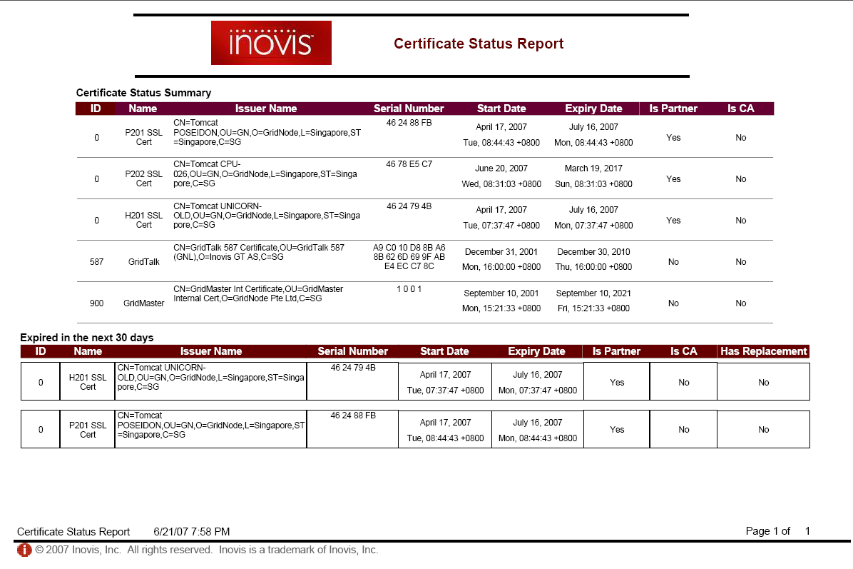
Figure 24: Sample Certificate Status Report

Expired in the next 30 days

The Expired in the next 30 days section shows those certificates that will be expired within the next 30 days. The section provides the following additional information:

Has Replacement:
This indicates whether a replacement certificate has been put in place in GridTalk for the certificate that will be expiring or has expired. If a replacement exists, this will display as ‘Yes’. Otherwise, this will display as ‘No’.

Report Footer

The report footer shows the following information:

Certificate Status Report:
This indicates the title of the report.

Generation Date:
This is the date/time of generation of the report.

Page X of Y:
This indicates the paging of the report. X is the current page number, while Y is the total number of pages in the report.

Transaction Archival and Restore

As time goes by, the transactions captured in the TXMR database may grow to a stage that it may impact the performance of the application. As such, it may be useful to archive out the past transactions from the database. Only when necessary, the archived transactions may be restored for checking purposes.

As a Web Admin, you are allowed to perform transaction archival as well as restore.

The Transaction Archival and Restore feature includes the following functionalities:

- Manage schedules for archival
- Archive transactions on ad-hoc basis
- Restore transaction archives

Scheduling Transaction Archival

- Go to Admin Page by clicking on the Control Panel link at the top right-hand corner of the TXMR UI.

- Go to Archive Transaction page by clicking the link at the Admin Tools menu.

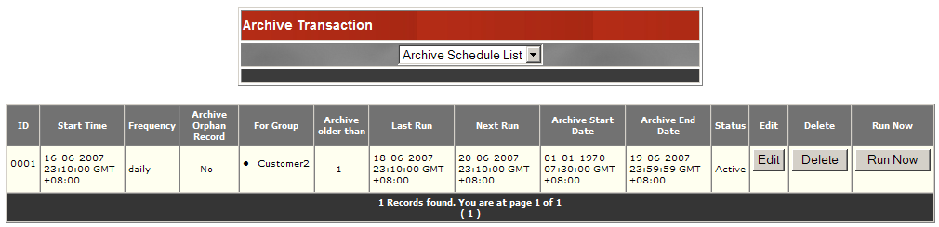
Figure 18: Archive Schedule List Page

The following options are available on the Archive Transaction list box:

- Archive Schedule List
- Archive Transaction
- Create New Schedule

The Archive Schedule List option allows you to view a listing of Archive Transaction schedules. Each row in the list identifies a schedule. The column header shows the following fields:

ID:
This identifies each row by a running number.

Start Time:
This indicates the date/time that the schedule starts to take effect. Before that time, the schedule would not run at the scheduled frequency.

Frequency:
This indicates whether the report will be generated on a “Daily”, “Weekly” or “Monthly” basis.

Archive Orphan Record:
This indicates whether to archive those records not belonging to any group. A transaction/process/event record may not belong to any group at its early creation stage when it is not yet known which customer the transaction belongs to. Those records may remain as ‘orphans’ if the transactions they represent failed at that early stage. If “Yes”, those records will be archived. Otherwise, they will not be archived.

For Group:
This indicates the group name which the archive was scheduled for.

Archive older than:
This indicates the maximum age of the transactions to retain in the system. The unit of the age depends on the Frequency. TXMR will archive any transaction(s) that occurred more than the indicated value number of days/weeks/months ago.

Last Run:
This indicates the date/time that the scheduled archival is last executed.

Next Run:
This indicates the date/time that the next archival will be executed. For details on its computation, refer to Appendix 4.1 Computation of Next Run Date/Time.

Archive Start Date:
This indicates the starting date/time range of the transactions that will be archived on the next archival. For details on its computation, refer to Appendix 4.2 Computation of Archive Date Range.

Archive End Date:
This indicates the ending date/time range of the transactions that will be archived on the next archival.

Status:
This indicates whether or not the schedule is in “Active” mode or “Not Active” mode. If “Active”, the schedule will run upon next run time. Otherwise, the schedule will not run.

Edit:
This button allows editing of the schedule.

Delete:
This button allows deletion of the schedule.

Run Now:
This button allows immediate execution of the archival, archiving transactions found between the indicated Archive Start Date and Archive End Date date/time range.

Creating a new Archive Schedule

To create a new archive schedule,

- Select the Create New Schedule option in the Archive Transaction option list box. The Add Schedule Archive page will be displayed, as shown in Figure 19: Add Schedule Archive Page.

- Enter the following fields:

Frequency:
Select how frequent you want archive the transactions – “Daily”, “Weekly” or “Monthly”.

Run Every:
Set the unit value for the selected archival frequency. For example:

- Run Every 1 Day(s)
- Run Every 2 Week(s)
- Run Every 3 Month(s)

Effective Start Date:
Set the date that you want the schedule to start taking effect. This can be done by clicking the icon to bring up the date picker, and select the desirable date.

Run Time:
Set the time of the day that you want the archival to run each time based on the schedule frequency. This can be done by selecting the desired Hour and Minute from their respective combo lists.

Scheduler Status:
Select “Enabled” for active mode or “Disabled” for non-active mode.

Archive Orphan Record:
Flag whether to archive those transactions not belonging to any Group. If ticked, Archive By Group field will be disabled.

Archive By Group:
Select the Group(s) whose transactions will be archived.

Archive Record Older Than:
Set the unit value for the age of the transactions to archive. Transactions older than the set value will be archived. For example,
- 14 Day(s) -- This will archive transactions occurring more than 14 days ago at the time of archival.
- 2 Week(s) – This will archive transactions occurring more than 2 weeks ago at the time of archival.
- 1 Month(s) – This will archive transactions occurring more than 1 month ago at the time of archival.

- To reset the changes, click the Reset button.

- To confirm the changes, click the Submit button. You will be prompted to confirm adding the schedule:

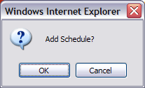

- Click OK to confirm adding the schedule. Otherwise, click Cancel.

If the schedule is successfully added, you will be directed to a page showing the submission status: “Archive Schedule is successfully created”

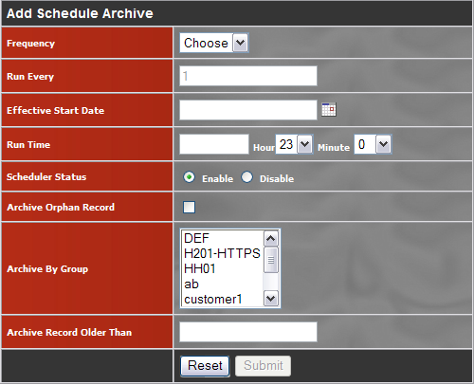
Figure 19: Add Schedule Archive Page

TIP: Three types of archive options are possible:

- Archive by date range and groups
All transaction records that fall within the date range and group will be archived.

- Archive by date range and Orphan
All transaction records that do not belong to any group and fall within the date range will be archived.

- Archive by date range
All transaction records that fall within the date range will be archived. This option includes the orphan records, if any.

Editing an Archive Schedule

To change an existing Archive Schedule,

- Click on the Edit button of schedule that you want to change at the Schedule Archive List. This displays the Edit Schedule Archive page, as shown on Figure 20: Edit Schedule Archive Page.

- Make the necessary changes to the fields you want.

- To reset the changes, click the Reset button.

- To confirm the changes, click the Submit button. You will prompted to confirm updating the schedule:
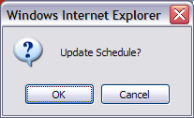

- To confirm updating the schedule, click OK. Otherwise, click Cancel.

If the schedule is updated successfully, you will be directed to a page showing the submission status: “Archive Schedule is successfully updated”.

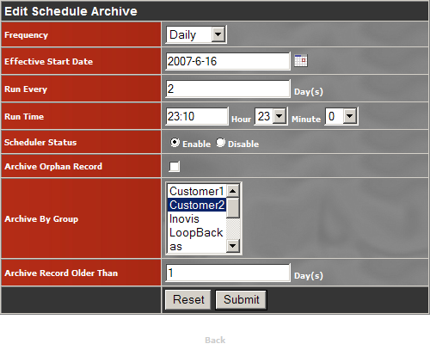
Figure 20: Edit Schedule Archive Page

Archiving Transactions on Ad-hoc Basis

You may perform an ad-hoc archival of the transactions when such a need arises. To do so,

- Select the Archive Transaction option in the Archive Transaction option list box. This displays the Archive Transaction page, as shown on Figure 21: Archive Transaction Page

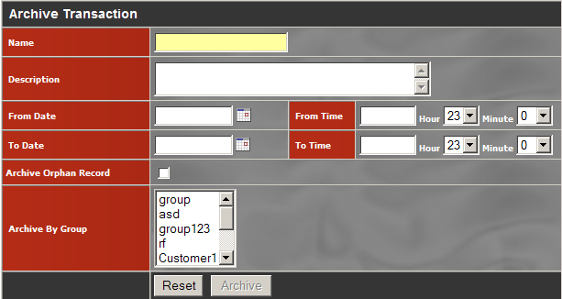
Figure 21: Archive Transaction Page

- Enter the following fields:

Name:
Set an arbitrary name to identify the archival.

Description:
Set a description for the archival.

From Date:
Set the start date range of the transactions to be archived.

From Time:
Set the start time range of the transactions to be archived.

To Date:
Set the end date range of the transactions to be archived.

To Time:
Set the end time range of the transactions to be archived.

Archive Orphan Record:
Flag whether to archive those transactions not belonging to any Group. If ticked, Archive By Group field will be disabled.

Archive By Group:
Set the group(s) whose transactions will be archived.

- To reset the entries, click the Reset button.

- To confirm the entries, click the Archive button. You will be prompted to confirm performing the archival now:

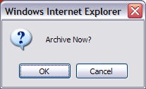

- To confirm performing the archival now, click OK. Otherwise, click Cancel.

If archival is started successfully, you will be directed to a page showing the archiving status: “The archival is currently processing. Email alert will be sent to user after the archive operation is completed.”

Overview of Archival Process

The TXMR transaction archival process, in general, is a 3-step process. It involves the archival of:
- Processes and transactions in GridTalk application (Archive by Process)
- Transactions imported into GridTalk application (Archive by Document)
- Monitored data (processes, transactions, and event histories) in TXMR application

The following figure shows an overview of the archival process:

Archive by Process
Archive monitored data
Archive by Document
Co-ordinate Archival
Start Archival
GridTalk
TXMR
End Archival
Output Archive
Archive
OK?
Yes
No
Abort Sub-archival
Archive next record set
More record sets?
End Sub-archival
Start Sub-archival
No
Yes
Generic Archive sub-process
Figure 22: Archival Process Overview

As can be seen from the above figure, there are 3 archive sub-processes. Each sub-process performs its own archival in a repetitive fashion, archiving a set of records in each round. In each round the successfully archived records are appended to the output archive. Otherwise, if a problem is found the sub-process archival will be abort. The entire archival will be considered complete upon completion of all of the 3 sub-processes. If any one of the sub-processes has been aborted, the entire archival is considered failed.

NOTE:

The status of archival sub-process(es) at GridTalk does not affect the archival sub-process at TXMR, and vice versa. That means to say, if Archive by Process is aborted, Archive monitored data may still continue processing till completion; however, Archive by Document will not be started since it depends on successful completion of Archive by Process.

Email Notifications

Throughout the archival process, email notifications will be sent out to the GridTalk and TXMR administrators (by default setting, unless changed) to inform of the archival process status.

With respect to Figure 22: Archival Process Overview, email notifications will be sent out at the following stages of the archival process:

- At the start of the entire archival (Start Archival)
- At the start of Archive by Process (Start Sub-archival)
- At the start of Archive by Document (Start Sub-archival)
- At the start of Archive monitored data (Start Sub-archival)
- At the completion of Archive by Process (End Sub-archival)
- At the completion of Archive by Document (End Sub-archival)
- At the completion of Archive monitored data (End Sub-archival)
- At the completion of the entire archival (End Archival)
- On error during Archive by Process (Abort Sub-archival)
- On error during Archive by Document (Abort Sub-archival)
- On error during Archive monitored data (Abort Sub-archival)
- On failure of the entire archival (End Archival)

Refer to Appendix 4.3 Archival Email Notification Samples for samples of the email notifications mentioned above.

The email notifications for Stages 2, 3, 5, 6, 9, and 10 may be customized in the GridTalk Alert Notification Center. Refer to GridTalk 4.0 Administration Guide for details on customizing message templates.

The other email notifications are not visible from any user interface. To change the email template, you will need to update accordingly on the “config_props” table in the GTVAN database schema. The following figures show the respective “config_props” records for each such email notification:

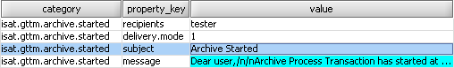
Figure 23: Email Template for Stage 1

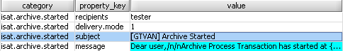
Figure 24: Email Template for Stage 4

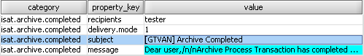
Figure 25: Email Template for Stage 7

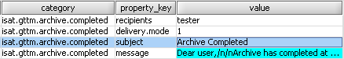
Figure 26: Email Template for Stage 8

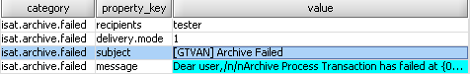
Figure 27: Email Template for Stage 11
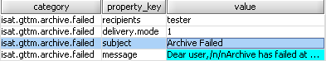
Figure 28: Email Template for Stage 12

An email template consists of the following property keys in a “config_props” category:

recipients
This refers to the email recipient groups to send the email. An email recipient group is one that is defined as a list of email recipient addresses under the ‘mail.recipients’ category.

For example,
category | property_key | value
mail.recipients | default | webadmin@mycoy.com
mail.recipients | tester | tester@mycoy.com
mail.recipients | customerA | cust1@custA.com, cust2@custA.com

delivery.mode
This refers to the mode of delivery of the notification. For now, only email is supported, whose value is 1. Setting to any other value would disable the email notification.

subject
This refers to the Subject of the email notification.

message
This refers to the message body of the email notification. The message may contain substitution variables (numbers enclosed in curly braces {}) that must already be supported by the archival module. Otherwise, they will not be resolved to any run-time values when the notification is sent.

Outputs from Archival

The output from one archival includes:
- A transaction archive summary file
- 0 to many archive ZIP files

The transaction archive summary file is an XML file containing the information about the archival. It is also used as a representation of a transaction archive which consists of 0 to many ZIP files produced during the archival. As will be touched on later in Section 3.4.4, the transaction archive summary file will be for restoring a transaction archive.

The archive ZIP files are produced from the archival sub-processes in the GridTalk data folder under:
- <GRIDTALK_HOME>/data/GNapps/gtas/data/archive/
- <GRIDTALK_HOME>/data/GNapps/gtvan/data/archive/

Sub-folders are created to group the multiple archive ZIP files, while the transaction archive summary file can be found directly under the above directories.

NOTE:

If the archival is aborted due to problems encountered during one of the archival sub-processes, those records that are already archived by that sub-process will still be intact in the archive ZIP file(s). The other archival sub-processes will also not be affected by that error. However, the entire archival is still considered as failed.

Under such situation, after correcting the error, you may want to restart the archival to continue archiving those not yet archived due to the previous error that occurred.

Concurrent Archival Requests

Concurrent archival requests activated (either submitted on ad-hoc basis or created from schedules) will not be fulfilled concurrently. This is to avoid concurrent attempts to archive the same records and also to prevent performance overkill for the GridTalk application, since the application will still be active handling transactions processing between the trading partners.

If a second archival request is activated while the first archival is still in progress, it will be pended until the first archival has ended. Under such situation, even though the second archival might not be run at the scheduled time (assuming it was scheduled), the archival date range will still be correct with respect to the time when the archival request is activated.

Restoring Transaction Archives

Transactions archived are stored in the application file system. When necessary, they can be restored back to the application for viewing purposes.

To view a list of the existing transaction archives,

- Go to Admin Page by clicking on the Control Panel link at the top right-hand corner of the TXMR UI.

- Go to List Archived page by clicking the link at the Admin Tools menu. You will be shown a list of archives that have been generated earlier, as shown in Figure 29: List Archived Page.

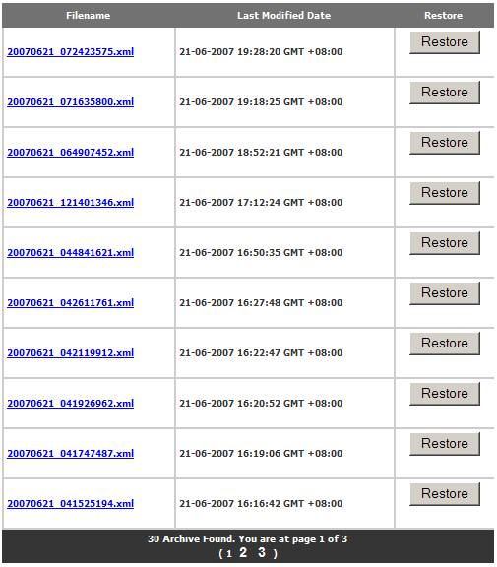
Figure 29: List Archived Page – With Data

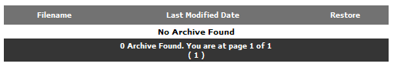
Figure 30: List Archived Page – Without Data

Each row in the list identifies an Archive Transaction. The column header shows the following fields:

Filename:
This indicates the filename of the transaction archive summary XML file. The hyperlink allows you to download it.

Last Modified Date:
This indicates the last date/time of which the transaction archive summary file has been modified.

Restore:
This button allows restore of the transaction archive.

You may perform the following actions on the List Archived page if it contains existing transaction archives:

- Download transaction archive summary file
- Restore transaction archive

Downloading a Transaction Archive Summary File

- Click on the filename link in the List Archived page you wish to download. The contents of the selected transaction archive summary file will be shown in a new browser window, as shown in Figure 31: Sample Transaction Archive Summary File.

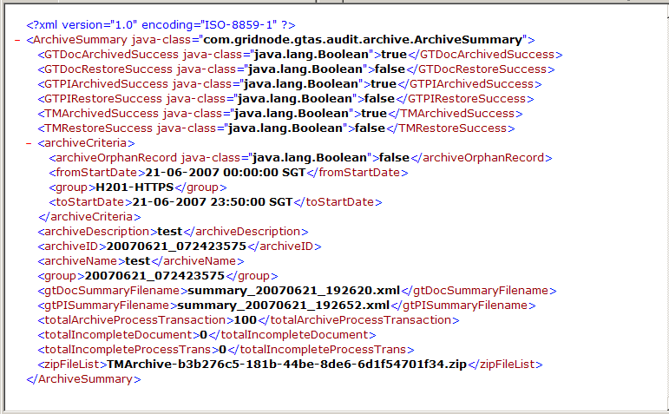
Figure 31: Sample Transaction Archive Summary File

Restoring a Transaction Archive

- On the List Archived page, click on the Restore button against the particular transaction archive which you which to restore.

You will be prompted to confirm the restore:

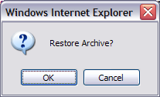

- Click OK to confirm restoring the transactions. Otherwise, click Cancel.

If restore is confirmed and the operation is started successfully, you will be directed to a page showing the submission status: “The restore is currently processing. Email alert will be sent to user after the restore operation is completed.”

Email Notifications

Throughout the restore process, email notifications will be sent out to the GridTalk and TXMR administrators (by default setting, unless changed) to inform of the restore process status. These include:

- Restore of processes and transactions has completed in GridTalk
- Restore of processes and transactions has failed in GridTalk
- Restore of monitored data has completed in TXMR
- Restore of monitored data has failed in TXMR

Refer to Appendix 4.4 Archive Restore Email Notification Samples for samples of the email notifications mentioned above.

The email notifications 1 and 2 may be customized in the GridTalk Alert Notification Center. Refer to GridTalk 4.0 Administration Guide for details on customizing message templates.

The other email notifications are not visible from any user interface. To change the email template, you will need to update accordingly on the “config_props” table in the GTVAN database schema. The following figures show the respective “config_props” records for each such email notification:

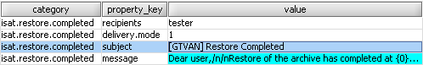
Figure 32: Email Template for Restore Completed
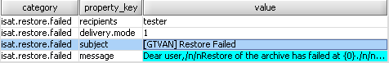
Figure 33: Email Template for Restore Failed

Configuring Web Settings

As a Web Admin, you will be able to configure various web settings for TXMR that would apply globally, i.e. to all users of TXMR.

The web settings that you may configure include the following:
- Web session idle time
- Database connection details
- Email settings
- Action logs housekeeping interval
- Paging display limit

Web Session Idle Time

The Web Session Idle Time is the maximum idle time for a session in TXMR. If the user leaves a session on after login without performing any action, the session will time out seconds after the Web Session Idle Time that is currently set.

Changing the Web Session Idle Time

- Go to Admin Page by clicking on the Control Panel link at the top right-hand corner of the TXMR UI.

- Go to Web Idle Setting Page by clicking on the link or icon at the Admin Tools menu or the Navigation Bar respectively.


Figure 34: Web Idle Setting Page

- Enter the following field:

Idle Time Before Expire:
Set the time that you want for the maximum idle time available for the TXMR session.
- To confirm the entry, click the Save button.

- The status of the submission will be displayed on the right of the Save button. If the submission is successful, you will see the “Set Idle Time to xxx” (the updated idle time). Otherwise, if the idle time entered was too small, you will see the “Minimum idle time is 20 second”.

TIP: As a security best practice in any web application, always set a reasonable idle time for the session. An idle time too short may be insufficient for you perform your task which requires occasional attention elsewhere. An idle time too long may give someone else a chance to misuse your account if you unintentionally forget to log out from the application.

Miscellaneous Web Configurations

There are other miscellaneous web configurations which are usually set one-time only:

- Database Connection properties
- Email settings
- HTTP URLs for transaction monitoring
- HTTP URLs for report generation
- Action logs housekeeping setting
- Paging display setting

Changing Web Configurations

- Go to Web Configuration Page by clicking on the link or icon at the Admin Tools menu or the Navigation Bar respectively.

- Make amendments to the web configuration in the text field. Amendments should be made inside the two double quotes (“”) followed by a semi-colon (;).

The web configurations are organized in several sections:

DATABASE CONNECTION
db_server | The connection URL to the database for GridTalk
dbuser | The login username for TXMR database schema ‘GTVAN’
dbpass | The login password for dbuser

EMAIL SETTING
Email_host | The SMTP server for email notifications
Email_username | The authentication user to Email_host. Takes effect on when authmode is “true”.
Email_password | The authentication password for Email_username. Takes effect on when authmode is “true”.
Email_from | The ‘From’ email address to use when the system sends emails
authmode | The SMTP authentication mode (true or false). Sets whether SMTP server authentication is required when sending emails.

Process URL
cancel_url | The HTTP URL used when cancelling process transactions.
reprocess_url | The HTTP URL used when re-processing transactions.
archive_servlet2 | The HTTP URL used when scheduling transaction archivals.
archive_servlet | The HTTP URL used when archiving transactions.

Report URL
create_report | The HTTP URL used when generating report online.
create_schedule | The HTTP URL used when creating report schedules.
update_schedule | The HTTP URL used when updating report schedules.
delete_schedule | The HTTP URL used when deleting report schedules.
generate_report | The HTTP URL used when generating report from report schedules.
view_report | The HTTP URL used when viewing reports from list of reports previously generated.
housekeep_report | The HTTP URL used when changing report housekeeping schedule.

LOG HOUSEKEEPING
del_log | The age limit (in days) of the user action logs to keep before purging.

Paging Limit
paging_limit | The maximum number of pages to display before the next button.

NOTE:

You do not need to make any amendments to the Process URL and Report URL sections, unless otherwise instructed by GridNode during software upgrades.

- To confirm the changes, click the Save button.

All changes will take effect immediately.

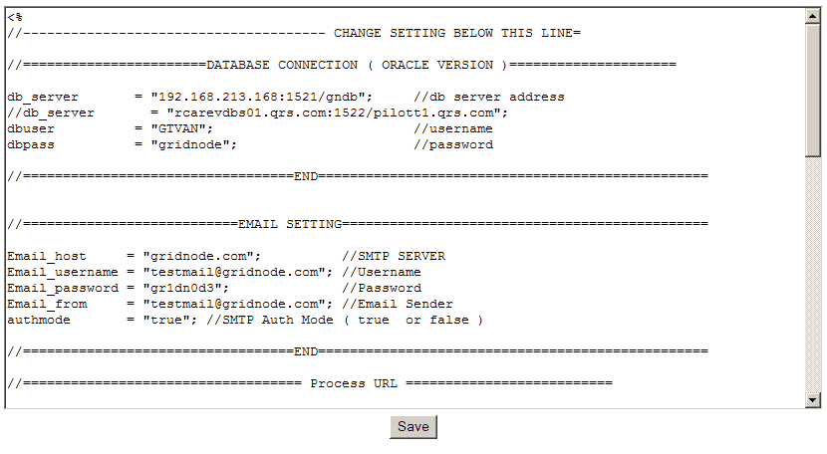
Figure 35: Web Configuration Page

Viewing User Action Logs

This feature allows you to search and view the user action logs.

To access this feature,

- Go to Admin Page by clicking on the Control Panel link at the top right-hand corner of the TXMR UI.

- Go to Show Log page by clicking on the link at the Admin Tools menu.

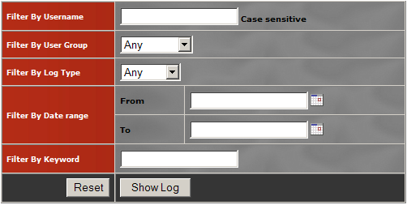
Figure 36: Show Log Page

- Enter the following search criteria fields you want:

Filter By Username:
Filter the logs by user name

Filter By User Group:
Filter the logs by user group

Filter By Log Type:
Filter the logs by the type of log: EVENT or ERROR.

Filter By Date range:
Filter the logs by date range.

Filter By Keyword:
Filter the logs by some keywords in the log message.

- To reset the entries, click the Reset button.

- To confirm the entries, click the Show Log button. After a few moments, the logs that fulfill the filtering criteria will be displayed in a new window, as shown in Figure 37: Show Log Search Result.

Each row in the list identifies a log entry. The column header shows the following fields:

Date / Time:
This indicates the date/time of the log captured.

User Level:
This indicates the user level of the person who did the action.

Group:
This indicates the group name of the person who did the action.

Username:
This indicates the username of the person who did the action.

Type:
This indicates the type of the log entry. If the log type is a “EVENT”, that particular log entry will be displayed normally. Otherwise, the particular log entry with log type as “ERROR” will be highlighted in a different color to indicate an error log was captured.

Log:
This indicates the description of the log entry.

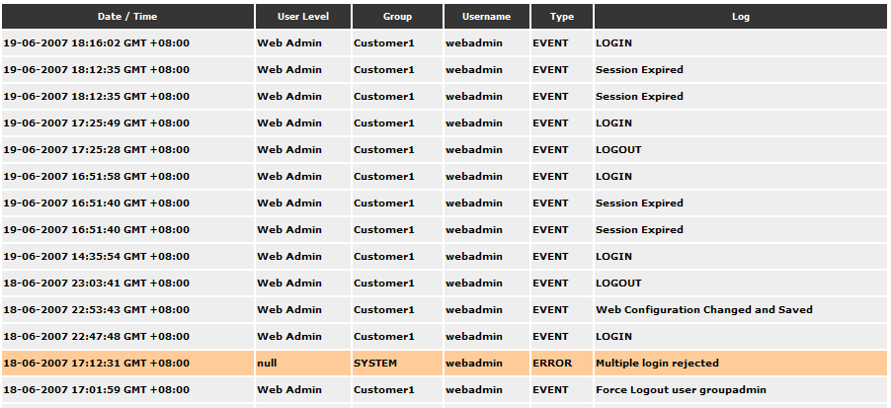
Figure 37: Show Log Search Result

NOTE:

It is not necessary to enter all the search criteria fields; you may even leave all of them empty and perform the search. Of course, a more constrained search has a better search performance.

Action Logs

User actions captured fall into two types: “EVENT” and “ERROR”.

The following user actions are captured under the ‘EVENT’ type:

- A user logs in to TXMR
- A login user logs out from TXMR
- A login session has expired (i.e. idle time exceeds Web Idle Time) when the user hit an action on the UI
- A user account has added, updated, or deleted by the Group Admin or Web Admin
- A user account’s user group or user level has been changed
- A user account has been updated by the user owner himself.
- A user account’s password has been reset
- A user has changed his or her own account password
- The Web Idle Setting has been changed and saved
- The Web Configuration has been changed and saved
- A Group has been added or deleted
- An archive schedule has been added, updated or deleted
- A request for ad-hoc transaction archival has been submitted
- A request for restoring a transaction archive has been submitted
- A report generation schedule has been added, updated or deleted
- The report housekeeping schedule has been updated
- An ad-hoc report is generated

User actions leading to errors are captured under the ‘ERROR’ type:

- A login attempt has failed e.g. wrong password, multiple login using the same user name, account is not activated
- Problem found when adding or updating a user account e.g. Incomplete form submitted, duplicate username, duplicate email address, etc
- Problem found when adding Group, e.g. duplicate Group name, duplicate Customer Entity ID
- Problem resetting a user password
- A user failed to change his own account password
- Invalid input submitted for Web Idle Setting
- A request for ad-hoc transaction archival has failed in submission
- A request for restoring a transaction archive has failed in submission
- An ad-hoc report fails in generation

Appendix

Computation of Next Run Date/Time

The Next Run date/time of the Archive Schedule is based on the Frequency, Effective Start Date, Run Time, and Run Every field inputs.

If the Effective Start Date is earlier than the current date at the time of entry, the Next Run date/time will also be adjusted accordingly to an appropriate date/time after the current date.

All the time computed will be based on the time zone selected during login to TXMR.

Frequency: Daily

We will add the number of days specified in Run Every to the Effective Start Date repeatedly, until the date is after the current date at the time of entry.

Example | Computed Next Run Date/Time
Effective Start Date: 01 May 2007  Run Time: 17:00:00  Run Every: 2 Day(s)  (Current time zone: GMT+8)  (Current date/time: before Effective Start Date) | 03 May 2007 17:00:00 GMT+8
Effective Start Date: 09 April 2007  Run Time: 22:00:00  Run Every: 2 Day(s)  (Current time zone: GMT+8)  (Current date/time: 10 April 2007 11:00:00 GMT+8) | 11 April 2007 22:00:00 GMT+8

Frequency: Weekly

We will add the number of weeks specified in Run Every to the nth week that the Effective Start Date falls within the month repeatedly, until the date is after the current date at the time of entry.

Example | Computed Next Run Date/Time
Effective Start Date: 10 April 2007 (falls within the 2nd week of the month)  Run Time: 10:00:00  Run Every: 2 Week(s)  (Current time zone: GMT+8)  (Current date/time: before Effective Start Date) | 24 April 2007 10:00:00 GMT+8
Effective Start Date: 02 April 2007 (falls within the 1st week of the month)  Run Time: 22:00:0  Run Every: 1 Week(s)  (Current time zone: GMT+8)  (Current date/time: 10 April 2007 11:00:00 GMT+8) | 16 April 2007 22:00:00 GMT+8

Frequency: Monthly

We will add the number of months specified in Run Every to the month that the Effective Start Date falls within repeatedly, until the date is after the current date at the time of entry. The day of Next Run date/time will be set as the first day of computed month.

Example | Computed Next Run Date/Time
Effective Start Date: 10 August 2007  Run Time: 23:00:00  Run Every: 1 Month(s)  (Current time zone: GMT+8)  (Current date/time: before Effective Start Date) | 1 September 2007 23:00:00 GMT+8
Effective Start Date: 05 March 2007  Run Time: 23:00:00  Run Every: 1 Month(s)  (Current time zone: GMT+8)  (Current date/time: 10 April 2007 11:00:00 GMT+8) | 1 May 2007 23:00:00 GMT+8

Computation of Archive Date Range

The Archive Date Range (Archive Start Date and Archive End Date) of the archive schedule is based on the Frequency and Archive Order Than field inputs and the computed Next Run date/time of the archive schedule.

All the time computed will be based on the time zone selected during login to TXMR.

Frequency: Daily

We will minus the number of days specified in Archive Order Than from Next Run time. The time of the Archive End Date will be adjusted to 23:59:59:999.

Example | Computed Archive Date Range
Next Run Time: 11 April 2007 22:00:00 GMT+8  Archive Older Than: 2 Day(s) | Archive Start Date: 01-01-1970 07:30:00 GMT+8  Archive End Date: 09 April 2007 23:59:59 GMT+8

Frequency: Weekly

We will minus the number of weeks specified in Archive Order Than from the week that Next Run date/time falls within the month. The day of the Archive End Date will be adjusted to the Saturday of the computed week, and the time will be adjusted to the 23:59:59:999.

Example | Computed Archive Date Range
Next Run Time: 16 April 2007 22:00:00 GMT+8 (fall on 3rd week of month)  Archive Older Than: 3 Week(s) | Archive Start Date: 01-01-1970 07:30:00 GMT+8  Archive End Date: 31 March 2007 23:59:59 GMT+8

Frequency: Monthly

We will minus the number of months specified in Archive Order Than from the month that Next Run date/time falls within. The day of Archive End Date will be adjusted to the last day of the computed month, and the time will be adjusted to the 23:59:59:999.

Example | Computed Archive Date Range
Next Run Time: 1 May 2007 23:00:00 GMT+8  Archive Older Than: 1 Month(s) | Archive Start Date: 01-01-1970 07:30:00 GMT+8  Archive End Date: 31 March 2007 23:59:59 GMT+8

Archival Email Notification Samples

At Start Archival

From: gtvan@gridnode.com
To: <TXMR admin>
Subject: Archive Started
Dear user,

Archive Process Transaction has started at 2007-06-26 17:49:17.694 +0800.

Archive Criteria
-------------------------------------------------
From Date/Time: 1970-01-01 07:30:00.000 +0730
To Date/Time: 2007-05-31 23:59:59.999 +0800
Is Orphan Record: false
Customer List: HUB01;

Archive ID: 20070626_054917693

Regards,
GTVAN System

At the start of Archive by Process

From: admin@gridnode.com
To: <GridTalk admin>
Subject: [GRIDTALK] Archive Started
Dear User,

Archive by [Process] has started at: 26 Jun 2007 09:49:41 UTC [26 Jun 2007 17:49:41 SGT]

Archive [Process] Criteria
-----------------------------------------------------
Is Enable Restore Archive : true
Is Enable Search Archive : false
From Date/Time : 30 Apr 2007 16:00:00 UTC [01 May 2007 00:00:00 SGT]
To Date Time : 31 May 2007 15:59:59 UTC [31 May 2007 23:59:59 SGT]
Process Definition : 0A1FailureNotification, 0A1FailureNotification1.1, 3C3, 3A4, 4A3_V02.02, 4A5_V02.00
Include Incomplete : true
Partners To Archive : []
Biz Entities To Archive : [H001]
Is Archive Orphan Record : false

Archive ID : 20070626_054917693

Regards,
Gridtalk Server

At the start of Archive by Document

From: admin@gridnode.com
To: <GridTalk admin>
Subject: [GRIDTALK] Archive Started
Dear User,

Archive by [Document] has started at: 26 Jun 2007 09:50:05 UTC [26 Jun 2007
17:50:05 SGT]

Archive [Document] Criteria
-----------------------------------------------------
Is Enable Restore Archive : true
Is Enable Search Archive : false
From Date/Time : 30 Apr 2007 16:00:00 UTC [01 May 2007 00:00:00 SGT]
To Date Time : 31 May 2007 15:59:59 UTC [31 May 2007 23:59:59 SGT]
Folder : Inbound, Import, Outbound, Export
Document Type : 4A3, 4A3_XML, 4A5_XML, 4A5, RN_FAILNOTF2, RN_FAILNOTF1, RN_EXCEPTION, RN_ACK, UC, 3C3RN, 3A4RN
Partners To Archive : []
Biz Entities To Archive : [H001]
Is Archive Orphan Record : false

Archive ID : 20070626_054917693

Regards,
Gridtalk Server

At the start of Archive Monitored Data

From: gtvan@gridnode.com
To: <TXMR admin>
Subject: [GTVAN] Archive Started
Dear user,

Archive Process Transaction has started at 2007-06-26 17:49:33.957 +0800.

Archive Criteria
-------------------------------------------------
From Date/Time: 2007-05-01 00:00:00.000 +0800
To Date/Time: 2007-05-01 23:59:59.999 +0800
Is Orphan Record: false
Customer List: HUB01;

Archive ID: 20070626_054917693

Regards,
GTVAN System

At the completion of Archive by Process

From: admin@gridnode.com
To: <GridTalk admin>
Subject: [GRIDTALK] Archive Completed
Attachments: summary_20070626_174952.xml
Dear User,

Archive by [Process] has completed at: 26 Jun 2007 09:49:52 UTC [26 Jun 2007 17:49:52 SGT]

Archive [Process] Criteria
-----------------------------------------------------
Is Enable Restore Archive : true
Is Enable Search Archive : false
From Date/Time : 30 Apr 2007 16:00:00 UTC [01 May 2007 00:00:00 SGT]
To Date Time : 31 May 2007 15:59:59 UTC [31 May 2007 23:59:59 SGT]
Process Definition : 0A1FailureNotification, 0A1FailureNotification1.1, 3C3, 3A4, 4A3_V02.02, 4A5_V02.00
Include Incomplete : true
Partners To Archive : []
Biz Entities To Archive : [H001]
Is Archive Orphan Record : false

Archive ID : 20070626_054917693

Number of [Process] archived : 330

Regards,
Gridtalk Server

At the completion of Archive by Document

From: admin@gridnode.com
To: <GridTalk admin>
Subject: [GRIDTALK] Archive Completed
Attachments: summary_20070626_175012.xml
Dear User,

Archive by [Document] has completed at: 26 Jun 2007 09:50:12 UTC [26 Jun 2007 17:50:12 SGT]

Archive [Document] Criteria
-----------------------------------------------------
Is Enable Restore Archive : true
Is Enable Search Archive : false
From Date/Time : 30 Apr 2007 16:00:00 UTC [01 May 2007 00:00:00 SGT]
To Date Time : 31 May 2007 15:59:59 UTC [31 May 2007 23:59:59 SGT]
Folder : Inbound, Import, Outbound, Export
Document Type : 4A3, 4A3_XML, 4A5_XML, 4A5, RN_FAILNOTF2, RN_FAILNOTF1, RN_EXCEPTION, RN_ACK, UC, 3C3RN, 3A4RN
Partners To Archive : []
Biz Entities To Archive : [H001]
Is Archive Orphan Record : false

Archive ID : 20070626_054917693

Number of [Document] archived : 330

Regards,
Gridtalk Server

At the completion of Archive Monitored Data

From: gtvan@gridnode.com
To: <TXMR admin>
Subject: [GTVAN] Archive Completed
Dear user,

Archive Process Transaction has completed at 2007-06-26 17:49:40.870 +0800.

Archive Criteria
-------------------------------------------------
From Date/Time: 2007-05-01 00:00:00.000 +0800
To Date/Time: 2007-05-31 23:59:59.999 +0800
Is Orphan Record: false
Customer List: HUB01;

Number of Process Transaction archived: 330
Number of Incomplete Process Trans archived: 0
Number of Incomplete Document archived: 0

Archive ID: 20070626_054917693
Archive Summary File: 20070626_054917693.xml

Regards,
GTVAN System

At the completion of entire archival

From: gtvan@gridnode.com
To: <TXMR admin>
Subject: Archive Completed
Dear user,

Archive has completed at 2007-06-26 17:50:29.953 +0800.

Archive Criteria
-------------------------------------------------
From Date/Time: 1970-01-01 05:30:00.000 +0730
To Date/Time: 2007-05-31 23:59:59.000 +0800
Is Orphan Record: false
Customer List: HUB01;

Archive ID: 20070626_054917693
Archive Summary File: 20070626_054917693.xml

Regards,
GTVAN System

On error during Archive by Process

From: admin@gridnode.com
To: <GridTalk admin>
Subject: [GRIDTALK] Archive Failed
Dear User,

Archive by [Process] has failed at: 26 Jun 2007 11:15:35 UTC [26 Jun 2007 19:15:35 SGT]

Archive [Process] Criteria
-----------------------------------------------------
Is Enable Restore Archive : true
Is Enable Search Archive : false
From Date/Time : 30 Apr 2007 16:00:00 UTC [01 May 2007 00:00:00 SGT]
To Date Time : 31 May 2007 15:59:59 UTC [31 May 2007 23:59:59 SGT]
Process Definition : 0A1FailureNotification, 0A1FailureNotification1.1, 3C3, 3A4, 4A3_V02.02, 4A5_V02.00
Include Incomplete : true
Partners To Archive : []
Biz Entities To Archive : [H001]
Is Archive Orphan Record : false

Archive ID : 20070626_071457604
Please verify the problem and restart the operation. (Note: Some documents/processes may have already been archived. It is safe to run the archival again.)

Exception : …
Trace:
------
:
:
:

Regards,
GridTalk Server

On error during Archive by Document

From: admin@gridnode.com
To: <GridTalk admin>
Subject: [GRIDTALK] Archive Failed
Dear User,

Archive by [Document] has failed at: 26 Jun 2007 11:15:35 UTC [26 Jun 2007 19:15:35 SGT]

Archive [Document] Criteria
-----------------------------------------------------
Is Enable Restore Archive : true
Is Enable Search Archive : false
From Date/Time : 30 Apr 2007 16:00:00 UTC [01 May 2007 00:00:00 SGT]
To Date Time : 31 May 2007 15:59:59 UTC [31 May 2007 23:59:59 SGT]
Folder : Inbound, Import, Outbound, Export
Document Type : 4A3, 4A3_XML, 4A5_XML, 4A5, RN_FAILNOTF2, RN_FAILNOTF1, RN_EXCEPTION, RN_ACK, UC, 3C3RN, 3A4RN
Partners To Archive : []
Biz Entities To Archive : [H001]
Is Archive Orphan Record : false

Archive ID : 20070626_071457604
Please verify the problem and restart the operation. (Note: Some documents/processes may have already been archived. It is safe to run the archival again.)

Exception : …
Trace:
------
:
:
:

Regards,
GridTalk Server

On error during Archive Monitored Data

From: gtvan@gridnode.com
To: <TXMR admin>
Subject: [GTVAN] Archive Failed
Dear user,

Archive Process Transaction has failed at 2007-06-26 19:16:20.364 +0800.

Archive Criteria
-------------------------------------------------
From Date/Time: 2007-05-01 00:00:00.000 +0800
To Date/Time: 2007-05-31 23:59:59.999 +0800
Is Orphan Record: false
Customer List: HUB01;

Number of Process Transaction archived: 205
Number of Incomplete Process Trans archived: 0
Number of Incomplete Document archived: 0

Archive ID: 20070626_071457604
Archive Summary File: 20070626_071457604.xml

Please verify the problem and restart the operation. (Note: some process transaction may have already been archived. It is safe to run the archival again.)

Exception : …
Trace:
------
:
:
:

Regards,
GTVAN System

On failure of entire archival

From: gtvan@gridnode.com
To: <TXMR admin>
Subject: Archive Failed
Dear user,

Archive has failed at 2007-06-26 19:16:20.364 +0800.

Archive Criteria
-------------------------------------------------
From Date/Time: 2007-05-01 00:00:00.000 +0800
To Date/Time: 2007-05-31 23:59:59.999 +0800
Is Orphan Record: false
Customer List: HUB01

Archive ID: 20070626_071457604
Archive Summary File: 20070626_071457604.xml

Please verify the problem and restart the operation. (Note: some process transaction may have already been archived. It is safe to run the archival again.)

Exception : …
Trace:
------
:
:
:

Regards,
GTVAN System

Archive Restore Email Notification Samples

Restore of Processes and Transactions Completed

From: admin@gridnode.com
To: <GridTalk admin>
Subject: [GRIDTALK] Restore Complete
Attachments: summary_20070626_191535.xml
Dear User,

Restore of the archive is completed with status: Successful The Archival Summary file is attached to this mail.

Regards,
GridTalk Server

Restore of Processes and Transactions Failed

From: admin@gridnode.com
To: <GridTalk admin>
Subject: [GRIDTALK] Restore Complete
Attachments: summary_20070626_191535.xml
Dear User,

Restore of the archive is completed with status: Failed The Archival Summary file is attached to this mail.

Regards,
GridTalk Server

Restore of Monitored Data Completed

From: gtvan@gridnode.com
To: <TXMR admin>
Subject: [GTVAN] Restore Completed
Dear user,

Restore of the archive has completed at 2007-06-27 17:16:28.828 +0800.

Archive Summary File: 20070626_071457604.xml

Regards,
GTVAN System

Restore of Monitored Data Failed

From: gtvan@gridnode.com
To: <TXMR admin>
Subject: [GTVAN] Restore Failed
Dear user,

Restore of the archive has failed at 2007-06-26 19:15:27.733 +0800.

Archive Summary File: 20070626_071457604.xml

Exception: . . .
Trace:
-------
:
:

Regards,
GTVAN System

COPYRIGHT
© Copyright 2008 GridNode Pte Ltd. All rights reserved.
No part of this description of functions may be reproduced or transmitted in any form or for any purpose without the express written permission of GridNode Pte Ltd. The information contained herein may be changed without prior notice.
Names of all products herein are used for identification purposes only and are trademarks and/or registered trademarks of their respective owners.
All rights reserved.

The URL is available from the GridTalk Deployment Guide
All the time in TXMR will be converted based on the selected time zone
Refer to TXMR User Guide Section 3 for the common functionalities of this feature.
A record set is a total set of records that are related to a single same process instance.

