
GRIDNODE PTE LTD

GRIDTALK ™ TXMR
User Guide

Release version 1.21.1

Copyright

© Copyright 2008 GRIDNODE PTE LTD. All rights reserved.

No part of this GRIDTALK™ TXMR administration and user guide may be reproduced or transmitted in any form or for any purpose without the express permission of GRIDNODE PTE LTD. The information contained herein may be changed without prior notice.

GRIDNODE PTE LTD further does not warrant the accuracy or completeness of the information, text, graphics, links, or other items contained within these materials. GRIDNODE PTE LTD shall not be liable for any special, indirect, incidental, or consequential damages, including without limitation, lost revenues or lost profits, which may result from the use of these materials. The information in this documentation is subject to change without notice and does not represent a commitment on the part of GRIDNODE PTE LTD for the future.

Some software products marketed by GRIDNODE PTE LTD and its distributors contain proprietary software components of other software vendors.

Names of all products herein are used for identification purposes only and are trademarks and/or registered trademarks of their respective owners.

GRIDTALK™ and GridNode™ are registered or unregistered trademarks of GRIDNODE PTE LTD.

All rights reserved.

GRIDTALK™
Transaction Monitoring & Reporting User Guide

Contents

Chapter Page

1 About the Guide 4
1.1 Terminology 4
2 Getting Started with TXMR 6
2.1 Accessing TXMR 6
2.2 Overview of TXMR User Interface 7
2.3 Basic Features of TXMR 8
2.3.1 Managing Own Account 8
2.3.2 Ending TXMR session 9
3 Transaction Document & Event Tracking 10
3.1 Search By Processes 10
3.2 Searching and Listing by Processes 13
3.2.1 Tracing the status of the Process Instances 15
3.2.2 Viewing the detail Information of a process 17
3.2.2.1 Process Details Page 17
3.2.2.2 Actions available on Process Details page 20
3.3 Searching and Listing By Transactions 23
3.3.1 Tracing the status of transactions 23
3.3.2 Viewing the detail information of a document 24
3.3.2.1 Transaction Detail Page 24
3.3.2.2 Actions available on Transaction Detail page 28
3.4 Search By Events 31
3.4.1 Tracing the status of the Events 32
3.4.2 Viewing the Event History and document information 33
3.4.2.1 Event History Tab 33
3.4.2.2 Actions available on Event History tab 34
3.4.2.3 General tab 34
3.4.2.4 Actions available on General tab 35
3.5 Common Functions 37
3.5.1 Exporting the table information as CSV Format 37
3.5.1.1 Example – Exporting Process Detail information to CSV file 37
3.5.2 Traversing list items from detail page 38
3.5.3 Printing the detail information 38
4 Transaction Re-processing 39
4.1 Re-processing a Transaction 39
4.1.1 Scenarios whereby Re-process is not allowed 40
4.2 Event History after re-processing 41
4.2.1 The Reprocess Doc event 41
4.2.2 After re-processing Incoming Transaction Document 41
4.2.3 After re-processing Outgoing transaction document 42
4.2.3.1 Case 1 Example 42
4.2.3.2 Case 2 Example 43
5 Supplementary Notes on Event History 44
5.1 List of Events in Event History 44
5.2 Typical Event Histories 48
5.2.1 Receiving Transactions 48
5.2.1.1 Example 1 – Happy Scenario 48
5.2.1.2 Example 2 – Receives duplicate transaction 48
5.2.1.3 Example 3 – Multiple attempts to deliver document to Backend 49
5.2.2 Sending Transactions 49
5.2.2.1 Example 1 – Happy Scenario 49
5.2.2.2 Example 2 – Document retries 50
5.2.2.3 Example 3 – No acknowledgement received from partner 51
5.2.3 Re-processing Transactions 51
5.2.3.1 Example 1 – Re-processing an Inbound Transaction 51
5.2.3.2 Example 2 – Re-processing a duplicate Inbound Transaction 52
5.2.3.3 Example 3 – Re-processing Outbound Transaction failed at mapping 52
5.2.3.4 Example 4 – Re-processing Outbound Transaction with no failures 53
5.2.4 Re-processing Signals 54
5.2.4.1 Example 1 – Re-processing an Outbound Signal 54
5.2.4.2 Example 2 – Re-processing an Inbound Signal 54
6 Group Admin Tasks 55
6.1 Managing Group Users 55
6.1.1 Administer User Accounts 55
6.1.1.1 Adding a new user 56
6.1.1.2 Editing an user account 57
6.1.1.3 Deleting a user account 58
6.2 Report Generation 59
6.2.1 Scheduling Report Generations 60
6.2.1.1 Creating a new Schedule 61
6.2.1.2 Changing an existing Schedule 64
6.2.1.3 Deleting an existing Schedule 65
6.2.1.4 Generating a report from Schedule for immediate viewing 65
6.2.2 Generating ad-hoc reports 66
6.2.3 Managing Generated Reports 67
6.2.3.1 Viewing a Report generated in the past 68
6.2.3.2 Purging a Report generated in the past 69
6.2.4 Supported Report Types 69
6.2.4.1 Transaction Status Report 69

About the Guide

This Transaction Monitoring User Guide is especially designed for the customer end users. The guide contains the step-by-step instructions and visual screens to enable you to perform the simple tasks while you are getting acquainted with the features in the GridTalk 4.1 TXMR application. This user guide is applicable for the Group Admin and Group User only, whereas Web Admin should refer to the admin guide.

This user guide covers mainly the following features which you should be able to perform the following tasks:

- Transaction Document & Event Tracking
Provide instructions on how to search and track Rosettanet (RN) transaction documents by processes and events.

- Report Generation
Provide instructions on how to generate reports, create report generation schedules, manage generated reports and report generation schedules.

- User Administration
Provide instructions on how to administer user accounts for organization’s business users to access the TXMR application.

Terminology

This document uses some terms or abbreviations extensively that you may not be familiar with. The following explains the terms and abbreviations used throughout the document.

Term/Abbreviation | What it stands for
Gateway | In this context, it refers to as a network application capable of handling RosettaNet business messages.
GridTalk | An application providing RosettaNet message processing capabilities.
HTTPBC | GridTalk HTTP Backend Connector module. It handles the deliveries of messages between GridTalk and the Customer HTTP backend systems.
RN | Common abbreviation used for RosettaNet.
RNIF | RosettaNet Implementation Framework. This provides the guidelines on the RosettaNet implementation.
RosettaNet | A messaging standard for exchanging business documents.
RosettaNet Gateway | In this context, it refers to module in GridTalk that fronts the communication with partner’s gateways.
PIP | Partner Interface Process. A model for fulfilling a business transaction between two partners in a given supply chain. In short, it defines the business process between two partners.
PIP instance | An instance of a business process.
Private Process | A business process internal to the organization. In this context, it means the processing required for handling messages from/to the customer’s backend systems.
Signal | A business signal message exchanged between two RosettaNet gateways to communicate certain events within the execution of a PIP instance, e.g. a Receipt Acknowledgement, or a General Exception.
Transaction | A business action message exchanged between two partners, e.g. Purchase Order Request
TXMR | An application providing Transaction Monitoring and Report Generation capabilities for the transactions exchanged between the customers and their trading partners using GridTalk.

Getting Started with TXMR

Accessing TXMR

- Launch a web browser and navigate to the login page by entering the TXMR URL. After a few moments, the following login screen will be shown.

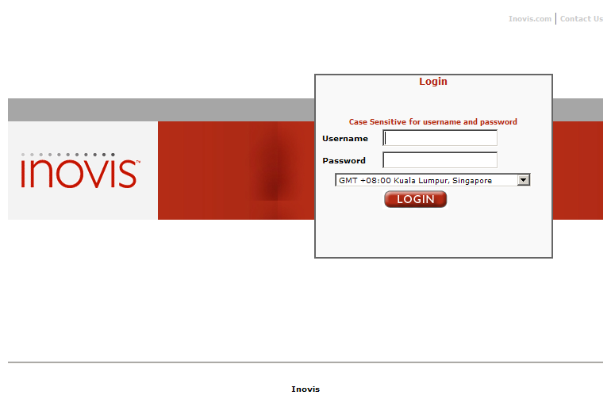
Figure 1: TXMR login screen

- Enter the username.

- Enter the password.

- Select the time zone that matches your area.

- Click on the ‘Login’ button.

- After successfully login, the page ‘RosettaNet Transaction Search’ will be displayed.

TIP: If you lose your password, you can contact your own group administrator to reset your password.

NOTE:

For those using Microsoft Internet Explorer 5 and above, after a successful login to TXMR, a pop up window will appear. This window is known as the session spy. It has the ability to detect if you have closed the browser without logging out from TXMR. If so, it would logout for you.

Overview of TXMR User Interface

The user interface displayed differently between a Group Admin and a Group User.

The following screen is applicable to Group Admin:
Links

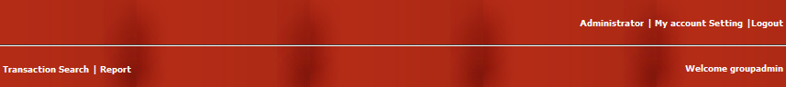

Links
Login Username
Figure 2: Group Admin Navigation Bar
Links
The following screen is applicable to Group User:

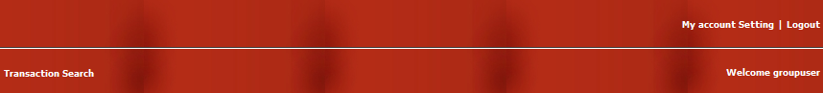

Links
Login Username

Figure 3: Group User navigation bar

The table below summarizes the use of each link on the navigation bar:

Link | Comment
 | This link is applicable for Group Admin to administer the users’ account in the TXMR.
 | This link is used to direct user to manage his or her user account in the TXMR.
 | This link is used to end the session and return user to the login page.
 | This link is used to direct user to the Transaction Search page.
 | This link is used to direct user to the Report Generation page.

Basic Features of TXMR

Managing Own Account

This feature allows a user to manage his or her user account in TXMR.

- Click link on the navigation bar. The page ‘My Account Setting’ will be displayed, for example:

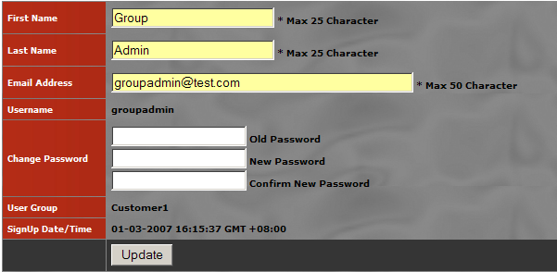
Figure 4: My account Setting Page

You are allowed to make changes to the First Name, Last Name, Email Address, and Change Password fields.

- Upon making the necessary updates, click on the ‘Update’ button to persist the changes. A dialog with message ‘Profile will be updated, Proceed?’ will be prompted.

- Click ‘OK’ to confirm the changes.

NOTE:

The update status will be displayed under the ‘Update’ button. Any error, for example, the entered old password does not match with the previous password, will also be displayed.

Ending TXMR session

To end your session, user is required to logout from the TXMR.

- Click on the link on the top right hand corner of navigation bar. After logout successfully, user will be redirected to the TXMR login page.

NOTE:

If session spy window is not on and you accidentally close the web browser without logout from the application, you will need to wait for a certain time interval in order to re-login to the application. This time interval is set by the TXMR administrator and should default to 30 minutes, unless otherwise communicated.

TIPS:

To recover from the above case immediately, you can contact your own group administrator to manually log you out from the application.

Transaction Document & Event Tracking

You can monitor the status of RosettaNet transaction processing, including both public and private processing, via the TXMR. This can be achieved by using the RosettaNet Transaction Search page.

Two options are provided for searching the transactions:
- Search By Processes
- Search By Event

Search By Processes

- Click link on the top left hand corner of the navigation bar. Select “By Processes” in the Search Option list box.

This option allows you to perform searching on the RosettaNet processes and the RosettaNet transaction documents.

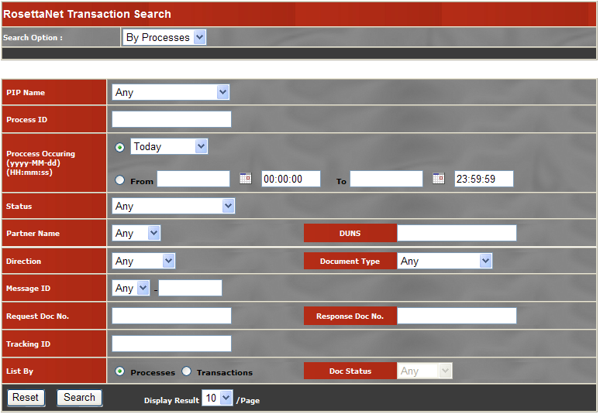
Figure 5: RosettaNet Transaction Search Page

The following search criteria are supported:

PIP Name:
The Process Definition name

Process ID:
The combination of the PIP Instance Identifier and the Initiator Identifier, separated by a slash ‘/’. (Note: The initiator indicates who initiate a process. If the Trading Partner is the initiator, this is the Trading Partner’s Identifier. If your organization is the initiator, this will be ‘SELF’).

Process Occurring:
This is the start time of the RosettaNet process. If the Trading Partner is the initiator of the process, this will be taken as the time the request document is first received from the Trading Partner. If your organization is the initiator of the process, this will be taken as the time whereby the request document is first attempted to be sent to the Trading Partner. Manually enter date and time is allowed. The format will be yyyy-MM-dd and HH:mm:ss for date field and time field respectively.

Status:
This is the status of the RosettaNet process. Available options are: Running, Completed, Abnormally Completed, Abnormally Terminated and Abnormally Aborted. Refer to xxx for explanation of these statuses.

Partner Name:
This is the name of the trading partner.

DUNS:
This is the D-U-N-S number of the trading partner.

Direction:
This is the direction of the transaction document. “Inbound” indicates that the transaction document is received from the trading partner, while “Outbound” indicates that the transaction is sent to the trading partner.

Document Type:
This is the document type of the transaction document.

Message ID:
This is the identifier that uniquely identifies a transaction document in GridTalk. This identifier consists of two portions: first portion is ‘IB’ or ‘OB’ that indicates the direction ‘Inbound’ or ‘Outbound’ respectively; the second portion is a running number associated to the document. The two portions are separated by a hyphen ‘-‘.

Request Doc No.:
This is the proprietary document identifier value of the request document in a RosettaNet process.

Response Doc No.:
This is the proprietary document identifier value of the response document in a two-action RosettaNet process.

Tracking ID:
This is an identifier that is extracted from the request document of the RosettaNet process, for easier identification purposes.

NOTE:

Due to the fact that the combination of Process ID and Request Doc No. may not uniquely identify a particular transaction, your organization may like to use your own way of identifying a unique transaction. The exact location from which this value is extracted from the request document should have been determined and communicated to your process implementer during process implementation.

List By:
This is the listing display option of the search result. Two options are provided:

Processes:
This provides a Process view of the document transactions. Refer to Section 3.2 Searching and Listing by Processes for this listing option.

Transactions:
This provides the view of document transactions directly. Refer to Section

Reset:
This resets the search criteria input fields to their default values.

Search:
This performs the search using the specified criteria.

Display Result:
This indicates the number of items to be listed on each search result page.

Searching and Listing by Processes

This listing option provides viewing of the RosettaNet processes and its document transactions and signal transactions.

- Under RosettaNet Transaction Search page, select the option ‘By Processes’

- Enter the combination of the search criteria. Specify List By option as ‘Processes’

- Click on the Search button. The search result page will be shown. The RosettaNet processes that fulfill the search criteria will be shown.

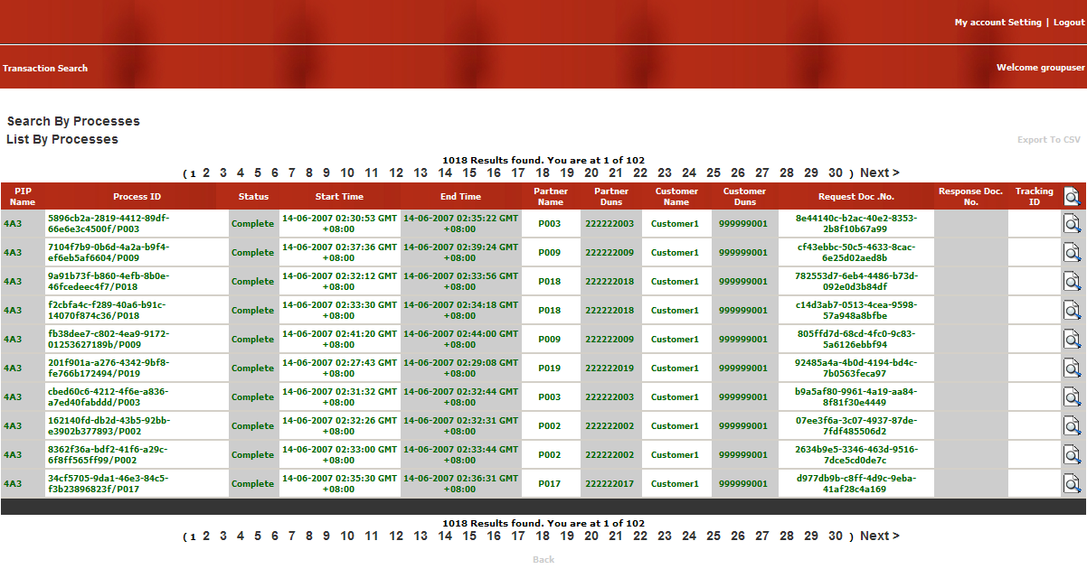
Figure 6: Search By Processes | List By Processes (Process Search Result Page)

The search results provide the snapshot information of the RosettaNet process instances, including:

PIP Name:
This shows the name of the RosettaNet process.

Process ID:
This shows PIP instance identifier and the initiator of the RosettaNet process. The PIP instance identifier and the initiator are separated by ‘/’.

For example, the following Process ID indicates that your organization is the initiator of the PIP instance.

gwf://10373/Notify of Invoice/SELF

The following Process ID indicates that your trading partner (P001) is the initiator of the PIP instance.

0dd44f36-b1b6-4ca6-9ecf-e98ebee2120a/P001

Status:
This shows the current status of the RosettaNet process instance. The following are the possible statuses:

- Running
This indicates that the process instance is still in active state.

- Complete
This indicates that the process instance has been completed successfully.

- Abnormally Completed
This indicates that the process instance has failed due to business failures.

A process instance may fail due to RosettaNet document validation errors, which leads to an Exception signal being generated and returned to the sender. A process instance may also fail upon receiving a PIP 0A1 from the trading partner for that process instance, or upon manual cancellation by the user.

- Abnormally Aborted
This indicates that the process instance has failed due to technical failures.

Technical failures includes that the current action of a two-action RosettaNet process instance has exceed Time-to-perform, or that the current action has exceeded Time-to-acknowledge and maximum retries and no acknowledgement has been received from the trading partner.

- Abnormally Terminated
This indicates that the process instance has failed due to any other failures that arise during the processing of the PIP.

Start Time:
This shows the start time of the RosettaNet process instance.

End Time:
This shows the completion time of the RosettaNet process instance.

Partner Name:
This shows the name of your trading partner, as recognized in GridTalk.

Partner Duns:
This shows the D-U-N-S number of your trading partner, as configured in GridTalk.

Customer Name:
This shows the name of your organization, as recognized in GridTalk.

Customer Duns:
This shows the D-U-N-S number of your organization, as configured in GridTalk.

Request Doc. No.:
This shows the proprietary document identifier of the request document of the RosettaNet process instance.

Response Doc. No.:
This shows the proprietary document identifier of the response document, if any, of the RosettaNet process instance.

Tracking ID
This shows the tracking identifier, if configured, extracted from the request document of the RosettaNet process instance.

TIPS:

By looking on the text color of each record, you can determine the status of the RosettaNet process instance:

- Green:
The process status is ‘Complete’

- Red:
The process status will be 'Abnormally Completed’, ‘Abnormally Terminated’ or ‘Abnormally Aborted’.

- Black:
The process status is ‘Running’.

Tracing the status of the Process Instances

For monitoring purpose, you may be much more concerned with which process instances have failed within a particular hour. The following illustrates the steps to achieve such a purpose.

- On RosettaNet Transaction Search page, select search option ‘By Processes’

- Specify the ‘Process Occurring’ date/time range using the date picker

- Select the one of the process statuses: ‘Abnormally Completed’, ‘Abnormally Terminated’, ‘Abnormally Aborted’.

- Click the Search button. The search result page may show the list of failed process instances.

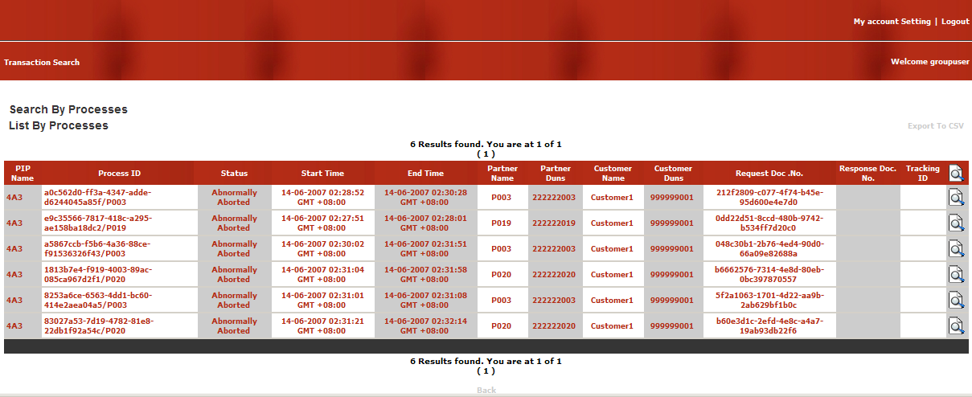
Figure 7: List of failed process instances

A process instance with status ‘Abnormally Aborted’ would have the following symptoms:

- The outbound transaction document has reached the maximum number of retries to send out to the trading partner.

For example, for a maximum retries of three times, under the Process Detail page, you will notice there are four ‘Outbound’ transaction documents under the Transactions section.

- The process instance has exceeded the allowable time to complete the two-action process that is initiated by your organization.

For example, under the Process Detail page, you will notice there are only ‘Outbound’ transaction documents under the Transactions section and also only ‘Inbound’ signal documents under the Signals section.

A process instance with status ‘Abnormally Completed’ would have the following symptoms:

- A PIP 0A1 has been received that indicates this process instance has failed.

This may occur when a there are problem sending out Signal documents for the transaction documents received from the trading partner, and subsequently the trading partner gives up re-trying and send a PIP 0A1.

For example, on the Process Detail page, under Process Summary section, the error reason is indicated as ‘Failure Notification - Timeout and exceed maximum retry times’

- The process instance has been cancelled by a user

For example, on the Process Detail page, under Process Summary section, the error reason is indicated as ‘User cancelled’

- There are document validations errors on the transaction documents sent or received.

For example, on the Process Detail page, under Signals subsection, there is a signal document with document type as ‘RN_EXCEPTION’

NOTE:

For a process instance whose status is ‘Complete’, it does not imply that private processing of the documents is successful. The private process may fail at a certain point, for example, the point trying to deliver to your organization backend system. In this case, depending on the point at which the private process failed, a re-process of the transaction may be necessary.

TIPS:

You can locate the error reason by accessing the Process Detail page. Under the Process Summary section, the error reason is provided.

Viewing the detail Information of a process

- Click the Detail button at the end of one of the Process search result. You will be presented with a Process Details page as follows:

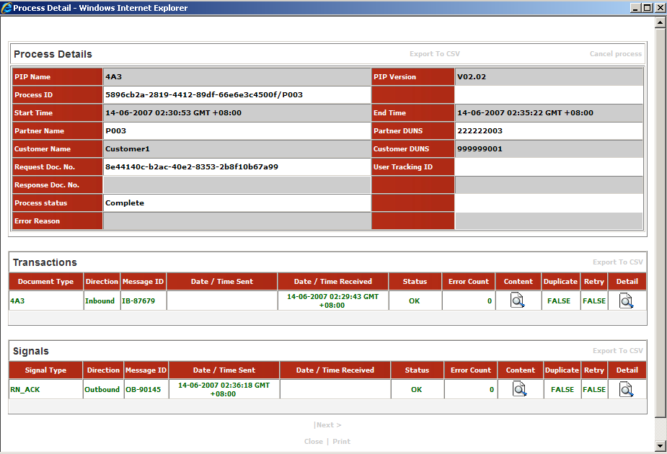
Figure 8: Process Details Page

Process Details Page

The Process Details page is divided into three sections, namely, Process Summary, Transactions, and Signals.

Process Summary

This section provides the summary information of a RosettaNet process instance. This information is a superset of the information available on the search result listing. For explanation on each field, please refer to section 3.1 Search By Processes. The following explains the additional fields shown here:

PIP Version:
This shows the version of PIP that is used for this process transaction.

Error Reason:
This shows the reason why the process instance has failed.

Transactions

This section provides the list of documents transacted for the process instance. The following fields will be shown:

Document Type:
This indicates the document type of the transaction document

Direction:
This indicates the direction of the transaction document. The direction can be one of the values of ‘Inbound’ or ‘Outbound’.

Message ID:
This indicates the unique identifier that identifies the transaction document in GridTalk.

Date/Time Sent:
This indicates the date and time of the transaction document that is successfully delivered to the partner. It will be available for ‘Outbound’ transaction documents.

Date/Time Received:
This indicates the date time of the transaction document that is received from the trading partner. It will be available for ‘Inbound’ transaction documents.

Status:
This indicates the status of the last event in the event list of the transaction document

Error Count:
This indicates the total number of errors found in the list of events of the transaction document. For example if we have problem to sending out the document to the trading partner, the Document Delivery event will be captured and its status is FAILED. So the Error count in this case will be 1. If the second retry also failed, the error count will be incremented to 2, and so forth.

Content:
This provides downloading or viewing of the transaction document, including any attachments to the document.

Duplicate:
This indicates whether the document transaction has been re-received from trading partner. It is applicable only for ‘Inbound’ document.

Retry:
This indicates whether the document has been re-sent from GridTalk. It is applicable only for ‘Outbound’ document.

Detail:
This allows viewing of the detail information of a document transaction.

Signals

This section provides the list of Signal documents transacted for the process instance. The following fields are shown:

Document Type:
This indicates the document type of the Signal document, may be either ‘RN_ACK’ or ‘RN_EXCEPTION’.

- RN_ACK: RosettaNet Acknowledgement of Receipt signal
- RN_EXCEPTION: RosettaNet General Exception signal

Direction:
This indicates the direction of the Signal document, may be either ‘Inbound’ or ‘Outbound’.

Message ID:
This indicates the unique identifier that identifies the signal document in the GridTalk.

Date/Time Sent:
This indicates the date and time at which the Signal document is successfully delivered to the partner. It will be available only for Outbound Signal documents.

Date/Time Received:
This indicates the date and time at which the Signal document is received from trading partner. It will be available only for Inbound Signal document.

Status:
This indicates the status of the last event in the event list of the signal document

Error Count:
This indicates the total number of errors in the list of events for the signal document. For example if we have problem to sending out the document to the trading partner, the Document Delivery event will be captured and its status is ‘FAILED’. So the Error count in this case will be 1. If the second retry is also failed, the error count will be incremented to 2, and so forth.

Content:
This provides downloading or viewing of the document contents of the Signal document.
Duplicate:
This indicates whether the Signal document has been re-received from trading partner. It is applicable for only Inbound documents.

Retry:
This indicates whether the Signal document has been re-sent from GridTalk. It is applicable only for Outbound documents.

Detail:
This provides viewing of the detail information of the Signal document.

NOTE:

Depending on the state of the process instance, the Process Detail page may not display the list of all document transactions and signal documents for a complete process instance.

TIPS:

The Previous/Next navigation link allows you to browse the Previous/Next Process Detail without going back to the search result page.

Actions available on Process Details page

On the Process Details page, you may perform the following tasks:

- Cancel Process
- Download the document content and attachments (if any)
- View the detail information of the documents
- Export the process information as CSV format

Cancelling a RosettaNet Process Instance

When a RosettaNet process instance is in progress, you may choose to cancel the process if, for example, there were some incorrect data in the transaction document, and there is no other PIPs that allow the changes to be updated.

When a process instance is cancelled, a PIP 0A1 will be initiated and sent to your trading partner, indicating the process instance that has been cancelled.

- In the search result page, select one of the Process transaction items which you wish to cancel by clicking on the button at the end of the selected item. You will be presented with the Process Details page..

- Click the Cancel Process hyperlink at the top right-hand corner of the Process Summary section. A confirmation window will be shown.

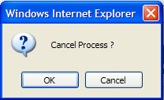

- Click OK to confirm canceling the process. After a few moments, a dialog prompt will be shown to indicate whether the cancel process request has been successfully submitted to GridTalk.

- Click OK to close the dialog.

NOTE:

A process instance can be cancelled if its process status is in either the ‘Running’ or ‘Complete’ state.

Downloading the document content and attachments

The document content and attachments (if any) can be downloaded to your local file system.

- Under the Transactions section, identify one of the documents for which to download content.

- Click the icon under the Content for the identified document. A window will pop up, listing the hyperlinks for downloading the document and any attachments.

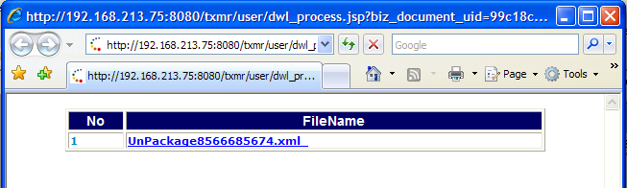

- Click on one of the hyperlinks to download as file. A window will pop up and prompt you to open or download the content.

- Click Save to download the content to a file.

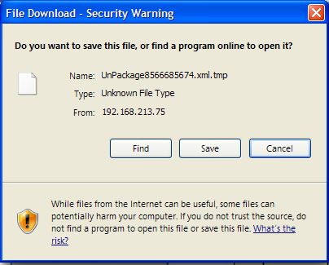

Viewing the detail information of the documents

The information shown on the Transactions and Signals sections is only a subset of all information tracking for a document.

To view the complete details of a document,

- Under the Transactions or Signal section, identify the document you wish to view its complete details.
- Click on icon. The Transaction Detail page will pop up, as shown.

Refer to Section 3.3.2.1 Transaction Detail Page for details on the Transaction Detail page.

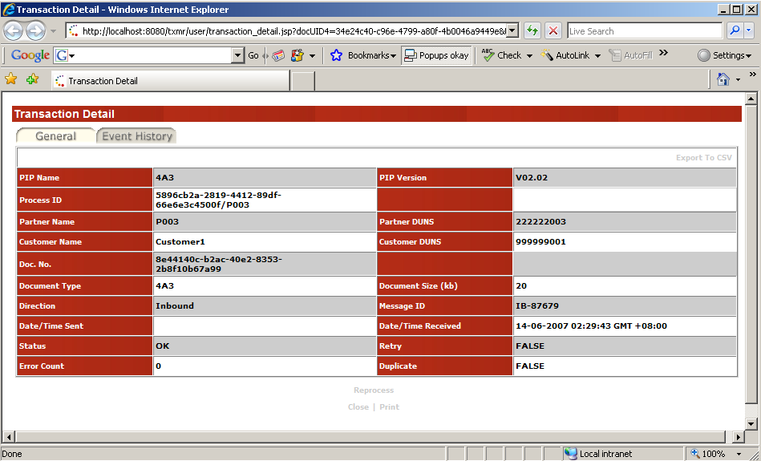
Figure 9: List By Processes | Process Details | Transaction Detail Page

Exporting process detail information as CSV

All the information shown under the Process Summary, Transactions, and Signals sections may be exported as Excel CSV format to your local file system.

- To download the Process Summary information, under the Process Summary section, click on the Export to CSV hyperlink on the header of the section table. A window will pop up and prompt you for download as CSV file.

- Click Save to save the CSV on your local file system.

Repeat the above steps to export the information on Transactions and Signals sections by clicking on the Export to CSV hyperlink on the header of the respective section table.

A sample screenshot of the sample CSV format is shown under Section 3.5.1 Exporting the table information as CSV Format.

Searching and Listing By Transactions

This listing option provides the viewing of the RosettaNet documents directly from the search results.

- Under RosettaNet Transaction Search Page, select By Processes for the Search Option.

- Enter the combination of the search criteria. Specify List By option as ’Transactions’

- Click Search. The search result page will be shown, listing the RosettaNet documents that fulfilled the search criteria.

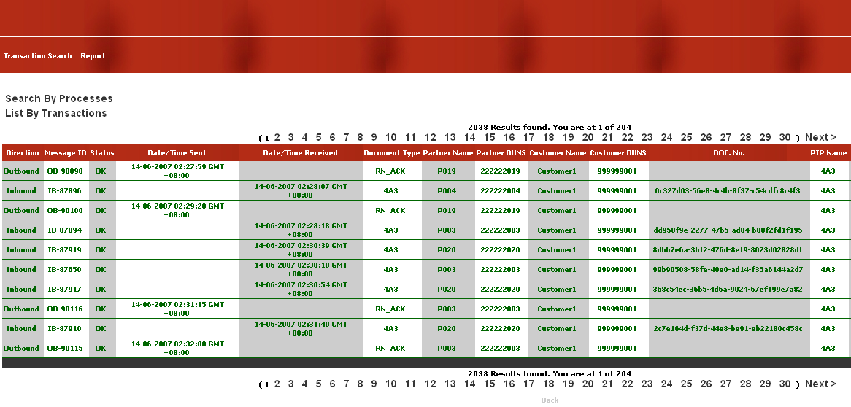
Figure 10: Search By Processes | List By Transactions (Transaction Search Result Page)

Tracing the status of transactions

For monitoring purpose, you may be more concerned with which RosettaNet transactions have failed within a particular hour. The following illustrates the step to achieve such a purpose.

- Under RosettaNet Transaction Search page, select Search Option ‘By Processes” and List By ‘Transactions’.

- Specify the Process Occurring date/time range by using the date picker

- Select the one of the listed document types that you are interested in.

- Click Search. The transaction search result page will be shown.

- Sort the status of the transactions by clicking on the Status column. The search result will show the list of documents whose statuses are indicated as ‘FAILED’, if any.

Figure 11: List of failed transactions

Viewing the detail information of a document

- On the Transaction Search result page, click on the button at the end of one of the listed items. You will be presented with the Transaction Detail page.

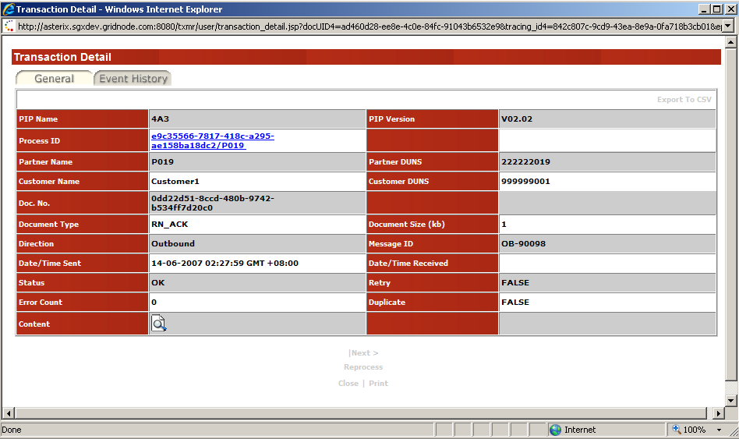
Figure 12: List By Transactions | Transaction Detail Page

The Transaction Detail page shown in the above figure is similar to the Transaction Detail page in 3.3.2.1 Transaction Detail Page. The only difference is that the above Transaction Detail page:
- provides the Process ID hyperlink to the Process Detail page of the process instance that it belongs to
- provides downloading of the document content

TIPS:

The Previous/Next navigation link allows you to browse the Previous/Next Transaction Document/Signal Document without going back to the search result page.

Transaction Detail Page

This section is applicable for both Transaction documents and Signal documents.

The Transaction Detail page provides the complete set of information for a RosettaNet document. The event history (round-trip history) of the document is also provided.

Figure 13: Transaction Detail page | General tab

General tab

The General tab shows the snapshot information of the process instance that the document belongs to. The information includes the PIP Name, PIP Version, Process ID, Partner Name, Partner Duns, Customer Name, and Customer Duns.

The General tab also shows the document transaction information. The information includes the Doc. No., Document Type, Document Size, Direction, Date Time Sent, Date/Time Received, Status, Error Count, Retry, and Duplicate.

The following summarizes the fields under the General tab:

PIP Name
This indicates the PIP name of the process instance this document belongs to.

PIP Version
This indicates the PIP Version of the process instance this document belongs to.

Process ID
This indicates the Process ID of the process instance this document belongs to.

Partner Name
This indicates the name of the trading partner who transacted with your organization.

Partner Duns
This indicates the D-U-N-S number of the trading partner.

Customer Name:
This indicates the name of your organization, as recognized by GridTalk.

Customer Duns
This indicates the D-U-N-S number of your organization.

Doc No
This indicates the proprietary document identifier of this document, not applicable to Signal documents.

Document Type
This indicates the document type of this document.

Document Size
This indicates the size of this document.

Direction
This indicates the direction of that this document is transacted. The value is either ‘Inbound’ or ‘Outbound’

Message ID
This indicates the unique identifier that identifies the document in GridTalk.

Date/Time Sent
This indicates the date and time at which this document is successfully delivered to the trading partner, applicable to ‘Outbound’ documents only.

Date/Time Received
This indicates the date and time at which this document is received from the trading partner, applicable to ‘Inbound’ documents.

Status
This indicates the status of the last event in the event list of this document.

Error Count:
This indicates the total number of errors found in the list of events of this document.

Duplicate
This indicates whether the document has been re-received from trading partner, applicable to ‘Inbound’ documents only.

Retry
This indicates whether the document has been re-sent to the trading partner, applicable to ‘Outbound’ documents only.

Event History tab

Under the Event History tab, you can track the event history list for a document.

The following summarizes the fields under Event History tab:

Event:
This indicates the name of the event that occurred

Date/Time:
This indicates the time of occurrence of the event

Message ID:
This indicates the Message ID of the particular document that the event was performed on.
NOTE:

A document transiting from one location to another would constitute a change in Message ID. For example, for a document imported into GridTalk, the Message ID starts with ‘IP’; however, when this document is being processed for sending out to the trading partner, a new Message ID starting with ‘OB’ is assigned.

Status:
This indicates the status of the event that has occurred. The value may be either ‘OK’ – for successful events, or ‘FAILED’ – for failed events.

Error Reason:
This indicates the error reason that caused the event to fail.

Remark:
This shows any additional information for the event, e.g. HTTP response code (Document Delivery) event.

Content:
For events that occurred at the entry and exit points of the GridTalk application, the document content will be saved for audit tracking. These events include:

- Document Received
The raw RosettaNet business message received from the trading partner will be saved.

- Document Received From Gateway
The document to be delivered to your backend systems will be saved.

- Document Received From Backend
The document received from your backend systems will be saved.

- Document Export
The document exported via a Port will be saved.

- Document Delivery
The raw RosettaNet business message sent successfully to the trading partner will be saved.

- Document Acknowledged
The raw RosettaNet business message of received Acknowledgement or Exception signal for a transaction will be saved.

The saved documents may be downloaded or viewed.

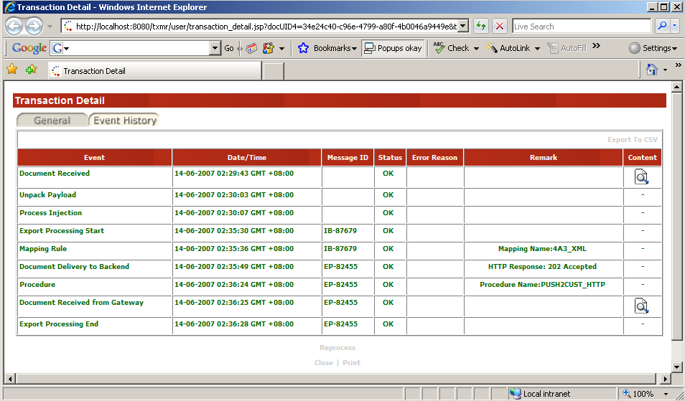
Figure 14: Transaction Detail | Event History tab

For outgoing document transactions, the event for the documents will be tracked upon receiving of the document from your backend system at the backend connector or upon import of the document directly into GridTalk. The tracking will end after the document has been sent to the trading partner, or upon completion of the private processing of the document.

For incoming document transactions, the event for the received documents will be tracked upon receiving of the document at the RosettaNet gateway. The tracking will be end after the document has been sent to your backend system, or upon completion of the private processing of the received document.

For details on the possible events on the Event History tab, refer to Section 5 Supplementary Notes on Event History.

Actions available on Transaction Detail page

On the Transaction Detail page, you may perform the following tasks:

- View the details of the associated process instance (for List by Transactions only)
- Download the document content (for List by Transactions only)
- Reprocess a Transaction
- Export the transaction information to CSV
- Download document content in event history list

Viewing details of associated process instance

For viewing other documents that belong to the same process instance as this document, you may click on the hyperlink in the Process ID field:

- Click on the hyperlink on the Process ID field. The Process Details page of the associated process instance will be shown.

Figure 15: Process Details page of associated Process Instance

To download the user document under General tab

- Click on the icon against Content field on Transaction Detail page. You will be presented with hyperlink(s) for the file(s) you may download.

- Click on the name of the file to download. You will be prompted to download and save the file.

- Click Save to persist the file on local file system.

Reprocessing a Transaction

The re-process function is applicable to Transaction documents and Signal documents. Refer to Section 4 Transaction Re-processing for details.

Exporting transaction information to CSV

The information under the General tab and Event History tab may be exported as CSV format by clicking on the ‘Export To CSV’ hyperlink at the top right-hand corner of the respective table. Refer to Section 3.5.1 Exporting the table information as CSV Format for details.

Downloading document content from Event History

The event that has a button under the Content column is applicable for downloading of document content.

- Click on Event History tab

- Click on the button at the end of the event row. You will be presented with a list of filename hyperlinks for the files you may download.

- Click on the name of the file to download. You will be prompted to download and save the file.

- Click Save button to save the content to local file system.

Search By Events

In some situations, the user may also monitor the transactions by their event status directly, such as:
- When a received document from a trading partner has failed to be un-packaged, particularly, the “Unpack Payload” event.
- When a received document from your HTTP backend system has failed to be imported into GridTalk, particularly, the “Document Delivery to Gateway” event

Under such situations, trying to search for transactions by Process may not work as the relevant RosettaNet process may not even be created at that stage. Thus, by enabling searching by events, it closes up the loop for total transaction monitoring. Of course, the user may find this feature useful for monitoring any events that had failed during certain period.

To perform search by events,

- Under RosettaNet Transaction Search page, select the Search Option as ‘By Events’.

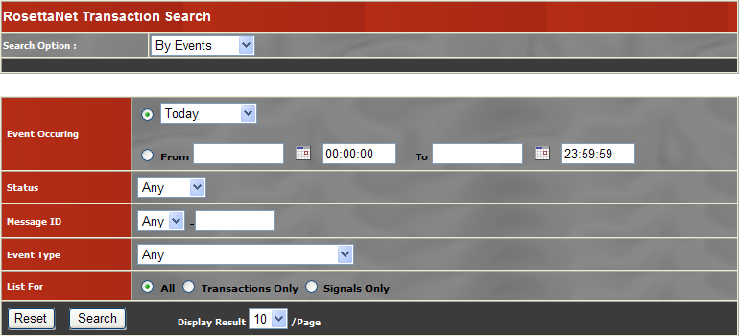
Figure 16: Search By Event Page

The following search criteria are supported:

Event Occurring:
This is the time of occurrence of the event. Manually enter date is allowed. The format will be yyyy-MM-dd HH:mm:ss.

Status:
This is the status of the event. Possible values are: ‘OK’ or ‘FAILED’

Message ID:
This is the identifier that uniquely identifies a transaction document in GridTalk. This can be used to retrieve a list of events that occurred upon a particular document.

Event Type:
This is the type of the event.

List For:
This is the option to constrain the search to include events for Transaction or Signal documents. Three options are provided:

All:
This option retrieves all matching events for all transaction and signal documents.

Transactions Only:
This option retrieves all matching events for transaction documents only.

Signals Only:
This option retrieves all matching events for signal documents only.

Reset:
This resets the search criteria input fields to their default values

Search:
This performs the search using the specified criteria

Display Result:
This indicates the number of items to be listed on each search result page.

Tracing the status of the Events

For monitoring purpose, you may be much more concerned with which events have failed within a particular hour. The following illustrates the steps to achieve such a purpose.

- On RosettaNet Transaction Search page, select Search Option ‘By Events’.

- Specify the Event Occurring date time range (both From and To fields) using the date picker.

To set a date and time, enter the time in the Time field, and then click on a date. This will close the popup date picker and set the chosen date and time in the respective fields.

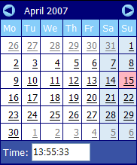

- Select ‘FAILED’ for Status.

- Click Search. The search result page may show the list of failed events.

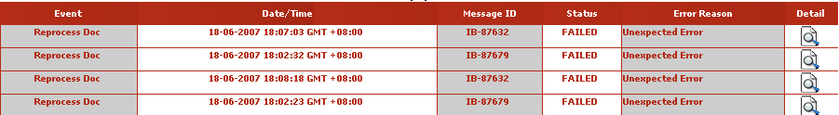
Figure 17: Search By Event Result page (List of failed events)

From the above figure, it indicates the event ‘Document Delivery to Backend’ has failed. The error reason ‘Unable to send document via HTTP’ means the transaction document has failed to be delivered to your organization backend system. When connectivity errors happen, please contact your TXMR support or your group administrator to investigate the issue.

TIPS:

After the administrator has identified the cause and fixed the connectivity issue, you can re-push the transaction document to your organization backend using the Reprocess function.

Refer to section 4 Transaction Re-processing for more details.

Viewing the Event History and document information

From the event search result page, you can trace back to the Event History that an event belongs to, as well as the transaction/signal document that the event has occurred upon. This helps you to identify the transaction/signal document that has failed to process.

- Under Event search result page, click on the Detail button at the end of the desired item. The Transaction Detail page will be displayed.

Event History Tab

The Event History shown here may belong to different documents, for the following scenarios:
- A transaction document is being re-tried for sending to trading partner, due to failure to deliver in previous attempts.
- A document is being reprocessed using the Reprocess function.

For more details, refer to Sections 5.2.2.2 and 5.2.3.4.

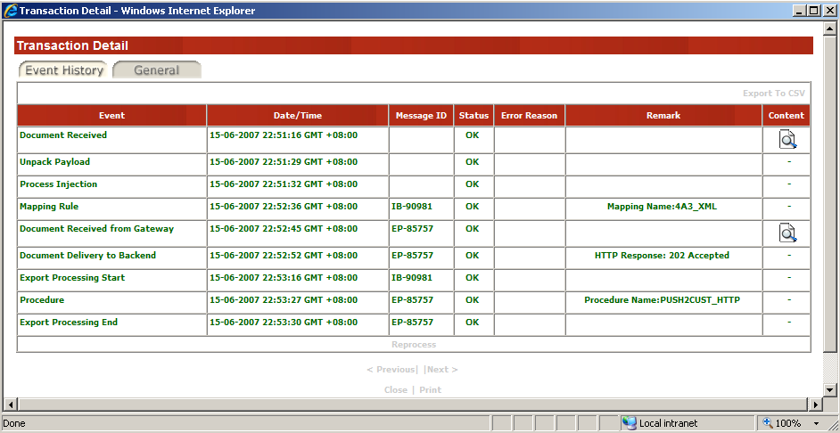
Figure 18 Search By Events | Transaction Detail Page | Event History Tab
TIPS:

The Previous/Next navigation link allows you to browse the Previous/Next event record without going back to the search result page.

Actions available on Event History tab

Under the Event History tab, you may perform the following tasks:

- Reprocess the transaction/signal document
- Download the document content
- Export the event history list as CSV format

Reprocessing a transaction/signal document

For details, refer to Section 4 Transaction Re-processing.

Downloading the document content

For details, refer to Section 3.3.2.2.5 Downloading document content from Event History.

Exporting Event History as CSV

For details, refer to Section 3.5.1 Exporting the table information as CSV Format.

General tab

The General tab shows a list of transactions or signals that are associated with the same list of events, that means, those transactions or signals are originated from the same source document.

From the General tab, you may view the current status of the RosettaNet transactions or signals. The information includes:

Direction:
This indicates the direction of the transaction or signal. Possible values are: ‘Inbound’ or ‘Outbound’.

Message ID:
This indicates the identifier that uniquely identifies a document in GridTalk.

Status:
This indicates the status of the last event in the event history list for the document.

Document Type:
This indicates the document type of the document, as defined in GridTalk.

Partner Name:
This indicates the name of the trading partner, as recognized in GridTalk.

Customer Name:
This indicates the name of your organization, as recognized in GridTalk.

PIP Name:
This indicates the name of the RosettaNet Process, as defined in GridTalk.

Process ID:
This indicates the PIP instance identifier and the initiator of the RosettaNet process.

Doc No:
This indicates the proprietary document identifier of the transaction document. Not applicable for signal documents.

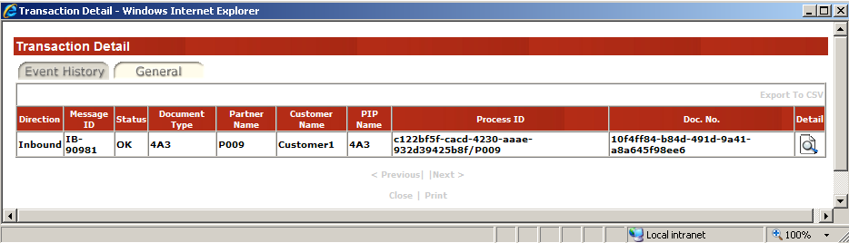
Figure 19: Search By Events | Transaction Detail page | General Tab

Detail:
This shows a button that allows you to view the document detail information on the Transaction Detail page.

Actions available on General tab

Viewing document detail information

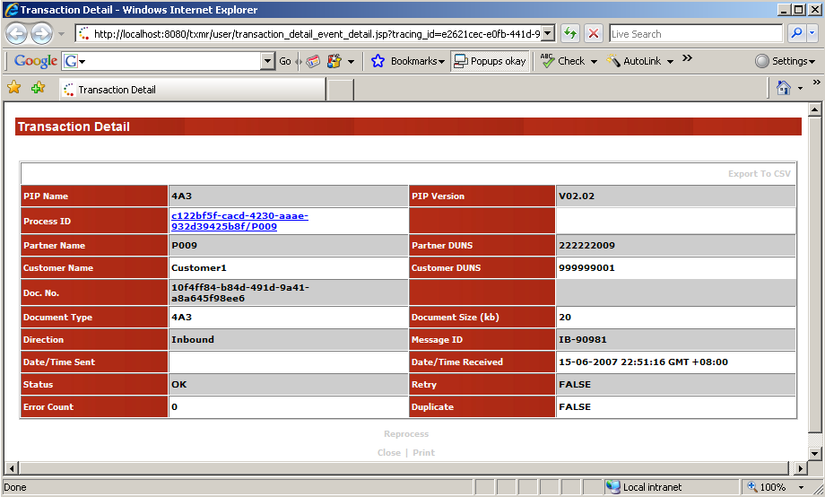
Figure 20: Search By Events | Transaction Detail | General Tab | Transaction Detail

The information shown here is similar to that in Section 3.3.2.1 Transaction Detail Page, with the Event History tab omitted.

You may access Process detail of the document by clicking on hyperlink in Process ID field.

You may reprocess the document by clicking on the Reprocess hyperlink.

Common Functions

The following section covers the common operations that are available in most pages.

Exporting the table information as CSV Format

This function appears as an Export to CSV hyperlink on the header of the information table, usually at the top right-hand corner. Upon performing this function, all the information shown within that table will be exported into CSV file.

- Click on the Export to CSV hyperlink on the header of the table. After a short moment, you will be prompted for downloading of the CSV file.

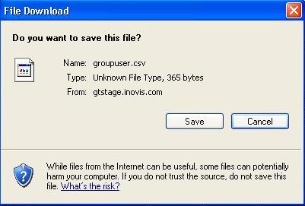

- Click Save to save the CSV file.

Example – Exporting Process Detail information to CSV file

The figure below shows the process summary information table on the Process Details page.

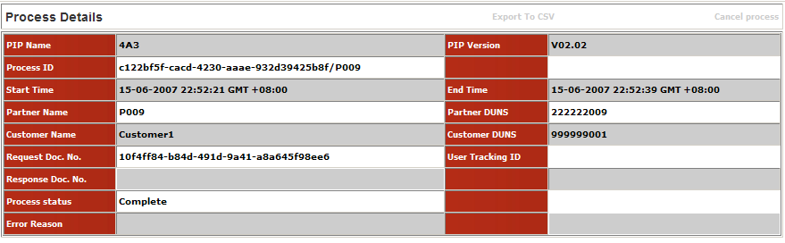
Figure 21: Process Summary section to be exported to CSV

Upon exported to CSV, the process summary information will be saved and shown as below:

Figure 22: Process Summary section exported as CSV

Traversing list items from detail page

Detail pages that are launched from a listing page, e.g. search result page, contain the navigation links to traverse items on the listing page back and forth. These navigation links are the ‘< Previous’ and ‘Next >’ hyperlinks shown at the bottom of the detail page. As the name suggests, ‘< Previous’ displays the detail information of the previous item on the listing, while ‘Next >’ displays the detail information of the next item on the listing. This saves you the need to go back to the listing to view the previous or next item on the list.

Printing the detail information

On the detail pages, a Print hyperlink appears at the bottom of the page, which allows you to send the displayed information for printing.

Transaction Re-processing

Incoming and Outgoing RosettaNet documents may be re-processed for cases such as:

- The document fails at some point in private processing, e.g. mapping failure
- The document is a duplicate which is never intended to be delivered to your organization’s backend system, but for internal business needs, it is desired to be delivered to your organization’s backend system.

NOTE:

Prior to re-processing the document, you should ensure that the cause of the failure has been resolved. Otherwise, the re-processing may still fail at the same point in the ‘Event History’.

Re-processing a Transaction

At the bottom of the Transaction Detail page, you may find a Reprocess hyperlink. This link allows you to trigger the re-processing of the transaction from the following points in the event flow:
- Inbound documents entering the Export processing
- Imported documents entering the Outbound processing

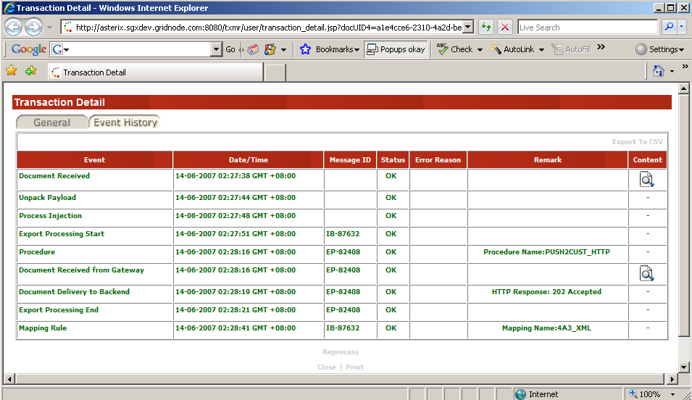
Figure 23: Transaction Detail page with Reprocess hyperlink boxed

- Click on the Reprocess link at the bottom of Transaction Detail page. You will be prompted to confirm to perform the re-process function.

- Click Yes. After a short moment, you will be shown with a popup which indicates the submission status of re-process request to GridTalk. If the status is successful, the popup will show the message: ‘[Reprocess] Request has been submitted to GridTalk’.

NOTE:

If the re-process request is not submitted successfully, you may see one of the following messages:

[Reprocess] Request initiating fail
This indicates that a problem is encountered when TXMR tries to initiate the request.

[Reprocess] Request is denied
This indicates that re-process is not allowed, for scenarios stated in Section 4.1.1 Scenarios whereby Re-process is not allowed.

[Reprocess] Request failed to be submitted to GridTalk
This indicates that the re-process request could not be submitted to GridTalk, probably due to a broken link between the applications.

- Click OK to close the popup.

- After a few moments, refresh the Transaction Detail page (you may do this by pressing ‘F5’). The Event History will be appended with events from the re-processing.

Scenarios whereby Re-process is not allowed

There are some scenarios whereby you would not be allowed to perform the re-process function. These are:

- When there is no Inbound document created, that is, the processing fails before the Inbound document has been created. In the Event History, you would probably see only the ‘Document Received’, ‘Unpack Payload’ or ‘Process Injection’ events.

- For outgoing documents, when there is no Document Import event with ‘OK’ status in the Event History; you would probably see only the ‘Document Received From Backend’ and ‘Document Delivery to Gateway’ events. If the document has not been imported successfully into GridTalk, re-processing is not possible.

- For outgoing response documents (that is, your organization is participating as the responding role in a two-action PIP), when an Outbound response document has been sent or is in the process of being sent to the trading partner.

Under the above scenarios, if the Reprocess function is triggered, the delivery status of the re-process request will be shown as: ‘[Reprocess] Request is denied’.

Event History after re-processing

The Reprocess Doc event

When a re-process is triggered, the Event History would be appended with a ‘Reprocess Doc’ event. This event separates the original event list from the new events for the re-processing.

On the ‘Reprocess Doc’ event, the following information will be captured:

Message ID
This indicates the document that will be used for re-processing.

Remark
This indicates the User name of the login user who initiated the re-process request.

After re-processing Incoming Transaction Document

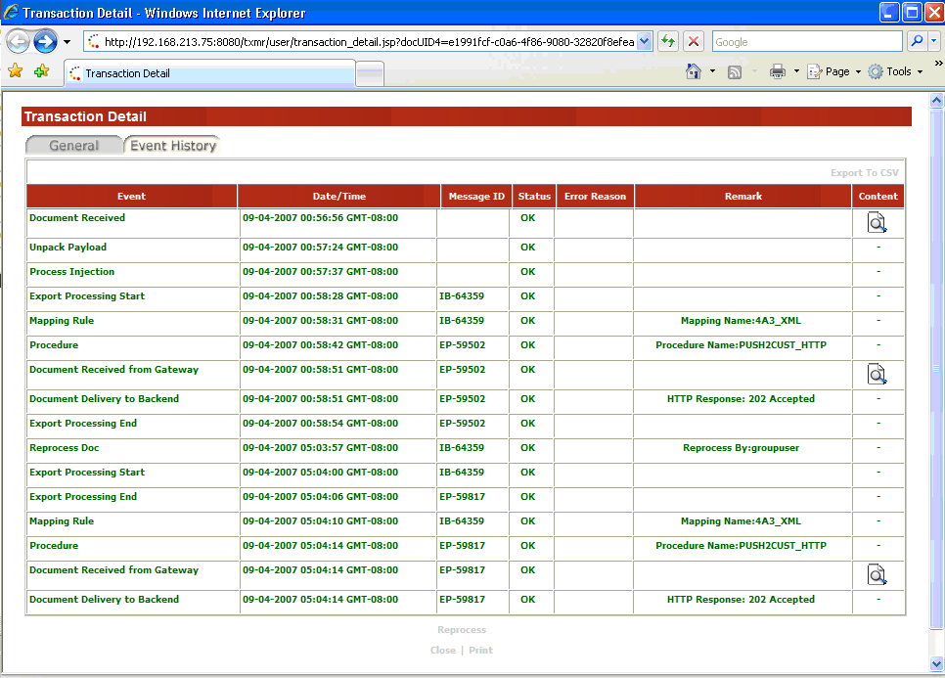Figure 24: Event History after re-processing incoming transaction document

From the above figure, the events marked within the box boundary are the additional events after re-processing the Inbound transaction document (Message ID: IB-64359).

For a sample event history after re-processing an incoming signal document, refer to Section 5.2.4.2 Example 2 – Re-processing an Inbound Signal.

After re-processing Outgoing transaction document

There are two cases whereby re-processing of outgoing transaction documents are allowed:

Case 1:
Your organization is the initiating role of the RosettaNet process.
When you re-process the outgoing transaction document, a new RosettaNet process instance will be generated. Events for re-processing will appear in the Event History for the new documents in the new process instance.

Case 2:
Your organization is the responding role of a two-action RosettaNet process, and the outbound transaction document has not been created.
When you re-process the outgoing transaction document, no new RosettaNet process instance will be generated. Events for re-processing will appear in the same Event History for the re-processed transaction document.

Case 1 Example
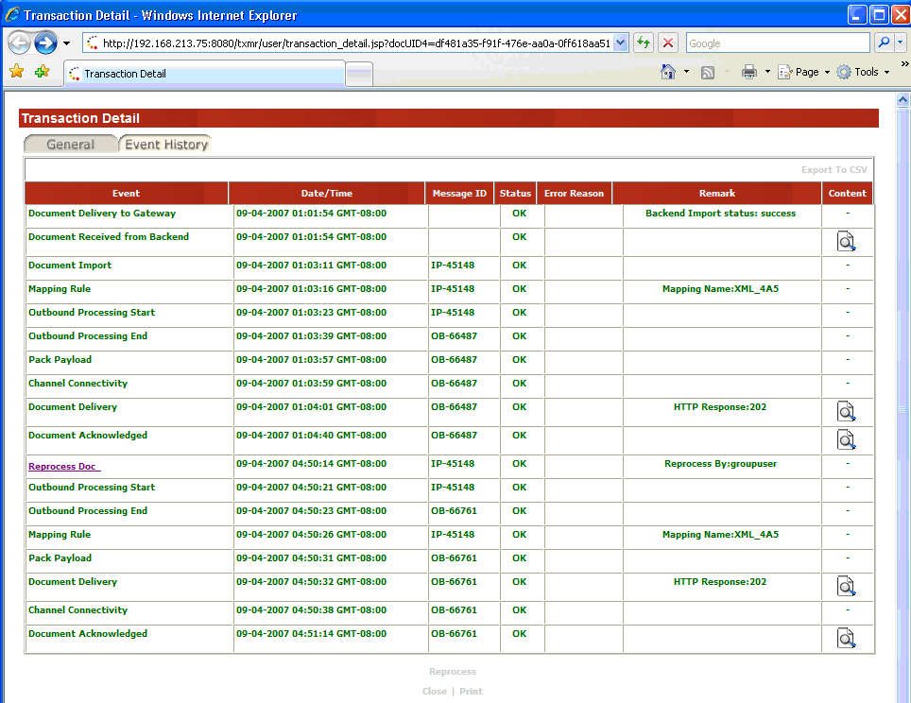Figure 25: Event History after reprocessing outgoing transaction document

From the above figure, the events marked within the box boundary are the additional events after the re-processing the outgoing transaction document (Message ID: IP-45148).

The ’Reprocess Doc’ Event contains a hyperlink to the new RosettaNet process instance if it has been generated successfully in GridTalk. Click on the hyperlink and the Process Details page for the new process instance will be shown.

The outgoing transaction document of the new process instance shares the same Event History as the original outgoing document.

For more details, refer to Section 5.2.3.4 Example 4 – Re-processing Outbound Transaction with no failures.

Case 2 Example

In the following Event history for an outgoing transaction document, the processing failed at the ‘Mapping Rule’ event. The Outbound document has not been created yet.

Event History for outgoing transaction failing at Mapping Rule:

Document Received from Backend →
Document Delivery to Gateway →
Document Import →
Mapping Rule: CVT_TXT_RN (FAILED) →

After the re-process request has been submitted and processed successfully, the events for the re-processing are appended to the Event history.

Event History list after re-processing:

Document Received from Backend →
Document Delivery to Gateway →
Document Import →
Mapping Rule: CVT_TXT_RN (FAILED) →
Reprocess Doc
Mapping Rule: CVT_TXT_RN (OK) →
Outbound Processing Start →
Channel Connectivity →
Outbound Processing End →
Pack Payload →
Document Delivery (OK) →
Document Acknowledged

No new process instance will be generated from the re-processing.

For re-processing of outgoing signal document, refer to Section 5.2.4.1 Example 1 – Re-processing an Outbound Signal.

Supplementary Notes on Event History

This section provides additional information on the Event History for those who may like to have a more in-depth understanding of the events occurring on the transactions within GridTalk.

List of Events in Event History

The table below provides the list of Events that may appear in the Event History for a transaction. It explains what each Event means, and what you could expect in the various fields of each Event.

Event Name | Description
Document Received | This indicates the point when GridTalk successfully receives a transaction/signal document through the RN gateway i.e. a 202 or 200 response code has been returned to the trading partner’s gateway.  The Content field saves the raw RN MIME message as received through HTTP connection.
Document Import | This indicates the point when an attempt has been made to import a document into GridTalk.  The Status indicates whether the document has been successfully imported into the application. If not, the error would be captured under Error Reason.  If the document comes from the Customer’s HTTP Backend, the document content will be captured under “Document Received from Backend” event. Otherwise, the Content field of this event saves the document that was imported successfully into GridTalk.
Document export | This indicates the point whereby document export via the indicated port has ended.  The Status indicates whether the execution is successful and, if not, the reason will be captured under Error Reason.  The Remark field indicates the name of the port that the document is exported to.  The Content field saves the document that is exported successfully via the indicated port.
Document Delivery | This indicates the point whereby the attempt to deliver the transaction/signal document to the trading partner has ended.  The Status indicates whether the delivery is successful and, if not, the reason would be captured under Error Reason.  The Remark field captures the response code returned from the trading partner. A successful delivery would mean that a 202/200 HTTP response code is received.  The Content field saves the raw RN message delivered successfully to the trading partner.
Document Acknowledged | This indicates the point whereby GridTalk has received the RN acknowledgement or exception signal for a prior sent transaction from the trading partner. By “received”, it means the raw signal message has been successfully unpacked and the unpacked signal document is persisted.  The Content field saves the raw RN signal message received from the trading partner.
Unpack Payload | This indicates the point when GridTalk has finished unpacking the raw message received from the trading partner.  During unpacking, the following actions would be performed:  - determine the sender and target recipient from the raw message  - decrypt the raw message using the determined customer’s (recipient) certificate  - verify the digital signature using the determined trading partner’s (sender) certificate  - validate the preamble, delivery, and service headers from the decrypted message  The Status indicates whether the above actions are successfully performed, and if not, the reason will be captured under Error Reason.  Nothing is saved under the Content field.
Pack Payload | This indicates the point when GridTalk has finished packing the RN message for transmission to the trading partner.  During packing, the following actions would be performed:  - encrypt the RN message using the trading partner’s (recipient) certificate  - sign the message using the customer’s (sender) certificate  The Status indicates whether the above actions are successfully performed, and if not, the reason will be captured under Error Reason.  Nothing is saved under the Content field.
Outbound Processing Start | This indicates the point whereby a transaction is being pushed to the Outbound processing stream.  Nothing is saved under the Content field.
Outbound Processing End | This indicates the point whereby a transaction has successfully finished its processing in the outbound processing stream. The kinds of processing it may have gone through include:  - Mapping Rule (indicated by the Mapping Rule event)  - User Procedure (indicated by the Procedure event)  - Message creation (this is indicated by a different Message ID from that in Outbound Processing Start event)  - Trigger channel connectivity (indicated by the Channel Connectivity event, however, this does not mean that channel connectivity is successful)  Nothing is saved under the Content field. However, the document content should be accessible from the Content field of the Outbound Transaction.
Export Processing Start | This indicates the point whereby the transaction is being pushed to the Export processing stream.  Nothing is saved under the Content field.
Export Processing End | This indicates the point whereby the transaction has successfully finished its processing in the export processing stream. The kind of processing it may have gone through includes:  - Message creation (this is indicated by a different Message ID from that in Export Processing Start event)  - Mapping Rule  - User Procedure  - Document Export  Nothing is saved under the Content field. However, the content of the exported document should be accessible from the Content field of the Document Export event, if it is successful.
Mapping Rule | This indicates the point whereby execution of the indicated mapping has ended.  The Status indicates whether the execution is successful and, if not, the reason will be captured under Error Reason.  The Remark field captures the name of the Mapping rule that was executed.  Nothing is captured under the Content field.
Procedure | This indicates the point whereby execution of the indicated user procedure has ended.  The Status indicates whether the execution is successful and, if not, the reason will be captured under Error Reason.  The Remark field captures the name of the User procedure that was executed.  Nothing is captured under the Content field.
Channel connectivity | This indicates the point whereby the initiation of channel connectivity has ended. During the initiation, the following actions would be performed:  - Determine the channel to use for connecting to the trading partner  - Trigger Pack Payload event  The Status indicates whether the initiation is successful and, if not, the reason would be captured under Error Reason.  Nothing is captured under the Content field.
Document Received from Backend | This indicates the point whereby the HTTPBC has successfully received a document from the Customer’s HTTP client, i.e. the document has been persisted for delivery and a 202 response code has been returned to the Customer’s HTTP client.  The Content field saves the raw document as received from the Customer’s HTTP client.
Document Received from Gateway | This indicates the point whereby the HTTPBC has successfully received a document from GridTalk, i.e. the document has been persisted for delivery to Customer’s HTTP Backend.  The Content field saves the the raw document as received from GridTalk.
Document Delivery to Backend | This indicates the point whereby the HTTPBC has made an attempt to deliver the document to Customer’s HTTP Backend for processing.  The Status indicates whether the delivery is successful and, if not, the reason would be captured under Error Reason.  Nothing is saved under the Content field.
Document Delivery to Gateway | This indicates the point whereby the HTTPBC has made an attempt to deliver the document to GridTalk for processing.  The Status indicates whether the delivery is successful and, if not, the reason would be captured under Error Reason.  Nothing is saved under the Content field.
Reprocess Doc | This indicates the point when a user has submitted a request to re-process request a document.  The Status indicates whether the re-process request is submitted successfully. If not, the reason would be captured under Error Reason.  The Remark field captures the user who submitted the re-process request.  Nothing is saved under the Content field.
Process Injection | This indicates the point when an attempt has been made to inject a received document from the trading partner to the RN process engine.  The Status indicates whether the injection is successful and, if not, the reason would be captured under Error Reason.  Nothing is saved under the Content field.

Typical Event Histories

The following sub-sections illustrates the typical event histories for transactions and signals.

Receiving Transactions

For a typical scenario of a single-action PIP initiated by the trading partner, you would expect to see an ‘Inbound’ Transaction, and it’s corresponding ‘Outbound’ Signal.

The following sub-sections illustrate the variants of the Event History that you may notice for receiving transactions from trading partner.

Example 1 – Happy Scenario
Inbound Transaction:

Document Received →
Unpack Payload →
Process Injection →
Export Processing Start →
Mapping Rule: CVT_RN_TXT →
User Procedure: SEND2_HTTP_BACKEND →
Document Received from Gateway →
Document Delivery to Backend →
Export Processing End

Outbound Signal:

Channel Connectivity →
Pack Payload →
Document Delivery

For the happy scenario, all events are successfully executed and the ‘Outbound’ signal is a RosettaNet Acknowledgement receipt.

Example 2 – Receives duplicate transaction
Inbound Transaction (duplicate):

Document Received →
Unpack Payload →
Process Injection (processing stopped after detecting duplicate)

Outbound Signal:

Channel Connectivity →
Pack Payload →
Document Delivery

When an ‘Inbound’ Transaction is detected as duplicate, it means that for the same process instance, another ‘Inbound’ Transaction has already been received earlier. In this case, the processing for the duplicate transaction stops at the “Process Injection” event.

Example 3 – Multiple attempts to deliver document to Backend
Inbound Transaction:

Document Received →
Unpack Payload →
Process Injection →
Export Processing Start →
Mapping Rule: CVT_RN_TXT →
Document Export: DEF →
User Procedure: PUSH2CUST_HTTP →
Export Processing End →
Document Received from Gateway →
Document Delivery to Backend (FAILED) →
Document Delivery to Backend (FAILED) →
… retry for limited times→
Document Delivery to Backend (OK)
Outbound Signal:

Channel Connectivity →
Pack Payload →
Document Delivery

Occasionally, connectivity problems may occur between GridTalk’s HTTPBC and the Customer’s HTTP Backend. When such issues occur, the HTTPBC would attempt to retry the delivery on a fixed interval (default is 10 secs) for a limited number of times (default is 10 times).

Sending Transactions

For a typical scenario of a single-action PIP initiated by the customer, you would expect to see an ‘Outbound’ Transaction, and it’s corresponding ‘Inbound’ Signal.

The following sub-sections illustrate the variants of the Event History that you may notice for sending transactions to trading partner.

Example 1 – Happy Scenario

Outbound Transaction:

Document Received from Backend →
Document Delivery to Gateway →
Document Import →
Mapping Rule: CVT_TXT_RN →
Outbound Processing Start →
Channel Connectivity →
Outbound Processing End →
Pack Payload →
Document Delivery →
Document Acknowledged

Inbound Signal:

Document Received →
Unpack Payload →
Process Injection →
Export Processing Start →
Document Export: DEF →
Export Processing End

For the happy scenario, all events are successfully executed and the ‘Inbound’ signal should be exported to the default port (DEF).

Example 2 – Document retries
Outbound Transaction:

Document Received from Backend →
Document Delivery to Gateway →
Document Import →
Mapping Rule: CVT_TXT_RN →
Outbound Processing Start →
Channel Connectivity → (first attempt)
Outbound Processing End →
Pack Payload →
Document Delivery (FAILED) → (first attempt failed)
Channel Connectivity → (second attempt)
Pack Payload →
Document Delivery (OK) → (second attempt successful)
Document Acknowledged

Occasionally, connectivity problems may occur between GridTalk and the trading partner’s RN gateway. In this case, governed by the RNIF Trading Partners Agreement, the initiator of the process should retry sending the transaction after Time-to-acknowledge has timed out, until the Maximum retries has exhausted.

The retried transaction’s events are appended to the Event History of the original transaction, i.e. both original and retried transactions have the same Event History.

Inbound Signal:

Document Received →
Unpack Payload →
Process Injection →
Export Processing Start →
Document Export: DEF →
Export Processing End

The ‘Inbound’ signal is possible if the retried transaction is delivered successfully to the trading partner.

Example 3 – No acknowledgement received from partner

Occasionally, a transaction may be sent successfully to the trading partner but no acknowledgement seems to be returned from the partner’s gateway. In this case, governed by the RNIF Trading Partners Agreement (TPA), the initiator of the process should retry sending the transaction after Time-to-acknowledge (default is 2 hrs) has timed out, until the Maximum retries (default is 3 times) has exhausted. For a default TPA, the process instance would fail if no acknowledgement or exception signal is received 2 hrs after the fourth attempt to retry the transaction.
Outbound Transaction:

Document Received from Backend →
Document Delivery to Gateway →
Document Import →
Mapping Rule: CVT_TXT_RN →
Outbound Processing Start →
Channel Connectivity → (first attempt)
Outbound Processing End →
Pack Payload →
Document Delivery (OK) →
Channel Connectivity → (second attempt)
Pack Payload →
Document Delivery (OK) →
Channel Connectivity → (third attempt)
Pack Payload →
Document Delivery (OK) →
Channel Connectivity → (fourth attempt)
Pack Payload →
Document Delivery (OK)
:
(Process failed with “Exceed Maximum Retries” 2 hours after the fourth attempt)
The retried transaction’s events are appended to the Event History of the original transaction, i.e. both original and retried transactions have the same Event History.

Re-processing Transactions

Under some situations, transactions may fail at the private processing, e.g. at mapping execution. In this case, re-processing of the transaction may be desired after the problem has been fixed.

The following sub-sections illustrate the variants of the Event History you may notice for re-processed transactions.

Example 1 – Re-processing an Inbound Transaction

For internal business needs, an Inbound transaction may be desired to be re-delivered to the customer’s backend even if the delivery has succeeded in the original processing.

The events for the re-processed transaction are appended to the same Event History as the original transaction.

Inbound Transaction:

Document Received →
Unpack Payload →
Process Injection →
Export Processing Start →
Mapping Rule: CVT_RN_TXT →
User Procedure: PUSH2CUST_HTTP →
Document Received from Gateway →
Document Delivery to Backend →
Export Processing End →
Reprocess Doc → (no extra Inbound transaction created)
Export Processing Start → (events for re-processed transaction starts here)
Mapping Rule: CVT_RN_TXT →
User Procedure: PUSH2CUST_HTTP →
Document Received from Gateway →
Document Delivery to Backend →
Export Processing End

Example 2 – Re-processing a duplicate Inbound Transaction
Inbound Transaction:

Document Received →
Unpack Payload →
Process Injection → (processing stopped after detecting duplicate)
Reprocess Doc → (no extra Inbound Document will be created)
Export Processing Start → (events for re-processed transaction starts here)
Mapping Rule: CVT_RN_TXT →
User Procedure: PUSH2CUST_HTTP →
Document Received from Gateway →
Document Delivery to Backend →
Export Processing End
For internal business needs, an Inbound transaction detected as duplicate may be desired to be delivered to the customer’s backend anyway.

The events for the re-processed transaction are appended to the same Event History as the original transaction.

Example 3 – Re-processing Outbound Transaction failed at mapping

Mapping execution failures are likely to occur when, for example,
- The mapping rule does not handle all possible document contents. Thus, when unexpected content is encountered, the mapping rule is not able to perform correctly.
- Document content deem as invalid by the mapping rule which does a validation on the document.

The re-process function is useful for the former example above, as the problem can be fixed by changing the mapping rule. Whereas for the latter example, there is no point of re-processing the transaction since the input document is invalid.
Outbound Transaction:

Document Received from Backend →
Document Delivery to Gateway →
Document Import →
Mapping Rule: CVT_TXT_RN (FAILED) →
Reprocess Doc → (no new OB transaction is created)
Outbound Processing Start → (events for re-processed transaction start here)
Mapping Rule: CVT_TXT_RN (OK) →
Outbound Processing End →
Channel Connectivity →
Pack Payload →
Document Delivery (OK) →
Document Acknowledged

Example 4 – Re-processing Outbound Transaction with no failures

For internal business needs, the customer may wish to re-send a document to the trading partner, initiating a new RosettaNet PIP instance.

In this case, a new Outbound transaction would be created; however, the events for the new transaction are appended to the same Event History as the original Outbound transaction.

The following illustrates the Event History changes:
Outbound Transaction (original/new):

Document Received from Backend →
Document Delivery to Gateway →
Document Import →
Mapping Rule: CVT_TXT_RN →
Outbound Processing Start →
Channel Connectivity →
Outbound Processing End →
Pack Payload →
Document Delivery →
Document Acknowledged →
Reprocess Doc → (a new OB transaction is created)
Outbound Processing Start → (events for new OB transaction start here)
Mapping Rule: CVT_TXT_RN →
Outbound Processing End →
Channel Connectivity →
Pack Payload → (a new process instance is initiated)
Document Delivery →
Document Acknowledged

Re-processing Signals

The following sub-sections gives examples of the event histories for re-processing signal documents.

Example 1 – Re-processing an Outbound Signal
Outbound Signal:

Channel Connectivity →
Pack Payload →
Document Delivery (FAILED) →
Reprocess Doc → (no extra OB signal created)
Channel Connectivity → (events for re-processed signal start here)
Pack Payload →
Document Delivery (OK)
Occasionally, connectivity problems may occur between GridTalk and the trading partner’s gateway. It may so happen that the Outbound signal could not be delivered to the partner’s gateway. Although the partner may retry sending the transaction after 2 hours, but it may be desired to re-delivery the signal once the connectivity issue is resolved.

The events for the re-processed signal are appended to the same Event History as the original signal.

Example 2 – Re-processing an Inbound Signal

In most cases, there is no need to re-process an Inbound signal, unless special handling of the signal is desired. By default, the received signal will be exported to the default Port in GridTalk.

Nevertheless, re-processing of the Inbound signal is still possible. No new Inbound Signal will be created. The events for the re-processed signal would be appended to the same Event History.
Inbound Signal:

Document Received →
Unpack Payload →
Export Processing Start →
Document Export: DEF →
Export Processing End
Reprocess Doc → (no extra Inbound signal created)
Export Processing Start → (events for re-processed signal start here)
Document Export: DEF →
Export Processing End

Group Admin Tasks

As a Group Admin, not only can you perform transaction monitoring as can be a Group User, you can also perform the following administrative tasks:

- Managing Group Users
- Generating Reports

The following sub-sections are applicable for Group Admin only.

Managing Group Users

The Group Admin is given the right to administer User Accounts, including:
- registration of new user account
- updating user’s information
- deleting a user
- ending the session of a particular user who belongs to your group

Administer User Accounts

This feature allows the Group Admin to administer all user accounts in the same group.

The figure below shows the Administrator page after clicking on the link on the top right-hand corner of the TXMR UI.

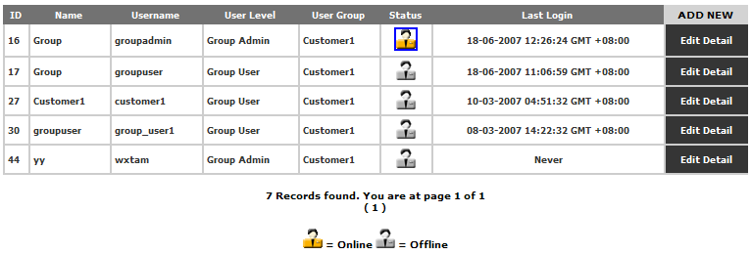
Figure 26: User Management page

Each row identifies a specific user. The columns in the header of the table are displayed as follows:

ID:
This is a unique number assigned to the user during registration.

Name:
This indicates the user’s name.

UserName:
This indicates the user’s login name.

User Level:
This indicates whether the user is a “Group Admin” or a “Group User”.

User Group:
This indicates the user’s group name.

Status:
This indicates whether the user is “Online” or “Offline”.
The Group admin may assist another user to logout from the TXMR session by clicking on the icon.

Last Login:
This indicates the date/time of last login of the user to TXMR.

Adding a new user

You may add more users or group admins for your organization for accessing TXMR.

- On the User Management page, click button. This directs you to the user registration page to register a new user. The registration page is as displayed below:

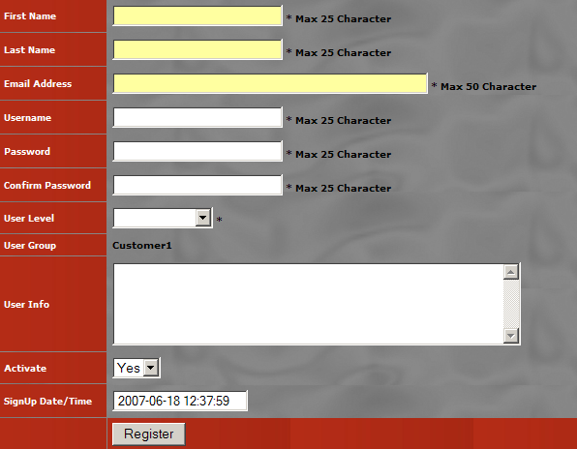
Figure 27: Register User page

- Enter the following fields (all fields with * are mandatory):

First Name:
Set the first name of the new user.

Last Name:
Set the last name of the new user.

Email Address:
Set the email address of the new user. The login information will be mailed to this email address.

Username:
Set the login name of the new user for TXMR.

Password:
Set the initial password for the new user to login to TXMR.

Confirm Password:
Set the same as initial password. This is required to check the consistency against the first entered password.

User Level:
Select whether the new user belongs to Group Admin or Group User. This is to grant the user rights for the new user.

User Group:
This identifies the group your organization belongs to in TXMR.

User Info:
Set any additional description you may like for the new user.

Activate:
Select Yes or No to activate the new user at the point of registration. If the account status set to ‘No’, the account will not be granted access to login, even with correct user name and password.

Sign Up Date/Time:
This identifies the date/time of which the registration page was displayed. This field is not editable.

- To abort the registration, click Back to User List button.

- To reset the entries, click Reset button.

- To confirm the entries, click Register button. After a few moments, the status of registering the new user will be shown beside the Register button, e.g.  for successful status.

Editing an user account

You may edit the information of a particular user account.

- On the User Management page, click at the end of a user record. The User Edit will be displayed as shown in the following figure.

- You may make changes to the First Name, Last Name, Email Address, User Level, User Info, and Activate fields.

TIP: Changing the Activate field to ‘No’ will freeze the user account. Upon saving the change, the user will not be able to login to TXMR even with correct login credentials. Similarly, to allow the user to login again, change the Activate field back to ‘Yes’.

- Upon making the necessary changes, select UPDATE option () beside the button.

- To confirm the changes, click the Execute button. All changes will be persisted after the button is clicked. The status of the changes will be displayed below the button.

- To just reset the password of the user instead of changing the details, click on the Reset Password button.

A new password will be randomly generated and mailed to the email address of the user.

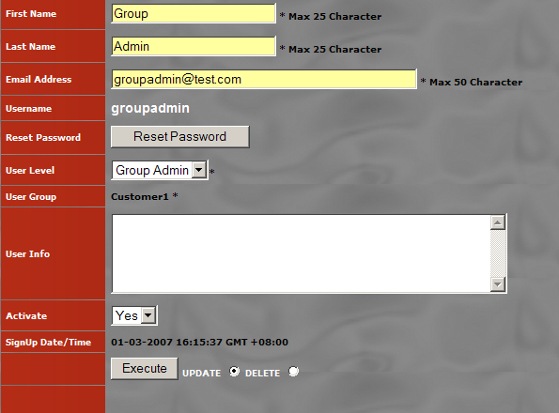
Figure 28: User Edit Page

Deleting a user account

You may delete an existing user account from the application database totally if the account is no longer required.

- On the User Management page, click at the end of a user record. The User Edit page will be displayed as shown in Error: Reference source not found.

- Select DELETE option beside the Execute button.

- To confirm the deletion, click the Execute button.

The user account will be removed from the database. The user details will be cleared from the page, and the status of the delete will be displayed below the Execute button.

Report Generation

Report Generation has the following functionalities:

- Manage schedules for report generation
- Generate report for online viewing or email
- Manage generated reports

Currently, the following report type(s) are available for generation:

- Transaction Status Report

To access the Report Generation feature,

- Go to Main Page by clicking on the Main Page link at the top right-hand corner of the TXMR UI.

- Click at the top left-hand corner of the screen. The Report Generation page is displayed, defaulting to the List Of Schedule page.

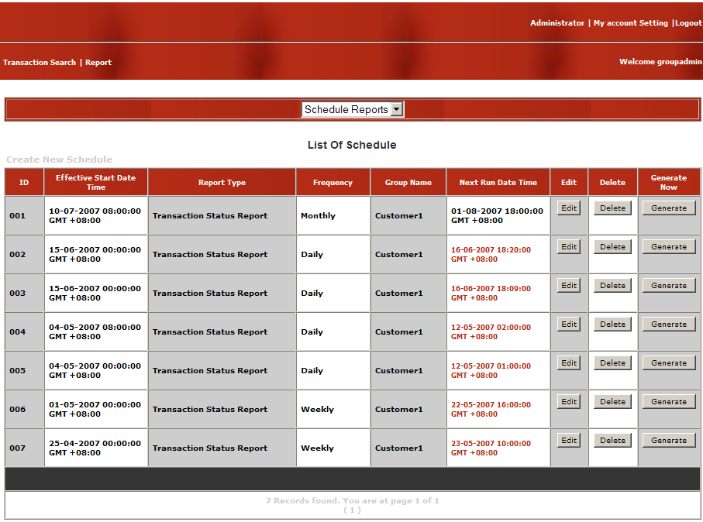
Figure 29: List Of Schedule Page

The following options are available on the Report Generation page:

- Schedule Reports
- Run Reports Now
- List of Report

Scheduling Report Generations

The Schedule Reports option allows user to schedule report generations in a regular basis. This removes the hassle of having to manually generate the same report regularly, such as a daily Transaction Status Report.

Upon selecting the Schedule Reports option of Report Generation, the List Of Schedule page is displayed. This page presents a list of schedules already created by the Group Admins of your group.

Each row in the list identifies a schedule. The column header shows the following fields:

ID:
This identifies each row by a running numbers.

Effective Start Date Time:
This indicates the date/time that the schedule starts to take effect. Before that time, the schedule would not run at the scheduled frequency.

Report Type:
This indicates the type of report to be generated.

Frequency:
This indicates whether the report will be generated on a “Daily”, “Weekly” or “Monthly” basis.

Customer Name:
This indicates your Group for which the report will be generated for.

Next Run Date Time:
This indicates the date/time of the next generation of the report.

Edit:
This button allows editing of the schedule.

Delete:
This button allows delete of the schedule.

Generate Now:
This button allows immediate generation of the report for viewing.

NOTE:

If the schedule record is highlighted in red, this means that some internal errors have caused the schedule to stop running. You are advised to contact your TXMR Web Administrator to further investigate on this issue. In the mean time, you may click on the Generate button to generate the report directly.

Creating a new Schedule

- Click on the link at the top of the List Of Schedule table. This displays the Add Schedule Report page.

- Enter the following fields:

Report Type:
Select the type of report to generate.

Frequency:
Select how frequent you want the report to be generated – “Daily”, “Weekly” or “Monthly”.

Report Effective Start Date:
Set the date that you want the schedule to start taking effect. The default value shown is the current date that the page is displayed. To change the value, clicking the icon to bring up the date picker, and select the desirable date.

Report Run Time:
Set the time that you want the schedule to generate the report. The default value shown is the current time that the page is displayed. To change the value, select the desirable Hour and Minute from their respective combo lists.

Report Format:
Select the format that you want the report to be in. Available formats are: Pdf, Html, Csv, Excel, Xml, Rich Text Format, and Plain Text.

Email Recipient(s):
Set the email addresses of the recipients that you want the generated reports to be sent to. Multiple email addresses must be separated with a semi-colon (;). If an invalid email address has been entered, you will be prompted to check the email address(es) entered upon submitting the entries.
- To clear the entries, click the Reset button. This resets the fields back to their default values.

- To confirm the entries, click the Submit button.

The status of the submission will be displayed on the right of the Submit button. If the submission is successful, you will see the “Schedule Created Successfully” message; otherwise, you will see the “Schedule NOT Successfully Created” message.

If the schedule has been created successfully, when you return to the List Of Schedule page, you will see the new Schedule added to the list, and the Next Run Date Time of the schedule being computed for your reference.

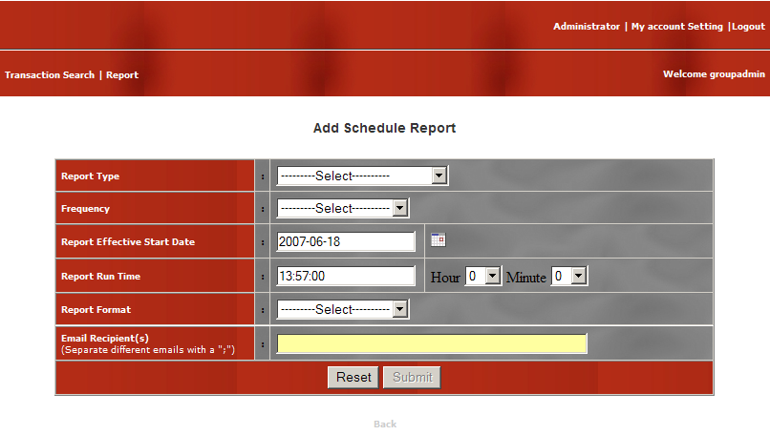
Figure 30: Add Schedule Report Page

Example 1 – Creating a Daily Transaction Status Report

Given the following scenario:

You wish to schedule a Transaction Status Report to be generated daily at 3pm with effective from today onwards.

Hence, you would create a schedule as follows:
Frequency: [Daily]
Report Effective Start Date: [current date] e.g. 2007-2-15
Report Run Time: [15:00:00]

Upon successful creation of the schedule, the first report will be generated on the next day (e.g. 2007-2-16) at 3pm, reporting transactions that ended on the previous day (e.g. 2007-2-15). On the following day after next (e.g. 2007-2-17), the report will be generated at 3pm again reporting transactions that ended on the previous day (e.g. 2007-2-16), and so on and so forth, until the schedule is deleted from the List Of Schedule page.

The table below summarizes the generation date/times for the above scenario:

On day | Generate at | Reported Transactions ended from
2007-2-15 | [no generation]
2007-2-16 | 15:00:00 | 2007-2-15 00:00:00 to 2007-2-15 23:59:59
2007-2-17 | 15:00:00 | 2007-2-16 00:00:00 to 2007-2-16 23:59:59
2007-2-18 | 15:00:00 | 2007-2-17 00:00:00 to 2007-2-17 23:59:59

Example 2 – Creating a Weekly Transaction Status Report

Given the following scenario:

You wish to schedule a Transaction Status Report to be generated weekly at 3pm with effective from today onwards.

Hence, you would create a schedule as follows:
Frequency: [Weekly]
Report Effective Start Date: [current date] e.g. 2007-2-15, Thursday
Report Run Time: [15:00:00]

Upon successful creation of the schedule, the first report will be generated a week later (e.g. 2007-2-22, Thursday) at 3pm, reporting transactions that ended on the previous week (e.g. 2007-2-15 to 2007-2-21). On the following week after next (e.g. 2007-3-1, Thursday), the report will be generated at 3pm again reporting transactions that ended on the previous week (e.g. 2007-2-22 to 2007-2-28), and so on and so forth, until the schedule is deleted from the List Of Schedule page.

The table below summarizes the generation date/times for the above scenario:

On day | Generate at | Reported Transactions ended from
2007-2-15 | [no generation]
2007-2-22 | 15:00:00 | 2007-2-15 00:00:00 to 2007-2-21 23:59:59
2007-3-01 | 15:00:00 | 2007-2-22 00:00:00 to 2007-2-28 23:59:59
2007-3-08 | 15:00:00 | 2007-3-01 00:00:00 to 2007-3-07 23:59:59

Example 3 – Creating a Monthly Transaction Status Report

Given the following scenario:

You wish to schedule a Transaction Status Report to be generated monthly at 3pm with effective from today onwards.

Hence, you would create a schedule as follows:
Frequency: [Monthly]
Report Effective Start Date: [current date] e.g. 2007-2-15, Thursday
Report Run Time: [15:00:00]

Upon successful creation of the schedule, the first report will be generated on the 1st of next month (e.g. 2007-3-1, Thursday) at 3pm, reporting transactions that ended on the previous month (e.g. 2007-2-1 to 2007-2-28). On the 1st of the following month after next (e.g. 2007-4-1, Sunday), the report will be generated at 3pm again reporting transactions that ended on the previous month (e.g. 2007-3-1 to 2007-3-31), and so on and so forth, until the schedule is deleted from the List Of Schedule page.

The table below summarizes the generation date/times for the above scenario:

On day | Generate at | Reported Transactions ended from
2007-2-15 | [no generation]
2007-3-01 | 15:00:00 | 2007-2-01 00:00:00 to 2007-2-28 23:59:59
2007-4-01 | 15:00:00 | 2007-3-01 00:00:00 to 2007-3-31 23:59:59
2007-5-01 | 15:00:00 | 2007-4-01 00:00:00 to 2007-4-30 23:59:59

Changing an existing Schedule

- On the List Of Schedule page, click on the Edit button of the schedule you wish to modify. This displays the Update Schedule Report page.

- Make the desired changes to the following fields:

Report Format:
Upon making this change, the next generated report will be in the new selected format.

Email Recipient(s):
Upon making this change, the next generated report will be emailed to the new list of addresses.

Note: If there is a need to change other fields, e.g. the Frequency, then you should delete this schedule and create a new schedule based on the new Frequency.

- To confirm the changes, click the Update button.

The status of the update will be displayed beside the Update button. If the update is successful, you will see the “Schedule Updated Successfully” message; otherwise, you will see the “Schedule NOT updated” message.

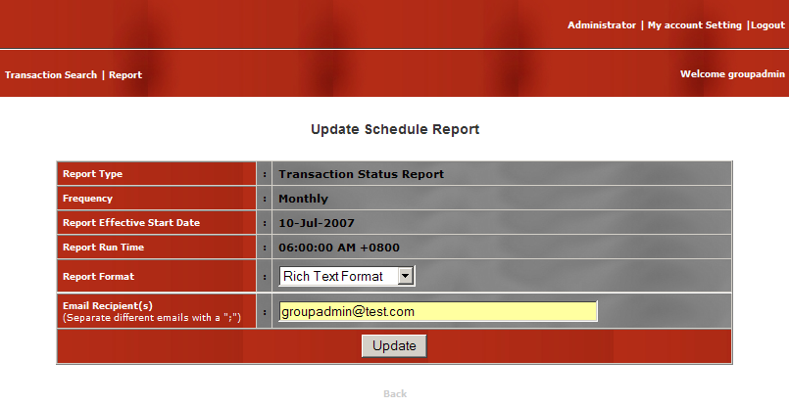
Figure 31: Update Schedule Report Page

Deleting an existing Schedule

- On the List Of Schedule page, click on the Delete button of the schedule you wish to delete. You will be prompted to confirm the deletion.

- To confirm the deletion, click OK.

- To cancel the deletion, click Cancel.

Generating a report from Schedule for immediate viewing

- On the List Of Schedule page, click on the Generate button of the schedule you wish to generate report.

- After a few moments, you will be presented with the report based on the following:

  - Report Format: [as per the schedule]
  - Reported Transactions ended between: [same range as per the Next Run Date/Time of the report]

For example, if the next run date/time of the report is 2007-2-16 15:00:00, reporting transactions ended between 2007-2-15 00:00:00 and 2007-2-15 23:59:59, then if you generate the report for immediate viewing on 2007-2-15 18:00:00, you will still be presented with transactions ended in the same date range (i.e. between 2007-2-15 00:00:00 and 2007-2-15 23:59:59). Of course, the number of transactions that get reported depends on the existing transactions at the time of generation.

NOTE:

Even if the Report Effective Start Date has not been reached, you could still perform the generation.

Generating ad-hoc reports

On certain occasions, you may wish to generate reports for one-time status diagnosis. The Run Reports Now option allows you to do so, without the need to create a schedule. You may choose to view the report online or receive the report via email.

- Select the Run Reports Now option of Report Generation. This displays the Run Report Now page.

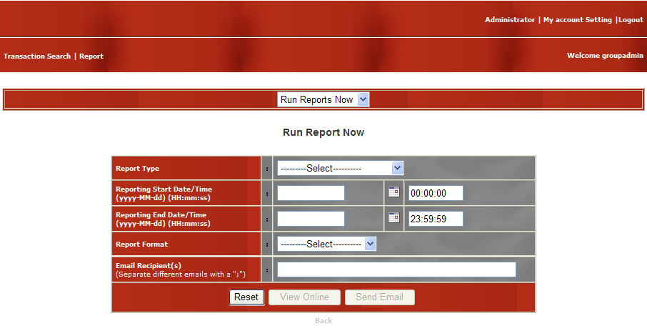
Figure 32: Run Reports Now Page

- Enter the following fields:

Report Type:
Select the type of report you wish to generate.

Reporting Start Date/Time:
Set the start date of the reported data range using the date picker. The default time will be 00:00:00. Both date and time field is allowed manually entered.

Reporting End Date/Time:
Set the end date of the reported data range using the date picker. The default time will be 23:59:59. Both date and time field is allowed manually entered.

Report Format:
Select the format that you wish the report to be in. Available formats are: Pdf, Html, Csv, Excel, Xml, Rich Text Format, and Plain Text.

Email Recipient(s):
Set the email address(es) of the recipients if you wish the report to be emailed. Multiple email addresses must be separated with a semi-colon (;).
This field is optional if you only want to view the report online.

- To reset the entries, click the Reset button.

- To view the report instantly, click the View Online button. Wait a few moments while the report is being generated.

If the report is generated successfully, you will be prompted to download the report for viewing. If the report could not be generated due to internal application errors, an error page will be displayed. You may like to try again later or contact your TXMR Web Admin.

- To receive the report via email, click the Send Email button. Wait a few moments while the report is being generated and emailed.

If the report is generated and emailed successfully, you will see the “Report Sent” message beside the Send Email button. Otherwise, you will see the “Report NOT sent” message.

NOTE:

You would be prompted for any invalid email address entry detected when you click the Send Email button.

Managing Generated Reports

For every report that has been generated, TXMR keeps a history of them. This allows you to view the report again at a later date. As the report history would be growing as time goes by, it is desired to be able to remove old reports that would not be required anymore. Thus, the List Of Report option of Report Generation provides the above functionalities.

Upon selecting the List of Report option, you will be presented with the List Of Report page. This page shows a list of reports that have been generated in the past.

Each row in the list identifies a specific generated report. The columns of each row show the following information:

ID:
This identifies each row by a running number.

Report Type:
This indicates the type of the report which was generated.

Frequency:
This indicates the frequency that the same report would be generated. For reports generated by schedule, this is the Frequency of the Schedule. For reports generated via Run Reports Now option, this would be shown as “Once”.

Customer List:
This indicates your Group.

Start Date Time:
This indicates the start date/time of the reporting range of the generated report.

End Date Time:
This indicates the end date/time of the reporting range of the generated report.

Created By:
This indicates the user who generated the report. For reports generated by schedules, this will be the Group Admin who created the schedule. For reports generated via Run Reports Now, this will be the Group Admin who created the report.

Group Name:
This indicates your Group.

Delete:
This button deletes the specific generated report.

View:
This button allows viewing of the generated report.

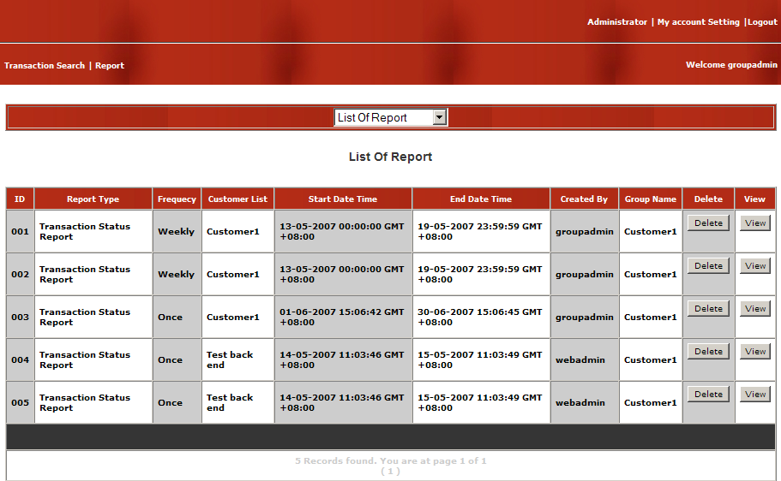
Figure 33: List of Report Page

Viewing a Report generated in the past

- Select the List Of Report option of Report Generation. This displays the List Of Report page.

- Click the View button for the report you wish to view.

- After a few short moments, you will be prompted to download the report for viewing.

Purging a Report generated in the past

- Select the List Of Report option of Report Generation. This displays the List Of Report page.

- Click the Delete button for the report you wish to purge. You will be prompted to confirm the deletion.

- Click OK to purge the report permanently; otherwise, click Cancel.

Supported Report Types

This section describes the different types of reports that are currently available for generation on TXMR.

Transaction Status Report

The Transaction Status Report provides a summary of the completed processes, whether successful or not, between you organization and your trading partners. For unsuccessful processes, it provides the detail reason on why the process has failed.

The following sub-sections describe the different parts of the report.

Report Header

The Transaction Status Report header shows the following information:

Transaction Status Report:
This is the title of the report.

Reporting Date from … to …:
This is the date/time range whereby the reported transactions are ended within.

Customer:
This is the Group name in TXMR for your organization.

DUNS:
This is the D-U-N-S number of your organization.

Process Summary

The Process Summary shows the following information:

TP Name:
This is the Partner name identifying your trading partner.

PIP Name:
This is the name of the RosettaNet Process that has been transacted with that trading partner.

Successful:
This is the count of total number of instances of that type of process successfully completed within the reporting date/tome range.

Unsuccessful:
This is the count of total number of instances of that type of process failed within the reporting date/time range.

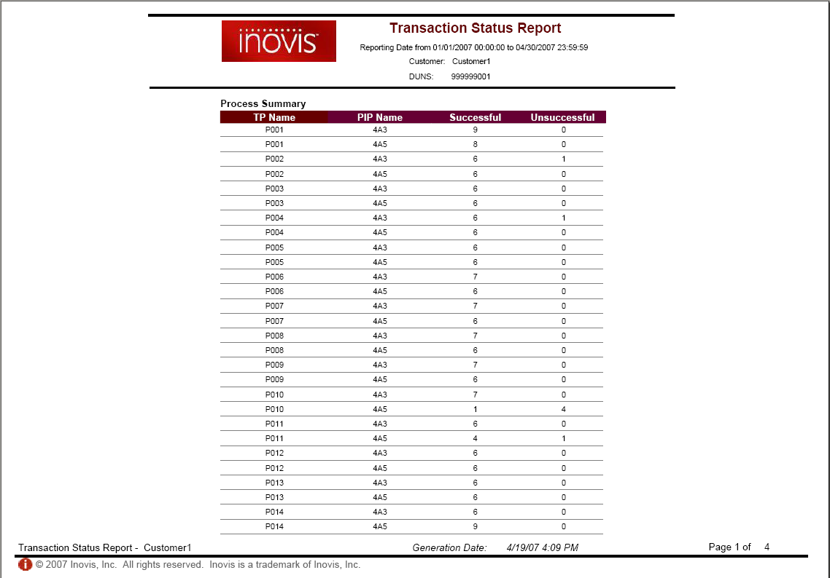
Figure 34: Sample Transaction Status Report – Process Summary

Failed Processes

The Failed Processes section provides the following information for each failed process instance:

ID:
This is the Process ID of the failed process instance.

Failure Reason:
This indicates two pieces of information: the type of error that occurred and the detail reason of the error (located underneath the error type).

TP DUNS:
This is the D-U-N-S number of the trading partner.

TP Name:
This is the Partner name identifying your trading partner.

Start Date/Time:
This is the start date/time of the process instance.

End Date/Time:
This is the end date/time of the process instance.

TP Doc. ID:
This is the proprietary document identifier in the document sent from the trading partner.

Cust Doc. ID:
This is the proprietary document identifier in the document sent from your organization.

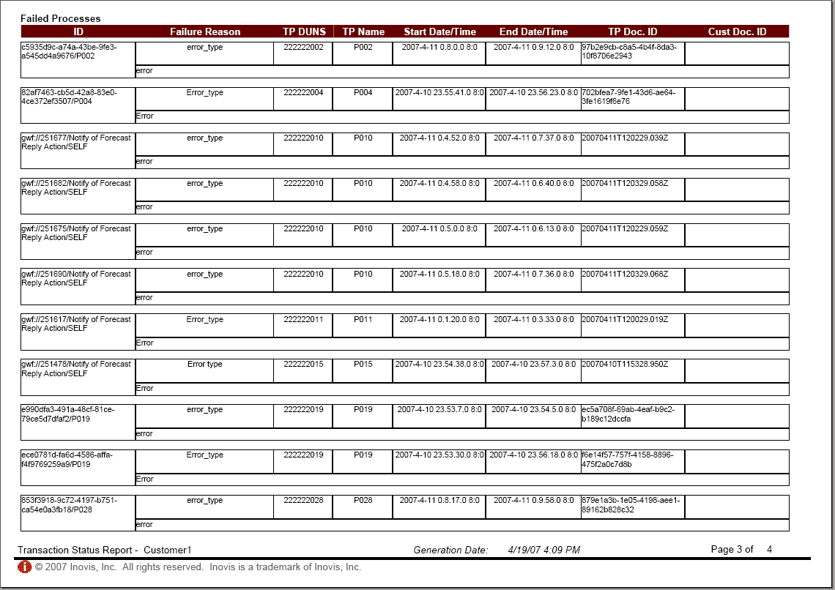
Figure 35: Sample Transaction Status Report – Failed Processes

Report Footer

The report footer shows the following information:

Transaction Status Report - XXX:
This indicates the title of the report, as well as the Group name identifying your organization.

Generation Date:
This is the date/time of generation of the report.

Page X of Y:
This indicates the paging of the report. X is the current page number, while Y is the total number of pages in the report.

COPYRIGHT
© Copyright 2008 GridNode Pte Ltd. All rights reserved.
No part of this description of functions may be reproduced or transmitted in any form or for any purpose without the express written permission of GridNode Pte Ltd. The information contained herein may be changed without prior notice.
Names of all products herein are used for identification purposes only and are trademarks and/or registered trademarks of their respective owners.
All rights reserved.

Your TXMR Admin will provide you with the URL
All the time in TXMR will be converted based on the selected time zone
For the list of available events, please refer to section 5.1
Do not mistake this with duplicate Inbound documents whose Event History only contains the same three events.
Except for reports generated in List Of Schedule using the Generate button.

