GridTalk Loopback Tester

Proposed Solution

[Version 1.0]

Document History
Date | Ver. | Changes | Author
14-Feb-2007 | 1.0 | Created | Alain Ah Ming

Table of Contents
1. Introduction 1
1.1. Overview 1
2. Proposed Solution 2
2.1. Assumptions 3
2.2. Start/Stop Loopback Tester Daemon 3
2.3. Test GridTalk-IB (Inbound) Document 3
2.4. Test GridTalk-OB (Outbound) Document 3
2.5. Configurable Parameters 4

Introduction

Overview
Inovis requires a test utility that will periodically verify that GridTalk is processing and dispatching documents smoothly.

The utility must also be able to link up with Inovis monitoring system (SiteScope) in order to report successful as well as failed test runs.

The proposed solution for this loopback tester is described in this document.

Proposed Solution

The following diagram gives a summarized view of the functionalities to be available within the loopback tester.

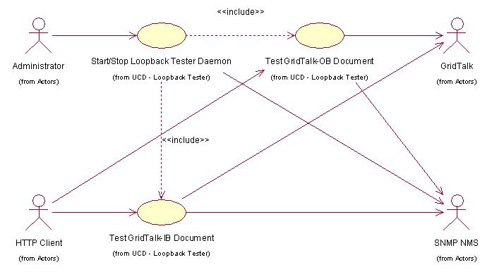
Figure 2.1 Use Case Diagram - GridTalk Loopback Tester

Assumptions
This solution is making the following assumptions:
- GridTalk will contain the necessary configurations to check its various components while the inbound/outbound test documents flow within its boundaries – entry point and exit point.
Note | GridTalk configurations will include setting up a test Partner, a test Customer (Back-end) and a test PIP.  The details of the internal tests to be performed will be described in a later version of this document.

- GridTalk logging mechanism will provide the means to perform further inspections of each test run for both successful and failed ones.

- SiteScope is able to act as the HTTP Client in Figure 2.1 above in order to trigger a test run.

Start/Stop Loopback Tester Daemon
This use case starts when the Administrator launches the loopback test daemon via a command line.
The program will test the operational state of GridTalk-inbound and GridTalk-outbound documents.
The outcome of such tests will be output into a log file (or, optionally, as SNMP trap).

The loopback tests will log the following information:
1. A test identifier to associate and track events to test instance.
2. Outcome of each test.
3. A heartbeat signal at a pre-configured interval.

This use case also allows the administrator to shut down the daemon.

Test GridTalk-IB (Inbound) Document
This use case starts when the daemon or a HTTP client requests for a GridTalk-inbound test to run.

The Loopback Test will send a test document to GridTalk cluster via HTTP.
GridTalk will be pre-configured to process this document as follows:
1. Reply with an ACK.
The loopback test program will listen for, and expect, this ACK.
2. Push the document to the pre-configured back-end.
The loopback test program will simulate the pre-configured back-end.
Failure to receive any of the ACK or the back-end document from GridTalk within a pre-configured time-out period is considered a failed test.

Each instance of the loopback test will assign a unique identifier to the test document.

Test GridTalk-OB (Outbound) Document
This use case starts when the daemon or a HTTP client requests for a GridTalk-outbound test to run.

The Loopback Test will simulate the back-end by importing a test document into GridTalk cluster via HTTP.
GridTalk will be pre-configured to process this document as follows:
1. Send the document out to a pre-configured test partner.
2. The loopback test program will simulate the test partner and listen for, and expect, this test document from GridTalk. Failure to receive any such document within a pre-configured time-out period is considered a failed test.
3. Send an ACK back to GridTalk.

Each instance of the loopback test will assign a unique identifier to the test document.

Configurable Parameters
This section mentions about some of the noteworthy types of configurable parameters of the Loopback Tester.
Note | A reboot of the daemon might be required in order to allow any changed parameter to take effect.

Parameter Description | Remarks
The interval between each test run | A special value can be used to disable the timer-based test.  This will allow the configured test to be triggered strictly on an on-demand basis e.g. from SiteScope.
GridTalk settings | These include IP/URL and any GridTalk-specific parameters that need to be configurable in order to provide some degree of flexibility.
Test time-out values | A special value can be used to disable the time-out.  This will allow the configured test to wait indefinitely.

- END -

