GridTalk Loopback Tester

Proposed Solution

[Version 1.1]

Document History
Date | Ver. | Changes | Author
14-Feb-2007 | 1.0 | Created | Alain Ah Ming
11-Mar-2007 | 1.1 | [Figure 2.1] Updated use case diagram to reflect  - Double-action pip (IB triggers OB)  - Timer-based tests  - Generalized receiver of test status  [Section 2.1] Removed assumption that SiteScope will trigger the tests.  [Section 2.4] Updated description of start of use-case in order to reflect the double-action via triggering by GridTalk-Inbound test  [Section 2.5] Added the detailed configuration parameters  [Section 3.1] Added Test Result Codes Description and State Diagram | Alain Ah Ming

Table of Contents
1. Introduction 1
1.1. Overview 1
2. Proposed Solution 1
2.1. Assumptions 1
2.2. Start/Stop Loopback Tester Daemon 1
2.3. Test GridTalk-IB (Inbound) Document 1
2.4. Test GridTalk-OB (Outbound) Document 1
2.5. Configurable Parameters 1
2.5.1. Main Configuration 1
2.5.2. Partner Simulator Configuration 1
2.5.3. Backend Configuration 1
3. Appendices I
3.1. Appendix I – Loopback Test Result Codes I

Introduction

Overview
Inovis requires a test utility that will periodically verify that GridTalk is processing and dispatching documents smoothly.

The utility must also be able to link up with Inovis monitoring system (SiteScope) in order to report successful as well as failed test runs.

The proposed solution for this loopback tester is described in this document.

Proposed Solution

The following diagram gives a summarized view of the functionalities to be available within the loopback tester.

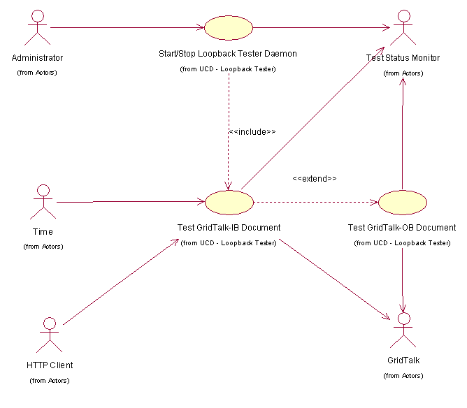
Figure 2.1 Use Case Diagram - GridTalk Loopback Tester

Assumptions
This solution is making the following assumptions:
- GridTalk will contain the necessary configurations to check its various components while the inbound/outbound test documents flow within its boundaries – entry point and exit point.
Note | GridTalk configurations will include setting up a test Partner, a test Customer (Back-end) and a test PIP.  The details of the internal tests to be performed will be described in a later version of this document.

- GridTalk logging mechanism and the transaction monitor module will provide the means to perform further inspections of each test run for both successful and failed ones.

Start/Stop Loopback Tester Daemon
This use case starts when the Administrator launches the loopback test daemon via a command line or as a Windows service.
The program will test the operational state of GridTalk-inbound and GridTalk-outbound documents.
The outcome of such tests will be output into a log file (or, optionally, as SNMP trap).

The loopback tests will log the following information:
1. A test identifier to associate and track events to test instance.
2. Outcome of each test.
3. A heartbeat signal at a pre-configured interval.

This use case will also allow the administrator to shut down the daemon.

Test GridTalk-IB (Inbound) Document
This use case starts when the daemon or a HTTP client requests for a GridTalk-inbound test to run.

The Loopback Test will send a test document to GridTalk cluster via HTTP.
GridTalk will be pre-configured to process this document as follows:
1. Reply with an ACK.
The loopback test program will listen for, and expect, this ACK.
2. Push the document to the pre-configured back-end and trigger the GridTalk-OB test [Section 2.4 Test GridTalk-OB (Outbound) Document below].
The loopback test program will simulate the pre-configured back-end.
Failure to receive any of the ACK or the back-end document from GridTalk within a pre-configured time-out period is considered a failed test.

Each instance of the loopback test will assign a unique identifier to the test document.

Test GridTalk-OB (Outbound) Document
This use case starts when the GridTalk-Inbound Test receives a backend document and triggers the GridTalk-Outbound test to run.

The Loopback Test will simulate the back-end by importing a test document into GridTalk cluster via HTTP.
GridTalk will be pre-configured to process this document as follows:
1. Send the document out to a pre-configured test partner.
2. The loopback test program will simulate the test partner and listen for, and expect, this test document from GridTalk. Failure to receive any such document within a pre-configured time-out period is considered a failed test.
3. Send an ACK back to GridTalk.

Each instance of the loopback test will assign the test Id as the test document identifier. The test Id will also be the same as the triggering GridTalk-Inbound test.

Configurable Parameters
This section mentions about the configurable parameters of the Loopback Tester.

Note | A reboot of the daemon might be required in order to allow any changed parameter to take effect.

Main Configuration
The main configuration file is a properties file located at ‘<GLBT_HOME>/glbt/conf/main.conf’.
The following table lists the configurable properties that are available:
Parameter | Description | Remarks
heartbeat.interval | System heartbeat interval in seconds.  E.g. 600 | Set to zero to disable heartbeat
test.interval | Test interval in seconds | Set to zero to disable timer-based tests
inbound.test.timeout | Time-out for GT-Inbound test in seconds | Set to zero to disable GridTalk-Inbound time-out
outbound.test.timeout | Time-out for GridTalk-Outbound test in seconds | Set to zero to disable GridTalk-Outbound time-out

Partner Simulator Configuration
The test partner configuration file is a properties file located at ‘<GLBT_HOME>/glbt/conf/partner.conf’.
The following table lists the configurable properties that are available:
Parameter | Description | Remarks
duns | DUNS number of test partner  E.g. 888888888 | This must match the configured test partner DUNS in GridTalk
partner.id | Partner Id of the Test Partner  E.g. loopback | This must match the configured test partner ID in GridTalk
gridtalk.rn.url | GridTalk RN URL to send document to.  E.g. http://rcagtapps01:8080/gridtalk/b2bi/rosettanet
pip.code | RN PIP to use for testing  E..g. 0C2 | Specifying other PIP codes will require some editing of template/parameter files.

Backend Configuration
The backend configuration is a properties file located at ‘<GLBT_HOME>/glbt/conf/backend.conf’.
The following table lists the configurable properties that are available:
Parameter | Description | Remarks
duns | DUNS number of test customer  E.g. 888888888 | This must match the configured test partner DUNS in GridTalk
be.id | Business Entity Id of the test customer  E.g. loopback | This must match the configured test customer’s Business Entity ID in GridTalk
httpbc.url | GridTalk HTTP backend connector URL to send backend document to.  E.g. http://rcagtapps01:8080/gridtalk/van/httpbc/receive
doc.type | Document type to use for testing  E.g. 0C2 | Specifying other document types will require some editing of template/parameter files.

Appendices

Appendix I – Loopback Test Result Codes
The following table contains the result code that will be logged by the loopback tester during test runs.
The Test Result Code is the exact string value that will be logged:
Test Result Code | Description | Remarks
[ INFO][GN.GLBT.TEST][IB-Init] | Inbound Test at initialization state. | FAILURE. Inbound test failed to start.
[ INFO][GN.GLBT.TEST][IB-SentRN] | Request PIP successfully sent to and received by GridTalk. | OK. Inbound test has started.
[ INFO][GN.GLBT.TEST][IB-ReceivedAck] | RN ACK received from GridTalk. | OK. Inbound test is ongoing.  If backend doc is received before ACK, this will not be available.
[ INFO][GN.GLBT.TEST][IB-ReceivedBackend] | Backend document received from GridTalk. | OK. Inbound test is ongoing.  If ACK is received before backend doc, this will not be available.
[ INFO][GN.GLBT.TEST][IB-ReceivedAckAndBackEnd] | Both RN ACK and backend document received from GridTalk. | OK. Inbound test has completed.
[ INFO][GN.GLBT.TEST][IB-TimedOut] | Inbound test timed out before completion. | FAILURE. Inbound test has timed out.
[ INFO][GN.GLBT.TEST][OB-Init] | Outbound test at initialization state. | FAILURE. Outbound test failed to start.
[ INFO][GN.GLBT.TEST][OB-SentBackend] | Backend document sent to and received by GridTalk. | OK. Outbound test has started.
[ INFO][GN.GLBT.TEST][OB-ReceivedRN] | Confirmation PIP received from GridTalk. | OK. Outbound test is ongoing.
[ INFO][GN.GLBT.TEST][OB-SentAck] | RN ACK sent to and received by GridTalk. | OK. Outbound test has completed.
[ INFO][GN.GLBT.TEST][OB-TimedOut] | Outbound test timed out before completion. | FAILURE. Outbound test has timed out.

The following diagram is the state chart diagram for a GridTalk-Inbound test in the loopback tester.
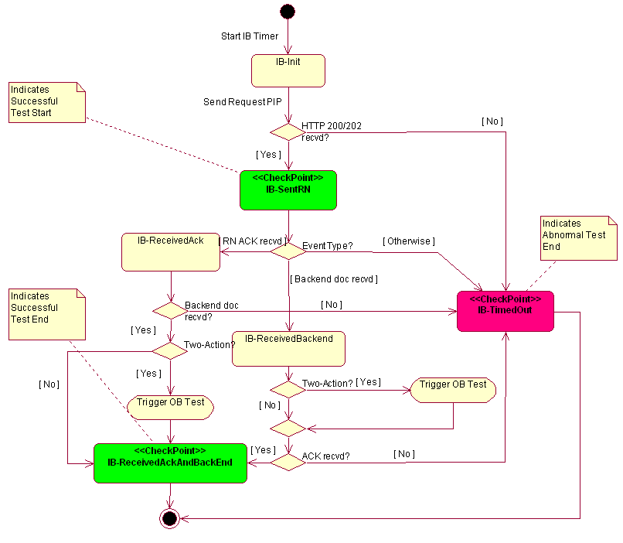
Figure 3.2 GridTalk-Inbound Test State Diagram

From the diagram above, IB-SentRN and IB-ReceivedAckAndBackEnd (both green) are the positive start and end check-points respectively. IB-TimedOut (red) is the negative end check-point.
The following diagram is the state chart diagram for a GridTalk-Outbound test in the loopback tester.
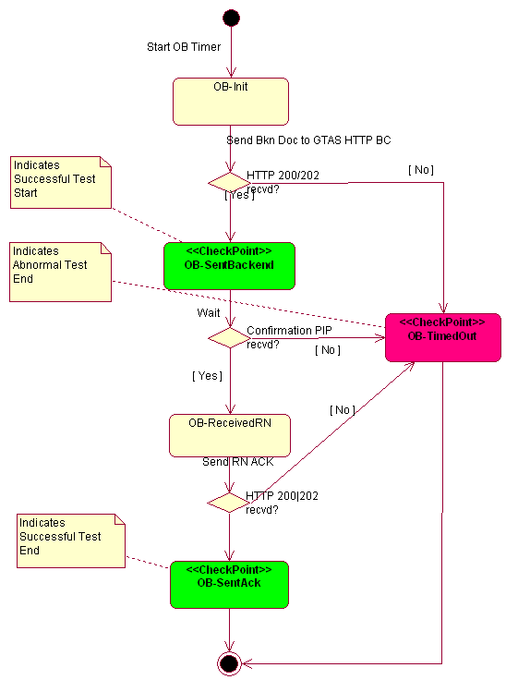
Figure 3.3 GridTalk-Outbound Test State Diagram
From the diagram above, OB-SentBackend and OB-SentAck (both green) are the positive start and end check-points respectively. OB-TimedOut (red) is the negative end check-point.

