
GRIDNODE PTE LTD

GRIDTALK ™ TXMR
Admin Guide

Release version 1.0

Copyright

© Copyright 2007 GRIDNODE PTE LTD. All rights reserved.

No part of this GRIDTALK™ TXMR administration and user guide may be reproduced or transmitted in any form or for any purpose without the express permission of GRIDNODE PTE LTD. The information contained herein may be changed without prior notice.

GRIDNODE PTE LTD further does not warrant the accuracy or completeness of the information, text, graphics, links, or other items contained within these materials. GRIDNODE PTE LTD shall not be liable for any special, indirect, incidental, or consequential damages, including without limitation, lost revenues or lost profits, which may result from the use of these materials. The information in this documentation is subject to change without notice and does not represent a commitment on the part of GRIDNODE PTE LTD for the future.

Some software products marketed by GRIDNODE PTE LTD and its distributors contain proprietary software components of other software vendors.

Names of all products herein are used for identification purposes only and are trademarks and/or registered trademarks of their respective owners.

GRIDTALK™ and GridNode™ are registered or unregistered trademarks of GRIDNODE PTE LTD.

All rights reserved.

GRIDTALK™
Transaction Monitoring & Reporting Admin Guide

Contents

Chapter Page

1 About the Guide 3
1.1 Terminology 3
2 Getting Started with TXMR 5
2.1 Accessing TXMR 5
2.2 Overview of TXMR User Interface 6
3 Web Admin Tasks 8
3.1 Administer User Accounts 8
3.2 Setting for Idle Time 9
3.2.1 Changing of Idle Time 9
3.3 Overall Web Configuration 10
3.3.1 Changing of Web Configuration 10
3.4 Administer All Existing Groups 12
3.4.1 Creating New Group 13
3.4.2 Deleting Existing Group 13
3.5 Searching of Log Files 14
3.6 Managing of Archive Transaction 16
3.6.1 Creating of New Archive Schedule 18
3.6.2 Editing of Existing Archive Schedule 19
3.6.3 Archiving of Transaction 20
3.7 Managing of Restore Transaction 21
3.7.1 Downloading of Archive Transaction 22
3.7.2 Restoring of Archive Transaction 23
4 Report Generation 24
4.1 Housekeeping of Generated Reports 25
4.2 Generating of Certificate Status Report 27
4.2.1 Certificate Status Report 27

About the Guide

This Transaction Monitoring Admin Guide is especially designed for the web administrator. The guide contains the step-by-step instructions and visual screens to enable you to perform the simple tasks while you are getting acquainted with the features in the GridTalk 4.1 TXMR application. This admin guide is applicable for the Web Admin only, whereas Group Admin and Group User should refer to the user guide.

As a Web Admin, not only can you perform transaction monitoring and some simple administrative tasks as can be a Group User or a Group Admin respectively, you can also perform more intensive administrative tasks as well as generation of higher authority report. Therefore, this admin guide covers mainly the features which are not found in the user guide, such as:

- Web Administration
Provide instructions on how to administer user accounts from all groups, to set idling time, to perform web configuration, to administer all existing groups, to track log files, and to manage archive transaction and restore transaction.

- Report Generation
Provide instructions on how to generate higher authority reports and scheduling of housekeep of generated reports.

Terminology

This document uses some terms or abbreviations extensively that you may not be familiar with. The following explains the terms and abbreviations used throughout the document.

Term/Abbreviation | What it stands for
Gateway | In this context, it refers to as a network application capable of handling RosettaNet business messages.
GridTalk | An application providing RosettaNet message processing capabilities.
HTTPBC | GridTalk HTTP Backend Connector module. It handles the deliveries of messages between GridTalk and the Customer HTTP backend systems.
RN | Common abbreviation used for RosettaNet.
RNIF | RosettaNet Implementation Framework. This provides the guidelines on the RosettaNet implementation.
RosettaNet | A messaging standard for exchanging business documents.
RosettaNet Gateway | In this context, it refers to module in GridTalk that fronts the communication with partner’s gateways.
PIP | Partner Interface Process. A model for fulfilling a business transaction between two partners in a given supply chain. In short, it defines the business process between two partners.
PIP instance | An instance of a business process.
Private Process | A business process internal to the organization. In this context, it means the processing required for handling messages from/to the customer’s backend systems.
Signal | A business signal message exchanged between two RosettaNet gateways to communicate certain events within the execution of a PIP instance, e.g. a Receipt Acknowledgement, or a General Exception.
Transaction | A business action message exchanged between two partners, e.g. Purchase Order Request
TXMR | An application providing Transaction Monitoring and Report Generation capabilities for the transactions exchanged between the customers and their trading partners using GridTalk.

Getting Started with TXMR

Accessing TXMR

- Launch a web browser and navigate to the login page by entering the TXMR URL. After a few moments, the following login screen will be showed.

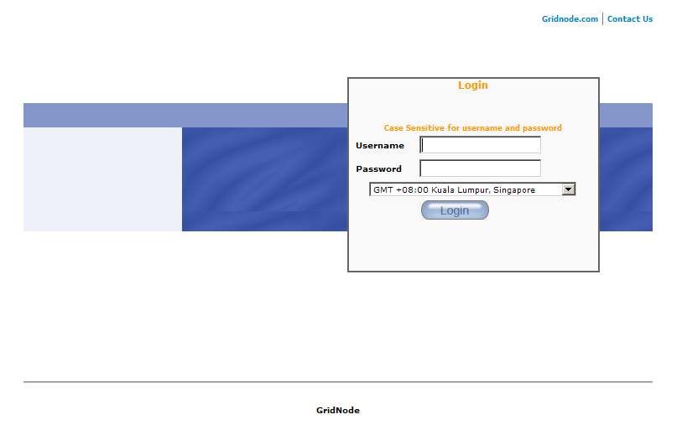
Figure1: TXMR Login Screen

- Enter the username.

- Enter the password.

- Select the time zone that matches your area.

- Click on the ‘Login’ button.

- After successfully login, the page ‘RosettaNet Transaction Search’ will be displayed.

TIP: If you lost your password, you can contact your own group administrator to reset your password.

Overview of TXMR User Interface

The user interface displayed for a Web Admin.

The following screen is applicable when you just login:
Links

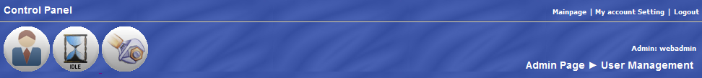

Links
Login Username

Page Name

Figure 1: Admin Page Navigation Bar

The following screen is applicable when you roll your mouse over the icon:

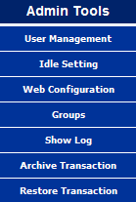
Links

Figure 2: Admin Menu

The following screen is applicable when you clicked on the link:
Links

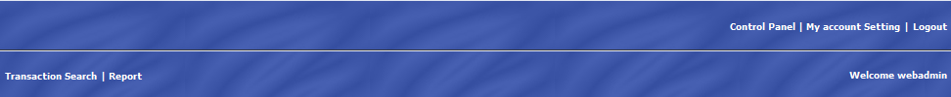

Links
Login Username
Figure 4: Main Page Navigation Bar

The table below summarizes the use of each link on the navigation bar:

Link | Comment
 | This link is applicable for Web Admin to access the main functionalities of the TXMR – Transaction Document & Event Tracking, and Report Generation.
 | This link is used to direct you to manage your own account in the TXMR.
 | This link is used to end the session and to direct you to the login page.
 | This link is used to direct you to the Admin page when you first login.
 | This link is used to direct you to the Transaction Search page.
 | This link is used to direct you to the Report Generation page.
 | This link is used to direct you to the User Management page.
 | This link is used to direct you to the Idle Setting page.
 | This link is used to direct you to the Web Configuration page.

The table below summarizes the use of each link on the admin menu:

Link | Comment
 | This link is used to direct you to the User Management page.
 | This link is used to direct you to the Idle Setting page.
 | This link is used to direct you to the Web Configuration page.
 | This link is used to direct you to the Groups page.
 | This link is used to direct you to the Show Log page.
 | This link is used to direct you to the Archive Transaction page.
 | This link is used to direct you to the Restore Transaction page.

Web Admin Tasks

To separate the task of a Group Admin and a Web Admin, you are able to identify an Admin Tool () at the left hand side of the screen when you first login. This Admin Tool involves more intensive administrative tasks which allow you to perform the following:

- Administer User Accounts
- Setting for Idle Time
- Overall Web Configuration
- Administer All Existing Groups
- Searching of Log Files
- Managing of Archive Transaction
- Managing of Restore Transaction

Administer User Accounts

This feature allows you to administer all user accounts in all groups.

The figure below shows the Administrator page after login to TXMR or when the link is clicked.

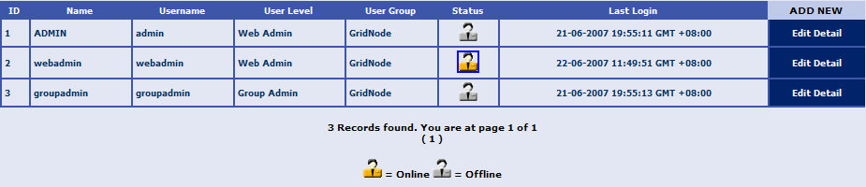
Figure 5: User Management Page

Setting for Idle Time

This feature allows you to set the maximum idle time for a session in TXMR. This will be made applicable to all TXMR users.

Changing of Idle Time

- Go to Web Idle Setting Page by clicking on the link or link at the Admin Tool icon or the Navigation Bar respectively.


Figure 6: Web Idle Setting Page

- Enter the following field:

Idle Time Before Expire:
Set the time that you want for the maximum idle time available for the TXMR session.
- To confirm the entry, click the Save button.

- The status of the submission will be displayed on the right of the Save button. If the submission is successful, you will see the “Set Idle Time to xxx” (the updated idle time). Otherwise, if the idle time entered was too small, you will see the “Minimum idle time is 20 second”.

NOTE:

3600 seconds = 1 hour
1800 seconds = 0.5 hour

Minimum idle time is 20 seconds.

TIPS:

As a security best practice in any web application, always set a reasonable idle time for the session. If the idle time before the whole session in TXMR expired is too short, you will not have enough time to perform your task. Hence, it will be a hazard to login again. If the idle time before the whole session in TXMR expired is too long, and so happen that you have forgotten to logout, someone might misused your TXMR account.

Overall Web Configuration

This feature allows you to make the following web configuration:

- Database Connection
- Email Setting
- Process HTTP URL
- Report HTTP URL
- Log House Keeping Duration
- Paging Limit on Every Page Displayed

Changing of Web Configuration

- Go to Web Configuration Page by clicking on the link or link at the Admin Tool icon or the Navigation Bar respectively.

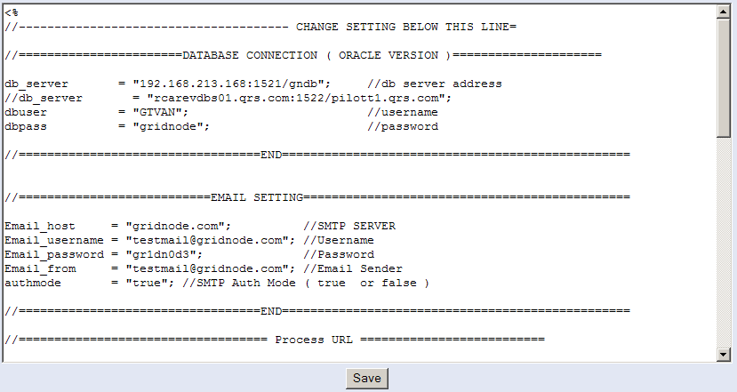
Figure 7: Web Configuration Page

- Make amendments to the web configuration in the text field. Amendments should be made inside the two double quotes (“”) followed by a semi-colon (;).
- To confirm the changes, click the Save button.

All changes will take effect immediately.

Web Configuration Details:

Database Connection involves the following variables information:
db_server → database server address/url
dbuser → username of database connection
dbpass → password of database connection

Email Setting involves the following variables information:
Email_host → SMTP server
Email_username → email username
Email_password → email password
Email_from → email sender
authmode → SMTP authentication mode ( true or false)

Process HTTP URL involves the following variables information:
cancel_url → HTTP URL when cancelling process transaction
reprocess_url → HTTP URL when reprocessing transaction
archive_servlet2 → HTTP URL when archiving transaction by schedule
archive_servlet → HTTP URL when archiving transaction normally

Report HTTP URL involves the following variables information:
create_report → HTTP URL when creating report
create_schedule → HTTP URL when creating report for scheduling
update_schedule → HTTP URL when updating scheduled report
delete_schedule → HTTP URL when deleting a scheduled report
generate_report → HTTP URL when generating a report online
view_report → HTTP URL when viewing a report online
housekeep_report → HTTP URL when scheduling time for housekeeping of
report

Log House Keeping involves the following variable information:
del_log → age limit (in days) of log before it will be automatically deleted

Paging Limit involves the following variable information:
paging_limit → total numbers to display on paging before next button

Variables information to ignore:
subroot

TIPS:

To ensure that TXMR is running properly, please make sure that all the variables are filled and not empty. At the end of declaring each variables, ensure that they are ended with a semi-colon – “;”.

Administer All Existing Groups

This feature allows you to administer all groups as well as creating of new groups. It has the following functionalities:

- Creating New Group
- Deleting Existing Group

To administer existing Groups feature,
- Go to Groups Management Page by clicking the link at the Admin Tool icon.

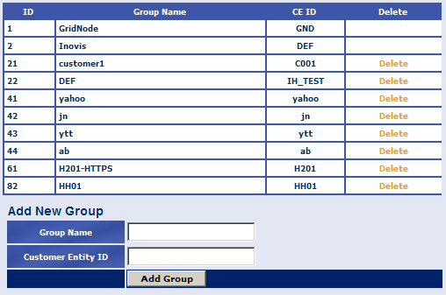
Figure 8: Groups Management Page

Each row in the list identifies a Group. The column header shows the following fields:

ID:
This indicates that identifies that uniquely identifies a Group in TXMR.

Group Name:
This indicates the name of the Group, as recognized in TXMR.

CE ID:
This indicates the Customer Entity ID, as recognized in TXMR. This will act as a unique identification reference to the customer.

Delete:
This link allows delete of the Group.

TIPS:

To editing any existing group(s), you may delete it first, and then re-create it again.

Creating New Group

- On the Groups Management Page, enter the following fields:

Group Name:
This indicates the name of the Group, as recognized in TXMR.

Customer Entity ID:
This is the unique identification reference to the customer.

- To confirm the entries, click on the Add Group button.

The newly created Group will appeared last in the list in the Group Management page. Otherwise, you will see the error message displayed on the right of the Add Group button.

NOTE:

The Group Name field and Customer Entity ID field are unique identifiers. Therefore, duplication of Group Name as well as Duplication of Customer Entity ID will not be allowed in TXMR.

Deleting Existing Group

- On the Groups Management Page, click on the Delete button of the Group you wish to delete. You will be prompted to confirm the deletion.

- To confirm the deletion, click YES.

- To cancel the deletion, click NO.

Searching of Log Files

This feature allows you to search and view the log files you want.

To access this feature,
- Go to Show Log Page by clicking on the link at the Admin Tool icon.

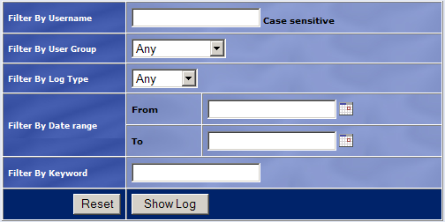
Figure 9: Search for Log Files Page
- Enter the following search criteria fields you want:

Filter By Username:
Search by username you wish to be filtered.

Filter By User Group:
Search by user group you wish to be filtered.

Filter By Log Type:
Search by Log Type you wish to be filtered.

Filter By Date range:
Search by data range you wish to be filtered.

Filter By Keyword:
Search by any keyword you wish to be filtered.

- To reset the entries, click the Reset button.

- To confirm the entries, click the Show Log button. Wait a few moments while TXMR is filtering the search criteria and retrieving the log files.

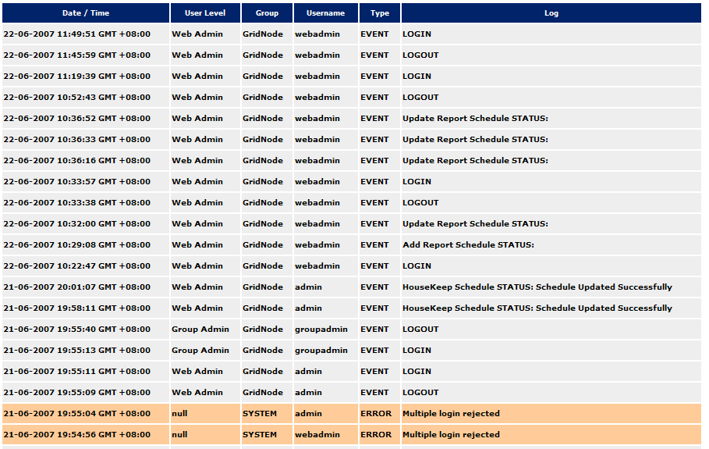
Figure 10: Search Result for Log Files
Each row in the list identifies a log entry. The column header shows the following fields:

Date / Time:
This indicates the date/time of the log captured.

User Level:
This indicates the user level of the person who made the log.

Group:
This indicates the group name of the person who made the log.

Username:
This indicates the username of the person who made the log.

Type:
This indicates the log type of the log entry. If the log type is a normal “EVENT”, that particular log entry will be displayed normally. Otherwise, the particular log entry with log type as “ERROR” will be highlighted in a different colour to indicate an error log was captured.

Log:
This indicates the description of the log entry.

NOTE:

It is not necessary to enter all the search criteria fields; you may even leave all of them empty and perform the searching of log files.

Managing of Archive Transaction

Managing of Archive Transaction feature includes the following functionalities:

- Creating of New Archive Schedule
- Editing of Existing Archive Schedule
- Archiving of Transaction

To access the Archive Transaction feature,

- Go to Archive Transaction Page by clicking the link at the Admin Tool icon.

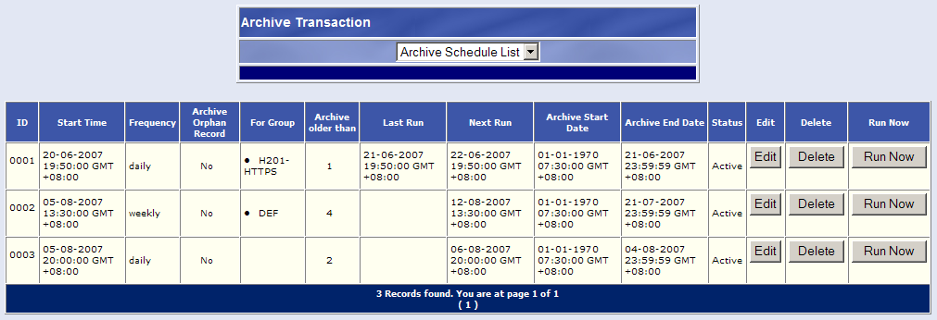
Figure 11: List of Archive Transaction Schedule Page

The following options are available on the Archive Transaction page:

- Archive Schedule List
- Archive Transaction
- Create New Schedule

The Archive Schedule List option allows you to view a listing of Archive Transaction schedule. Each row in the list identifies a scheduled Archive Transaction. The column header shows the following fields:

ID:
This identifies each row by a running numbers.

Start Time:
This indicates the date/time that the schedule starts to take effect. Before that time, the schedule would not run at the scheduled frequency.

Frequency:
This indicates whether the report will be generated on a “Daily”, “Weekly” or “Monthly” basis.

Archive Orphan Record:
This indicates whether to archive those Transactions without any group information and without any dependency on other records. If “Yes”, those records without any group information and dependency on other records will be archived. Otherwise, those records will not be archived.

For Group:
This indicates the group name which the Archive Transaction was scheduled for.

Archive older than:
This indicates the number of days since the Transaction has been made. TXMR will archive any Transaction(s) which are more than this value.

Last Run:
This indicates the date/time of the last scheduled Archive Transaction being triggered.

Next Run:
This indicates the date/time of the next scheduled Archive Transaction which will be triggered.

Archive Start Date:
This indicates the start date/time range of the Archive Transaction.

Archive End Date:
This indicates the end date/time range of the Archive Transaction.

Status:
This indicates whether or not the scheduled Archive Transaction is in “Active” mode or “Not Active” mode. If this field indicated “Active”, the scheduler for this particular Archive Transaction is still running. Otherwise, the scheduler for this particular Archive Transaction has stopped.

Edit:
This button allows editing of the schedule. Archive Transaction.

Delete:
This button allows delete of the schedule.

Run Now:
This button allows immediate generation of the Archive Transaction.

Creating of New Archive Schedule

This feature allows you to create a new Archive Transaction schedule.

- Select the Create New Schedule option in the Archive Transaction Page.

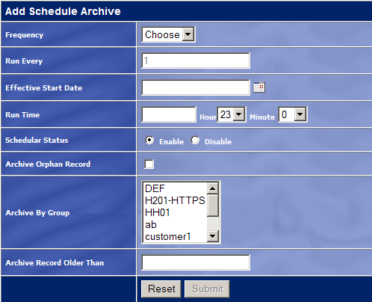
Figure 12: Creating of Archive Schedule Page

Enter the following fields:

Frequency:
Select how frequent you want the scheduler to trigger the archiving of Transaction – “Daily”, “Weekly” or “Monthly”.

Run Every:
Set the Frequency field range. For example:

- Run Every 1 Day(s)
- Run Every 2 Week(s)
- Run Every 3 Month(s)

Effective Start Date:
Set the date that you want the scheduler to start taking effect. This can be done by clicking the icon to bring up the date picker, and select the desirable date.

Run Time:
Set the time that you want the scheduler to archive Transaction(s). This can be done by selecting the desirable Hour and Minute from their respective combo lists.

Scheduler Status:
Select the status of the scheduler – whether to be “Enabled” or “Disabled”.

Archive Orphan Record:
Flag whether to archive those Transactions without any group information and without any dependency on other records. If ticked, Archive By Group field will be disabled.

Archive By Group:
Set the group(s) which the Transaction will be archiving for.

Archive Record Older Than:
Set the number of days old of the Transaction, and TXMR will archive any Transaction(s) which are more than this value.

Editing of Existing Archive Schedule

- Click on the Edit button at the Archive Transaction Page. This displays the Editing of Archive Schedule Page.

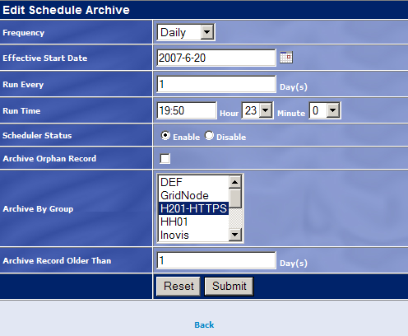
Figure 13: Editing of Archive Schedule Page

- Make the desirable changes to the fields you want.

- To reset the changes, click the Reset button.

- To confirm the changes, click the Submit button.

You will be directed to a page showing the submission status.

Archiving of Transaction

- Select the Archive Transaction option in the Archive Transaction Page.

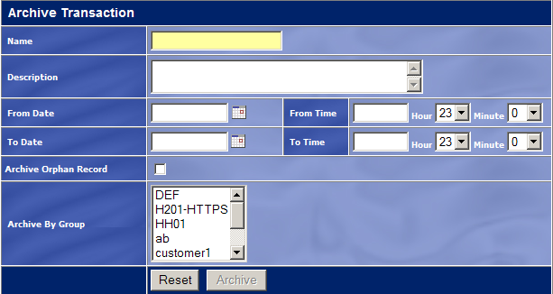
Figure 14: Archiving of Transaction Page

Enter the following fields:

Name:
Set the name for the Archive Transaction.

Description:
Set the description for the Archive Transaction.

From Date:
Set the start date range of the Archive Transaction.

From Time:
Set the start time range of the Archive Transaction.

To Date:
Set the end date range of the Archive Transaction.

To Time:
Set the end time range of the Archive Transaction.

Archive Orphan Record:
Flag whether to archive those Transactions without any group information and without any dependency on other records. If ticked, Archive By Group field will be disabled.

Archive By Group:
Set the group(s) which the Transaction will be archiving for.

- To reset the entries, click the Reset button.

- To confirm the entries, click the Archive button.

You will be directed to a page showing the archiving status.

Managing of Restore Transaction

Managing of Restore Transaction feature includes the following functionalities:

- Downloading of Archive Transaction
- Restoring of Archive Transaction

To access the Restore Transaction feature,

- Go to Restore Transaction Page by clicking the link at the Admin Tool icon.

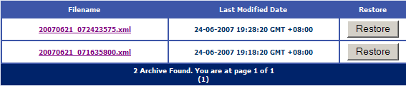
Figure 15: Restoring of Archive Transaction Page – With Data

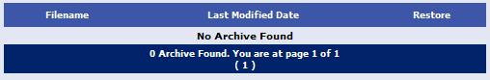
Figure 16: Restoring of Archive Transaction page – Without Data

Each row in the list identifies an Archive Transaction. The column header shows the following fields:

Filename:
This link indicates the filename of the Archive Transaction, thus allowing you to download it.

Last Modified Date:
This indicates the latest date/time of which the Archive Transaction has been modified.

Restore:
This button allows restoring of the Archive Transaction.

Downloading of Archive Transaction

- Click on the filename link in the Restore Transaction Page you wish to download.

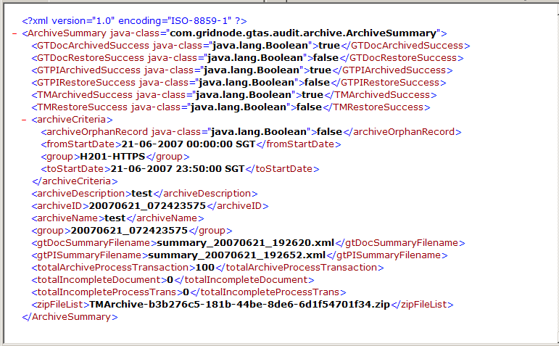
Figure 17: Sample Archived Transaction File

Restoring of Archive Transaction

- Click on the Restore button in the Restore Transaction Page you wish to restore.

You will be prompted to confirm the restoration.

- Click OK for restoration of the Archive Transaction.

Figure 18: Message to show that restoration status

Report Generation

On top of what a Group Admin and a Group User can access in transaction monitoring report generation, Web Admin has the following additional functionalities:

- Generating of Certificate Status Report
- Housekeeping of Generated Reports

Besides the mentioned additional functionalities, you are enabled to select the customer(s) you wish to generate for during generation of reports. This additional feature is applicable to the following pages:

- Creating a New Schedule
- Changing an Existing Schedule
- Generating Ad-Hoc Reports

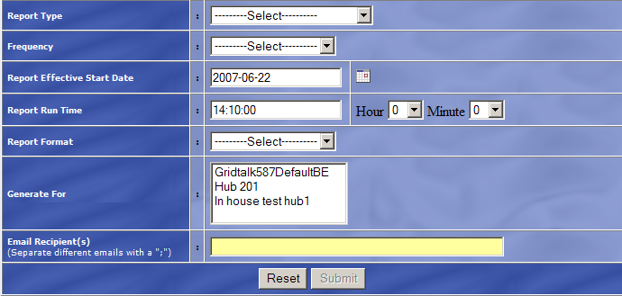
Figure 19: Add Schedule Report Page

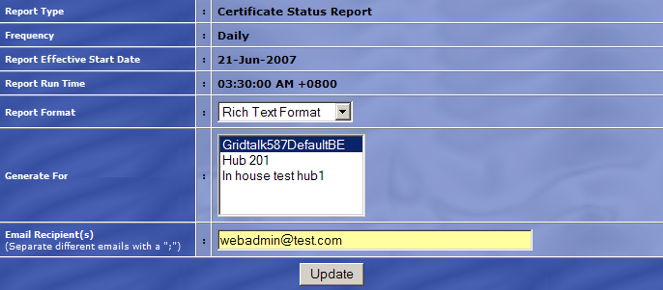 Figure 20: Update Schedule Report Page

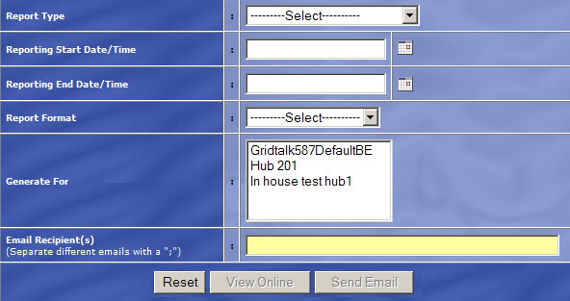
Figure 21: Run Reports Now Page
Generate For:
This set / indicates the customer(s) whom you wish to generate for.

Housekeeping of Generated Reports

The feature allows user to schedule a deletion of generated reports. This feature will ease the trouble of deleting generated report individually and thus lesser report to keep track of. Housekeep report will be done in batch – all generated reports which met the housekeep report criteria will be deleted automatically.

- Click on the link at the top of the List Of Report table.

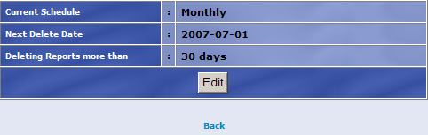
Figure 22: Displaying of Current Schedule of Housekeeping Reports

- The Housekeep Report page will be displayed with the following fields:

Current Schedule:
This field identifies the current scheduling of deletion of generated reports – whether it is “Once”, “Daily”, “Weekly” or “Monthly”.

Next Delete Date:
This field identifies the next date which the scheduler will be triggered to perform the deletion of generated reports.

Deleting Reports more than x days:
This field identifies the number of days of which the report has existed since the day of its creation. Any generated reports which were more than x number of days will be deleted.

- Click on the Edit button for editing the fields displayed.

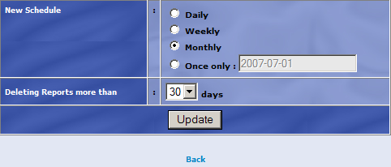
Figure 23: Editing of Current Schedule of Housekeeping Reports

- The updating of Housekeep Report page will be displayed with the following fields (all fields are mandatory unless stated):

New Schedule:
This field allows user to select the frequency of the scheduler to be triggered. If the “Once only” option was selected, the field next to it will be enabled for input. This field is entered by clicking on the icon to select the desired date for deletion.

Deleting Reports more than x days:
This field allows user to select the number of days of which the report has existed since the day of its creation to be deleted.

- Click on the Update button.

- The Housekeep Report main page will be displayed with the status of updating will be down beside the Edit button. “Schedule updated successfully” will be displayed for any successful updates and “Schedule NOT updated” will be displayed for any unsuccessful updates. Thus, in any cases when unsuccessful updates are made, user may want to contact the administrator.

Generating of Certificate Status Report

Certificate Status Report

The Certificate Status Report provides a summary of the certificates in TXMR, whether they will be expiring soon or not. For certificates which will be expiring in the next 30 days will be checked if it already has a replacement certificate.

The following sub-sections describe the different parts of the report.

Report Header

The Certificate Status Report header shows the following information:

Certificate Status Report:
This is the title of the report.

Certificate Status Summary

The Certificate Status Summary shows the following information:

ID:
This indicates the identification number of the Certificate.

Name:
This indicates the name of the Certificate as recognized in GridTalk.

Issuer Name:
This indicates the information of the issuer of the Certificate.

Serial Number:
This indicates the serial number of the Certificate.

Start Date:
This indicates the date/time of which the Certificate was first created.

Expiry Date:
This indicates the date/time of which the Certificate expired.

Is Partner:
This indicates whether the Certificate belongs to the Trading Partner.

Is CA:
This indicates whether the Certificate belongs to the Certificate Authority.

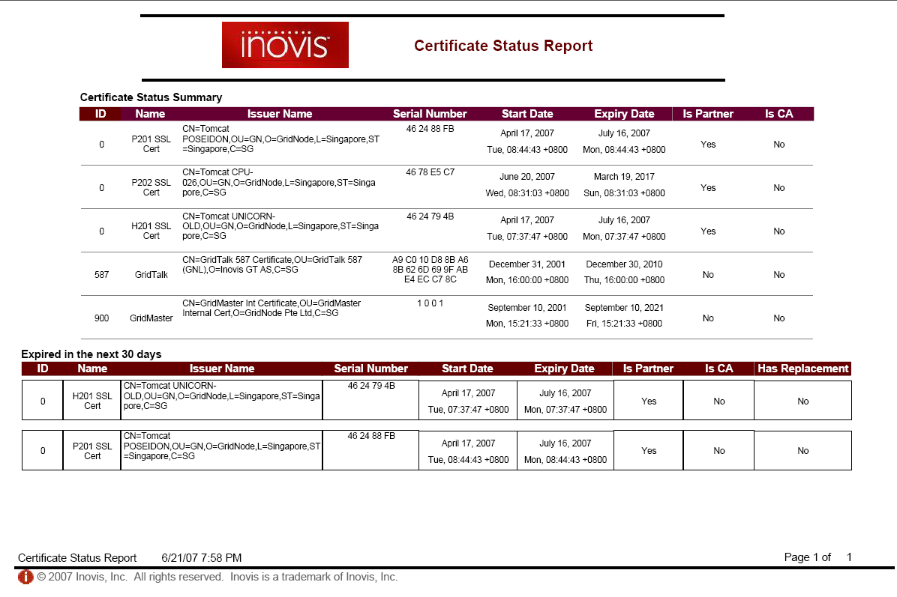
Figure 24: Sample Certificate Status Report

Expired in the next 30 days

The Expired in the next 30 days section provides the following addition check:

Has Replacement:
This indicates whether the expiring Certificate has been issued a replacement Certificate yet. If it has not been issued with a new Certificate, the field will display NO. Otherwise, the field will display YES.

Report Footer

The report footer shows the following information:

Certificate Status Report:
This indicates the title of the report.

Generation Date:
This is the date/time of generation of the report.

Page X of Y:
This indicates the paging of the report. X is the current page number, while Y is the total number of pages in the report.

Your TXMR Admin will provide you with the URL
All the time in TXMR will be converted based on the selected time zone

