GridTalk 4.0 Enhancement: Batch Import Schemas
Proposed by: Neo Sok Lay
Date: 27 February 2006

Objective
To allow nested schemas to be imported to the GridTalk system together with the root schema so as to eliminate the need of the user to manually copy the nested schemas to GridTalk schema folder.

Analysis
The same set of nested schemas may be applicable to more than one root schema, for example a two action PIP may refer to the same set of nested schemas in the Request schema and Response schema. Thus, it is useful to allow the user to import the entire set of schemas for a single PIP into the GridTalk system at one go. At the same time, the Mapping File entries will only be created for the root schemas that are directly referred to during schema validation.

A typical scenario of importing the schema set is as follows:
- The set of schemas pertaining to a PIP is contained in a single zip file
- The user imports the zip file, and select, from the zip file contents, the root schema(s) to be created as Mapping File records.
- The selected root schema(s) will be created as Mapping File records
- The rest of the schemas will be extracted and saved under the GridTalk schema folder.

Design

- User Interface
  - Mapping Files Listing Page
    - A new hyperlink “Batch Import Schema Mapping File” will be added to the Mapping Files listing page. See Figure 1.
    - On selection of the hyperlink, the screen as shown in Figure 2 will be displayed.
  - Batch Import Schema Mapping Files – Step 1
    - Field Entry
- Zip Filename
  - The zip file to be imported
  - Text field
  - Possible Values: path of selected file
  - Validation: File must exist
  - Mandatory to go ‘Next’
    - Hyperlinks
- Next
  - Proceed to Step 2
  - Validation on click: Validate entries as stated above. Prompt user for any invalid inputs.
  - Action after validation pass: The zip file will be read and the Zip entries will be extracted and displayed in the next screen, as shown in Figure 3.
- Help
  - Hyperlink to display the context-sensitive help for Batch Import Mapping Files
  - Validation on click: None
- Cancel
  - Hyperlink to discard the inputs and return to Mapping File Listing Page
  - Validation on click: None
  - Batch Import Schema Mapping Files – Step 2
    - Field Entry
- Base Directory
  - The base directory to group the imported schemas. This base directory will created under the GridTalk schema root folder.
  - Text field
  - Possible Values: file system accepted directory name.
  - Validation
    - Total length with any of the Schema Mapping’s Path must not exceed 80 char i.e. Length(‘/’ + BaseDirectory + ‘/’ + Path) must <= 80.
  - Not mandatory
- The schema files to be created as Mapping File(s) will be presented in table form as shown in Figure 3.
- Mapping Name
  - The name of the Mapping File to create
  - Label
- Description
  - The description of the Mapping File to create
  - Label
  - Text field
  - Possible Values: any String combination
  - Validation: None
  - Not mandatory, required if Description is specified for the same row
- Schema File
  - The path of the schema file in the zip file
  - Label
- Description
  - The Description for the Mapping File record to create
  - Text field
  - Possible Values: any String combination
  - Validation: None.
  - Not mandatory, required if Mapping Name is specified for the same row
    - Hyperlinks
- Create Schema Mapping
  - Create a schema Mapping File
  - Validation on click: None
  - Action: Divert to Schema Mapping File screen, as shown in Figure 4.
  - Action after return: If the creation is confirmed, the Schema Mapping will be displayed in the table
- Delete Schema Mapping
  - Delete the selected Schema Mappings (checkbox ticked against). Do not perform creation in database during Import Files.
  - Validation on click: None
  - Action: Remove all selected Schema Mappings from the table.
- Edit
  - Change the Schema Mapping entries
  - Validation on click: None.
  - Action: Display the Schema Mapping File screen default with the field entries of the selected Schema Mapping.
- Import Files
  - Proceed to perform the import
  - Validation on click: Validate the inputs as stated above. Prompt user on any invalid inputs.
  - Action: Transfer the zip file to server end and dispatch the Batch Import Schemas event.
  - Action after event successful: return to Mapping Files listing page.
- Help
  - Hyperlink to display the context-sensitive help for Batch Import Mapping Files
  - Validation on click: None
- Cancel
  - Hyperlink to discard the inputs and return to Step 1
  - Validation on click: None
  - Schema Mapping File
    - Field Entry
- Path
  - The path of the schema file in the zip file
  - Combo box
  - Possible Values: all unique directory paths of the schema files in the zip file
  - Validation: None
  - Action on selection: refresh the Filename(s) lists
  - Mandatory to save
- Filename
  - The name of the schema file in the zip file
  - Combo box
  - Possible Values: names of all schema files that are under the selected Path
  - Validation: None
  - Mandatory to save
- Mapping Name
  - The name of the Mapping File to create
  - Text field
  - Possible Values: any String combination, max 30 char
  - Validation: None
  - Mandatory to save
- Description
  - The Description for the Mapping File to create
  - Text field
  - Possible Values: any String combination, max 80 char
  - Validation: None
  - Mandatory to save
    - Hyperlinks
- Save Schema Mapping
  - Save the Schema Mapping entry
  - Validation on click: Validate the input entries as stated above. Prompt user on any invalid inputs.
  - Action on validation pass: Return to Step 2 with the Schema Mapping entry appended to the table.
- Help
  - Hyperlink to display the context-sensitive help for Batch Import Mapping Files
  - Validation on click: None
- Cancel
  - Hyperlink to discard the inputs and return to Step 2
  - Validation on click: None

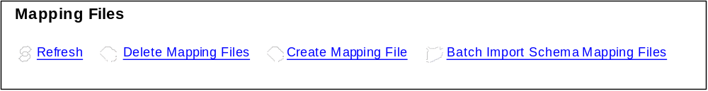
Figure 1 Mapping Files listing page header

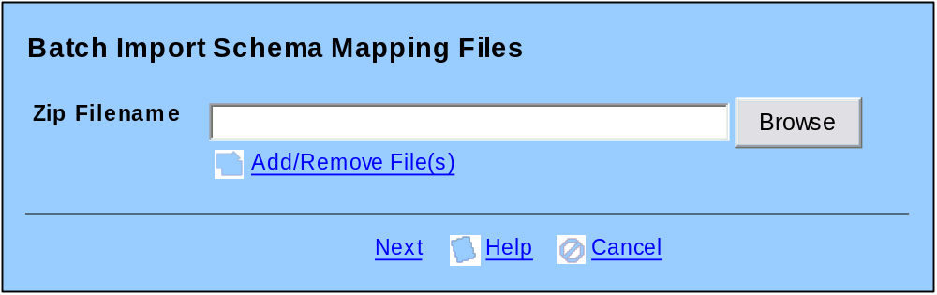
Figure 2 Batch Import Schema Mapping Files – Step 1

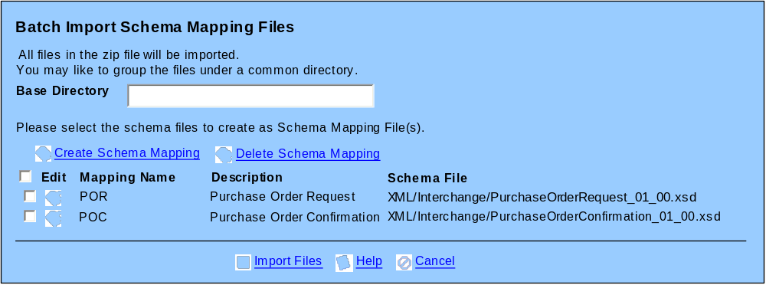
Figure 3 Batch Import Schema Mapping Files - Step 2
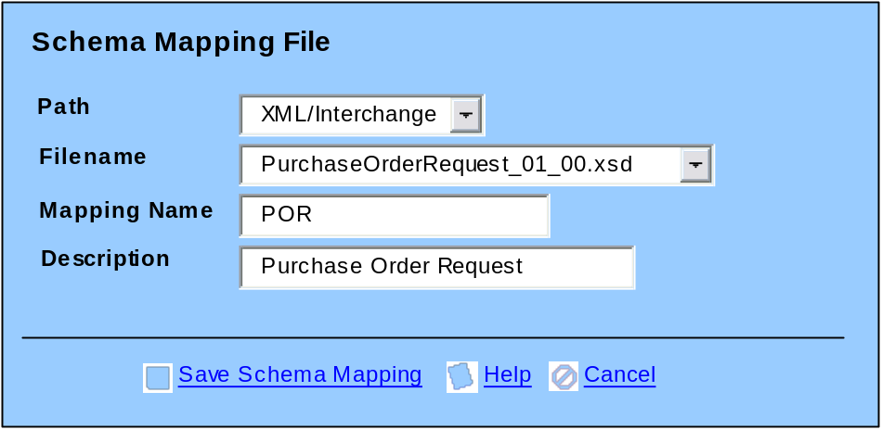
Figure 4 Create Schema Mapping

- Processing
  - Operations
      - Batch Import Schemas
- Inputs:
  - File path to Zip file
  - Set of selected schemas to create as Mapping Files, containing
    - Zip entry name
    - Path
    - Filename
    - Mapping Name
    - Description
  - Base Directory
- For each zip entries where in the set of selected are specified,
  - A Mapping File record will be created
    - NAME: Mapping Name
    - DESCRIPTION: Description
    - TYPE: SCHEMA (‘4’)
    - PATH: path key for schema
    - SUBPATH: ‘/’ + (BaseDirectory + ‘/’ +) Path (e.g. PIP3A4_V11.00.00_047897855_PO_01.00_POR/XML/Interchange)
      - (BaseDirectory + ‘/’ +) only if BaseDirectory is specified
    - FILENAME: Filename (e.g. PurchaseOrderRequest_01_00.xsd) – must resolve to unique
  - If any mapping file could not be created (could be due to duplicate mapping name), the entire processing must be aborted and the user must be prompt for the problem.
  - The schema file will be extracted and saved under the path: GridTalk schema root directory + SUBPATH.
- For other zip entries
  - The schema file will be extracted and saved under the path: Gridtalk schema root directory + ‘/’ + (BaseDirectory + ‘/’ +) directory path in zip.
    - (BaseDirectory + ‘/’ +) only if BaseDirectory is specified.
  - If the destination folder already contains a file with the same filename, file will be overwritten.

- Data Model
  - No additional persistent entity
  - Non-persistent entity
- SchemaMapping
      - PATH
    - Type: String
    - Length: 80
      - FILENAME
    - Type: String
    - Length: 80
      - MAPPING_NAME
    - Type: String
    - Length: 30
      - DESCRIPTION
    - Type: String
    - Length: 80
      - ZIP_ENTRY_NAME
    - Type: String
    - Length: 255

