GridTalk 4.0 Enhancements on Certificate Management

Objective
This document describes the various enhancements proposed for the Certificate Management module of GridTalk 4.0.

Description
The following enhancements are desired and proposed by the PS team, to ease the handling of certificates by the PS team as well as the customers. Some enhancements are also proposed by the PD team for prevention of potential issues with the current design of the module.

S/N | Enhancement Description | Proposed by | Impact
1 | To display the validity period of a certificate in the Certificate detail page.  This is to enable the PS/customer to know when a certificate would be effective or expired on first glance into the Certificate detail page.  The current way requires the certificate file to be downloaded to local file system before the validity dates can be viewed. | PS | Need to extract the Validity dates from the X.509 certificate and display on the Certificate detail page (Certificate tab).  Alternatively, save the validity dates in the certificate table when the certificate is imported.  Minor. Involves UI and data model change.
2 | To allow the service header and service content in the audit file of Outbound user documents to be decrypted.  Currently, this is not possible as the encrypted content is meant for the target recipient partner to decrypt. On sender side, we do not have the partner’s private certificate to decrypt. This may result in potential issue for auditing purpose. | PS/PD | Need to add sender’s public certificate as additional recipient certificate during encryption, so that when need arises, the encrypted content can be decrypted at sender’s end.  Minor. Involves change to S/MIME encryption logic.
3 | To set the replacement certificate for an expiring certificate, so that we are sure of which certificate is replacing an expiring certificate.  The current way only sets a certificate as the replacement certificate for an expiring certificate, without filtering off those certificates that have already set with replacement certificates. This potentially could result in multiple replacement certificates being set for an expiring certificate, and from the expiring certificate detail page, we would not know which certificate will be replacing it when it expires. | PD | Need to add a Replacement Certificate field to the Certificate detail page. During import of pending certificate, the list of expiring certificates should be those that have not been set as replacement certificate for another certificate.  The expiring certificate detail page would display which certificate it will be replaced by, but not editable. To clear, it is necessary to clear the As Pending Certificate For field set at the replacement certificate detail page. The replacement certificate should not be delete-able also as long as the expiring certificate still links to it.  When the certificate expires, the replacement certificate can be obtained in a straightforward manner.  Medium. Involves UI and data model change, CUD logic change, and replacement logic change.
4a | To prompt user, on exporting a partner certificate to trust store, if the parent CA certificate for the partner certificate does not exist in the trust store.  The current problem is partner certificate is exported to trust store, but the parent CA certificate is not in trust store, thus resulting in authentication problem during HTTPS. | PS | When a partner certificate is to be exported to trust store, need to check if the parent CA certificate (if any) of the partner certificate exists in the trust store, if not, prompt to the user, and do not allow export.  Medium. Involves export to trust store logic change.
4b | To allow import of missing CA certificates into the trust store using GridTalk UI.  Currently, it is necessary to use external tool such as KeyMan to import CA certificate into the Truststore. | PS | The current Partner Certificates listing would be changed to allow import of CA certificates. The imported CA certificates would be allowed to be exported to the Trust store like the partner certificates. A flag would be added to indicate a CA certificate.  Medium. Involves UI and probably filtering criteria change in affected areas due to the additional flag.
5 | To display the Serial Number of a Certificate in the Certificate detail page.  This is for easier identification of a certificate between two certificates if they are exactly the same (even though they may be imported given a different certificate name).  The current way requires the certificate file to be downloaded to local file system before the Serial Number can be viewed. | PS | Need to convert the Serial Number from Base64-encoded to HEX string during display.  Minor. Involves UI change.
6 | To trigger alert notification when any of the certificates are expiring or has expired.  Currently, this is a manual process to track whether any certificates are expiring. | PS | Need to add a Scheduled Task that periodically runs to check the end validity dates of the certificates, and if any certificate is expiring within 30 days, or has expired, trigger an alert email containing the information of the lists of certificates, indicating which are expiring, which have expired.  Medium.

Order of Delivery

The following table lists the order of implementing and estimated efforts of the enhancements:

Enhancements to be implemented | Estimated Effort (man days)
1 and 5 | 2
4a and 4b | 4
6 | 3
3 | 2
2 | 0.5

Design

This section presents the design for the proposed enhancements described above. It detailed out the user interface changes, data model changes, processing changes for each enhancement, as well as the backward compatibility issues that need to be taken care of when older version of GridTalk are patched with the enhancement changes. Take note that the user interfaces shown for each enhancement are presented independent of each other, and such does not necessary reflect the final user interface.

- Certificate Validity Dates

Options:
  - When the user views the certificate detail, then the validity dates are extracted out from the X.509 certificate object. This means that the validity dates are visible only through viewing from the Certificate UI, and every view would incur additional Event to the server to (i) retrieve the Certificate record from database and (ii) convert the stored certificate content (Base64encoded) into X.509 format.
  - When a certificate is imported into GridTalk database, the validity dates are extracted from the X.509 certificate object (which is readily available) and saved with the Certificate record. This allows the validity dates to be visible without UI, and enables easier filtering or searching or troubleshooting should need arises. The impact is two additional fields for the Certificate table, and most of the interfaces to insert certificate needs to be changed to include the two fields.

The preferred option is b, which is a cleaner way and provides more potential benefits.

User Interface Changes:
- In Certificate detail page, add Valid from and Valid to fields that indicate Start Date and End Date for the certificate, for example, in View mode:

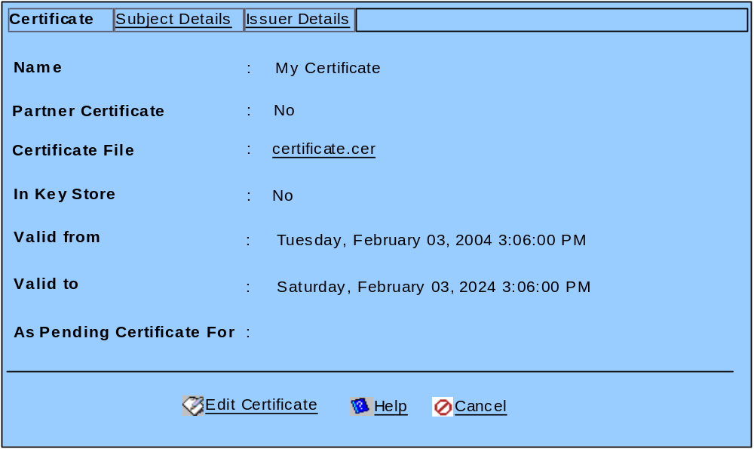

- In Import mode, both fields will be shown (with value) only if the user chose to Add/Remove File(s) after selecting the certificate file.

- In Edit mode, the both fields will not be editable.

Data Model Changes:
- Certificate Entity
- Add
  - “StartDate”, “START_DATE”, java.util.Date
  - “EndDate”, “END_DATE”, java.util.Date
- Table “certificate”
- Add
  - “StartDate”, DATE
  - “EndDate”, DATE

Processing Changes:
- During Import of certificate, the StartDate and EndDate are extracted from the X.509 certificate and saved into the Certificate record.
- Changed Interfaces
  - CertificateManagerBean.createCertificate
  - CertificateEntityHandler.createCertificate

Backward Compatibility:
During patch, the existing certificate records need to be retrieved, convert to X.509 Certificate format to get the StartDate and EndDate, and populate into the record.

- Decryption of Outbound Audit files

Processing Changes:
  - During S/MIME encryption, add Own certificate as recipient
- Changed Interfaces
  - SecurityServiceBean.encrypt(X509Certificate, byte[], CertJ, CertPathCtx, String, int)

- Change to Certificate replacement

User Interface Changes:
  - In Certificate detail page, add On expire, use field to indicate the replacement certificate, for example, in View mode:

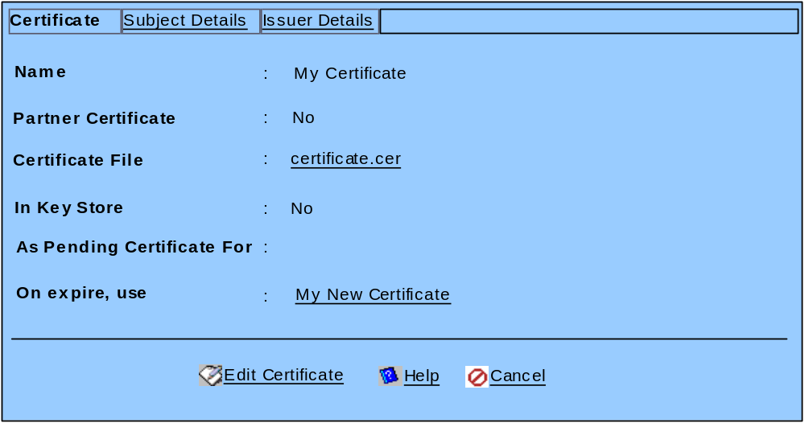

  - In Import mode, the On expire, use field should not be shown.

  - In Edit mode,

- The On expire, use field will not be editable.
- The As Pending Certificate For field show list only those certificates that (i) has the same Partner Certificate value; (ii) are not revoked (iii) On expire, use field is not set (iv) not the same certificate as this one being edited.

Data Model Changes:
  - Certificate Entity
- Add
  - “ReplacementCertUid”, “REPLACEMENT_CERT_UID”, Long
  - Table “certificate”
- Add
  - “ReplacementCertUid”, BIGINT(20)

Processing Changes:
  - Update Certificate Action.
- Changed Interfaces
  - CertificateManagerBean.updateCertificate(Long, String, Long)
    - If relatedCertUid is set,
      - update the selected relatedCert’s replacementCertUid to this certificate’s UID
      - update all other non-revoked certificates (if any) whose replacementCertUid is this certificate’s UID to clear the replacementCertUid.
    - If relatedCertUid is not set,
      - Update all non-revoked certificates (if any) whose replacementCertUid is this certificate’s UID to clear the replacementCertUid.

  - When a certificate being retrieved has expired, the replacement (pending) certificate is retrieved based on replacementCertUid, if set.
- CertificateEntityHandler.getX509Certificate
  - If replacement certificate could not be retrieved, throw exception
  - If replacement certificate has already expired or has been revoked, if its replacementCertUid is set, retrieve that replacement certificate. Repeat until a valid replacement certificate is retrieved, or no more could be retrieved, in which case, throw exception.
  - If a valid replacement certificate could be retrieved,
    - If the replacement certificate is not the one originally set, update the replacementCertUid in the certificate that is originally being retrieved
    - revoke only the certificate that is originally being retrieved.

  - When a certificate is revoked,
- [PartnerProcess]EntityChangeListenerMDBean.handleCertificateUpdated
  - If replacement certificate is set and is not revoked, update all business certificate mappings that are currently set to the revoked certificate and change to the replacement certificate.
- [App-Channel]EntityChangeListenerMDBean.handleCertificateUpdated
  - If replacement certificate is set and is not revoked, update all security profiles that are currently set to the revoked certificate and change to the replacement certificate.

  - Remove Certificate Action
- If the certificate to be deleted is set with a replacement certificate, it should not be allowed for deletion.
  - Add [Base-Certificate]EntityDependencyChecker.checkDependentReplacementUsage(Long relatedCertUid)
    - Retrieve the replacement certificate and return as dependent entities.
  - Add the dependency checker in dependency-Certificate.xml
- If the certificate to be deleted is used as a replacement certificate, during deletion, clear the related certificate’s replacementCertUid

Backward Compatibility:
During patch, if a non-revoked certificate (Cert A)’s relatedCertUid is set, update the relatedCert Certificate record’s replacementCertUid to Cert A’s UID. No special handling if multiple certificates point to the same relatedCert, just blindly set.

- Partner CA certificates management

User Interface Changes:
  - Add a CA Certificate field in the Certificate detail page, for example, in Import mode:

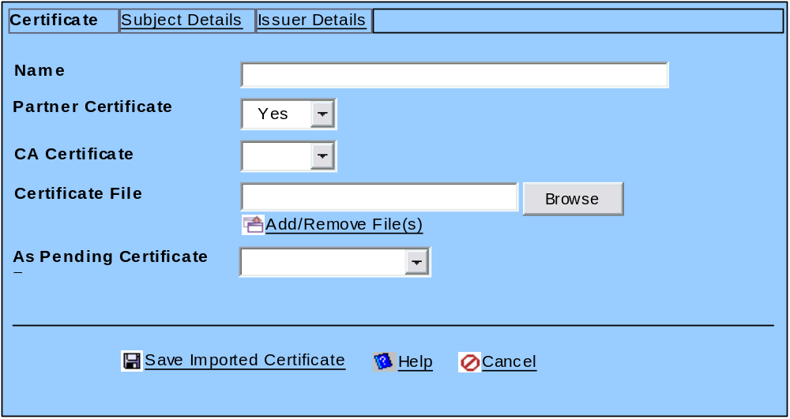

- The CA Certificate field displays options (Yes, No).
- In Import and Edit mode, the field is only visible for selection (i.e. editable) when the Partner Certificate field has the value Yes.
- In View mode, the field is visible.

  - Add a Is CA column in the Partner Certificates listing:

 | Edit | Name | Id | Is CA | In Trust Store
 |  | Partner ABC | 0 | No | No
 |  | Verisign Level 2 Cert | 0 | Yes | No
 |  | Verisign Root Cert | 0 | Yes | No

Data Model Changes:
- [Base-Certificate]Certificate Entity
- Add
  - “IsCA”, “IS_CA”, Boolean
- Table “certificate”
- Add
  - “IsCA”, TINY_INT(1), NOT NULL DEFAULT 0

- Certificate Serial Number

User Interface Changes:
  - Add the Serial Number field on the Certificate detail page, for example, in View mode:

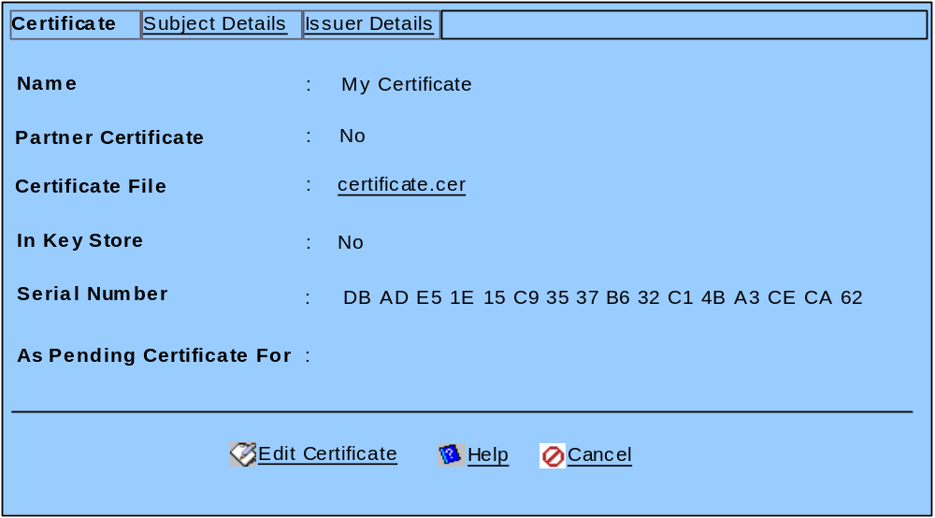

  - In Import mode, the Serial Number field will be shown (with value) only when the user clicks the “Add/Remove File(s)” after selecting the Certificate File to import.

  - In Edit mode, Serial Number field will not be editable.

Processing Changes:
- Get Certificate Action
- Decode the SerialNum of the Certificate into byte[], use: [Base-Certificate]GridCertUtilities.decode(String)
- Convert each byte to Hex, use: GridCertUtilities.hexEncode(byte)

- Certificate Expiry Checking

User Interface Changes:
- A new Scheduled Task for User Procedure “User Procedure for Checking Certificate Expiry”, and is scheduled to perform daily, mid-noon, enabled by default.
- The Scheduled Task is editable but not delete-able by the user.

Data Model Changes:
- New recurring alarm record
- New Alert records
- Alert Type – “CERT_EXPIRY_CHECK”, “Certificate Expiry Check”
- Alert – “CERT_EXPIRY_ NOTFN”, “Default Certificate Expiry Notification Alert”
- Email Template
Name | CERT_EXPIRY_NOTFN_EMAIL
From | <#USER=admin#>
To | <#USER=admin#>
Subject | Notification of Certificate Expiry for <%CertExpiry.CERT_NAME%>
Message | GridTalk has found the following certificate to <?Nhave expiredN?%CertExpiry.CHECK_DAYS#’be expiring in ‘##’ days or less’%>:  Certificate Details:  --------------------  Category : <%CertExpiry.CATEGORY%> - [O] Own [P] Partner  Name : <%CertExpiry.CERT_NAME%>  Issuer : <%CertExpiry.ISSUER_NAME%>  Serial Number : <%CertExpiry.SERIAL_NUM%>  Subject :  Common Name : <%CertExpiry.SUBJECT_CN%>  Org. Unit : <%CertExpiry.SUBJECT_OU%>  Organisation: <%CertExpiry.SUBJECT_O%>  Country : <%CertExpiry.SUBJECT_C%>  Valid from : <%CertExpiry.START_DT#EEEE, MMM dd, yyyy hh:mm:ss a%>  Valid to : <%CertExpiry.END_DT#EEEE, MMM dd, yyyy hh:mm:ss a%>  Take note that an expired certificate cannot be used for document exchange. Please take necessary actions to renew the certificate as soon as possible.

- Log Template
Name | CERT_EXPIRY_CHECK_LOG
Location | certexpiry.log
Append | Yes
Message | [<%System.CURRENT_DATETIME%>] <%CertExpiry.CERT_NAME%> <?Nhas expiredN?%CertExpiry.CHECK_DAYS#’will be expiring in ‘##’ days or less’%>.

- New User Procedure records
- Procedure Definition File
  - “CERT_EXPIRY_CHECK”
  - “Java Procedure for Checking Certificate Expiry”
  - “gt-cert-expiry-check.jar”
- User Procedure
  - “CHECK_CERT_EXPIRY_PROC”
  - “User Procedure for Checking Certificate Expiry”
  - Java Procedure Configuration
    - “com.gridnode.gridtalk.certificate.ExpiryChecker”
    - Method: void start(String checkerDelegate, int daysToRemind, String alertName)
  - Parameters
    - “checkerDelegate”, “Class name of delegate to perform the check”, User Defined, String, “com.gridnode.gtas.server.certificate.helpers.ExpiryCheckerDelegate”
    - “daysToRemind”, “Days to remind before expire”, User Defined, Integer, 30
    - “alertName”, “The alert to trigger”, User Defined, String, “CERT_EXPIRY_ NOTFN”

Processing Changes:
- User Procedure
- com.gridnode.gridtalk.certificate.IExpiryCheckerDelegate
  - Interface for the delegate
  - Void setAlertName(String)
  - Void setDaysToRemind(int)
  - Void retrieveCertificates()
  - Boolean nextCertificate()
  - Boolean isCertExpired()
  - Boolean isCertExpiring()
  - Void raiseAlert()
  - Void cleanup()
- com.gridnode.gridtalk.certificate.ExpiryChecker
  - Instantiate “checkerDelegate” by reflection
  - Invoke the relevant methods to perform the checking
- com.gridnode.gtas.server.certificate.model.CertExpiryData
  - provider data for the alert
  - Refer to the alert templates under Data Model Changes for the required information.
- com.gridnode.gtas.server.certificate.helpers.ExpiryCheckerDelegate
  - implements the delegate interface
  - retrieveCertificates()
    - retrieve all non-revoked certificates from database for checking
    - cache the list
  - nextCertificate()
    - increment current certificate index
    - return false if no more certificates
  - isCertExpired()
    - check if the current certificate is expired as of time of check
    - return true if certificate has expired
  - isCertExpiring()
    - check if the current certificate will be expired after “daysToRemind” days
    - return true if so
  - raiseAlert()
    - raise the alert “alertName” for the current certificate
      - construct the necessary provider data based on the current certificate
  - cleanup()
    - remove all cached data

