GridTalk 4.0 Enhancement: JMS Alert Notification
Proposed by: Neo Sok Lay
Date: 19 December 2005

Objective
To enable alert notification to be sent using JMS messaging.

Analysis
The JMS alert can be configured at the Message template level, which currently supports Log and Email message type.

The Message Template will be enhanced as follows:
- A new Message type will be added: JMS
- The Content type will be default to: Text
- The user must be able to configure the following in some manner
  - The destination type: Queue or Topic
  - The JNDI lookup name for the destination
  - The JNDI lookup name for the JMS connection factory
  - The JNDI lookup properties for the JMS server
  - The JMS connection authentication user and password, if any
  - The Delivery mode for the message: Persistent or Non-persistent
  - The Priority for the message
- The Message text content constitutes the JMS message body
- To aid use of message selector on the receiving side, message properties may be configured
- To be able to retry sending the JMS message if connection to the JMS server fails or destination not found at the time of sending.

Design

- User Interface
  - Message Template Configuration
    - The Message Type combo box will have a new type: JMS
    - On selection of type JMS, the screen will be displayed as shown in the Figure 1 Message Template configuration for JMS.
    - The JMS Destination combo box will show the list of available JMS Destinations
    - On selection of , the screen diverts to create a new JMS Destination (or edit an existing JMS Destination if one is selected when is clicked).
    - Message Properties
- A table of message properties for the JMS message
- The user may add or remove property using the Add Property or Remove Property hyperlinks respectively
- Key
  - Text field
  - Possible Values: any string combination
  - Validation: Non-empty
  - Mandatory for each property
- Type
  - Combo box
  - Possible Values: Boolean, Byte, Double, Float, Int, Long, Short, String
  - Mandatory for each property
- Value
  - Text field
  - Possible Values: any string combination
  - Support field substitution
    - The Message can be entered as per normal, that is, field substitutions are supported.
    - On Save Message Template, if JMS Destination has not been configured, error message must be prompted for the user to select a JMS Destination
    - Otherwise, the Message Template will be saved to use the selected JMS Destination.
- JMS Destination Configuration
    - Name
        - Text box
        - Possible Values: any string combination of [a-z][A-Z][0-9], underscore (_), and space
        - Mandatory
        - Default Value: <empty>
        - Validation: Must be unique among all JMS Destinations
    - Type
        - Combo box
        - Possible Values: Queue, or Topic
        - Mandatory
        - Default Value: Queue
    - JNDI Name
        - Text field
        - Possible Values: any string combination of [a-z][A-Z][0-9], and underscore (_), backslash (/), colon (:), and space. If ‘:’ is specified, there should be only one occurrence and not in the first or last position.
        - Mandatory
        - Default Value: <empty>
    - Delivery Mode
        - Combo box
        - Possible Values: Default, Persistent, or Non-Persistent
        - Mandatory
        - Default Value: Default
    - Priority
        - Combo box
        - Possible Values: Default, 0, 1, 2, …9
        - Mandatory
        - Default Value: Default
    - Connection Factory Name (JNDI)
        - Text field
        - Possible Values: any string combination of [a-z][A-Z][0-9], and underscore (_), backslash (/), colon (:), and space. If ‘:’ is specified, there should be only one occurrence and not in the first or last position.
        - Mandatory
        - Default Value: <empty>
    - User Name
        - Text field
        - Possible Values: any string combination
        - Non-mandatory; required if Password is specified
        - Default Value: <empty>
    - Password
        - Text field with password masking
        - Possible Values: any string combination
        - Non-mandatory; required if User Name is specified
        - Default Value: <empty>
    - Lookup Properties
        - A table of Name and Value pairs
        - User can add or remove a pair using the Add Property or Remove Property respectively.
        - Non-mandatory to have any property
        - Default Value: <empty>
    - Name
        - Combo box
        - Possible values: List of possible environment properties for javax.naming.Context interface.
        - Mandatory for each Property
        - Default Value: <none selected>
    - Value
        - Text field
        - Possible values: any string combination
        - Mandatory for each Property
        - Default Value: <empty>
    - Add Property
        - Hyperlink to add a new row of Name and Value pair under Lookup Properties
        - Validation on click: None
    - Remove Property
        - Hyperlink to remove the selected (checkbox is checked) rows of Name and Value pairs under Lookup Properties
        - Validation on click: None. If no row is selected, does nothing.
    - Retry Interval (minutes)
        - Text box
        - Possible values: positive integer, must be at least 1
        - Mandatory
        - Default Value: 5
    - Maximum Retries
        - Text box
        - Possible values: -1, 0, or any positive integer
        - Mandatory
        - Default Value: 20
    - Save JMS Destination
        - Hyperlink to save the configuration (not to db yet) and return to the Message Template configuration
        - Validation on click: Validate the entries as listed above. Prompt user for any invalid inputs
    - Help
        - Hyperlink to display the context-sensitive help for JMS Destination configuration
        - Validation on click: None
    - Cancel
        - Hyperlink to discard the inputs and return to Message Template configuration.
        - Validation on click: None

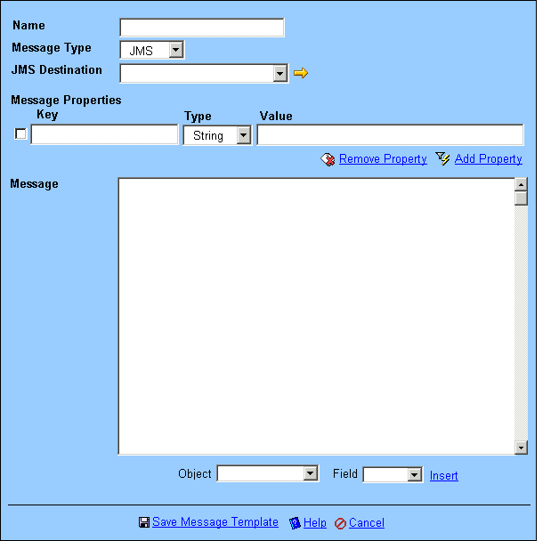
Figure 1 Message Template configuration for JMS

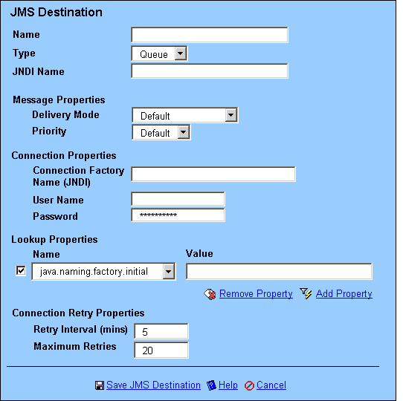
Figure 2 JMS Destination Configuration

- Processing
  - Operations
      - Create Message Template
- If message type is JMS, the Message Template will be linked to the UID of the JMS Destination
      - Update Message Template
- If previous message type is JMS but new message type is not, the link to UID of JMS Destination record will be removed from the Message Template. Message Properties will also be cleared from the Message Template.
- If previous message type is not JMS but new message type is JMS, the Message Template will now link to the UID of the JMS Destination
- If both previous and new message type are JMS, update the link to the UID of the new JMS Destination.
      - Delete Message Template
- If message type is JMS, deleting the Message Template will not affect the JMS Destination
      - Retrieve Message Template
- If message type is JMS, the UID of the linked JMS Destination will be retrieved and returned in the Message Template entity.
      - Create JMS Destination
- If Maximum Retries <> 0, a new JMS retry timer (identified by JMS destination name) will be added to retry sending JMS messages that failed to send out
      - Update JMS Destination
- The existing JMS retry timer will be modified according to current settings
- If the Maximum Retries = 0, the existing JMS retry timer will be deleted
- If the Maximum Retries <> 0 and there is no existing JMS retry timer, one will be added to the database
      - Delete JMS Destination
- The existing JMS retry time will be deleted as well, if any
      - Retrieve JMS Destination
      - Send JMS Alert message
- A new Alert action handler will be added for JMS
- The handler will not support alert attachment
- Field substitution is only supported for Message field
- A JMS TextMessage will be sent out to the configured JMS Destination
- The Message will be persisted as physical file if the Message fails to send due to any of the following reasons:
        - Fail to lookup Connection Factory
        - Fail to create a connection to the JMS server
        - Fail to lookup Destination
        - Fail to create JMS Session
        - Fail to create Message Producer
        - Send message results in exception
- The persisted physical file must be identifiable by the Name of JMS Destination, and keeps track of the retry count
      - Retry sending JMS Alert message
- The retry timer for each JMS Destination will run every Retry Interval configured for that JMS Destination
- On each retry, the JMS alert action handler will look for those persisted message files for the JMS Destination
- For each message file
        - The handler attempts to send the message again
        - If the message is sent successfully, the message file will be deleted
        - Otherwise, the retry count for the message file will be incremented by one
        - If retry count exceeds maximum retries (-1 is considered no limit) for that JMS Destination,
          - The message is moved to failed folder
          - The retry timer is cancelled/deleted

- Data Model
  - Add New Entity: JmsDestination
      - UID
- Type: Long
      - NAME
- Type: String
- Length: 30
      - TYPE
- Type: Integer: 1=‘Queue’, 2=‘Topic’
      - JNDI_NAME
- Type: String
- Length: 255
      - DELIVERY_MODE
- Type: Integer: 0=’Default’, 1=’Persistent’, 2=’Non-Persistent’
      - PRIORITY
- Type: Integer: -1=’Default’, 0=’0’, 1=’1’, …, 9=’9’
      - CONNECTION_FACTORY_JNDI
- Type: String
- Length: 255
      - CONNECTION_USER
- Type: String
- Length: 30
      - CONNECTION_PASSWORD
- Type: String
- Length: 30
      - LOOKUP_PROPERTIES
- Type: Property String (save as ‘Text’, retrieve as Properties)
      - RETRY_INTERVAL
- Type: Integer
      - MAXIMUM_RETRIES
- Type: Integer
  - Modify Entity: MessageTemplate
      - MESSAGETYPE
- Add new type: ‘JMS’
      - JMS_DESTINATION
- Type: Long
- Link to UID of JmsDestination entity
      - MESSAGE_PROPERTIES
- Type: Xml Text (save as ‘Text’, retrieve as collection of MessageProperty)
  - Add embedded entity: MessageProperty
      - KEY
- Type: String
- Length: 50
      - TYPE
- Type: int: 1=’Boolean’, 2=’Byte’, 3=’Double’, 4=’Float’, 5=’Int’, 6=’Long’, 7=’Short’, 8=’String’
      - VALUE
- Type: String
- Length: 255

Sequence Diagrams

- Trigger Alert Notification – JMS message type
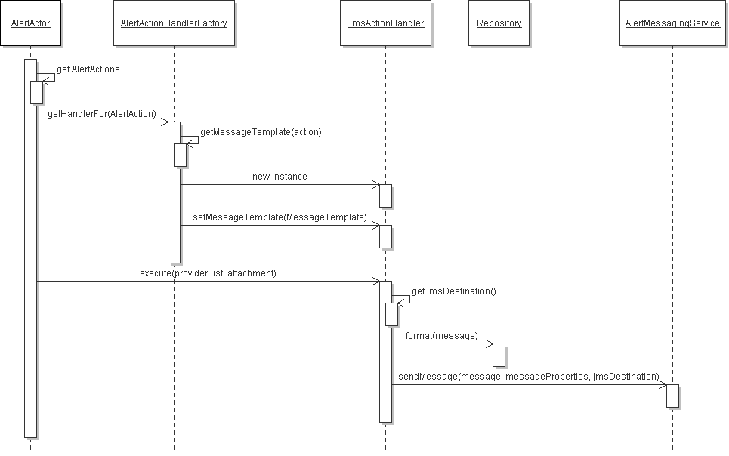
- Send JMS Alert Message
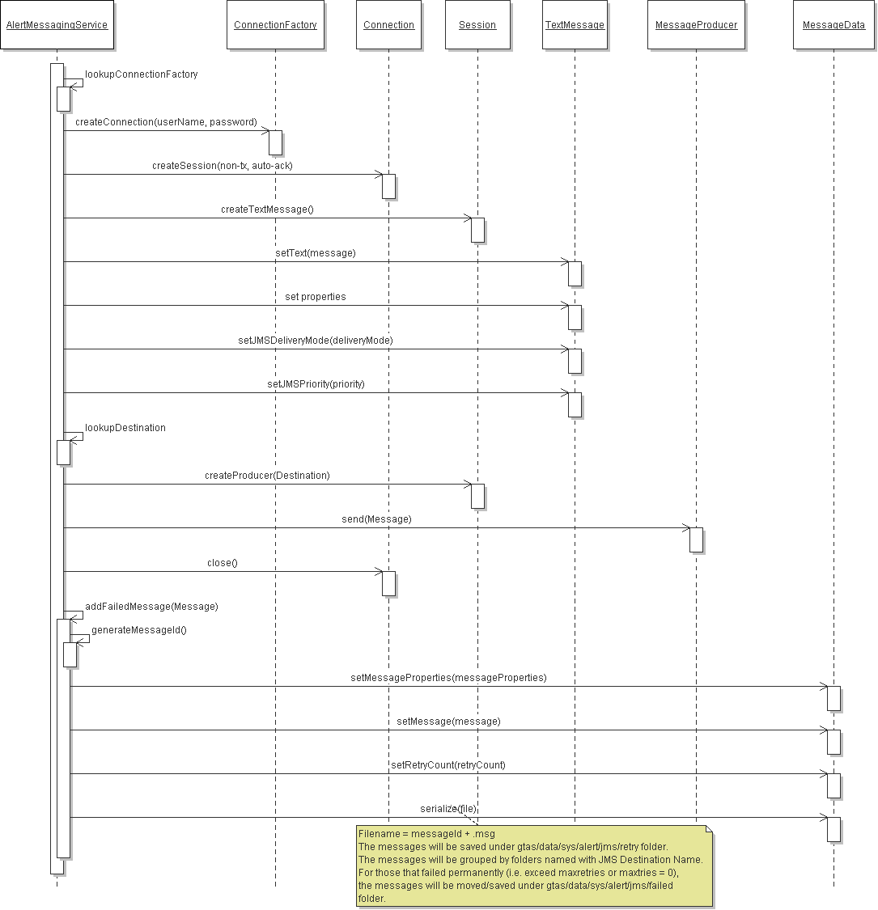
- Retry Send JMS Alert Message
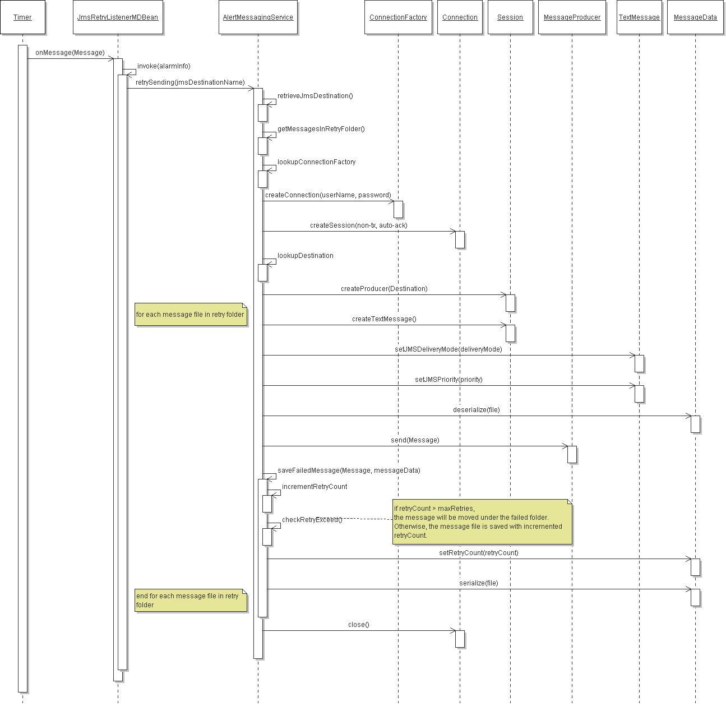
Class Diagrams

