GridTalk 4.0 Enhancement : Support multiple Doc Type for AS2 Document (EDI-X12 & EDI-FACT)
Proposed by: Tam Wei Xiang
Date: 27 Aug 2008

Purpose
This enhancement aim to resolve the limitation on the AS2 module which we are only allowed to receive one type of document from the same TP (for example if we need to apply different mapping rule). This is due to we explicitly set the incoming AS2 Document type as “AS2 Message”. Thus, the incoming document can only go through the same partner function meaning we can't apply different mapping rule to the document.

As the user of GTAS usually make use of the AS2 module to transfer EDI document, we will perform the content scanning on the incoming document to determine the corresponding document type in GTAS. This enable the GTAS to trigger different partner function.

New Screenshot
The following “AS2 Doc Type Mapping” list view page will be added under the tab “Mapping”.
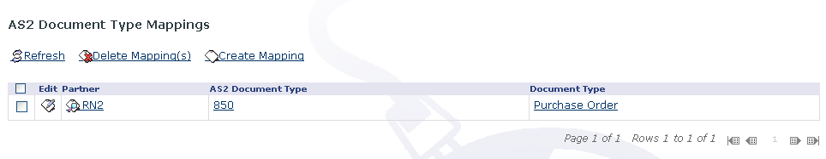Illustration 1: AS2 Doc Type List View Page
The following “AS2 Doc Type Mapping” page will be displayed after user click on the “Create Mapping” link in the list view page.

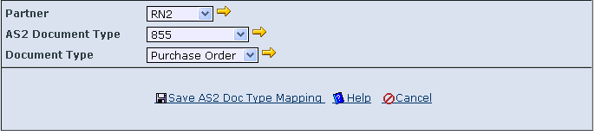Illustration 2: Edit AS2 Doc Type Mapping screen

The following “AS2 Doc Type Mapping” page will be displayed after user click on the “Edit” link in the list view page.

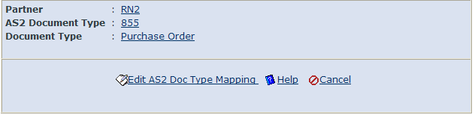Illustration 3: View AS2 Doc Type Mapping Screen

New Backend model

New Entity
Define entity (“AS2DocTypeMapping”) under package com.gridnode.gtas.server.document.model with the following instance variable

as2DocType: String, 30 VARCHAR
docType: String, 30 VARCHAR
partnerID: String 20 VARCHAR

partnerID and as2DocType formed a unique key.

Entity bean is also needed to be added. The corresponding FMI, and its SQL script.

Add Entity Handler
Define entity handler (“AS2DocTypeMappingEntityHandler”) under package com.gridnode.gtas.server.document.helpers..

This class handle the CRUD of the “AS2DocTypeMapping” entity.

Modify DocumentManagerBean
Add the following method in com.gridnode.gtas.server.document.facade.ejb.DocumentManagerBean

public AS2DocTypeMapping findAS2DocTypeMappingByUID(Long uid)
public Collection findAS2DocTypeMappingByFilter(IDataFilter filter)
public void addAS2DocTypeMapping(AS2DocTypeMapping mapping);
public void deleteAS2DocTypeMapping(Long uid);
public void updateAS2DocTypeMapping(AS2DocTypeMapping docTypeMapping)

Modify AS2MessageHandler
Modify the following method in com.gridnode.gtas.server.document.handlers.AS2MessageHandler

New logic to determine AS2 document Type (Only for EDI-X12 and EDI-FACT)
We will add in the logic to determine the AS2 document type by parsing the document content of EDIFact and EDI X12.

Some sample of the AS2 document type for EDI-X12 includes “855” (Purchase order), “835” (Electronic Remittance).

Some sample of the AS2 document type for EDI-FACT includes “PAYORD” (Payment Order), “INVOIC” (Invoices). The AS2 Doc type is formed with 6 characters.

Refer to the section “Extract AS2 Doc Type from EDI-X12” and “Extract AS2 Doc Type from EDI-FACT”for extracting the EDI-X12, EDI-FACT respectively .

Map from AS2 Doc Type to GTAS Doc Type
protected void processReceivedRequest(..... .... ....)

We will add in the logic to determine the mapping from AS2DocType to GTAS internal representative doc type.

NOTE:
If we can not find the corresponding mapping (REGARDLESS whether we can't determine the document type for example it is non EDI document or we encounter exception in extracting the AS2 Doc type), we will follow the existing logic which use “AS2 Message” as the document type.

CRUD for the AS2DocTypeMapping
Refer the “ProcessMapping” entity for the list of “Action”, “Event” that is required for the user to perform CRUD for the AS2DocTypeMapping.

Put under package com.gridnode.gtas.server.document.actions

Shared by Client Tier and BL Tier
Define the Accessible FieldID class and FieldID interface under package com.gridnode.gtas.model.document

UI

Represent entity in client tier
Define entity (“DefaultAS2DocumentTypeMappingEntity”), interface (“IGTAS2DocumentTypeMappingEntity”) class under package com.gridnode.gtas.client.ctrl

Define new entity entry
Add new entry under com.gridnode.gtas.client.ctrl.IGTEntity

Manager for client tier entity
Define manager (“DefaultAS2DocumentTypeMappingManager”), interface (“IGTAS2DocumentTypeMappingManager”) under package com.gridnode.gtas.client.ctrl

1 day

Define new manager entry
Add new entry under com.gridnode.gtas.client.ctrl.IGTManager and com.gridnode.gtas.client.ctrl.DefaultGTManagerFactory

Strut Form
Define strut form “AS2DocTypeMappingAForm” under package com.gridnode.gtas.client.web.document

Renderer
Define renderer “AS2DocTypeMappingRenderer” under package com.gridnode.gtas.client.web.document

DispatchAction
Define “AS2DocTypeMappingDispatchAction” under package com.gridnode.gtas.client.web.document.

HTML page
Define “edit-as2DocTypeMapping.html”, “view-as2DocTypeMapping.html” under folder GTAS\GridTalk\web\web-inf\pages\document

UI validation
Warn user if one or more field is not specified by user.

Additional stuff

Export AS2DocTypeMapping entity
Modify configuration file GTAS\GridTalk\conf\server\default\exportable-entities.xml to add in the entry for exporting AS2DocTypeMapping.

Entity Dependence check
DocumentType and Partner can't be deleted if there is reference in “AS2 Doc Type Mapping”.

1) Define EntityDependencyChecker under package com.gridnode.gtas.server.document.helpers which perform checking on the dependency from AS2DocTypeMapping to Partner and DocumentType.

2) Modify file GTAS\GridTalk\conf\server\default\dependency\dependency-DocumentType.xml and dependency-Partner.xml to include the above dependency checker.

Extract AS2 Doc Type from EDI-FACT
The EDI-FACT document containing a few segments. The pair of segments formed an envelope for example UNH/UNT formed the “MESSAGE” envelope and “UNB/UNZ” formed the “INTERCHANGE” envelope.

There is an optional segment “UNA” which will indicate the information regarding the separators for example “segment terminator”, “data element delimiter”. If such segment is exist, we will extract the necessary delimiters/terminator.

Seperator | Character of UNA | Def value if no “UNA” segment
Component Element Separator | 4th | :
Data Element Separator | 5th | +
Decimal Notation | 6th | . or ,
Release Character | 7th | ?
Repetition Character | 8th | Space
Segment Separator | 9th | '

Some customer TP may not exactly follow the above convention for example they ignored the “Repetition Character” without specifying the space. Thus we only have 8 characters including the “UNA” segment instead of the default 9 characters.

In our case, we just need to determine the “segment” separator and “data element” separator.

The doc type for EDI-FACT is under the segment “UNH” as follow. The “DESADV” is the doc type.

UNA:+.?'
UNB+UNOA:1+AP-MEMC:ZZ+STMZ:ZZ+070309:1620+20070309162010'
UNH+20070309162010+DESADV:D:97A:UN:EDDS05'

NOTE that the segment can be chained up together into one line instead of formatting nicely into next line.

Extract AS2 Doc Type from EDI-X12
The EDI-X12 document also containing a few segments. The segment identifier usually formed with 2 ~ 3 characters for example “ISA”, “GS”, “ST”, “BHT”.

There is a segment “ISA” that contain the information regarding the separators.

Separator | Charater | FYI
Data Element Separator | 4th
Segment Separator | 106th | Some TP may not indicate this character, thus we assume that the next segment is located in the next line.

We can identify the AS2 Doc Type under the segment “ST”. See following for the snippet of EDI-X12 document.

ISA*00* *00* *ZZ*AMTEK *14*003897733SAP *070817*2113*U*00401*000002734*0*P*>~
GS*PR*AMTEK*ESGAP*20070817*2113*770*X*004010~
ST*855*4344~
BAK*06*AD*32F2H04010*20070817****0005035637*20070817~

The “855” is the doc type.

NOTE that the segment can be chained up together into one line instead of formatting nicely into next line.

TO BE CONFIRMED
The segment seperator may not exist, if so, we assume the next segment is on next line

http://www.gxs.com/pdfs/Tutorial/Tutor_EDIFACT_GXS.pdf
http://msdn.microsoft.com/en-us/library/bb226404.aspx

