**MP2-Multi-Programming**

**Deadline : 2014/11/17 23:59**

* **Setting**

Copy MP1 to a new folder

cp –r NachOS-4.0_MP1 NachOS-4.0_MP2

* **Goal**

The NachOS doesn’t support multi-programming now, you have to modify the code to make NachOS support it.

Without multi-programming

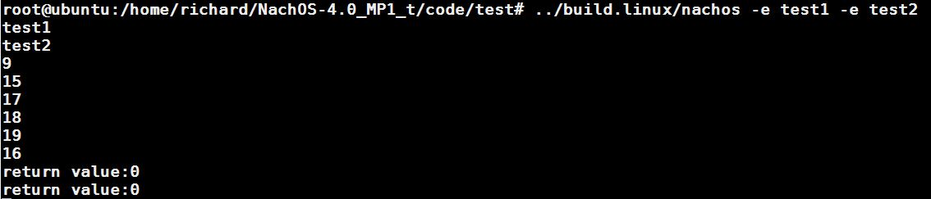

After implement multi-programming

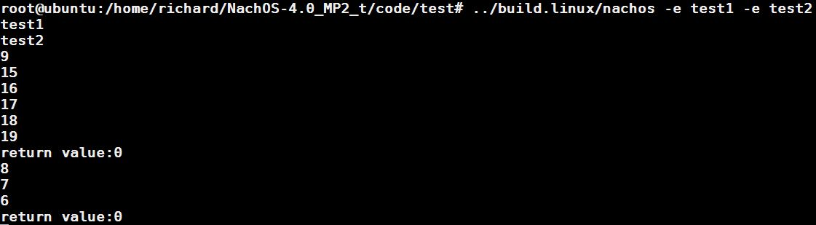

* **Hint**

The following files “may” be modified…

1. userprog/addrspace.*
2. threads/kernel.*

* **Compile**

1. cd $NachOS_home/code/build.linux
2. make

* **Grading**

1. **Demo 60%**

Implement multi-programming & upload the code to server before deadline

Execute “../build.linux/nachos –e test1 –e test2” correctly

1. **Trace code 25%**

Explain how a thread go through in NachOS and other detail

Filename : MP2_trace_[yourGroupNumber].pdf

Upload to iLMS

1. **Report 15%**

Explain how you modified the code & group contribution

Filename : MP2_code_[yourGroupNumber].pdf

Upload to iLMS