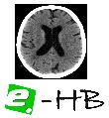 | The 6th IEEE International Conference on E-Health and Bioengineering - EHB 2017  Grigore T. Popa University of Medicine and Pharmacy, Sinaia, Romania, June 22-24, 2017 | 
Ultra-Short-Term Heart Rate Variability Analysis on Accelerometric Signals from Mobile Phone
Wearable systems and sensors, m-health and p-health systems
Biosignal processing

Abstract- The feasibility of measuring stress-related parameters by ultra-short variability (USV) indices (SDNN and RMSSD) calculated from the ballistocardiographic signal acquired by the mobile phone accelerometers (m-BCG) positioned on the navel was tested, and its accuracy compared with gold standard ECG-derived indices. The m-BCG was acquired in six healthy volunteers (mean age 22±1 years) while in supine position, during spontaneous breathing (CTRL) and during 1 minute of mental stress (MS) induced by arithmetic serial subtraction task. Beat occurrence was independently and automatically extracted from both ECG and m-BCG signals, to compute USV parameters in 30 s intervals, during both the CTRL and MS phases. Linear regression and Bland-Altman analyses between RR series and m-BCG derived beat-to-beat measurements (JJ series) showed very high correlation (r²>0.97), no bias, and narrow limits of agreement (±2SD < ±34 ms) for both CTRL and MS. A significant decrease (p=0.03 Wilcoxon test) in beat duration, SDNN and RMSSD was found in MS compared to CTRL, in both RR and JJ variability series, underlying the ability of m-BCG in capturing the decrease in parasympathetic tone in agreement with the induced stimulus.
Keywords: smartphone accelerometers; seismocardiography; ballistocardiography; ultra-short heart-rate variability; self-monitoring.
Introduction
By 2020, the smartphone users around the globe are estimated to reach 2.87 billions [1]. As in other fields, also in medicine the introduction of smartphone and tablets is influencing the way healthcare is provided [2]. Smartphones have both communication and computational capabilities thanks to powerful processors, embedded sensors, web and wireless connectivity and high-resolution touch screen that let the users to interact with. In this rapidly evolving context, healthcare industry and biomedical research are developing health applications, such as smartphone related technology solutions, for the acquisition and analysis of vital parameters (i.e. heart rate, blood pressure, oxygen saturation and respiration) to be used for medical purposes or well-being [3]. This also opens new scenarios in which smartphone’s users can be provided by a personal assistant device that could measure, store and monitor physiological data, or transfer it to a telemedicine center for a proper analysis by a specialist.
Recent studies [4]–[6] have demonstrated the possibility of recording the heart-beat induced vibrations, by means of the 3-axial accelerometer once the smartphone is positioned properly on the body, whose morphology depends on where the smartphone is positioned. If the device is positioned in proximity to the center of mass of the body, the signal will show the characteristic morphology of the ballistocardiographic (BCG) signal, with its specific systolic waves (H, I, J and K) [7]. On the other hand, if it is in proximity of the cardiac apex or on the sternum, the signal will resemble the seismocardiogram (SCG), with the characteristic peaks (IVC and AO, corresponding to isovolumetric contraction and aortic opening, respectively) relevant to the systolic phase [8]. To differentiate from signals acquired by specific accelerometric sensors, we will define as mobile-BCG (m-BCG) and mobile-SCG (m-SCG) those ones acquired by using a mobile phone.
By implementation of suitable processing algorithms, the proper identification of main peaks on these accelerometric signals allows to extract the beat-to-beat time series, as conventionally performed on the ECG to detect the R-wave.
The analysis of heart rate variability (HRV), both in time and frequency domains, represents a consolidated noninvasive method usually applied to the RR beat-to-beat series to evaluate the sympatho-vagal balance of the autonomous nervous system (ANS) on the cardiorespiratory system [9]. Ramos-Castro et al [4] proved the feasibility of applying short-term HRV analysis on beat-to-beat series obtained from 5 minutes of m-SCG signal. When acquiring the m-BCG or m-SCG, the main limitation is keeping in position the mobile phone for such a long time, thus making difficult the standard HRV analysis on such signals. For ECG-derived HRV analysis, the interest in using very short recordings (<5 minutes, even up to 10 sec) is emerging in the recent years, leading to the extraction of ultra-short variability (USV) indices in the time domain, able to characterize the sympatho-vagal balance in different circumstances [10]-[12], especially when acquisition time is restricted.
We hypothesized that beat-to-beat series extracted from m-BCG or m-SCG could be suitable for USV analysis. Accordingly, our aim was to test the feasibility of detecting changes in ANS sympatho-vagal state provoked by mental task by extracting beat-to-beat occurrence series from m-BCG, computing USV parameters and comparing results with the USV analysis of the conventional RR series, considered as the gold standard.
MATERIALS AND METHODS
- Study Population and Experimental Set-up
Six healthy volunteers took part in this pilot study (age 22±1; BMI 23±3 kg/m²; 3 males). The experimental procedures described in this paper were in agreement with the ethics defined in the Helsinki Declaration of 1975, as revised in 2000.
The experimental set-up is similar to the one designed and used in a previous study [13]. In detail, a smartphone (iPhone 6s; sampling frequency fs=100 Hz) positioned approximately on the belly near the navel was used to acquire the m-BCG. The device was aligned with its top towards the head. The subject laid in supine posture on a rigid support positioned over a multicomponent biomechanical force plate (Type 9286B, Kistler®) based on 3D piezoelectric load cells. The system allowed to obtain the 3-component ballistocardiographic signal (BCG, fs=960 Hz), and simultaneously, the 3-lead ECG (fs=2048 Hz) was acquired. ECG and BCG signals were synchronized using a squared wave generated by a function generator, while the BCG and the smartphone were synchronized by a force impulse applied on the subject shoulder that produced a motion artifact sensed by both systems. The three orthogonal components of the BCG and m-BCG corresponded to left-to-right (LR), head-to-foot (HF) and antero-posterior (AP) directions, respectively.
The protocol included: a) 3-minute control stage, during spontaneous breathing (CTRL) and b) 1 minute of mental stress (MS) condition induced by arithmetic serial subtraction task.
- Preprocessing
As the LR component of the BCG mainly records the lateral force impulse, it was used to synchronize the m-BCG with the BCG. Consequently, the m-BCG and the ECG resulted synchronized through the force-plate system.
The AP and HF components of the m-BCG were selected for the subsequent analysis. The accelerometric components were band-pass filtered with 4th order Butterworth filter (AP band pass: 5-25 Hz; HF band pass: 1-25 Hz). This step allowed to remove out-of-band noise and breath related motion artifacts. Different band pass ranges were applied in order to enhance, in AP direction, the chest wall vibrations due to the acoustic waves and to retain the body acceleration due to the recoil forces, along the HF direction.
- Fiducial points detection and algorithm performance
The R peak positions were detected on the ECG signal using a wavelet-based ECG delineator [14] from which the RR series was extracted and considered as the gold standard for comparison purposes with m-BCG.
In this study, the BCG nomenclature (I, J and K) for the detection of the systolic waves was adopted also for the m-BCG. As the J wave appears as the most prominent wave compared to the I and K waves, it was considered as the easiest fiducial point to be detected on the m-BCG.
To detect the J fiducial points on the m-BCG, an algorithm based on template matching technique was applied as following:
- the signal was divided into 30s segments;
- for each segment, a template of the systolic complex (IJK) was extracted within the first 10s. This template corresponded to a fixed window of 400 ms duration, centered at the absolute maximum found within the first 10s, which is supposed to correspond with a J peak, assuming to be in a noise-free segment (Figure 1, top).
- once the template is extracted, a cross-correlation between this template and the m-BCG signal segment was computed (Figure 1, bottom);
- IJK complexes are then identified from this cross-correlation function, corresponding to maximum values (a threshold in this cross-correlation was defined). The points in correspondence with the maximum values ​​of cross-correlation were considered as the central points of the windows used to search precisely the J peak, defined as the wave with the maximum amplitude (Figure 2).
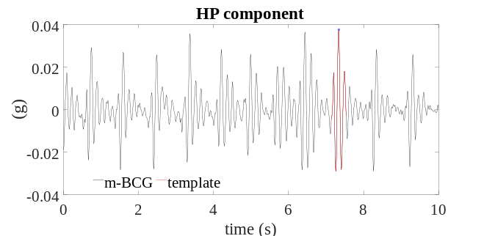
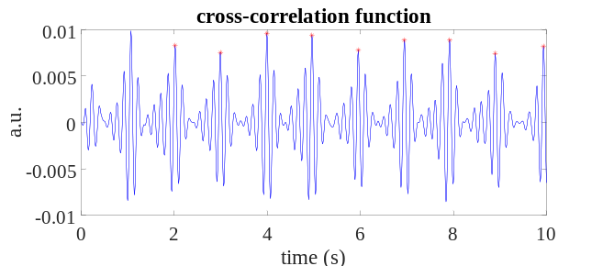
Figure 1 (Top) On the HP component, for each 30s segment, within the first 10s the absolute maximum (blue dot) is identified and used as the central point of the template. The template (red) corresponded to the IJK systolic complex with 400 ms duration. The m-BCG signal is in g, where 1g corresponds to 9.8 m/s². (Bottom) The cross-correlation function is represented with its maximum peaks superimposed (red dots).
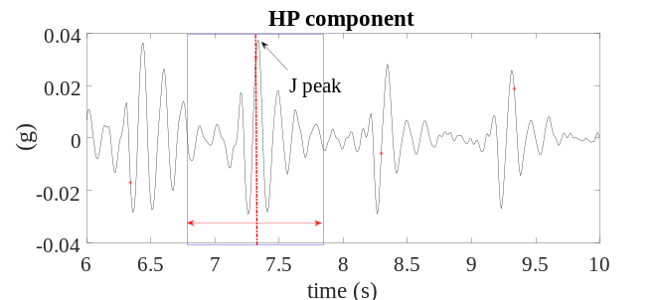
Figure 2. Procedure for fiducial peaks detection on the m-BCG signal. Each cross-correlation maximum point (red dots) was used to create a window (blue rectangle) in which to search for the J peak (the most prominent peak). The length of the window is calculated taking into consideration the mean of the previous heart beats durations.
After J wave identification in both AP and HF components, the JJ beat duration series, defined as the distance between two consecutive J waves, were computed resulting in the JJ^{AP} and JJ^{HF} time series, respectively. Furthermore, the algorithm was designed to automatically select the optimum JJ time series (JJ^{OPT}) considered as the one with the minimum mean square deviation with respect to a 5th polynomial that fits the data.
All the J peaks were visually inspected together with ECG annotations in order to check for possible misdetections and categorized in true positive (TP) as peaks in the correct position; false positive (FP) as double detection or incorrect position, false negative (FN) as missing peak. The FP and FN peaks were manually corrected before the USV analysis.
First, it was evaluated if the detection algorithm obtained an equivalent number of J with respect to R peaks. The JJ series were discarded if the manual correction of J peaks was not feasible. The feasibility was considered as the percentage of number of JJ series retained for the processing. The algorithm sensitivity ratio (1) was calculated as:
TABLE I
RR AND JJ^{OPT} DURATIONS IN CONTROL (CTRL) AND DURING MENTAL STRESS (MS)
 | RR (ms) | JJ^{OPT} (ms)
CTRL | 865  (810 ; 889) | 865  ( 810 ; 889 )
MS | 702 *  (577 ; 818) | 697 *  (581 ; 815)
Durations are expressed in median (25th; 75th percentiles)
*: p=0.03 Wilcoxon test CTRL vs MS

TABLE II
SDNN AND RMSSD PARAMETERS OF USV ANALYSIS FROM RR AND JJ^{OPT} SERIES

 | RR (ms) |  | JJ^{OPT} (ms)
 | SDNN | RMSSD | SDNN | RMSSD
CTRL (30 s) | 59  (52 ; 66) | 56  (44 ; 66 ) | 62  ( 53 ; 64) | 59  (47 ; 69 )
MS (30 s) | 35  ( 28 ; 46) | 29 *  (12 ; 48 ) | 37  ( 28 ; 46 ) | 29 *  (15 ; 47)
SDNN and RMSSD in median (25th; 75th percentiles)
*: p=0.03 Wilcoxon test control (CTRL) vs mental stress (MS)

$${\text{se}}_{\text{\%}}\text{=}\frac{\text{TP}}{\text{TP+FN}} (1)$$
and the accuracy (2) of the detection algorithm as:
$${\text{Acc}}_{\text{\%}}\text{=}\frac{\text{TP}}{\text{FP+FN+TP}} (2)$$
- Ultra-short heart rate variability
After correction of misdetected beats and artifacts from the beat-to-beat series, the following time domain USV features were calculated using the central 30 s segment of CTRL and MS stages, from both the RR and the JJ^{OPT} series: the standard deviation of the normal-to-normal intervals (SDNN) and the root mean square of successive difference of intervals (RMSSD).
- Statistical analysis
Linear correlation and Bland-Altman analyses were performed to define the accuracy of the detected beat-to-beat intervals from JJ^{OPT} with respect to the RR series. The presence of significant bias was verified by paired t-test against null values. Non-parametric Wilcoxon paired test was used to analyze the difference between CTRL and MS condition, to verify significant differences in ANS sympatho-vagal status.
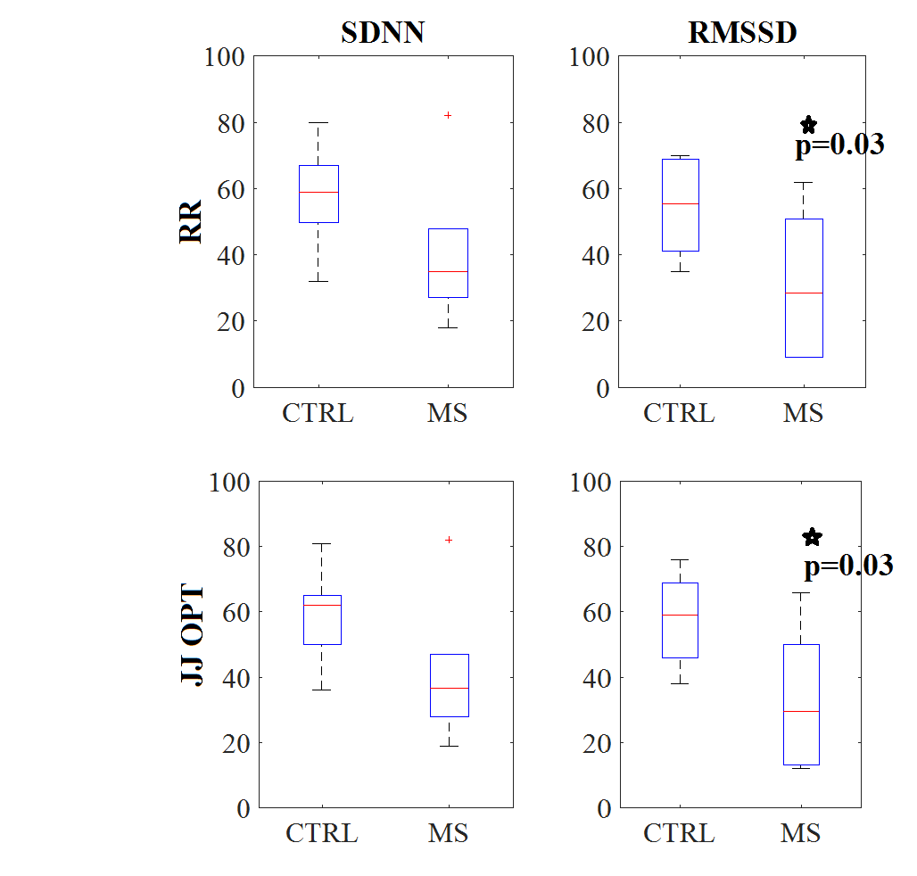
Figure 3. (top) Boxplots for RR series for USV indices , SDNN and RMSSD, in CTRL and MS stages. (bottom) Boxplots for JJ^{OPT} series for USV indices , SDNN and RMSSD, in CTRL and MS stages. *:p=0.03 Wilcoxon test CTRL vs MS

RESULTS
The feasibility was 83% in CTRL, 67% in MS, when considering only the HF component, while it reached the 100% with AP component in both stages. A 100% feasibility was obtained when the algorithm automatically chose for the best of both (i.e. all signals from the 6 subjects were available for processing).
For both CTRL and MS, the algorithm accuracy and sensitivity in properly detecting the heartbeats on m-BCG signal was > 98% compared to the gold standard R-wave detection.
Linear regression and Bland-Altman analyses between RR and JJ^{OPT} series showed very high correlation (r²: CTRL=0.985; MS=0.984), no bias, and narrow limits of agreement (±2SD: ±32 ms in CTRL; ±34 ms in MS).
The MS condition induced a significant decrease in beat duration compared to CTRL as evident in both RR and JJ^{OPT} series (see Table I). Also, no significant differences in SDNN and RMSSD parameters calculated from the RR and JJ^{OPT} series were found, and RMSSD was significantly decreased in MS with respect to CTRL (see Table II) and Figure 3.

DISCUSSION AND CONCLUSION
Automated heart beat duration estimation from the m-BCG signal recorded at navel level was feasible. The developed algorithm was able to detect the J peaks that were used to estimate the beat-to-beat duration time series for further USV analysis, both in control and during mental stress, with high accuracy when compared to the gold standard RR measures, derived from ECG.
In this pilot study, we focused on testing feasibility to detect changes in ANS provoked by the applied MS condition using very short recordings (30 sec) by means of USV analysis. From the obtained results, despite computed in a reduced sample of only 6 subjects, the capability to derive the USV parameters from the smartphone accelerometer signals was confirmed. Furthermore, the mental number subtraction exercise induced a significant decrease in the average beat duration, SDNN and RMSSD parameters, visible both in ECG and m-BCG derived variability series, underlying a significant decrease in parasympathetic activation in agreement with the induced stimulus.
Therefore, m-BCG resulted to be accurate in rest condition and sensitive enough to accurately detect stimulus-specific modifications.
Once confirmed in a larger number of subjects, a 30 sec m-BCG acquisition could be considered as an easy, non-invasive way for the self-evaluation of stress using accelerometers already embedded in the mobile phone. This technology could have potential benefits in both cardiac disease prevention and self-assessment of patients with chronic disease, where simple but effective measurement tools are needed to have reliable at-home measurements managed directly by the patient himself.

Acknowledgment
This research was supported by the Italian Space Agency (contract 2013-064-R.0, PI E.G. Caiani).

References

[1] “Number of smartphone users worldwide 2014-2020,” Statista. [Online]. Available: https://www.statista.com/statistics/330695/number-of-smartphone-users-worldwide/. [Accessed: 03-Mar-2017].
[2] E. Ozdalga, A. Ozdalga, and N. Ahuja, “The Smartphone in Medicine: A Review of Current and Potential Use Among Physicians and Students,” J. Med. Internet Res., vol. 14, no. 5, Sep. 2012.
[3] N. Bruining, E. Caiani, C. Chronaki, P. Guzik, and E. van der Velde, “Acquisition and analysis of cardiovascular signals on smartphones: potential, pitfalls and perspectives By the Task Force of the e-Cardiology Working Group of European Society of Cardiology,” Eur. J. Prev. Cardiol., vol. 21, no. 2 suppl, pp. 4–13, Nov. 2014.
[4] J. Ramos-Castro et al., “Heart rate variability analysis using a seismocardiogram signal,” in 2012 Annual International Conference of the IEEE Engineering in Medicine and Biology Society, 2012, pp. 5642–5645.
[5] C. Gavriel, K. H. Parker, and A. A. Faisal, “Smartphone as an ultra-low cost medical tricorder for real-time cardiological measurements via ballistocardiography,” in 2015 IEEE 12th International Conference on Wearable and Implantable Body Sensor Networks (BSN), 2015, pp. 1–6.
[6] J. Hernandez, D. J. McDuff, and R. W. Picard, “Biophone: Physiology monitoring from peripheral smartphone motions,” in 2015 37th Annual International Conference of the IEEE Engineering in Medicine and Biology Society (EMBC), 2015, pp. 7180–7183.
[7] J. W. Gordon, “Certain Molar Movements of the Human Body produced by the Circulation of the Blood,” J. Anat. Physiol., vol. 11, no. Pt 3, pp. 533–536, Apr. 1877.
[8] J. M. Zanetti and D. M. Salerno, “Seismocardiography: a technique for recording precordial acceleration,” in Computer-Based Medical Systems, 1991. Proceedings of the Fourth Annual IEEE Symposium, 1991, pp. 4–9.
[9] “Heart rate variability: standards of measurement, physiological interpretation and clinical use. Task Force of the European Society of Cardiology and the North American Society of Pacing and Electrophysiology,” Circulation, vol. 93, no. 5, pp. 1043–1065, Mar. 1996.
[10] M. L. Munoz et al., “Validity of (Ultra-)Short Recordings for Heart Rate Variability Measurements,” PLOS ONE, vol. 10, no. 9, p. e0138921, set 2015.
[11] M. R. Esco and A. A. Flatt, “Ultra-Short-Term Heart Rate Variability Indexes at Rest and Post-Exercise in Athletes: Evaluating the Agreement with Accepted Recommendations,” J. Sports Sci. Med., vol. 13, no. 3, p. 535, Sep. 2014.
[12] E. Karp, A. Shiyovich, D. Zahger, H. Gilutz, A. Grosbard, and A. Katz, “Ultra-Short-Term Heart Rate Variability for Early Risk Stratification following Acute ST-Elevation Myocardial Infarction,” Cardiology, vol. 114, no. 4, pp. 275–283, Oct. 2009.
[13] F. Landreani et al., “Feasibility study for beat-to-beat heart rate detection by smartphone’s accelerometers,” in E-Health and Bioengineering Conference (EHB), 2015, 2015, pp. 1–4.
[14] J. P. Martinez, R. Almeida, S. Olmos, A. P. Rocha, and P. Laguna, “A wavelet-based ECG delineator: evaluation on standard databases,” IEEE Trans. Biomed. Eng., vol. 51, no. 4, pp. 570–581, Apr. 2004.

