Andrew Mackay

Comp 210

ID: 3441988

Unit 3: Accessing and learning a free online graphics program

After downloading the free photo editing software “Gimp” version 2.10.28 I then watched 2 brief tutorials on using this software. I have previous experience with GIMP when I was more into photography as I learned that the full version of “Photoshop” is quite expensive. There are also a few other editing Apps I had used on my phone that were similar in nature to this which also helped with my experience, even though these are only simple changes to make.

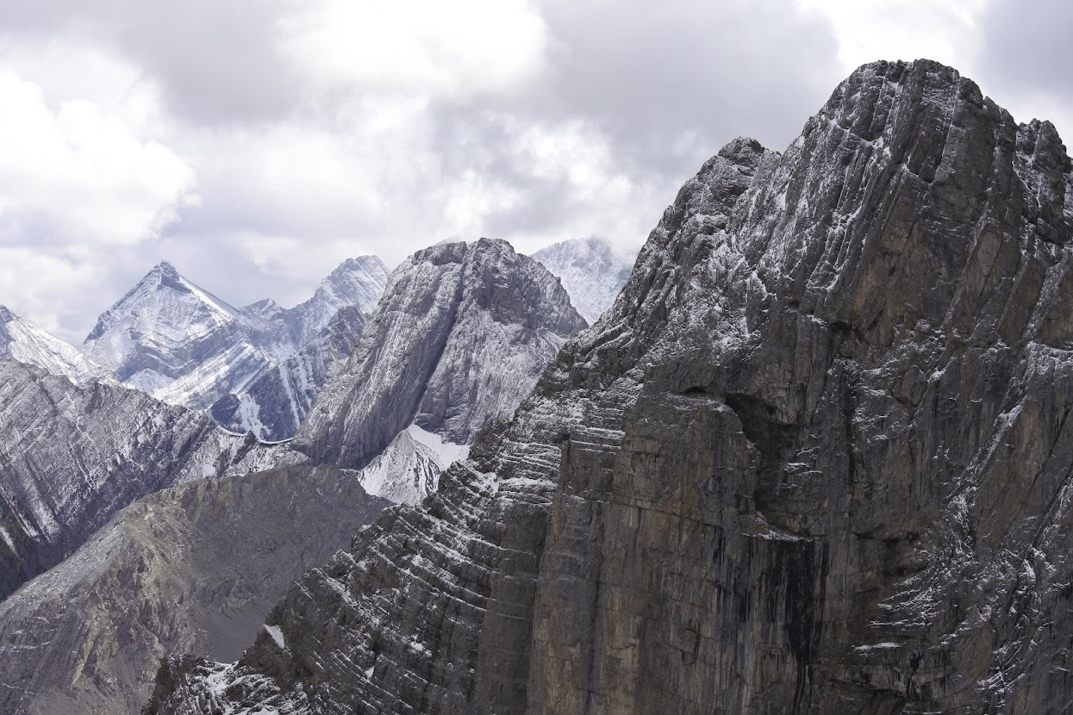

Image 1, unedited. Taken on Tent Ridge mountain, Alberta Canada in early October 2021.

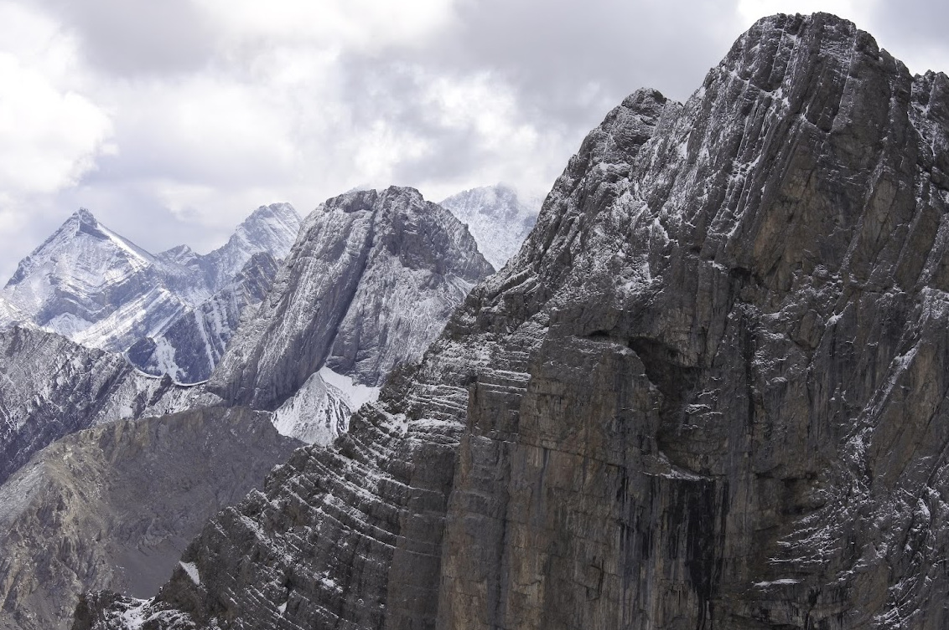

This is a cropped version of the first image and changed from .NEF file type to Jpg.

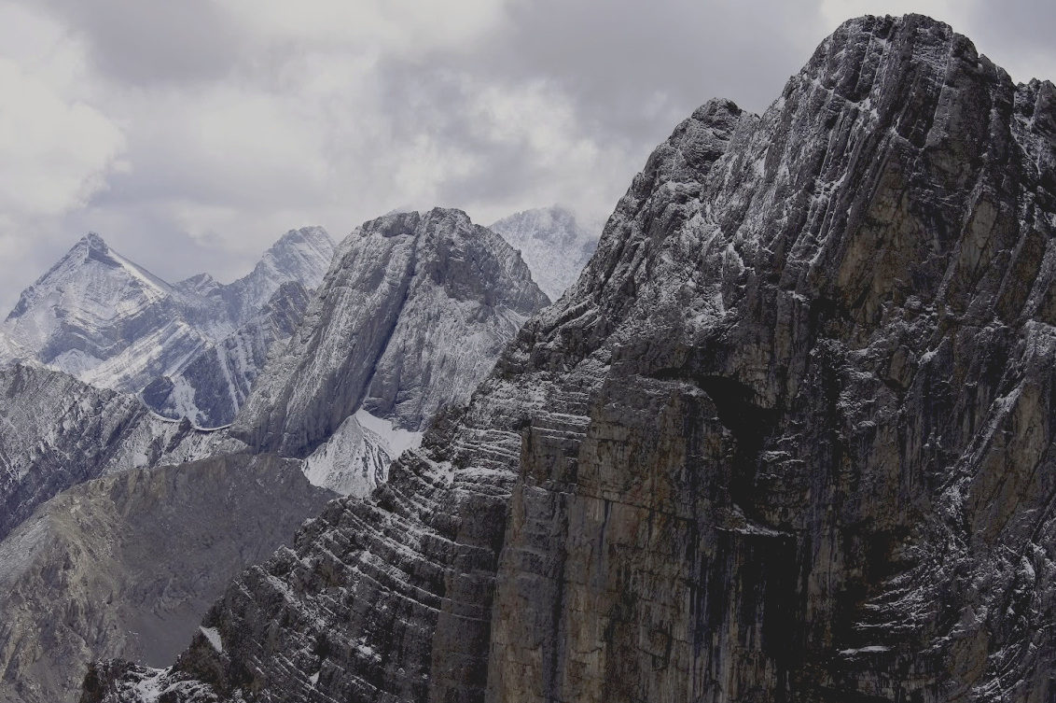

This is the same cropped image but with altered brightness and contrast, plus shadows and highlights.

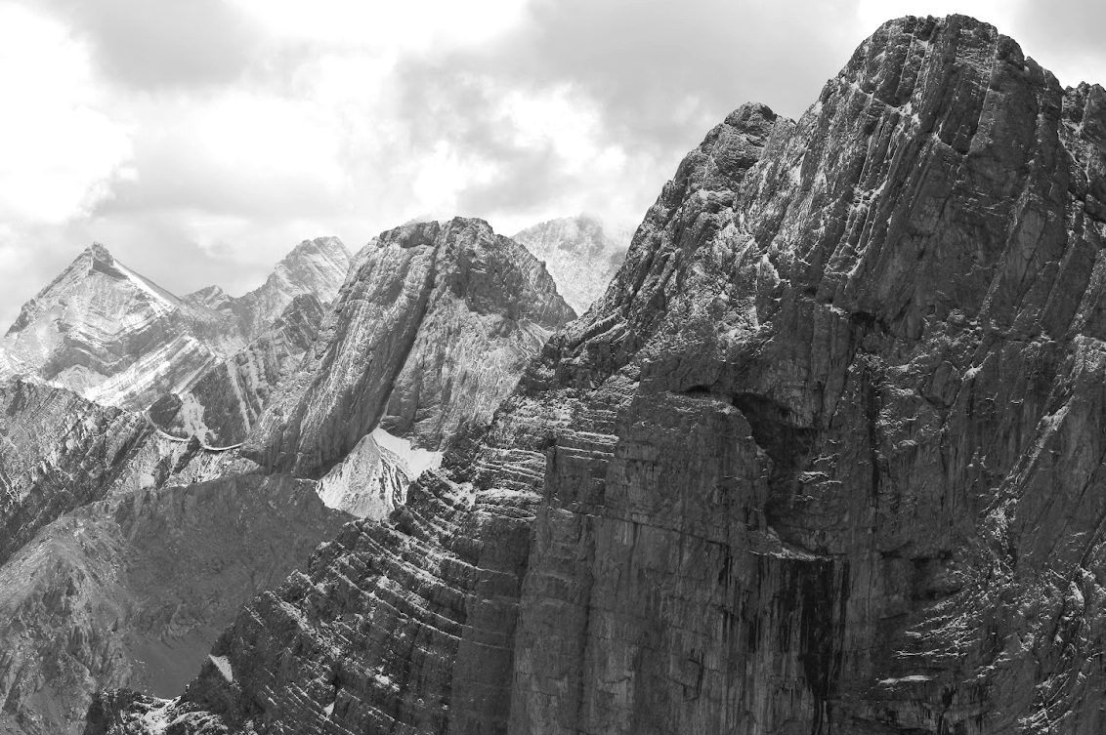

In this photo it is the cropped image gray scaled via desaturation.