Customer Obsession
Leaders start with the customer and work backwards. They work vigorously to earn and keep customer trust. Although leaders pay attention to competitors, they obsess over customers.
Ownership
Leaders are owners. They think long term and don’t sacrifice long-term value for short-term results. They act on behalf of the entire company, beyond just their own team. They never say “that’s not my job".
Invent and Simplify
Leaders expect and require innovation and invention from their teams and always find ways to simplify. They are externally aware, look for new ideas from everywhere, and are not limited by “not invented here". As we do new things, we accept that we may be misunderstood for long periods of time.
Are Right, A Lot
Leaders are right a lot. They have strong judgment and good instincts. They seek diverse perspectives and work to disconfirm their beliefs.
Learn and Be Curious
Leaders are never done learning and always seek to improve themselves. They are curious about new possibilities and act to explore them.
Hire and Develop the Best
Leaders raise the performance bar with every hire and promotion. They recognize exceptional talent, and willingly move them throughout the organization. Leaders develop leaders and take seriously their role in coaching others. We work on behalf of our people to invent mechanisms for development like Career Choice.
Insist on the Highest Standards
Leaders have relentlessly high standards - many people may think these standards are unreasonably high. Leaders are continually raising the bar and drive their teams to deliver high quality products, services and processes. Leaders ensure that defects do not get sent down the line and that problems are fixed so they stay fixed.
Think Big
Thinking small is a self-fulfilling prophecy. Leaders create and communicate a bold direction that inspires results. They think differently and look around corners for ways to serve customers.
Bias for Action
Speed matters in business. Many decisions and actions are reversible and do not need extensive study. We value calculated risk taking.
Frugality
Accomplish more with less. Constraints breed resourcefulness, self-sufficiency and invention. There are no extra points for growing headcount, budget size or fixed expense.
Earn Trust
Leaders listen attentively, speak candidly, and treat others respectfully. They are vocally self-critical, even when doing so is awkward or embarrassing. Leaders do not believe their or their team’s body odor smells of perfume. They benchmark themselves and their teams against the best.
Dive Deep
Leaders operate at all levels, stay connected to the details, audit frequently, and are skeptical when metrics and anecdote differ. No task is beneath them.
Have Backbone; Disagree and Commit
Leaders are obligated to respectfully challenge decisions when they disagree, even when doing so is uncomfortable or exhausting. Leaders have conviction and are tenacious. They do not compromise for the sake of social cohesion. Once a decision is determined, they commit wholly.
Deliver Results
Leaders focus on the key inputs for their business and deliver them with the right quality and in a timely fashion. Despite setbacks, they rise to the occasion and never settle.

35 behavioral questions asked in 95% of Amazon interviews with examples
Team / time management (positive & negative) https://youtu.be/CQG4Ui0oAmk
1. Tell me about a time when you were not able to meet a time commitment. What prevented you from meeting it? What was the outcome and what did you learn from it?

2. Describe a long-term project that you managed. How did you keep everything moving along in a timely manner?

3. Give me an example of a time when you set a goal and were able to meet or achieve it
Adaptation https://youtu.be/ys7fLcH5gpg

4. Tell me about a time you had to quickly adjust your work priorities to meet changing demands.

Team / decision https://youtu.be/3NExTeMnobU
5. an example when you had to push back to HQ or challenged a decision

6. Tell me about the toughest decision you've had to make in the past six months

7. Tell me about a decision that you regret.

Team / leadership https://youtu.be/Tg6BVRTsuic
8. What did you do when you needed to motivate a group of individuals?

9. Tell me about a time you stepped up into a leadership role

Team / communication & negotiation https://youtu.be/UJXkaide9bU
10. Do you collaborate well?

11. Describe a situation when you negotiated with others in your organization to reach agreement.

Team / coworkers https://youtu.be/ZsxkoZdyEcw
12. We've all had to work with people that don't like us. How do you deal with someone that doesn't like you?

13. We all make mistakes we wish we could take back. Tell me about a time you wish you’d handled a situation differently with a colleague.

14. The last time you had to apologize to someone

Team / conflict https://youtu.be/Zz8iQ852YMs
15. Give me an example of a time you faced a conflict while working on a team. How did you handle that?

16. Tell me about a time when you received negative feedback from your manager. How did you respond?

Problem solving https://youtu.be/2XxCUain1IU
17. Tell me about a time when you missed an obvious solution to a problem

18. A time when you faced a problem that had multiple possible solutions

19. Tell me about a time when you came up with a new approach to a problem.

20. Describe a time when you anticipated potential problems and developed preventive measures.

21. Describe a situation in which you found a creative way to overcome an obstacle.
Strategy / data https://youtu.be/oRGKHTiM29E

22. How have you leveraged data to develop a strategy?

23. a time when you were 75% through a project, & you had to pivot strategy

24. Tell me about a time when you had to choose between technologies for a project

25. Tell me about a time you had to deal with ambiguity

Innovation https://youtu.be/774ovkE2y5I
26. What’s the most innovative new idea that you have implemented?

Ownership principle https://youtu.be/Rn3EjvukTkI
27. Describe a time when you sacrificed short term goals for long term success

28. Provide an example of when you personally demonstrate ownership.
Strength / weakness https://youtu.be/q8fK73QjmbA

29. What's your greatest strength

30. Biggest weakness
Clients https://youtu.be/OFEUzyB12rE
I get nervous when I need to speak in front of a large group. In my second year, my Advisor asked me to do a presentation in the joint retreat of our department, and I did it quite bad., I got so nervous and could not understand the questions asked. I realized that this is a big problem for me, so I kept taking English courses provided where you need to present every class. Also, I am TAing many semesters, so the situation get much better. Now I am comfortable presenting for small team, but for large group of people. I am still not sure if I can do it confidently.

31. We all deal with difficult customers from time to time. Tell me about a challenging client-facing situation and how you handled it.

32. How do you show customer obsession?
Failure https://youtu.be/eaUUeFoB9CQ

33. Tell me about a time you recovered from a difficult situation

34. Tell me about a time you failed and what you learned from it

35. Why Amazon https://youtu.be/H_KGM0i9jkA

1. Basics
a) Tell me about yourself
b) Why this company
c) Why this position / this team
d) Why leave your last position
e) Walk me through your typical day at work.
2. Failure
a) Tell me a time when you failed on something
b) Tell me a time when you made a mistake
c) Tell me a time when you received a negative feedback
d) Tell me a time when you showed resilience
e) Tell me a time when you didn't meet the expectation
f) Tell me a time when you took a risk / without approval then you failed
g) Tell me a goal you didn't achieve
3. Success
a) Tell me a time when you succeed / a project you proud of
b) Tell me a time when you exceed the expectation
c) Tell me a time when you took a risk / without approval then succeed
d) Tell me a goal you achieved
4. Conflict
a) Tell me a time when you resolved a conflict on your team
b) Tell me a time when you disagreed with your manager
c) Tell me a time when you disagreed with your team / peer
d) Tell me a time when you provided suggestion but had not been considered, what was the impact of it
e) Tell me a time when you had to go behind your manager's back to do something
5. Pressure / Challenge
a) Tell me a time when you handle difficult customer / task
b) Tell me a time when you were forced to do something you are not familiar with
c) Tell me a time when you worked under pressure / managed numerous responsibilities / had to multitask
d) Tell me a time when you overcame an obstacle and delivered the result
e) Tell me a time when you overcame a challenge
f) Tell me a time when you worked under close supervision or extremely loose supervision
6. Leadership / Relationship
a) Tell me a time when you helped a peer / other
b) Tell me a time when you lead a team to achieve
c) Tell me a time when you earned trust of others
d) Tell me a time when you motivated others
e) Tell me a time when you persuaded someone to do something
f) Tell me a time when you showed leadership
g) Tell me about a time when you had to deal with a poor performer on your team.
h) Tell me about a time when you had to convince your team on some design decision.
7. Responsibility / High Standard / Deep Dive
a) Tell me a time when your team or company undergoing some change
b) Tell me a time when you took on something outside your area of responsibility
c) Describe a time when you were the resident technical expert. What did you do to make sure everyone was able to understand you?
d) Tell me about a time you were dissatisfied in your work. What could have been done to make it better?
e) Tell me a time when you improved a process
f) Tell me about a time when you could have stopped working but persisted.
g) Tell me about a time when you had to dive deep into the system / data to solve some technical bug / problems.
8. Decision
a) Tell me a time when you made a difficult decision / choice
b) Tell me a time when you made a bad decision
c) Tell me a time when you made a quick and successful decision
d) Tell me a time when you took the initiative to deal with something
e) Tell me a time when you dealt with ambiguity
f) Tell me a time when you broke the rule
g) Tell me about a time when you had to take a decision in your project where the complete data was not available
h) Tell me about a time when you had to make some changes backward because it was impacting your customer.
9. New ideas, Innovations, Inventions
a) Tell me a time when you invented/innovated something
b) Tell me a time when you propose a new business
c) Tell me a time when you learned something about yourself
d) Tell me a time when you learned something new
10. Deadline / Efficiency
a) Tell me a time when you missed a deadline
b) Tell me a time when you had to deal with a tight deadline but deliver in time
c) Tell me a time when you provided a simple solution to a complex problem
d) Tell me a time you had to be very strategic in multitasks and meet all your top priorities.
e) Describe a long-term project that you managed. How did you keep everything moving along in a timely manner?
11. Frugality
a) Tell me about a time where you thought of a new way to save money for the company.
b) Describe a time when you had to manage a budget (or manage time/money/resources/etc.). Were you able to get more out of less?
c) Tell me about a time when you had to work with limited time and resources / no resource.
12. Common Follow-ups
a) What’s your role in this project
b) What’s your impact in this project
c) What were the challenges and how you made sure that you finished it perfectly
d) What did your manager / peer say, how did they like it
e) What did you do afterward
f) What did you sacrifice to deliver it and how did you feel
g) Why did you make that decision
h) Why did you think that decision was appropriate
i) Do you think you could have done better
j) How did you find / fix this problem
k) How deep did you track down the problem
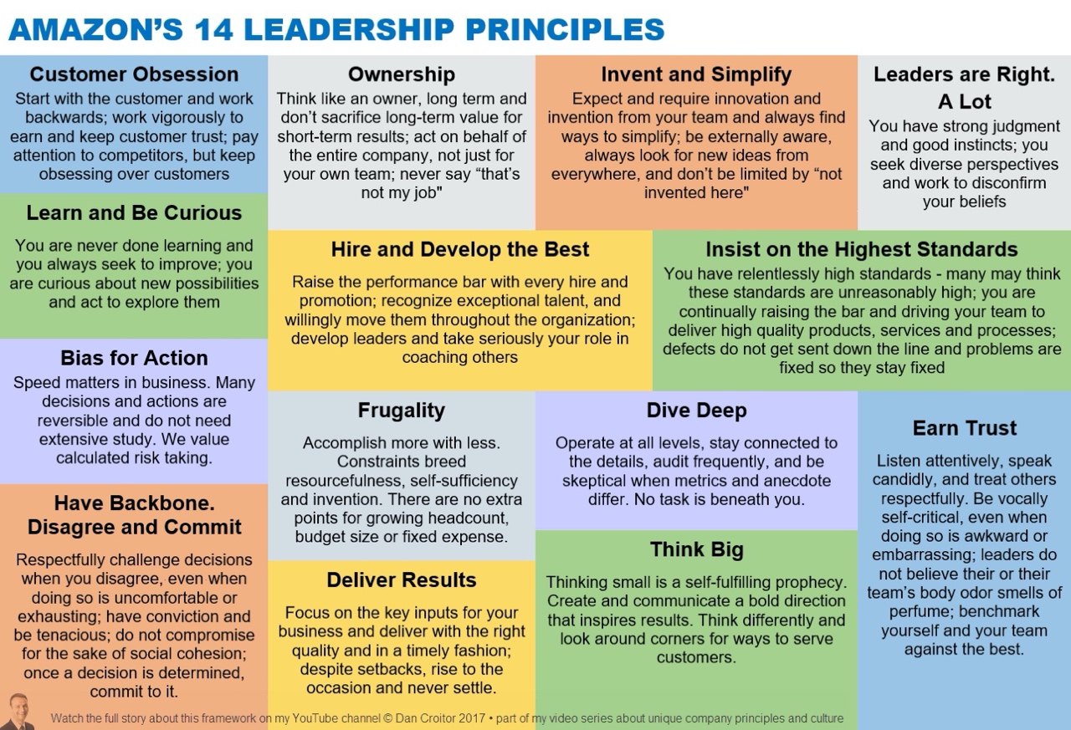

Deliver results:
I used to work on a web crawler, which will scan all the resources it found and analysis these resources to see if there is any securety flaws such as sql injection inside. This process used to take a long time, and my job is to prototype ways to speed it up.
iapproach this task from two aspects: change the crawler to work in a Breath First manner and handle the crawling and analysis in a multi-thread way. The first change has been proved to be a more efficient way crawling the web. The second change makes all the other analysis component working while keep crawling.
我从两方面入手：首先让爬虫分别用广度优先搜索和树状图搜索的方式工作。在经过一些研究之后我发现第一种方法比较有效，不容易出现重复。而第二种方法使得爬虫的其他分析组件得以继续工作。
Even though I run into some multi-thread lock issue, I was able to solve them and improve the whole process by 60 percent. This is a hard problem for me to remember a long time since it's very open ended and the reward can be huge.

