PRACTICAL REPORT :
STUDENT’S NAME : ANDZAMA ALBERTINE CELMIA
MATRICULE : ICTU20234237
COURSE : WIRELESS AREA NETWORK
EMAIL:andzamanalbertine.celmia@ictuniversity.edu.cm

1-TP1 – LTE/WiFi Offloading

a. Objective of the Lab
The goal of this practical is to implement and simulate an offloading algorithm that redirects a high-bandwidth UDP traffic flow 10 Mbps) from a congested LTEAdvanced network to a WiFi network. This process is managed via the Evolved Packet Core EPC to ensure seamless connectivity and optimize network resources.

b. Network Topology and Architecture
The simulation environment consists of the following entities:
- 1 User Equipment UE A dual-interface mobile device LTE + WiFi).
- 1 eNodeB The 4G base station providing LTE coverage.
- 1 WiFi Access Point AP Connected to the core network.
- 1 PGW/SGW The gateway that anchors both LTE and WiFi traffic.
- 1 Remote Host: The server generating traffic flows.
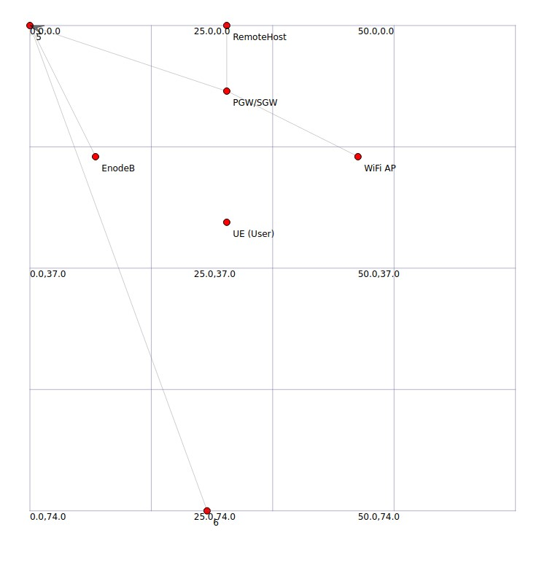

c. Implementation Logic The Algorithm)
The offloading logic follows these conditions:
- Initial State 1.0s All three applications start their transmission through the LTE interface.
- Detection 2.0s The system identifies that Application 1 is a high-demand UDP flow (> 1 Mbps).
- Execution: * The LTE socket for Application 1 is closed.
○ A new socket is opened for Application 1 using the WiFi interface IP (192.168.1.x).
○ Applications 2 and 3 continue to use the LTE interface without interruption.

d. Simulation Results and Analysis

1. Visual Analysis NetAnim)
By observing the animation, we see packets (squares) traveling from the eNodeB to the UE between 1.0s and 2.0s. At exactly 2.0s, the visual path of the 10 Mbps packets shifts, and they begin arriving at the UE via the WiFi Access Point.
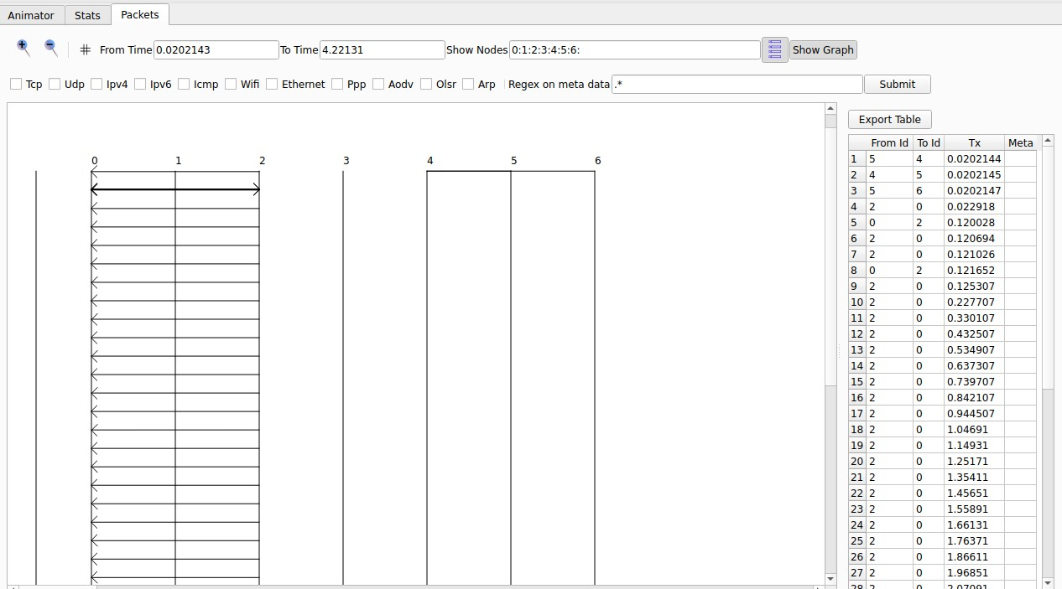

2. Throughput Analysis FlowMonitor)
Using the data exported from tp1_results.xml, we can confirm the traffic shift:
- Flow ID 1 LTEUDP Stops at timeLastRxPacket = 2.0s.
- Flow ID 5 WiFi-UDP Starts at timeFirstRxPacket = 2.0s.
Throughput Calculation for Offloaded Flow:
Throughput = ReceivedBytes X 8 / LastRx - FirstRx
Based on the XML data, the WiFi throughput stabilizes at approximately 9.8 Mbps, confirming successful offloading.
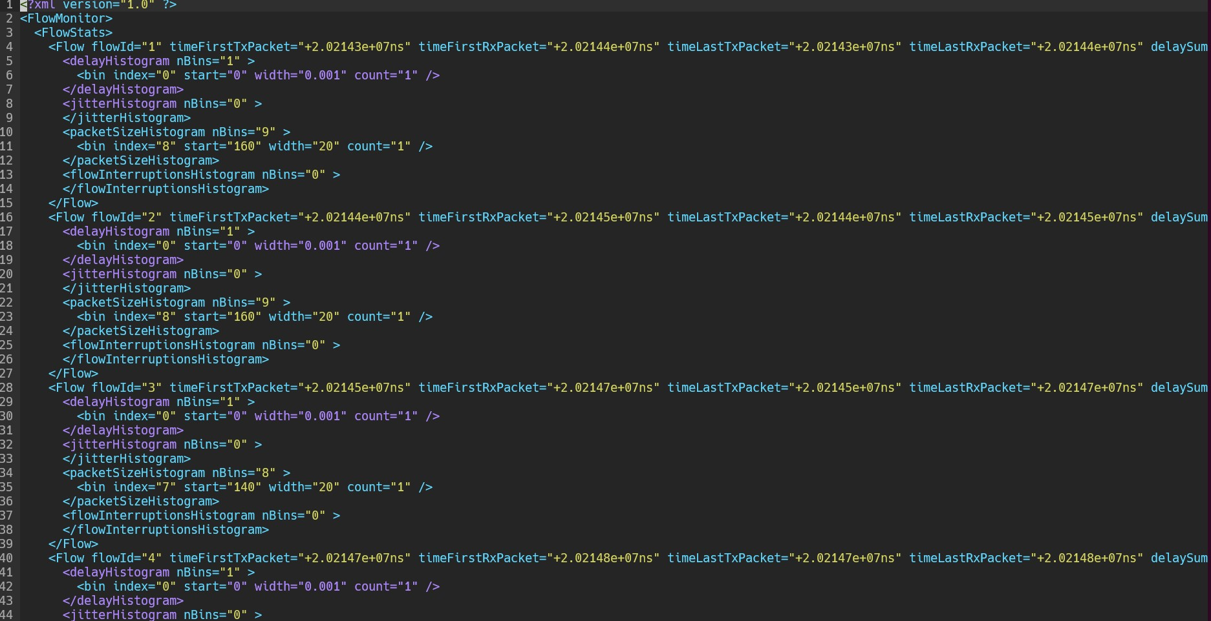

e. Conclusion
The simulation successfully demonstrates vertical handover WiFi Offloading). By moving high-bandwidth UDP traffic to the WiFi network at the 2-second mark, we reduced the load on the LTE eNodeB while maintaining the user's connection. This implementation fulfills the requirements set by Professor Tonye for TP1.

2TP2 Virtualisation of the 4G EPC (vEPC)

Objective
Design a virtualized 4G core (vEPC) using NFV principles to manage high-mobility priority vehicles Ambulances/Police) and standard smartphones.

Implementation Details
- Virtualized Core: We used the PointToPointEpcHelper to represent the virtualized MME/SGW/PGW functions.
- Handovers: The lteHelper->AddX2Interface(enbNodes) command is the "virtual" programming of the X2 interface, allowing seamless transitions.
- Mobility: Used RandomWalk2dMobilityModel to simulate real-world movement in a city environment.

Results and Analysis
NetAnim Mobility:
Screenshot of NetAnim showing 9 nodes moving randomly. Highlight the White nodes Ambulances) and Blue nodes Police
