THE UNITED REPUBLIC OF TANZANIA

UNIVERSITY OF DODOMA

System Requirement Specification Document

CHAPTER 1 5
1.1 Introduction 5
1.1.1 Project Overview 5
1.1.2 Problem Statement 5
1.1.3 Purpose of the System 5
1.1.4 Intended Audience 5
1.15 Intended Use 6
1.1.6 Scope of the System 6
1.1.7 Definitions, Acronyms, and Abbreviations 6
1.2 Overall Description 7
1.2.1 Software Development Methodology 7
1.2.2 Assumptions and Dependencies 7
1.2.2.1 Assumptions 7
1.2.2.2 Dependencies 8
1.2.2.3 Constraints 8
1.2.2.4 Operating Environment 9
1.3 System Features and Requirements 9
1.3.1 Functional Requirements 9
1.3.1.1 User Functional Requirements 9
1.3.2 Non-Functional Requirements 10
1.3.3 System Features 12
1.3.4 Data Requirements, Data Sources, and Data Acquisition 12
1.4 Planning 13
1.4.1 Cost–Benefit Analysis 13
1.4.2 Cost Identification 13
CHAPTER TWO: SSAD 24
2.1 Context free diagram 24
2.2 Level 0 DFD 25
2.3 Entity relationship diagram (ERD) 26
2.4 Logic Diagrams 27
2.4.2 State diagram 28
CHAPTER THREE: OOSAD 29
3.1 Use-Case Diagram 29
3.2 Class Diagram 31
Sequence Diagram 31
3.4 Other 2 logical diagrams 32
3.4.2 Deployment Diagram 32
CHAPTER 4: SYSTEM DESIGN 33
4.1 System Architecture 33
4.2.1 Physical Design 36
4.2.2 Database Design 36
4.2.3 Interface Design 39

Table of Figures
Figure 1 22
Figure 2 23
Figure 3 24
Figure 4 25
Figure 5 26
Figure 6 27
Figure 7 28
Figure 8 30
Figure 9 31
Figure 10 31
Figure 11 32
Figure 12 32
Figure 13 34

CHAPTER 1

1.1 Introduction

1.1.1 Project Overview
The Intelligent Chatbot for University Services is an automated information system designed to provide instant responses to university inquiries. By utilizing Natural Language Processing (NLP), the system allows users to interact in a conversational manner to access academic and administrative information.

1.1.2 Problem Statement
Current university information delivery faces several challenges that this system seeks to address:
- Manual Workload: Staff currently handle a high volume of repetitive manual inquiries regarding admissions and fees.
- Delayed Responses: Users often face delays when seeking basic information through physical visits or traditional channels.
- Limited Availability: Traditional university offices are not available 24/7 to assist students and prospective applicants.

1.1.3 Purpose of the System
The primary goal is to improve service delivery efficiency and reduce staff workload. The system aims to:
- Provide real-time automated responses to frequently asked questions (FAQs).
- Offer a centralized knowledge base for consistent information retrieval.
- Guide users to appropriate departments when automated resolution is not possible.

1.1.4 Intended Audience
The system is designed for the following stakeholders:
- Students: For queries on courses, academic calendars, and registration.
- Staff and Lecturers: To access teaching schedules and administrative policies.
- Prospective Applicants: To inquire about admission requirements and application procedures.
- Administrators: To manage the knowledge base and monitor system usage.

1.15 Intended Use
The Intelligent Chatbot for University Services is intended to be used as an automated digital assistant that provides real-time responses to university-related inquiries. The system is designed for continuous access through web and mobile platforms, enabling students, staff, prospective applicants, and administrators to obtain accurate academic and administrative information without requiring physical visits to university offices.
The chatbot will be used to:
- Answer frequently asked questions regarding admissions, courses, fees, academic calendars, and university services.
- Support users in navigating university information quickly and efficiently.
- Reduce the workload of administrative staff by automating repetitive inquiries.
- Provide 24/7 availability of institutional information.
- Assist administrators in monitoring inquiries and improving information delivery through interaction analysis.
The system is intended for academic demonstration, usability testing, and controlled institutional deployment within the university environment.

1.1.6 Scope of the System
- In-Scope: NLP-based query processing, web and mobile platform support, and an administrator dashboard for content management.
- Out-of-Scope: The system is restricted to the university context and may not cover all real-life scenarios outside the defined academic scope.
- Constraints: Development is limited by a student project budget and a fixed academic schedule.

1.1.7 Definitions, Acronyms, and Abbreviations
NLP : Natural Language Processing
Agile : An iterative development approach focusing on short sprints
OOSAD : Object-Oriented System Analysis and Design
SSAD : Structured System Analysis and Design
FAQ : Frequently Asked Questions
ROI : Return on Investment
ERD : Entity relationship diagram

1.2 Overall Description

1.2.1 Software Development Methodology
The development of the Intelligent Chatbot for University Services will follow the Agile Software Development Methodology, adopting the Scrum framework. Agile is an iterative and incremental approach that supports continuous refinement of system requirements, design, and implementation throughout the development lifecycle.
The system will be developed in short iterations (sprints), where each sprint focuses on delivering a specific chatbot capability such as query handling, response generation, or data retrieval. Each iteration will include requirement analysis, system modelling, implementation, testing, and review.

1.2.2 Assumptions and Dependencies

1.2.2.1 Assumptions
The development of this system is based on the following assumptions:
- It is assumed that all users of the system have basic knowledge of using computer and smartphones .
- It is assumed that users will provide accurate and valid data when interacting with the system.
- It is assumed that users will have access to a stable internet connection when using the system.
- It is assumed that the system will be used within an academic environment for learning and demonstration purposes.
- The system assumes that all required data sources will be accessible during development and testing.
- It is assumed that the institution will provide the necessary support and approval for system usage.
- It is assumed that stakeholders will provide necessary requirements and feedback on time.
- It is assumed that the system will be accessed through supported web browsers or mobile devices
- It is assumed that the users of the system are fluent in English and Kiswahili language.

1.2.2.2 Dependencies
The system depends on the following factors to operate effectively:
1. Hardware dependencies
- Availability of Server and hosting environment
- Availability of appropriate hardware such as computers or mobile devices.
2. Software dependencies
- Availability of software tools required for system development and modelling.
- Operating system (Windows , Linux or Android)
- Web browser (Chrome , Firefox , Edge)
- Development tools ( VS Code. Draw.io. StarUML)

3. Data Dependencies
- Dependence on a reliable database management system for data storage and retrieval.
- Availability of required datasets and user input data
4. User Dependencies
- Active participation of users and administrators to the input of correct and complete data.
- Proper system usage following provided guidelines

5. External Dependencies
- Dependence on network services to enable online access and data exchange.
- Dependence on third-party libraries or frameworks used during system development.

1.2.2.3 Constraints
The following constraints may affect the system development process:
- Limited development time due to academic schedule.
- Limited financial resources since the system is developed as a student project.
- Limited access to real-world datasets.
- The system is restricted to the scope defined in this project and may not cover all real-life scenarios.
- Academic schedule constraints
- Hardware and software availability

1.2.2.4 Operating Environment
The system is expected to operate in the following environment:
- Operating System: Windows, Linux, or Android
- Development Tools: Any suitable modelling and development software
- Database: Relational database system
- Network: Internet-based environment

1.3 System Features and Requirements

1.3.1 Functional Requirements
This section describes the functional requirements of the Intelligent Chatbot for University Services. Functional requirements define the specific actions and behaviors that the system must perform in order to meet user needs and system objectives. These requirements are categorized according to system users and core system processes.

1.3.1.1 User Functional Requirements
a) Student Functional Requirements
- The system shall allow students to interact with the chatbot using natural language text input.
- The system shall provide automated responses to student queries related to courses, programs, and departments.
- The system shall provide information on academic calendars, examination schedules, and registration deadlines.
- The system shall allow students to inquire about tuition fees, payment procedures, and financial policies.
- The system shall respond to frequently asked questions (FAQs) in real time.
- The system shall guide students to the appropriate university office or department when necessary.
- The system shall maintain a record of previous interactions for reference during a session.
b) Staff and Lecturer Functional Requirements
- The system shall allow academic and administrative staff to submit queries through the chatbot interface.
- The system shall provide information related to teaching schedules, academic policies, and staff services.
- The system shall respond to staff-related administrative inquiries.
- The system shall provide official announcements and updates relevant to staff members.
c) Prospective Applicant Functional Requirements
- The system shall allow prospective students to inquire about admission requirements.
- The system shall provide information on available academic programs and entry qualifications.
- The system shall respond to questions regarding application procedures and deadlines.
- The system shall provide general university information to non-registered users.
1.3.1.2 Administrator Functional Requirements
- The system shall allow administrators to manage chatbot content and the knowledge base.
- The system shall allow administrators to add, update, or remove university information stored in the system.
- The system shall allow administrators to monitor chatbot interactions and system usage.
- The system shall allow administrators to review unanswered or unresolved user queries.
- The system shall allow administrators to manage system users and access privileges.
1.3.1.3 Core System Processing Requirements
- The system shall accept and process user queries submitted through the chatbot interface.
- The system shall analyze user input using Natural Language Processing (NLP) techniques.
- The system shall identify user intent from submitted queries.
- The system shall retrieve relevant information from the knowledge base or database.
- The system shall generate accurate and context-appropriate responses.
- The system shall provide responses to users in real time.
- The system shall handle multiple user requests concurrently.
- The system shall escalate queries that cannot be resolved automatically for further review.
1.3.1.4 System Interaction Requirements
- The system shall support interaction through web-based and mobile platforms.
- The system shall provide consistent responses regardless of the access platform.
- The system shall ensure smooth communication between the user interface, chatbot engine, and database components.

1.3.2 Non-Functional Requirements
- Performance Requirements
- The system shall respond to user queries within 2-3 seconds under normal operating conditions.
- The chatbot shall support multiple concurrent users without noticeable performance degradation.
- The system shall process frequently asked questions instantly using pre-trained responses.
- The chatbot shall operate continuously with minimal downtime.

- Usability Requirements
- The system shall provide a simple and user-friendly interface suitable for students and staff with minimal technical knowledge.
- The system shall support natural language interaction to allow users to communicate easily.
- The chatbot shall provide clear error messages when it cannot understand a user request.
- The system shall be accessible through common platforms such as web browsers and mobile devices.

- Security Requirements
- The system shall require user authentication for accessing personalized university services.
- The chatbot shall protect sensitive user information such as registration numbers and academic details.
- The system shall restrict administrative access to authorized personnel only.
- The chatbot shall log all interactions for monitoring and security auditing purposes.

- Reliability Requirements
- The system shall be available at least 99% of the time during university work hours.
- The chatbot shall recover automatically from minor system failures.
- The system shall maintain consistent performance during peak usage periods such as registration weeks.

- Scalability Requirements
- The system shall allow easy addition of new services such timetable queries, fee information and examination results.
- The chatbot shall support future integration with other university information systems.
- The system shall accommodate an increasing number of users without major architectural changes.

- Maintainability Requirements
- The system shall be designed in a modular manner to allow easy updates and maintenance.
- The chatbot knowledge base shall be easy to update by authorized administrators.
- The system shall allow quick fixes without affecting overall system functionality.
- Compatibility Requirements
- The system shall be compatible with modern web browsers.
- The chatbot shall operate on smartphones.

1.3.3 System Features
The Intelligent Chatbot for University Services is a system designed to provide a convenient, interactive, and efficient way for users to access university-related information. The system offers a set of features that focus on simplicity, accessibility, and reliability, ensuring that users can obtain the information they need with minimal effort.
One of the key features of the system is the interactive chat interface, which allows users to communicate with the chatbot using natural language. This feature enables students, staff, and prospective applicants to type questions in a conversational manner, similar to chatting with a human assistant.
The system also includes an automated question-and-answer feature, where the chatbot instantly responds to commonly asked questions related to courses, admissions, academic calendars, fees, and university services. This helps reduce delays and eliminates the need for users to physically visit university offices for basic inquiries.
Another important feature is multi-user support, which allows multiple users to interact with the chatbot simultaneously without affecting system performance. This is particularly useful during peak academic periods such as registration and examination seasons.
The chatbot is supported by a centralized knowledge base, where all university information is stored and managed. This ensures consistency in responses and allows the system to retrieve accurate information efficiently.
For system management, the chatbot provides an administrator management feature. Authorized administrators can add, update, or remove information in the knowledge base, review chatbot interactions, and monitor system usage. This feature ensures that the information provided by the chatbot remains current and relevant.
Additionally, the system offers a query escalation feature, where questions that cannot be answered automatically are identified and flagged for further review by administrators. This helps improve chatbot performance over time and ensures that users are not left without guidance.

1.3.4 Data Requirements, Data Sources, and Data Acquisition
Data Requirements
The Intelligent Chatbot for University Services relies on accurate and well-organized data to function effectively. The system requires data related to academic programs, admission requirements, tuition fees, academic calendars, examination schedules, and general university information. It also requires user interaction data such as submitted queries and chatbot responses, which are useful for monitoring performance and improving response accuracy.
Administrative data, including user roles and access privileges, is also required to ensure secure system management and controlled access to sensitive operations.
Data Sources
The data used by the system will be obtained from official university sources to ensure reliability and accuracy. These sources include university policy documents, academic handbooks, course catalogs, admission guidelines, fee structures, and official announcements. Additional data may be provided directly by university departments and administrative offices.
User-generated data, such as chatbot queries and interaction logs, will also serve as an internal data source for system improvement and analysis.
Data Acquisition
Data acquisition for the system will be carried out through both manual and automated processes. Initially, administrators will manually enter and upload verified university information into the chatbot’s knowledge base. This allows full control over the quality and correctness of the data.
As the system operates, data will also be acquired automatically through user interactions with the chatbot. These interactions will be recorded and stored in the database for analysis, enabling administrators to identify frequently asked questions, improve responses, and update the knowledge base accordingly.
Regular updates will be performed by administrators to ensure that all information remains accurate, current, and aligned with changes in university policies and academic schedules.

1.4 Planning

1.4.1 Cost–Benefit Analysis
The Intelligent Chatbot for University Services is intended to automate responses to common student inquiries such as admission procedures, course registration, fee structures, academic calendars, and examination schedules. This reduces manual workload on university staff and improves service delivery efficiency.
Economic feasibility is evaluated using Cost–Benefit Analysis, by identifying costs, benefits, and calculating ROI, NPV, and Break-Even Point (BEP).

1.4.2 Cost Identification
A. One-Time Costs
Cost Item | Description | Amount (TZS)
System Development | Design, coding, testing | 2,000,000
Data Preparation | FAQs, university documents | 500,000
Software & Tools | Development tools, libraries | 300,000
User Training | Staff orientation | 200,000
Total One-Time Cost |  | 3,000,000

B. Recurring Costs (Annual)
Cost Item | Description | Amount (TZS / Year)
System Maintenance | Updates & bug fixing | 400,000
Hosting & Server | Cloud services | 300,000
Internet & Utilities | Connectivity | 100,000
Total Recurring Cost |  | 800,000

1.4.3 Benefit Identification
A. Tangible Benefits (Annual)
Benefit | Description | Amount (TZS / Year)
Reduced Staff Workload | Fewer manual inquiries | 1,500,000
Faster Service Delivery | Reduced processing time | 1,000,000
Reduced Operational Costs | Less paper & admin work | 700,000
Total Annual Benefits |  | 3,200,000

B. Intangible Benefits
- Improved student satisfaction
- 24/7 access to university services
- Improved university image and innovation
- Better decision support through chat logs
1.4.4 Calculations
Assumptions
- Project duration: 5 years
- Discount rate: 12%
- Initial cost occurs in Year 0
- Benefits increase gradually as system reliability improves by 10%
- Recurring costs increase gradually by 20%
Cost–Benefit Analysis Table (5 Years)

Where;
Y - the amount of benefit/cost of a certain year
r – Discount rate, n – The number of the year of that particular amount
Item | Year 0 | Year 1 | Year 2 | Year 3 | Year 4 | Year 5 | Total (PV)
Total Benefits | – | 3,200,000 | 3,520,000 | 3,872,000 | 4,259,200 | 4,685,120 | 19,536,320
PV of Benefits | – | 2,857,280 | 2,807,000 | 2,756,000 | 2,707,000 | 2,659,000 | 13,794,280
Total Costs | 3,000,000 | 800,000 | 880,000 | 968,000 | 1,064,800 | 1,171,280 | 7,884,080
PV of Costs | 3,000,000 | 714,320 | 701,536 | 689,000 | 676,000 | 665,000 | 6,445,856
Net Cash Flow (PV) | (3,000,000) | 2,142,960 | 2,105,464 | 2,067,000 | 2,031,000 | 1,994,000 | 7,348,424
Cumulative Net Cash Flow | (3,000,000) | (857,040) | 1,248,424 | 3,315,424 | 5,346,424 | 7,348,424 | –

i. Net Present Value (NPV)
Formula:

“OR”

Interpretation:
Therefore, the positive NPV shows the enhancement is financially viable.
ii. Return on Investment (ROI) Calculations
Formula:

Interpretation:
Therefore, based on the ROI estimated, the project provides a strong return for a reliability and a focused banking system.

iii. Break-Even Point (BEP)
- Cumulative discounted benefits exceed costs between Year 3 and Year 4

- Estimated discounted break-even point: approximately 1.69 years
Economic Feasibility Conclusion
The enhancement:
- Has a positive NPV
- Achieves break-even within a reasonable time
- Generates long-term benefits
Therefore, this is economically feasible

WORK BREAKDOWN STRUCTURE
ID | Task Name | Description | Duration (Days) | Dependency
Epic 1: Product Backlog Initialization & Core Data
1.1 | Product Backlog Setup | Define epics, user stories and priorities | 3 | –
1.1.1 | Identify Core Student Intents | Fees, exams, admissions, contacts | 3 | 1.1
1.1.2 | Define MVP Scope | Select stories for first increment | 2 | 1.1
1.2 | Data Infrastructure (MVP) | Initial DB and knowledge setup | 10 | –
1.2.1 | Minimal DB Schema Design | Core tables for fees, dates, FAQs | 4 | 1.1.1
1.2.2 | Initial Knowledge Population | Manual entry of essential data | 4 | 1.2.1
1.2.3 | Data Validation Rules | Constraints and data consistency | 2 | 1.2.1
Epic2: NLP and conversation engine
2.1 | NLP Engine Setup | Base NLP framework and pipeline | 4 | -
2.1.1 | Intent Recognition (Basic) | Rule-based / baseline ML model | 4 | 1.1.2
2.1.2 | Entity Extraction Logic | Detect reg no, course code, year | 3 | 1.1.2
2.1.3 | Response Generation Logic | Fetch and format DB responses | 4 | 1.2.2, 2.1.1
2.2 | Bilingual Processing | English–Kiswahili support | 6 | –
2.2.1 | Language Detection Module | Auto-detect user language | 3 | 1.1.2
2.2.2 | Bilingual Data Mapping | Translate static responses | 3 | 1.2.2
Epic 3: Frontend And Early Integration (Early Value Delivery)
3.1 | Web Chat UI (MVP) | Simple chatbot interface | 5 | -
3.1.1 | Chat Bubble UI | Web-based conversational UI | 3 | 1.1.2
3.1.2 | API Integration | Connect UI to response API | 3 | 2.1.3
3.2 | Mobile Optimization | Responsive design adjustments | 4 | 3.1.1
Epic 4: Security, Personalization And Admin
4.1 | Authentication Module | Student login integration | 5 | -
4.1.1 | Role-Based Access Control | Student vs admin privileges | 3 | 3.1.2
4.2 | Data Encryption | Secure sensitive data | 4 | 3.1.2
4.3 | Admin Dashboard | Manage unanswered queries | 5 | -
4.3.1 | Query Review Interface | Staff review and response | 3 | 2.1.3
4.3.2 | Knowledge Update Tools | Modify data without DB access | 3 | 2.1.3
Epic 5: Escalation, Performance and Release
5.1 | Escalation System | Email/SMS for unresolved queries | 4 | 4.3.1
5.2 | Performance Tuning | DB indexing And NLP optimization | 5 | 2.1.3
5.3 | Load and Stress Testing | 100+ concurrent users | 5 | 5.2
5.4 | System Integration Testing | End-to-end testing | 4 | 3.2, 4.2, 5.1
5.5 | Sprint Review & Release | Final increment delivery | 2 | 5.4

Critical Path
- 1.1.1 -> 1.2.1 -> 1.2.2 -> 2.2.2
3 + 4 + 4 + 3 = 14
- 1.1.1 -> 1.2.1 -> 1.2.3
3 + 4 + 2 = 9
- 1.1.1 -> 1.2.1 -> 1.2.2 -> 2.1.3 -> 5.2 -> 5.3
3 + 4 + 4 + 4 + 5 + 5 = 25
- 1.1.1 -> 1.2.1 -> 1.2.2 -> 2.1.3 -> 3.1.2 -> 4.1.1
3 + 4 + 4 + 4 + 3 + 3 = 21
- 1.1.1 -> 1.2.1 -> 1.2.2 -> 2.1.3 -> 3.1.2 -> 4.2 -> 5.4 -> 5.5 (CRITICAL PATH)
3 + 4 + 4 + 4 + 3 + 4 + 4 + 2 = 28
- 1.1.1 -> 1.2.1 -> 1.2.2 -> 2.1.3 -> 4.3.1 -> 5.1 -> 5.4 -> 5.5 (CRITICAL PATH)
3 + 4 + 4 + 4 + 3 + 4 + 4 + 2 = 28
- 1.1.1 -> 1.2.1 -> 1.2.2 -> 2.1.3 -> 4.3.2
3 + 4 + 4 + 4 + 3 = 18
- 1.1.2 -> 2.2.1
2 + 3 = 5
- 1.1.2 -> 2.1.2
2 + 3 = 5
- 1.1.2 -> 2.1.1 -> 2.1.3 -> 5.2 -> 5.3
2 + 4 + 4 + 5 + 5 = 20
- 1.1.2 -> 2.1.1 -> 2.1.3 -> 3.1.2 -> 4.1.1
2 + 4 + 4 + 3 + 3 = 16
- 1.1.2 -> 2.1.1 -> 2.1.3 -> 3.1.2 -> 4.2 -> 5.4 -> 5.5
2 + 4 + 4 + 3 + 4 + 4 + 2 = 23
- 1.1.2 -> 2.1.1 -> 2.1.3 -> 4.3.2
2 + 4 + 4 + 3 = 13
- 1.1.2 -> 2.1.1 -> 2.1.3 -> 4.3.1 -> 5.1 -> 5.4 -> 5.5
2 + 2 + 4 + 3 + 4 + 4 + 2 = 21

Therefore, there are two critical paths, path number 5 and path number 6, with 28 days.

PERT CHART FOR INTELLIGENT CHATBOT FOR UNIVERSITY SERVICES
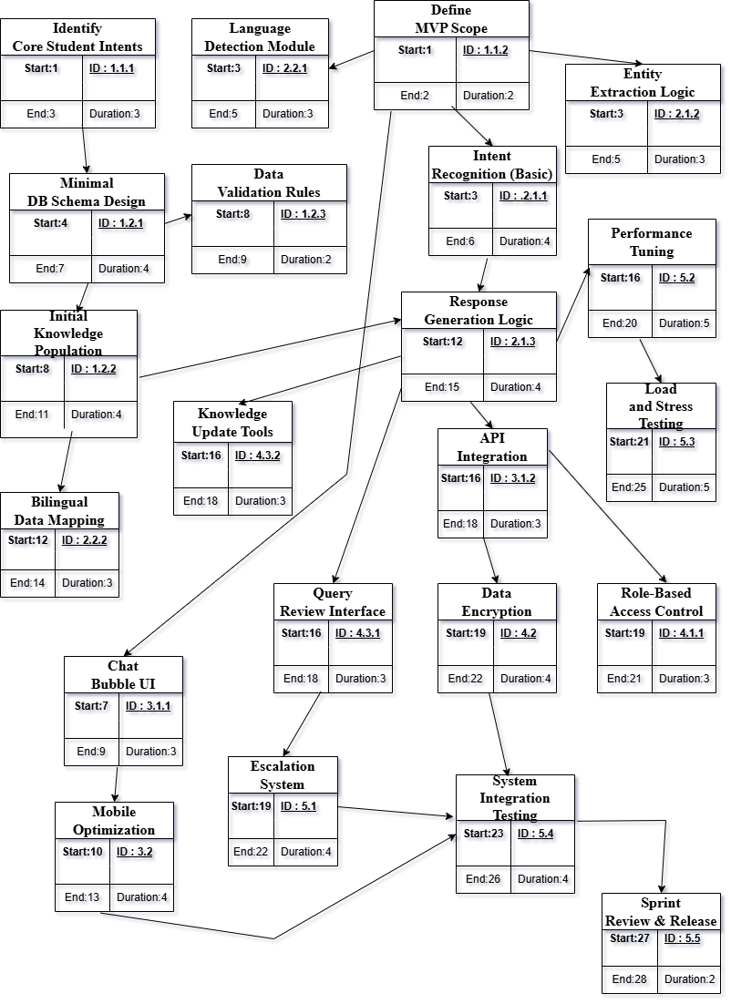
Figure 1

GAHHT CHAART FOR INTELLIGENT CHATBOT FOR UNIVERSITY SERVICES

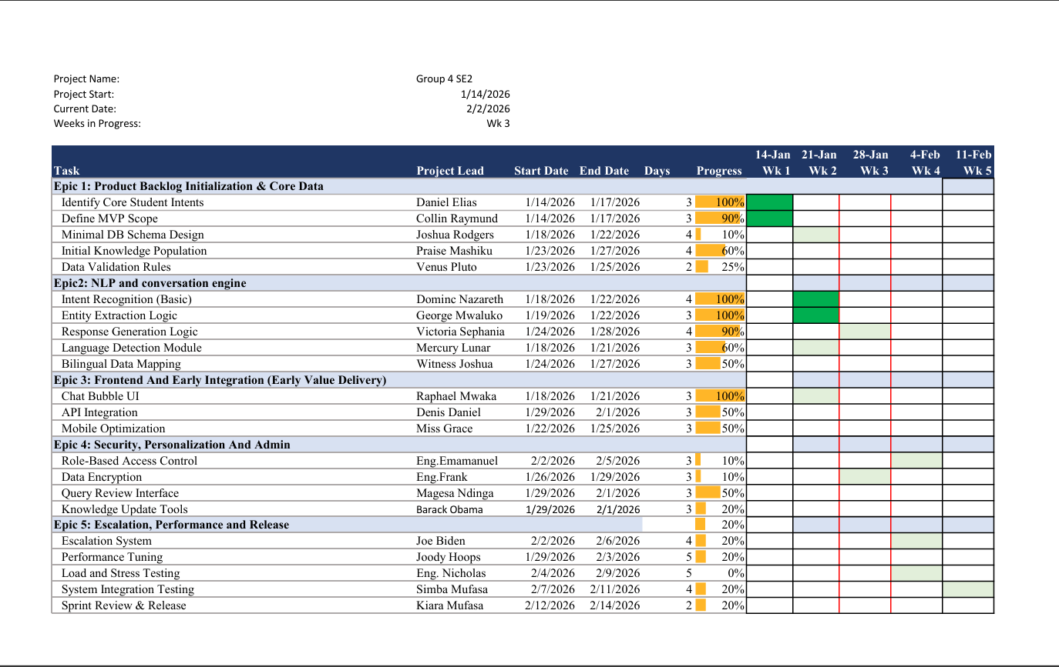
Figure 2

CHAPTER TWO: SSAD

2.1 Context free diagram
The context diagram presents a high-level view of the Intelligent Chatbot for University Services and shows how the system interacts with external entities. At this level, the entire chatbot system is represented as a single process, emphasizing the system boundary and the flow of information between the system and its users.
The primary external entities interacting with the system are students, staff/lecturers, prospective applicants, and administrators. Students, staff, and prospective applicants submit queries to the chatbot and receive automated responses related to university services such as courses, admissions, academic calendars, and fees. These interactions enable users to obtain relevant information quickly without direct human intervention.
Administrators interact with the system by managing and updating the chatbot’s knowledge base. They provide updated university information, review unresolved queries, and monitor system usage to ensure the chatbot delivers accurate and up-to-date responses. In return, the system provides administrators with reports, logs, and flagged queries that require attention.
Overall, the context diagram illustrates how the Intelligent Chatbot acts as a central communication interface between the university community and the institutional information resources, ensuring efficient information exchange while clearly defining the system’s scope and external dependencies.

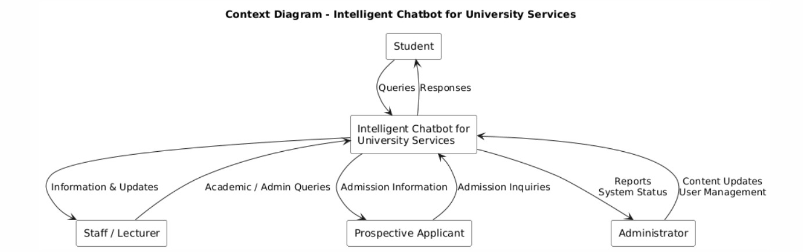
Figure 3

2.2 Level 0 DFD
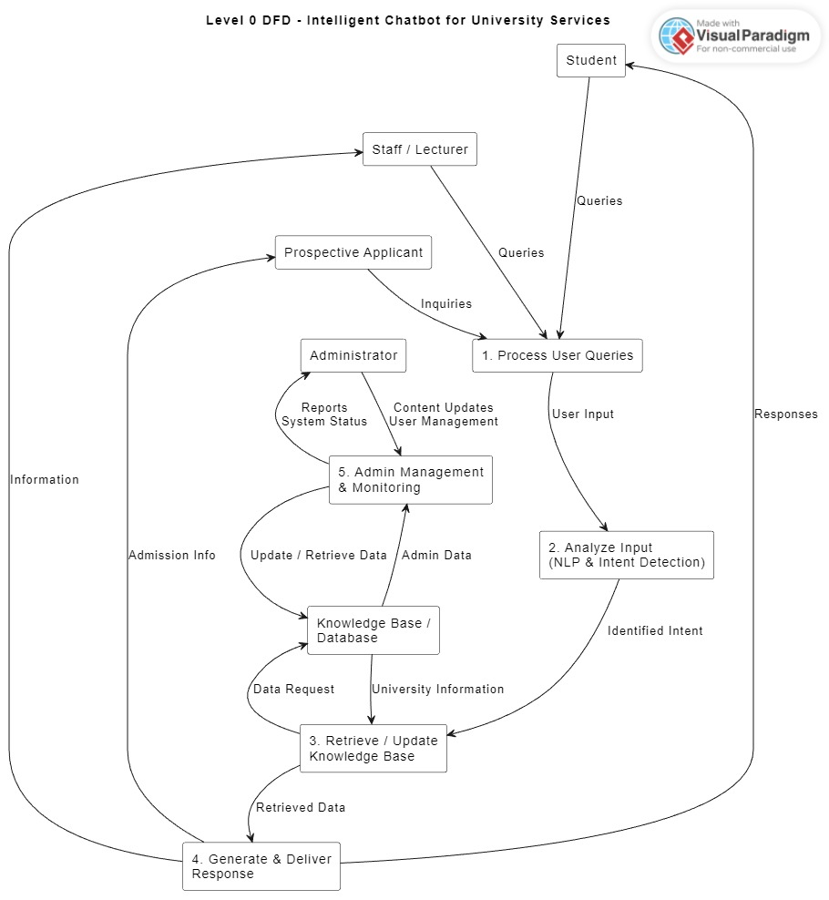
Figure 4

2.3 Entity relationship diagram (ERD)
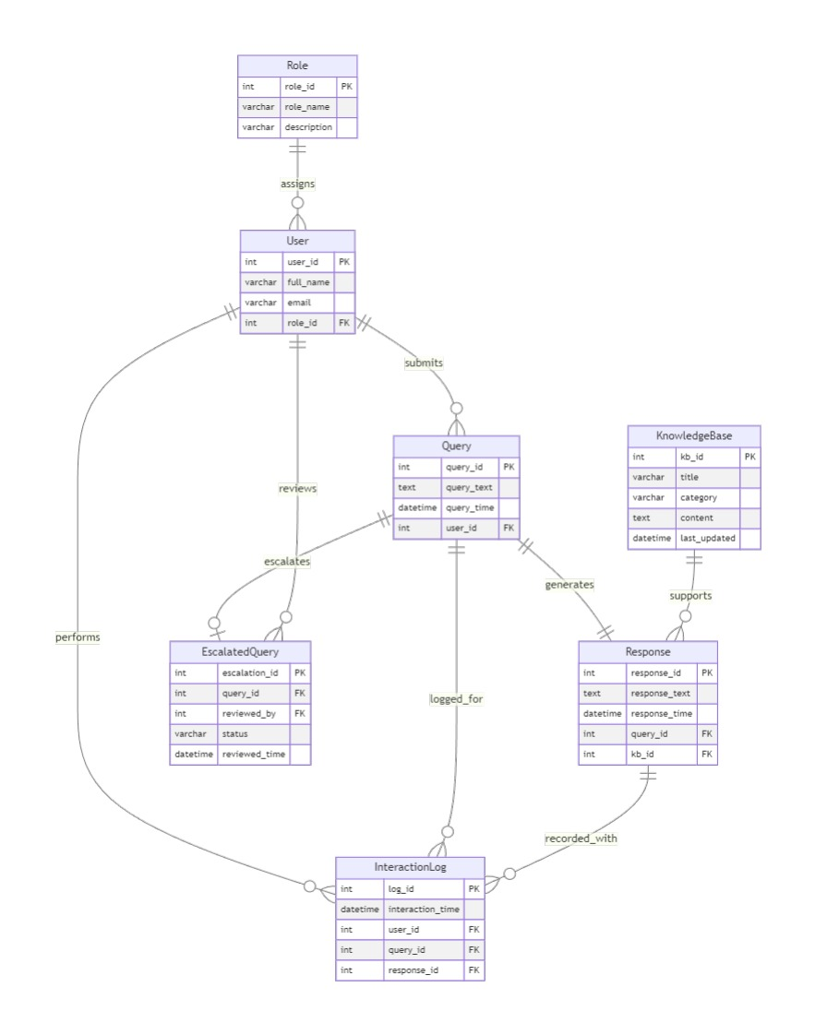
Figure 5

2.4 Logic Diagrams
2.4.1 Process Flowchart
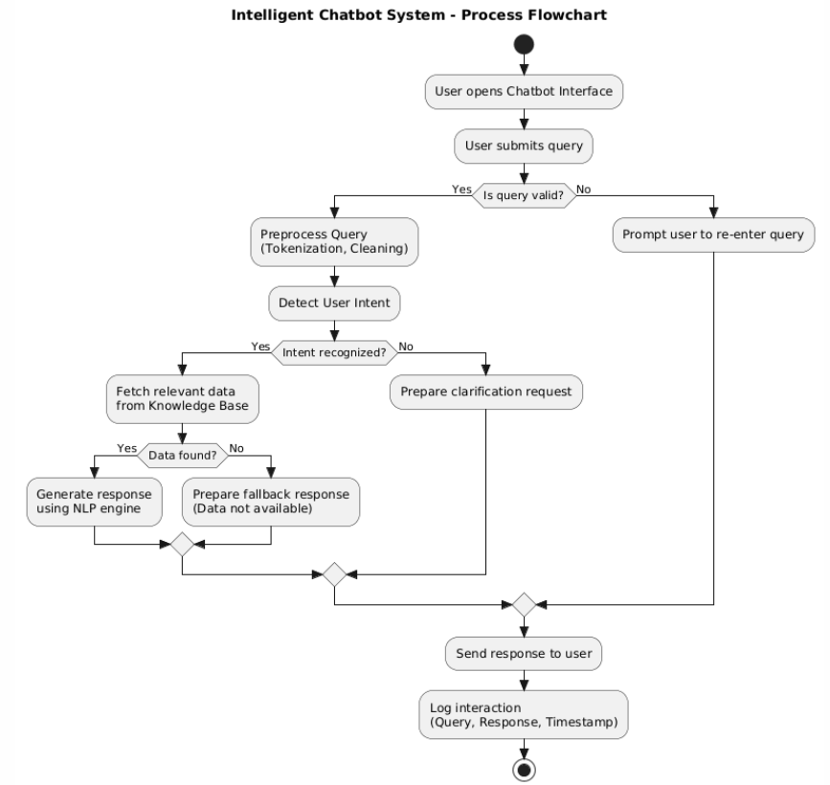
Figure 6

2.4.2 State diagram
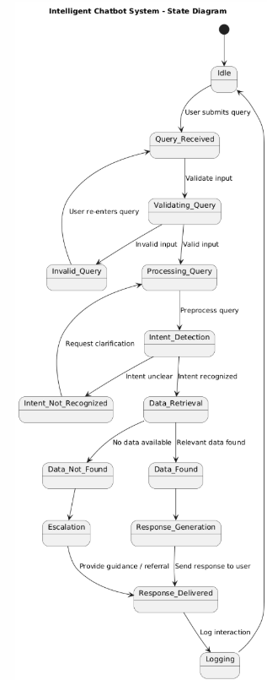
Figure 7

CHAPTER THREE: OOSAD

3.1 Use-Case Diagram
Primary Actors
- Student
- Staff / Lecturer
- Prospective Applicant
- Administrator
Core Use Cases (shared)
- Ask Question
- Receive Automated Response
Student / Staff / Applicant Use Cases
- View Academic Information
- View Admission Information
- View Fee Information
- Get Department Guidance
Administrator Use Cases
- Update University Information
- Monitor Chatbot Interactions
- Manage Users & Access
Relationships:
• Ask Question
<<include>> Process User Query
<<include>> Generate Response
• Escalate Unresolved Query
<<extend>> Ask Question

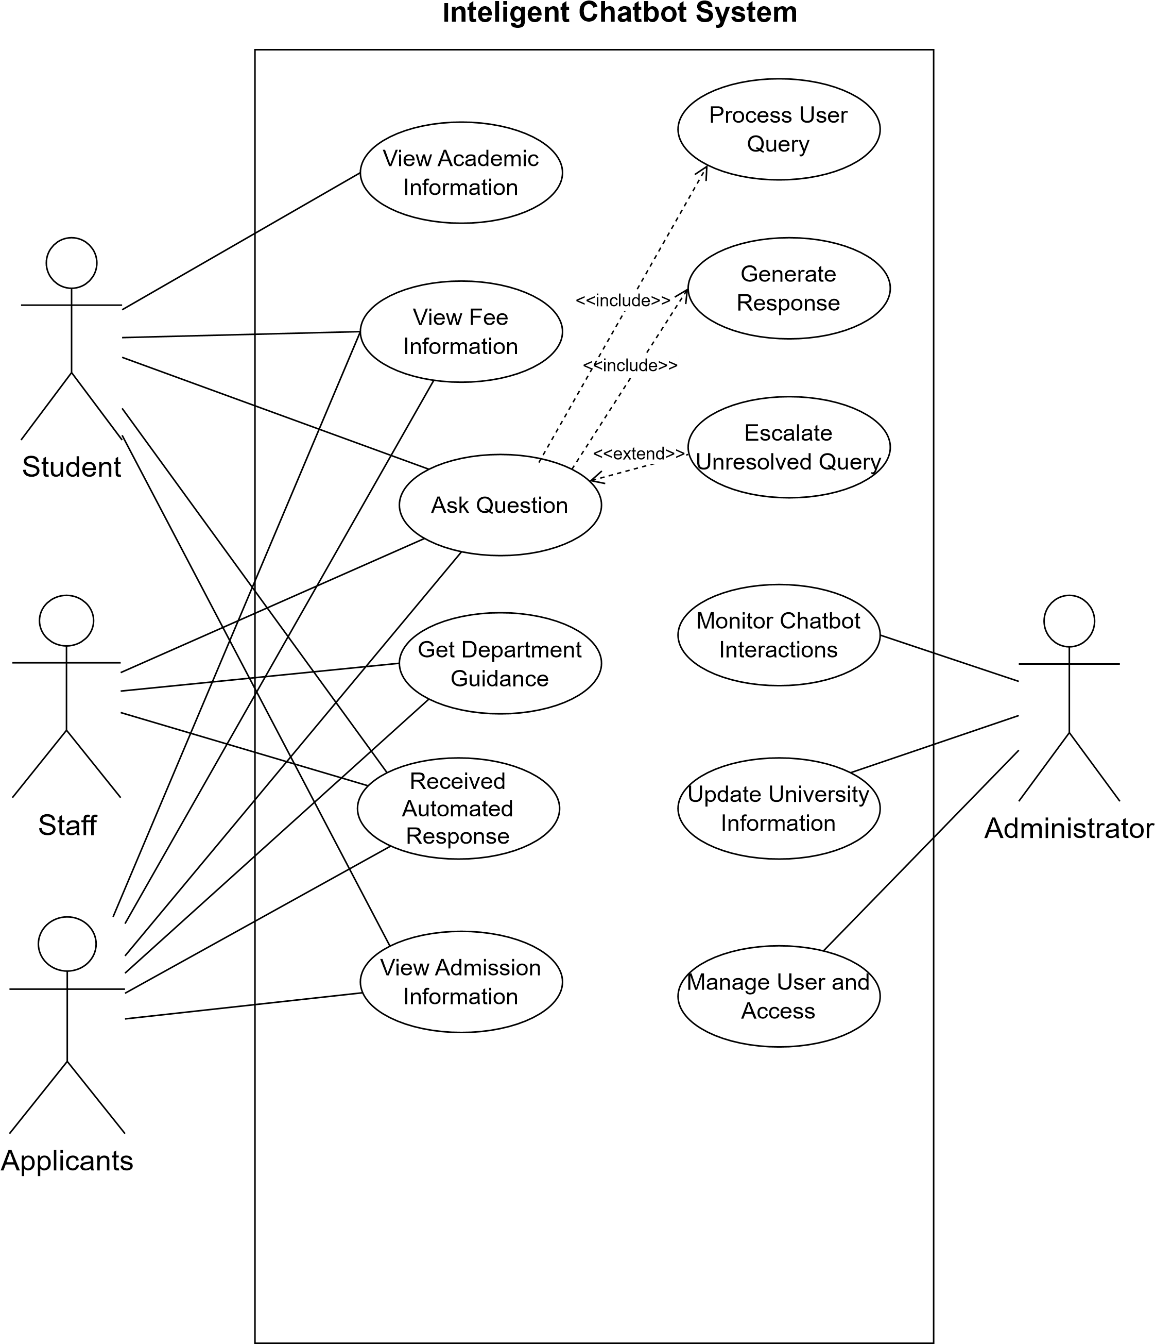
Figure 8

3.2 Class Diagram

User
userID
name
userType
submitQuery()
receiveResponse()
Administrator
adminID
addFAQ()
updateFAQ()
deleteFAQ()
monitorSystem()
Chatbot
chatbotID
status
processQuery()
identifyIntent()
generateResponse()
escalateQuery()
Knowldgebase
chatbotID
status
processQuery()
identifyIntent()
generateResponse()
escalateQuery()
1
0..*
retrieves
1
1..*
interacts
1
0..*
manages
Figure 9

Sequence Diagram

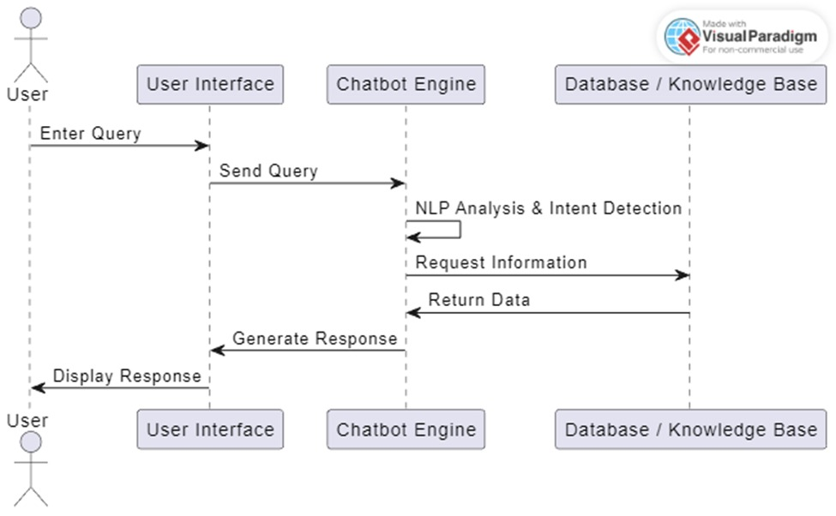
Figure 10

3.4 Other 2 logical diagrams
3.4.1 Component Diagram
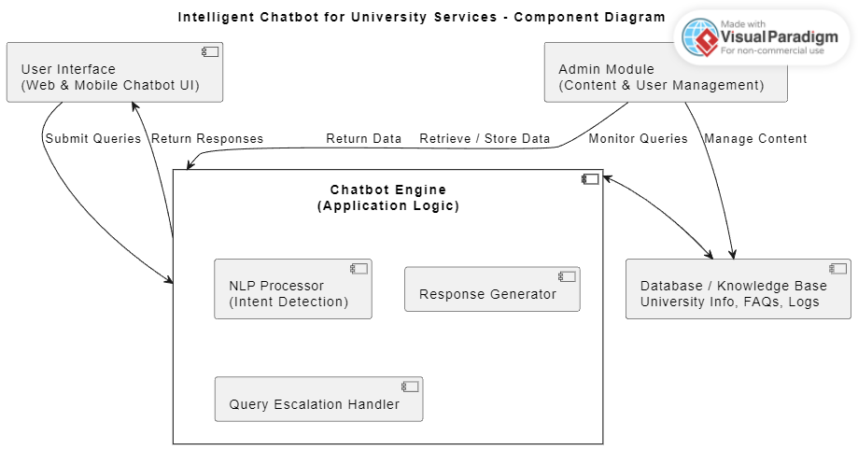
Figure 11

3.4.2 Deployment Diagram
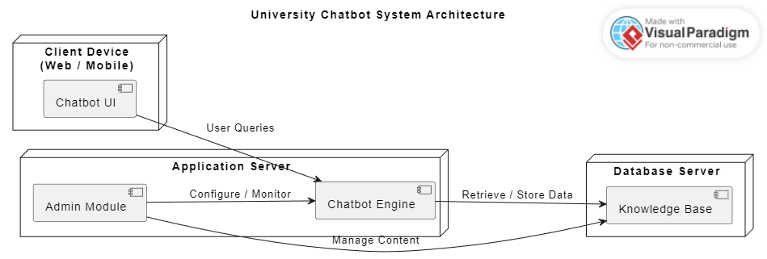
Figure 12

CHAPTER 4: SYSTEM DESIGN
This chapter presents the system design of the Intelligent Chatbot for University Services. It includes the system architecture, physical design, database design, and interface design. The design is based on the system requirements and models developed in the previous chapters and ensures that the system is efficient, secure, scalable, and easy to maintain.
Design Tools Used
The following software tools were used during the design process:
- Visual Paradigm – for designing system architecture diagrams, data flow diagrams, and ER diagrams
- Microsoft Word – for documentation and report preparation

4.1 System Architecture
The Intelligent Chatbot for University Services follows a Client–Server Architecture with a Layered (Three-Tier) design. This architecture separates the system into presentation, application, and data layers to improve performance, scalability, and maintainability.
Architecture Pattern
Client–Server / Three-Tier Architecture
Architecture Description
The system allows multiple users such as students, staff, prospective applicants, and administrators to interact with the chatbot through a web or mobile interface. User requests are processed by the chatbot application server, which performs natural language processing and retrieves relevant information from the database before generating responses.

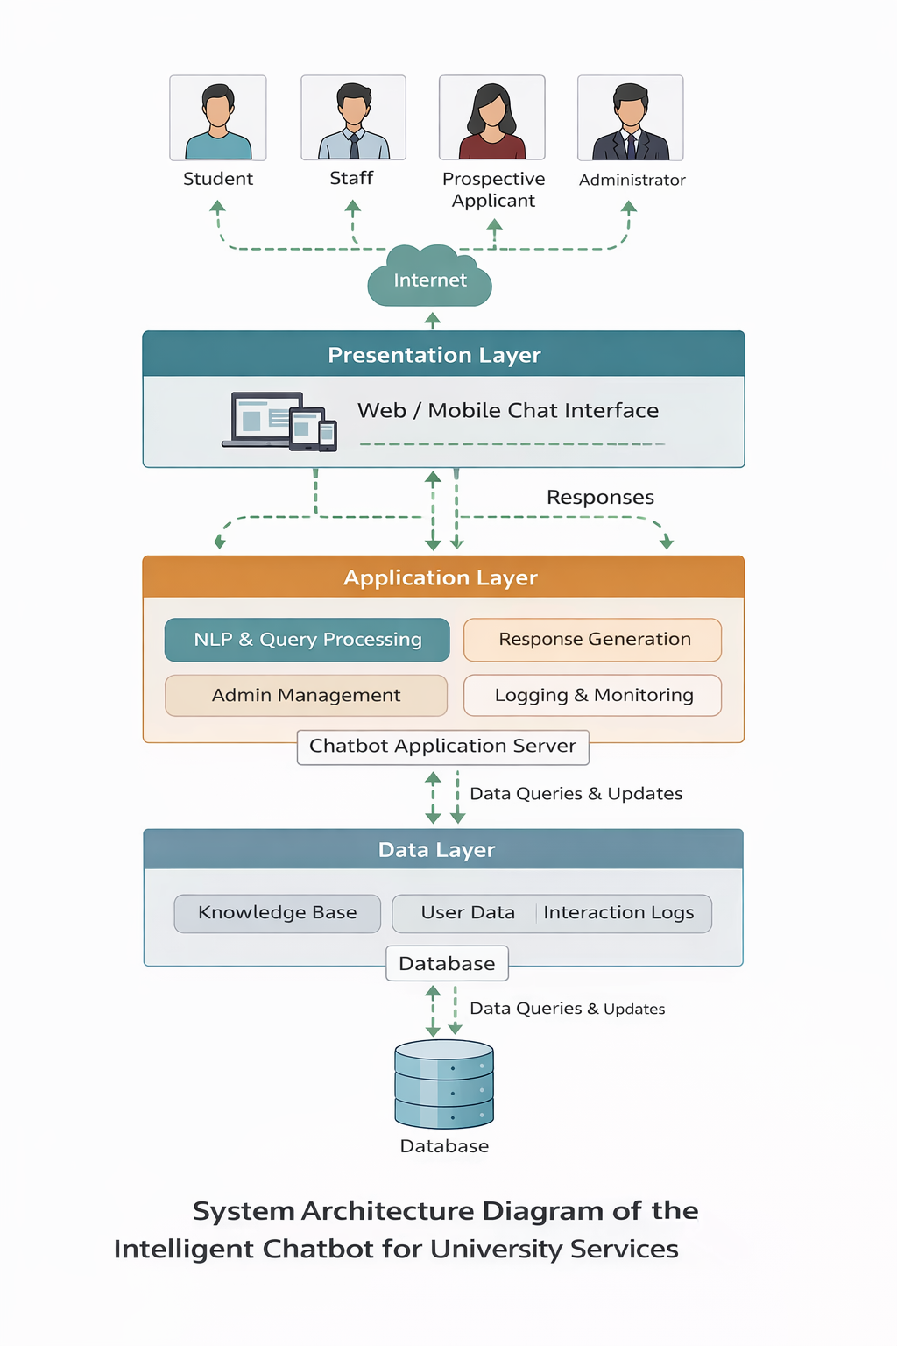
Figure 13
Figure 13: System Architecture Diagram of the Intelligent Chatbot for University Services
Architecture Layers
Tier 1: Presentation Layer
- Technology: Web browser (HTML, CSS, JavaScript)
- Responsibilities:
  - Chat interface for users
  - Accepting user queries
  - Displaying chatbot responses
  - Handling user interactions
Tier 2: Application Layer
- Technology: Node.js or Python
- Responsibilities:
  - Processing user queries
  - Natural Language Processing (NLP) and intent detection
  - Retrieving information from the knowledge base
  - Generating and delivering responses
  - Administrator management and monitoring
Tier 3: Data Layer
- Technology: MySQL Database
- Responsibilities:
  - Storing university information
  - Managing user data and roles
  - Storing queries, responses, and interaction logs
  - Ensuring data integrity and security

4.2 Detailed System Design
This section presents the detailed design of the system, including physical design, database design, and interface design, based on the system models developed during analysis.

4.2.1 Physical Design
The physical design describes the hardware and software environment required to deploy and operate the Intelligent Chatbot for University Services.
Hardware Requirements
- Server computer for hosting the application and database
- Client devices such as desktop computers, laptops, and smartphones
- Reliable internet connectivity
Software Requirements
- Operating System: Windows or Linux
- Database Management System: MySQL
- Web Browser: Google Chrome, Mozilla Firefox, or any modern browser
- Design Tool: Visual Paradigm

4.2.2 Database Design
The database design is based on the Entity Relationship (ER) diagram developed during system analysis. The database stores all system data including user information, queries, responses, knowledge base content, and interaction logs.
Key entities in the database include:
- User
- Role
- Query
- Response
- KnowledgeBase
- InteractionLog
- EscalatedQuery
The relationships between these entities ensure efficient data retrieval, secure access control, and proper logging of all chatbot interactions.

DATA DICTIONARY – DATABASE DESIGN
The data dictionary describes the structure of the database used by the Intelligent Chatbot for University Services. It defines the tables, fields, data types, constraints, and descriptions to ensure data consistency, integrity, and proper understanding of the database schema.

Table 1: Role
Field Name | Data Type | Constraints | Description
role_id | INT | Primary Key | Unique identifier for user role
role_name | VARCHAR(50) | NOT NULL | Name of the role (e.g., Student, Admin)
description | VARCHAR(255) | NULL | Description of the role

Table 2: User
Field Name | Data Type | Constraints | Description
user_id | INT | Primary Key | Unique identifier for a user
full_name | VARCHAR(100) | NOT NULL | Full name of the user
email | VARCHAR(100) | UNIQUE, NOT NULL | User email address
role_id | INT | Foreign Key (Role.role_id) | User role identifier

Table 3: Query
Field Name | Data Type | Constraints | Description
query_id | INT | Primary Key | Unique identifier for a query
query_text | TEXT | NOT NULL | Text of the user query
query_time | DATETIME | NOT NULL | Date and time the query was submitted
user_id | INT | Foreign Key (User.user_id) | User who submitted the query

Table 4: Response
Field Name | Data Type | Constraints | Description
response_id | INT | Primary Key | Unique identifier for a response
response_text | TEXT | NOT NULL | Chatbot response text
response_time | DATETIME | NOT NULL | Date and time the response was generated
query_id | INT | Foreign Key (Query.query_id) | Associated query
kb_id | INT | Foreign Key (KnowledgeBase.kb_id) | Source knowledge base record

Table 5: KnowledgeBase
Field Name | Data Type | Constraints | Description
kb_id | INT | Primary Key | Unique identifier for knowledge record
title | VARCHAR(100) | NOT NULL | Title of the knowledge entry
category | VARCHAR(50) | NOT NULL | Category of information
content | TEXT | NOT NULL | Knowledge base content
last_updated | DATETIME | NOT NULL | Last update timestamp

Table 6: InteractionLog
Field Name | Data Type | Constraints | Description
log_id | INT | Primary Key | Unique identifier for interaction log
interaction_time | DATETIME | NOT NULL | Time of interaction
user_id | INT | Foreign Key (User.user_id) | User involved
query_id | INT | Foreign Key (Query.query_id) | Related query
response_id | INT | Foreign Key (Response.response_id) | Related response

Table 7: EscalatedQuery
Field Name | Data Type | Constraints | Description
escalation_id | INT | Primary Key | Unique escalation identifier
query_id | INT | Foreign Key (Query.query_id) | Escalated query
reviewed_by | INT | Foreign Key (User.user_id) | Admin reviewing the query
status | VARCHAR(30) | NOT NULL | Escalation status
reviewed_time | DATETIME | NOT NULL | Review timestamp

4.2.3 Interface Design
The interface design focuses on providing a simple, user-friendly, and accessible interaction between users and the chatbot system.
User Interfaces
- Chat
Interface:
Allows students, staff, and prospective applicants to interact with the chatbot using natural language.
- Administrator
Interface:
Enables authorized administrators to manage content, monitor system usage, and review chatbot interactions.
- Login
Interface:
Provides secure authentication for users accessing personalized services.
The interface design follows principles of simplicity, clarity, and responsiveness to ensure usability on both desktop and mobile devices.

