C++ Assignment 1

1. Design a class TIME which stores hour, minute and second. The class should have

the methods to support the following:

1.User may give the time value in 24-hour format.

2.User may give the time value in AM/PM format

3. Display the time in 24-hour format.

4. Display the time in AM/PM format.

5. User may like to add minute with a time value.

OUPUT SCREENSHOTS :

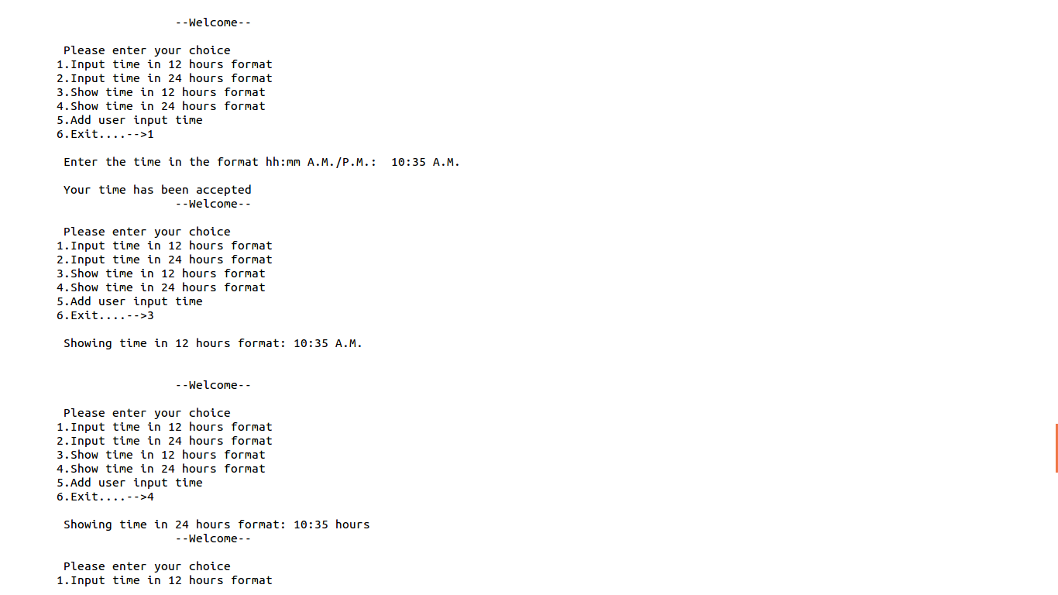

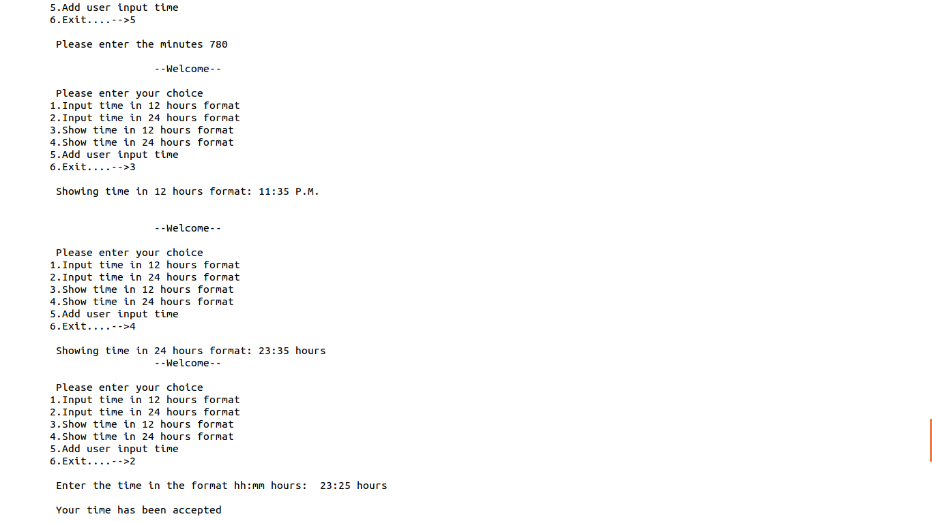

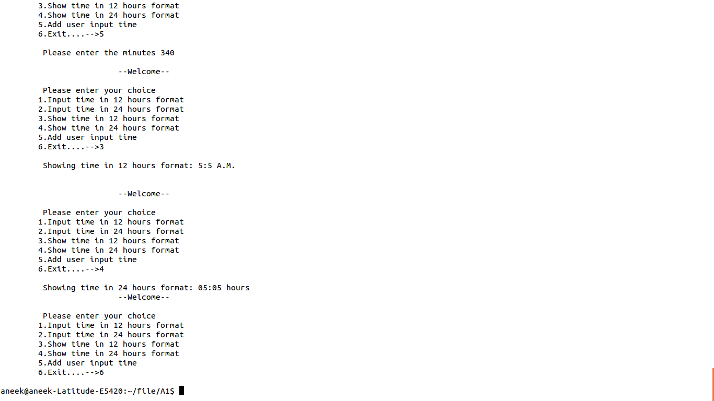

2. Design a COMPLEX class, which will behave like normal integer with respect to

1. addition,

2. subtraction,

3. accepting the value and

4. displaying the value.

OUTPUT SCREENSHOTS :

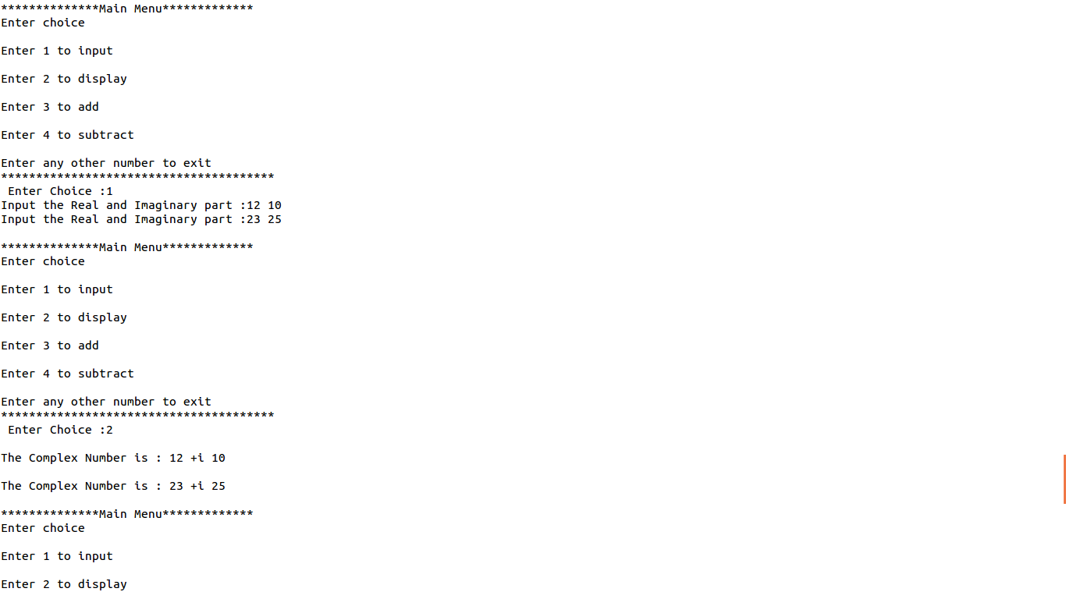

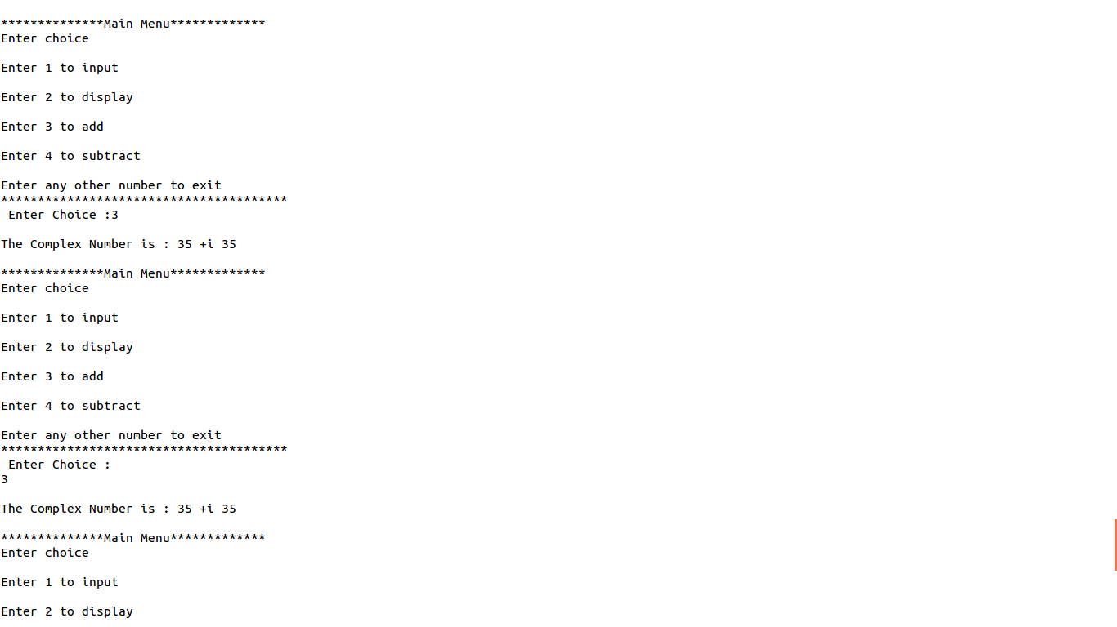

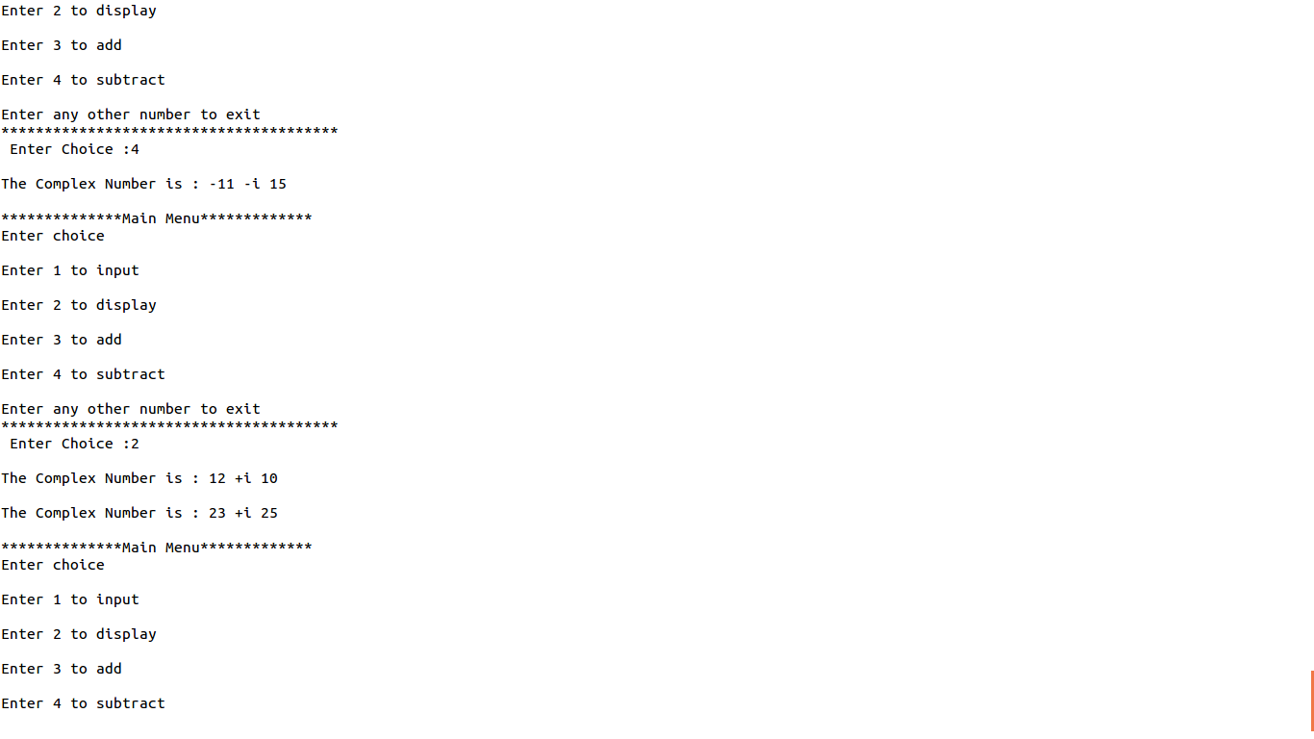

3. Design a TOLLTAX class to store the number of cars that crossed the bridge and

total amount collected. It must support the following activities.

1. Receiving toll.

2. Display number of cars that crossed the bridge.

3. Display the amount of toll collected.

OUTPUT SCREENSHOTS :

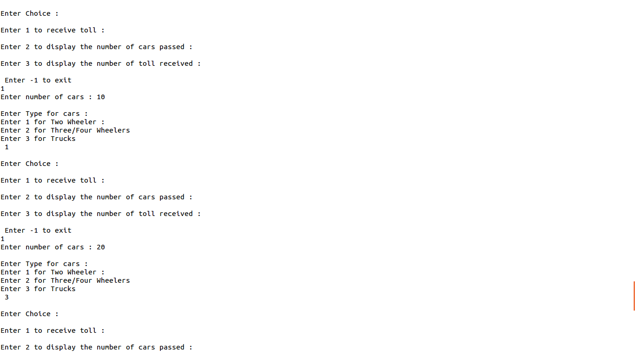

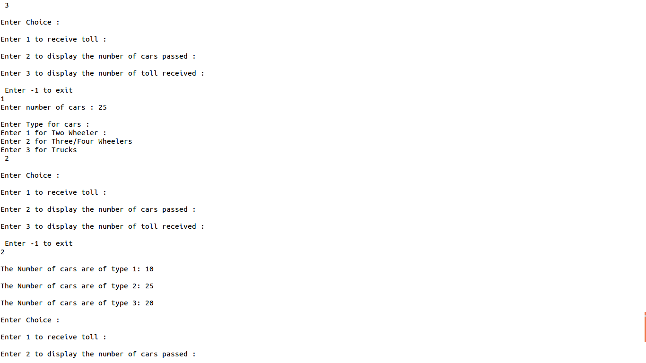

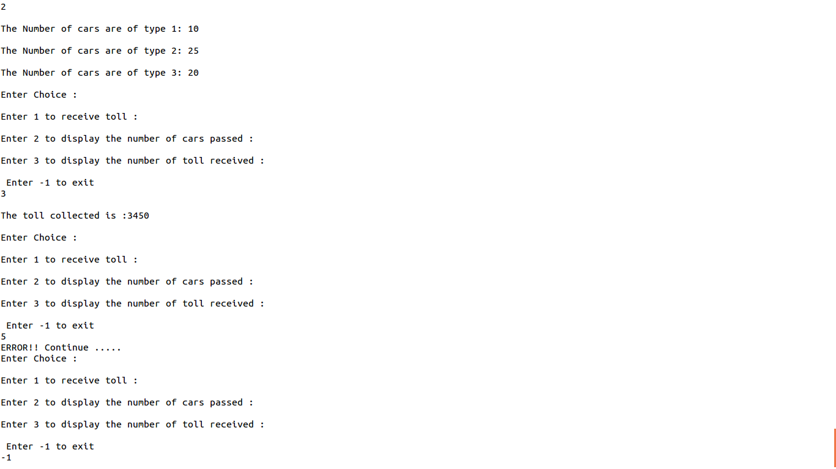

4. Design a class for the following scenario:

- An item list contains item code, name, rate, and quantity for several items.
- Whenever a new item is added in the list uniqueness of item code is to be checked.
- Time to time rate of the items may change.
- Whenever an item is issued or received existence of the item is checked and quantity is updated.
- In case of issue, availability of quantity is also to be checked.
- User may also like to know price/quantity available for an item.

OUTPUT SCREENSHOTS :

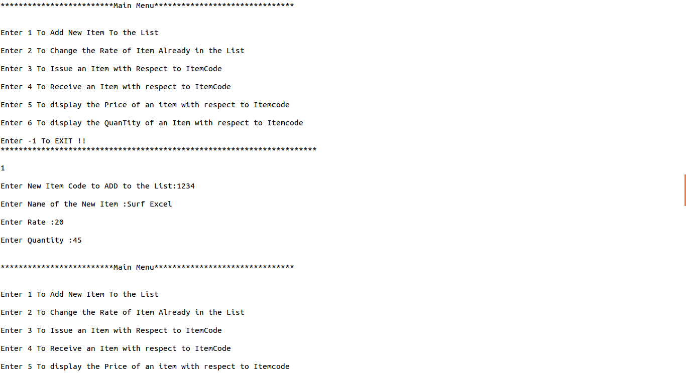
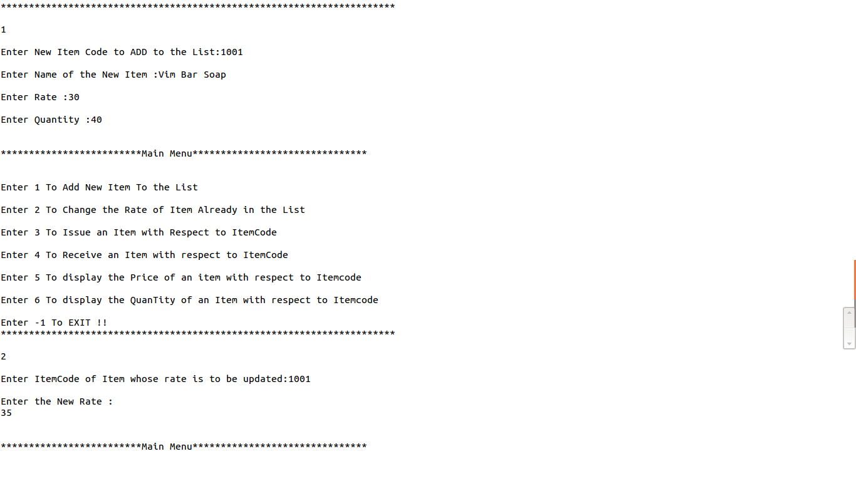
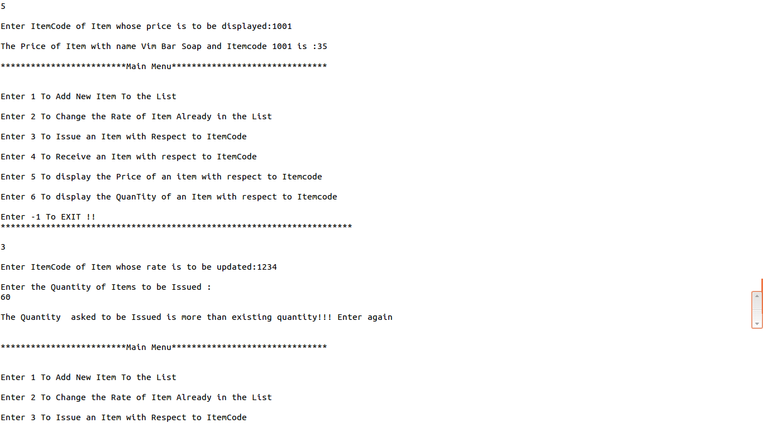

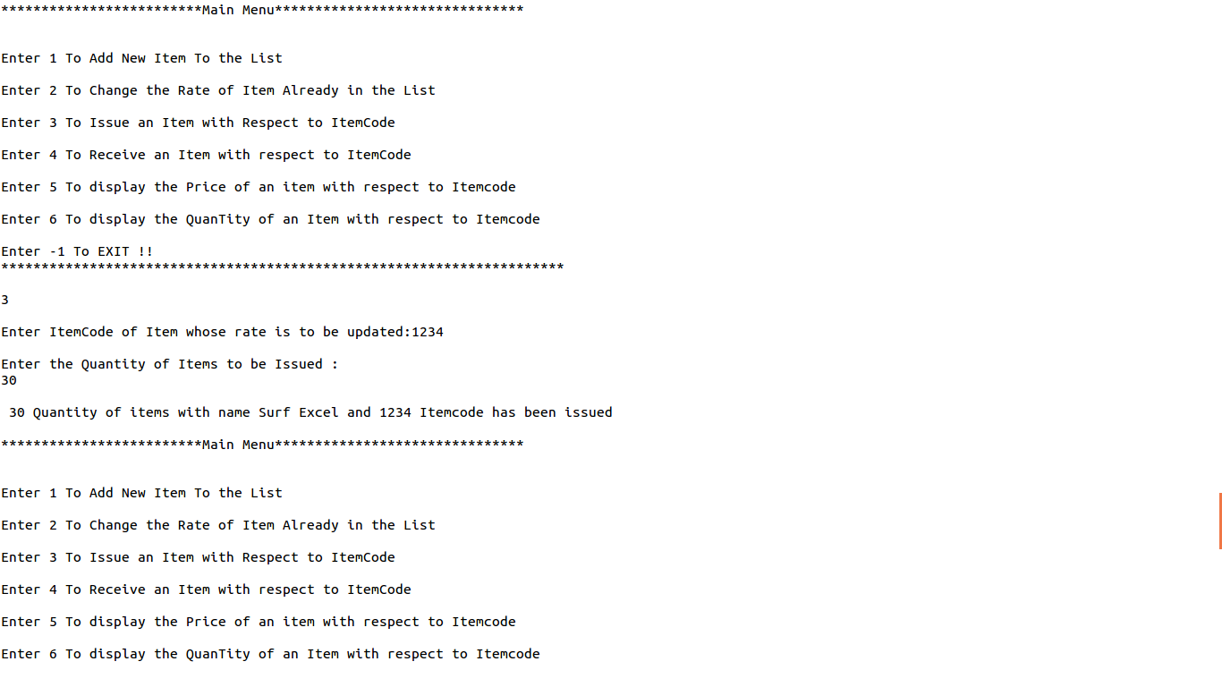

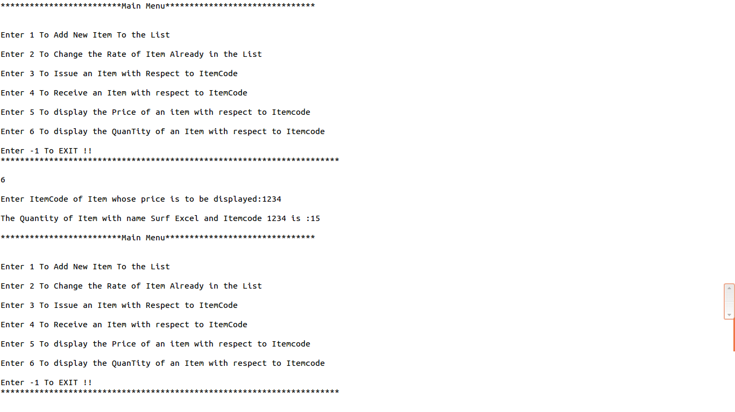
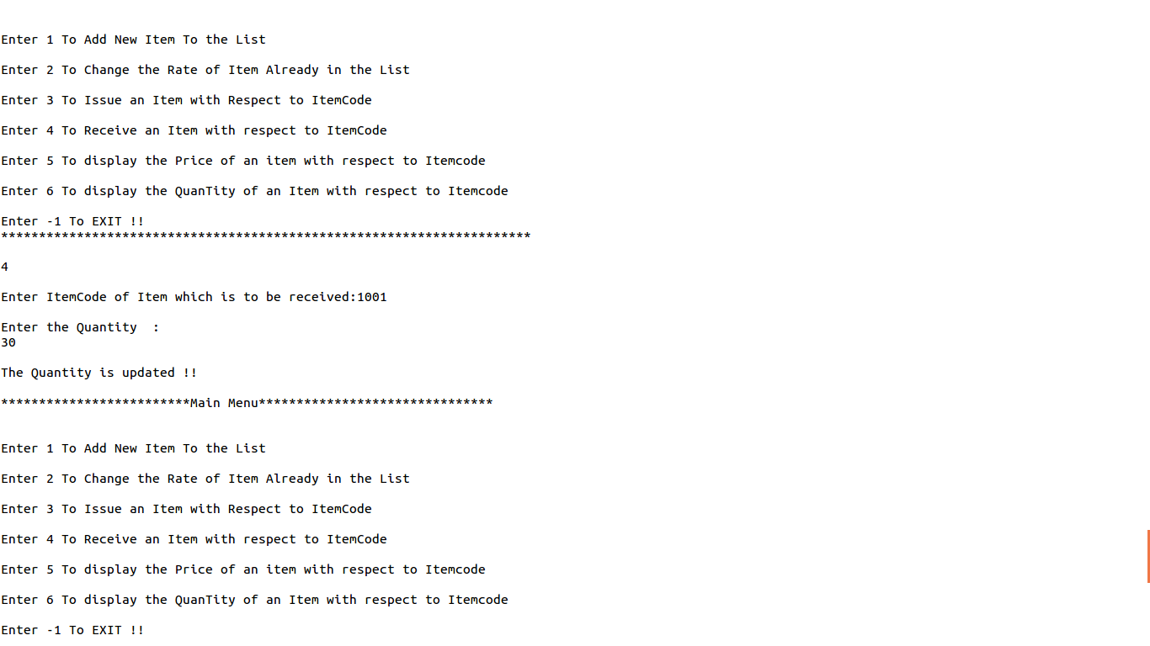

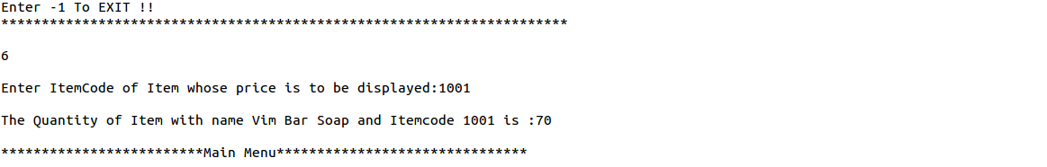

5. Design a STUDENT class to store roll, name, course, admission date and marks in 5subjects. Provide methods corresponding to admission date and receiving marks,preparing mark sheet. Support must be there to show the number of students who have taken admission.

OUTPUT SCREENSHOTS :
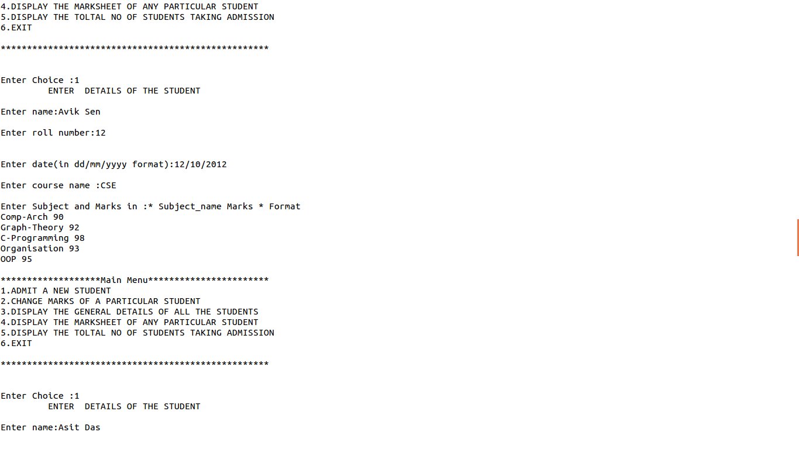
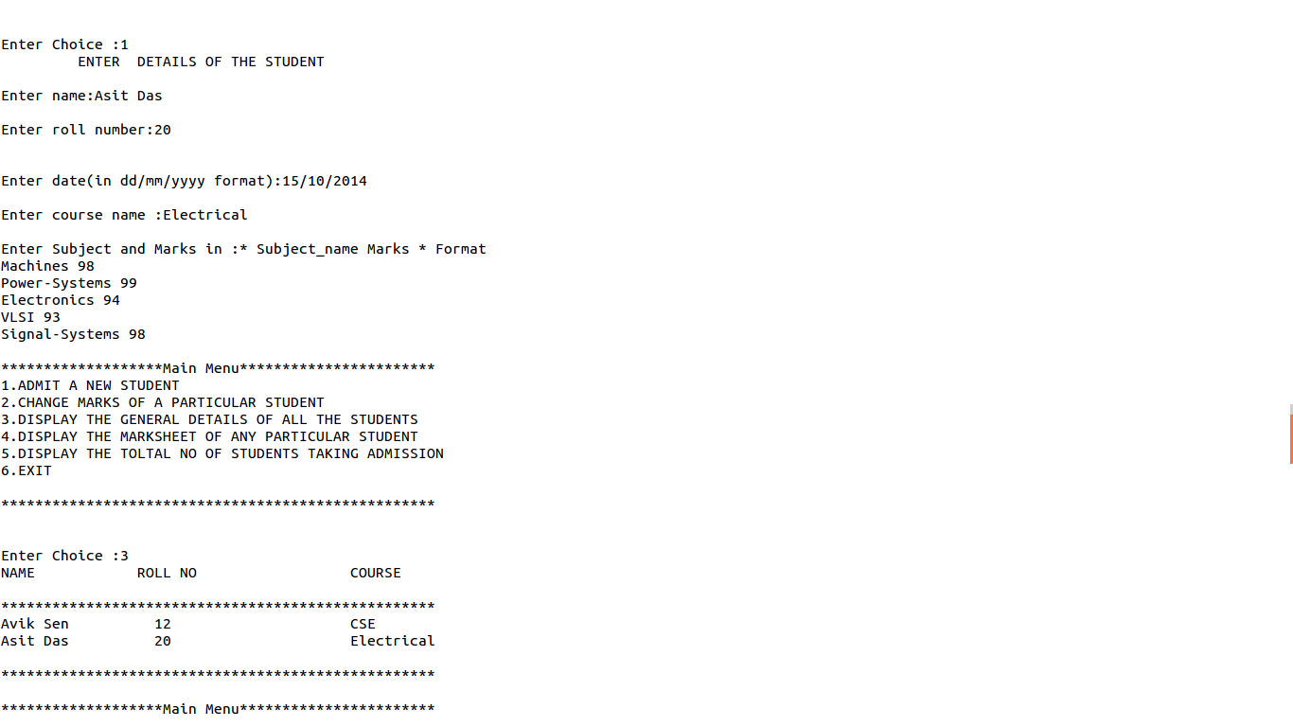

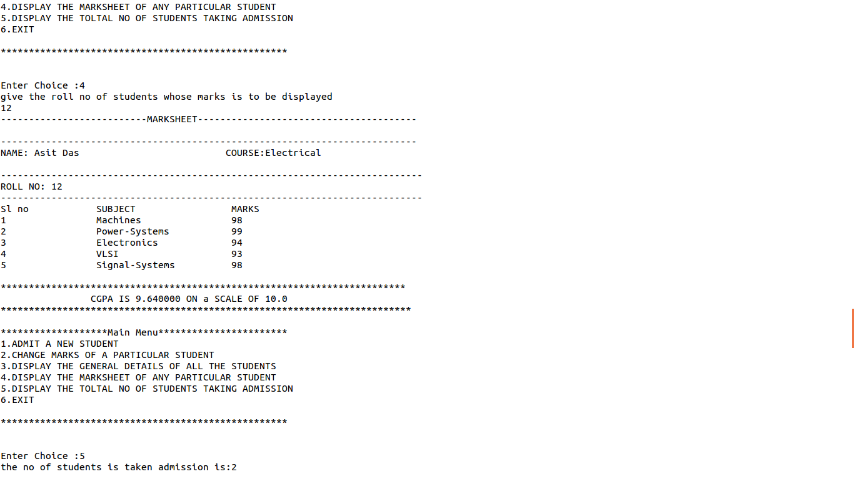

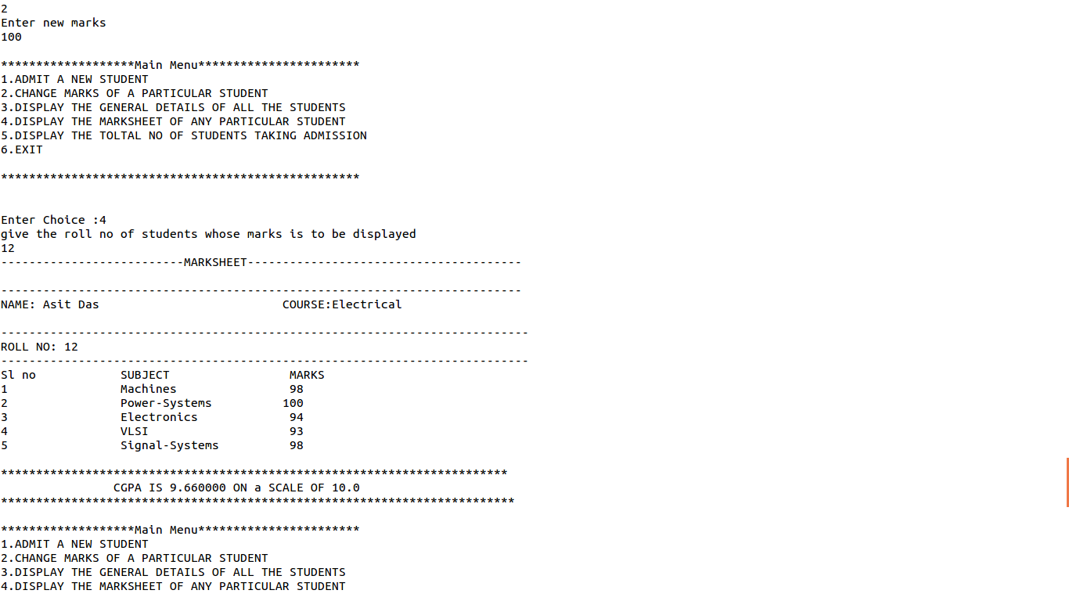

Assignment 2 : C++

