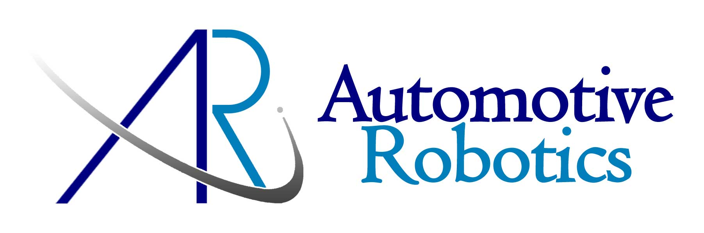
Professional Summary

- About 6+ years of experience in Mobile Technology development mainly on Android Native and Html5.
- Hands on Android Application Development Using Android and HTML5
- Having Hands on Experience on Python.
- Good knowledge on Singleton Design Patterns.
- Possess good knowledge on AnjularJS.
- Have a Basic Knowledge on NodeJS.

Work Experience
- Working as an Engineer-III in Mahindra & Mahindra from April 2016 to till date.
- Worked as an Engineer-II in Automotive Robotics (India) Pvt.Ltd from Dec 2013 to March 2016.
- Worked as SMTS (Senior Member in Technical Staff) for Gaian Solutions India Pvt ltd from Jun 2013 to Dec 2013.
- Worked as Software Developer for Wipro, Hyderabad from Dec-2009 to Dec-2013

General Trainings at ARi
- Python

Technical Skills
Programming Languages | Core Java
Mobile Technologies | Android, HTML5,AnjularJS,NodeJS
IDE | Eclipse
Database | SQLite

Educational Qualification

- B.Tech from Jawaharlal Nehru Technological University, Kakinada – 2005 to 2008.

Projects

Project #1
Ari Mobile Calibrations
Description: The Android App Designed to read the Data from Bluetooth (HC-05) in a Specified Intervals and Reads the GPS Co-ordinates and Generate the Report on Google Map with data collected from Bluetooth Device and Google API’s.

Responsibilities:
- Understand the app requirements and design it from scratch
- Follow MVC design pattern and ensure correct coding standards
- Involved in testing the app and resolving issues
- Work on app improvements and feedback from concerned stakeholders

Technologies: Android

Project #2
OMS – Homepage Approval Notification Widget
Description: The widget app was designed to provide alerts to employees based on the requests they create. The app will listen for changes to an xml file containing employee details on a constant basis using the node module Socket.IO. Any changes to the xml file will trigger a 'emit' event and the Change will subsequently be displayed to the UI using AngularJS.
.
Responsibilities:
- Understand the app requirements and design it from scratch
- Follow MVC design pattern and ensure correct coding standards
- Involved in testing the app and resolving issues
- Work on app improvements and feedback from concerned stakeholders

Technologies: HTML5, CSS, jQuery, JavaScript, AngularJS, Socket.IO module in Node.js,
Bootstrap.

Project #3
SMART IO
Description: A mobile application is developed using android to generate Pulse Width Modulated signal with desired frequency and duty cycle which can be varied, digital switch implementation and getting the digital data using ATMEGA 328p controller . The main aim of the project is to receive the data from the mobile application using Bluetooth module HC-05 and generate digital output or Pulse Width Modulated Signal or return a digital value of an analog signal to application.
.
Responsibilities:
- Understand the app requirements and design it from scratch
- Follow MVC design pattern and ensure correct coding standards
- Involved in testing the app and resolving issues
- Work on app improvements and feedback from concerned stakeholders

Technologies: Android
Project #4
Ari Travel Request App
Description: ARi Travel Request App provides the feature set to send out push notifications to iOS (iPhone/iPad) and Android devices using Apple's Push Notification Service (APNS) as well as Google Cloud Messaging (GCM) and the Android Cloud to Device Messaging framework (C2DM). This module does not rely on any external services and allows site owners to send out push notifications to any mobile device for free.

Responsibilities:
- Understand the app requirements and design it from scratch
- Follow MVC design pattern and ensure correct coding standards
- Involved in testing the app and resolving issues
- Work on app improvements and feedback from concerned stakeholders

Technologies: Android, GCM, NodeJS, HTML5, CSS3, JavaScript.

Project #5
GAIA TV
Description: Gaian Platform frameworks for the Home entertainment market are a Telco grade solution. Notyet another cloud OTT service! In other words, though cloud hosted to leverage operational, economic andvalue added benefits of the cloud, the solution does not compromise in terms of compliance, regulatory and quality of service requirements deemed of a Cable or MSO grade solution. In other words with GAIATV, our customers get the best of both the worlds while leveraging all the economic and disruptive benefits of the cloud on one hand they can still offer a full feature, wholly compliant carrier grade solution on the other.

Responsibilities:
- Understand the app requirements and design it from scratch
- Supporting The Team Members for Resolving complicated issues.
Technologies: Android (ICS), Eclipse (Juno), ADT Plug-in, JSE, MySQL.

Project #6
Durga Education
Description: Durga Education App contains mainly four features such as Engineering colleges info, Notifications, Results and Jobs. Engineering college’s info feature provides the information related to the engineering colleges, Notifications feature displays the notifications released by the universities, Results feature provides the Students results released by the universities and Jobs feature helps to search the jobs easily all over the India.
Responsibilities:
- Understand the app requirements and design it from scratch
- Supporting The Team Members for Resolving complicated issues.
- Involved in User Interface designing in the Project.
- Involved in the development of major modules on android platform.
- Responsible for validating controls and fixing bugs.

Technologies: Android (ICS), Eclipse (Juno), ADT Plug-in, JSE, MySQL.

Project #7
Durgalbrce Electronic Application
Description: Electronic device control is used to control the electronic devices like fan, bulbs, TV, AC and current cooker by using the mobile devices. It saves time and power. This is very comfortable to the users. It is a very big and prestigious project
Responsibilities:
- Understand the app requirements and design it from scratch
- Supporting The Team Members for Resolving complicated issues.
- Involved in User Interface designing in the Project.
- Involved in the development of major modules on android platform.
- Responsible for validating controls and fixing bugs.

Technologies: Android (ICS), Eclipse (Juno) , ADT Plug-in, JSE,MySql,
Project #8
Jobs Manza (DurgaEducation)
Description: Jobs Manza App contains mainly four features such as Engineering colleges info, Notifications, Results and Jobs. Engineering college’s info feature provides the information related to the Engineering colleges, Notifications feature displays the notifications released by the universities, Results feature provides the Students results released by the universities and Jobs feature helps to search the jobs easily all over the India.
Responsibilities:
- Understand the app requirements and design it from scratch
- Supporting The Team Members for Resolving complicated issues.
- Involved in User Interface designing in the Project.
- Involved in the development of major modules on android platform.
- Responsible for validating controls and fixing bugs.

Technologies: Android (ICS), Eclipse (Juno), ADT Plug-in, JSE,MySQL.

Sambasivarao Pendela

