**Operating Systems (EE), Spring 2020**

**Assignment (PLO 12)**

Synchronization has always been a problem, you can find multiple solutions on synchronization problem. You can observe a lot of systems around us where multiple processes try to access same database at the same time. Take airline reservation system or hotel reservation system for an example. You’ll get to see similarity in these kind of problems.

In this assignment, your task is to come up with a synchronized solution for synchronization problems in general. You are required to do the following:

1. **Recognize** the nature of Problem and try to **Search** relevant information independently from as many sources as you can get but don’t forget to mention the sources here. [SLO 12.1]
2. **Acquire** new knowledge or skills gathered from the knowledge you have gathered already to help develop an efficient solution. [SLO 12.2]
3. **Apply** knowledge or skill gathered from above two steps and develop the solution.[SLO 12.3]
4. Finally, when you have come up with a solution, you must be able to **Reflect** your thoughts on merits/demerits of your solution. You must also be able to **Teach** yourself by suggesting steps for improvement. [SLO 12.4]

You are required to discuss synchronization problem in the context of multiprocessor systems. Do this for points 1 and 2. Write a report (about 10-12 pages) analyzing the problem and possible solutions with their pros and cons.

For points 3 and 4, implement **The Dining Philosophers Problem** using a synchronization primitive of your choice in Linux. You are required to simulate the synchronization using five to six philosophers. Write a project report.

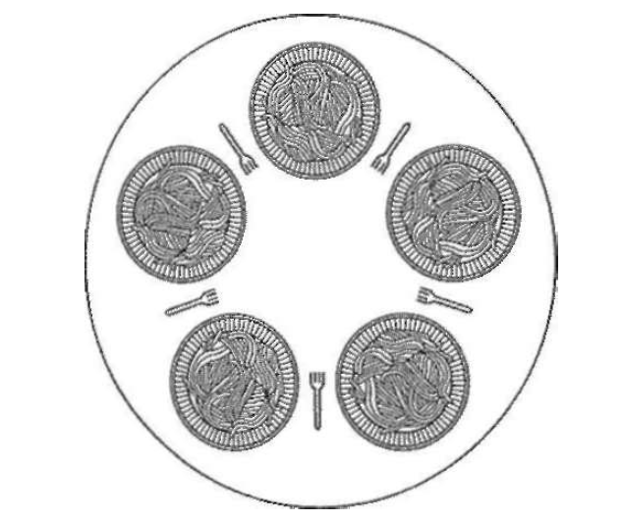

Figure 1: Dining Table for five philosophers

Submission Requirements:

1. Submit a report on Points 1 and 2 in google classroom folder.
2. You are required to submit solution i.e code (Point 3) along with the output (screenshots) on google classroom Lab folder.
3. For Point 4, you will have to present your final solution on google meet session and be evaluated accordingly.
4. Use 12 point Times New Roman font for reports.
5. Provide list of references.
6. Minimum penalty for plagiarism is zero in the assignment.
7. Due date for Reports is 21st May and codes will be evaluated in respective lab sessions (i.e Lab 13 and Lab 14).

Late submissions will not be graded.