**INDIAN INSTITUTE OF TECHNOLOGY JODHPUR**

**NH 62 Nagaur Road, Karwar, Jodhpur, Rajasthan**



**MTech in Data Engineering – Semester 1**

**Machine Learning with Big Data**

**Project Report**

**On**

**Book Recommendation System**

**Submitted By:**

**Aneerban Chowdhury, M24DE3011**

**Pavani Racham, M24DE3059**

**Naresh Krishna Vemuri, M24DE3052**

**Book Recommendation System**

**Abstract**

The Book Recommendation System aims to enhance user experience by providing personalized book recommendations based on user preferences and reading history. This system will leverage Google Cloud services such as **Google Cloud Storage (GCS), and Machine Learning models** to process and analyze large datasets efficiently. The recommendation engine will employ **collaborative** **filtering** and to generate accurate suggestions. The solution will also feature a user-friendly frontend for interaction and a backend for data processing and model inference.

**List of Key Technology Challenges:**

* **Data Collection & Storage:** Handling large volumes of book metadata, user interactions, and preferences efficiently in GCS.
* **Data Processing & Pipelines:** Creating scalable ETL pipelines for cleaning, transforming, and processing data.
* **Real-Time Processing:** Ensuring low-latency recommendations through optimized model execution and inference.
* **Scalability & Performance:** Managing high user traffic and large datasets without performance bottlenecks.
* **Frontend Integration:** Delivering seamless interaction between users and the recommendation engine.

**Technology Stack:**

* **Code Environment:** Python, Jupyter Notebook
* **UI**: Flask
* **Storage**: Google Cloud Storage
* **Machine** **Learning**: Scikit-Learn, Google AI Platform

**List of Deliverables:**

* **Data Ingestion & Processing Pipelines**: GCS for ingesting book data and user interactions.
* **Recommendation** **Engine**: Collaborative filtering for book recommendations.
* **User** **Interface**: Interactive frontend for users to browse and receive recommendations.
* **Performance** **Optimization**: Efficient model execution and inference for real-time suggestions.
* **Deployment** **&** **Scaling**: Fully deployed system on Google Cloud ensuring scalability and reliability.
* **Technical** **Documentation**: Comprehensive documentation for system architecture and ML models.

**Data Sources:**

* Kaggle Dataset - Collaborative Filtering Books Recommendation
* Size of Dataset & Attributes
  + Books 271360 rows X 8 columns – ISBN, Title, Author, Publication, Year of Publishing
  + Users 278858 rows X 3 columns – User ID, Location, Age
  + Ratings 1149780 rows X 3 columns – User ID, ISBN, Rating

**Introduction**

The Book Recommendation System is designed to deliver personalized book suggestions by analyzing user preferences and reading history. Leveraging Google Cloud technologies such as Google Cloud Storage, and the Google AI Platform, the system processes large-scale datasets efficiently. It combines collaborative filtering to enhance recommendation accuracy. The solution includes scalable ETL pipelines, a Flask-based interactive user interface, and a backend for real-time inference. Using a Kaggle dataset of books, users, and ratings, the system ensures high performance, scalability, and a seamless user experience, making it an effective tool for discovering books tailored to individual interests.

**Problem Statement**

1. **Data Management**:  
   Efficiently managing and processing large-scale datasets comprising book metadata, user information, and rating histories is crucial. The system must handle both structured and semi-structured data formats while ensuring data consistency, accuracy, and security. Challenges include the ingestion of millions of records, reliable storage in Google Cloud Storage and fast retrieval for downstream analytics and recommendations.
2. **Analytics**:  
   Extracting meaningful insights from user interaction data to understand reading habits, popular authors, and genre preferences is essential for improving engagement. The system will analyze trends in user ratings and behavior to support decision-making around content curation, targeted marketing, and user retention strategies.
3. **Prediction**:  
   The system will implement machine learning models using collaborative filtering techniques to accurately predict book preferences for individual users. Leveraging historical data, the models aim to forecast future user interests, providing personalized suggestions and enhancing the discovery experience.
4. **Accessibility**:  
   A user-friendly frontend built with Flask will offer seamless interaction between users and the recommendation engine. The interface will present recommendations clearly and intuitively, making it accessible for both technical and non-technical users. Interactive features will enable users to explore suggestions, provide feedback, and refine their preferences.
5. **Scalability**:  
   The system architecture will be designed to scale effortlessly with growing datasets and user base. It will support high concurrency and performance by leveraging cloud-native solutions, ensuring real-time recommendation delivery without latency issues, even under increased load conditions.

**Methodology**

**System Architecture**

The project is built using a modular architecture that integrates the following components:

1. **Data Storage:** Google Cloud Storage for structured and unstructured data.
2. **Data Processing:** Python scripts for data cleaning, transformation, and loading (ETL).
3. **Machine Learning:** Scikit-learn for predictive analytics.
4. **Frontend:** Flask for web interface development.

**Implementation Steps**

**Step 1: Environment Setup**

* Installed Python and essential libraries like Scikit Learn, Surprise, Numpy, Pandas, Pickle
* Set up GCP with appropriate permissions and billing.
* Configured Jupyter Notebook for development and debugging

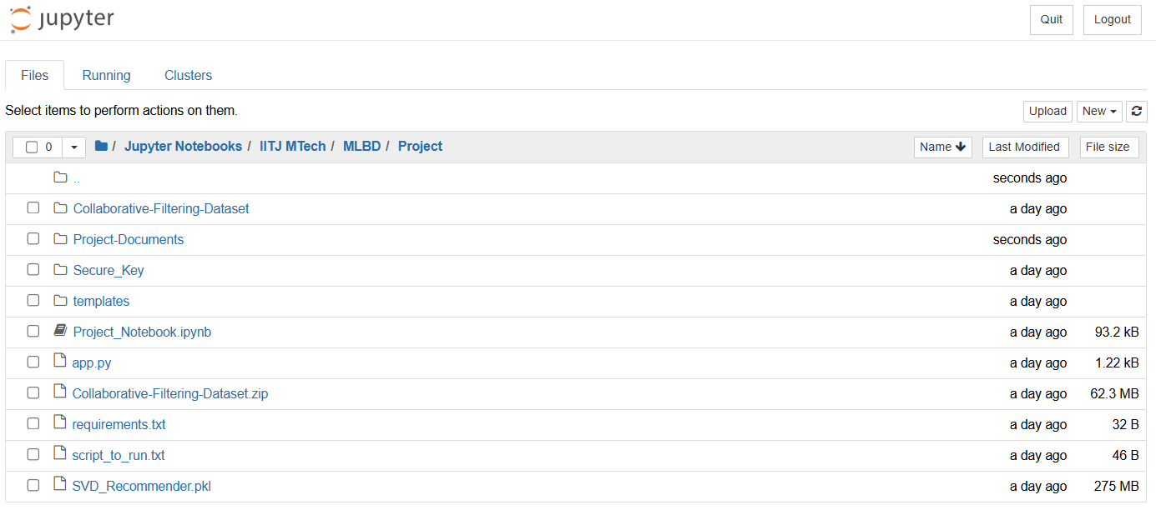

**Step 2: Data Design**

Uploaded three main files to GCS. Data sourced from Kaggle

* Books 271360 rows X 8 columns – ISBN, Title, Author, Publication, Year of Publishing
* Users 278858 rows X 3 columns – User ID, Location, Age
* Ratings 1149780 rows X 3 columns – User ID, ISBN, Rating

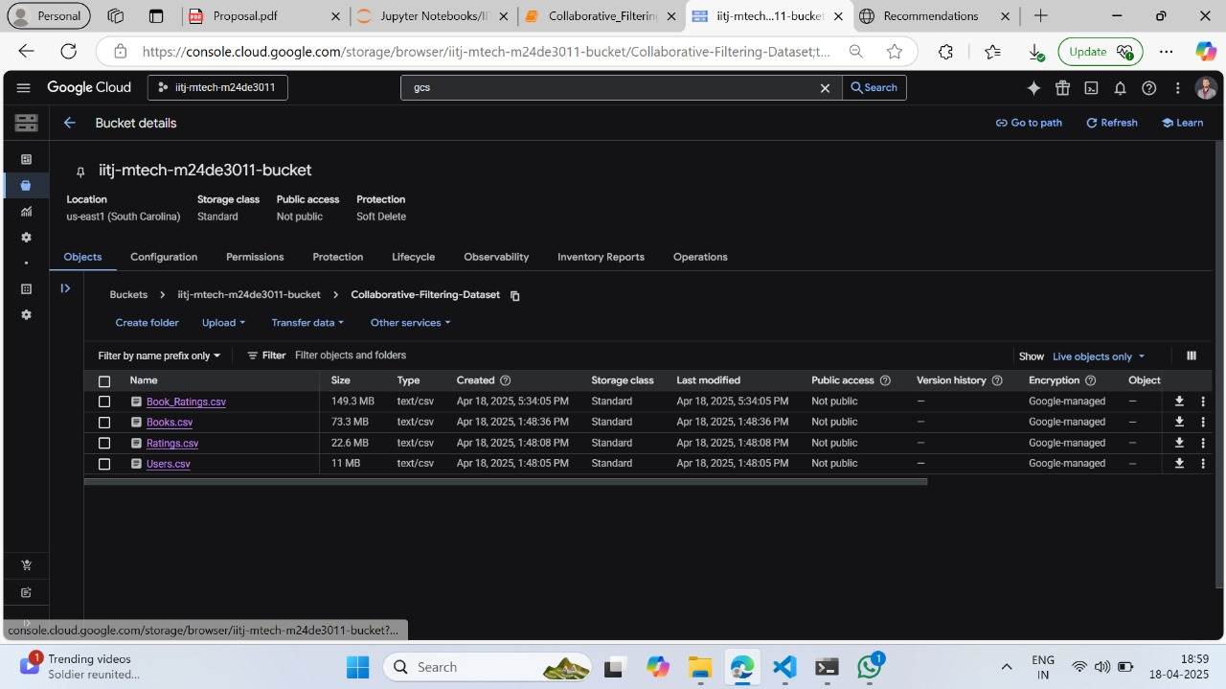

**Step 3: EDA and Save the Processed Dataset on GCS**

* Did EDA to clean the data
* Created Books_Rating dataset by joining two datasets i.e. Books and Ratings.
* Save it to GCS to use it further.

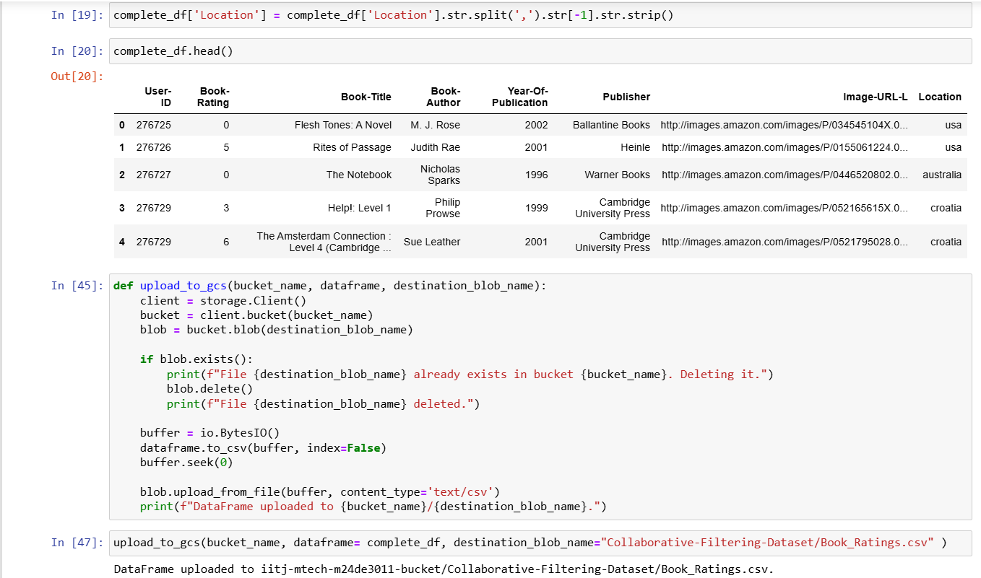

**Step 4: Collaborative Filtering and SVD**

* **Create User-Item Matrix**:  
  Construct a matrix where rows represent users, columns represent books (ISBN), and cells contain the user's rating for that book.
* **Compute User Similarity**:  
  Use cosine similarity or Pearson correlation to calculate similarity between users based on their rating vectors.
* **Predict Ratings**:  
  Estimate ratings for unrated books by taking a weighted average of ratings from similar users.
* **Generate Recommendations**:  
  Recommend the top-N highest predicted rated books that the user hasn't rated yet

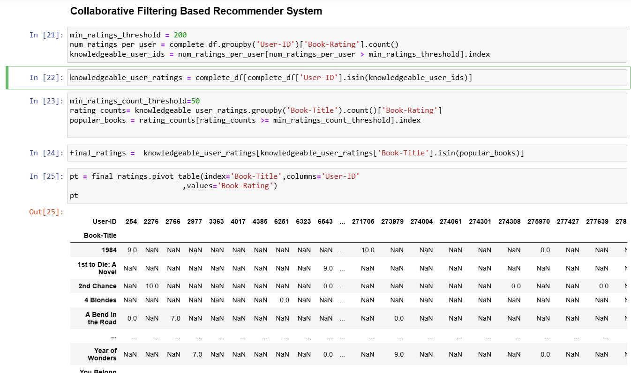

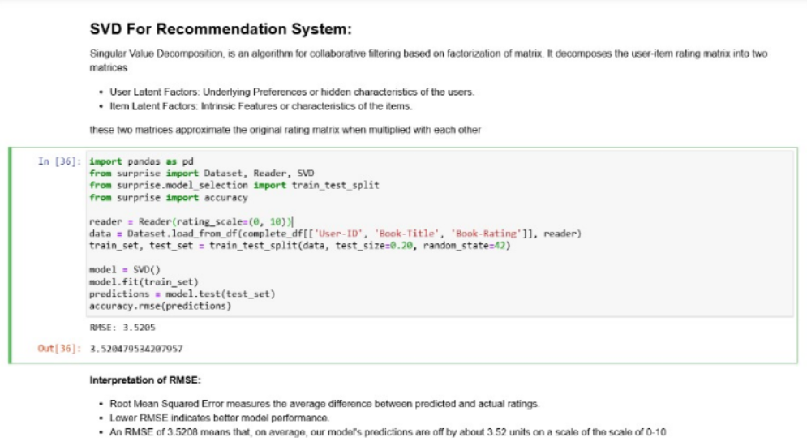

**Step 5: Frontend using Flask**

* Designed a basic yet functional HTML interface integrated with Flask templates.
* Displayed order summaries and visualizations dynamically.

1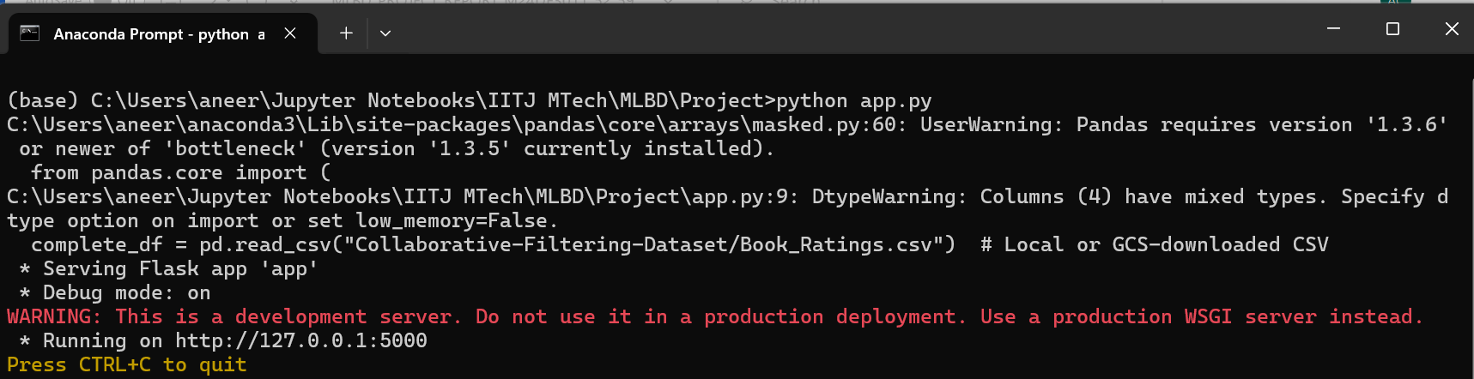

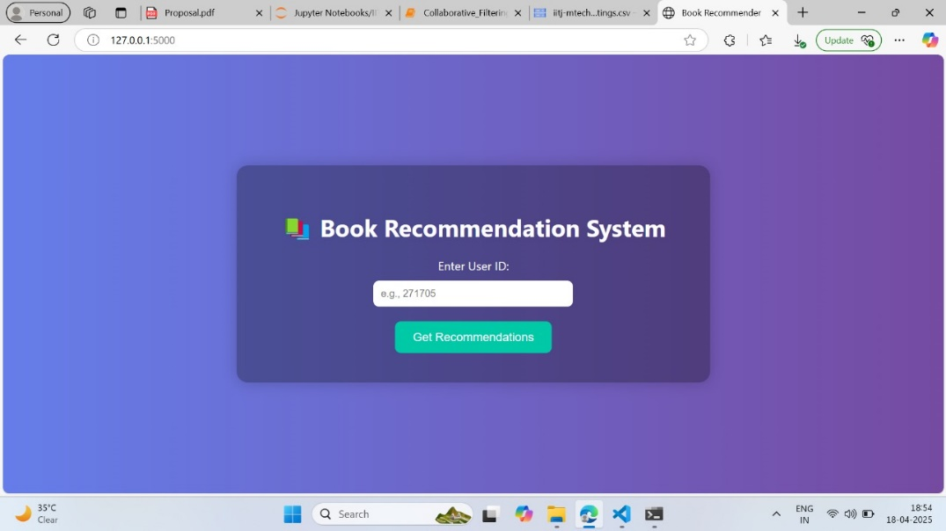

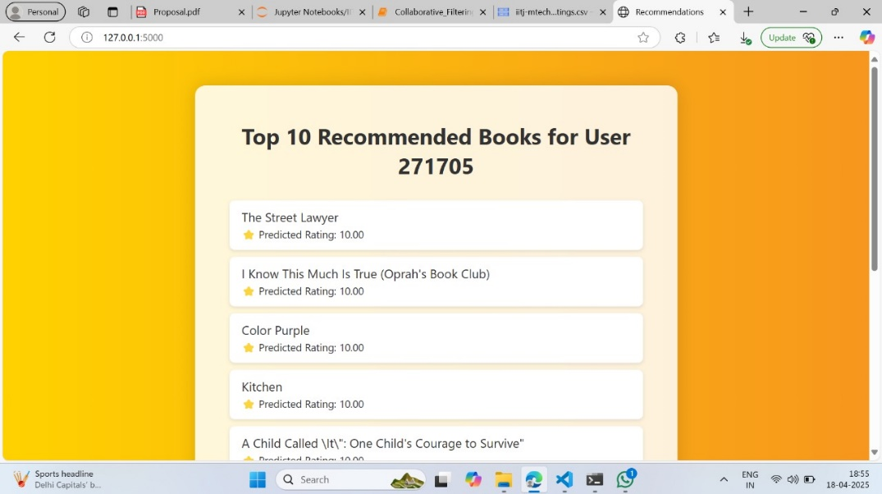

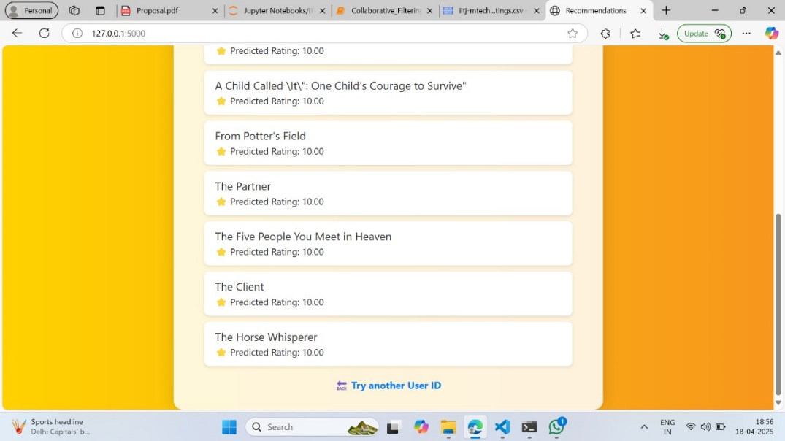

**Results**

**Achievements**

1. **Scalability:** Successfully stored and processed datasets on GCS.
2. **Efficiency:** Reduced data processing time using GCP tools.
3. **Predictive Insights:** Achieved acceptable accuracy in predicting order trends.
4. **Accessibility:** Enabled stakeholders to interact with the system through frontend.

**Challenges**

1. **Data Cleaning:** Ensuring data consistency during EDA.
2. **Visualization:** Balancing clarity and complexity in visual outputs using Flask.

**Future Scope**

1. **Hybrid Recommendation Models**: Combine collaborative filtering, content-based filtering, and deep learning-based approaches to improve personalization and accuracy.
2. **Real-Time Personalization**: Integrate real-time user interaction tracking to update recommendations dynamically using stream processing tools like Apache Kafka or Pub/Sub.
3. **User Profile Enrichment**: Include demographic data, reading goals, and sentiment analysis to build richer user profiles for more targeted suggestions.
4. **Mobile App Integration**: Extend the system to a mobile app using Flutter or React Native, enabling users to access personalized recommendations on the go.
5. **Cloud Optimization**: Optimize cost and performance by experimenting with serverless architectures, auto-scaling, and managed AI services on GCP.

**Conclusion**

The Book Recommendation System successfully demonstrates how user preferences and historical reading behavior can be leveraged to deliver personalized book suggestions using collaborative filtering techniques. By integrating Google Cloud services for scalable data storage, processing, and model deployment, the system ensures efficient handling of large datasets and real-time recommendations. A user-friendly interface enables seamless interaction, while machine learning models enhance the accuracy and relevance of suggestions.

Project Link: [**https://github.com/aneerban10/mlbd-group-project-Aneerban-Pavani-Naresh**](https://github.com/aneerban10/mlbd-group-project-Aneerban-Pavani-Naresh)

**References**

1. Google Cloud Platform Documentation
2. Scikit-learn Reference
3. Flask Documentation