**AUSTRALIA**

1. *Exchange Rates graph from 2006-2020*

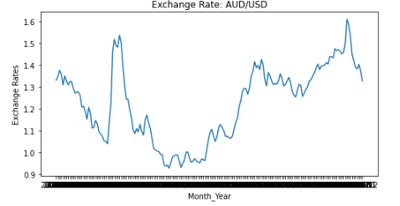

1. *Actual vs Predicted Data from 2016-2020*

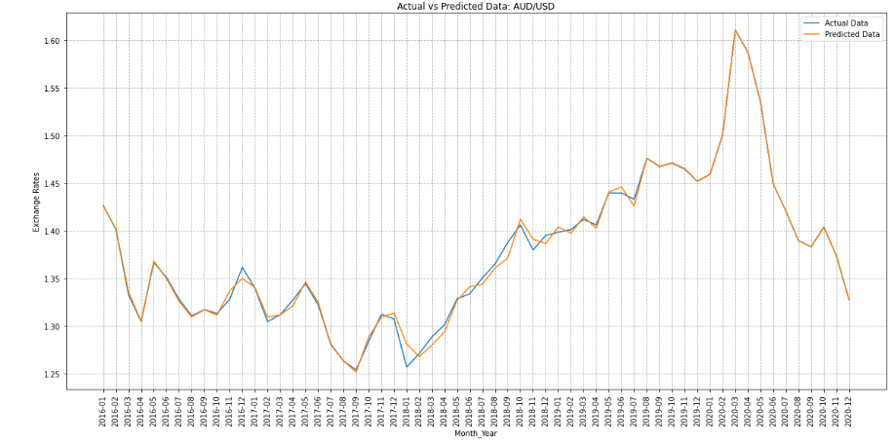

1. *Polynomial Regression Graph*

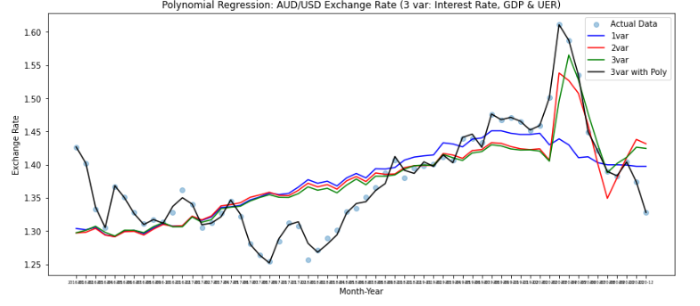

1. *R-squared and MSE Graph to check for Overfitting*

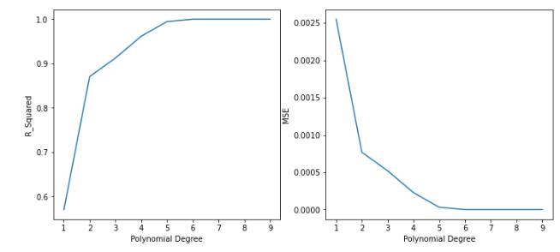

1. *Ridge and Lasso Regression Graph*

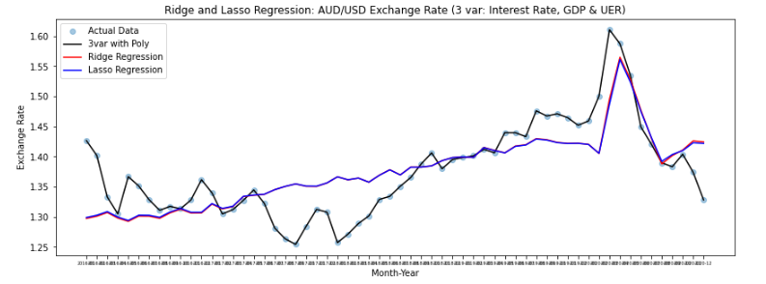

1. *Graph to check for different components in a time-series data*

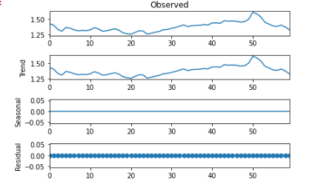

1. *Auto Correlation(ACF) and Partial Autocorrelation(PACF) Graph:*

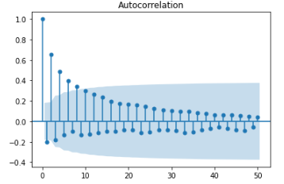 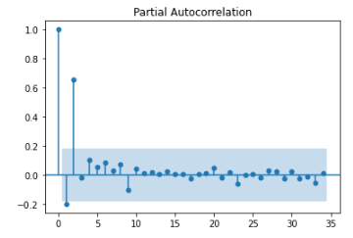

1. *ARIMA Model Results*
   * *Order:(2,1,3)*

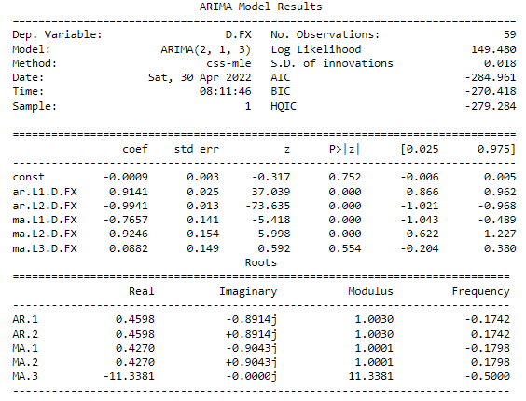

* *Order:(1,1,1)*

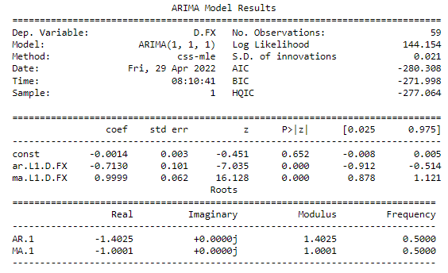

1. *Actual vs Forecasted Graph:*

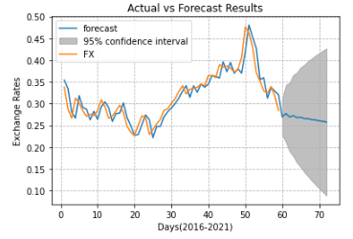

1. *Polynomial Regression Graph along with the Forecasted Data:*

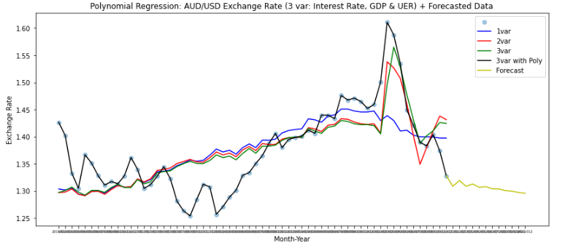

1. *Exchange Rate Graph of 2021:*

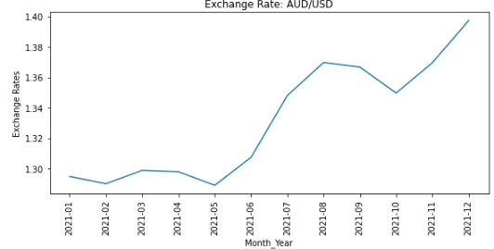

1. *Actual vs Forecasted Data of 2021 Graph:*

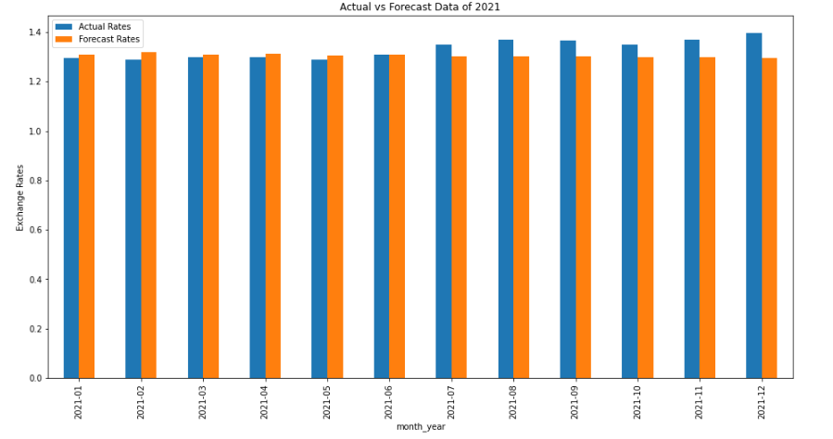

1. *2021 Accuracy Chart*

