**User Manual Guide**

**Scoutstock**



Table of Contents

**1: Choose Plan** 3

**2: Create Business Account** 4

**3: Confirmation Email** 5

**4: Profile Display** 8

**4.1: Edit Profile** 9

**4.2: Seller Info** 10

**5: Products** 14

**5.1: Create a Product** 15

**5.2: Product Display** 17

**5.3: Product Reviews** 18

**6: Message Center** 19

**6.1: Customer Communication** 19

**6.2: Admin Communication** 20

**7: Note:** 23

# **1: Choose plan**

**Step 1: Visit the pricing page**

To explore Scout Stock pricing options, start by visiting the pricing page at <https://scoutstock.com/pricing>.

**Step 2: Choose your plan**

On the pricing page, you'll see two plan options:

1. **Free plan**
2. **Professional plan**

**Step 3: Select your plan**

Click on the plan you're interested in – either the free plan or the professional plan. This will take you to the next page.

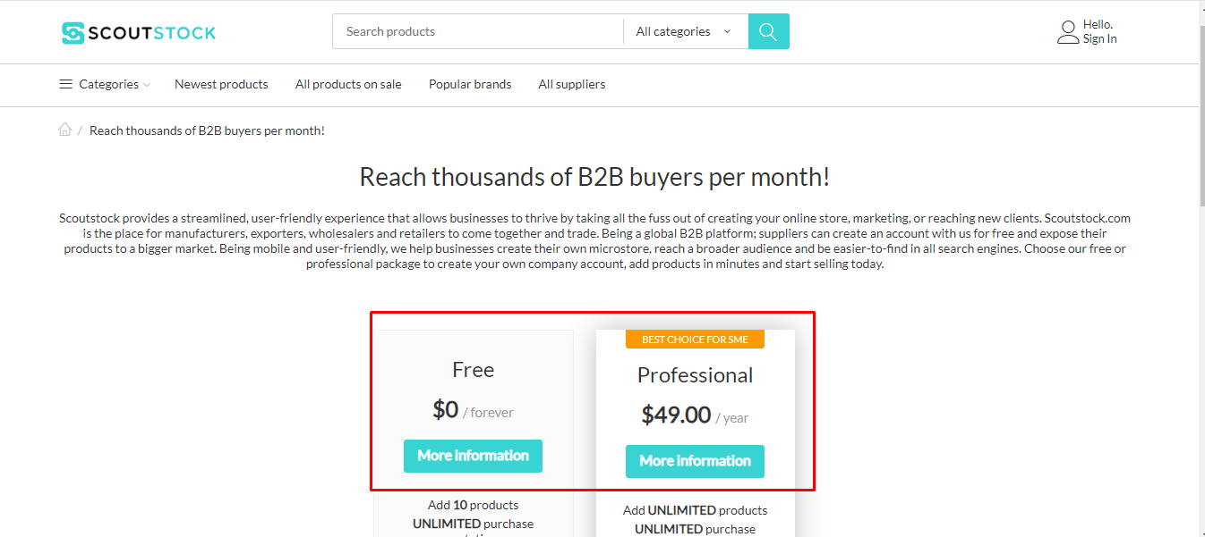

**Step 4: Explore the next page**

After choosing your plan, you'll be directed to the next page where you can find detailed information about the selected plan. This may include features, pricing details, and any additional information you need to know.

# **2: Create business account**

**Step 1: After choosing the free plan**

Once you've selected the Free Plan on **Scoutstock** pricing page <https://scoutstock.com/pricing>, you'll be redirected to the next page to fill in some basic information.

**Step 2: Provide Essential Details**

On this page, you'll need to fill in the following details:

* **Company name:** Enter the name of your company.
* **Plan:** This might be pre-selected as you've chosen the Free Plan.
* **First name:** Your first name.
* **Last name:** Your last name.
* **Email:** Use a valid email address for account communication.
* **Company description:** Briefly describe your company.
* **Address:** Your company's physical address.
* **City:** The city where your company is located.
* **Country:** Select your country from the list.
* **Zip code:** Your company's zip or postal code.

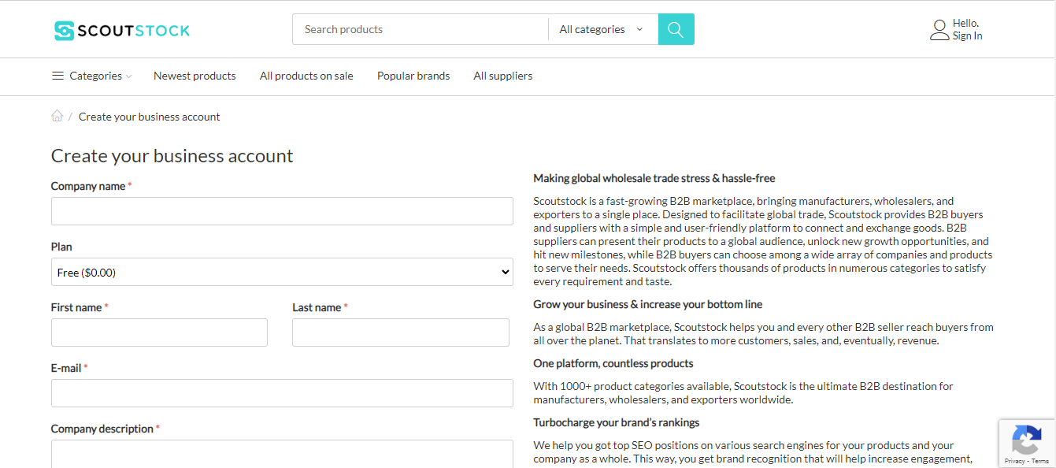

**Step 3: Agreement and submission**

After completing all the fields, look for an "**Agree**" checkbox. Make sure to read any terms or conditions associated with it. If you agree, check the box.

**Step 4: Submit your information**

Finish the process by clicking on the "**Submit**" button.

**Step 5: Confirmation and verification**

You might receive a confirmation message or, in some cases, an email for verification. Follow any instructions provided to confirm your registration.

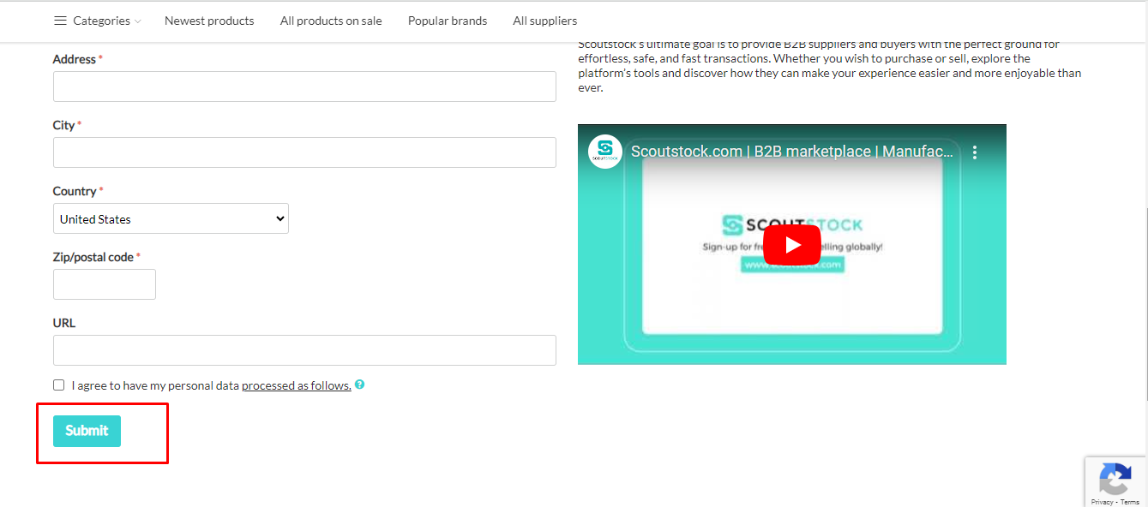

# **3: Confirmation Email**

**Step 1: Submission and Confirmation Email**

After you've filled in all the necessary details on the registration page, click the "**Submit**" button. Shortly after, check your email inbox for a confirmation message.

**Step 2: Open the Confirmation email**

Look for an email from **Scoutstock** in your inbox on in spam folder. The subject may include something like "**Scoutstock** account confirmation" or similar.

**Step 3: Find your credentials**

In the confirmation email, you'll find important information:

* **New administrator creation:** The email will confirm that a new administrator account has been created for you.
* **Login credentials:** Your login credentials, including your username or email and a password, will be provided in this email. Keep these details secure.

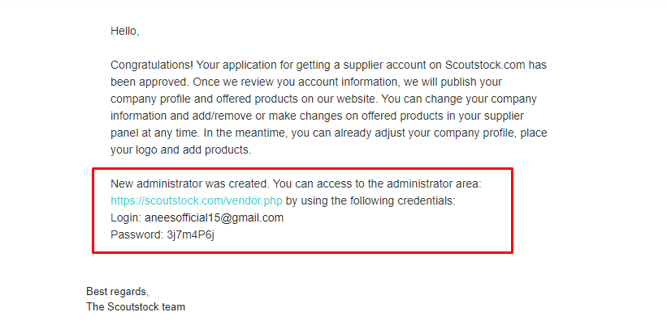

**Step 4: Click on the login link**

Within the email, there will be a link to the login page. Click on this link to access the Scout Stock login page.

**Step 5: Enter your credentials**

On the login page, enter the credentials provided in the confirmation email – usually, your email or username and the password.

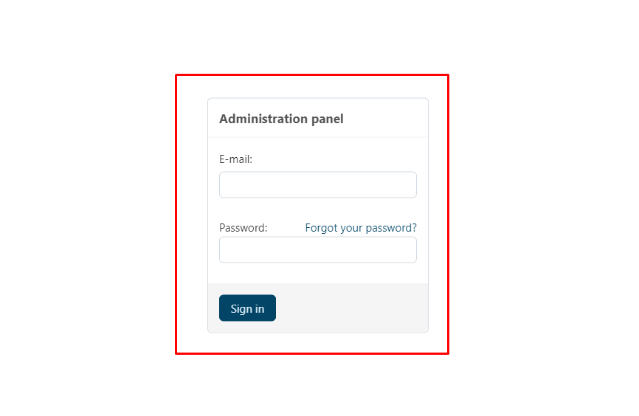

**Step 6: Welcome to your Scoutstock account**

Upon successful login, you'll be directed to your Scout Stock account. Welcome aboard!

**Step 7: Explore and start using Scoutstock**

Take a moment to familiarize yourself with the platform. You can now access the features and tools that come with your Scout Stock account.

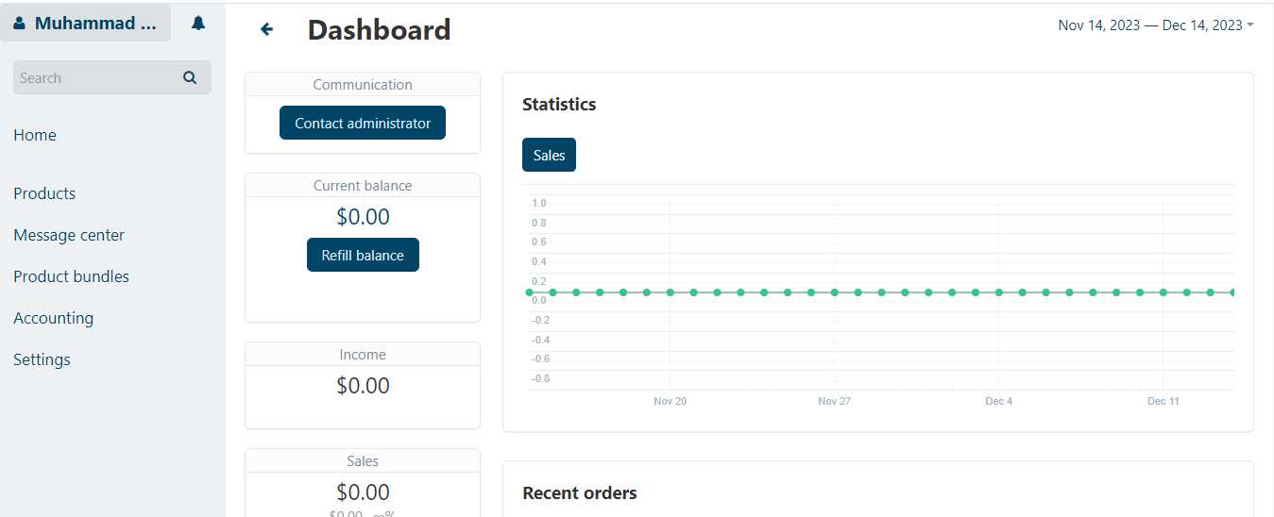

# **4: Profile display**

**Step 1: Accessing the supplier page**

Start by logging into your Scout Stock supplier account. Once logged in, navigate to the supplier page.

**Step 2: Locate your profile name**

In the top-right corner of the page, you'll find your profile name. Look for it near the account or notification icons.

**Step 3: Click on the three dots**

Next to your profile name, there will be **three dots**. Click on these dots to reveal a dropdown menu.

**Step 4: Explore the dropdown menu**

The dropdown menu will present several options:

* **US dollar:** This option allows you to set or view your preferred currency.
* **Edit profile:** Click here to make changes to your profile information. Update details like contact information or profile picture.
* **Seller info:** Access important information related to your seller account. This may include performance metrics, ratings, or seller-specific details.
* **Sign out:** If you're done using your account, select this option to log out.

Choose the tab you're interested in by clicking on it. For example, click on "**US dollar**" to manage your currency preferences

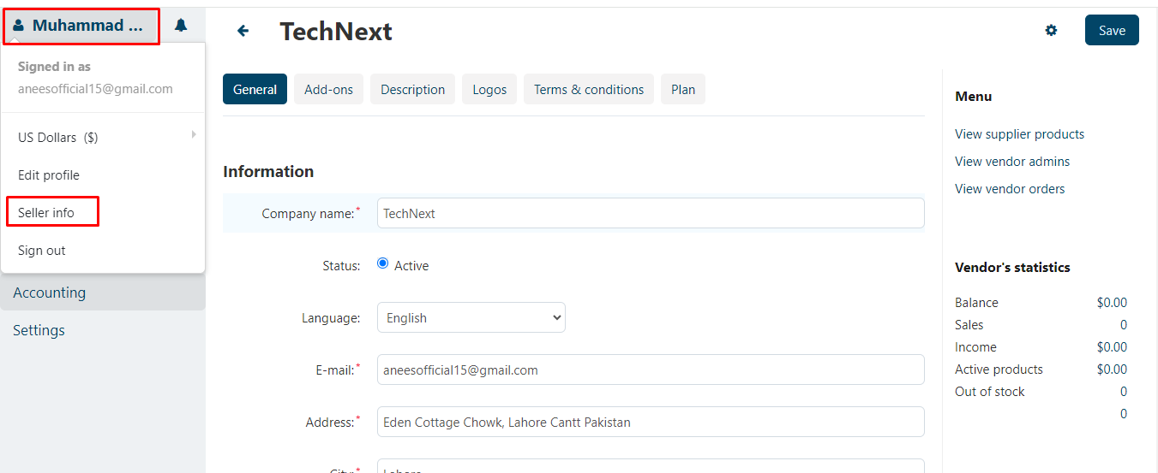

## **4.1: Edit profile**

**Step 2: Select "edit profile"**

In the dropdown menu, click on "**edit profile**." This will take you to the page where you can modify your user details.

**Step 3: Review User Details**

On the "**edit profile**" page, you'll see your current user details, including information like your **name, contact details**, and any other relevant fields.

**Step 4: make changes**

If you want to change any information, simply click on the field you wish to edit. For example, you might update your **email address, phone number**, or **profile picture**.

**Step 5: Save your changes**

After making the desired changes, look for a "**save**" button on the page. Click on it to ensure that your modifications are saved.

**Step 6: Confirmation message**

Once you've successfully saved your changes, you may receive a confirmation message or see a visual cue indicating that your details have been updated.

**Step 7: Verify changes**

To double-check, you can revisit your profile page or the "**Edit Profile**" section to confirm that the updated details are now reflected.

**Step 8: Done!**

Congratulations, you've successfully edited and saved your profile details on Scout Stock. Your account is now updated with the changes you made.

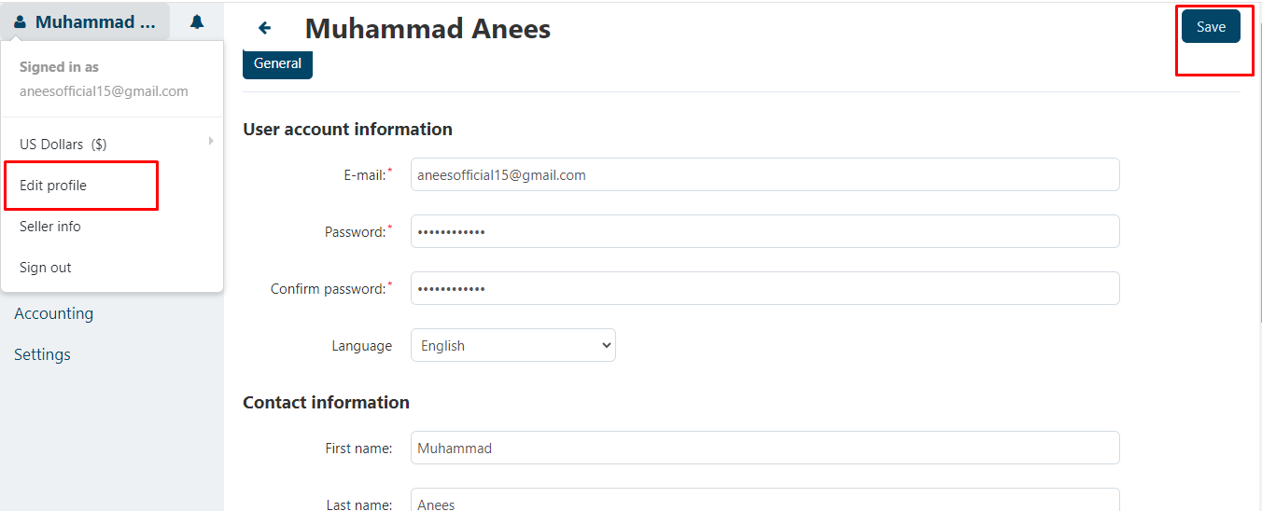

## **4.2: Seller Info**

**Step 1: Locate the seller info button**

Once you're on your **Scoutstock** supplier account, find your profile name in the top-right corner. Click on the three dots next to it, and in the dropdown menu, select **"Seller info."**

**Step 2: Overview of seller details**

Upon clicking "**Seller info**," a new page will open, displaying various sections with details you provided during your supplier account setup.

**Step 3: General section**

In the "**General**" section, find key information such as your company name, status, language, address, and contact details. This is where you can verify or update essential details related to your seller account.

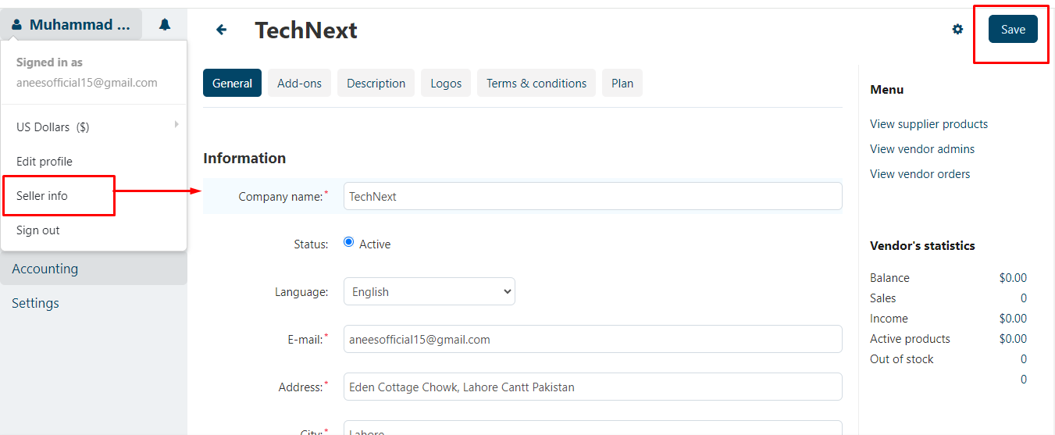

**Step 4: Ads-on section**

The "**Ads-on**" section might include information about additional features or services that you can utilize to enhance your seller experience. Explore this section to understand any extra offerings.

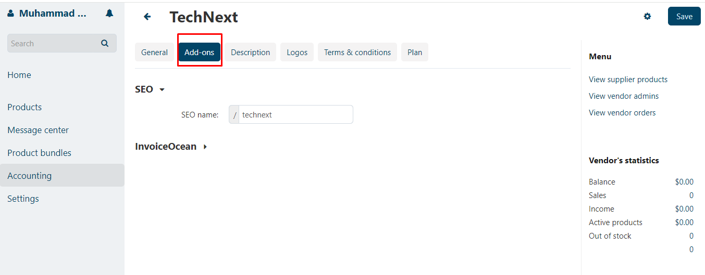

**Step 5: Description section**

The "**Description**" section allows you to provide a brief overview or description of your company. This is an opportunity to showcase what makes your products or services unique.

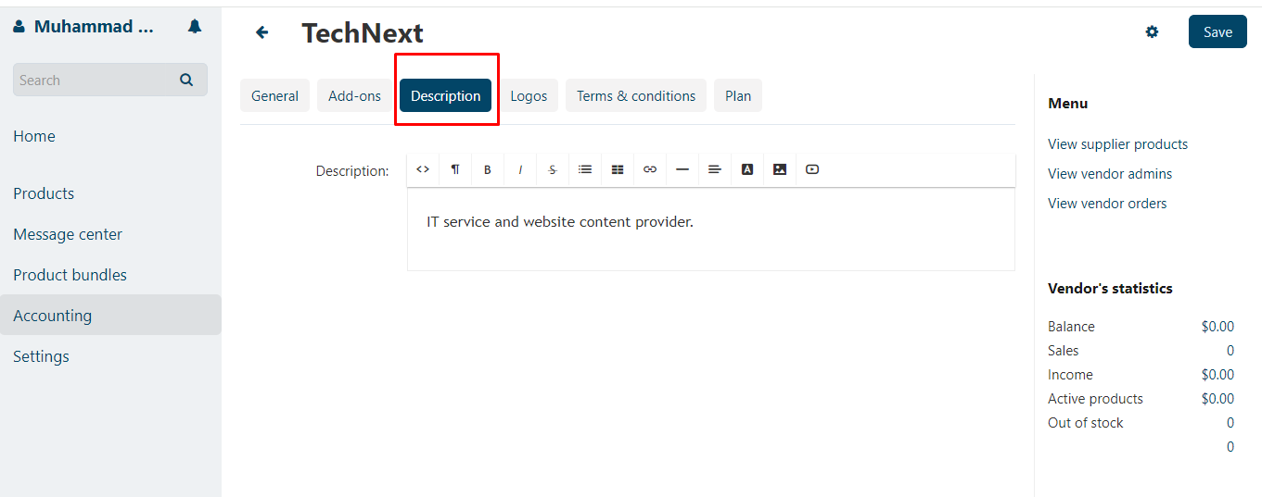

**Step 6: Logos section**

Under **"Logos,"** you can manage and upload your company logos. Ensure your branding is represented accurately by updating or verifying your logo files in this section.

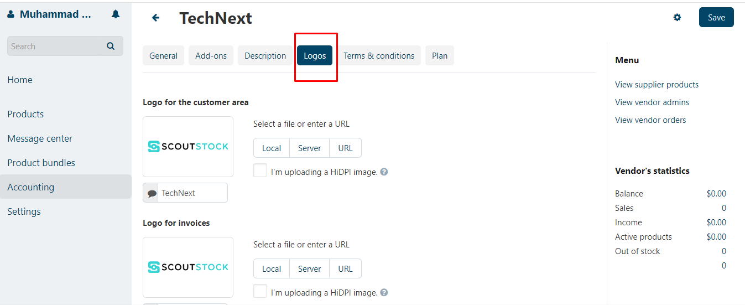

**Step 7: Terms and conditions section**

Review and, if necessary, update the "**Terms and conditions**" associated with your seller account. This section outlines the guidelines and agreements between you and Scout Stock.

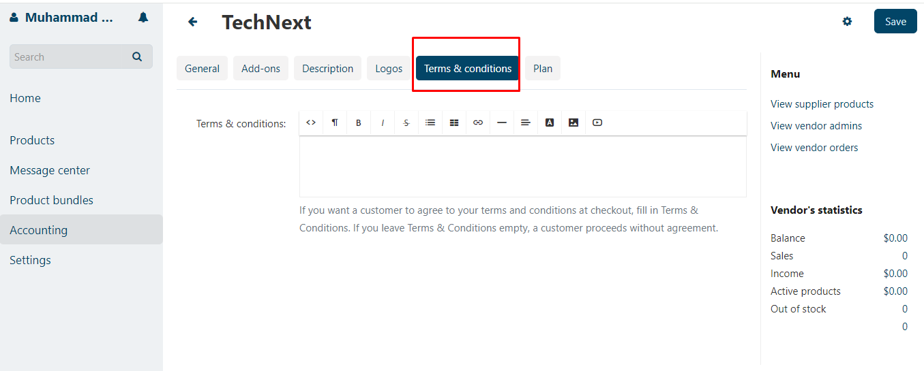

**Step 8: Plan section**

In the "**Plan**" section, you'll find information about your current subscription or plan. This may include details about features included in your plan and any limitations.

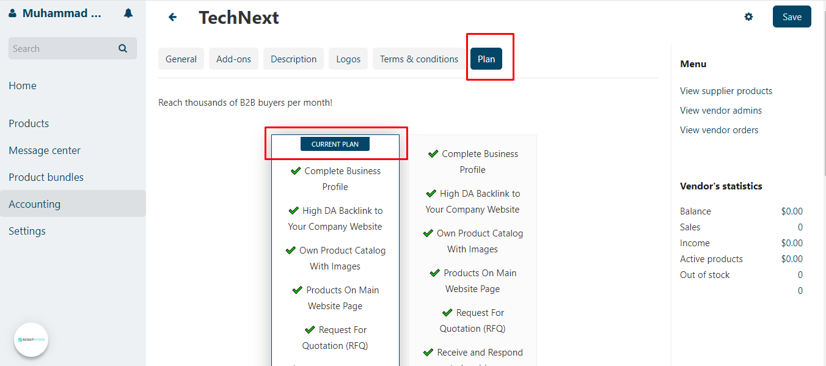

**Step 9: Make changes as needed**

If any details need modification, click on the relevant section and follow the prompts to update your information. Remember to save changes if required.

# **5: Products**

**Step 1: Access the product module**

Start by navigating to the left-side menu. Look for the "**Product**" module and click on it. This action will take you to the product page.

**Step 2: View your existing products**

On the product page, you'll find a list of your products if you've already added some. This is where you can easily review and manage your existing inventory.

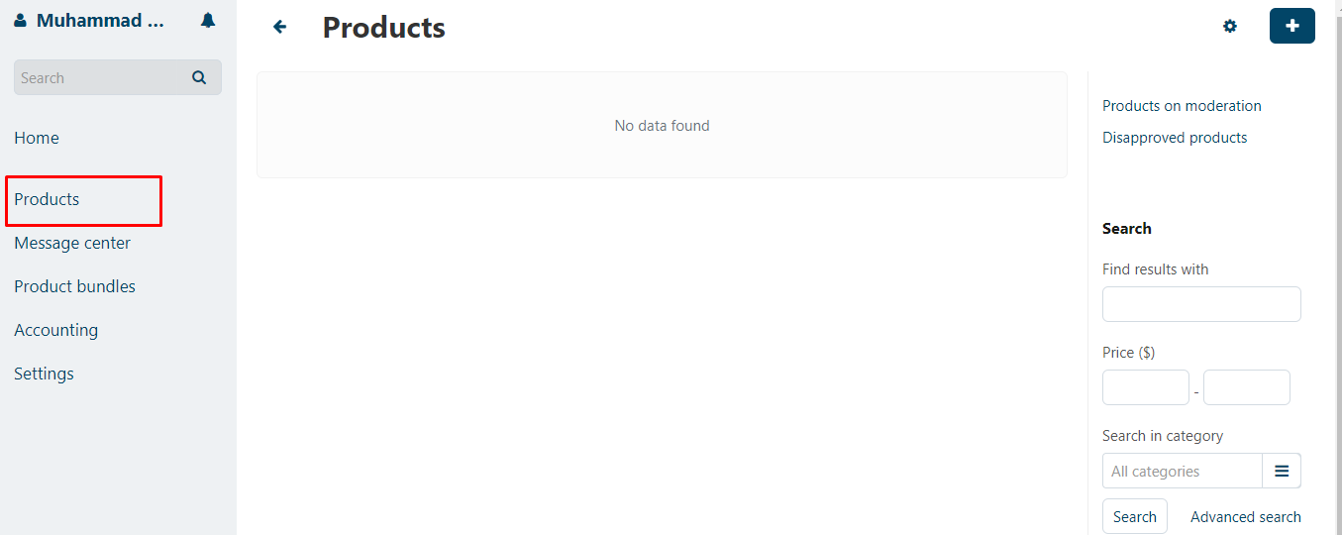

## **5.1: Create a product**

**Step 1: Navigate to the product page**

On Scoutstock, go to the product page by selecting the "**Product**" module from the left-side menu.

**Step 2: Find "create new product"**

In the top-right corner of the product page, you'll see the option to "**Create new product**." Click on this to initiate the process of adding a new product to your inventory.

**Step 3: Fill in product details**

After clicking "**create new product**," a new page will open. Here, you'll be prompted to provide essential details for your new product:

* **Name:** Enter the name of your product.
* **Categories:** Select the relevant categories that best describe your product.
* **Price:** Set the price for your product.
* **Description:** Write a brief description to highlight key features or details.
* **Image:** Upload an image to visually represent your product.

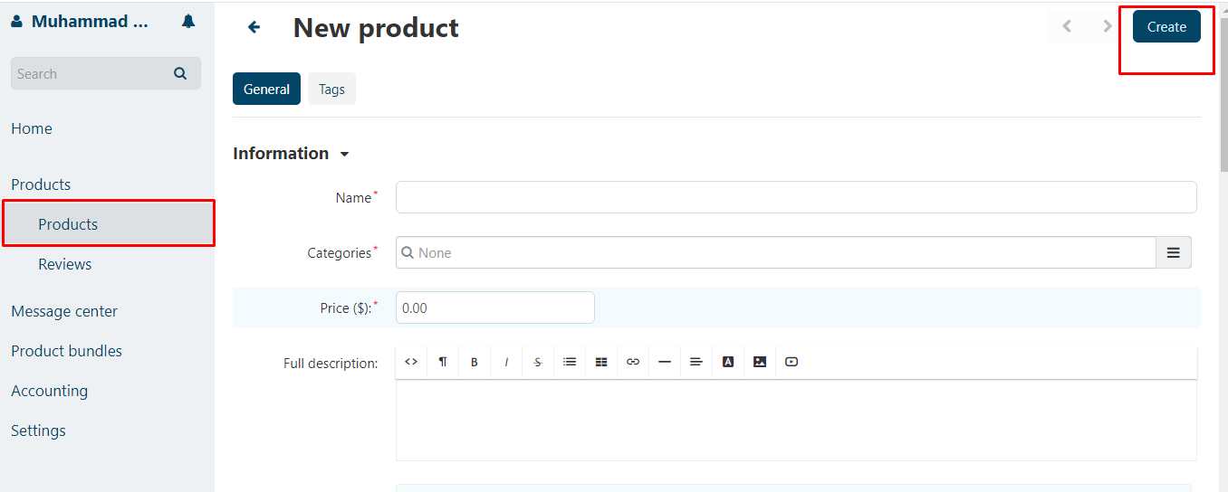

**Step 4: Optional fields (If desired)**

You may encounter optional fields that you can choose to fill in based on your preferences or product specifics. These could include additional details such as SKU, weight, dimensions, or any other relevant information.

**Step 5: Save or submit your product**

Look for a "**Create**" or "**Submit**" button at the bottom of the page. Click on it to save the details you've entered and officially add the new product to your inventory.

**Step 6: Review your new product**

After saving, you may be redirected to your product page where you can see the newly added product. Take a moment to review the information and make sure it's accurate.

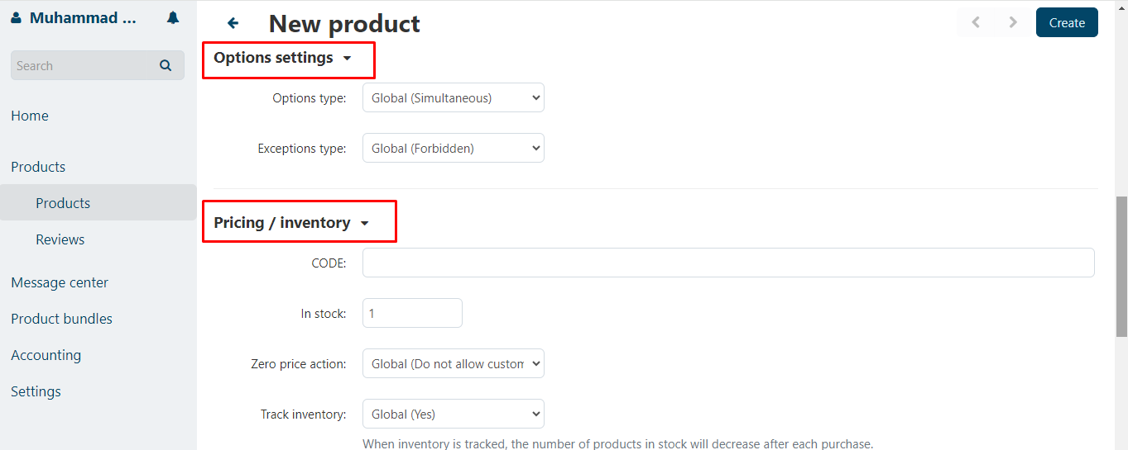

## **5.2: Product Display**

**Step 1: Fill in product details**

After entering all the necessary details for your new product—such as name, categories, price, description, and optional fields—ensure everything is accurate and to your satisfaction.

**Step 2: Locate the "Create" button**

In the top-right corner of the product creation page, you'll find the "**Create**" button. Click on this to finalize the addition of your new product to Scout Stock.

**Step 3: Wait for confirmation**

After clicking "**Create**," give the platform a moment to process your request. A confirmation message or visual cue will appear to indicate that your product has been successfully created.

**Step 4: View your new product**

Once confirmed, you'll be redirected to the product page where you can see your newly added product. This page showcases essential information about the product you just created.

**Step 5: Check product details**

On the product page, look for details such as the **product name, price, quantity**, and **status**. This allows you to quickly verify that the information you entered is correctly displayed.

**Step 6: Review quantity and status**

Take note of the quantity available and the product's status. This information is vital for managing your inventory and keeping track of the availability of your products.

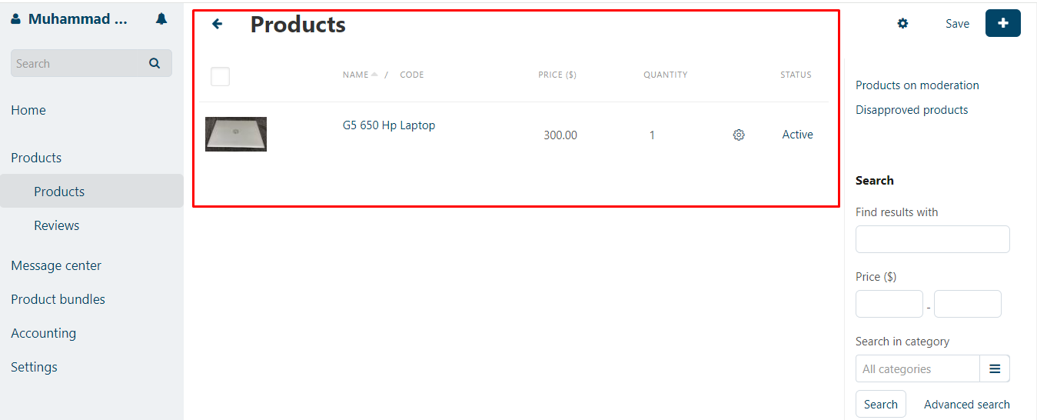

## **5.3: Product reviews**

**Step 1: Navigate to the reviews section**

Begin by accessing the "**Reviews**" section on Scout Stock. This might be located on the product details page or in a dedicated reviews section on the platform.

**Step 2: Use the search function**

Look for a search bar or filter options within the reviews section. This allows you to find specific customer reviews efficiently.

**Step 3: Enter customer details**

In the search bar, input the specific details of the customer you are looking for.

**Step 4: Review details**

Once you initiate the search, the platform will display reviews specific to the customer you entered. Each review typically includes:

* **Customer name:** Type in the name of the customer whose review you're interested in.
* **Advantages:** Positive aspects or features highlighted by the customer.
* **Disadvantages:** Areas of concern or aspects the customer found lacking.
* **Comment:** The detailed feedback or comments provided by the customer.
* **Rating:** The numerical or star-based rating assigned by the customer.
* **Helpfulness:** Indicates how helpful other users found the review.
* **Photo:** A visual representation, if the customer uploaded a photo.

**Step 5: Read and understand**

Click on the specific review to read the details provided by the customer. Understand their experiences, feedback, and any photos they may have shared.

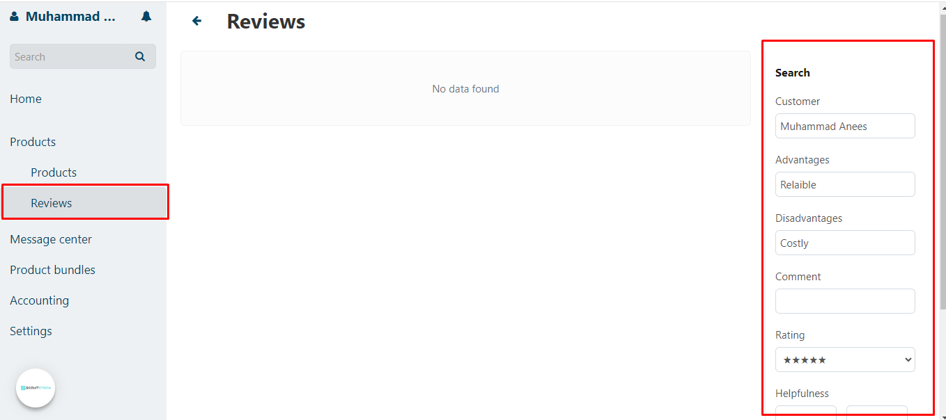

# **6: Message center**

**Access the message center module**

Start by locating and clicking on the "**Message center**" module on the left side of the **Scoutstock** platform.

## **6.1: Customer communication**

Within the Message Center, you'll find two main sections: "**Customer communication**" and "**Admin communication."** Click on the relevant section based on the type of messages you want to review.

**Step 1: Customer communication: find messages**

* In the "**Customer communication**" section, you can view messages you've received from customers.
* To find specific messages, use the following fields:
  + **Customer name:** Enter the name of the customer you want to check messages from.
  + **Apply period filter:** Set a specific period for message retrieval.
  + **Date filter:** Narrow down results by selecting a specific date or date range.
* Click on the "**Search**" button to see the messages matching your criteria.

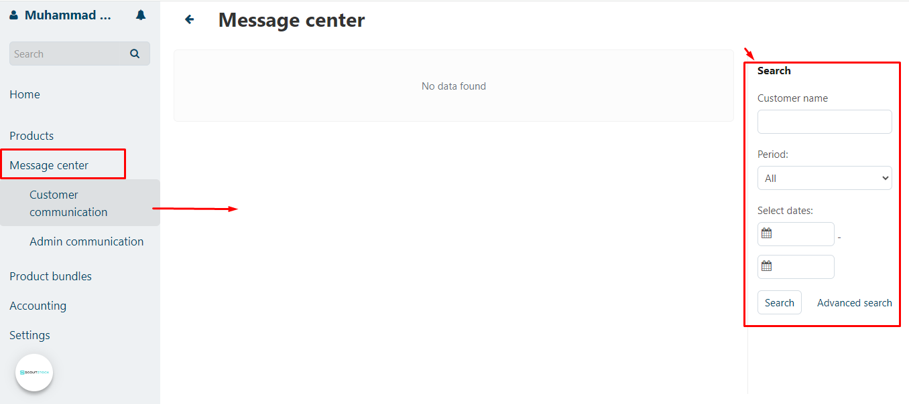

## **6.2: Admin communication**

This functionality facilitates communication between suppliers and our support team. If suppliers have any questions or concerns, particularly regarding the process of adding products, we encourage them to reach out to **Scoutstock** Support at [support@scoutstock.com](mailto:support@scoutstock.com). Our dedicated team is here to provide assistance, ensuring that your experience is smooth and free of any challenges. Don't hesitate to get in touch; we're committed to helping you navigate the platform seamlessly.

# **7: Note:**

If you require assistance, please don't hesitate to reach out to **Scoutstock** Support at support@scoutstock.com. We're here to help and ensure your experience is seamless.