EMPLOYEE BACKGROUND VERIFICATION FORM COMPANY NAME

Please note that it is mandatory for you to complete the form in all respects. The information you provide must be complete and correct and the same shall be treated in strict confidence.

The details on this form will be used for all official requirements should you join the organization.

|  |  |  |  |  |  |  |  |
| --- | --- | --- | --- | --- | --- | --- | --- |
| **Position applied for** | | |  | |  | **Location** | |
| Sr.Software Engineer | | |  | |  | Chennai | |
|  | | |  | |  | | |
| **Personal Information** | | |  |  |  | | |
| Full Name (First, Middle, Last)  Velidandla Madhuri | | | | Former Name / Maiden Name (if Applicable) | | | |
| Father's Name  Velidandla Murali Mohan Reddy | | | | Date of Birth (dd/mm/yy)  30/06/1991 | | | |
| Gender  Female | Social Security Number (if applicable) | | | Nationality  Indian | | | Marital Status  Married |
| Current Address  V.Madhuri,  H No:113,  Road No:5(watertank lane),  Vemana colony,  Chandanagar,  Hyderabad-500050.  Prominent Landmark | | Period of From (mm/yy) To (mm/yy) stay | | | | | Residence Number  7200269605  Mobile number  9884595248 |
| Permanent Address  V.Madhuri,  H No:113,  Road No:5(watertank lane),  Vemana colony,  Chandanagar,  Hyderabad-500050.  Prominent Landmark | | Period of From (mm/yy) To (mm/yy) stay | | | | | Residence Number  7200269605  Mobile number  9884595248 |

|  |  |  |  |  |  |  |  |
| --- | --- | --- | --- | --- | --- | --- | --- |
| **Education Qualification - Please attach copy of Degree and Final year mark sheet** | | | | | |  |  |
| **College Name & Address** | **University Name & Address** | | **Dates Attended** | | | **Qualification Gained** | **ID /Roll No** |
|  |  | **From** |  | **To** |
| Jawaharlal Nehru Technological University, Kakinada, Andhra Pradesh 533003 | Jawaharlal Nehru Technological University, Kakinada, Andhra Pradesh 533003 | | dd/mm/yy  081/08/2008 | | dd/mm/yy  01/08/2012 | Full Time Part Time | 08F91A0238 |
|  | | | | | |  | |
| **College Name & Address** | **University Name & Address** | | **Dates Attended** | | | **Qualification Gained** | **ID /Roll No** |
|  |  | **From** |  | **To** |
|  |  | | dd/mm/yy | | dd/mm/yy | Full Time Part Time |  |
| Please tick mark the documents submitted for this qualification along with this form  Marksheet Provisional Certificate Degree Certificate None | | | | | | | |

**Employment History- Current Employment**

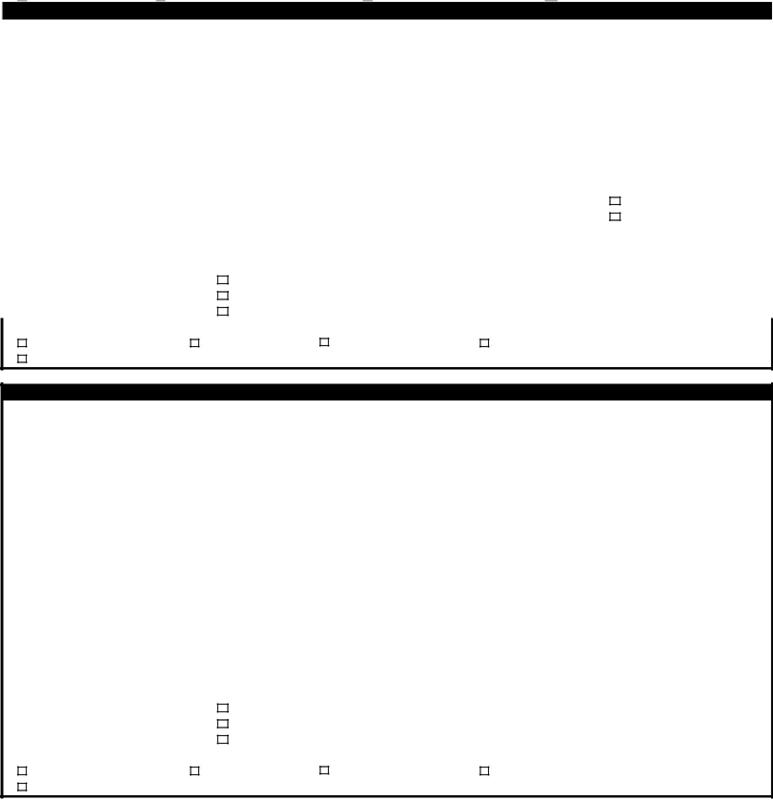

## Current Employment

|  |  |  |  |  |  |  |  |
| --- | --- | --- | --- | --- | --- | --- | --- |
| Name of Current Employer  Kyyba | | | | Address of Current Employer  1st Floor, 7th Block, DLF IT/ITES Special Economic Zone, Sivaji Gardens, Moonlight Stop, Nandambakkam Post, Mount Poonamallee Rd, Chennai, 600089 | | | |
| Telephone No | | Employee Code/No  1567 | | Designation  Sr.Software Engineer | | Department  Software Development | |
| Employment Period | | | Manager's Name | | Manager's Contact No | | Can a reference taken now?  Yes No |
| From  05/05/21 | To | |
| Manager's Email ID | |
| Duties & Responsibilities | | | | | Reasons for leaving | | |
| First Salary drawn | | | Was this Position  Permanent  Temporary Contractual | Agency Details (if temporary or contractual), provide details | | | |
| Last Salary drawn | | |

Please tick mark the documents submitted for this employment

Service Certificate Relieving letter Offer letter Any Other None (please specify)

**Previous Employment History -** Please attach a copy of your relieving letter/service certificate

**Note: Please ensure that you are descriptive wherever necessary – e.g. If company has closed, do mention it. Employee Code/**

## ID/ Number is mandatory. If your previous employer did not provide one, please mention and state reasons for the same.

|  |  |  |  |  |  |  |  |
| --- | --- | --- | --- | --- | --- | --- | --- |
| Name of Employer (1)  STG INFOTECH (INDIA) LLP | | | | Address of Employer  801 A North, 8th Floor, Tidel Park, No. 4, Rajiv Gandhi Salai, Taramani, Chennai - 600 113 | | | |
| Telephone No | Employee Code/No  STGI-917 | | | Designation  Software Engineer | | | Department  -- |
| Employment Period | | | Manager's Name  Sivakumar Arumugam | | | Manager's Contact No  9840217392 | |
| From  28/09/2015 | To  26/02/2021 | |
| Manager's Email ID  sivakumara@stgit.com | |
| Duties & Responsibilities  I was working with client @ Ford Motor Company Pvt Ltd as a Software Engineer with different levels of roles in PDO(Product Driven Organization)team | | | | | Reasons for leaving  For better prospects | | |
| First Salary drawn  450000 Rs/-per year | | Was this Position  Permanent Temporary  Contractual | | Agency Details (if temporary or contractual), provide details | | | |
| Last Salary drawn  850000 Rs/-per year | |

Please tick mark the documents submitted for this employment

Service Certificate Relieving letter Offer letter Any Other None (please specify)

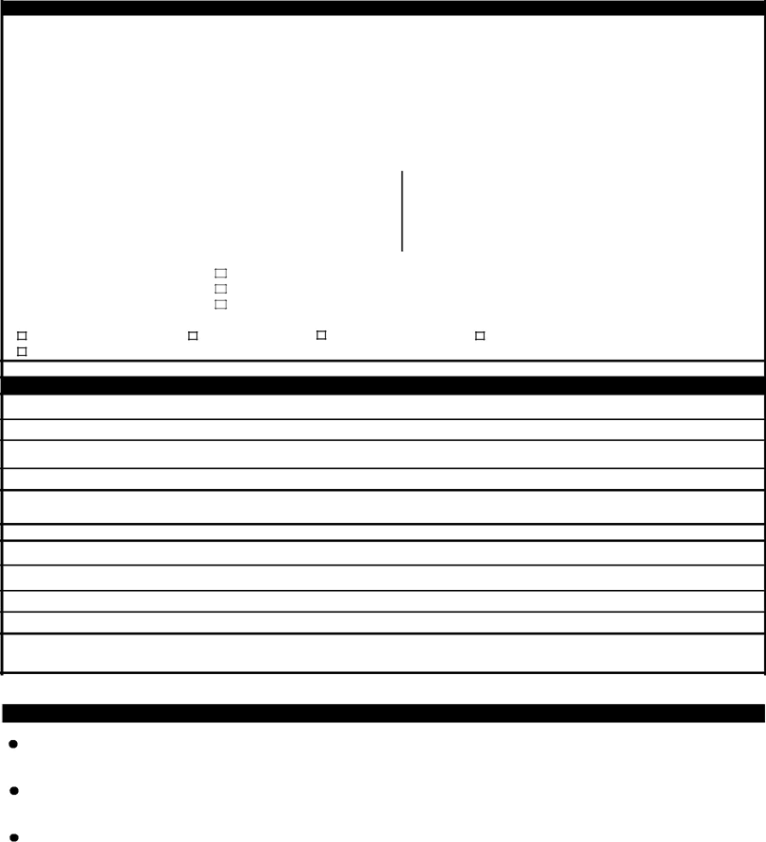**Previous Employment History -** Please attach a copy of your relieving letter/service certificate

|  |  |  |  |  |  |
| --- | --- | --- | --- | --- | --- |
| Name of Employer (2) | | | Address of Employer | | |
| Telephone No | Employee Code/No | | Designation | | Department |
| Employment Period | | Manager's Name | | Manager's Contact No | |
| From | To |
| Manager's Email ID | |

Duties & Responsibilities Reasons for leaving

|  |  |  |
| --- | --- | --- |
| First Salary drawn | Was this Position Permanent Temporary  Contractual | Agency Details (if temporary or contractual), provide details |
| Last Salary drawn |

Please tick mark the documents submitted for this employment

Service Certificate Relieving letter Offer letter Any Other None (please specify)

## References: Please provide the details of professional reference(Any two, who are not your relatives) Reference (1)

Name & Position held:

Email Address:

Contact Number:

How do you know

this person?

## Reference (2)

Name & Position held:

Email Address:

Contact Number:

How do you know

this person?

# Documents Required (Mandatory)

Education:

Photocopy of degree certificate and final mark sheet of all examinations

Employment

Photocopy of relieving / experience letter for each employer metioned in the form

Identity

Pan Card / Passport Copy/ Driving License



**Declaration and Authorization**

I hereby authorize GoldQuest Global HR Services Private Limited and its representative to verify information provided in my application for employment and this employee background verification form, and to conduct enquiries as may be necessary, at the company’s discretion. I authorize all persons who may have information relevant to this enquiry to disclose it to GoldQuest Global HR Services Private Limited or its representative. I release all persons from liability on account of such disclosure.

I confirm that the above information is correct to the best of my knowledge. I agree that in the event of my obtaining employment, my probationary appointment, confirmation as well as continued employment in the services of the company are subject to clearance of medical test and background verification check done by the company .

Signature: Madhuri



Name: Velidandla Madhuri Date: 23/05/2021

ssss