**Independent Variables**:

*Source: Strack, 2014*

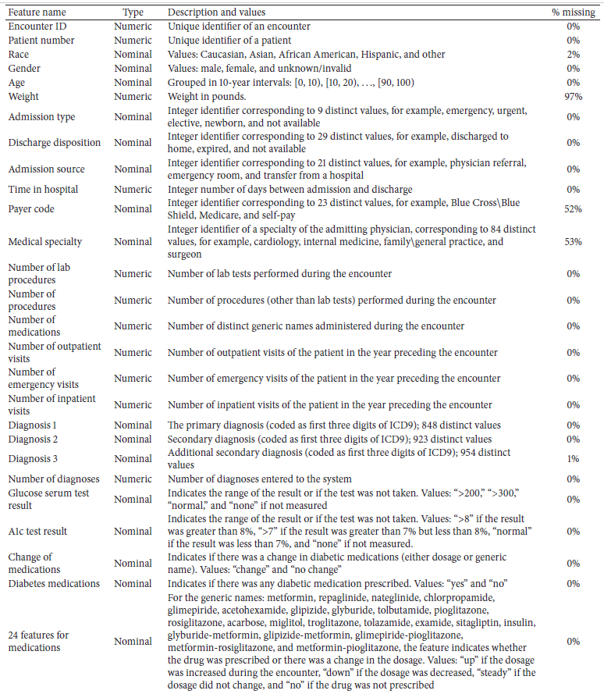

**Target Variable:**



**Admission_type_id**

|  |  |
| --- | --- |
| 1 | Emergency |
| 2 | Urgent |
| 3 | Elective |
| 4 | Newborn |
| 5 | Not available |
| 6 | Null |
| 7 | Trauma Center |
| 8 | Not mapped |

**Discharge_disposition_id**

|  |  |
| --- | --- |
| 1 | Discharged to home |
| 2 | Discharged/transferred to another short term hospital |
| 3 | Discharged/transferred to SNF |
| 4 | Discharged/transferred to ICF |
| 5 | Discharged/transferred to another type of inpatient care institution |
| 6 | Discharged/transferred to home with home health service |
| 7 | Left AMA |
| 8 | Discharged/transferred to home under care of Home IV provider |
| 9 | Admitted as an inpatient to this hospital |
| 10 | Neonate discharged to another hospital for neonatal aftercare |
| 11 | Expired |
| 12 | Still patient or expected to return for outpatient services |
| 13 | Hospice / home |
| 14 | Hospice / medical facility |
| 15 | Discharged/transferred within this institution to Medicare approved swing bed |
| 16 | Discharged/transferred/referred another institution for outpatient services |
| 17 | Discharged/transferred/referred to this institution for outpatient services |
| 18 | NULL |
| 19 | Expired at home. Medicaid only, hospice. |
| 20 | Expired in a medical facility. Medicaid only, hospice. |
| 21 | Expired, place unknown. Medicaid only, hospice. |
| 22 | Discharged/transferred to another rehab fac including rehab units of a hospital . |
| 23 | Discharged/transferred to a long term care hospital. |
| 24 | Discharged/transferred to a nursing facility certified under Medicaid but not certified under Medicare. |
| 25 | Not Mapped |
| 26 | Unknown/Invalid |
| 27 | Discharged/transferred to another Type of Health Care Institution not Defined Elsewhere |
| 28 | Discharged/transferred to a federal health care facility. |
| 29 | Discharged/transferred/referred to a psychiatric hospital of psychiatric distinct part unit of a hospital |

**Admission_source _id**

|  |  |
| --- | --- |
| 1 | Physician Referral |
| 2 | Clinic Referral |
| 3 | HMO Referral |
| 4 | Transfer from a hospital |
| 5 | Transfer from a Skilled Nursing Facility (SNF) |
| 6 | Transfer from another health care facility |
| 7 | Emergency Room |
| 8 | Court/Law Enforcement |
| 9 | Not Available |
| 10 | Transfer from critial access hospital |
| 11 | Normal Delivery |
| 12 | Premature Delivery |
| 13 | Sick Baby |
| 14 | Extramural Birth |
| 15 | Not Available |
| 16 | NULL |
| 17 | Transfer From Another Home Health Agency |
| 18 | Readmission to Same Home Health Agency |
| 19 | Not Mapped |
| 20 | Unknown/Invalid |
| 21 | Transfer from hospital inpt/same fac reslt in a sep claim |
| 22 | Born inside this hospital |
| 23 | Born outside this hospital |
| 24 | Transfer from Ambulatory Surgery Center |
| 25 | Transfer from Hospice |
| 26 | Physician Referral |

**Model Summaries**

|  |  |  |  |  |
| --- | --- | --- | --- | --- |
|  |  | ***Test Data Set*** | | |
| **Model** | **Iteration** | **Accuracy** | **Sensitivity** | **Specificity** |
| PCA | Accuracy models not deemed appropriate for PCA model | | | |
| Naïve Bayes | 1 | 61.5% | 69.14% | 51.89% |
| Naïve Bayes | 2 | 58.36% | 68.8% | 45.23% |
| SVM |  |  |  |  |
| SVM - linear | 1 | 63.45% | 63.24% | 63.7% |
| SVM - radial | 2 | 62.88% | 69.37% | 55.11% |
| SVM - polynomial | 3 | 54.5% | 99.94% | 0.0006553% |
| SVM - sigmoid | 4 | 62.7% | 69.04% | 55.11% |
| Logistic Regression | 1 | 89.23% | 2.39% | 99.7% |
| Logistic Regression | 2 | 89.26% | 1.65% | 99.8% |
| Decision Tree | 1 | 62.72% | 71.31% | 51.8% |
| Decision Tree | 2 | 62.61% | 75.29% | 46.46% |