Basic Program Construction
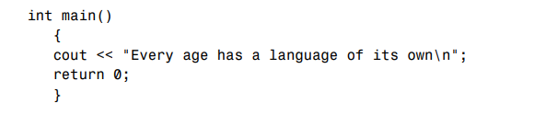
Program Statements
cout << “Every age has a language of its own\n”;
return 0;
Whitespace
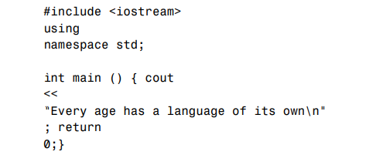
Comment Syntax
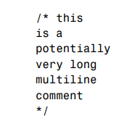
Integer Variables
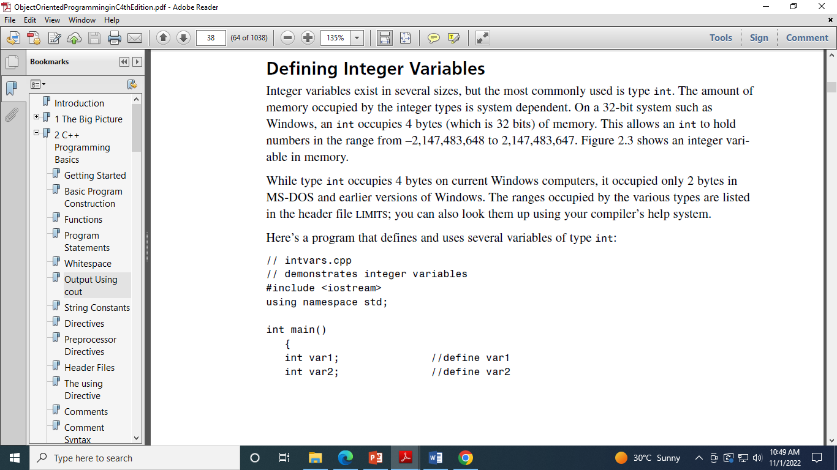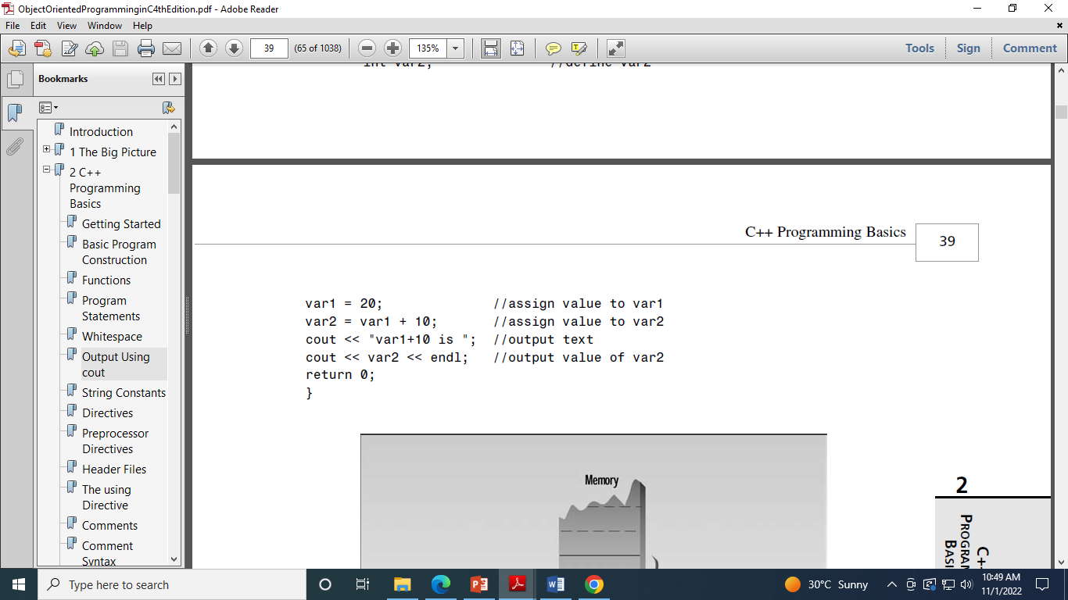
Character Variables

Escape sequences
Input with cin>>

Floating point Types

The Setw manipulator
Type Conversion

Arithmetic Operator

Arithmetic assignment operator
Increment operators, decrement operators

Postfix and prefix

Library functions
Library files

