**MEASURE ENERGY CONSUMPTION**

**INNOVATIVE TECHNIQUES:**

* Ensemble methods and deep learning architectures are powerful techniques that can significantly enhance the accuracy and robustness of prediction systems.

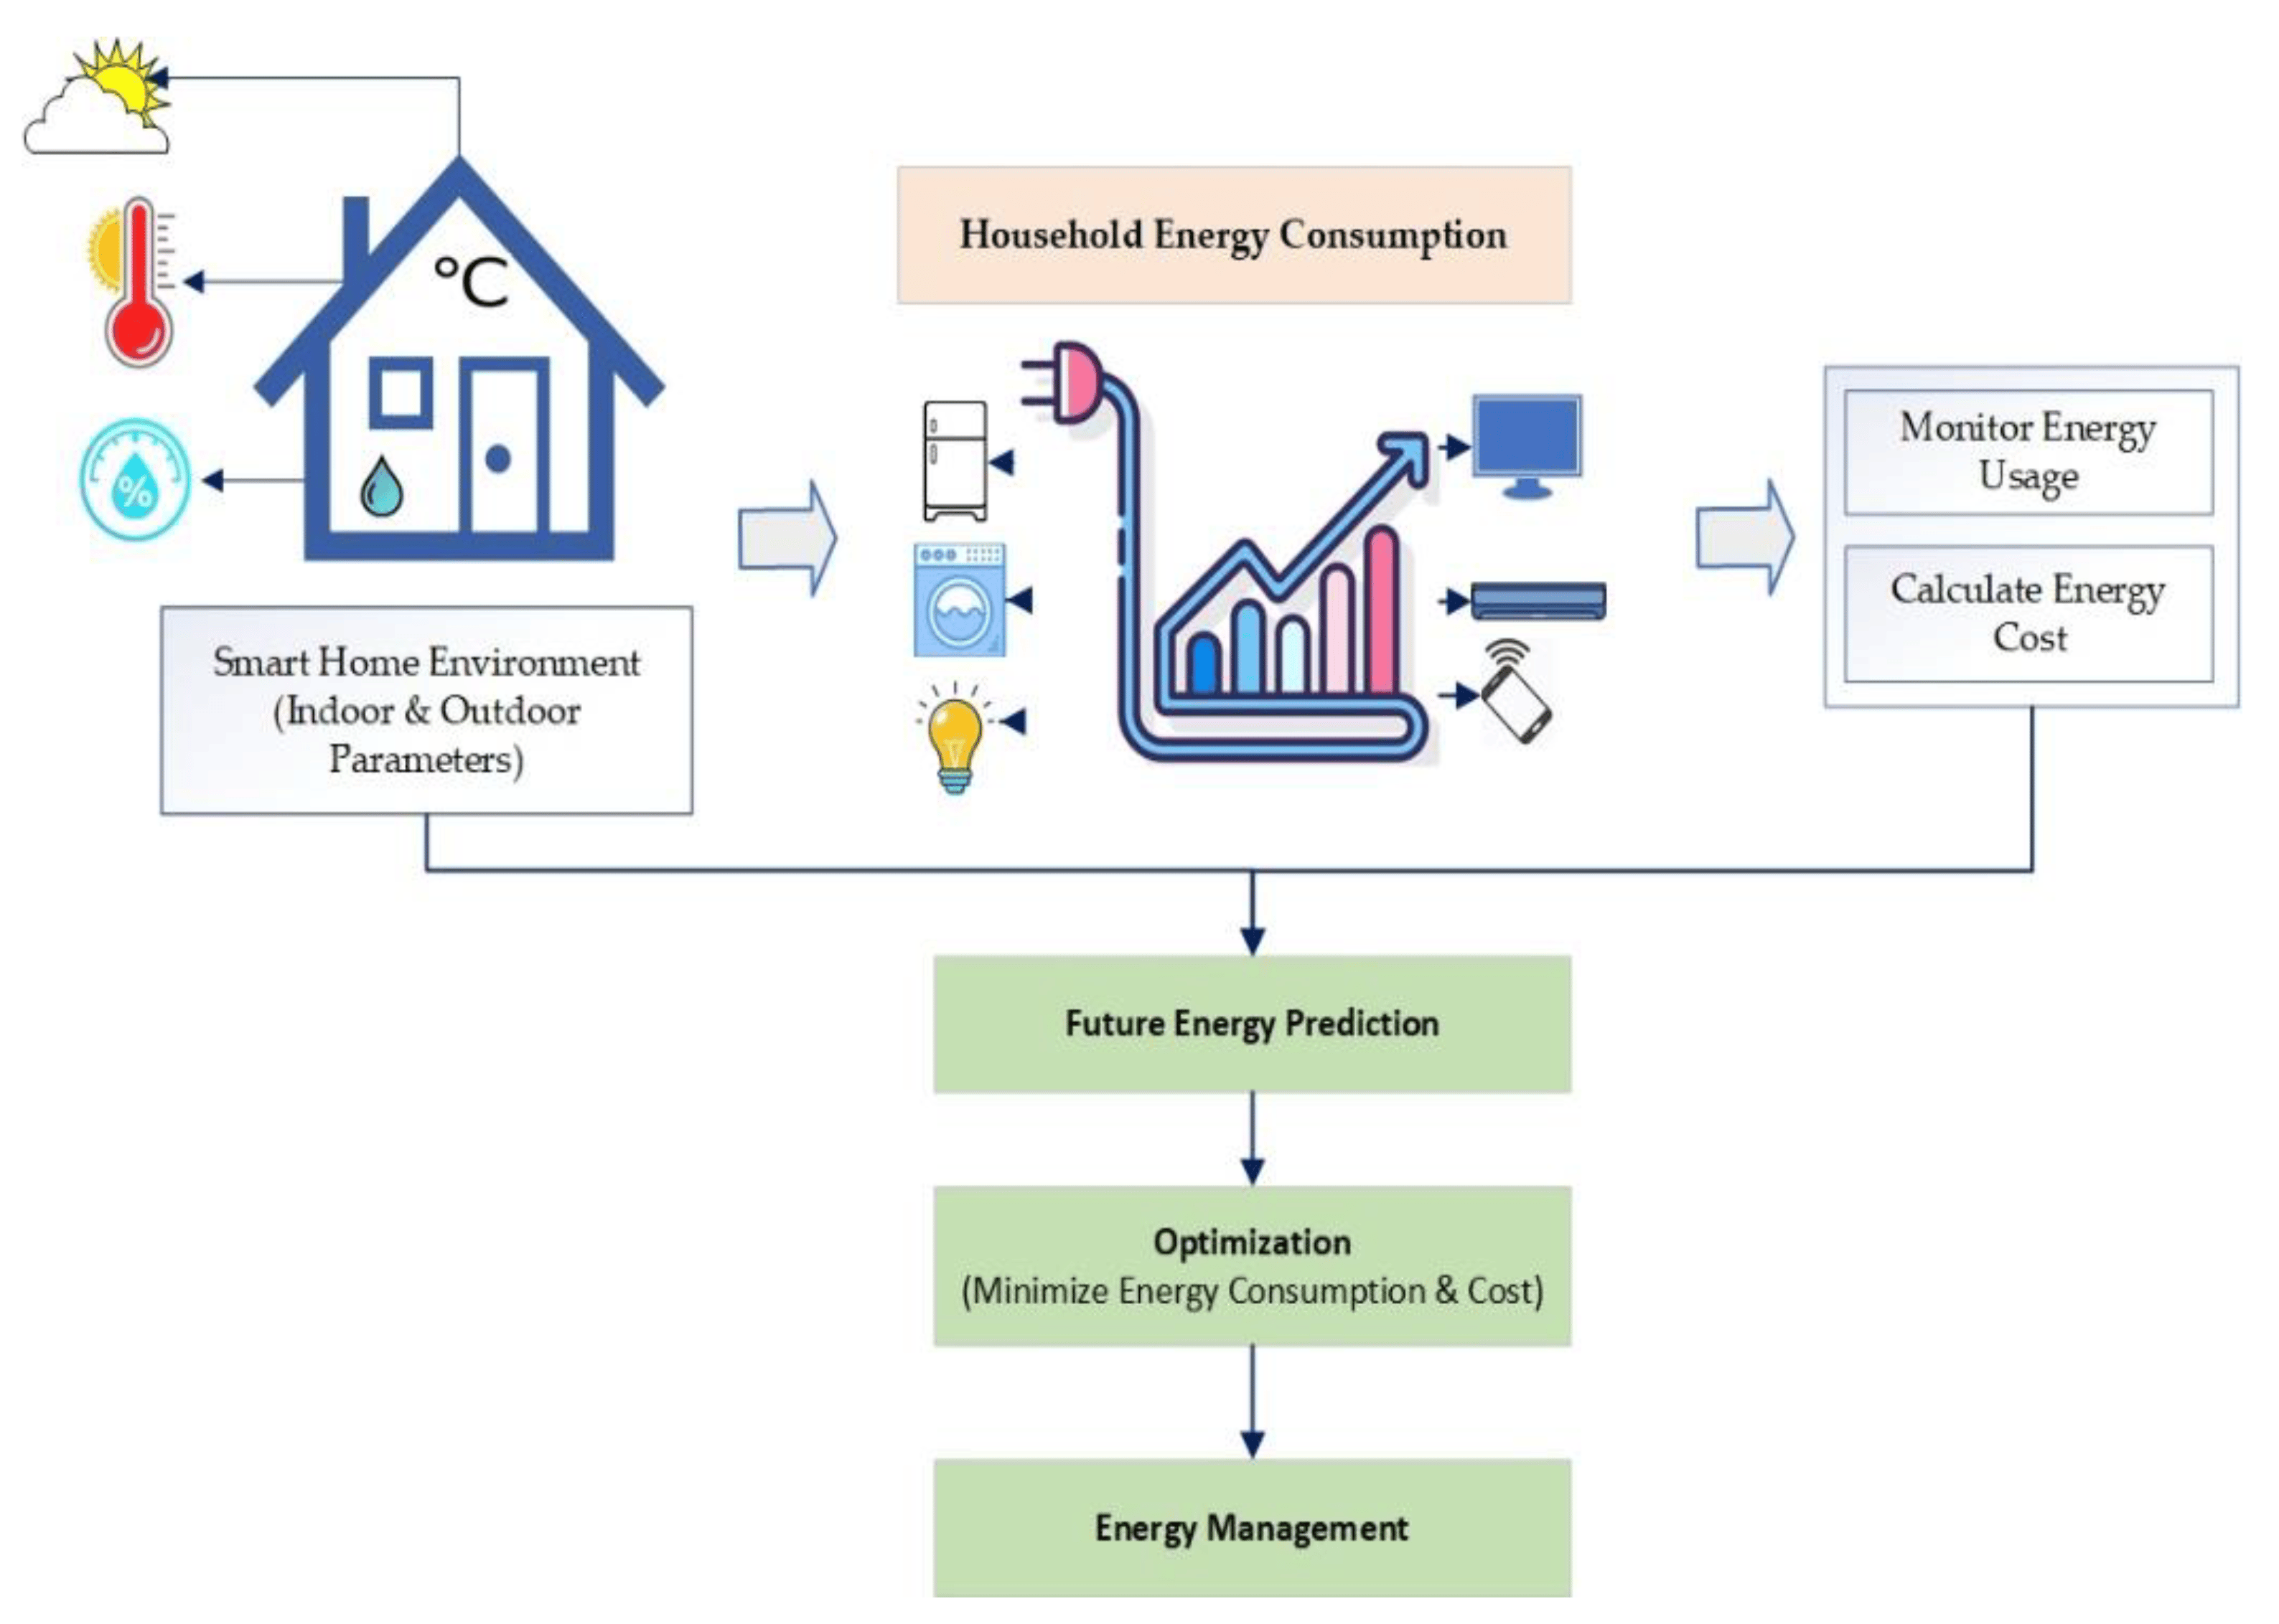

**MACHINE LEARNING MODELS:**

* **Regression Models:**

Linear regression, polynomial regression, and support vector regression can be used to model energy consumption as a function of various parameters like temperature, time of day, day of the week, etc.

* **Random Forest and Gradient Boosting:**

These ensemble learning methods are effective for handling complex interactions between different features affecting energy consumption.

* **XGBoost and LightGBM:**

These gradient boosting algorithms are known for their speed and accuracy in handling large datasets and complex features.

* **Recurrent Neural Networks (RNNs):**

Similar to LSTM, RNNs can be used for time series data and can capture sequential dependencies.

* **Neural Networks:**

Multi-layer perceptrons (MLPs) can be used for regression tasks to capture non-linear relationships in the data.

* **Feature Engineering:**

Incorporate weather data (temperature, humidity, etc.), time of day, day of the week, holidays, and special events as features. These factors often have a significant impact on energy consumption.

* **Data Preprocessing:**

Handle missing values, outliers, and perform data normalization or standardization to prepare the data for modeling.

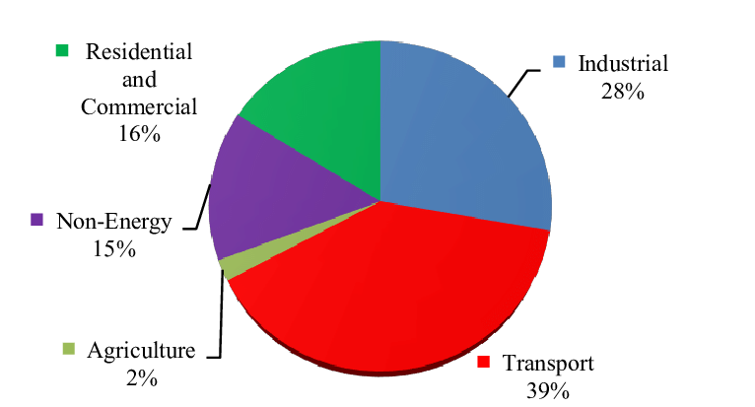

* **Cross-Validation:**

Use techniques like k-fold cross-validation to assess the performance of the models and avoid overfitting.

* **Hyperparameter Tuning:**

Optimize the parameters of the chosen models to improve their predictive power.

* **Model Evaluation:**

Utilize metrics such as Mean Absolute Error (MAE), Mean Absolute Percentage Error (MAPE), Root Mean Square Error (RMSE), etc., to evaluate the performance of the models.

**CONCLUSION:**

These techniques, when applied judiciously and with proper tuning, can significantly improve the accuracy and robustness of energy consumption prediction systems. It's important to note that the choice of technique should be based on the specific characteristics of the data and the problem at hand. Additionally, ensembling methods and deep learning architectures can also be combined to further enhance prediction performance.