Wireframe Document

1. Introduction

The wireframe document provides an overview of the user interface design for the Mushroom Classification System. This document outlines the various screens, components, and interactions within the system.

2. Wireframe Screens

2.1 Mushroom Input Screen

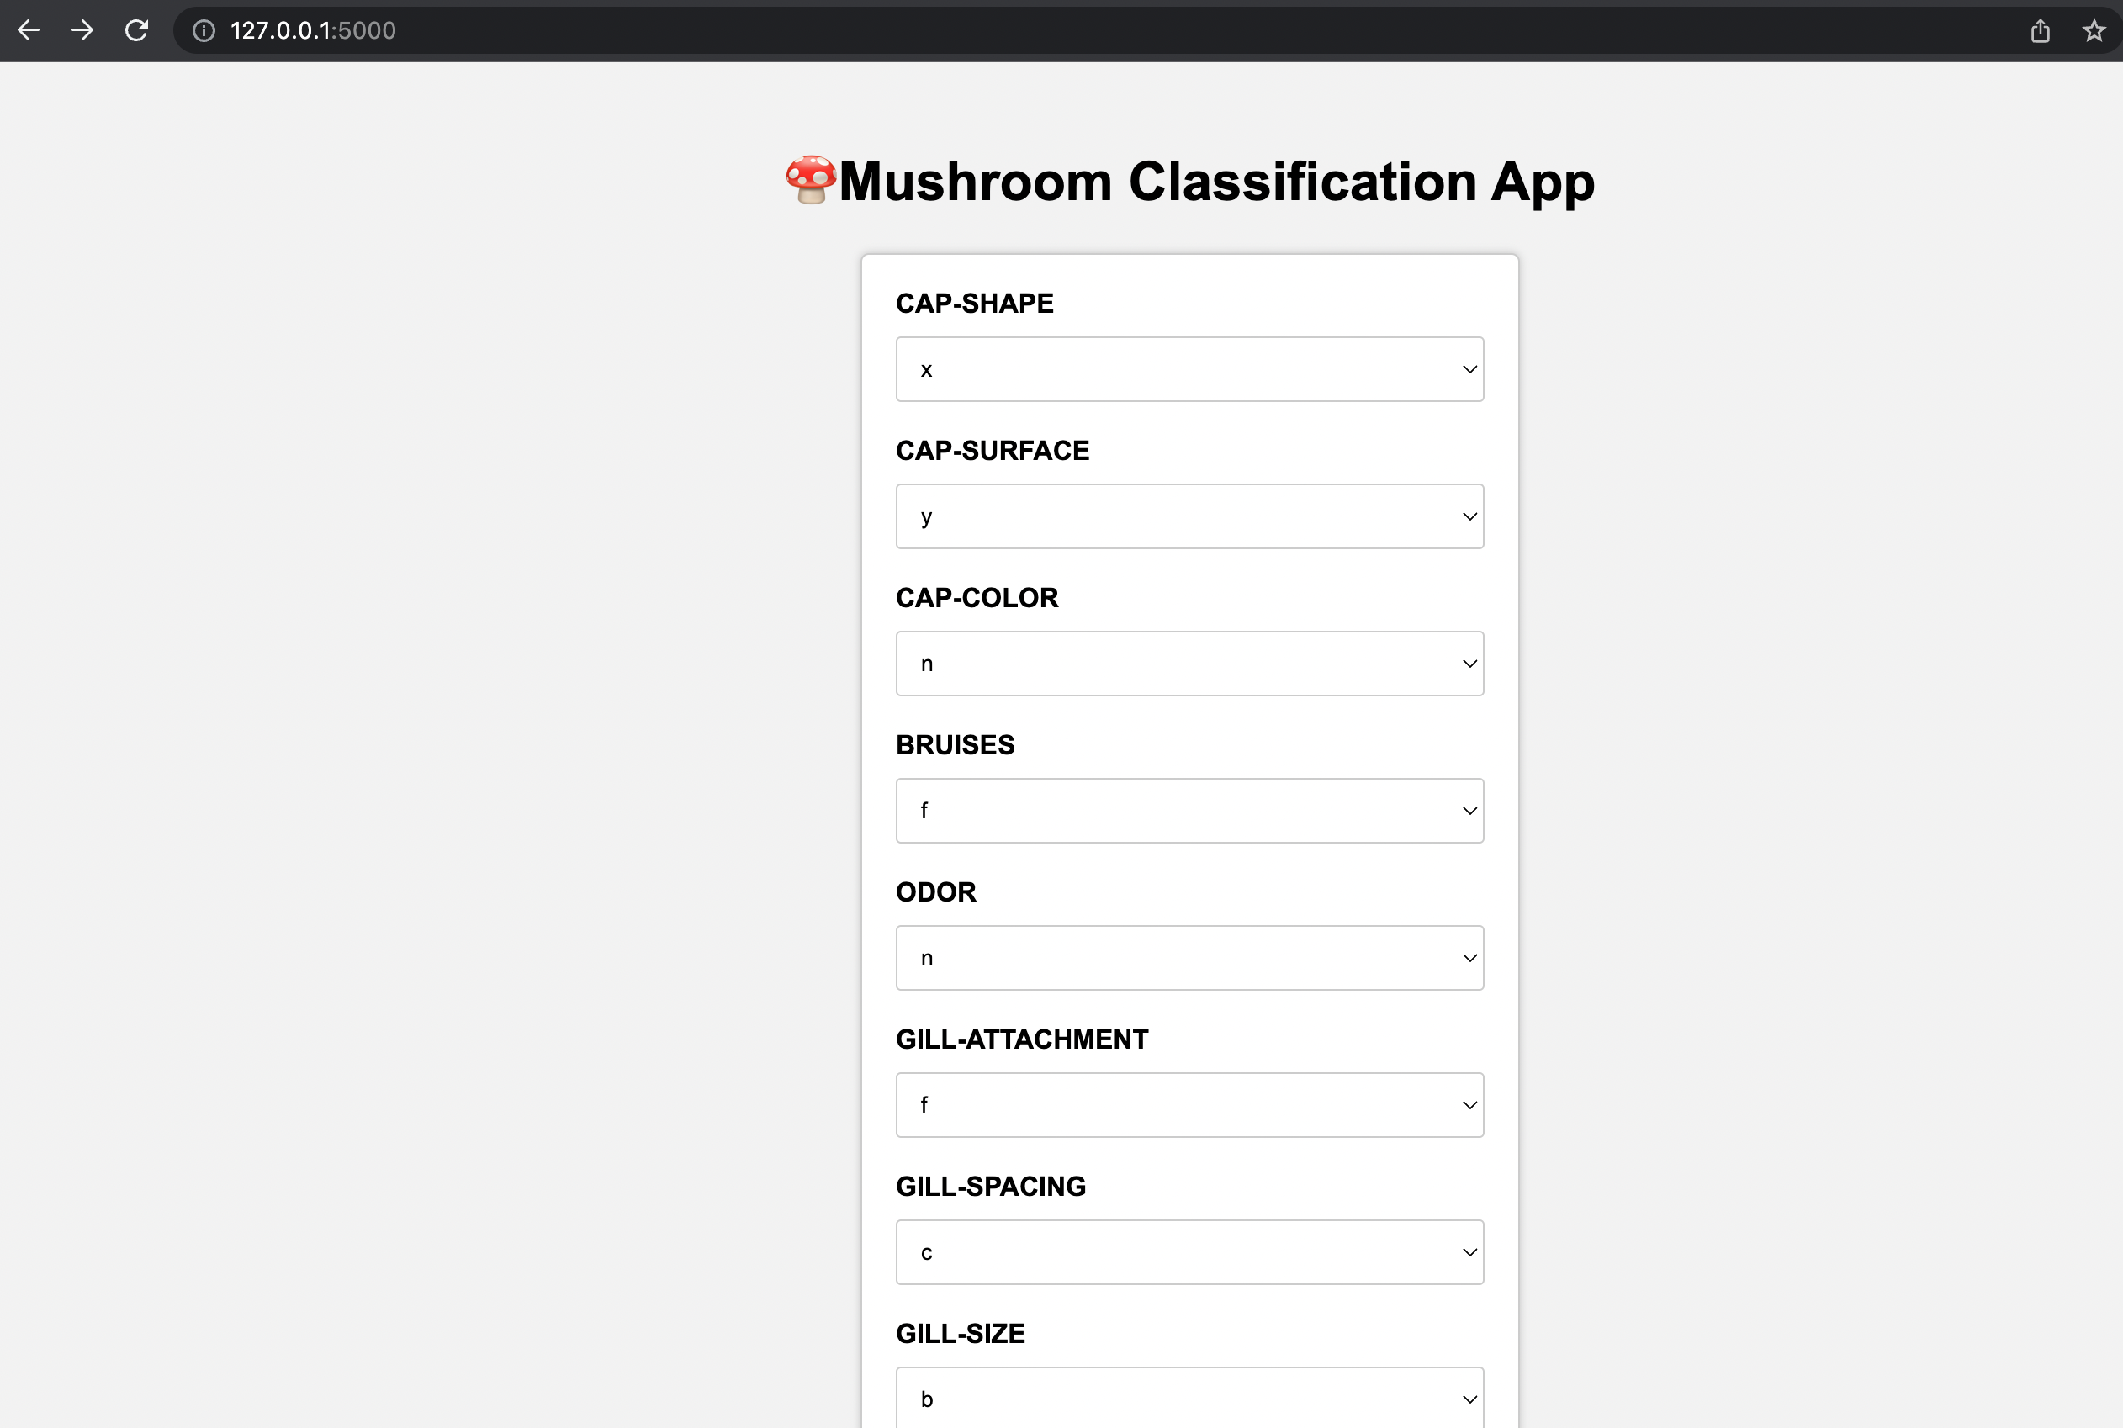

Description: The home screen serves as the landing page for the Mushroom Classification System. The mushroom input screen allows users to provide the attributes and characteristics of a mushroom for classification.

Content:

* Title or heading indicating the purpose of the screen.
* Form fields for inputting mushroom attributes, such as cap shape, color, odor, gill size, etc.
* Predict button to initiate the classification process.

2.2 Classification Results Screen

Description: The classification results screen displays the predicted mushroom species based on the provided attributes.

Content:

* Title or heading indicating the purpose of the screen.
* Display area to present the classification results.
* Contact information or links to learn more.

3. Wireframe Interactions

3.1 Train Model Route

Description: The train route initiates the training process for the mushroom classification model.

Interaction: When the train route is initiated, the system validates the training data and starts the model training process. Once the training is complete it redirects to the homepage.

3.2 Predict Button

Description: The Predict button triggers the classification process after the user has provided the mushroom attributes.

Interaction: When the predict button is clicked, the system validates the input, sends the data to the server for processing, and displays the classification results on the Classification Results screen.

4. Conclusion

The wireframe document provides a visual representation of the user interface design for the Mushroom Classification System. It outlines the screens, components, and interactions necessary to facilitate user input and display classification results. This document serves as a reference for the development team to implement the system's user interface effectively.