|  |
| --- |
| Assignment-Decision Tree(Rapidminer) |
| By:Anees Azhar |
| Roll no 13, Section A |

**Decision Tree:**

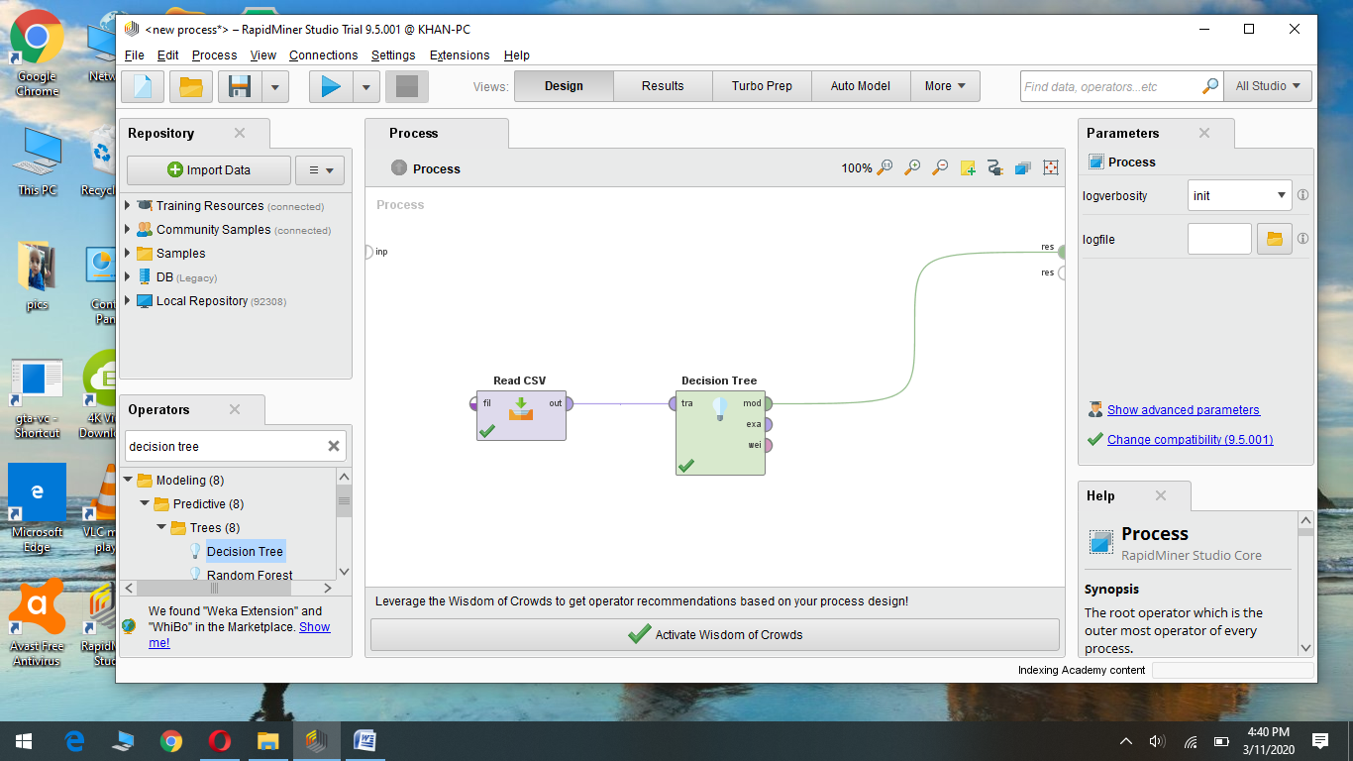

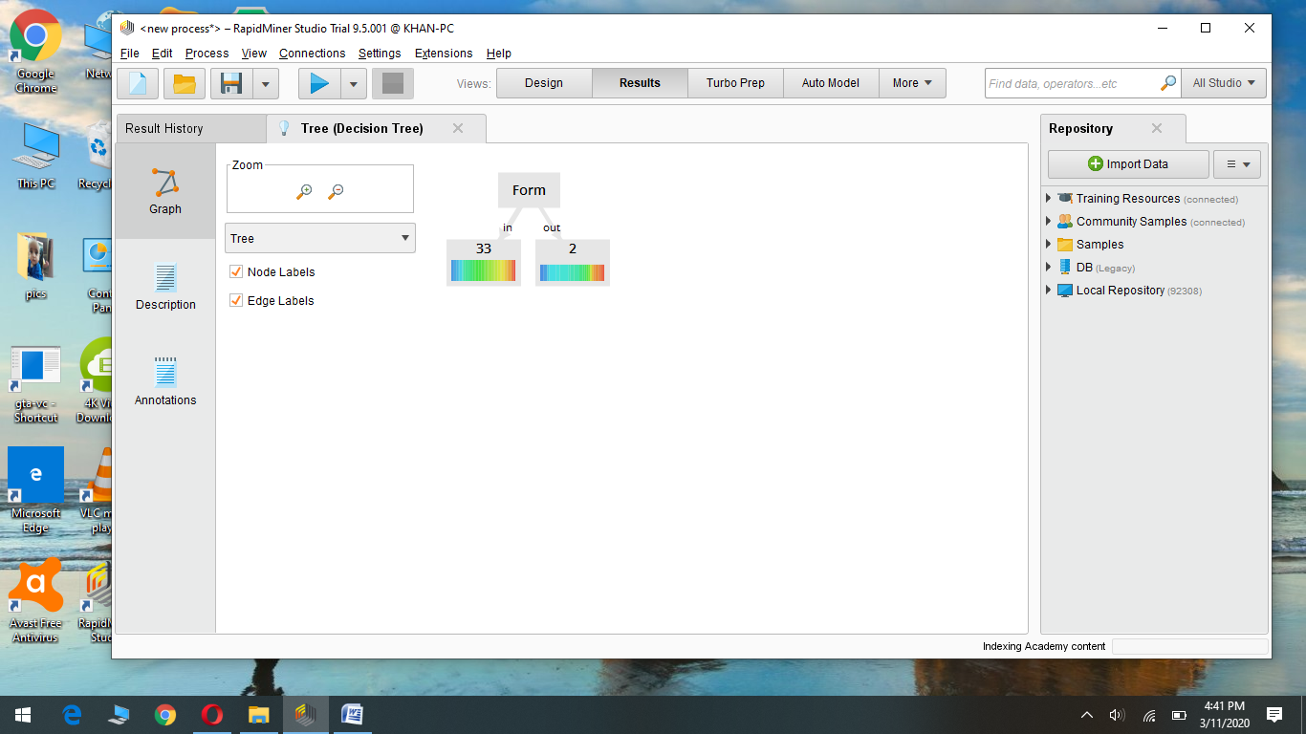

Q: Explain decision tree

Ans.)A decision tree is a tool that allows us or a program to make a decision based on the outcomes and the data. In Rapidminer the decision is made depending on the label column.