|  |
| --- |
| Naïve Bayer |
| By Anees Azhar |
| Section A Roll no 13 |















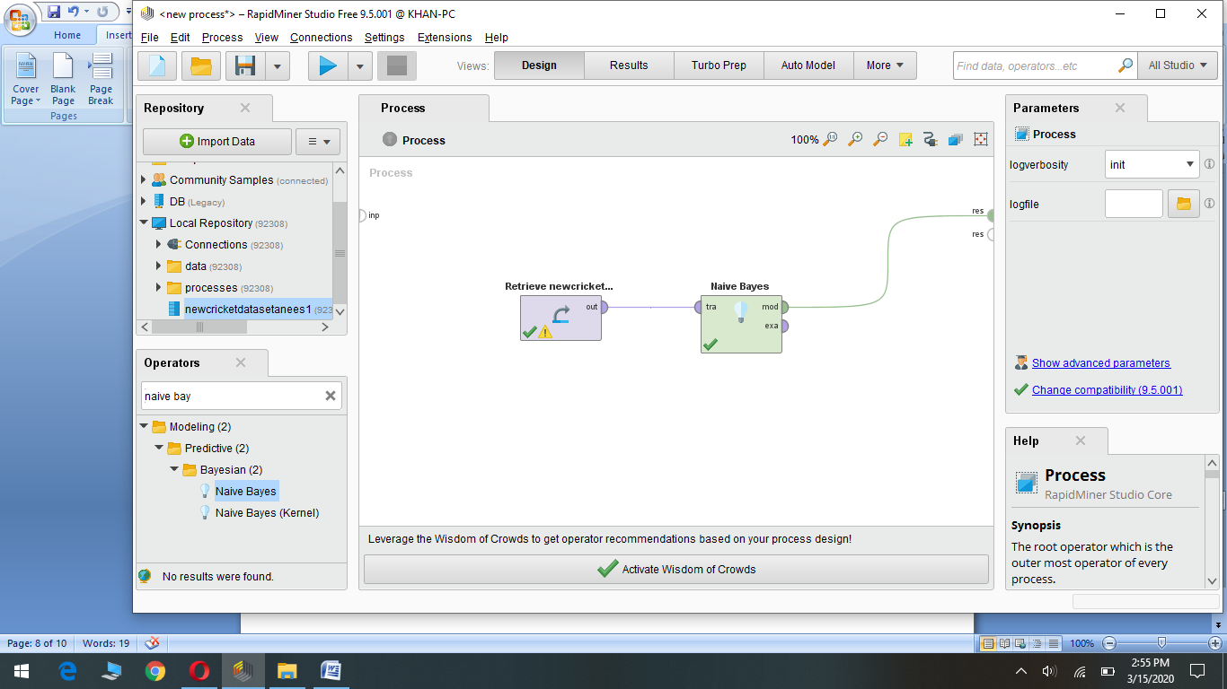

Q.)Explain laplace correction

Ans.) The simplicity of Naive Bayes includes a weakness: if within the training data a given Attribute value never occurs in the context of a given class, then the conditional probability is set to zero. When this zero value is multiplied together with other probabilities, those values are also set to zero, and the results will be misleading. Laplace correction is a simple trick to avoid this problem, adding one to each count to avoid the occurrence of zero values. For most training sets, adding one to each count has only a negligible effect on the estimated probabilities