**Assignment – 4**

Design Approach of the application:

The project is built to stimulate a Covid-19 vaccination booking appointment application.   
The design allows users to book their vaccination appointments for both the doses at their preferred location, date and time. It provides a user-friendly interface which can do the job in 3 simple steps and display the details of the appointment at the end. Users can create an account to save their booked appointments and can also review, edit or cancel them in future. The website is designed to be responsive and to be available in 2 languages (English & French) to increase the accessibility across different users of Canada.

The implementation of the structure of the website is based on **HTML**. **CSS** is used to style it and **JavaScript** language is used to provide functionality to the interface. We used **Bootstrap** framework to customise and beautify the interface even more. We have also used the **jQuery** library for efficient DOM manipulation and event handling. **Visual Studio Code** IDE has been used to create all the files in this project.

Testing of the application:

Usability testing of the project was done by asking some family members to try using the website. Their feedback was collected and amendments were made to the project accordingly. Some examples of redesigns to the website on the evaluation of feedbacks are as follows:

1. Earlier, while selecting a nearby clinic location, the users had to click on select and then on a save button in order for the app to process it. This made it more time consuming due to 2 clicks as shown below: 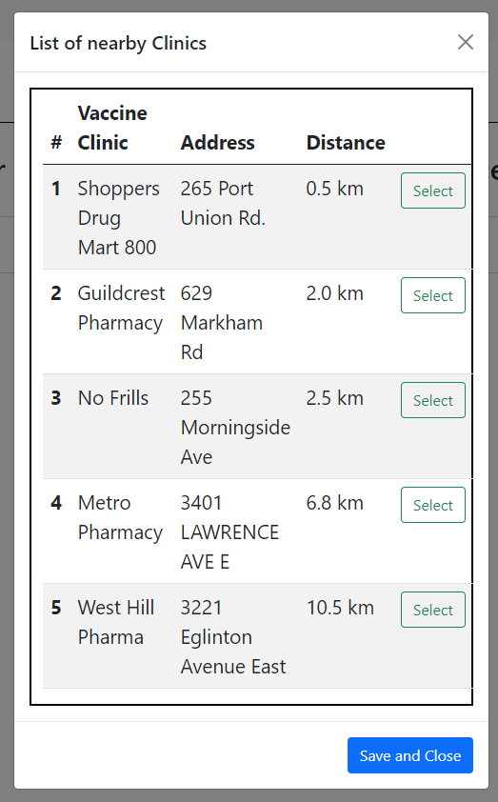  
   Based on this feedback, we discarded the ‘save and close’ button and implemented its functionality in the ‘select’ button itself as shown below. Also, a wider window reduced the action of scrolling and showed more information in less viewport of the screen by utilising the space better.   
   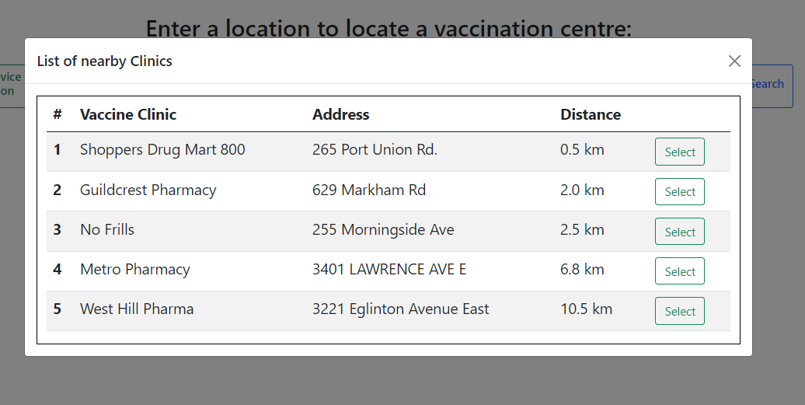
2. Earlier, the steps to book the appointment were skippable. The users could go to the next step without even completing the 1st one. This created a sense of confusion among some of then as it was not clear if they did everything right and should continue or not. This scenario was as below:

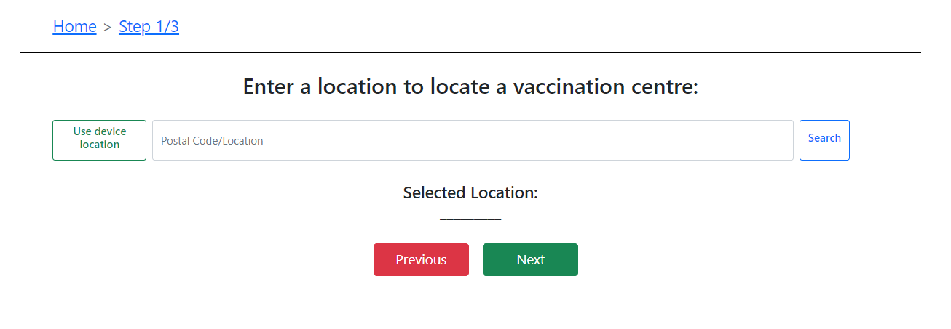Based on this feedback, we disabled the ‘next’ button which makes it unclickable until the current step is completed. The user is still able to go to the previous step to change their previous response but cannot go to the next step without completing the current step successfully. This scenario is as below:   
