**k-out-of-n multicast using Distance Vector Routing Protocol**

1. **Problem Statement**

This k-out-of-n multicast protocol is used because routers have a better knowledge of the network than the user nodes, such as best shortest path to other routers and user nodes. This knowledge helps in making better decisions related forwarding and splitting of packet datagram.

This protocol has applications in offices (closest printing station for printing documents), emergency systems (closest hospitals or police stations to send an emergency message).

1. **Routing**

Routers send Update packets periodically to neighboring nodes. The Update packets consist of type, source address, sequence number and a  payload field. The payload field consists of the destination - cost pair table which is also known as the Update table.

When a router receives an Update packet, it adds the cost to update sending node (one hop in this case), to all costs in the table. Then, the router checks the addresses in the table. If the address is of a new node, then adds the cost and the next hop (which will be the address of the node which send the update message) to the current Router table.

Pseudo Code for updating the Router Table:

If (address in the update entry is not present in router’s routing table)

   {

       add entry to router’s routing table

   }

else if (address in the update entry is present in the router’s routing table)

    {

          then check the cost column

          If (cost in update table entry = cost in routing table)

              {

                   then add the entry to the Routing table if the number of entries already present < 3

   }

           else if (cost in update table entry < cost in routing table)

    {

        then the entry in Routing Table is replaced with the update table entry

     }

           else if (cost in update table entry > cost in routing table)

                {

                   Discard update table entries

                 }

1. **Packet Format**

**Hello packet syntax:**

|  |  |  |
| --- | --- | --- |
| **Type** | **Source Address** | **Sequence Number** |

 1 byte 2 bytes 1 byte

**Update packet syntax:**

|  |  |  |  |  |
| --- | --- | --- | --- | --- |
| **Type** | **Source Address** | **Sequence Number** | **Length** | **Payload** |

1 byte    2 bytes 1 byte 2 bytes

**Acknowledgment packet syntax:**

|  |  |  |  |
| --- | --- | --- | --- |
| **Type** | **Source Address** | **Sequence Number** | **Destination Address** |

1 byte 2 bytes 1 byte 2 bytes

### **Data packet Format**

|  |  |  |  |  |  |  |  |  |
| --- | --- | --- | --- | --- | --- | --- | --- | --- |
| **Type** | **Source Address** | **Seq Num** | **K** | **Destination 1 address** | **Destination 2 address** | **Destination 3 address** | **Length** | **Payload** |

1 byte      2 bytes  1 byte   1 2 bytes             2 bytes             2 bytes         2 bytes

                                            byte

1. **System Diagram**

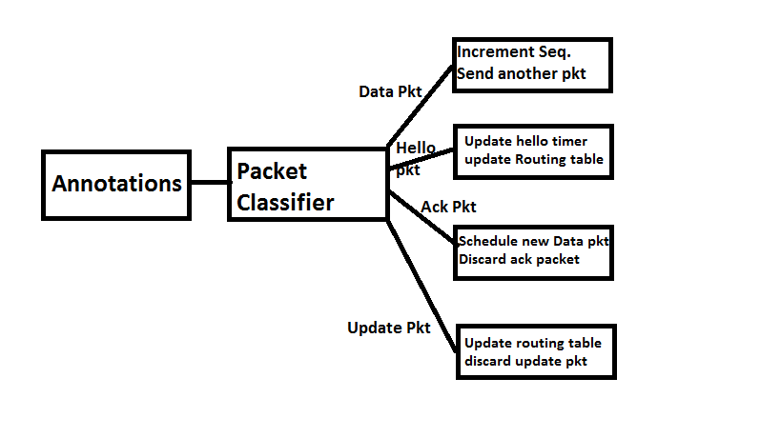

1. **Router Architecture**

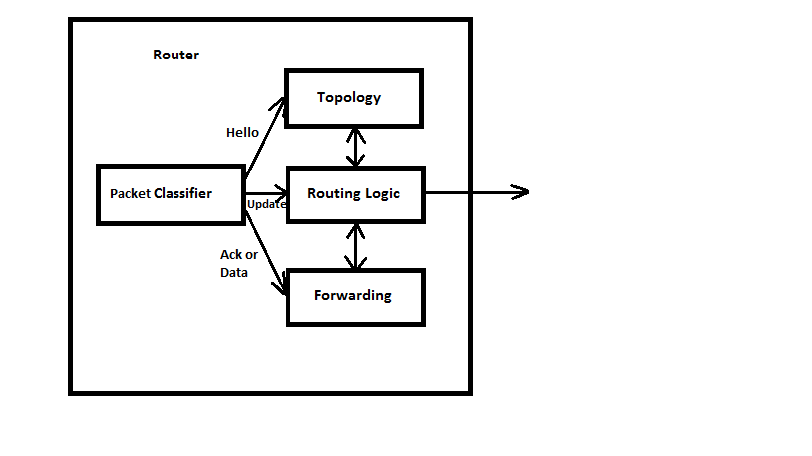

The Packet Classifier classifies packets into Hello, Update, Data and Ack as shown in System Diagram. It takes decision regarding what to do with that packet. It sends the packets passed on their types to topology, routing, forwarding. The routing table gets updated if it is an update packet and forwarding table is updated. The packet is forwarded using the forwarding table.

1. **Output**

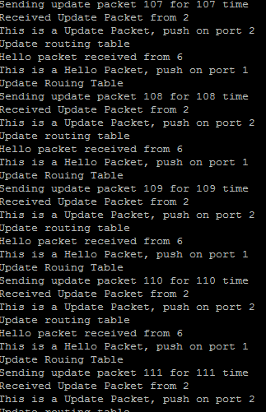

Output screen when multiple instances of router.click are run