Corporate Governance and Capital Budgeting Evaluation of Rolls-Royce Holdings plc
Aneesh Barhate
Advanced Corporate Finance / 25-26_FI502E
Dima Tawil
Rennes School of Business / Finance and Geopolitics
07/12/2025

Abstract

This​‍​‌‍​‍‌​‍​‌‍​‍‌ report focuses on Rolls-Royce Holdings plc through two different but related lenses: the effectiveness of corporate governance and the evaluation of capital budgeting. Part 1 of the report examines the changes in governance of the company during the period of the strategic turnaround and recovery. The evaluation covers board composition, the role of the chairman, committee oversight, pay alignment, and risk management practices. Their findings show that governance changes have helped the operational and financial performance, which in turn has led to higher margins, better capital discipline, and more consistent oversight after some years of volatility. However, at the same time, the company is still dealing with compliance issues from the past and its concentrated exposure to long-cycle aerospace programmes, which makes it necessary to have solid monitoring and transparent accountability structures in place.
Part 2 of the paper serves as a basis for determining the financial feasibility of the UltraFan Neo development project through the implementation of capital budgeting methods in line with the lecture materials and cost-of-capital inputs derived from Bloomberg. The paper incorporates scenario, sensitivity, and probabilistic exercises to reflect the uncertainties of the valuation. Their findings reveal that the first scenario and all subsequent variants lead to negative net present value results due to the combination of the high upfront development costs, long cash-flow periods, and the sensitivity of the project to the key operating assumptions. The report is part of the Rolls-Royce portfolio, which is a technological transition to the future and the only reason why it is not financially attractive is that it is still a limited program under current assumptions. The conclusion section of the report contains recommendations aimed at enhancing governance oversight and facilitating disciplined investment ​‍​‌‍​‍‌​‍​‌‍​‍‌decision-making.

Table of Contents
Abstract 2
1.Introduction 5
Part 1: corporate governance analysis 6
2.1 Governance Structure 6
2.1.1 Board Composition and Independence 6
2.1.2 Leadership Structure and CEO Duality 6
2.1.3 Executive Compensation 6
2.1.4 Bloomberg Governance Indicators 7
2.2 Additional Governance Dimensions 7
2.2.1 Shareholder Rights and Ownership 7
2.2.2 Risk Management and Audit Quality 7
2.3 Link to Financial Performance and Agency Issues 8
2.4 Conclusion and Recommendations 8
Part 2: Capital budgeting and valuation with leverage 9
3.1 Capital Structure Analysis 9
3.1.1 Overview of Current Capital Structure 9
3.1.2 Five-Year Evolution of Capital Structure (2019–2024) 9
3.1.3 Capital Structure Ratios Analysis 10
3.1.4 Interpretation of Market-Based Cost-of-Capital Inputs 10
3.1.5 Leverage Assessment and Peer Comparison 11
3.2 Capital Budgeting and Valuation with Leverage 11
3.2.1 Capital Structure and Cost of Capital Components 11
3.2.2 Valuation Methodologies and Results 12
3.2.3 Sensitivity, Scenario, Monte Carlo and Breakeven Analysis 12
3.2.4 Investment Decision and Recommendation 13
3.2.5 Limitations of the Analysis 13
Part 2: Conclusion and Recommendations 14
Appendices 15
Appendix A. Governance Summary Metrics 15
Appendix B. Capital Structure Ratios (2019–2024) 15
Appendix C. Peer Comparison: Capital Structure and Risk Profile 17
Appendix D. Sensitivity Risk Analysis 18

1.Introduction
Rolls-Royce​‍​‌‍​‍‌​‍​‌‍​‍‌ Holdings plc is a global manufacturer of propulsion systems serving the civil aerospace, defence, and power systems markets. During the COVID-19 pandemic, the company had a massive financial shock, as the drop in global aviation activity led to a significant fall in flying-hour revenues and a noticeable liquidity pressure. Rolls-Royce has since embarked on a deep restructuring aimed at strengthening its balance sheet, restoring profitability, and enhancing operational discipline. The company's governance framework and the financial impact of its long-term investment decisions can be evaluated against this period of change.
This report consists of two major parts. Part one assesses the firm’s corporate governance environment focusing on board composition, independence, committee functioning, leadership structure, remuneration alignment, and risk monitoring. The paper examines how these instruments help the board to be accountable, have clear strategy and be financially resilient during an organisational transformation phase.
Part 2 uses capital budgeting and valuation techniques to evaluate the UltraFan Neo development project, in which the WACC inputs are derived from Bloomberg and were considered in cash flow forecasting. Multiple analysis such as scenario, sensitivity, and Monte-Carlo simulation are employed to assess the effect of uncertainty on investment results. The objective behind this section was to judge the economic viability of the project given the financial position and capital structure of ​‍​‌‍​‍‌​‍​‌‍​‍‌Rolls-Royce.

Part 1: corporate governance analysis

2.1 Governance Structure

2.1.1 Board Composition and Independence
In‍‌‍‍‌‍‌‍‍‌ 2022 Rolls-Royce's board was made up of 13 directors, which changed to 12 in 2023. Independent Non-Executive Directors (NEDs) accounted for more than 83% of the board—this is significantly higher than the requirements of the UK Corporate Governance Code. It is very important for a company which is dealing with long-cycle, safety-critical programmes, where the lack of proper oversight can lead not only to financial but also to regulatory consequences of a serious nature, to have high independence. The directors have the expertise across aerospace engineering, defence, finance, and technology, which helps them to effectively challenge the management in a technically complex business.
The female representation is close to one-third of the total, which corresponds to the UK average, however, the ethnic diversity is still lower than the Parker Review standards. The principal committees (Audit, Nominations, Remuneration, Science & Technology, and Safety & Ethics) consist only of independent NEDs, and the attendance is consistently at a high level. The good performance of the committees is very important given that Rolls-Royce is subject to operational, compliance, and safety risks. (Summary metrics are included in Appendix ‍‌‍‍‌‍‌‍‍‌A.)

2.1.2 Leadership Structure and CEO Duality
Chair and CEO roles are not combined, with Sir Ian Davis acting as Chair and Tufan Erginbilgiç being made CEO in 2023. This distinction offers monitoring and control mechanisms during a period of strategic change, therefore is decrease the probability of dominant decision-making by balancing the power control and helping the accountability of management around restructuring initiatives.

2.1.3 Executive Compensation
Executive pay includes a base salary, an annual bonus linked to profit and cash flow, and a long-term incentive plan (LTIP) based on relative TSR, ROCE, and ESG metrics. The plan is to comply with capital discipline and encourage operational efficiency – both are very important in a business with high fixed costs. But at present, ESG metrics are quite limited; if they were expanded to cover areas such as safety, workforce capability, and supply chain resilience, executives would be better incentivized in line with Rolls-Royce’s operational risk profile. Say-on-pay support was much higher in 2023, which is a signal of better investor alignment.

2.1.4 Bloomberg Governance Indicators
Bloomberg governance scores do not show major changes with only a slight drop of the Governance Pillar Score from 2022 to 2023 and disclosure levels being generally the same. Although the change is minor, it points out stakeholder expectations for more profound reforms in culture and risk governance as the company develops. The independence and attendance of the Audit Committee remain at a high level, which are very important security measures in a situation with the complexity of long-term engine contracts and the occurrence of historical compliance issues.

2.2 Additional Governance Dimensions

2.2.1 Shareholder Rights and Ownership
Rolls-Royce continues to have a broadly dispersed institutional ownership base and maintains a one-share-one-vote policy. The setup safeguards the minority shareholders and, thus, places the board as the main organ responsible for good governance. So, the strong independence of the board members is, therefore, the key factor in ensuring that the interests of shareholders are protected.

2.2.2 Risk Management and Audit Quality
The three-lines-of-defence model (business units being responsible for their risks, Group Risk oversight, and Internal Audit assurance) facilitates robust risk governance throughout the worldwide operations. KPMG is the external auditor, while the non-audit fees are at a level that ensures independence is maintained. Thorough financial control is especially necessary because there is a lot of estimation and judgement involved in the long-term service agreements.

2.3 Link to Financial Performance and Agency Issues
Stronger governance practices are reflected in a significant improvement of financial performance that is, margins, ROCE, and shareholder returns all increased significantly in 2023. This is evidence of enhanced capital allocation discipline and increased accountability.
However, the failures from previous years – the most notable example being the 2017 global bribery settlement – still emphasize that the company is exposed to compliance and reputational risks. As the company is heavily dependent on defence contracts and global supply chains, it is very important to keep strong oversight and provide transparent reports as a way of agency issue prevention.

2.4 Conclusion and Recommendations
Rolls-Royce portrays a good example of UK governance standards with the features of strong board independence, efficient committee structures, and clear separation of leadership roles.These​‍​‌‍​‍‌​‍​‌‍​‍‌ features allow the firm to successfully navigate the difficult challenges of an operational turnaround and attain improved financial outcomes.
Key recommendations:
(1) Senior management should noticeably increase ethnic diversity.
(2) Broaden ESG-linked incentive metrics so that they mirror a wider range of operational and workforce risks.
(3) Fix the issue of governance scores that have been stagnating for a while by becoming more transparent in the areas of culture and risk oversight.
(4) Continue with the most thorough and detailed audit work especially in those areas like long-term contract accounting and global compliance where there is a ​‍​‌‍​‍‌​‍​‌‍​‍‌risk.

Part 2: Capital budgeting and valuation with leverage

3.1 Capital Structure Analysis

3.1.1 Overview of Current Capital Structure
As of December 2024, Rolls-Royce’s capital structure has improved significantly as a result of the financial difficulties experienced during the pandemic. The company has decreased its debt, while at the same time increased its liquidity. Rolls-Royce's total debt is £5132 million, which consists of £1097 million of short-term liabilities and £4035 million long-term debt, representing a significant reduction from the peak of £7776 million reached in 2021. The company's debt is made up of financial debt as well as IFRS 16 lease liabilities. Shareholders' equity remains negative at approximately –£881 million, although the amount has improved significantly from –£6016 million in 2022 and –£3629 million in 2023 due to the continued recovery from the cumulative losses incurred when the company experienced a collapse in its operating cash flows during the pandemic. The issue of £2 billion in rights in 2020 further increased shareholders' equity from £705 million to £2686 million in order to provide essential liquidity for the company during this period. The decline in net debt of £5155 million in 2021 to a current net cash position of £443 million has been supported by the increase in cash and cash equivalents of £5575 million. Consequently, the improved capital structure of Rolls-Royce reflects the company's continued transition towards normalisation through the reduction of leverage, improved liquidity, and recovering profitability, all contributing to a lower level of financial risk than it faced during the crisis period.

3.1.2 Five-Year Evolution of Capital Structure (2019–2024)
Rolls-Royce's capital structure changes over the years 2019 to 2024 have been influenced by the company's struggles during the pandemic and its gradual recovery thereafter. The company had a stable leverage ratio before the year 2020, which was kept under control by the predictable cash flows from the aftermarket generated through long-term service agreements. The aviation activity's sharp contraction in 2020 led to losses from operations, liquidity tightness, and the reduction of shareholders' equity. A rights issue of £2 billion in late 2020 was a key factor in turning around liquidity even though negative equity remained through 2022 due to the weakness in flying hours and engine deliveries. The peak of gross debt was at £7,776 million in 2021 when the company had to go for external financing to keep the business going and at the same time maintain the investment levels. Civil aerospace activities have been improving since 2023, so the company has been able to generate more cash and reduce its debt. The gross debt was reduced to £5,132 million in 2024 and the cash balances increased to £5,575 million, thus giving a net cash position. The company's equity position moved towards positive territory as the negative figure was reduced to -£881 million, showing that the balance sheet restructuring was still in progress. The story goes from one of crisis, through to stabilisation and a gradual return to normality, which is in line with the nature of aerospace operations that have long cycles.

3.1.3 Capital Structure Ratios Analysis
Rolls-Royce’s capital structure ratios for the fiscal year 2024 show that the company is moving away from financial distress and heading towards stabilization. However, the effects of the past are still noticeable. The debt-to-equity ratio cannot be determined as the equity is negative and amounts to –£881 million. Hence, leverage ratios based on assets give more accurate figures: total debt-to-assets is 14.4% while long-term debt accounts for 78.6% of total borrowings. Interest coverage ratios reveal that the company is getting back on its feet as the EBITDA-to-interest expense is 7.6x and the EBIT-to-interest expense is 6.1x, which means that the company has enough capacity to meet its debt obligations. The evolution of these ratios over the last five years is shown in Appendix B. The comparison with the peer group (Section 3.1.5) shows that Rolls-Royce still appears more leveraged relative to peers due to the fact that it has negative equity.

3.1.4 Interpretation of Market-Based Cost-of-Capital Inputs
First of all, market-based inputs depict how investors outside the company view Rolls-Royce's risk profile. The risk-free rate of 4.4263%, which is derived from long-term UK government bond yields, is the minimum return that an investor should expect from an investment that carries no corporate risk. This rate is used as a starting point in the calculation of risk-adjusted discount rates. The equity beta of 1.011 is the measure of sensitivity which is close to that of the overall equity market and it implies that most of the risk of Rolls-Royce is systematic rather than unsystematic and the company is mainly affected by market factors. Although market-based credit indicators are not used to calculate discount rates in this task, they give an idea of credit risk without providing explicit ratings or measures. In brief, these inputs comprise the financial context in which capital allocation decisions are made.

3.1.5 Leverage Assessment and Peer Comparison
Unlike the major aerospace peers, Rolls-Royce’s capital structure is significantly different due to its negative equity position of -£881 million, which makes certain leverage ratios less interpretable. As a result, its balance sheet is more leveraged than those of GE Aerospace, Safran, and MTU Aero Engines, which all have positive equity and more financially stable capital structures, because 78.6% of total borrowings are from long-term debt. These peers also have stronger interest coverage and more balanced financing profiles, as evidenced in Appendix C, since they operate with a more conservative capital structure. Compared to this peer group, Rolls-Royce is considered to be more leveraged which is indicative of a capital structure that is still in the process of rebuilding equity and is more heavily weighted with long-term borrowings.

3.2 Capital Budgeting and Valuation with Leverage

3.2.1 Capital Structure and Cost of Capital Components
The UltraFan Neo programme is a major investment that will require a substantial expenditure at the very beginning for the design, testing, certification, and manufacturing capability, along with the ongoing working capital to support production and aftermarket activities. This type of projects usually have long development horizons, large concentrated early-stage outflows, and revenue streams that gradually appear over engine deliveries and subsequent service contracts over a very long period of time. Therefore, the valuation not only reflects the firm's financial environment but also the cash flow characteristics of the project.
The project assumptions in the model describe the economic structure of turbofan programmes. The revenue projections feature engine deliveries and aftermarket activities; the cost assumptions reflect production requirements and the evolution of margins as the operations mature; the working capital requirements increase with the operating activity; and the capital expenditure covers both the initial and the sustaining investment. The terminal value concept is used to represent the cash flows beyond the explicit forecast period. The cash flows are unlevered and fall within the FCFF framework.
This analysis is informed by market-based cost-of-capital inputs. The risk-free rate of 4.4263% sets the base for the required returns, while the equity beta of 1.011 indicates systematic risk exposure. Financial-condition-related factors in the credit area provide additional context for the situation of the firm although they are not explicitly featured in the discount rate calculations for this assignment. These factors combined define the environment within which valuation techniques are applied in the following sections.

3.2.2 Valuation Methodologies and Results
Three valuation approaches have been used to estimate the value of a project: WACC-based discounted cash flow, adjusted present value (APV), and free cash flow to equity (FCFE). The WACC method uses a blended rate reflecting the firm's capital structure to discount unlevered free cash flows. The APV model separates the value of the operations from the value of the financing by first valuing a project as if it were financed only with equity and then adding the benefits related to the financing. The FCFE method looks at the cash flows that are available to the equity holders after all debt-related obligations have been met.
None of the three methods produce positive results. The WACC-based valuation shows that the projected cash flows are not enough to meet the returns required by the providers of capital under the present financing structure. APV analysis also ends up with a negative valuation as the sum of operating value and financing components results in an outcome lower than the required returns. The FCFE method also points to negative value from the perspective of equity holders. The consistency of these results from three different frameworks strengthens the directional conclusion that the project is not a value creator under the given assumptions.

3.2.3 Sensitivity, Scenario, Monte Carlo and Breakeven Analysis
Risk analysis is about determining the impact of uncertainties in the most important assumptions on the valuation results. Sensitivity analysis looks at one variable at a time, with the tornado chart in Appendix D indicating that although some inputs have a significant directional influence, none of them lead to a positive valuation within the tested ranges. Scenario analysis considers different combinations of assumptions corresponding to optimistic, central, and adverse states; all resulting in negative outcomes. Monte Carlo simulation allows for simultaneous variations in several parameters and, thus, it produces a distribution with a centre below zero and only a very small probability of non-negative results. Breakeven analysis uncovers that the changes necessary to achieve zero NPV are far beyond the limits of what is operationally feasible. In all methods, the project is still negative, and the uncertainty does not change the directional conclusion.

3.2.4 Investment Decision and Recommendation
According to Capital budgeting principles, a project should only be taken if it generates more value than its opportunity cost of capital. In line with the NPV rule, investments that lead to negative valuations ought to be turned down. All the three valuation methods used here (WACC, APV, and FCFE) point to negative outcomes, meaning that the cash flows projected do not satisfy the returns required by the firm's financial structure. A risk analysis also indicates that the valuation results stay negative at the different sensitivity ranges, scenarios, probabilistic simulations, and breakeven thresholds. Taking into account these persistently negative results as well as the firm's strategy of rebuilding its equity, the project is not deemed to meet the acceptance criteria. The correct recommendation based on capital budgeting theory is to reject the proposal.

3.2.5 Limitations of the Analysis
This analysis is dependent on discounted cash flow modeling, which requires the forecasting of revenues, costs, capital expenditure, and working capital, all of which are highly uncertain. The projections simplify the cash flows dynamics and assume that the relationships will remain stable when in fact they may change. The estimation of terminal value is another source of uncertainty as long-term assumptions significantly affect the residual value. The inputs of the cost of capital, e.g. the risk-free rate and the equity beta, represent market conditions at a specific time and may not capture changes in systematic risk.
The risk assessment methods used also have limitations: sensitivity analysis changes inputs one at a time; scenarios represent only chosen states; Monte Carlo simulations rely on selected distributions; and breakeven thresholds depend on model structure. These limitations are commonplace in capital budgeting and they specify that the conclusions are conditional.

Part 2: Conclusion and Recommendations
The assessment of the UltraFan Neo project based on all the valuation and risk assessment methods leads to consistent negative findings. The WACC, APV, and FCFE approaches all signal that the cash flows in the forecast are not sufficient to meet the required returns. At the same time, analyses based on sensitivity, scenario, Monte Carlo, and breakeven confirm that this result holds under all variations tested. Together with the firm's plan to rebuild its equity and the necessity of a disciplined capital allocation, the findings lead to a very clear conclusion: under current assumptions, the project should be discontinued. This suggestion is in line with the principles of capital budgeting and is a reflection of the strength of the negative results across various analytical approaches.

Appendices

Appendix A. Governance Summary Metrics
Metric | 2022 | 2023
Governance Pillar Score | 7.76 | 7.66
Board Size | 13 | 12
% Independent Directors | 83.3% | 83.3%
% Women on Board | 50.0% | 50.0%
Audit Committee Meetings | 9 | 9
Compensation Committee Meeting Attendance | 100% | 100%
Say-on-Pay Support | 99.9% | 99.9%
Source: Bloomberg (2025)

Appendix B. Capital Structure Ratios (2019–2024)
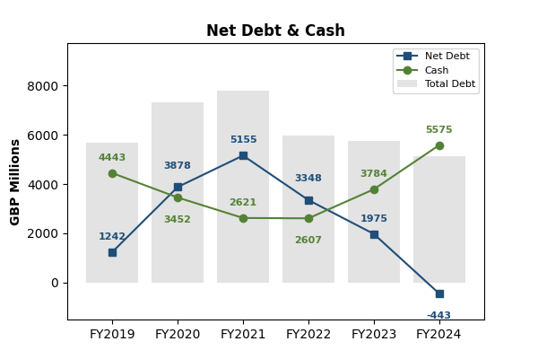
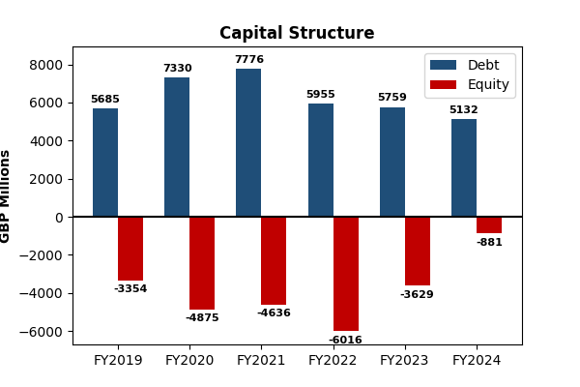
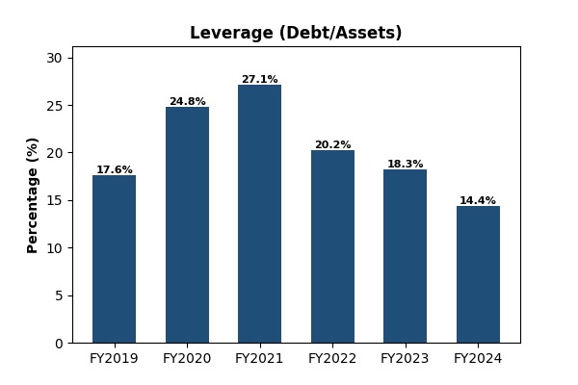
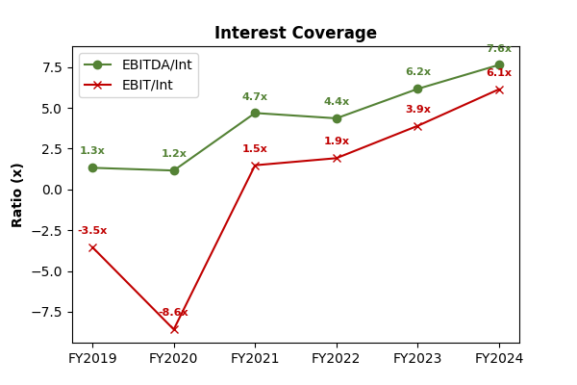
Source: Bloomberg (2025)

Appendix C. Peer Comparison: Capital Structure and Risk Profile
Metric | Rolls-Royce | Safran (FR) | GE Aero (US) | Industry Avg.
Solvency
Debt / Assets | 14.40% | 8.70% | 16.00% | 53.70%
Debt / Equity | N/A (Neg. Eq) | 49.90% | 105.00% | 54.00%
Coverage
EBITDA / Interest | 7.6x | 34.5x | 15.0x | 12.0x
EBIT / Interest | 6.1x | 26.2x | 12.3x | 8.7x
Liquidity
Net Debt position | Net Cash (-£443m) | Net Cash (-£1.5bn) | Net Debt (£4.5bn) | —
Structure
Long-Term Debt % | 79% | 85% | 82% | 80%
Source: Bloomberg (2025)

Appendix D. Sensitivity Risk Analysis

Source: Bloomberg (2025)

Rolls-Royce Holdings plc. (2024). Annual report 2023. https://www.rolls-royce.com/~/media/Files/R/Rolls-Royce/documents/annual-report/2024/2023-annual-report.pdf
Rolls-Royce Holdings plc. (2024). Annual report 2023. https://www.rolls-royce.com/~/media/Files/R/Rolls-Royce/documents/annual-report/2024/2023-annual-report.pdf
Hampton-Alexander Review. (2017). FTSE women leaders: Improving gender balance in FTSE leadership. Department for Business, Energy & Industrial Strategy. https://www.gov.uk/government/publications/ftse-women-leaders-hampton-alexander-review
Rolls-Royce Holdings plc. (2024). Annual report 2023. https://www.rolls-royce.com/~/media/Files/R/Rolls-Royce/documents/annual-report/2024/2023-annual-report.pdf
Rolls-Royce Holdings plc. (2024). Annual report 2023. https://www.rolls-royce.com/~/media/Files/R/Rolls-Royce/documents/annual-report/2024/2023-annual-report.pdf
Bloomberg L.P. (2023). ESG data and governance indicators for Rolls-Royce Holdings plc. Bloomberg Terminal.
Bloomberg L.P. (2024). ESG governance metrics: Rolls-Royce Holdings plc. Bloomberg Terminal.
Rolls-Royce Holdings plc. (2024). Annual report 2023. https://www.rolls-royce.com/~/media/Files/R/Rolls-Royce/documents/annual-report/2024/2023-annual-report.pdf
Rolls-Royce Holdings plc. (2024). Annual report 2023. https://www.rolls-royce.com/~/media/Files/R/Rolls-Royce/documents/annual-report/2024/2023-annual-report.pdf
Rolls-Royce Holdings plc. (2024). Annual report 2023. https://www.rolls-royce.com/~/media/Files/R/Rolls-Royce/documents/annual-report/2024/2023-annual-report.pdf
Rolls-Royce Holdings plc. (2024). Annual report 2023. https://www.rolls-royce.com/~/media/Files/R/Rolls-Royce/documents/annual-report/2024/2023-annual-report.pdf
Serious Fraud Office. (2017). Rolls-Royce plc – deferred prosecution agreement. https://www.sfo.gov.uk/cases/rolls-royce-plc/
Bank of England. (2024). Yield curve data: UK government bond rates. https://www.bankofengland.co.uk/statistics/yield-curves
European Union Aviation Safety Agency. (2023). Aviation risk and market environment: Annual review. https://www.easa.europa.eu/en/document-library/general-publications
Bank for International Settlements. (2023). Corporate credit spreads and market-implied default risk indicators. https://www.bis.org
International Air Transport Association. (2024). Airline industry economic performance report. https://www.iata.org/en/publications/economic-reports/
PwC. (2023). Aerospace & defence outlook: Cost structures, capital intensity, and programme economics. https://www.pwc.com/gx/en/industries/industrial-manufacturing/aerospace-defence.html
McKinsey & Company. (2023). How aerospace OEMs manage programme economics and cash-flow cycles. https://www.mckinsey.com/industries/aerospace
ICAEW Corporate Finance Faculty. (2022). Discounted cash flow valuation: Technical briefing. https://www.icaew.com/technical/corporate-finance/capital-investment-appraisal
Ruback, R. S. (2002). Capital cash flows: A simple approach to valuing risky cash flows. Financial Management, 31(2), 85–103. https://doi.org/10.2307/3666223
Harrington, S. E., & Niehaus, G. (2023). Enterprise risk and capital management in cyclical industries. https://doi.org/10.2139/ssrn.4578312
Pannell, D. J. (1997). Sensitivity analysis of normative economic models: Theoretical framework and practical strategies. Agricultural Economics, 16(2), 139–152. https://doi.org/10.1016/S0169-5150(96)01217-0
Deloitte. (2024). Scenario planning in capital-intensive industries. https://www2.deloitte.com/global/en/pages/strategy-operations
Hertz, D. B. (1964). Risk analysis in capital investment. Harvard Business Review, 42(1), 95–106. https://hbr.org
Saltelli, A., & Annoni, P. (2010). How to avoid a perfunctory sensitivity analysis. Environmental Modelling & Software, 25(12), 1508–1517. https://doi.org/10.1016/j.envsoft.2010.04.012
Government Office for Science. (2023). Techno-economic uncertainty and long-term investment modelling. https://www.gov.uk/government/publications
IFRS Foundation. (2024). IAS 36, IAS 38 and guidance on treatment of development expenditure. https://www.ifrs.org/issued-standards/list-of-standards/
Modigliani, F., & Miller, M. H. (1958). The cost of capital, corporation finance and the theory of investment. The American Economic Review, 48(3), 261–297. https://www.jstor.org/stable/1809766
Fama, E. F., & French, K. R. (1997). Industry costs of equity. Journal of Financial Economics, 43(2), 153–193*. https://doi.org/10.1016/S0304-405X(96)00896-3

