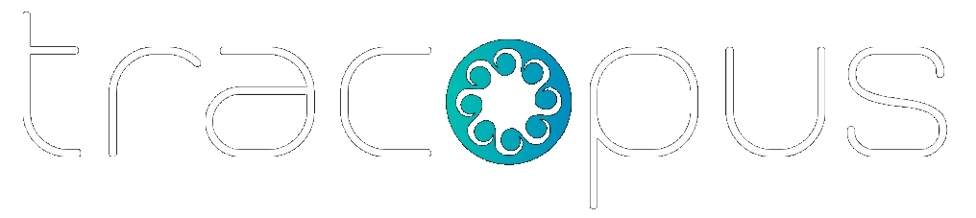  Enterprise Work Intelligence Platform  One platform for people, projects, resources, payroll, finance, governance, and AI-driven execution.  Tracopus connects workforce operations, project delivery, resource planning, approvals, analytics, and enterprise intelligence into one unified system for employees, managers, HR, finance, and executives. | CONNECTED ENTERPRISE OPERATING GRAPH  People • Projects • Resources • Payroll • Finance • Governance • AI  ◎  Executive Visibility + AI Intelligence  Projects 128 Employees 6,842 Revenue $245.6M On-Time 92.6%

1 Why Tracopus ────────────────────────────────────
◆  Unified Operating Layer  ━  People, projects, resources, payroll, approvals, and financial operations in one connected system. | ●  Role-Aware Experience  ━  Employees, managers, HR, finance, and executives get focused dashboards and workflows. | ✓  Governance by Design  ━  Approvals, audit trails, status controls, secure access, and policy workflows are built in. | ✦  AI with Human Control  ━  AI agents provide recommendations, evidence, confidence, and approval-aware actions.

2 Built for Every Role ────────────────────────────────────
●  Employees  ━  Self-service work, attendance, leave, timesheets, paychecks, expenses, documents. | ●  Managers  ━  Team approvals, staffing, delivery progress, utilization, and risks. | ●  HR & Payroll  ━  Employee lifecycle, policies, payroll operations, compliance. | ●  Finance  ━  Project financials, invoices, billing, reimbursements, cost controls. | ●  Executives  ━  Portfolio visibility, risk trends, workforce and business intelligence. | ●  Admins  ━  Configuration, access control, integrations, audit, and governance.

3 Implemented Platform Modules ────────────────────────────────────
Workspace  command center | Projects  plan and deliver | People  employee lifecycle | Resources  capacity and staffing | Finance  billing and costing | Payroll  payruns and paychecks
Performance  goals and reviews | Analytics  dashboards and reports | AI  agents and insights | Integrations  connectors and APIs | Admin  security and settings | Mobile  responsive experience

4 What Makes Tracopus Different ────────────────────────────────────
Project + HRMS + Payroll + PSA  One enterprise operating platform | Luxury UX  Role-based dashboards and workflows | Closed-loop Intelligence  Work to payroll to revenue | Production Ready  Audit, integrations, and secure controls

Tracopus | Enterprise Work Intelligence Platform Client overview

◎ Enterprise Capabilities  Tracopus combines workforce operations, project execution, resource intelligence, finance, governance, and AI into one production-ready enterprise platform. | PAGE 2 OF 2  Role-aware dashboards | unified audit | AI agents | enterprise integrations

●  People & Workforce  ━  • Employee 360 across profile, attendance, leave, timesheets, payroll, projects, documents, assets, approvals, and activity.  • Onboarding, offboarding, policies, holidays, regularization, and employee requests.  • Performance goals, reviews, feedback, growth plans, and lifecycle intelligence. | ■  Projects & Delivery  ━  • Project portfolio, project details, deliverables, work items, taskboard, milestones, and dependencies.  • Timeline/Gantt, risks, issues, actions, approvals, governance controls, and lessons learned.  • Portfolio visibility, executive delivery insights, operational reports, files, chat, calendar, and notes. | $  Resources, Finance & Payroll  ━  • Resource planning, allocation timeline, skills matrix, bench management, utilization, and staffing requests.  • Bid requests, purchase orders, accounts, invoices, billing plans, project financials, and revenue forecast.  • Payroll groups, salary structures, payroll runs, paychecks, benefits, deductions, expenses, reimbursements, and employee finance. | ✦  AI, Integrations & Governance  ━  • AI agents for WBS planning, staffing, timesheet intelligence, payroll readiness, executive briefings, and risk insights.  • Integration center for Salesforce, Jira, GitHub, Azure DevOps, Teams, Slack, payroll, accounting, CSV/SFTP, webhooks, and APIs.  • Universal approvals, delegation, SLA tracking, escalations, unified audit, feature flags, data controls, analytics, exports, and scheduled reports.

Role-Based Dashboards ────────────────────────────────────
Employee Dashboard  My work, attendance, leave, timesheets, expenses, paychecks, documents | Manager Dashboard  Team approvals, staffing, delivery progress, utilization, risks | HR & Payroll Dashboard  Employee operations, policies, payroll readiness, compliance metrics | Finance Dashboard  Billing, reimbursements, invoices, project costs, revenue visibility | Executive Dashboard  Portfolio health, financial trends, workforce insights, business performance

Production-Ready by Design ────────────────────────────────────
◆  Role-based access and data masking | ◆  Microsoft Entra ID SSO and secure sessions | ◆  Unified audit trail across modules | ◆  Adapters and APIs for enterprise integrations | ◆  Configurable workflows, flags, and policies | ◆  Responsive web and mobile-ready experience

Business Outcomes ────────────────────────────────────
Faster decisions  Shared operational visibility | Better control  Delivery, workforce, and finance aligned | Less manual work  Connected workflows across teams | One platform  Reduce fragmented operational tools

Ready to unify work, workforce, and intelligence?
Tracopus helps organizations operate with clarity, governance, and measurable execution excellence. Contact us for a personalized walkthrough.

tracopus | Enterprise Work Intelligence Platform Client overview

