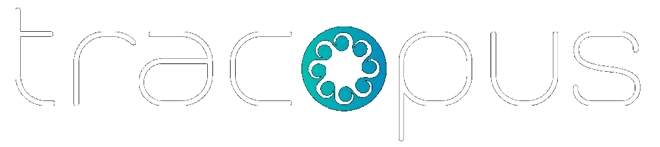
Enterprise Work Intelligence Platform
A category-defining enterprise platform that connects workforce operations, delivery execution, finance, governance, and AI into one system of record and action.
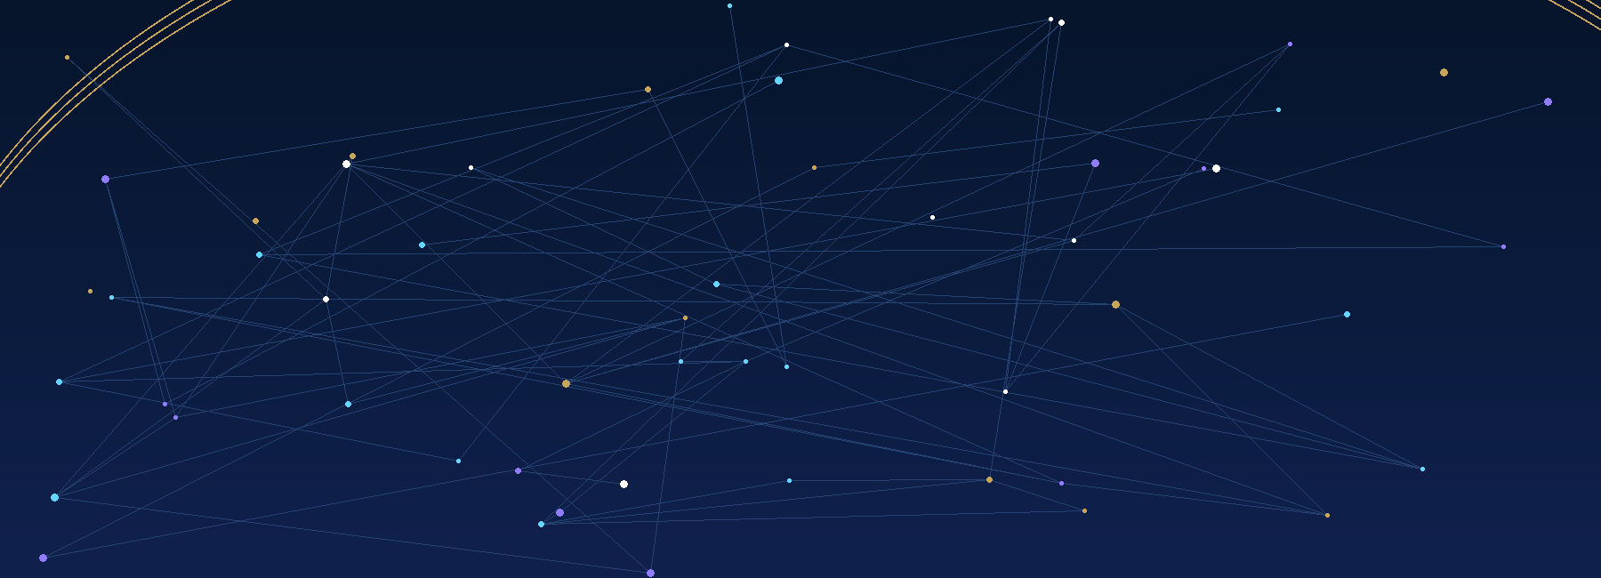

One Platform. Multiple Revenue Workflows. Enterprise-Scale Control.
Enterprise Sales Deck

EXECUTIVE OVERVIEW
The enterprise operating system for work, people, and revenue
Tracopus replaces fragmented systems across HR, delivery, payroll, finance, analytics, and governance with one enterprise platform that improves visibility, accelerates approvals, reduces operational friction, and strengthens control.
360°  Enterprise visibility | 1  Unified source of truth | AI  Evidence-based agents | Audit  Governance built in

• The Market Problem  • People, project, payroll, finance, and governance data often live across disconnected systems.  • Managers struggle with delayed approvals, resource conflicts, delivery risk, and scattered reporting.  • Executives and operators lack a single trusted view of capacity, delivery health, payroll readiness, costs, approvals, and revenue impact. | • Why Tracopus Wins  • A single work-intelligence platform that connects employees, managers, HR, finance, PMO, and executives.  • Role-aware dashboards, workflows, approvals, analytics, and AI recommendations tailored to each persona.  • Enterprise-ready architecture with audit trails, role-based controls, integrations, configurable workflows, and governed AI—reducing adoption risk and supporting scalable rollout.

• Plan Work  Projects, portfolios, deliverables, milestones, dependencies, risks, and issues. | • Staff Work  Skills, capacity, allocation, bench, roll-offs, staffing requests, and utilization. | • Track Work  Attendance, leave, timesheets, approvals, activity, and operational audit. | • Convert Work to Value  Payroll, expenses, invoices, billing plans, costs, margins, and executive intelligence.
Tracopus | Enterprise Work Intelligence Platform · Page 2 · Executive Overview

ROLE-AWARE EXPERIENCE
Role-based experiences for every level of the enterprise
Each stakeholder gets a role-specific workspace with the right data, the right actions, and the right controls—improving adoption without sacrificing governance.
E Employees  • My work, tasks, attendance, leave, timesheets, documents, assets, expenses, and paychecks.  • Self-service workflows reduce administrative dependency. | M Managers  • Team attendance, leave, timesheets, approvals, utilization, staffing, delivery progress, and risks.  • Operational control without jumping across systems. | • HR & Payroll  • Employee lifecycle, policies, payroll readiness, attendance exceptions, compliance, paychecks, and employee finance.  • Sensitive fields protected through masking and RBAC.
$ Finance  • Invoices, purchase orders, billing plans, expense approvals, reimbursements, cost allocation, and revenue visibility.  • Work-to-revenue traceability across projects and teams. | ★ Executives  • Portfolio health, workforce intelligence, financial trends, approvals, risk signals, and AI executive briefings.  • Strategic visibility from a single control tower. | A Admins  • Configuration, roles, feature flags, integrations, workflow policies, data retention, and audit controls.  • Production operations are governed by design.

Employee  Self-service | Manager  Team control | HR/Payroll  Lifecycle + payroll | Executive  Control tower
Tracopus | Enterprise Work Intelligence Platform · Page 3 · Role-Based Dashboards

PLATFORM MODULES
A complete operating suite for enterprise execution
Tracopus unifies the capabilities often spread across separate HR, PSA, project, payroll, finance, analytics, and AI tools—simplifying the stack and improving operational continuity.
:: Workspace  Daily command center, my work, notifications, and approvals | :: People  Employee 360, onboarding, attendance, leave, documents, assets, and policies | :: Projects  Portfolio, projects, deliverables, work items, taskboard, timeline, risks, and issues
:: Resources  Capacity, allocation, skills, staffing, bench, roll-offs, and utilization | :: Payroll  Salary structures, payroll runs, paychecks, deductions, benefits, and readiness | :: Finance  Accounts, bids, purchase orders, invoices, billing plans, expenses, and revenue
:: Performance  Goals, reviews, feedback, competencies, growth plans, and calibration | :: Analytics  Executive dashboards, report builder, scheduled reports, and domain insights | :: AI  WBS, staffing, risk, payroll readiness, timesheet, revenue, and executive agents
:: Integrations  Salesforce, Jira, GitHub, Azure DevOps, Teams, Slack, accounting, payroll, APIs | :: Admin  Configuration, RBAC, policies, audit, feature flags, notifications, and data controls | :: Governance  Universal approvals, delegation, SLA, escalations, decisions, and compliance evidence
Tracopus | Enterprise Work Intelligence Platform · Page 4 · Platform Modules

PEOPLE INTELLIGENCE
Employee lifecycle, workforce operations, and Employee 360
A connected people operations layer that gives HR, managers, payroll, finance, and employees a shared operating model for faster execution and cleaner compliance.
• Employee 360  • Profile, employment, attendance, leave, timesheets, payroll, projects, documents, assets, approvals, notes, and activity history.  • Live operational status helps every stakeholder see the right context quickly. | • Onboarding & Offboarding  • Checklist-driven onboarding, document collection, policy acknowledgement, asset provisioning, IT access, probation, exit, and final settlement workflows.
• Attendance & Leave  • Attendance matrix, regularization, leave policies, balances, calendars, approvals, holidays, LOP calculation, and capacity impact. | • Documents, Assets & Policies  • Document vault, expiry reminders, policy acknowledgements, asset assignment, return, condition tracking, and access lifecycle.

• Key Experiences  • Employee self-service hub  • Manager team dashboard  • HR operations dashboard  • Payroll readiness view | • Business Value  • Reduced manual HR administration  • Better workforce visibility  • Improved compliance evidence  • Cleaner employee lifecycle execution
Tracopus | Enterprise Work Intelligence Platform · Page 5 · People Intelligence

DELIVERY AND RESOURCE INTELLIGENCE
Delivery, capacity, staffing, and governance in one control model
Tracopus links project execution, workforce planning, and risk governance so delivery leaders can improve predictability, utilization, and cross-functional coordination.
• Project Delivery  • Project dashboard, project list, project details, deliverables, work items, taskboard, files, chat, calendar, notes, and operational reports.  • Designed for delivery managers, PMs, team leads, and executives. |  | • Timeline & Governance  • Timeline/Gantt, milestones, dependencies, critical path, planned vs actual variance, risks, issues, actions, decisions, and approval gates.
• Resource Management  • Resource planner, allocation timeline, team capacity, skills matrix, staffing requests, bench management, over-allocation, and upcoming roll-offs. |  | • Portfolio Control Tower  • Portfolio hierarchy, cross-project health, budget burn, risk heatmap, resource heatmap, delivery trends, and executive visibility.

Gantt  Dependencies | Risks  Early warning | Capacity  Forecasting | Portfolio  Executive view
Tracopus | Enterprise Work Intelligence Platform · Page 6 · Delivery & Resource Intelligence

PAYROLL, FINANCE, AND REVENUE INTELLIGENCE
A closed-loop model from work to payroll, billing, and revenue
Tracopus connects time, approvals, payroll, expenses, billing, and revenue into a governed operating flow that reduces reconciliation effort and helps prevent leakage.
Work | Time | Approval | Payroll | Expense | Billing | Revenue

• Payroll Operations  • Payroll groups, salary structures, payroll runs, calculation previews, deductions, reimbursements, exceptions, approval, finalization, lock, and reopen controls. | • Paychecks & Employee Finance  • Payslip preview, PDF download, publish/retract, payment tracking, YTD summaries, compensation history, benefits, loans, advances, and cost centers.
• Finance Operations  • Accounts, bid requests, purchase orders, invoices, billing plans, project financials, expenses, reimbursements, and revenue forecasts. | • Revenue Leakage Intelligence  • Detect missing timesheets, unbilled work, delayed approvals, PO risk, bench cost, margin erosion, and payroll blockers.

Payroll  Readiness | Costs  Controlled | Invoices  Connected | Revenue  Visible
Tracopus | Enterprise Work Intelligence Platform · Page 7 · Payroll, Finance & Revenue

AI, INTEGRATIONS, AND AUTOMATION
Intelligence embedded into enterprise workflows
Tracopus embeds AI into enterprise workflows with approval, evidence, and auditability—helping teams move faster without introducing unmanaged risk.
AI WBS Planning Agent  Generates task structures, estimates, dependencies, risks, and draft project plans with human review. | AI Staffing Agent  Recommends the best resources based on skills, availability, cost, location, utilization, and margin impact. | AI Payroll Readiness Agent  Finds missing approvals, negative leave balances, attendance issues, unapproved timesheets, and payroll exceptions.
AI Executive Briefing Agent  Creates leadership-ready summaries for workforce, delivery, finance, risk, approvals, and business performance. | AI Risk & Revenue Agents  Predicts delivery risk, revenue leakage, billing delay, staffing gaps, and margin erosion with evidence and confidence. | API Integration Center  Connector hub for Salesforce, Jira, GitHub, Azure DevOps, Teams, Slack, accounting, payroll, CSV/SFTP, REST APIs, and webhooks.

• AI Governance  • Evidence-backed recommendations  • Confidence scores  • Human approval before write actions  • Prompt and decision audit logs | • Connector Governance  • Sync health dashboard  • Field mapping  • Retry queues  • Stale data and failure diagnostics
Tracopus | Enterprise Work Intelligence Platform · Page 8 · AI & Integrations

PRODUCTION-READY GOVERNANCE
Security, audit, configuration, and compliance controls
Enterprise buyers need trust, control, observability, and rollout confidence. Tracopus is structured to meet those requirements from pilot through scale.
• Secure Access  • Microsoft Entra ID SSO, secure sessions, role-based access, CRUD matrices, team scope, module switches, page flags, and sensitive field masking. |  | • Unified Audit Trail  • Audit events across employee, project, timesheet, attendance, leave, payroll, finance, integration, and AI decisions.
• Workflow Governance  • Universal approvals, delegation, escalation, SLA reminders, decision logs, status controls, policy enforcement, and evidence export. |  | • Operational Readiness  • Feature flags, pilot enablement, service health, logs, exports, notifications, data retention, runbooks, rollback, and QA automation.

Controls | Visibility | Reliability | Adoption
RBAC, masking, flags | Charts, dashboards, insights | Tests, runbooks, rollback | Guided tours, help, role UX
Tracopus | Enterprise Work Intelligence Platform · Page 9 · Governance & Production Readiness

WHY TRACOPUS
Why enterprises buy—and why the platform expands
Tracopus helps enterprise teams simplify fragmented operations, improve execution visibility, strengthen governance, and create a foundation for scalable platform adoption across functions.
 | Business Need | Traditional Approach | Tracopus Approach
 | Workforce visibility | Separate HRMS, attendance, leave, payroll, documents, and assets | Employee 360 and role-aware dashboards
 | Delivery control | Project tools disconnected from staffing, payroll, finance, and approvals | Projects, resources, risks, approvals, time, billing, and executive insights connected
 | Financial control | Manual reconciliation between timesheets, payroll, expenses, invoices, and revenue | Closed-loop flow from work to payroll to billing to revenue
 | Executive intelligence | Reports assembled manually from many tools | Enterprise control tower with AI-generated briefings and trusted metrics

OK Faster Enterprise Decisions  Shared operational visibility across people, delivery, finance, approvals, and risks. | OK Better Control  Unified governance, audit trails, role-based access, workflow approvals, and compliance evidence.
OK Platform Consolidation  One enterprise platform replaces disconnected project, HRMS, payroll, finance, and reporting tools. | OK Scalable Platform Adoption  A modular expansion path across workforce, delivery, finance, governance, analytics, and AI.
Ready to consolidate enterprise operations and scale revenue intelligence?
Tracopus helps enterprise leaders reduce fragmentation, increase execution visibility, strengthen governance, and turn operational data into measurable business performance.
Schedule an enterprise demo and solution walkthrough.

Tracopus | Enterprise Work Intelligence Platform · Page 10 · Business Outcomes

