

**Bansilal Ramnath Agarwal Charitable Trust’s**

Vishwakarma Institute of Technology, Pune-37

*(Anautonomous Institute of Savitribai Phule Pune University)*

**Department of Computer Engineering**

|  |  |
| --- | --- |
| **Division** | **A** |
| **Batch** | **B2** |
| **GR-no** | **12110353** |
| **Roll no** | **10** |
| **Name** | **Aneesh Hemant Dighe** |

***Commands in CMD***

***1.ipconfig- This command gives an overall view of the current IP address configuration you are connected to.***

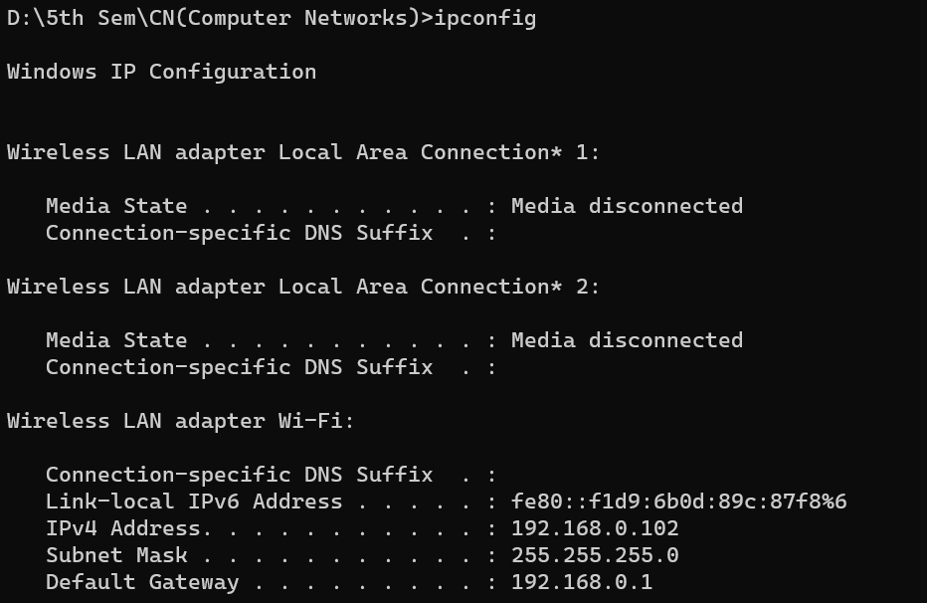

***Ipconfig/all – Gives additional information of the IP address***

***2.nslookup-The command is used to look for issues in the system.It gives information about the IP address,Domain name and Server name.***

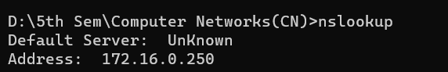

***3.hostname-The command displays the hostname of the system***

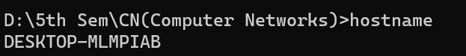

***4.ping-It is one of the most used commands in the networking tools.It is used to check the connectivity of our system to another host.The system sends 4 packets to the destination host and if it receives all of them successfully it indicates that the connection between 2 has been established.***

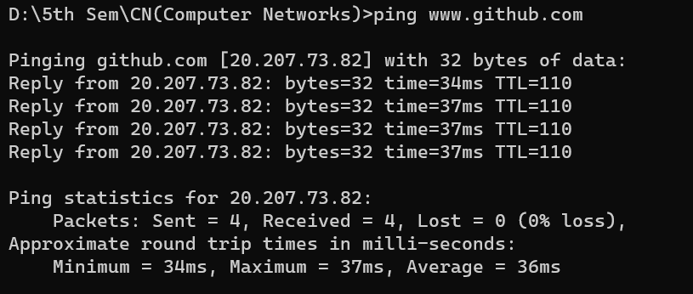

***5.tracert-This command is used to trace the route of the data packets from the source host to the destination host***

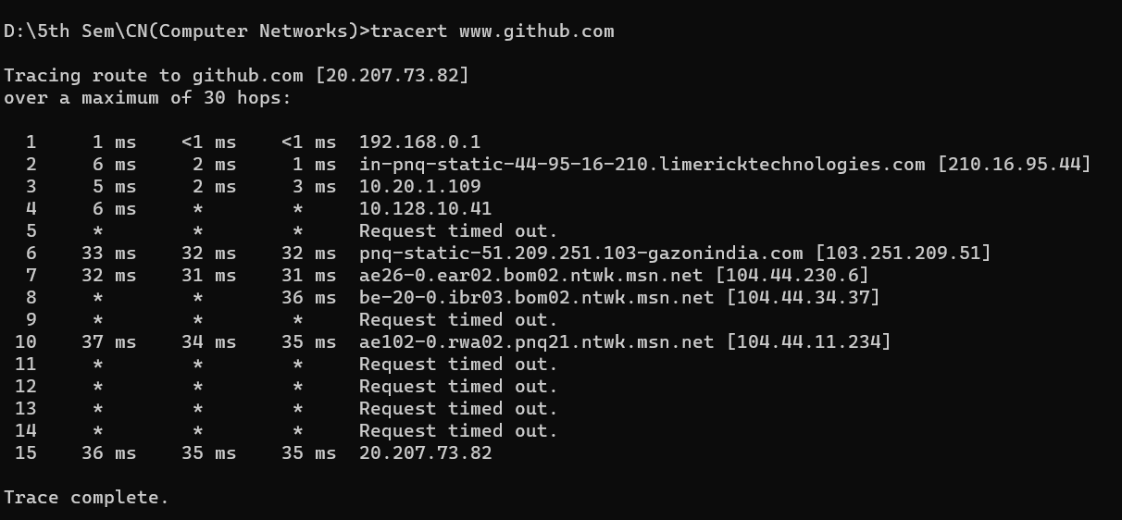

***6.pathping- It includes the functionalities of commands of ping and tracert.***

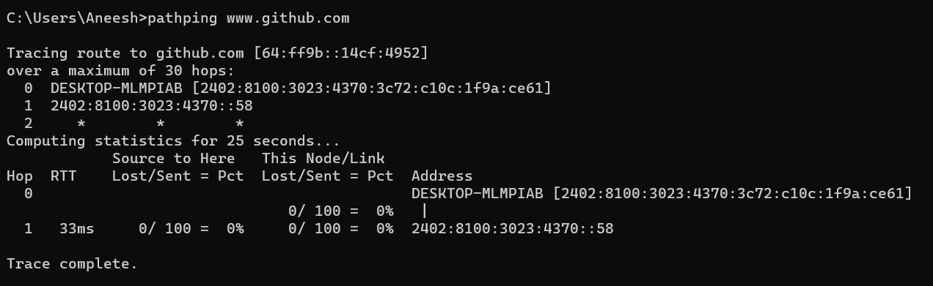

***7.arp-Displays and manages the ARP(Address Resolution Protocol) cache, which is used to map IP addresses on a local network.***

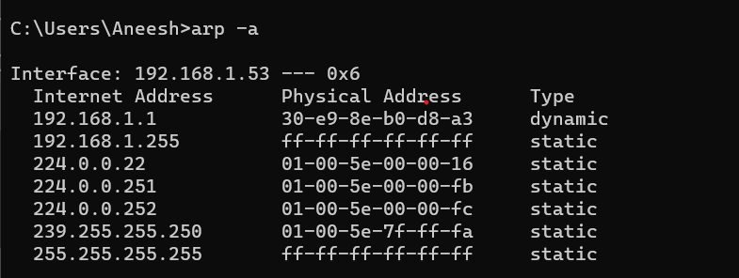

***8.netstat-Displays active network connections,routing tables,interface statistics,masquerade connections and more.***

Active Connections

Proto Local Address Foreign Address State

TCP 0.0.0.0:135 0.0.0.0:0 LISTENING

TCP 0.0.0.0:445 0.0.0.0:0 LISTENING

TCP 0.0.0.0:554 0.0.0.0:0 LISTENING

TCP 0.0.0.0:2869 0.0.0.0:0 LISTENING

TCP 0.0.0.0:3306 0.0.0.0:0 LISTENING

TCP 0.0.0.0:5040 0.0.0.0:0 LISTENING

TCP 0.0.0.0:5357 0.0.0.0:0 LISTENING

TCP 0.0.0.0:5500 0.0.0.0:0 LISTENING

TCP 0.0.0.0:10243 0.0.0.0:0 LISTENING

TCP 0.0.0.0:49664 0.0.0.0:0 LISTENING

TCP 0.0.0.0:49665 0.0.0.0:0 LISTENING

TCP 0.0.0.0:49666 0.0.0.0:0 LISTENING

TCP 0.0.0.0:49667 0.0.0.0:0 LISTENING

TCP 0.0.0.0:49668 0.0.0.0:0 LISTENING

TCP 0.0.0.0:49670 0.0.0.0:0 LISTENING

TCP 127.0.0.1:8884 0.0.0.0:0 LISTENING

TCP 192.168.1.53:139 0.0.0.0:0 LISTENING

TCP 192.168.1.53:49445 20.198.119.143:443 ESTABLISHED

TCP 192.168.1.53:61875 20.89.134.221:443 ESTABLISHED

TCP 192.168.1.53:61877 20.198.119.143:443 ESTABLISHED

TCP 192.168.1.53:61937 100.21.106.127:443 ESTABLISHED

TCP 192.168.1.53:62001 140.82.113.26:443 ESTABLISHED

TCP 192.168.1.53:62005 20.40.207.23:8883 ESTABLISHED

TCP 192.168.1.53:62017 35.186.224.39:443 ESTABLISHED

TCP 192.168.1.53:62024 35.186.224.39:443 ESTABLISHED

TCP 192.168.1.53:62087 91.108.56.164:443 ESTABLISHED

TCP 192.168.1.53:62167 74.125.200.188:5228 ESTABLISHED

TCP 192.168.1.53:62170 52.38.7.83:443 ESTABLISHED

TCP 192.168.1.53:62172 35.186.224.13:443 ESTABLISHED

TCP 192.168.1.53:62173 142.250.199.165:443 ESTABLISHED

TCP 192.168.1.53:62180 104.26.9.101:443 ESTABLISHED

TCP 192.168.1.53:62184 35.190.80.1:443 ESTABLISHED

TCP 192.168.1.53:62185 13.67.9.5:443 CLOSE_WAIT

TCP 192.168.1.53:62190 151.101.38.248:443 ESTABLISHED

TCP 192.168.1.53:62191 151.101.38.248:443 ESTABLISHED

TCP 192.168.1.53:62192 151.101.38.248:443 ESTABLISHED

TCP 192.168.1.53:62199 151.101.38.248:443 ESTABLISHED

TCP 192.168.1.53:62207 151.101.38.248:443 ESTABLISHED

TCP 192.168.1.53:62222 35.186.224.25:443 TIME_WAIT

TCP 192.168.1.53:62223 35.186.224.25:443 TIME_WAIT

TCP 192.168.1.53:62226 13.107.42.12:443 TIME_WAIT

TCP 192.168.1.53:62227 3.227.77.213:443 CLOSE_WAIT

TCP 192.168.1.53:62234 13.69.109.130:443 ESTABLISHED

TCP 192.168.1.53:62237 23.192.97.88:443 ESTABLISHED

TCP 192.168.1.53:62238 20.207.199.231:443 ESTABLISHED

TCP 192.168.1.53:62240 52.98.34.194:443 ESTABLISHED

TCP 192.168.1.53:62241 52.98.34.194:443 ESTABLISHED

TCP [::]:135 [::]:0 LISTENING

TCP [::]:445 [::]:0 LISTENING

TCP [::]:554 [::]:0 LISTENING

TCP [::]:2869 [::]:0 LISTENING

TCP [::]:3306 [::]:0 LISTENING

TCP [::]:5357 [::]:0 LISTENING

TCP [::]:10243 [::]:0 LISTENING

TCP [::]:49664 [::]:0 LISTENING

TCP [::]:49665 [::]:0 LISTENING

TCP [::]:49666 [::]:0 LISTENING

TCP [::]:49667 [::]:0 LISTENING

TCP [::]:49668 [::]:0 LISTENING

TCP [::]:49670 [::]:0 LISTENING

TCP [::1]:49669 [::]:0 LISTENING

UDP 0.0.0.0:3702 *:*

UDP 0.0.0.0:3702 *:*

UDP 0.0.0.0:3702 *:*

UDP 0.0.0.0:3702 *:*

UDP 0.0.0.0:5004 *:*

UDP 0.0.0.0:5004 *:*

UDP 0.0.0.0:5005 *:*

UDP 0.0.0.0:5005 *:*

UDP 0.0.0.0:5050 *:*

UDP 0.0.0.0:5353 *:*

UDP 0.0.0.0:5353 *:*

UDP 0.0.0.0:5353 *:*

UDP 0.0.0.0:5353 *:*

UDP 0.0.0.0:5353 *:*

UDP 0.0.0.0:5353 *:*

UDP 0.0.0.0:5353 *:*

UDP 0.0.0.0:5355 *:*

UDP 0.0.0.0:49836 *:*

UDP 0.0.0.0:50335 172.217.166.74:443

UDP 0.0.0.0:51109 *:*

UDP 0.0.0.0:56782 142.250.182.206:443

UDP 0.0.0.0:57076 172.217.174.227:443

UDP 0.0.0.0:57822 35.186.224.13:443

UDP 0.0.0.0:64121 *:*

UDP 0.0.0.0:64518 142.250.192.138:443

UDP 0.0.0.0:64742 *:*

UDP 0.0.0.0:65283 142.250.183.106:443

UDP 127.0.0.1:1900 *:*

UDP 127.0.0.1:49664 127.0.0.1:49664

UDP 127.0.0.1:62750 *:*

UDP 192.168.1.53:137 *:*

UDP 192.168.1.53:138 *:*

UDP 192.168.1.53:1900 *:*

UDP 192.168.1.53:2177 *:*

UDP 192.168.1.53:62749 *:*

UDP [::]:3702 *:*

UDP [::]:3702 *:*

UDP [::]:3702 *:*

UDP [::]:3702 *:*

UDP [::]:5004 *:*

UDP [::]:5005 *:*

UDP [::]:5353 *:*

UDP [::]:5353 *:*

UDP [::]:5353 *:*

UDP [::]:5353 *:*

UDP [::]:5355 *:*

UDP [::]:49836 *:*

UDP [::]:51109 *:*

UDP [::]:64122 *:*

UDP [::]:64743 *:*

UDP [::1]:1900 *:*

UDP [::1]:62748 *:*

UDP [fe80::805:c087:ae02:3229%6]:1900 *:*

UDP [fe80::805:c087:ae02:3229%6]:2177 *:*

UDP [fe80::805:c087:ae02:3229%6]:62747 *:*

***9.nbtstat:Displays NetBIOS over TCP/IP statistics,including current NetBIOS sessions and open files.***

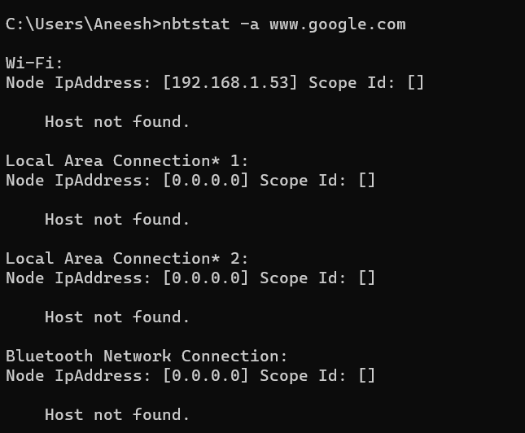

***10.Route:Displays and manages the routing table,which determines how data packets are forwaded between networks.***

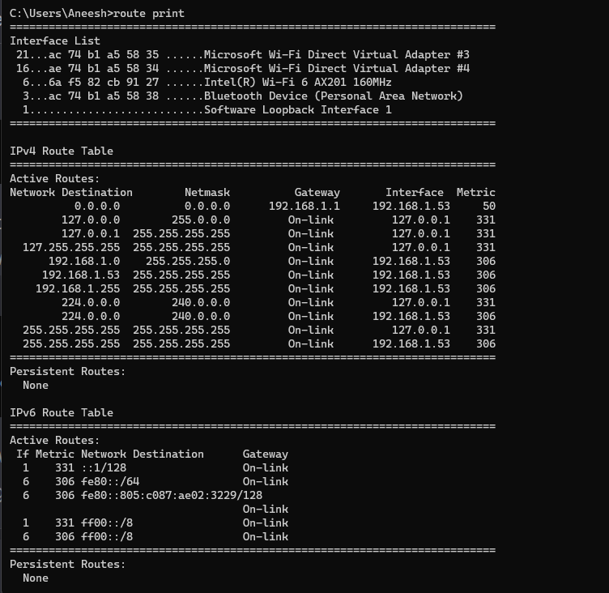

***8.nmap-A network scanning tool used for discovering hosts and services on a computer network***

