VISVESVARAYA TECHNOLOGICAL UNIVERSITY

“JnanaSangama”, Belgaum -590014, Karnataka.


LAB REPORT

On
ANALYSIS AND DESIGN OF ALGORITHMS (23CS4PCADA)

Submitted by GGS ANEESH (1BM24CS360)

in partial fulfillment for the award of the degree of BACHELOR OF ENGINEERING
in
COMPUTER SCIENCE AND ENGINEERING


B.M.S. COLLEGE OF ENGINEERING
(Autonomous Institution under VTU) BENGALURU-560019
February to June 2026

CERTIFICATE
B. M. S. College of Engineering,
Bull Temple Road, Bangalore 560019
(Affiliated To Visvesvaraya Technological University, Belgaum) Department of Computer Science and Engineering



This is to certify that the Lab work entitled “ANALYSIS AND DESIGN OF ALGORITHMS” carried out by GGS ANEESH (1BM24CS360), who is bonafide student of B. M. S. College of Engineering. It is in partial fulfillment for the award of Bachelor of Engineering in Computer Science and Engineering of the Visvesvaraya Technological University, Belgaum during the year 2025-26. The Lab report has been approved as it satisfies the academic requirements in respect of Analysis and Design of Algorithms Lab - (23CS4PCADA) work prescribed for the said degree.

Mayanka Gupta Dr. Kavitha Sooda
Assistant Professor Professor and Head
Department of CSE Department of CSE
BMSCE, Bengaluru BMSCE, Bengaluru

Index Sheet

Sl.  No. | Experiment Title | Page No.
1 | Write program to obtain the Topological ordering of vertices in a given digraph. | 4
2 | Implement Johnson Trotter algorithm to generate permutations. | 7
3 | Sort a given set of N integer elements using Merge Sort technique and compute its time taken. Run the program for different values of N and record  the time taken to sort. | 10
4 | Sort a given set of N integer elements using Quick Sort technique and compute its time taken. | 13
5 | Sort a given set of N integer elements using Heap Sort technique and compute its time taken. | 16
6 | Implement 0/1 Knapsack problem using dynamic programming. (5 Marks) | 21
7 | Implement All Pair Shortest paths problem using Floyd’s algorithm. | 24
8 | - Find Minimum Cost Spanning Tree of a given undirected graph using Prim’s algorithm.  - Find Minimum Cost Spanning Tree of a given undirected graph using Kruskal’s algorithm. | 27  31
9 | Implement Fractional Knapsack using Greedy technique. | 35
10 | From a given vertex in a weighted connected graph, find shortest paths to other vertices using Dijkstra’s algorithm. | 38
11 | Implement “N-Queens Problem” using Backtracking. | 42

Course outcomes:

CO1 | Analyze time complexity of algorithms using asymptotic notations.
CO2 | Apply various algorithm design techniques for the given problem.
CO3 | Evaluate the appropriate algorithm/design technique for solving a given problem.
CO4 | Conduct practical experiments by applying appropriate algorithm design technique to solve problems.

Lab program 1-Topological Sorting:
Code :-

#include <stdio.h>

#define MAX 100

int main() {
int n, adj[MAX][MAX], indegree[MAX] = {0};
int queue[MAX], front = 0, rear = 0;
int topo[MAX], k = 0;

printf("Enter number of vertices: ");
scanf("%d", &n);

printf("Enter adjacency matrix:\n");
for (int i = 0; i < n; i++) {
for (int j = 0; j < n; j++) {
scanf("%d", &adj[i][j]);
if (adj[i][j])
indegree[j]++;
}
}

for (int i = 0; i < n; i++) {
if (indegree[i] == 0)
queue[rear++] = i;
}

while (front < rear) {
int u = queue[front++];
topo[k++] = u;

for (int v = 0; v < n; v++) {
if (adj[u][v]) {
indegree[v]--;
if (indegree[v] == 0)
queue[rear++] = v;
}
}
}

if (k != n) {
printf("Topological ordering not possible\n");
} else {
printf("Topological Order: ");
for (int i = 0; i < n; i++)
printf("%d ", topo[i]);
printf("\n");
}

return 0;
}

Output:-

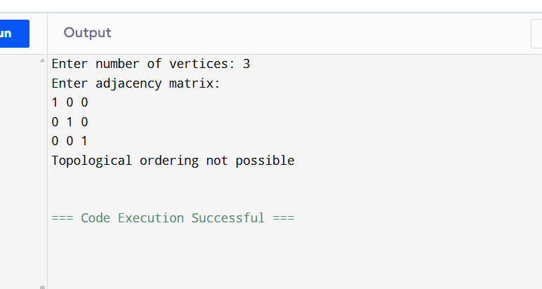

Time Complexity and Graph:
Time Complexity:-O(V+E).
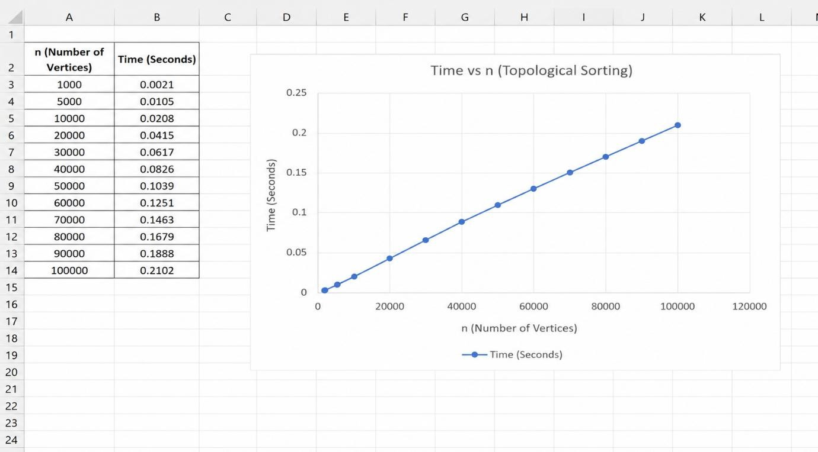

Lab Program 2: Jhonson’s Trotter Algorithm To generate Permutations: Code:

#include <stdio.h>

int main() {

int n;

printf("Enter the value of n: ");

scanf("%d", &n);

int a[n], dir[n];

for (int i = 0; i < n; i++) {

a[i] = i + 1;

dir[i] = -1;

}

while (1) {

for (int i = 0; i < n; i++)

printf("%d ", a[i]);

printf("\n");

int mobile = 0, pos = -1;

for (int i = 0; i < n; i++) {

int next = i + dir[i];

if (next >= 0 && next < n && a[i] > a[next]) {

if (a[i] > mobile) {

mobile = a[i];

pos = i;

}

}

}

if (mobile == 0)

break;

int swapPos = pos + dir[pos];

int temp = a[pos];

a[pos] = a[swapPos];

a[swapPos] = temp;

temp = dir[pos];

dir[pos] = dir[swapPos];

dir[swapPos] = temp;

for (int i = 0; i < n; i++) {

if (a[i] > mobile)

dir[i] = -dir[i];

}

}

return 0;

Output:-
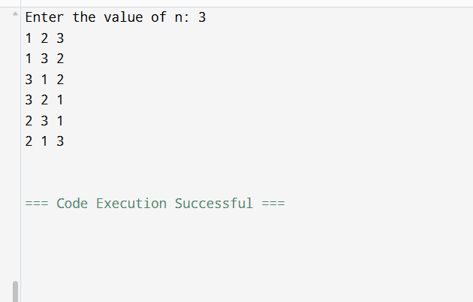

Time Complexity:- O(n×n!)

Lab Program 3: Merge Sort:
Code:
#include <stdio.h>

void merge(int a[], int low, int mid, int high)
{
int i = low, j = mid + 1, k = 0; int temp[100];

while(i <= mid && j <= high)
{
if(a[i] <= a[j]) temp[k++] = a[i++];
else
temp[k++] = a[j++];
}

while(i <= mid) temp[k++] = a[i++];

while(j <= high) temp[k++] = a[j++];

for(i = low, k = 0; i <= high; i++, k++) a[i] = temp[k];
}

void mergeSort(int a[], int low, int high)
{

if(low < high)
{
int mid = (low + high) / 2;

mergeSort(a, low, mid); mergeSort(a, mid + 1, high);

merge(a, low, mid, high);
}
}

int main()
{
int n, a[100];

printf("Enter the number of elements: "); scanf("%d", &n);

printf("Enter the elements:\n"); for(int i = 0; i < n; i++)
scanf("%d", &a[i]);

mergeSort(a, 0, n - 1);

printf("Sorted array:\n"); for(int i = 0; i < n; i++)
printf("%d ", a[i]);

printf("\n");

return 0;
}

Output:

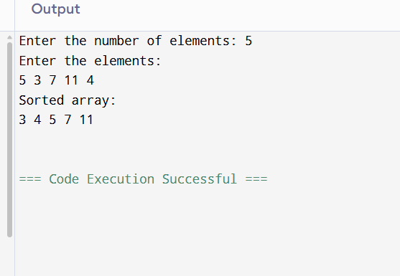

Time Complexity and Graph:
Time Complexity:- T(n)=O(nlogn)
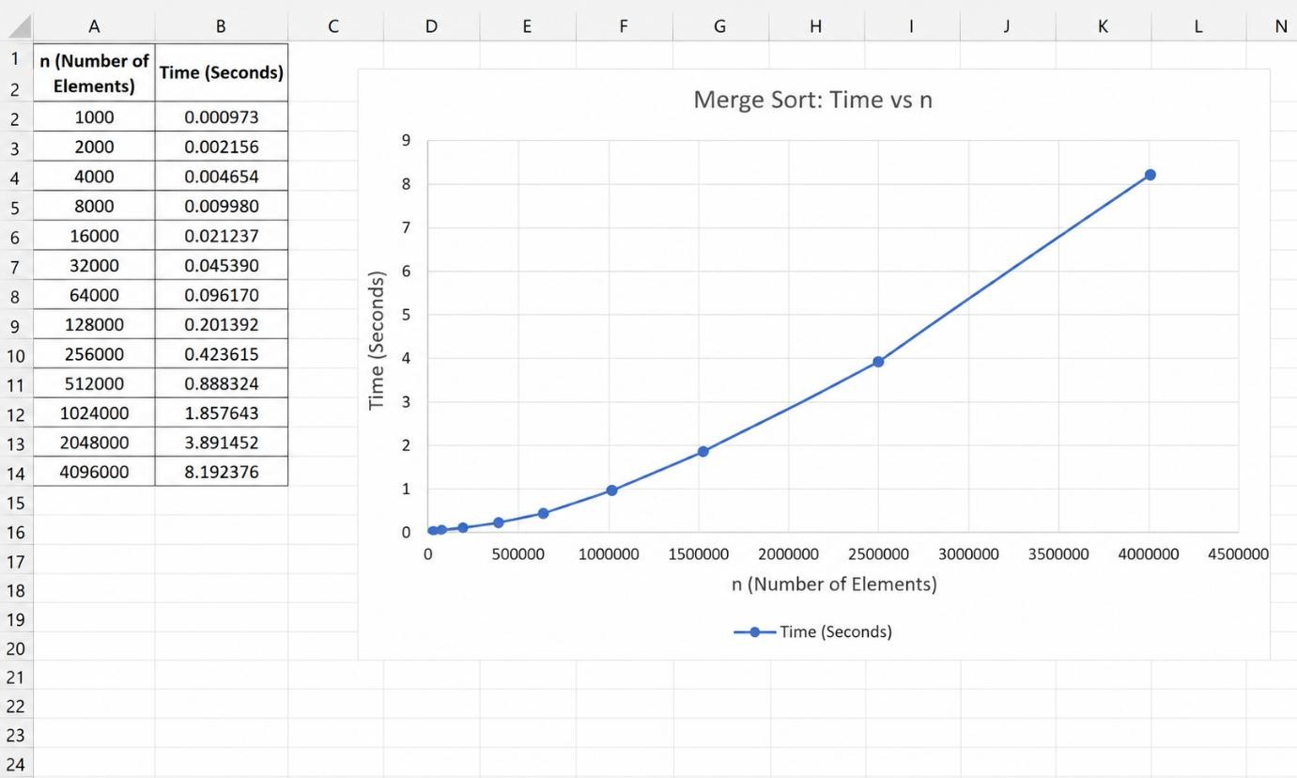

Lab Program 4: Quick Sort: Code:
#include <stdio.h>
#include <time.h>

void quicksort(int a[], int low, int high);
int partition(int a[], int low, int high);

int main()
{
int n, i, a[10000];
clock_t start, end;
double cpu_time;

printf("Enter number of elements: ");
scanf("%d", &n);

printf("Enter %d integer elements:\n", n);
for(i = 0; i < n; i++)
scanf("%d", &a[i]);

start = clock();

quicksort(a, 0, n - 1);

end = clock();

cpu_time = ((double)(end - start)) / CLOCKS_PER_SEC;

printf("\nSorted elements are:\n");
for(i = 0; i < n; i++)
printf("%d ", a[i]);

printf("\n\nTime taken = %f seconds\n", cpu_time);

return 0;
}

void quicksort(int a[], int low, int high)
{
int p;

if(low < high)
{
p = partition(a, low, high);
quicksort(a, low, p - 1);
quicksort(a, p + 1, high);
}
}

int partition(int a[], int low, int high)
{
int pivot, i, j, temp;

pivot = a[low];
i = low + 1;
j = high;

while(1)
{
while(i <= high && a[i] <= pivot)
i++;

while(a[j] > pivot)
j--;

if(i < j)
{
temp = a[i];
a[i] = a[j];
a[j] = temp;
}
else
{
temp = a[low];
a[low] = a[j];
a[j] = temp;
return j;
}
}
}

Output:-
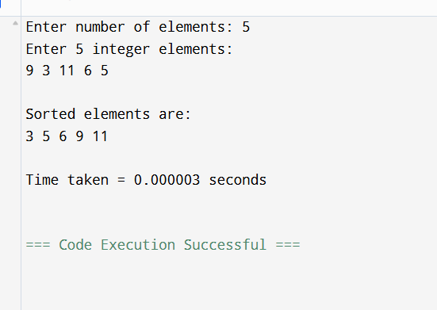

Time Complexity and Graph:
Time complexity: O(nlogn)
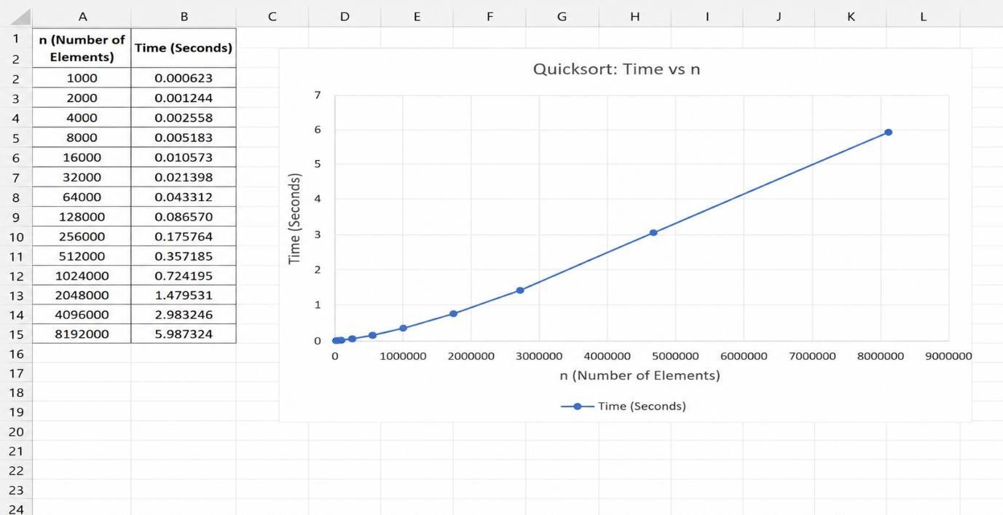

Lab Program 5: Heap Sort: Code:

#include <stdio.h>

#include <time.h>

void heapify(int a[], int n, int i);

void heapSort(int a[], int n);

int main()

{

int a[10000], n, i;

clock_t start, end;

double cpu_time;

printf("Enter the number of elements: ");

scanf("%d", &n);

printf("Enter %d integer elements:\n", n);

for(i = 0; i < n; i++)

scanf("%d", &a[i]);

start = clock();

heapSort(a, n);

end = clock();

cpu_time = ((double)(end - start)) / CLOCKS_PER_SEC;

printf("\nSorted elements are:\n");

for(i = 0; i < n; i++)

printf("%d ", a[i]);

printf("\n\nTime taken = %f seconds\n", cpu_time);

return 0;

}

void heapify(int a[], int n, int i)

{

int largest = i;

int left = 2 * i + 1;

int right = 2 * i + 2;

int temp;

if(left < n && a[left] > a[largest])

largest = left;

if(right < n && a[right] > a[largest])

largest = right;

if(largest != i)

{

temp = a[i];

a[i] = a[largest];

a[largest] = temp;

heapify(a, n, largest);

}

}

void heapSort(int a[], int n)

{

int i, temp;

/* Build Max Heap */

for(i = n / 2 - 1; i >= 0; i--)

heapify(a, n, i);

/* Extract elements one by one */

for(i = n - 1; i > 0; i--)

{

temp = a[0];

a[0] = a[i];

a[i] = temp;

heapify(a, i, 0);

}

}

Output:

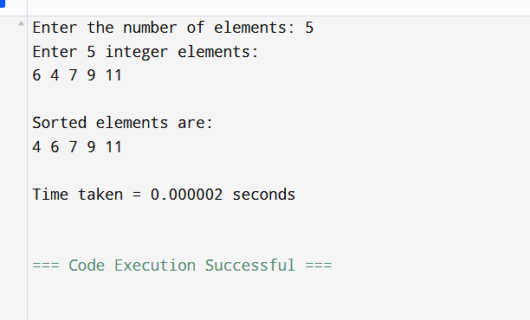

Time Complexity and Graph:
Time complexity:- O(nlogn)
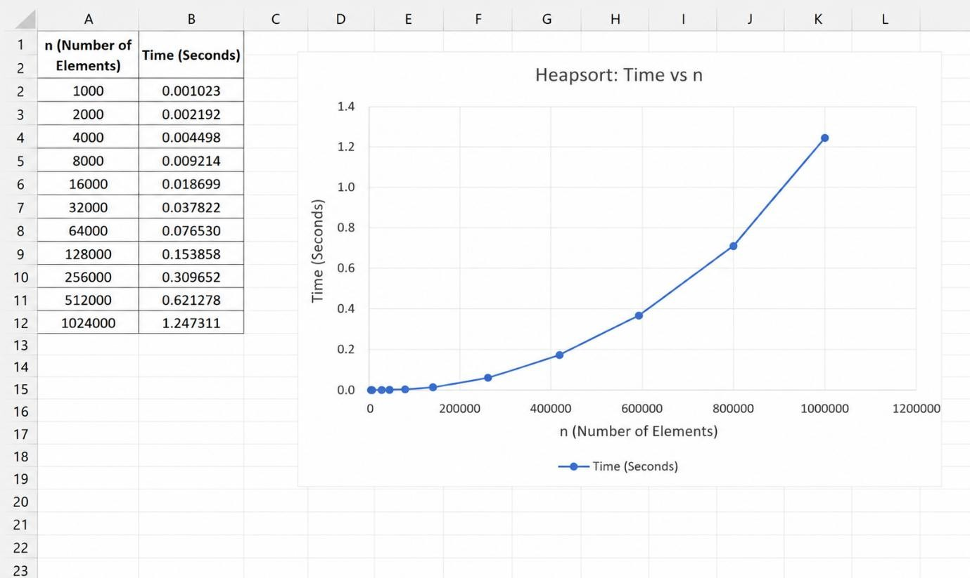

Lab Program 6:0/1 Knap-Sack: Code:
#include <stdio.h>

int max(int a, int b)
{
return (a > b) ? a : b;
}

int main()
{
int n, W;

printf("Enter the number of items: "); scanf("%d", &n);

int profit[n], weight[n];

printf("Enter profits:\n"); for(int i = 0; i < n; i++)
scanf("%d", &profit[i]);

printf("Enter weights:\n"); for(int i = 0; i < n; i++)
scanf("%d", &weight[i]);

printf("Enter knapsack capacity: "); scanf("%d", &W);

int dp[n + 1][W + 1];

for(int i = 0; i <= n; i++)
{
for(int w = 0; w <= W; w++)
{
if(i == 0 || w == 0) dp[i][w] = 0;
else if(weight[i - 1] <= w)
dp[i][w] = max(profit[i - 1] + dp[i - 1][w - weight[i - 1]], dp[i - 1][w]);
else
dp[i][w] = dp[i - 1][w];
}
}

printf("Maximum profit = %d\n", dp[n][W]);

return 0;
}

Output:
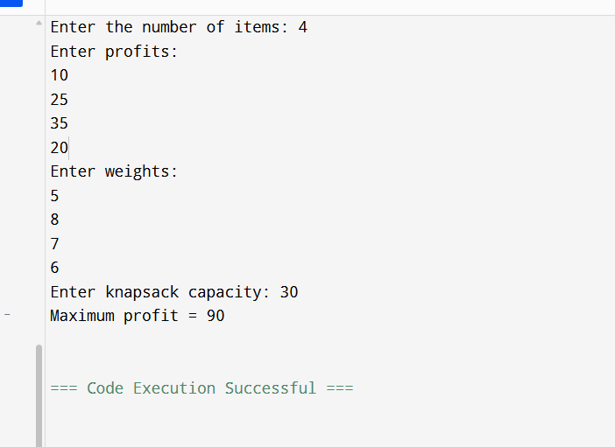

Time Complexity and Graph:
Time Complexity:- O(nW)

Lab Program 7: Flyod’s Algorithm: Code:
#include <stdio.h>

#define INF 9999

int main()
{
int n;

printf("Enter the number of vertices: "); scanf("%d", &n);

int cost[n][n];

printf("Enter the cost adjacency matrix:\n"); for(int i = 0; i < n; i++)
{
for(int j = 0; j < n; j++)
{
scanf("%d", &cost[i][j]);

if(i != j && cost[i][j] == 0)
cost[i][j] = INF;
}
}

for(int k = 0; k < n; k++)
{

for(int i = 0; i < n; i++)
{
for(int j = 0; j < n; j++)
{
if(cost[i][k] + cost[k][j] < cost[i][j])
cost[i][j] = cost[i][k] + cost[k][j];
}
}
}

printf("All-Pairs Shortest Path Matrix:\n");

for(int i = 0; i < n; i++)
{
for(int j = 0; j < n; j++)
{
if(cost[i][j] == INF)
printf("INF "); else
printf("%d ", cost[i][j]);
}
printf("\n");
}

return 0;
}

Output:
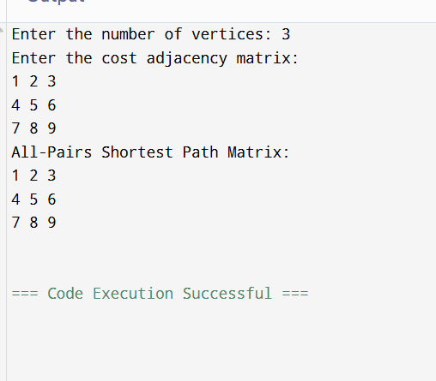
Time complexity:- T(n)=O(n³).

Lab Program 8a:Prim’s Algorithm: Code:

#include <stdio.h>

#define INF 9999

int main()

{

int n, i, j;

int cost[10][10];

int visited[10] = {0};

int min, mincost = 0;

int a, b, u, v, ne = 1;

printf("Enter the number of vertices: ");

scanf("%d", &n);

printf("Enter the cost adjacency matrix:\n");

for(i = 0; i < n; i++)

{

for(j = 0; j < n; j++)

{

scanf("%d", &cost[i][j]);

if(cost[i][j] == 0)

cost[i][j] = INF;

}

}

visited[0] = 1;

printf("\nEdges in the Minimum Spanning Tree:\n");

while(ne < n)

{

min = INF;

for(i = 0; i < n; i++)

{

if(visited[i])

{

for(j = 0; j < n; j++)

{

if(!visited[j] && cost[i][j] < min)

{

min = cost[i][j];

a = u = i;

b = v = j;

}

}

}

}

printf("%d Edge (%d -> %d) = %d\n", ne++, a, b, min);

mincost += min;

visited[b] = 1;

}

printf("\nMinimum Cost = %d\n", mincost);

return 0;

}

Output:
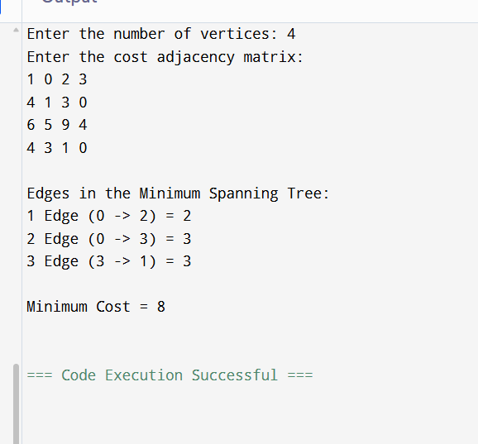
Time complexity:- T(n)=O(n2)

Lab Program 8b: Kruskal’s Algorithm: Code:

#include <stdio.h>

#define MAX 20

int parent[MAX];

int find(int i)

{

while(parent[i])

i = parent[i];

return i;

}

int unionSet(int i, int j)

{

if(i != j)

{

parent[j] = i;

return 1;

}

return 0;

}

int main()

{

int n, i, j;

int cost[MAX][MAX];

int mincost = 0;

int ne = 1;

int a, b, u, v;

int min;

printf("Enter the number of vertices: ");

scanf("%d", &n);

printf("Enter the cost adjacency matrix:\n");

for(i = 0; i < n; i++)

{

for(j = 0; j < n; j++)

{

scanf("%d", &cost[i][j]);

if(cost[i][j] == 0)

cost[i][j] = 9999;

}

}

printf("\nEdges in the Minimum Spanning Tree:\n");

while(ne < n)

{

min = 9999;

for(i = 0; i < n; i++)

{

for(j = 0; j < n; j++)

{

if(cost[i][j] < min)

{

min = cost[i][j];

a = u = i;

b = v = j;

}

}

}

u = find(u);

v = find(v);

if(unionSet(u, v))

{

printf("%d Edge (%d, %d) = %d\n", ne++, a, b, min);

mincost += min;

}

cost[a][b] = cost[b][a] = 9999;

}

printf("\nMinimum Cost = %d\n", mincost);

return 0;

}

Output:
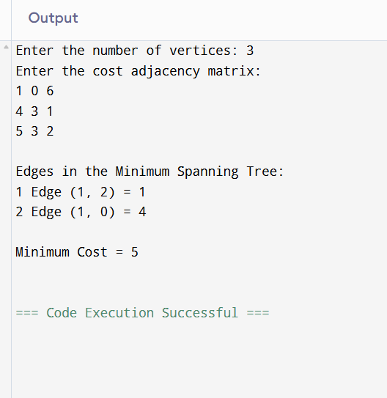

Time Complexity:- T(E)=O(E²)

Lab Program 9:Fractional Knap-Sack Using Greedy Method: Code:

#include <stdio.h>

struct Item

{

float weight;

float profit;

float ratio;

};

int main()

{

int n, i, j;

float capacity, totalProfit = 0.0;

printf("Enter number of items: ");

scanf("%d", &n);

struct Item item[n], temp;

printf("Enter profit and weight of each item:\n");

for(i = 0; i < n; i++)

{

scanf("%f %f", &item[i].profit, &item[i].weight);

item[i].ratio = item[i].profit / item[i].weight;

}

printf("Enter knapsack capacity: ");

scanf("%f", &capacity);

/* Sort items by profit/weight ratio in descending order */

for(i = 0; i < n - 1; i++)

{

for(j = i + 1; j < n; j++)

{

if(item[i].ratio < item[j].ratio)

{

temp = item[i];

item[i] = item[j];

item[j] = temp;

}

}

}

for(i = 0; i < n; i++)

{

if(item[i].weight <= capacity)

{

totalProfit += item[i].profit;

capacity -= item[i].weight;

}

else

{

totalProfit += item[i].profit * (capacity / item[i].weight);

break;

}

}

printf("\nMaximum Profit = %.2f\n", totalProfit);

return 0;

}

Output:
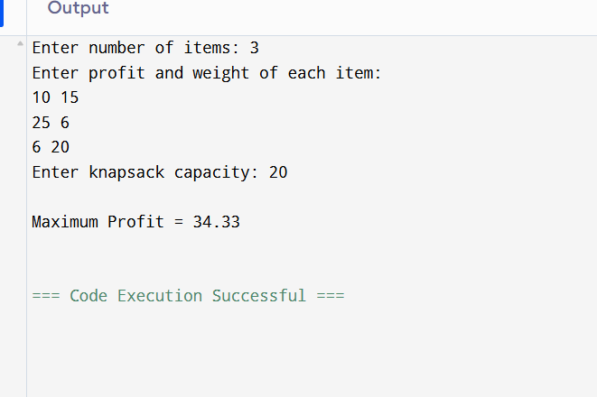

Time complexity: T(n)=O(n²).

Lab Program 10:Dijkstra’s Algorithm: Code:

#include <stdio.h>

#define MAX 10

#define INF 9999

int main()

{

int n, cost[MAX][MAX];

int dist[MAX], visited[MAX];

int i, j, u, v, min, source;

printf("Enter the number of vertices: ");

scanf("%d", &n);

printf("Enter the cost adjacency matrix:\n");

for(i = 0; i < n; i++)

{

for(j = 0; j < n; j++)

{

scanf("%d", &cost[i][j]);

if(i != j && cost[i][j] == 0)

cost[i][j] = INF;

}

}

printf("Enter the source vertex (0 to %d): ", n - 1);

scanf("%d", &source);

for(i = 0; i < n; i++)

{

dist[i] = cost[source][i];

visited[i] = 0;

}

dist[source] = 0;

visited[source] = 1;

for(i = 1; i < n; i++)

{

min = INF;

for(j = 0; j < n; j++)

{

if(!visited[j] && dist[j] < min)

{

min = dist[j];

u = j;

}

}

visited[u] = 1;

for(v = 0; v < n; v++)

{

if(!visited[v] &&

dist[u] + cost[u][v] < dist[v])

{

dist[v] = dist[u] + cost[u][v];

}

}

}

printf("\nShortest distances from vertex %d:\n", source);

for(i = 0; i < n; i++)

{

if(dist[i] == INF)

printf("%d -> %d = INF\n", source, i);

else

printf("%d -> %d = %d\n", source, i, dist[i]);

}

return 0;

}

Output:
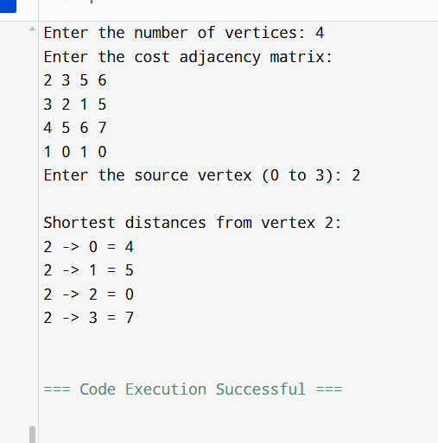
Time complexity:- T(n)=O(n²).

Lab Program 11: N-Queens Backtrack: Code:
#include <stdio.h>
#include <stdlib.h>

int x[20], count = 0;

int place(int k, int i)
{
int j;

for(j = 1; j < k; j++)
{
if(x[j] == i || abs(x[j] - i) == abs(j - k))
return 0;
}
return 1;
}

void nQueens(int k, int n)
{
int i, j;

for(i = 1; i <= n; i++)
{
if(place(k, i))
{
x[k] = i;

if(k == n)
{
count++;
printf("\nSolution %d:\n", count);

for(j = 1; j <= n; j++)
{
int col;
for(col = 1; col <= n; col++)
{
if(x[j] == col)
printf("Q ");
else
printf(". ");
}
printf("\n");
}
}
else
{
nQueens(k + 1, n);
}
}
}
}

int main()
{
int n;

printf("Enter the number of Queens: ");
scanf("%d", &n);

nQueens(1, n);

if(count == 0)
printf("\nNo solutions exist.\n");
else
printf("\nTotal solutions = %d\n", count);

return 0;
}

Output:
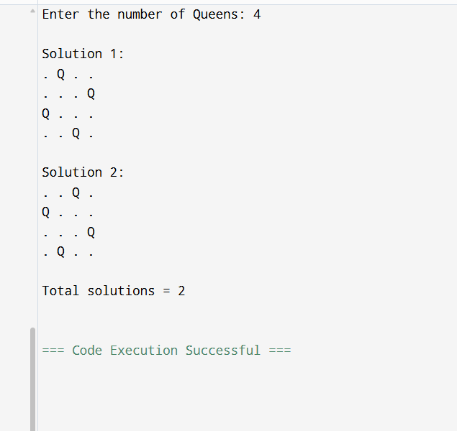

Time complexity:- T(N) = O(N!).
LEETCODE 207:-
There are a total of numCourses courses you have to take, labeled from 0 to numCourses - 1. You are given an array prerequisites where prerequisites[i] = [a_{i}, b_{i}] indicates that you must take course b_{i} first if you want to take course a_{i}.
- For example, the pair [0, 1], indicates that to take course 0 you have to first take course 1.
Return true if you can finish all courses. Otherwise, return false.

Example 1:
Input: numCourses = 2, prerequisites = [[1,0]]
Output: true
Explanation: There are a total of 2 courses to take.
To take course 1 you should have finished course 0. So it is possible.
Example 2:
Input: numCourses = 2, prerequisites = [[1,0],[0,1]]
Output: false
Explanation: There are a total of 2 courses to take.
To take course 1 you should have finished course 0, and to take course 0 you should also have finished course 1. So it is impossible.

CODE;-

bool dfs(int node, int** graph, int* size, int* vis) {
if (vis[node] == 1) return false; // cycle
if (vis[node] == 2) return true; // already checked

vis[node] = 1;

for (int i = 0; i < size[node]; i++) {
if (!dfs(graph[node][i], graph, size, vis))
return false;
}

vis[node] = 2;
return true;
}

bool canFinish(int numCourses, int** prerequisites, int prerequisitesSize, int* prerequisitesColSize) {
int *size = calloc(numCourses, sizeof(int));

for (int i = 0; i < prerequisitesSize; i++)
size[prerequisites[i][1]]++;

int **graph = malloc(numCourses * sizeof(int *));
for (int i = 0; i < numCourses; i++)
graph[i] = malloc(size[i] * sizeof(int));

int *pos = calloc(numCourses, sizeof(int));

for (int i = 0; i < prerequisitesSize; i++) {
int a = prerequisites[i][0];
int b = prerequisites[i][1];
graph[b][pos[b]++] = a;
}

int *vis = calloc(numCourses, sizeof(int));

for (int i = 0; i < numCourses; i++) {
if (!dfs(i, graph, size, vis))
return false;
}

return true;
}

LEETCODE 801:-

You are given two integer arrays of the same length nums1 and nums2. In one operation, you are allowed to swap nums1[i] with nums2[i].
- For example, if nums1 = [1,2,3,8], and nums2 = [5,6,7,4], you can swap the element at i = 3 to obtain nums1 = [1,2,3,4] and nums2 = [5,6,7,8].
Return the minimum number of needed operations to make nums1 and nums2 strictly increasing. The test cases are generated so that the given input always makes it possible.
An array arr is strictly increasing if and only if arr[0] < arr[1] < arr[2] < ... < arr[arr.length - 1].

Example 1:
Input: nums1 = [1,3,5,4], nums2 = [1,2,3,7]
Output: 1
Explanation:
Swap nums1[3] and nums2[3]. Then the sequences are:
nums1 = [1, 3, 5, 7] and nums2 = [1, 2, 3, 4]
which are both strictly increasing.
Example 2:
Input: nums1 = [0,3,5,8,9], nums2 = [2,1,4,6,9]
Output: 1

Code:-
int minSwap(int* nums1, int nums1Size, int* nums2, int nums2Size) {
int keep = 0, swap = 1;

for (int i = 1; i < nums1Size; i++) {
int nKeep = 1000000, nSwap = 1000000;

if (nums1[i] > nums1[i - 1] && nums2[i] > nums2[i - 1]) {
nKeep = keep;
nSwap = swap + 1;
}

if (nums1[i] > nums2[i - 1] && nums2[i] > nums1[i - 1]) {
if (swap < nKeep) nKeep = swap;
if (keep + 1 < nSwap) nSwap = keep + 1;
}

keep = nKeep;
swap = nSwap;
}

return keep < swap ? keep : swap;
}

LEETCODE 287:-

Given an array of integers nums containing n + 1 integers where each integer is in the range [1, n] inclusive.
There is only one repeated number in nums, return this repeated number.
You must solve the problem without modifying the array nums and using only constant extra space.

Example 1:
Input: nums = [1,3,4,2,2]
Output: 2
Example 2:
Input: nums = [3,1,3,4,2]
Output: 3

Code:-
int findDuplicate(int* nums, int numsSize) {
int slow = nums[0];
int fast = nums[0];

do {
slow = nums[slow];
fast = nums[nums[fast]];
} while (slow != fast);

slow = nums[0];

while (slow != fast) {
slow = nums[slow];
fast = nums[fast];
}

return slow;
}

LEETCODE 200:-

Given an m x n 2D binary grid grid which represents a map of '1's (land) and '0's (water), return the number of islands.
An island is surrounded by water and is formed by connecting adjacent lands horizontally or vertically. You may assume all four edges of the grid are all surrounded by water.

Example 1:
Input: grid = [
["1","1","1","1","0"],
["1","1","0","1","0"],
["1","1","0","0","0"],
["0","0","0","0","0"]
]
Output: 1

CODE:-
void dfs(char** grid, int r, int c, int rows, int cols) {
if (r < 0 || c < 0 || r >= rows || c >= cols || grid[r][c] != '1')
return;

grid[r][c] = '0';

dfs(grid, r + 1, c, rows, cols);
dfs(grid, r - 1, c, rows, cols);
dfs(grid, r, c + 1, rows, cols);
dfs(grid, r, c - 1, rows, cols);
}

int numIslands(char** grid, int gridSize, int* gridColSize) {
int count = 0;
int cols = gridColSize[0];

for (int i = 0; i < gridSize; i++) {
for (int j = 0; j < cols; j++) {
if (grid[i][j] == '1') {
count++;
dfs(grid, i, j, gridSize, cols);
}
}
}

return count;
}

LEETCODE 733:-

You are given an image represented by an m x n grid of integers image, where image[i][j] represents the pixel value of the image. You are also given three integers sr, sc, and color. Your task is to perform a flood fill on the image starting from the pixel image[sr][sc].
To perform a flood fill:
- Begin with the starting pixel and change its color to color.
- Perform the same process for each pixel that is directly adjacent (pixels that share a side with the original pixel, either horizontally or vertically) and shares the same color as the starting pixel.
- Keep repeating this process by checking neighboring pixels of the updated pixels and modifying their color if it matches the original color of the starting pixel.
- The process stops when there are no more adjacent pixels of the original color to update.
Return the modified image after performing the flood fill.

Example 1:
Input: image = [[1,1,1],[1,1,0],[1,0,1]], sr = 1, sc = 1, color = 2
Output: [[2,2,2],[2,2,0],[2,0,1]]

CODE:-

void dfs(int** image, int r, int c, int rows, int cols, int oldColor, int newColor) {
if (r < 0 || c < 0 || r >= rows || c >= cols)
return;

if (image[r][c] != oldColor)
return;

image[r][c] = newColor;

dfs(image, r + 1, c, rows, cols, oldColor, newColor);
dfs(image, r - 1, c, rows, cols, oldColor, newColor);
dfs(image, r, c + 1, rows, cols, oldColor, newColor);
dfs(image, r, c - 1, rows, cols, oldColor, newColor);
}

int** floodFill(int** image, int imageSize, int* imageColSize,
int sr, int sc, int color,
int* returnSize, int** returnColumnSizes) {

int oldColor = image[sr][sc];

if (oldColor != color)
dfs(image, sr, sc, imageSize, imageColSize[0], oldColor, color);

*returnSize = imageSize;
*returnColumnSizes = imageColSize;

return image;
}

