VISVESVARAYA TECHNOLOGICAL UNIVERSITY
“JnanaSangama”, Belgaum -590014, Karnataka.



LAB REPORT
on

OPERATING SYSTEMS

Submitted by

Aneesh Gururaj Kulkarni (1BF24CS048)

in partial fulfillment for the award of the degree of

BACHELOR OF ENGINEERING
in
COMPUTER SCIENCE AND ENGINEERING


B.M.S. COLLEGE OF ENGINEERING
(Autonomous Institution under VTU)
BENGALURU-560019
Feb-2026 to June-2026

B. M. S. College of Engineering,
Bull Temple Road, Bangalore 560019
(Affiliated To Visvesvaraya Technological University, Belgaum)
Department of Computer Science and Engineering


CERTIFICATE
This is to certify that the Lab work entitled “OPERATING SYSTEMS – 23CS4PCOPS” carried out by Aneesh Gururaj Kulkarni (1BF24CS048), who is Bonafide student of B. M. S. College of Engineering. It is in partial fulfilment for the award of Bachelor of Engineering in Computer Science and Engineering of the Visvesvaraya Technological University, Belgaum during the year Feb-2026 to June-2026 . The Lab report has been approved as it satisfies the academic requirements in respect of a OPERATING SYSTEMS - (23CS4PCOPS) work prescribed for the said degree.

Sandhya A Kulkarni Dr. Kavitha Sooda
Assistant Professor Professor and Head
Department of CSE Department of CSE
BMSCE, Bengaluru BMSCE, Bengaluru

Index Sheet
Sl.  No. | Experiment Title | Page No.
1. | Write a C program to simulate the following CPU scheduling algorithm to find turnaround time and waiting time.  →FCFS  → SJF (pre-emptive & Non-preemptive)  → Priority (pre-emptive & Non-pre-emptive)  →Round Robin (Experiment with different quantum sizes for  RR algorithm) | 5-20
2. | Write a C program to simulate multi-level queue scheduling algorithm considering the following scenario. All the processes in the system are divided into two categories – system processes and user processes. System processes are to be given higher priority than user processes. Use FCFS scheduling for the processes in each queue. | 21-23
3. | Write a C program to simulate Real-Time CPU Scheduling algorithms:  - Rate- Monotonic  - Earliest-deadline First  - Proportional scheduling | 24-29
4. | Write a C program to simulate  a)producer-consumer problem using semaphores  b)concept of Dining Philosophers problem. | 30-35
5. | Write a C program to simulate  a)Bankers algorithm for the purpose of deadlock avoidance.  b)Deadlock Detection | 36-43
6. | Write a C program to simulate the following contiguous memory allocation techniques.  a) Worst-fit  b) Best-fit  c) First-fit | 44-48
7. | Write a C program to simulate page replacement algorithms.  a) FIFO  b)LRU  c)Optimal | 49-55

Course Outcomes
C01 | Apply the different concepts and functionalities of Operating System
C02 | Analyse various Operating system strategies and techniques
C03 | Demonstrate the different functionalities of Operating System.

C04 | Conduct practical experiments to implement the functionalities of Operating system.

Program – 1
Question:
Write a C program to simulate the following CPU scheduling algorithm to find turnaround time and waiting time.
→FCFS
→ SJF (pre-emptive & Non-preemptive)
→ Priority (pre-emptive & Non-pre-emptive)
→Round Robin (Experiment with different quantum sizes for
RR algorithm)

Code:
FCFS
#include<stdio.h>
int main()
{
printf("Name: Urchintla Muhammed Muzammil Shaik\nUSN: 1BF24CS324\n\n");
int p[100],at[100],bt[100],ct[100],tat[100],wt[100],rt[100],n,g[100],c=0,a=0,b=0;
printf("Enter no of processes : ");
scanf("%d",&n);
for(int i=0;i<n;i++){
p[i]=i;
}
printf("Enter Arrival time and Burst time of processes (AT BT) \n ");
for(int j=0;j<n;j++){
printf("Process %d \n",j);
scanf("%d%d",&at[j],&bt[j]);
}
for(int i=0;i<n-1;i++){
for(int j=i+1;j<n;j++){
if(at[i]>at[j]){
int t;
t=at[i];
at[i]=at[j];
at[j]=t;
t=bt[i];
bt[i]=bt[j];
bt[j]=t;
t=p[i];
p[i]=p[j];
p[j]=t;
}
}
}
c=0;
for (int i=0;i<n;i++){
if(c<at[i]){
c=at[i];
}
ct[i]=c+bt[i];
tat[i]=ct[i]-at[i];
wt[i]=tat[i]-bt[i];
c=ct[i];
}
printf(" Pid\tat\tbt\tct\ttat\twt\n");
for(int i=0;i<n;i++){
printf(" %d\t%d\t%d\t%d\t%d\t%d\n",p[i],at[i],bt[i],ct[i],tat[i],wt[i]);
}
for(int i=0;i<n;i++){
a=a+tat[i];
b=b+wt[i];
}
printf("Avg Turn around time : %d \n Avg waiting time : %d",a/n,b/n);
return 0;
}

Result: 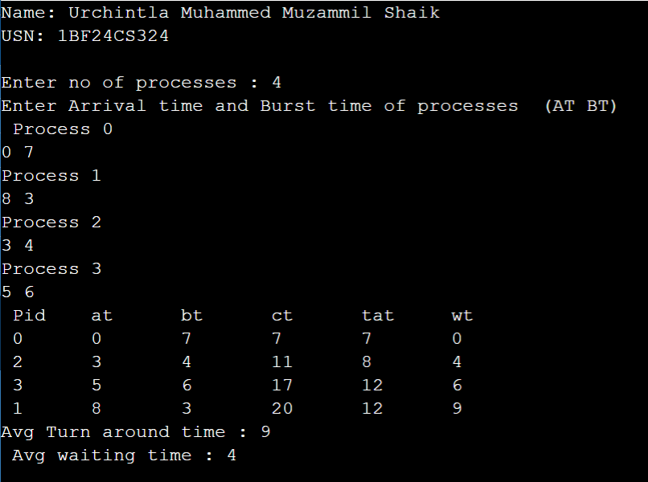

SJF(Non-preemptive):

#include<stdio.h>
int main()
{
printf("Name: Urchintla Muhammed Muzammil Shaik\nUSN: 1BF24CS324\n\n");
int p[100],at[100],bt[100],ct[100],tat[100],wt[100],rt[100],n,g[100],c=0,a=0,b=0,f[100]={0}, completed=0;
printf("Enter no of processes : ");
scanf("%d",&n);
for(int i=0;i<n;i++){
p[i]=i;
}
printf("Enter Arrival time and Burst time of processes (AT BT) \n ");
for(int j=0;j<n;j++){
printf("Process %d \n",j);
scanf("%d%d",&at[j],&bt[j]);
}
while(completed<n){
int Bursttime=1000,index=-1;
for(int i=0;i<n;i++){
if(f[i]==0 && at[i]<=c){
if (bt[i]<Bursttime){
Bursttime=bt[i];
index=i;
}
}
}
if(index==-1){
c++;
}
else{
int i=index;
ct[i]=c+bt[i];
tat[i]=ct[i]-at[i];
wt[i]=tat[i]-bt[i];
c=ct[i];
f[i]=1;
completed++;
}
}
printf(" Pid\tat\tbt\tct\ttat\twt\n");
for(int i=0;i<n;i++){
printf(" %d\t%d\t%d\t%d\t%d\t%d\n",p[i],at[i],bt[i],ct[i],tat[i],wt[i]);
}
for(int i=0;i<n;i++){
a=a+tat[i];
b=b+wt[i];
}
printf("Avg Turn around time : %d \n Avg waiting time : %d",a/n,b/n);
return 0;
}

Result:
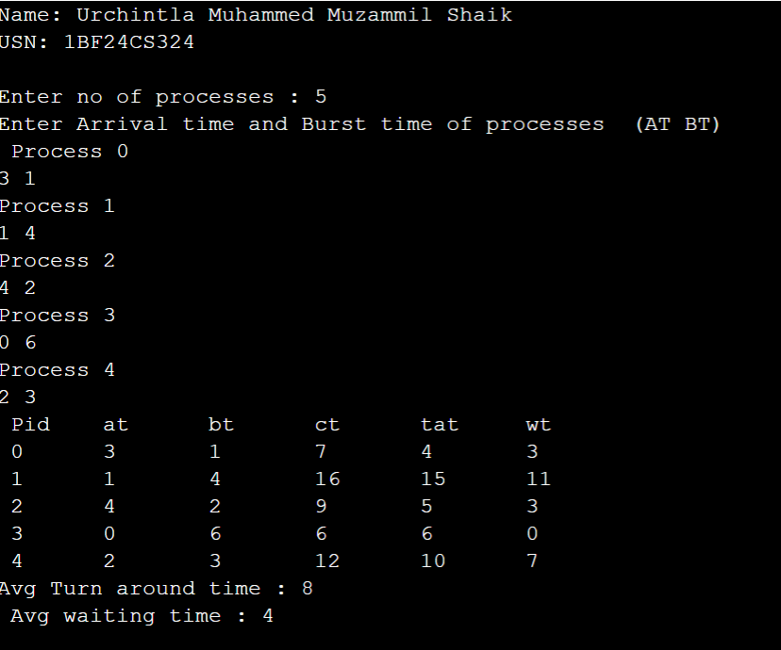

SJF(Preemptive):

#include<stdio.h>
int main()
{

int p[100],at[100],bt[100],ct[100],tat[100],wt[100],rt[100],n,g[100],c=0,a=0,b=0,f[100]={0},completed=0;
printf("Enter no of processes : ");
scanf("%d",&n);
for(int i=0;i<n;i++){
p[i]=i;
}
printf("Enter Arrival time and Burst time of processes (AT BT) \n ");
for(int j=0;j<n;j++){
printf("Process %d \n",j);
scanf("%d%d",&at[j],&bt[j]);
rt[j]=bt[j];
}
while(completed<n){
int Remainingtime=1000,index=-1;
for(int i=0;i<n;i++){
if(rt[i]>0 && at[i]<=c){
if (rt[i]<Remainingtime){
Remainingtime=rt[i];
index=i;
}
}
}
if(index==-1){
c++;
}
else{
int i=index;
rt[i]--;
c++;
if (rt[i]==0){
ct[i]=c;
tat[i]=ct[i]-at[i];
wt[i]=tat[i]-bt[i];
completed++;
}
}
}
printf(" Pid\tat\tbt\tct\ttat\twt\n");
for(int i=0;i<n;i++){
printf(" %d\t%d\t%d\t%d\t%d\t%d\n",p[i],at[i],bt[i],ct[i],tat[i],wt[i]);
}
for(int i=0;i<n;i++){
a=a+tat[i];
b=b+wt[i];
}
printf("Avg Turn around time : %d \n Avg waiting time : %d",a/n,b/n);
return 0;
}

Result:
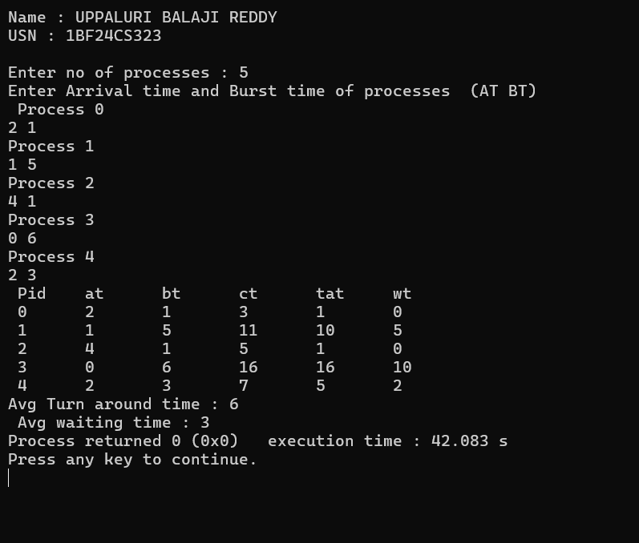

Priority Non-premptive:
#include<stdio.h>
int main()
{
printf("Lower number ,Higher Priority\n");
int p[100],at[100],bt[100],ct[100],tat[100],wt[100],comp[100]={0},n,c=0,a=0,b=0,pr[100],completed=0;
printf("Enter no of processes : ");
scanf("%d",&n);
for(int i=0;i<n;i++){
p[i]=i+1;
}
printf("Enter Arrival time,Burst and priority of processes (AT BT PR) \n ");
for(int j=0;j<n;j++){
printf("Process %d \n",j+1);
scanf("%d%d%d",&at[j],&bt[j],&pr[j]);
}
while(completed<n){
int hp=1000,index=-1;
for(int i=0;i<n;i++){
if(comp[i]==0 && at[i]<=c){
if (pr[i]<hp){
hp=pr[i];
index=i;
}
}
}
if(index==-1){
c++;
}
else{
int i=index;
ct[i]=c+bt[i];
tat[i]=ct[i]-at[i];
wt[i]=tat[i]-bt[i];
c=ct[i];
comp[i]=1;
completed++;
}
}
printf(" Pid\tat\tbt\tpr\tct\ttat\twt\n");
for(int i=0;i<n;i++){
printf(" %d\t%d\t%d\t%d\t%d\t%d\t%d\n",p[i],at[i],bt[i],pr[i],ct[i],tat[i],wt[i]);
}
for(int i=0;i<n;i++){
a=a+tat[i];
b=b+wt[i];
}

printf("Avg Turn around time : %f \n Avg waiting time : %f",(float)a/n,(float)b/n);
return 0;
}

Result:
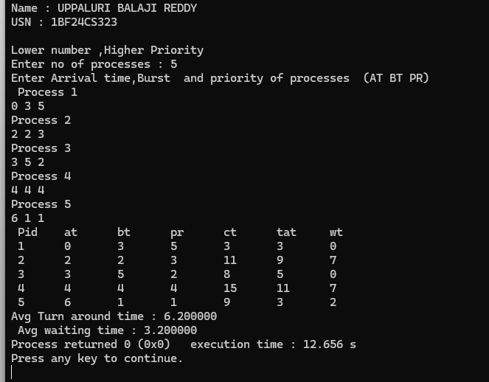

Priority premptive:
#include<stdio.h>
int main()
{
printf("\nLower number ,Higher Priority\n");
int p[100],at[100],bt[100],ct[100],tat[100],wt[100],n,c=0,a=0,b=0,pr[100],completed=0 ,rt[100];
printf("Enter no of processes : ");
scanf("%d",&n);
for(int i=0;i<n;i++){
p[i]=i+1;
}
printf("Enter Arrival time,Burst and priority of processes (AT BT PR) \n ");
for(int j=0;j<n;j++){
printf("Process %d \n",j+1);
scanf("%d%d%d",&at[j],&bt[j],&pr[j]);
rt[j]=bt[j];
}
while(completed<n){
int hp=1000,index=-1;
for(int i=0;i<n;i++){
if(rt[i]>0 && at[i]<=c){
if (pr[i]<hp){
hp=pr[i];
index=i;
}
}
}
if(index==-1){
c++;
}
else{
int i=index;
rt[i]--;
c++;
if (rt[i]==0){
ct[i]=c;
tat[i]=ct[i]-at[i];
wt[i]=tat[i]-bt[i];
completed++;
}
}
}
printf(" Pid\tat\tbt\tpr\tct\ttat\twt\n");
for(int i=0;i<n;i++){
printf(" %d\t%d\t%d\t%d\t%d\t%d\t%d\n",p[i],at[i],bt[i],pr[i],ct[i],tat[i],wt[i]);
}
for(int i=0;i<n;i++){
a=a+tat[i];
b=b+wt[i];
}
printf("Avg Turn around time : %f \n Avg waiting time : %f",(float)a/n,(float)b/n);
return 0;
}

Result: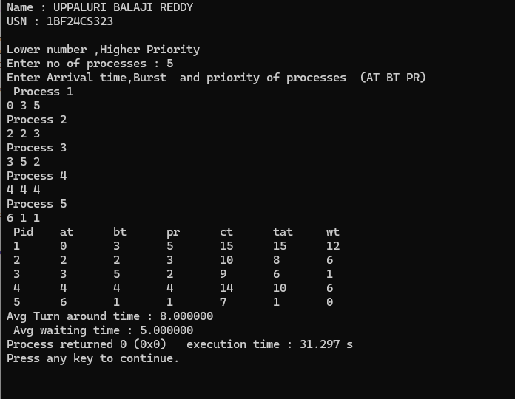

Round Robin:

#include <stdio.h>

int main() {
int n, tq;
int at[100], bt[100], rt[100];
int wt[100], tat[100], ct[100];
int queue[100], front = 0, rear = 0;
int visited[100] = {0};
int time = 0, completed = 0;

printf("Enter number of processes: ");
scanf("%d", &n);

printf("Enter Time Quantum: ");
scanf("%d", &tq);

printf("Enter Arrival time and Burst time of processes (AT BT) \n ");
for(int j=0;j<n;j++){
printf("Process %d \n",j+1);
scanf("%d%d",&at[j],&bt[j]);
rt[j]=bt[j];
}

for(int i = 0; i < n; i++) {
if(at[i] <= time && visited[i] == 0) {
queue[rear++] = i;
visited[i] = 1;
}
}

while(completed < n) {

if(front == rear) {
time++;
for(int i = 0; i < n; i++) {
if(at[i] <= time && visited[i] == 0) {
queue[rear++] = i;
visited[i] = 1;
}
}
continue;
}

int p = queue[front++];

if(rt[p] > tq) {
time += tq;
rt[p] -= tq;
} else {
time += rt[p];
rt[p] = 0;

ct[p] = time;
tat[p] = ct[p] - at[p];
wt[p] = tat[p] - bt[p];

completed++;
}

for(int i = 0; i < n; i++) {
if(at[i] <= time && visited[i] == 0) {
queue[rear++] = i;
visited[i] = 1;
}
}

if(rt[p] > 0) {
queue[rear++] = p;
}
}

float avg_wt = 0, avg_tat = 0;

printf("\nPID\tAT\tBT\tCT\tTAT\tWT\n");

for(int i = 0; i < n; i++) {
printf("%d\t%d\t%d\t%d\t%d\t%d\n",
i + 1, at[i], bt[i], ct[i], tat[i], wt[i]);

avg_wt += wt[i];
avg_tat += tat[i];
}

printf("\nAverage Waiting Time: %.2f", avg_wt / n);
printf("\nAverage Turnaround Time: %.2f\n", avg_tat / n);

return 0;
}

Result:
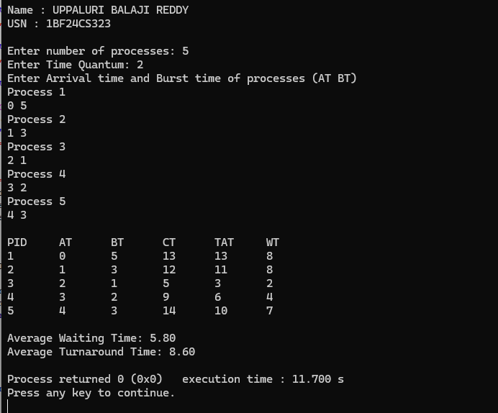

Program – 2
Question:

Write a C program to simulate multi-level queue scheduling algorithm considering the following scenario. All the processes in the system are divided into two categories – system processes and user processes. System processes are to be given higher priority than user processes. Use FCFS scheduling for the processes in each queue.
Code:
Multilevel queue scheduling:
#include <stdio.h>
struct Process {
int id;
int at;
int bt;
int ct;
int tat;
int wt;
int type;
int completed;
};
int main() {
int n, i;

int completed_count = 0;
int current_time = 0;
float total_wt = 0, total_tat = 0;
printf("Enter the total number of processes: ");
scanf("%d", &n);
struct Process p[n];
for (i = 0; i < n; i++) {
p[i].id = i + 1;
printf("\nProcess %d\n", p[i].id);
printf("Enter Arrival Time: ");
scanf("%d", &p[i].at);
printf("Enter Burst Time: ");
scanf("%d", &p[i].bt);
printf("Enter Process Type (1 for System, 2 for User): ");
scanf("%d", &p[i].type);
p[i].completed = 0;
}
while (completed_count < n) {
int selected_process = -1;
int highest_priority_type = 3;
int earliest_arrival = 999999;
for (i = 0; i < n; i++) {
if (p[i].completed == 0 && p[i].at <= current_time) {
if (p[i].type < highest_priority_type) {
highest_priority_type = p[i].type;
earliest_arrival = p[i].at;
selected_process = i;
}

else if (p[i].type == highest_priority_type && p[i].at < earliest_arrival) {
earliest_arrival = p[i].at;
selected_process = i;
}
}
}
if (selected_process != -1) {
current_time += p[selected_process].bt;
p[selected_process].ct = current_time;
p[selected_process].tat = p[selected_process].ct - p[selected_process].at;
p[selected_process].wt = p[selected_process].tat - p[selected_process].bt;
p[selected_process].completed = 1;
total_tat += p[selected_process].tat;
total_wt += p[selected_process].wt;
completed_count++;
} else {
current_time++;
}
}
printf("\n--- Scheduling Results ---\n");
printf("PID\tType\tAT\tBT\tCT\tTAT\tWT\n");
for (i = 0; i < n; i++) {
printf("%d\t%s\t%d\t%d\t%d\t%d\t%d\n",
p[i].id,
(p[i].type == 1 ? "SYS" : "USR"),
p[i].at, p[i].bt, p[i].ct, p[i].tat, p[i].wt);
}
printf("\nAverage Turnaround Time: %.2f\n", total_tat / n);
printf("Average Waiting Time: %.2f\n", total_wt / n);

return 0;
}

Result:
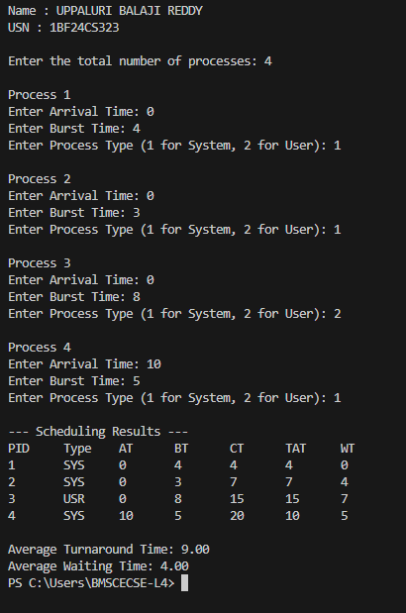

Program – 3
Question:

Write a C program to simulate Real-Time CPU Scheduling algorithms:
a)Rate- Monotonic
b)Earliest-deadline First
c)Proportional scheduling
Code:
Rate-Monotonic Scheduling:

#include <stdio.h>
#include <math.h>
int gcd(int a, int b) {
while (b) {
int t = b;
b = a % b;
a = t;
}
return a;
}
int lcm(int a, int b) {
return (a * b) / gcd(a, b);
}

int main() {

int n;
printf("Enter the number of processes:");
scanf("%d", &n);
int C[n], P[n];
printf("Enter the CPU burst times:\n");
for (int i = 0; i < n; i++)
scanf("%d", &C[i]);
printf("Enter the time periods:\n");
for (int i = 0; i < n; i++)
scanf("%d", &P[i]);
for (int i = 0; i < n - 1; i++) {
for (int j = i + 1; j < n; j++) {
if (P[i] > P[j]) {
int t;
t = P[i]; P[i] = P[j]; P[j] = t;
t = C[i]; C[i] = C[j]; C[j] = t;
}
}
}
int hp = P[0];
for (int i = 1; i < n; i++)
hp = lcm(hp, P[i]);

printf("LCM=%d\n\n", hp);
printf("Rate Monotone Scheduling:\n");
printf("PID Burst Period\n");
for (int i = 0; i < n; i++)
printf("%d %d %d\n", i + 1, C[i], P[i]);
float u = 0;
for (int i = 0; i < n; i++)
u += (float)C[i] / P[i];
float b = n * (pow(2, 1.0/n) - 1);
printf("\n%f <= %f =>%s\n", u, b, (u <= b) ? "true" : "false");
printf("Scheduling occurs for %d ms\n\n", hp);

int r[n];
for (int i = 0; i < n; i++)
r[i] = 0;

int prev = -2;
for (int t = 0; t < hp; t++) {
for (int i = 0; i < n; i++)
if (t % P[i] == 0)
r[i] = C[i];
int f = -1;
for (int i = 0; i < n; i++)
if (r[i] > 0) {
f = i;
break;
}
if (f != prev) {
if (f == -1)
printf("%dms onwards: CPU is idle\n", t);
else
printf("%dms onwards: Process %d running\n", t, f + 1);
prev = f;
}
if (f != -1)
r[f]--;
}
return 0;
}

Result:
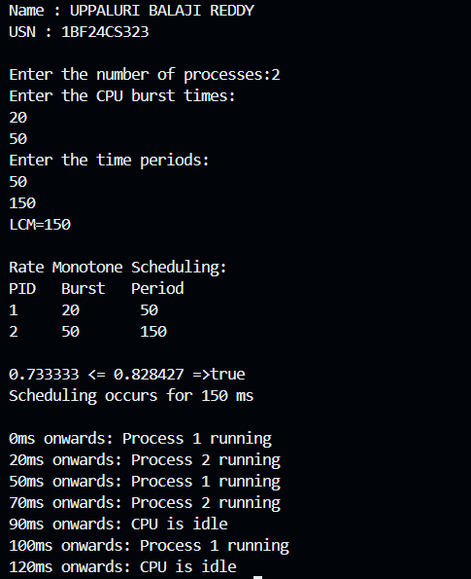

Earliest DeadLine First:

#include <stdio.h>

int gcd(int a, int b) {
while (b) {
int t = b;
b = a % b;
a = t;
}
return a;
}

int lcm(int a, int b) {
return (a * b) / gcd(a, b);
}

int main() {

int n;
printf("Enter the number of processes: ");
scanf("%d", &n);

int C[n], D[n], P[n], r[n];

printf("Enter capacities:\n");
for (int i = 0; i < n; i++) {
scanf("%d", &C[i]);
r[i] = 0;
}

printf("Enter deadlines:\n");
for (int i = 0; i < n; i++)
scanf("%d", &D[i]);
printf("Enter time periods:\n");
for (int i = 0; i < n; i++)
scanf("%d", &P[i]);
int hp = P[0];
for (int i = 1; i < n; i++)
hp = lcm(hp, P[i]);
printf("\nLCM=%d\n\n", hp);
printf("Earliest Deadline First Scheduling:\n");
printf("PID Capacity Deadline Period\n");
for (int i = 0; i < n; i++)
printf("%d %d %d %d\n", i + 1, C[i], D[i], P[i]);
float u = 0;
for (int i = 0; i < n; i++)
u += (float)C[i] / P[i];
printf("\nUtilization = %.6f\n", u);
if (u > 1.0)
printf("Warning: Utilization > 1, schedule may be infeasible.\n");
int time = 0, prev = -2;
printf("\nScheduling:\n");
while (time < hp) {
for (int i = 0; i < n; i++) {
if (time % P[i] == 0)
r[i] = C[i];
}
int min_deadline = 1000000;
int selected = -1;
for (int i = 0; i < n; i++) {
if (r[i] > 0) {
int instances = time / P[i];
int abs_deadline = instances * P[i] + D[i];
if (abs_deadline < min_deadline) {
min_deadline = abs_deadline;
selected = i;
}
}
}
if (selected != prev) {
if (selected == -1)
printf("%dms onwards: CPU is idle\n", time);
else
printf("%dms onwards: Process %d running\n", time, selected + 1);
prev = selected;
}
if (selected != -1)
r[selected]--;
time++;
}
printf("\nScheduling completed at %d ms\n", time);
return 0;
}

Result:
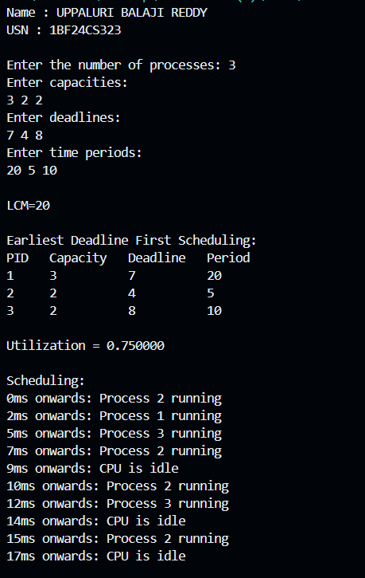

Program – 4
Question:

Write a C program to simulate
a) producer-consumer problem using semaphores
b)concept of Dining Philosophers problem.
Code:
Producer consumer problem:

#include <stdio.h>

int in = 0, out = 0;
int mutex = 1, Full = 0, Empty = 10;
int a[10];

void wait(int *s)
{
while (*s <= 0)
;
(*s)--;
}

void signal(int *s)
{
(*s)++;
}

int main()
{
int p, item,c=0;;

while (1)
{
printf("\n1: Produce\n2: Consume\n3: Exit\nEnter choice: ");
scanf("%d", &p);
if (p == 1)
{
wait(&Empty);
wait(&mutex);
printf("Enter number to produce: ");
scanf("%d", &item);
if(c==10){
printf("Over FLow");
}
a[in] = item;
in = (in + 1) % 10;
c++;
printf("Produced: %d\n", item);
signal(&mutex);
signal(&Full);
}
else if (p == 2)
{
wait(&Full);
wait(&mutex);
if(c==0){
printf("Under FLow");
}
item = a[out];
out = (out + 1) % 10;
printf("Consumed: %d\n", item);
c--;
signal(&mutex);
signal(&Empty);
}
else if (p == 3)
{
break;
}
else
{
printf("Invalid choice\n");
}
}
return 0;
}
Result:
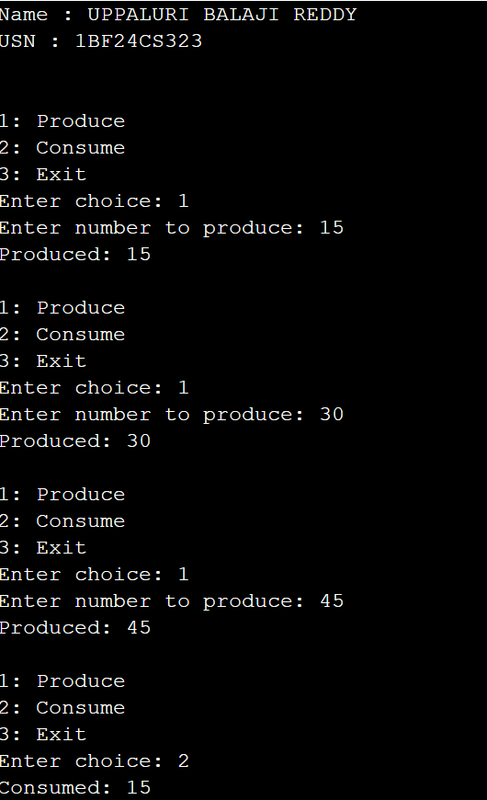

Dining Philosopher:

#include <stdio.h>
#include <pthread.h>
#include <unistd.h>

#define N 5

pthread_mutex_t forks[N];
pthread_t philosophers[N];

void *philosopher(void *num)
{
int id = *(int *)num;
int left = id;
int right = (id + 1) % N;
while (1)
{
printf("Philosopher %d is thinking\n", id);
sleep(1);
if (id % 2 == 0)
{
pthread_mutex_lock(&forks[left]);
printf("Philosopher %d picked up left fork %d\n", id, left);
pthread_mutex_lock(&forks[right]);
printf("Philosopher %d picked up right fork %d\n", id, right);
}
else
{
pthread_mutex_lock(&forks[right]);
printf("Philosopher %d picked up right fork %d\n", id, right);

pthread_mutex_lock(&forks[left]);
printf("Philosopher %d picked up left fork %d\n", id, left);
}
printf("Philosopher %d is eating\n", id);
sleep(2);
pthread_mutex_unlock(&forks[left]);
pthread_mutex_unlock(&forks[right]);
printf("Philosopher %d put down forks %d and %d\n",
id, left, right);
}
return NULL;
}

int main()
{
int i, ids[N];

for (i = 0; i < N; i++)
{
pthread_mutex_init(&forks[i], NULL);
ids[i] = i;
}
for (i = 0; i < N; i++)
{
pthread_create(&philosophers[i], NULL,
philosopher, &ids[i]);
}
for (i = 0; i < N; i++)
{
pthread_join(philosophers[i], NULL);
}

for (i = 0; i < N; i++)
{
pthread_mutex_destroy(&forks[i]);
}

return 0;
}

Result:
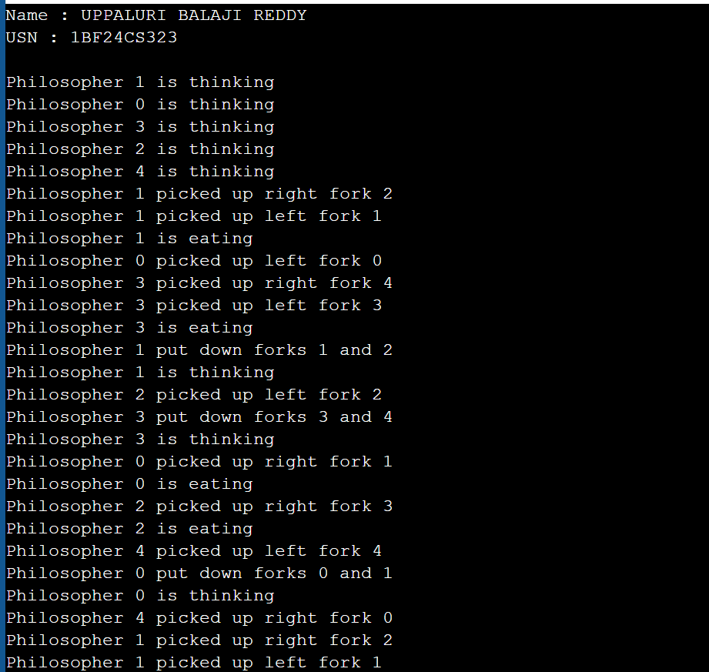

Program – 5
Question:

Write a C program to simulate
a)Bankers algorithm for the purpose of deadlock avoidance
b)Deadlock Detection
Code:
Banker’s Algorithm:

#include <stdio.h>

int main()
{
int n, m, i, j, k;
printf("Enter number of processes: ");
scanf("%d", &n);

printf("Enter number of resources: ");
scanf("%d", &m);

int alloc[n][m], max[n][m], need[n][m], avail[m];

printf("Enter Allocation Matrix:\n");
for(i = 0; i < n; i++)
{
for(j = 0; j < m; j++)
{
scanf("%d", &alloc[i][j]);
}
}

printf("Enter Max Matrix:\n");
for(i = 0; i < n; i++)
{
for(j = 0; j < m; j++)
{
scanf("%d", &max[i][j]);
}
}

printf("Enter Available Resources:\n");
for(i = 0; i < m; i++)
{
scanf("%d", &avail[i]);
}

for(i = 0; i < n; i++)
{
for(j = 0; j < m; j++)
{
need[i][j] = max[i][j] - alloc[i][j];
}
}

int finish[n], safeSeq[n], work[m];
int count = 0;

for(i = 0; i < m; i++)
work[i] = avail[i];

for(i = 0; i < n; i++)
finish[i] = 0;

while(count < n)
{
int found = 0;

for(i = 0; i < n; i++)
{
if(finish[i] == 0)
{
for(j = 0; j < m; j++)
{
if(need[i][j] > work[j])
break;
}

if(j == m)
{
for(k = 0; k < m; k++)
work[k] += alloc[i][k];

safeSeq[count++] = i;
finish[i] = 1;
found = 1;
}
}
}

if(found == 0)
{
printf("\nSystem is not in a safe state.\n");
return 0;
}
}

printf("\nSystem is in a safe state.\n");
printf("Safe Sequence: ");

for(i = 0; i < n; i++)
{
printf("P%d", safeSeq[i]);
if(i != n - 1)
printf(" -> ");
}

printf("\n");

return 0;
}

Result:
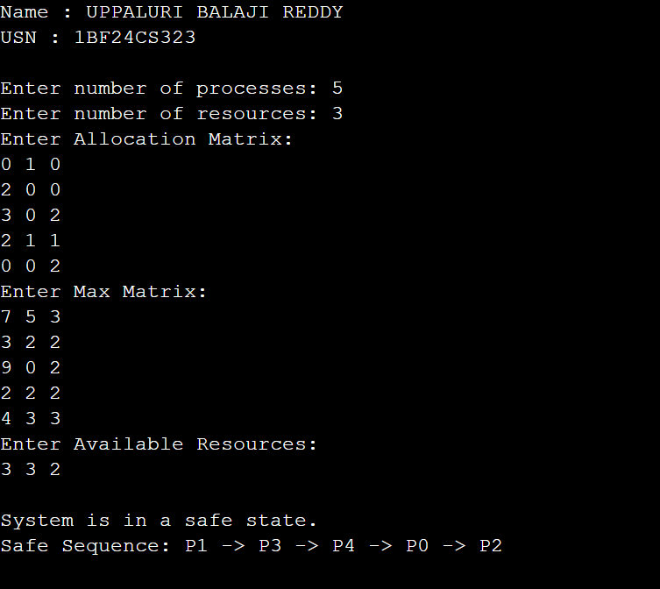

DeadLock Detetion:

#include <stdio.h>

int main()
{
int n, m, i, j, k;
printf("Enter number of resources: ");
scanf("%d", &m);

printf("Enter number of processes: ");
scanf("%d", &n);

int alloc[n][m], req[n][m], avail[m];
int finish[n], work[m], safeSeq[n];
int count = 0;

printf("Enter Allocation Matrix:\n");
for(i = 0; i < n; i++)
{
for(j = 0; j < m; j++)
{
scanf("%d", &alloc[i][j]);
}
}

printf("Enter Request Matrix:\n");
for(i = 0; i < n; i++)
{
for(j = 0; j < m; j++)
{
scanf("%d", &req[i][j]);
}
}

printf("Enter Available Resources:\n");
for(i = 0; i < m; i++)
{
scanf("%d", &avail[i]);
}

for(i = 0; i < n; i++)
finish[i] = 0;

for(i = 0; i < m; i++)
work[i] = avail[i];

while(count < n)
{
int found = 0;

for(i = 0; i < n; i++)
{
if(finish[i] == 0)
{
int flag = 1;

for(j = 0; j < m; j++)
{
if(req[i][j] > work[j])
{
flag = 0;
break;
}
}

if(flag)
{
for(k = 0; k < m; k++)
{
work[k] += alloc[i][k];
}

finish[i] = 1;
safeSeq[count++] = i;
found = 1;
}
}
}

if(found == 0)
break;
}

if(count == n)
{
printf("\nSystem is in safe state\n");
printf("Safe Sequence: ");

for(i = 0; i < n; i++)
{
printf("P%d", safeSeq[i]);

if(i != n - 1)
printf(" -> ");
}
}
else
{
printf("\nDeadlock detected!\n");
printf("Processes in deadlock are: ");

for(i = 0; i < n; i++)
{
if(finish[i] == 0)
printf("P%d ", i);
}
}

return 0;
}

Result:
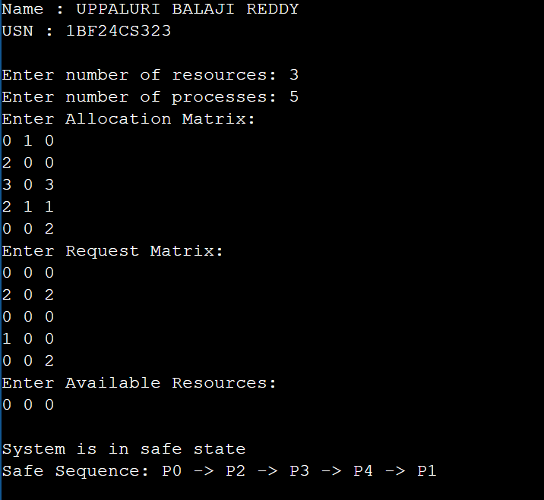

Program – 6
Question:

Write a C program to simulate the following contiguous memory allocation techniques.
a) Worst-fit
b) Best-fit
c) First-fit
Code:
Continuous Memory Allocation:

#include <stdio.h>

void firstFit(int bs[], int b, int ps[], int p)
{
int a[p];
int u[b];

for(int i = 0; i < p; i++)
a[i] = -1;

for(int i = 0; i < b; i++)
u[i] = 0;

for(int i = 0; i < p; i++)
{
for(int j = 0; j < b; j++)
{
if(!u[j] && bs[j] >= ps[i])
{
a[i] = j;
u[j] = 1;
break;
}
}
}

printf("\nFirst Fit\n");
printf("Process\tSize\tBlock\n");

for(int i = 0; i < p; i++)
{
printf("P%d\t%d\t", i + 1, ps[i]);

if(a[i] != -1)
printf("%d\n", a[i] + 1);
else
printf("Not Allocated\n");
}
}

void bestFit(int bs[], int b, int ps[], int p)
{
int a[p];
int u[b];

for(int i = 0; i < p; i++)
a[i] = -1;

for(int i = 0; i < b; i++)
u[i] = 0;

for(int i = 0; i < p; i++)
{
int bestIdx = -1;

for(int j = 0; j < b; j++)
{
if(!u[j] && bs[j] >= ps[i])
{
if(bestIdx == -1 || bs[j] < bs[bestIdx])
bestIdx = j;
}
}

if(bestIdx != -1)
{
a[i] = bestIdx;
u[bestIdx] = 1;
}
}

printf("\nBest Fit\n");
printf("Process\tSize\tBlock\n");
for(int i = 0; i < p; i++)
{
printf("P%d\t%d\t", i + 1, ps[i]);

if(a[i] != -1)
printf("%d\n", a[i] + 1);
else
printf("Not Allocated\n");
}
}

void worstFit(int bs[], int b, int ps[], int p)
{
int a[p];
int u[b];

for(int i = 0; i < p; i++)
a[i] = -1;

for(int i = 0; i < b; i++)
u[i] = 0;
for(int i = 0; i < p; i++)
{
int worstIdx = -1;

for(int j = 0; j < b; j++)
{
if(!u[j] && bs[j] >= ps[i])
{
if(worstIdx == -1 || bs[j] > bs[worstIdx])
worstIdx = j;
}
}
if(worstIdx != -1)
{
a[i] = worstIdx;
u[worstIdx] = 1;
}
}
printf("\nWorst Fit\n");
printf("Process\tSize\tBlock\n");
for(int i = 0; i < p; i++)
{
printf("P%d\t%d\t", i + 1, ps[i]);

if(a[i] != -1)
printf("%d\n", a[i] + 1);
else
printf("Not Allocated\n");
}
}
int main()
{
int blocks, processes;
printf("Enter number of blocks: ");
scanf("%d", &blocks);
int blockSize[blocks];
printf("Enter block sizes:\n");
for(int i = 0; i < blocks; i++)
scanf("%d", &blockSize[i]);
printf("Enter number of processes: ");
scanf("%d", &processes);

int processSize[processes];
printf("Enter process sizes:\n");
for(int i = 0; i < processes; i++)
scanf("%d", &processSize[i]);
firstFit(blockSize, blocks, processSize, processes);
bestFit(blockSize, blocks, processSize, processes);
worstFit(blockSize, blocks, processSize, processes);
return 0;
}

Result:
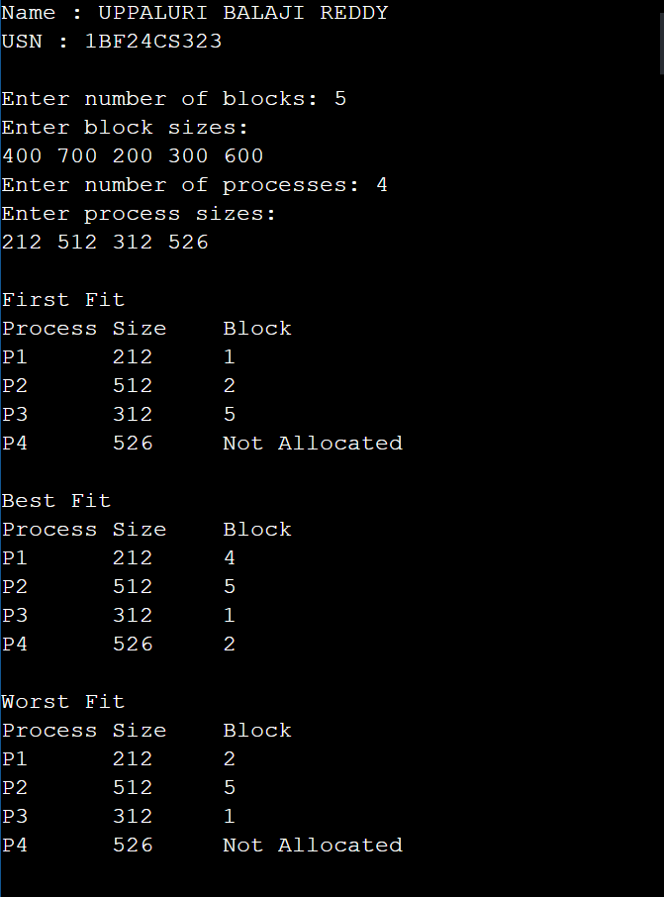

Program – 7
Question:

Write a C program to simulate page replacement algorithms.
a) FIFO
b)LRU
c)Optimal
Code:
Page Replacement Algorithms:
#include <stdio.h>

void simulate(int p[], int n, int c, int mode)
{
int f[20], faults = 0, next_fifo = 0;
int last_used[20];

for(int i = 0; i < c; i++)
{
f[i] = -1;
last_used[i] = 0;
}

printf("\n%s Page Replacement:\n",
mode == 0 ? "FIFO" :
mode == 1 ? "Optimal" : "LRU");

for(int i = 0; i < n; i++)
{
int found = -1, empty = -1;

for(int j = 0; j < c; j++)
{
if(f[j] == p[i])
found = j;

if(f[j] == -1 && empty == -1)
empty = j;
}

if(found != -1)
{
if(mode == 2)
last_used[found] = i;
}
else
{
faults++;

int rep = empty;

if(rep == -1)
{
if(mode == 0) /* FIFO */
{
rep = next_fifo;
next_fifo = (next_fifo + 1) % c;
}
else if(mode == 1) /* Optimal */
{
int farthest = -1;
rep = 0;

for(int j = 0; j < c; j++)
{
int next_use = 9999;

for(int k = i + 1; k < n; k++)
{
if(f[j] == p[k])
{
next_use = k;
break;
}
}

if(next_use > farthest)
{
farthest = next_use;
rep = j;
}
}
}
else /* LRU */
{
rep = 0;

for(int j = 1; j < c; j++)
{
if(last_used[j] < last_used[rep])
rep = j;
}
}
}

f[rep] = p[i];

if(mode == 2)
last_used[rep] = i;
}

printf("Page %d -> ", p[i]);

for(int j = 0; j < c; j++)
{
if(f[j] == -1)
printf("- ");
else
printf("%d ", f[j]);
}

if(found == -1)
printf("(Fault)");

printf("\n");
}

printf("Total Page Faults: %d\n", faults);
}

int main()
{
int p[50], n, frames;
printf("Enter number of pages: ");
scanf("%d", &n);

printf("Enter reference string:\n");
for(int i = 0; i < n; i++)
scanf("%d", &p[i]);

printf("Enter number of frames: ");
scanf("%d", &frames);

for(int m = 0; m < 3; m++)
simulate(p, n, frames, m);

return 0;
}

Result:
