OpenShift HPA, Container & Pod Communication Guide
Horizontal Pod Autoscaler, Container-to-Container & Pod-to-Pod Networking

1. Horizontal Pod Autoscaler (HPA)
HPA automatically scales the number of Pods in a Deployment, ReplicaSet, or StatefulSet based on observed CPU utilization, memory usage, or custom metrics. It ensures applications can handle varying loads without manual intervention.
Key characteristics of HPA:
- Scales Pods horizontally (adds/removes Pod replicas)
- Works with Deployments, ReplicaSets, and StatefulSets
- Uses metrics from the Metrics Server (CPU / Memory)
- Can use custom metrics via Prometheus Adapter
- Requires resource requests (cpu / memory) to be defined on containers

1.1 HPA YAML Example
The following HPA scales a generic app deployment between 1 and 10 replicas based on CPU and memory usage:
apiVersion: autoscaling/v2
kind: HorizontalPodAutoscaler
metadata:
name: app-hpa
spec:
scaleTargetRef:
apiVersion: apps/v1
kind: Deployment
name: myapp
minReplicas: 1
maxReplicas: 10
metrics:
- type: Resource
resource:
name: cpu
target:
type: Utilization
averageUtilization: 50
- type: Resource
resource:
name: memory
target:
type: Utilization
averageUtilization: 70
Note: HPA requires the Metrics Server to be running in the cluster to collect CPU and memory metrics from Pods.

1.2 HPA Commands
oc apply -f hpa.yaml
oc get hpa
oc describe hpa app-hpa
oc autoscale deployment myapp --min=1 --max=10 --cpu-percent=50
oc delete hpa app-hpa
Tip: Always set resource requests and limits on your containers. HPA cannot scale without them.

1.3 HPA Workflow
- Create Deployment with resource requests/limits defined
- Create HPA targeting the Deployment
- HPA monitors metrics from Metrics Server
- When CPU > 50%, HPA increases replicas (up to maxReplicas)
- When CPU < 50%, HPA decreases replicas (down to minReplicas)
- Verify with: oc get hpa, oc get deployment, oc get pods

2. Container-to-Container Communication
In Kubernetes / OpenShift, a Pod can contain multiple containers. All containers within the same Pod share the same Network Namespace. This means they can communicate with each other using localhost and share the same IP address. They can also share volumes via emptyDir or mounted volumes.
Key points:
- Containers in the same Pod share the same IP address and port space
- Communication happens via localhost:<port> (not via Service)
- They share the same loopback interface (127.0.0.1)
- Volumes can be shared between containers in the same Pod
- Use multi-container Pods for tightly coupled helper processes (e.g., sidecar pattern)
Note: It is generally NOT recommended to run an application and its database in the same Pod. They should be in separate Pods for independent scaling and management. The example below is for demonstration only.

2.1 Diagram: Container-to-Container Communication
The diagram below shows two containers (WordPress and MySQL) running inside a single Pod, sharing the same network namespace:
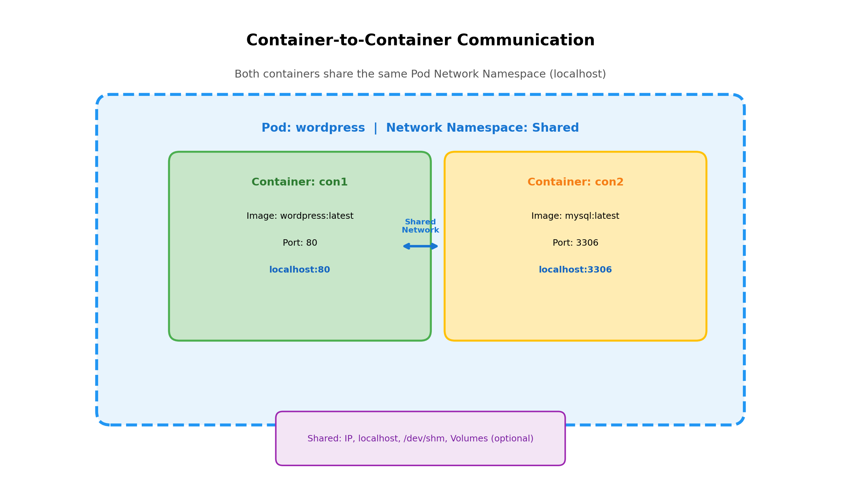

2.2 YAML: Multi-Container Pod
The following YAML creates a single Pod with two containers that communicate via localhost:
apiVersion: v1
kind: Pod
metadata:
labels:
app: wordpress
name: wordpress
spec:
containers:
- name: con1
image: wordpress:latest
ports:
- containerPort: 80
resources:
requests:
memory: 64Mi
cpu: 100m
limits:
memory: 512Mi
cpu: 1000m
- name: con2
image: mysql:latest
ports:
- containerPort: 3306
env:
- name: MYSQL_ROOT_PASSWORD
value: test123
- name: MYSQL_DATABASE
value: wordpress
---
apiVersion: v1
kind: Service
metadata:
name: wordpress-svc
spec:
selector:
app: wordpress
ports:
- port: 80
protocol: TCP
targetPort: 80
---
apiVersion: route.openshift.io/v1
kind: Route
metadata:
name: wordpress
spec:
port:
targetPort: 80
to:
kind: ""
name: wordpress-svc
weight: null

2.3 How It Works
- Container con1 (WordPress) listens on localhost:80
- Container con2 (MySQL) listens on localhost:3306
- WordPress connects to MySQL using localhost:3306 (same Pod)
- The Service wordpress-svc exposes the WordPress container externally on port 80
- The Route wordpress exposes the Service to external users
oc apply -f multi-container-pod.yaml
oc get pods
oc describe pod wordpress
oc logs wordpress -c con1
oc logs wordpress -c con2
oc exec -it wordpress -c con1 -- /bin/bash
oc exec -it wordpress -c con2 -- mysql -u root -p

3. Pod-to-Pod Communication via Service
In Kubernetes / OpenShift, Pods are ephemeral — their IPs change when they are recreated. Services provide a stable network endpoint (DNS name + ClusterIP) that routes traffic to a set of Pods matching a label selector. This enables reliable Pod-to-Pod communication.
Key points:
- Each Pod gets its own unique IP address within the cluster
- Services provide a stable DNS name and ClusterIP for a group of Pods
- Services use label selectors to find target Pods (Endpoints)
- Pods communicate with other Pods via Service DNS name (e.g., mydb-svc)
- OpenShift Routes expose Services to external traffic

3.1 Diagram: Pod-to-Pod Communication (WordPress + MySQL)
The diagram below shows WordPress Pod connecting to MySQL Pod through the mydb-svc Service, and external access via Route:
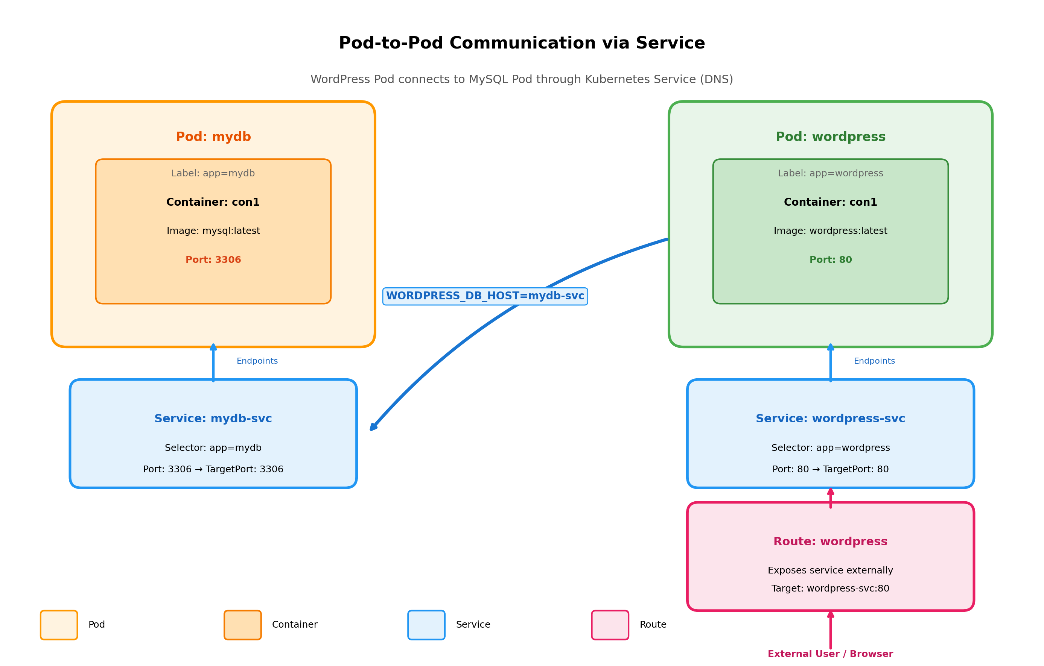

3.2 YAML: MySQL Pod + Service
apiVersion: v1
kind: Pod
metadata:
labels:
app: mydb
name: mydb
spec:
containers:
- name: con1
image: mysql:latest
ports:
- containerPort: 3306
env:
- name: MYSQL_ROOT_PASSWORD
value: test123
- name: MYSQL_DATABASE
value: wordpress
---
apiVersion: v1
kind: Service
metadata:
name: mydb-svc
spec:
selector:
app: mydb
ports:
- port: 3306
protocol: TCP
targetPort: 3306

3.3 YAML: WordPress Pod + Service + Route
apiVersion: v1
kind: Pod
metadata:
labels:
app: wordpress
name: wordpress
spec:
containers:
- name: con1
image: wordpress:latest
ports:
- containerPort: 80
env:
- name: WORDPRESS_DB_HOST
value: mydb-svc
- name: WORDPRESS_DB_USER
value: root
- name: WORDPRESS_DB_PASSWORD
value: test123
- name: WORDPRESS_DB_NAME
value: wordpress
- name: WORDPRESS_TABLE_PREFIX
value: wp_
---
apiVersion: v1
kind: Service
metadata:
name: wordpress-svc
spec:
selector:
app: wordpress
ports:
- port: 80
protocol: TCP
targetPort: 80
---
apiVersion: route.openshift.io/v1
kind: Route
metadata:
name: wordpress
spec:
port:
targetPort: 80
to:
kind: ""
name: wordpress-svc
weight: null

3.4 How It Works
- MySQL Pod (mydb) runs with label app=mydb and exposes port 3306
- mydb-svc Service selects Pods with label app=mydb and exposes port 3306
- WordPress Pod connects to MySQL using the Service DNS name: WORDPRESS_DB_HOST=mydb-svc
- The Service routes traffic to the MySQL Pod regardless of its actual IP
- wordpress-svc Service exposes the WordPress Pod internally on port 80
- The Route exposes wordpress-svc to external users via a public URL
oc apply -f mysql-pod.yaml
oc apply -f wordpress-pod.yaml
oc get pods -o wide
oc get svc
oc get endpoints mydb-svc
oc get endpoints wordpress-svc
oc get route
oc describe svc mydb-svc
oc describe svc wordpress-svc

4. Pod → Service → Route Communication Flow
This section explains the layered networking approach in OpenShift: Pod provides the application, Service provides stable internal access, and Route provides external access.

4.1 Diagram: Simple Communication Flow
The diagram below illustrates the three-layer flow from external user to application Pod:
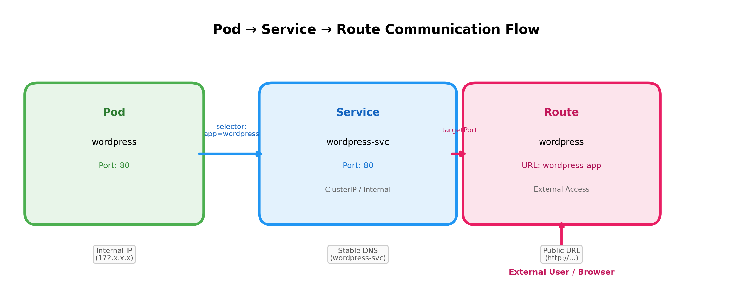

4.2 Explanation of Each Layer
Pod Layer: The actual application container running inside OpenShift. It has an ephemeral internal IP and exposes a containerPort. Other Pods or Services can reach it only through its containerPort.
Service Layer: Acts as an internal load balancer and provides a stable DNS name + ClusterIP. It uses label selectors to find target Pods (Endpoints). Even if a Pod is recreated with a new IP, the Service DNS remains unchanged.
Route Layer: OpenShift-specific resource that exposes a Service to external traffic. It creates a public URL (hostname) that routes HTTP/HTTPS traffic to the target Service. Routes are the OpenShift equivalent of Kubernetes Ingress.

4.3 Traffic Flow Summary
- External User sends request to Route URL (e.g., http://wordpress-app.apps.cluster.com)
- OpenShift Router (HAProxy) receives the request and forwards it to the target Service
- Service (wordpress-svc) receives traffic on port 80 and load-balances to matching Pods
- Pod (wordpress) receives traffic on containerPort 80 and processes the request
- WordPress application connects to mydb-svc:3306 to reach the MySQL database
- mydb-svc routes the database request to the MySQL Pod on port 3306
Tip: In production, use Deployments instead of standalone Pods, and use Secrets for sensitive data like passwords instead of plain env values.

5. Comparison: Container-to-Container vs Pod-to-Pod
Aspect | Container-to-Container (Same Pod) | Pod-to-Pod (Different Pods)
Network | Shared Network Namespace | Separate Network Namespaces
IP Address | Same IP for all containers | Unique IP per Pod
Communication | localhost:<port> | <service-name>:<port> or <pod-ip>:<port>
Lifecycle | Tied together (same Pod) | Independent (separate Pods)
Scaling | Cannot scale independently | Scale independently via Deployment
Use Case | Sidecars, init helpers, tight coupling | App + Database, microservices
Example | WordPress + MySQL in same Pod | WordPress Pod + MySQL Pod via Service

6. Complete Commands Summary

6.1 HPA Commands
oc apply -f hpa.yaml
oc get hpa
oc describe hpa app-hpa
oc autoscale deployment myapp --min=1 --max=10 --cpu-percent=50
oc delete hpa app-hpa

6.2 Multi-Container Pod Commands
oc apply -f multi-container-pod.yaml
oc get pods
oc describe pod wordpress
oc logs wordpress -c con1
oc logs wordpress -c con2
oc exec -it wordpress -c con1 -- /bin/bash
oc get svc wordpress-svc
oc get route wordpress

6.3 Pod-to-Pod Communication Commands
oc apply -f mysql-pod.yaml
oc apply -f wordpress-pod.yaml
oc get pods -o wide
oc get svc
oc get endpoints mydb-svc
oc get endpoints wordpress-svc
oc get route
oc describe svc mydb-svc
oc describe svc wordpress-svc
oc exec -it wordpress -- env | grep WORDPRESS

— End of Document —

