Heart Disease Risk Prediction
End-to-End MLOps Pipeline
Machine Learning Operations (MLOps) AIMLCZG523 - Assignment 01
Student: Aneesh Kumar M /2025ae05593
Repository: https://github.com/aneeshkumar520-hub/my-lab/tree/main/heart-disease-mlops

1. Introduction
This project builds a classifier that predicts the presence of heart disease from 13 routine clinical measurements (UCI Heart Disease, Cleveland subset) and delivers it the way a production team would: reproducible data and training code, tracked experiments, automated tests and CI, a Docker image, Kubernetes manifests and Prometheus/Grafana monitoring. The emphasis is on the engineering around the model rather than on squeezing the last point of accuracy out of 302 patients.
Key results. The selected model is a logistic-regression pipeline with a hold-out ROC-AUC of 0.918 (accuracy 0.836, precision 0.846, recall 0.786) and a nested cross-validated ROC-AUC of 0.907 +/- 0.039. The service passes 38 automated tests (78% line coverage), reproduces from a fresh virtual environment using only requirements-dev.txt, and exposes /predict with prediction and confidence.
Honest scope note. The model is for education, not clinical use; the test set has only 61 patients so reported test metrics have wide uncertainty (roughly +/- 0.1 on accuracy).
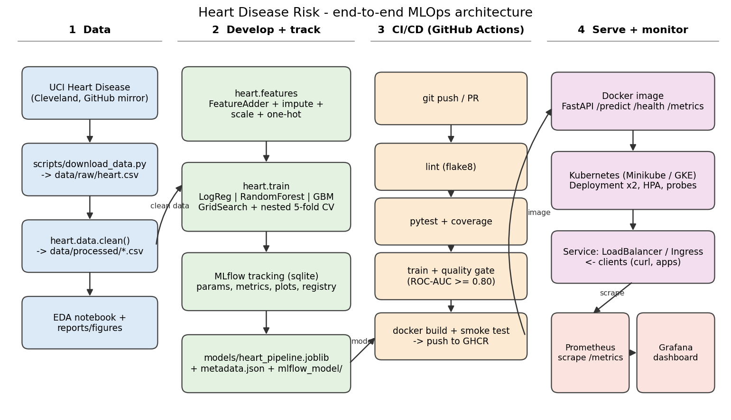
Figure 1 - End-to-end architecture: data, development/tracking, CI/CD and serving/monitoring.

2. Setup and installation
git clone https://github.com/<your-username>/heart-disease-mlops.git && cd heart-disease-mlops
python3 -m venv .venv && source .venv/bin/activate # Python 3.12
pip install -r requirements-dev.txt
export PYTHONPATH=src
python scripts/download_data.py # data/raw/heart.csv (copy committed)
python -m heart.data # cleaned dataset -> data/processed/
python -m heart.train # tune, evaluate, log to MLflow, save models/
pytest --cov=src/heart && flake8 src tests scripts
uvicorn heart.api:app --port 8000 # or: docker build -t heart-disease-api:1.0.0 .

Dependencies are pinned in requirements.txt (training) and requirements-serve.txt (slim inference image without MLflow/plotting libraries). To verify reproducibility, a pristine copy of the repository without any generated artefacts was installed into a new virtualenv and the whole flow (download, clean, train, test) was executed successfully (Figure 2).
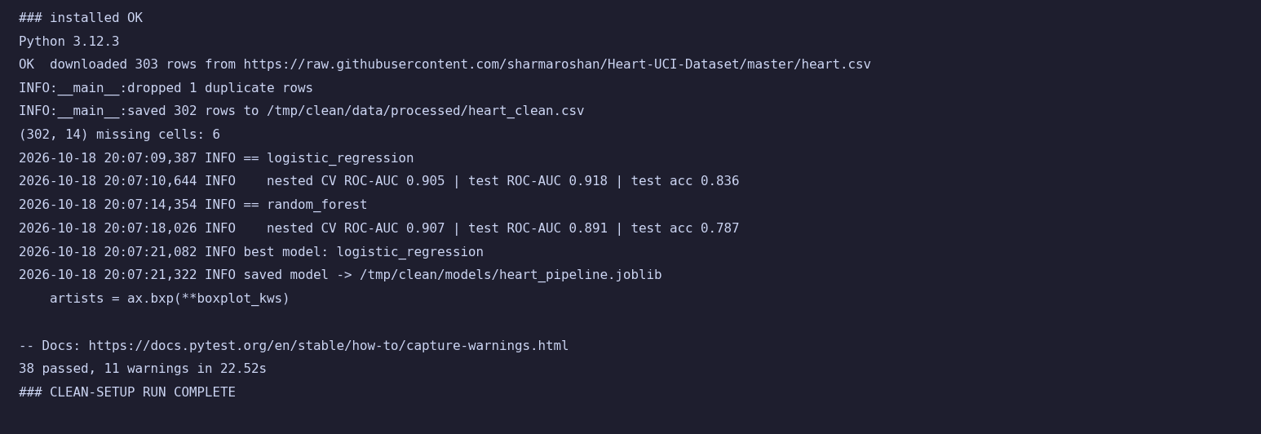
Figure 2 - Terminal output of the clean-environment run (real output; text rendered as an image).

3. Data acquisition, cleaning and EDA
Source. The UCI Machine Learning Repository host was not reachable from the build environment, so scripts/download_data.py downloads the widely mirrored 14-column CSV of the same Cleveland data from GitHub (with a second mirror as fallback and content validation). The README explains the official UCI route and its different coding.
Cleaning (heart.data.clean): (i) schema validation; (ii) numeric coercion; (iii) invalid category codes (ca = 4, thal = 0) become missing; (iv) one exact duplicate removed; (v) target inversion. In this mirror target = 1 encodes absence of disease: those patients have a higher maximum heart rate and less exercise angina, and the class counts match UCI's 164 healthy / 139 diseased. After cleaning, 1 = disease present. Result: 302 patients, 164 negative / 138 positive, and 6 missing cells (4 in ca, 2 in thal) - exactly UCI's documented missing values. Missing values are imputed inside the model pipeline so that statistics come only from training folds.
Feature group | Columns | Treatment
Continuous | age, trestbps, chol, thalach, oldpeak | median imputation, standard scaling
Engineered | pct_max_hr = thalach/(220-age); st_depression_with_angina = oldpeak x exang | as continuous
Categorical | sex, cp, fbs, restecg, exang, slope, ca, thal | most-frequent imputation, one-hot (unknown ignored)

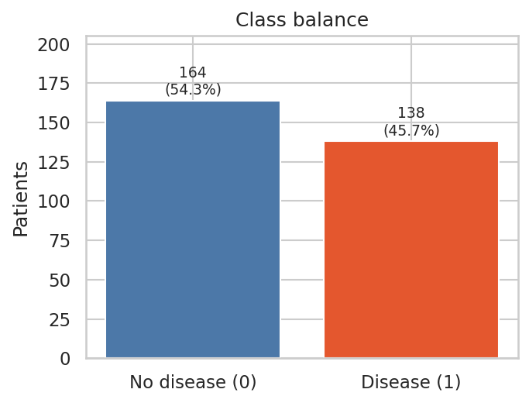
Figure 3 - Class balance (54% / 46%): near-balanced, so accuracy is meaningful; recall and ROC-AUC are reported too.
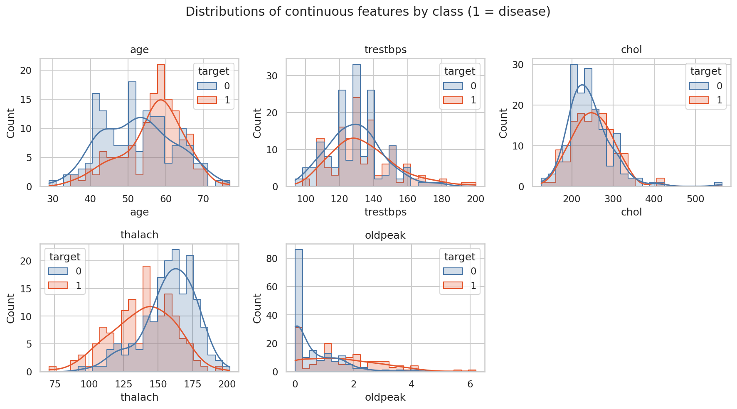
Figure 4 - Continuous features by class. Disease cases are older, reach a lower maximum heart rate and show larger ST depression.
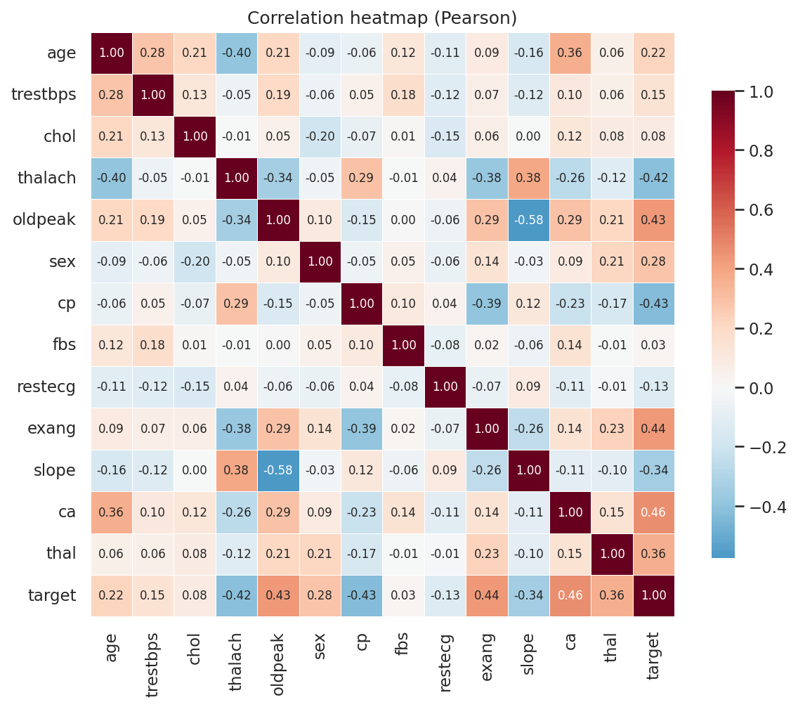
Figure 5 - Correlation heatmap. Strongest links to the target: ca (+0.46), exang (+0.44), cp (-0.43), oldpeak (+0.43), thalach (-0.42); no predictor pair above |r| = 0.58, so no feature was dropped.
Other observations. cp = 0 covers 47% of patients and 73% of them have disease (18-30% for other codes); exercise angina raises the disease rate from 31% to 77%. Cholesterol above 400 mg/dl and oldpeak above 5 are rare but plausible, so they were kept (scaling and the chosen models tolerate them).

4. Feature engineering and model development
All preprocessing and the estimator live in a single scikit-learn Pipeline, guaranteeing identical transformations in training, cross-validation, notebooks, the API and the container. Data were split 80/20 (stratified, seed 42): 241 training and 61 test patients. Three classifiers were compared, each tuned with grid search (5-fold stratified, ROC-AUC):
Model | Hyper-parameter grid
Logistic regression | C in {0.01, 0.1, 0.5, 1, 5, 10}; class_weight in {None, balanced} (12 combinations)
Random forest | n_estimators {100, 300}; max_depth {3, 5, None}; min_samples_leaf {1, 3, 5} (18)
Gradient boosting | n_estimators {50, 100, 200}; learning_rate {0.03, 0.1}; max_depth {2, 3} (12)

Evaluation protocol. To avoid optimistic estimates from tuning on the same folds, performance was estimated with nested cross-validation (3-fold inner search inside a 5-fold outer loop) on the training split using accuracy, precision, recall, F1 and ROC-AUC; each tuned model was then scored once on the hold-out test set.
Model | CV ROC-AUC | CV accuracy | CV recall | Test ROC-AUC | Test acc. | Test recall
Logistic regression (selected) | 0.907 +/- 0.039 | 0.846 | 0.809 | 0.918 | 0.836 | 0.786
Random forest | 0.910 +/- 0.036 | 0.830 | 0.791 | 0.894 | 0.787 | 0.679
Gradient boosting | 0.900 +/- 0.030 | 0.830 | 0.809 | 0.879 | 0.770 | 0.643

Model selection. The three CV ROC-AUC values differ by 0.01, well within the fold-to-fold standard deviation (0.03-0.04), so choosing the nominal winner (random forest, 0.910) would mean choosing noise. I therefore applied the one-standard-error rule: among models within one SD of the best CV score, take the simplest. This rule uses CV results only - the test set played no part in the decision. Logistic regression is selected; it is also the most interpretable and had the best CV accuracy and F1. Best parameters and all metrics are stored in models/metadata.json.
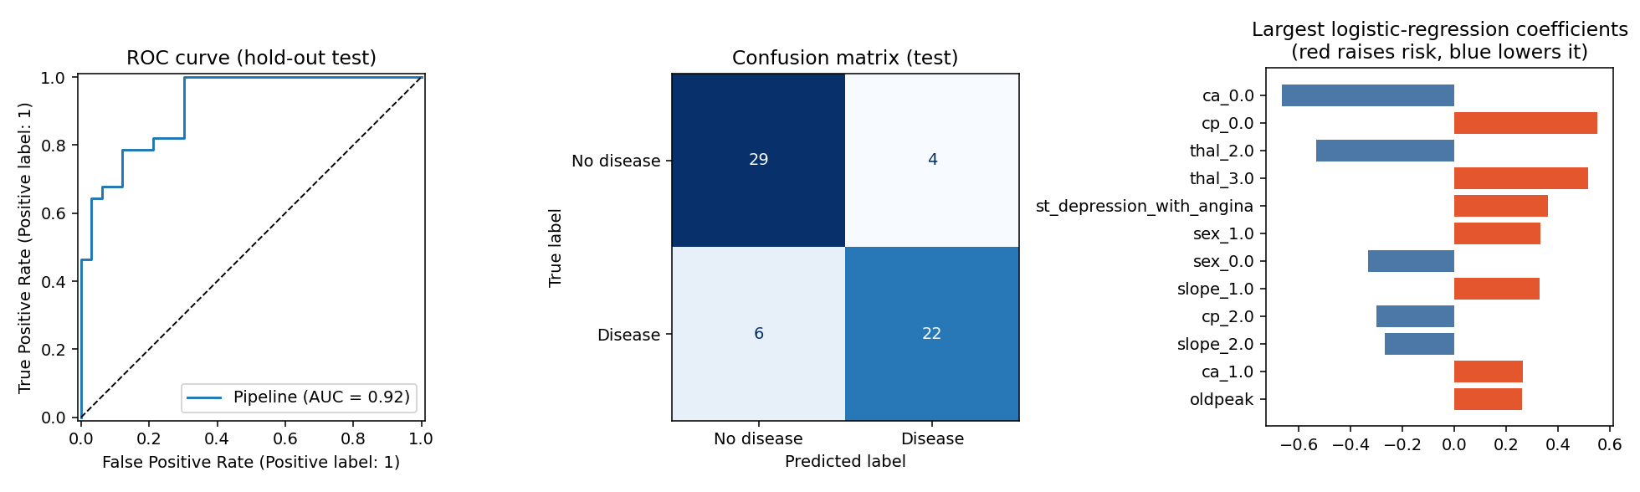
Figure 6 - Selected model on the hold-out test set: ROC curve, confusion matrix and the largest coefficients.
Limitations. With 61 test patients, one extra error moves accuracy by 1.6 points. The default 0.5 threshold gives recall 0.79; for screening a lower threshold could be configured (notebook 02 shows the precision/recall trade-off).
Figure 7 - Output of python -m heart.train (nested CV and test metrics for all candidates).

5. Experiment tracking (MLflow)
heart.train opens one parent run and one child run per model in the experiment heart-disease-risk (SQLite backend mlflow.db). Each child run logs: parameters (model, best hyper-parameters, seed, split sizes, CV folds, data MD5, library versions); metrics (tuning score, nested-CV mean and SD for five metrics, five test metrics); artifacts (ROC curve, confusion matrix, feature importance, full grid-search results CSV, classification report) and the fitted pipeline with a signature and input example. The parent run stores the comparison table and chart, the selection rule and the selected model, which is registered as heart-disease-classifier in the MLflow model registry.
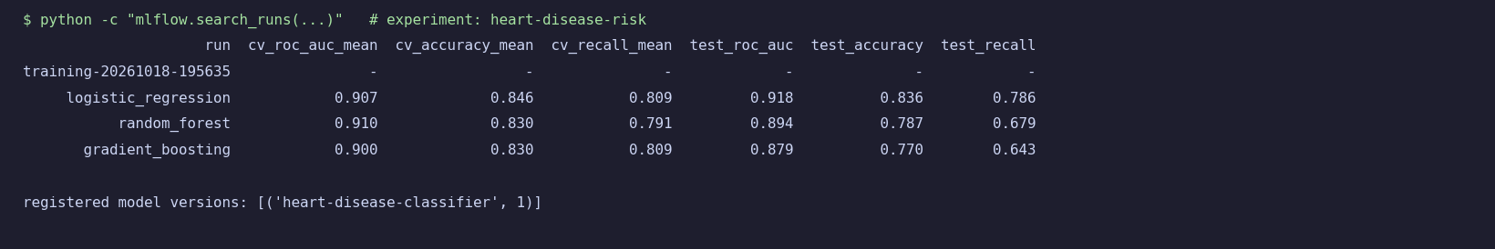
Figure 8 - MLflow runs queried via the Python API (real output).

6. Model packaging and reproducibility
- Formats: models/heart_pipeline.joblib (used by the API) and an MLflow model directory models/mlflow_model/ (MLmodel, conda.yaml, requirements.txt). The serialized object is the whole pipeline (feature engineering, imputers, scaler, encoder, classifier), so no preprocessing code is duplicated at serving time.
- Environment: pinned requirements*.txt; Python 3.12; fixed random seeds; training verified deterministic by a unit test.
- Lineage: metadata.json records model version, training time, metrics, feature list, library versions and the MD5 of the training data.
- Clean-setup proof: Figure 2 (fresh venv, requirements only, 38 tests passing).

7. CI/CD pipeline and automated testing
Tests (pytest, 38 tests, 78% coverage): data cleaning (invalid codes, duplicates, target inversion, published-statistics check), feature engineering (values, immutability, finite output with missing data, unseen categories, standardisation), model training (metric ranges, determinism, artifact round-trip, optional-field handling, risk monotonicity, selection rule), the download script (mocked network and mirror fallback), EDA output and the API (valid/invalid inputs, metrics endpoint, request-ID correlation, no patient payload in logs).
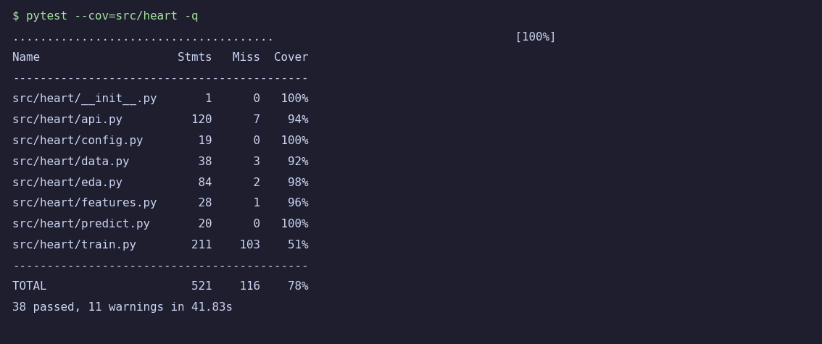
Figure 11 - pytest with coverage (real output).
Workflow (.github/workflows/ci.yml): lint (flake8) → test (pytest, coverage, JUnit XML uploaded as artifact) → train (download, clean, train with MLflow, quality gate: hold-out ROC-AUC must be at least 0.80; model, mlflow.db and training log uploaded) → docker (build the image, run it, wait for /health, POST a patient to /predict, check /metrics; container logs uploaded) → publish (push image to GHCR on main only). Jobs depend on each other with needs, so any non-zero exit stops the pipeline and the step log shows the failure. To demonstrate this, a deliberate bug was introduced into the feature code in a throw-away copy: the test step failed and returned exit code 1 (Figure 12).
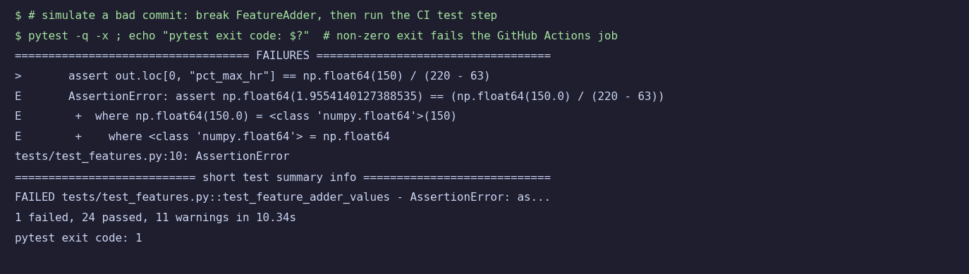
Figure 12 - A broken commit makes the test step fail with a non-zero exit code (real output from a local simulation).

8. Containerisation
The Dockerfile uses python:3.12-slim, installs the slim serving requirements first (layer caching), copies only src/ and the trained model artifacts, runs as an unprivileged user (UID 10001), declares a HEALTHCHECK and starts uvicorn on port 8000. .dockerignore keeps data, notebooks, tests and MLflow files out of the image.
Endpoint | Purpose
POST /predict | JSON with 13 features (ca, thal optional) → prediction, label, confidence (probability of the predicted class), probability_disease, model_version; invalid input → HTTP 422
GET /health | Liveness/readiness, model version
GET /model-info | Stored metadata: metrics, parameters, data hash
GET /metrics | Prometheus metrics

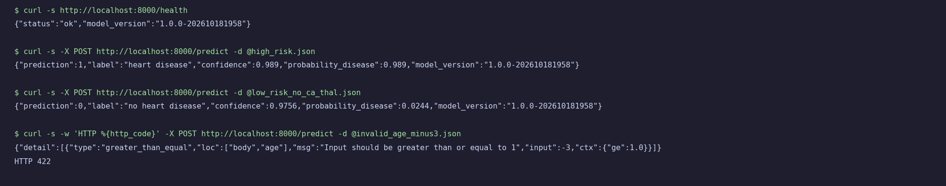
Figure 15 - Live API test with curl: two predictions and a rejected invalid request (real output from the local uvicorn server).

9. Production deployment (Kubernetes)
k8s/ contains a Namespace, a Deployment (2 replicas, rolling update with zero unavailable, readiness and liveness probes on /health, CPU/memory requests and limits, non-root security context, Prometheus scrape annotations), a Service of type LoadBalancer (port 80 → 8000), an optional Ingress and a HorizontalPodAutoscaler (2-5 pods at 70% CPU), plus a kustomization file. Deploy with kubectl apply -k k8s/. On Minikube the image is loaded locally and minikube tunnel provides the external IP; on a cloud cluster the image is pulled from GHCR (published by the pipeline) after editing the image: line.

10. Monitoring and logging
Logging. Every request produces one JSON log line (timestamp, request ID, method, path, status, latency, client) on stdout and in a rotating file logs/api.log; each prediction adds a line with the same request ID, the predicted class and confidence. Raw patient payloads are deliberately not logged because they are health data (a unit test enforces this).
Figure 19 - Structured request and prediction logs sharing a request_id (real output).
Metrics. Prometheus counters and histograms: api_requests_total (method, endpoint, status), api_request_latency_seconds, predictions_total (by class), prediction_confidence and model_info. docker compose up starts the API, Prometheus and Grafana with a provisioned dashboard (request rate, p95 latency, predictions by class, error count, median confidence). Prediction-class and confidence drift would be visible there; true label feedback is not available, so accuracy cannot be monitored online.
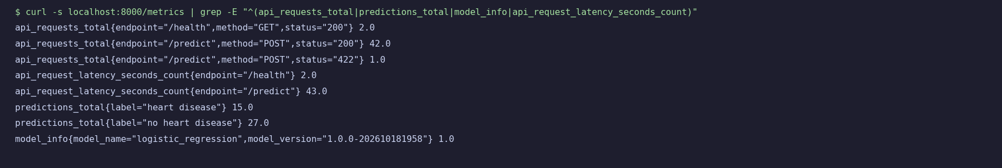
Figure 20 - /metrics output after test traffic (real output).

11. Conclusions, limitations and next steps
- A simple, interpretable model performs as well as tree ensembles on this small tabular dataset; the one-standard-error rule documents why it was chosen.
- The dataset (302 patients, single site) limits generalisation and the 61-patient test set limits precision of the estimates; the service must not be used clinically.
- Not exercised in the build environment: Docker image build, Kubernetes deployment and GitHub Actions execution (configuration was validated for syntax only; evidence screenshots are added by the author).
- Next steps: data-drift monitoring on input features, a model-registry-driven rollout, a configurable decision threshold for screening, calibration analysis and a larger multi-site dataset.
Code repository: https://github.com/aneeshkumar520-hub/my-lab/tree/main/heart-disease-mlops
Deployed API: not publicly hosted; run locally with Docker or Minikube as described in Sections 2, 8 and 9.

