

**PROJECT REPORT ON**

***“College Blog”***

Submitted in partial fulfillment of the requirements for Enterprise Computing Project Lab for 4th Semester

Master of Computer Applications

Submitted by

***Aneesh Mathew 19CS801005***

***Jerin Joji 19cs801016***

Under the guidance of

**Prof. Ayshwarya B**



**CERTIFICATE**

This is to certify that the project titled ***“College Blog”*** has been satisfactorily completed by **Mr. JERIN JOJI** with **19CS801016**, in partial fulfillment of the requirements for ***NoSQL Databases Project Lab*** with course code **MCASP2A51,** for the Vth Semester MCA course during the academic semester from June 2020 to March 2021 as prescribed by Bangalore University.

**Faculty In-charge Head of the Department**

**Valued by**

Examiner 1:_______________________ Date :

Examiner 2:_______________________ Centre: Kristu Jayanti College

**ACKNOWLEDGEMENT**

First of all, we would like to thank the God Almighty for all the blessings he has showered on us. Our spiritual quotient gave us more strength and motivation that helped immensely.

We would like to thank **Rev.** **Dr. Augustine George,** our Principal, for providing us his constant guidance and support. I would also like to thank **Rev. Fr. Lijo P Thomas,** our Financial Administrator, for providing us with the best facilities.

We are extremely thankful to our **Dr. R. Kumar**, Head, Department of Computer Science (PG) for giving us the essential support in the form of allocating comfortable lab hours and necessary resources.

We would like to extend our heartfelt thanks to **Prof. Ayshwarya B**, our project guide for providing us the necessary details related to project development and process identification enabling us to finish the project within the stipulated time.

We thank all other faculty members who helped us a lot in completing this project. The computer lab was always open for us. We thank the lab administrator and other technical staff for their help and support.

We thank our class mates, who have pointed out errors and guided us a lot and we thank each and every one who has helped us.

**Synopsis**

**Title of the Project** - College Blog

**Introduction**

A blog is a place to express yourself to the world. A place to share your thoughts and your passions. It can help in the promotion of critical and analytical thinking, increased access and exposure to quality content, and a combination of solitary and social interactions with peers. Currently, students in schools or colleges are unable to express their ideas, their talent, or anything that can be expressed for some benefit for everyone. College blog is a perfect platform for students, teachers, and institutional administrative purposes to promote collaboration between students and teachers. It increases motivation for reading and writing and showcases the student’s accomplishments, talents, ideas, or anything that they can’t express.

**Definition of the System**

The Online Blogging System will allow the users to publish the writings, videos, images, or audios if he/she should have credentials to log in. The main users of this project are students, teachers and administrators.

**List of Modules**

* Login/Registration
* View Blog
* Search Blog
* Write New Blog
* Read Blog
* Edit Blog
* Delete Blog
* Update User Account

**Technology**

* **Frontend** - Html,Css & React
* **Backend** - Python, MongoDB

**CONTENTS**

|  |  |  |
| --- | --- | --- |
| **SI.NO**  **1.**  **2.**  **3.**  **4.**  **5.**  **6.**  **7.**  **8.**  **9.**  **10.**  **11.** | **Description**  **Introduction**   * **Problem Definition** * **Project Description**   **System Study**  **2.1 Existing System**  **2.2 Proposed System**  **2.3 Use Case Diagram**  **2.4 Activity Diagram**  **System Configuration**  **3.1 Hardware Configuration**  **3.2 Software Configuration**  **Details of Software**  **4.1 Overview of Front End**  **4.2 Overview of Back End**  **System Design**  **5.1 Architectural Design**  **5.2 Input Design**  **5.3 Output Design**  **5.4 Database Design**  **Source Code**  **Testing**  **Implementation**  **Screen Shot**  **Conclusion**  **Bibliography** | **Pg. No** |

**Introduction**

**Project Definition**

A blog is a place to express yourself to the world. A place to share your thoughts and your passions. It can help in the promotion of critical and analytical thinking, increased access and exposure to quality content, and a combination of solitary and social interactions with peers. Currently, students in schools or colleges are unable to express their ideas, their talent, or anything that can be expressed for some benefit for everyone. College blog is a perfect platform for students, teachers, and institutional administrative purposes to promote collaboration between students and teachers. It increases motivation for reading and writing and showcases the student’s accomplishments, talents, ideas, or anything that they can’t express.

**Project Description**

The College Blog will allow the users to publish the writings, videos, images, or audios if he/she should have credentials to log in. The main users of this project are students, teachers and administrators. The users of this website can read and search any blogs they would like to read and sort the blogs according to their title, categories, etc. The users can also write a blog adding with pictures and also like and comment on other users’ blog.

We have only one actor playing role in this system that is **Users**.

The module for users are:

* **Login/Registration** – The new users of this website has to register to the website to read the blogs. The existing users has to login to read the blogs. Validations are added to the register page like existing emails not allowed.
* **View Blog** – The Users can view all the blogs present in the database along with their name, author and a small description.
* **Search Blog** – The users can search specific blogs based on the keyword given. It can search based on title, authors or categories.
* **Write New Blog** – The users can write new blogs by writing the title and content with a small description and references.
* **Read Blog** – The user can see the other blogs title, author and small description of the blog and also read the whole blog.
* **Edit Blog** – The user can edit their own blogs if they want to.
* **Delete Blog** – The user can delete their own blog if they want to.
* **Update User Account** – The user can edit their own profile and add other details.

**System Study**

**Existing System**

Colleges today needs to give students a platform where students and express their thoughts, passion and research. It can help in the promotion of critical and analytical thinking, increased access and exposure to quality content, and a combination of solitary and social interactions with peers. Currently, students in schools or colleges do not have any specific platform to express their ideas, their talent, or anything that can be expressed for some benefit for everyone. So, we thought of giving students a platform where students can express their thoughts, ideas, talent, etc.

**Proposed System**

College blog is a perfect platform for students, teachers, and institutional administrative purposes to promote collaboration between students and teachers. It increases motivation for reading and writing and showcases the student’s accomplishments, talents, ideas, or anything that they can’t express. It will allow the users to publish the writings, videos, images, or audios if he/she should have credentials to log in. The users of this website can read and search any blogs they would like to read and sort the blogs according to their title, categories, etc. The users can also write a blog adding with pictures and also like and comment on other users’ blog.

**Use Case Diagram**

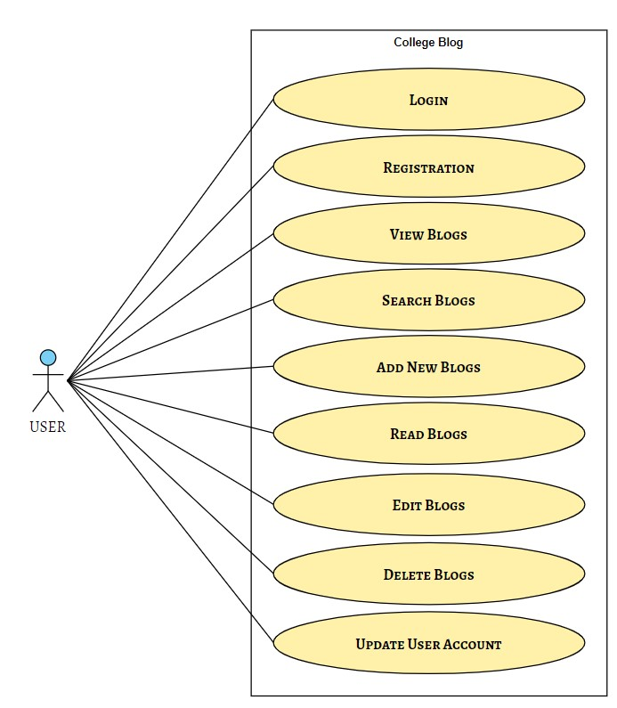

**Activity Diagram**

**System Configuration**

**Hardware Configuration**

|  |  |
| --- | --- |
| **RAM** |  |
| **Hard Disk** |  |
| **Processor** |  |
| **Keyboard** |  |
| **Mouse** |  |

**Software Configuration**

|  |  |
| --- | --- |
| **Operating System** | Windows 11 |
| **Front-End** | Html, CSS, JavaScript, React |
| **Back-End** | Python, Flask, MongoDB |
| **Tools** | VSCode, MongoCompass, Git |
| **Documentation Tools** | MS Word 2013 |

**Details of Software**

**Overview of Front End**

For the front-end design, we used **HTML, CSS, JavaScript and React** to build our view of the system. We used many types of tags with their attributes and CSS attached to them each for our many different views. We used: -

* **<h1> to <h6>** - To displaying headings
* **<p>** - To display the text
* **<a>** - To put a hyperlink
* **<form>** - To create user forms
* **<input type = text, number, date, email, submit>** - To display various inputs each with a type of input.
* **<div>** - To divide and create partitions
* **<img>** - To display images
* **<li>** - To display list
* **<hr>** - To display a horizontal line

And many more tags and attributes which can can make the view of the system more and more user friendly.

**Overview of Back End**

When we completed the work on frontend it was time to put some actions and make the system working by working on its back-end. We used **Flask and Python** as the the language to make the system into a working system. We thought that Python can be a better language to interact with the server and get the job done. We also needed a database to store the data and to fetch the necessary data when required. So, we used **MongoDB** as a tool for storing the data and fetching it.

In Flask, we used **pymongo** in python which can help with fetching and inserting the data in MongoDB. For connecting python with MongoDB, we need the connection string of MongoDB that is **localhost:27017.**

We also used many imports for making this website. The imports are Flask, Response, request, session, redirect, url_for, render_template, flash.

* bcrypt==3.2.0
* Flask==2.0.1
* Flask-Bcrypt==0.7.1
* Jinja2==3.0.1
* passlib==1.7.4
* pycparser==2.20
* pymongo==3.12.0

**System Design**