Predictive QoS Aware PPO Routing for SDN
Computer Networks Project Report
Thwalha -
Avani Vasistha -
PANGULURU ANEESH - 25BCE2328
Project area: Software Defined Networking and Reinforcement Learning
Implementation: Mininet, Ryu, Stable Baselines3 and Python
Evaluation: Simulation and live emulated network experiments

Github Link: https://github.com/aneeshpanguluru-oss/sdn-qos-ppo
Literature Review:
Ref. | Author(s), Year | Category / Theme | Proposed Technique | Dataset / Tools | Key Findings | Limitations
[1] | Wang et al. (2025) | Segment-routing traffic engineering | RS4SR: recommends promising routing candidates from historical solutions and clusters similar traffic flows to reduce the optimization search space | Large-scale network evaluations; specific topologies | Reported near-optimal solutions within a two-second time limit using a relatively small set of historical solutions | Accelerates mathematical optimization; performance under rapidly changing traffic conditions needs further study
[2] | Tian et al. (2025) | Adaptive segment-routing traffic engineering | Adpt-SRTE: PPO with action branching; learns from historical traffic matrices and uses current link utilization for online decisions | Three real-world network topologies | Reported up to 33% reduction in maximum link utilization and online decisions in tens of milliseconds | Focuses on segment routing; generalization to unfamiliar traffic patterns and other SDN settings requires study
[3] | Guo et al. (2025) | Persistent routing; supervised learning | PROM: predicts routing strategies from historical traffic matrices using candidate paths generated by a k-shortest-paths algorithm | Three real-world network topologies; centralized and distributed implementations | Reported effective routing strategies, with comparable performance from the distributed implementation | Depends on historical examples; adaptation to unexpected traffic changes needs investigation
[4] | Zhou et al. (2025) | Hybrid SDN traffic engineering; representation learning | CRTE: combines contrastive traffic representation learning with reinforcement learning; uses K-means to form training samples | Hybrid SDN evaluation; topology and tool details | Reported reductions in maximum link utilization and end-to-end latency, and robustness under network failures | Encoder, RL algorithm, topology, and baseline details should be verified in the full paper
[5] | Chen et al. (2025) | SD-WAN traffic engineering; multi-QoS routing | MTEAL: extends TEAL with multi-dimensional QoS measures and a two-stage reward function | Small, NSFNET, and GBN topologies; comparisons include UsCarrier, Kdl, and B4 | Reported improvements over comparison methods, including results for delay, flow loss, failure stability, and generalization | Exact reward formula and topology-specific numerical results should be checked in the full article
[6] | Wu et al. (2026) | SDN routing; topology-aware DRL | IROD-BC: combines DRL routing with betweenness centrality to guide optimization | Specific topologies, tools, and implementation details | Intended to guide routing using network-structure information and address traffic concentration on important network elements | Available summary does not establish the precise algorithm, centrality calculation, baselines, or quantitative gains
[7] | Awad et al. (2026) | SDN routing; transfer learning | DDPG-DR: applies transfer learning to a DDPG routing agent so it can reuse prior experience after topology changes or link failures | Ryu controller and Mininet; Abilene topology; traffic loads from 20% to 80% | Reported higher throughput than OSPF; at 80% load, 39 Mbps versus 24.7 Mbps | Evaluation summary covers a limited topology and load range; exact delay comparisons should be checked against the paper
[8] | Lin et al. (2025) | SDN routing; bandwidth-demand-aware path selection | Hop-by-hop DRL routing considers flow bandwidth demand and available link capacity; uses prioritized experience replay | Ryu, Open vSwitch, Docker, and Mininet; tests include 9-switch and 34-node networks and larger topologies | Reported 39.95% bandwidth utilization versus 36.35% for Q-WPRA; inference time of about 1.05–2.85 ms across tested topologies | Reported experiments use particular traffic and network scenarios; broader evaluations are needed to establish generality
[9] | Aguirre S. et al. (2025) | SDN congestion avoidance; QoS-aware routing | LCA: classifies traffic, monitors live QoS and congestion, selects routes with DRL, and validates routes | Ryu controller and Docker-based networking; ten service classes; classifier trained on 500,000 flows | Reported 5–10% lower delay, 5–20% lower packet loss, and 25–30% lower jitter under congestion | Classifier, monitoring, and validation add system components; performance outside the evaluated setup is not established by the summary
Research Gaps
- Limited testing on unfamiliar traffic and topologies:
Many learning-based methods use historical traffic or a limited set of network topologies. Their ability to generalize to unseen traffic patterns, new topologies, or sudden network changes remains insufficiently established.
- Need for faster adaptation to failures:
Some papers investigate link failures or transfer learning, but more work is needed to evaluate how quickly routing agents recover from failures and whether they can adapt without extensive retraining.
- Incomplete multi-objective evaluation:
Several studies focus primarily on congestion, link utilization, or throughput. A more complete evaluation should consider these alongside delay, packet loss, jitter, bandwidth demand, and routing overhead.
- Limited comparison of traffic representations:
Methods use different input information, such as raw traffic measurements, learned traffic features, link utilization, or topology measures. The effect of these representations on routing performance has not been compared consistently.
- Unclear deployment and scalability trade-offs:
Although some studies report quick routing decisions, further evaluation is needed on controller workload, communication overhead, scalability to larger networks, and performance in live or larger-scale deployments.
- Limited connection between predictive and SDN routing:
Predictive congestion avoidance has been studied in AAV networks, while most SDN papers react to current network conditions. The usefulness of predicting future traffic and congestion for SDN routing remains an opportunity for investigation.

Abstract
This project develops and evaluates a quality of service aware routing controller for software defined networks. The controller selects one of several paths between hosts h1 and h4 using Proximal Policy Optimization (PPO). It observes link utilization, path delay, packet loss estimates, residual capacity, and flow demand. A predictive PPO variant adds a one interval utilization forecast. The study compares both PPO policies with fixed shortest delay and min hop baselines in a controlled simulator and in a live Mininet network controlled by Ryu.
The central result is that PPO policies maintain high admitted throughput in the simulator and successfully reroute live traffic after an s2 to s4 link failure. Fixed Min hop fails when its selected route contains the broken link. The shortest delay baseline avoids that failed link but is constrained by a 15 Mbps bottleneck on its selected route.

1 Project Objective
The objective is to determine whether a reinforcement learning based SDN controller can make better route selections than fixed routing rules when link capacity, delay, background load, and failures affect quality of service.
- Train a PPO agent to choose among three candidate paths between s1 and s4.
- Compare PPO with fixed shortest delay and min hop routing rules.
- Evaluate throughput, maximum utilization, delay, loss, feasibility, decision time, and route churn in simulation.
- Validate the controller in Mininet with Ryu and iperf3 under normal traffic and an injected link failure.

2 System Design
The network uses a six switch Mininet topology with hosts h1 and h4 attached to the experiment switches. The controller selects one of three predefined candidate routes. Explicit switch identifiers and port mappings let Ryu install OpenFlow flow rules and measure physical port utilization.
Candidate | Route | Main capacity constraint | Approximate delay
0 | s1 - s2 - s4 | 25 Mbps on s2-s4 | 10 ms
1 | s1 - s3 - s4 | 20 Mbps on s1-s3 | 11 ms
2 | s1 - s2 - s3 - s4 | 15 Mbps on s2-s3 | 9 ms

Table 1. Candidate paths used by the routing action space.

3 Methods

3.1 PPO Routing State and Reward
For each candidate path, the standard PPO agent receives normalized maximum utilization, delay, loss estimate, and residual capacity. The final state feature is the incoming flow demand. The predictive agent adds a momentum based utilization forecast. The reward favors admitted throughput and residual capacity while penalizing high utilization, delay, loss, and unnecessary route changes.

3.2 Baselines
- Shortest delay: always selects candidate 2 because it has the lowest fixed delay.
- Min hop: always selects candidate 0 because it has the fewest switches.
- PPO standard QoS: policy trained on current QoS features.
- PPO predictive QoS: policy trained with the added utilization forecast feature.

3.3 Failure Model
The simulation disables the s2-s4 link halfway through each episode. In the live environment, the same fault is injected with the Mininet command link s2 s4 down. PPO modes receive the port down event, remove stale managed flows, and install a viable route. Fixed baselines have automatic recovery disabled to keep the comparison fair.
4 Simulation Results
Both PPO policies were trained for 100,000 timesteps and evaluated across 50 simulated episodes of 120 steps each. The values below are mean results from the project evaluation program. Higher throughput and feasibility are better; lower maximum utilization, delay, loss, decision time, and route churn are better.

4.1 Normal Traffic Scenario
Policy | Throughput  Mbps | Max  Util | Delay  ms | Loss | Feasible | Decision  us | Churn  per ep
Shortest path delay | 1.76 | 0.665 | 9.00 | 1.61% | 28.7% | 4.3 | 0.0
Min hop | 3.40 | 0.757 | 10.00 | 1.67% | 42.6% | 1.3 | 0.0
PPO standard QoS | 5.70 | 0.667 | 10.27 | 1.29% | 65.2% | 252.0 | 69.4
PPO predictive QoS | 5.62 | 0.659 | 10.38 | 1.24% | 63.9% | 227.4 | 70.4

Table 2. Simulation results under normal traffic.
Interpretation. Standard PPO achieves the highest simulated throughput and feasibility. Predictive PPO has the lowest average utilization and loss, but it does not outperform standard PPO on throughput in this training run. Both PPO policies substantially outperform the fixed baselines on throughput and feasibility.

4.2 Link Failure Scenario
Policy | Throughput  Mbps | Max  Util | Delay  ms | Loss | Feasible | Decision  us | Churn  per ep
Shortest path delay | 1.76 | 0.665 | 9.00 | 1.61% | 28.7% | 5.1 | 0.0
Min hop | 1.74 | 0.881 | 10.00 | 50.96% | 21.4% | 1.0 | 0.0
PPO standard QoS | 4.83 | 0.694 | 10.07 | 1.53% | 57.0% | 238.3 | 60.9
PPO predictive QoS | 4.67 | 0.690 | 10.36 | 1.51% | 55.8% | 240.8 | 60.1

Table 3. Simulation results when the s2-s4 link fails at step 60.
Interpretation. Min hop is heavily affected because its fixed route uses s2-s4. Its simulated loss reaches 50.96 percent. Both PPO policies preserve much higher throughput and feasibility by selecting viable alternatives. The shortest delay route is unchanged because it does not use the failed s2-s4 link, but it remains limited by the lower capacity s2-s3 link.

5 Live Ryu and Mininet Validation
The Ryu controller was connected to the Mininet topology and monitored port statistics. Traffic was generated with iperf3 using a 20 Mbps UDP offered load. The fault experiment lowered the s2-s4 link after approximately ten seconds. PPO controller logs confirmed the selected candidate path and, on failure, reported recovery to candidate 1: s1 - s3 - s4.

5.1 Observed Live Normal Traffic Results
Policy | Selected route | Received throughput | Loss
Min hop | s1-s2-s4 | 19.9Mbps | 0.38%
Shortest delay | s1-s2-s3-s4 | 14.1 Mbps | 27%
PPO standard QoS | s1-s2-s4 | 19.9 Mbps | 0.4%
PPO predictive QoS | s1-s2-s4 | 18,7 Mbps | 0.44

Table 4. Live Ryu and Mininet normal traffic observations, 20 Mbps UDP offered load.
The measured normal-traffic results show why fixed shortest-delay routing is not automatically the best QoS choice: its selected route has a 15 Mbps bottleneck and therefore drops traffic at a 20 Mbps offered load. The standard PPO controller selected the higher-capacity route and delivered 19.9 Mbps with 0.36 percent loss.

5.2 Observed Live Link Failure Results
Policy | Path behavior after s2-s4 failure | Received throughput | Loss | Outcome
Min hop | Fixed path s1-s2-s4 becomes unavailable | 5.02 Mbps* | About 61.1%* | Route failure
Shortest delay | Continues on s1-s2-s3-s4 | 14.5 Mbps | 26% | 15 Mbps bottleneck
PPO standard QoS | Reroutes to s1-s3-s4 | 19.5 Mbps | 1.6% | Recovered
PPO predictive QoS | Reroutes to s1-s3-s4 | 19.5 Mbps | 1.5% | Recovered

Table 5. Live Ryu and Mininet fault test, 20 Mbps UDP offered load for 60 seconds. *For Min hop, iperf3 receiver reporting was disrupted by the route break. The loss estimate is derived from 103,590 sender datagrams and 40,344 receiver datagrams.
The live test supports the simulation findings. Both PPO controllers continued delivering approximately 19.5 Mbps after the failed link and incurred only around one to two percent loss. Min hop lost its selected route. Shortest delay did not use the failed link but was limited by its 15 Mbps bottleneck, so it achieved 14.5 Mbps with 26 percent loss.

6 Commands Used
Simulation comparison command:
PYTHONPATH=src python -m sdn_rl.evaluate --compare-all --episodes 50
Live controller modes:
PYTHONPATH=src ROUTING_MODE=ppo ryu-manager sdn_rl.ryu_app
PYTHONPATH=src ROUTING_MODE=predictive ryu-manager sdn_rl.ryu_app
PYTHONPATH=src ROUTING_MODE=minhop ryu-manager sdn_rl.ryu_app
PYTHONPATH=src ROUTING_MODE=shortest ryu-manager sdn_rl.ryu_app
Fault injection in the Mininet CLI: start a persistent h4 iperf3 server, start a 60 second h1 UDP client, wait approximately ten seconds, then run link s2 s4 down. Restore with link s2 s4 up after the test.

7 Conclusion
The project demonstrates an end to end SDN traffic engineering workflow: a Gymnasium environment trains PPO policies, Stable Baselines3 produces the models, Ryu applies policy decisions as OpenFlow paths, and Mininet validates behavior under controlled traffic and faults. In simulation, PPO improves throughput and feasible decisions compared with fixed policies. In the live fault test, standard and predictive PPO reroute successfully and maintain near offered load, while Min hop fails on the broken path and shortest delay is constrained by capacity. The next practical extension is multi flow routing with a broader set of source and destination pairs.

Proofs:
Training Predictive and Non Predictive PPO:
Simulated Results:
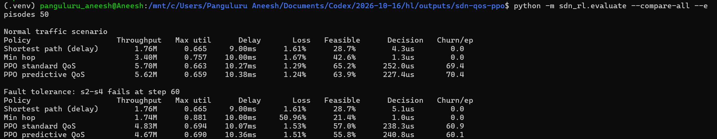

No Link Failure Results:
- Shortest Delay:
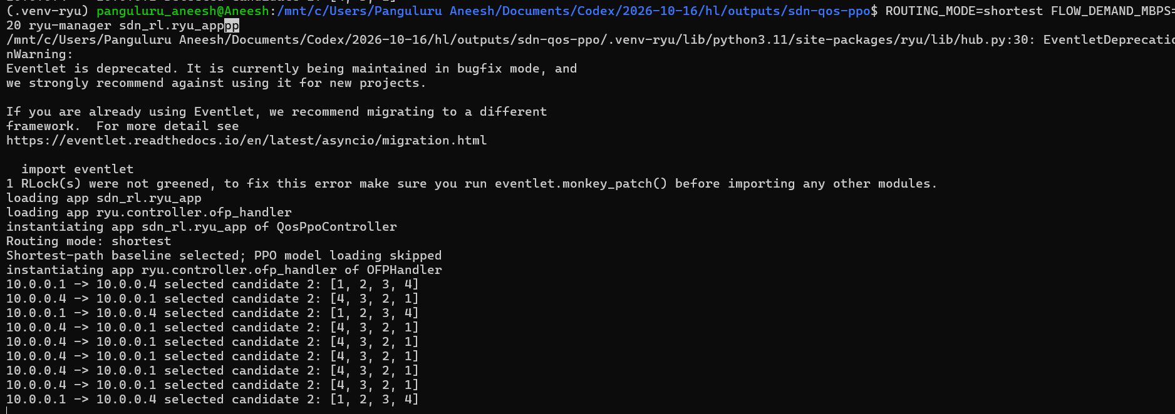
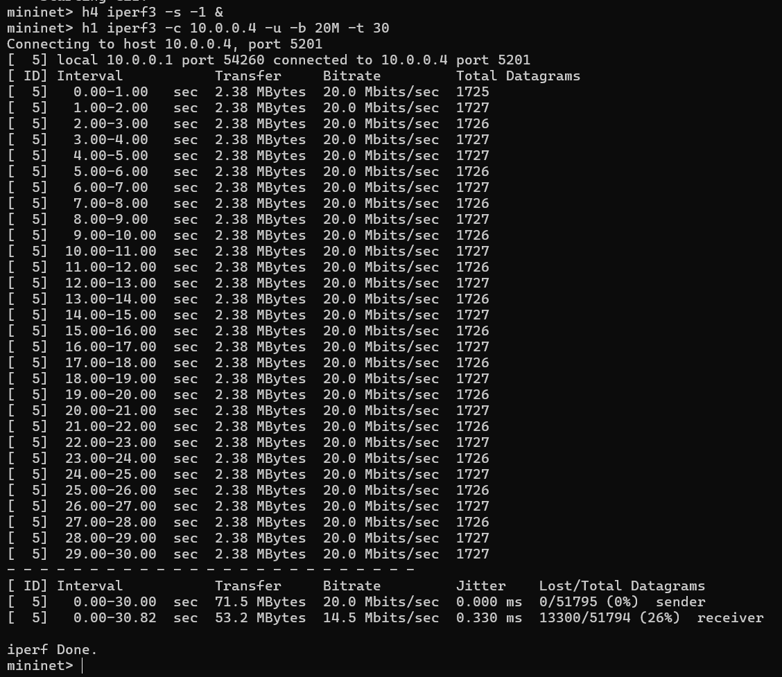
- Min Hop:
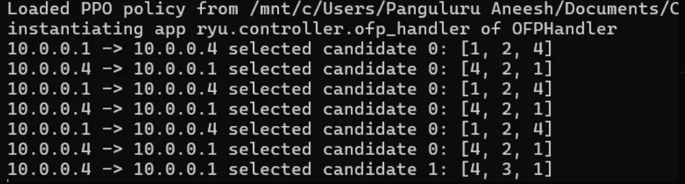
- Non Predictive PPO:
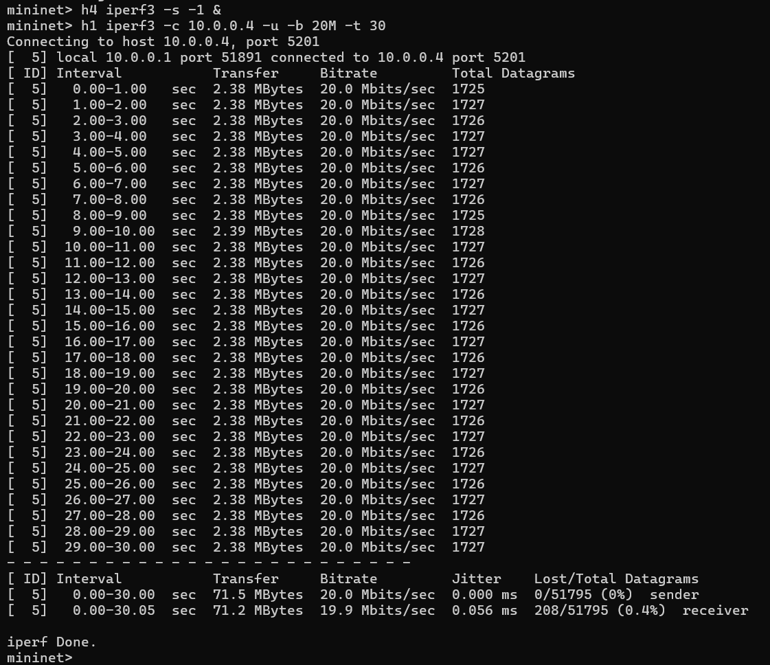
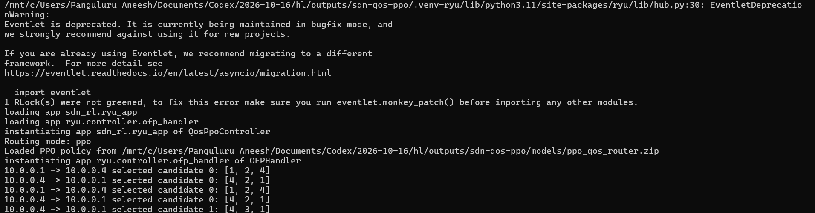
- Predictive PPO:
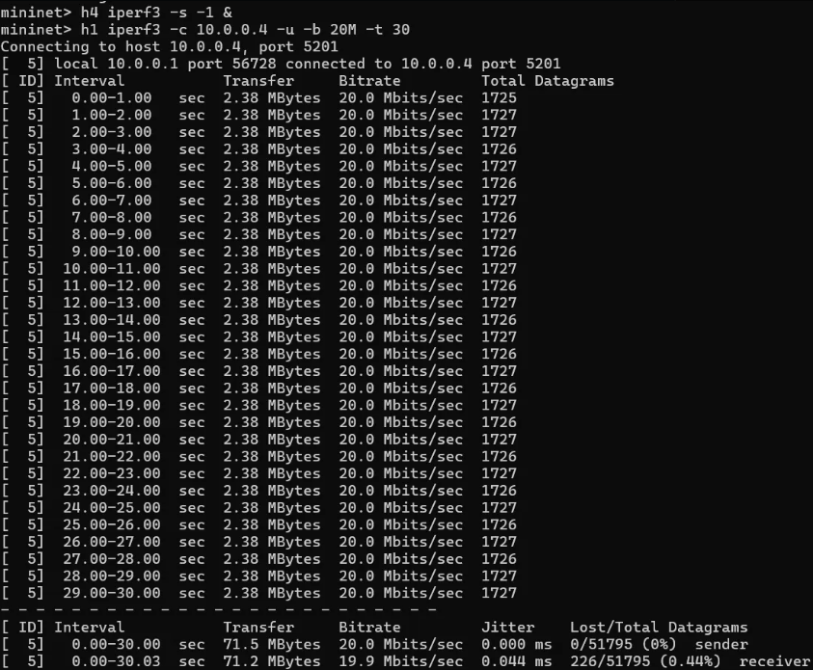

s2-s4 link failure Results:
- Shortest Delay:
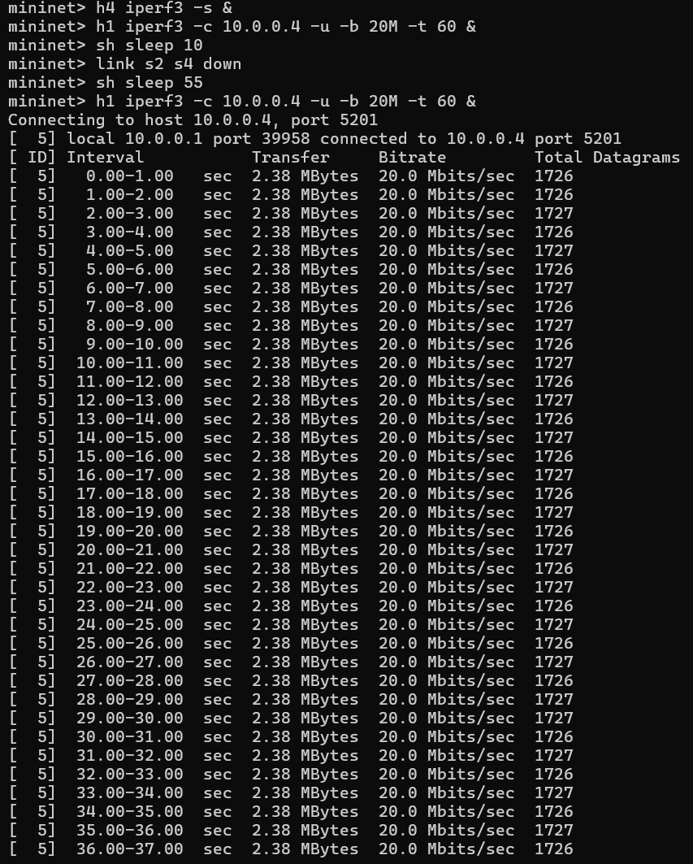
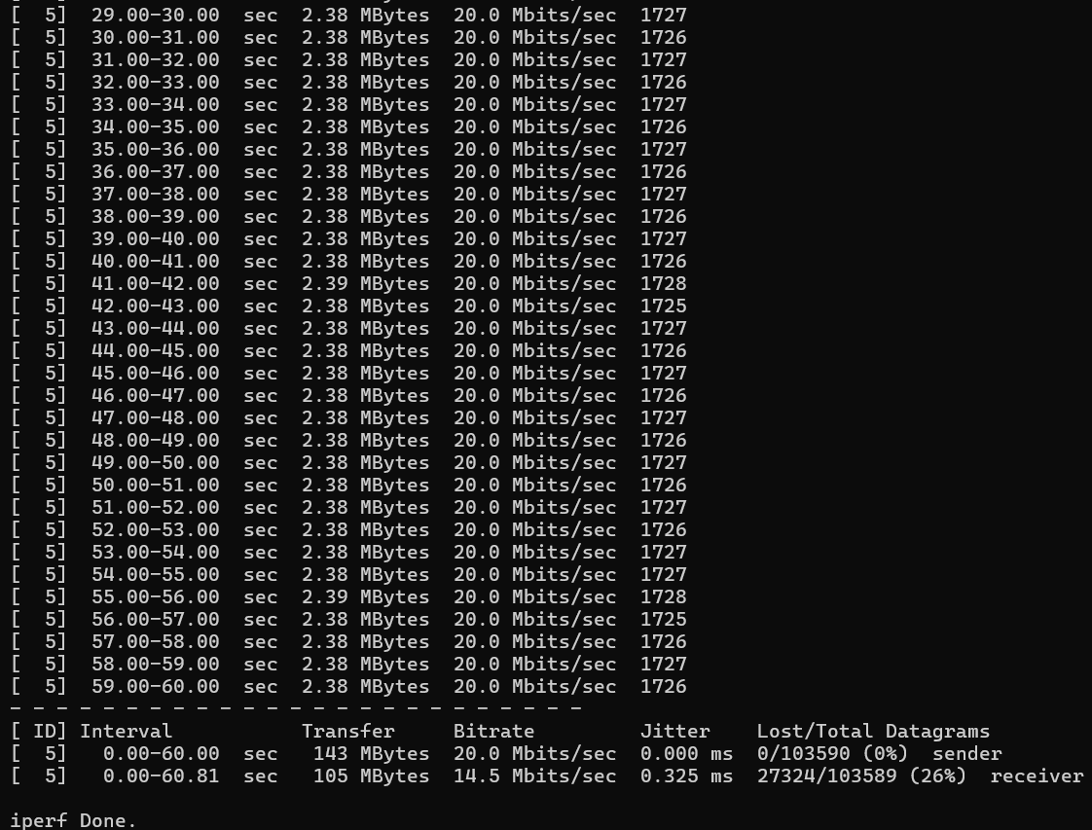
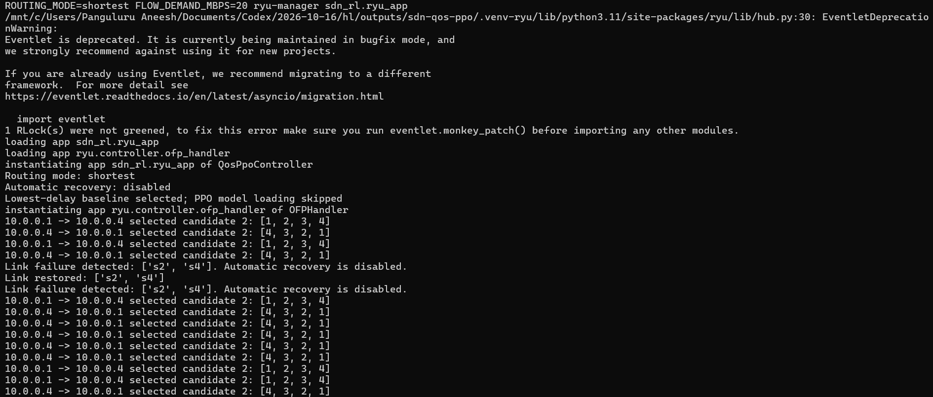
- Min Hop:

- Non-predictive PPO:
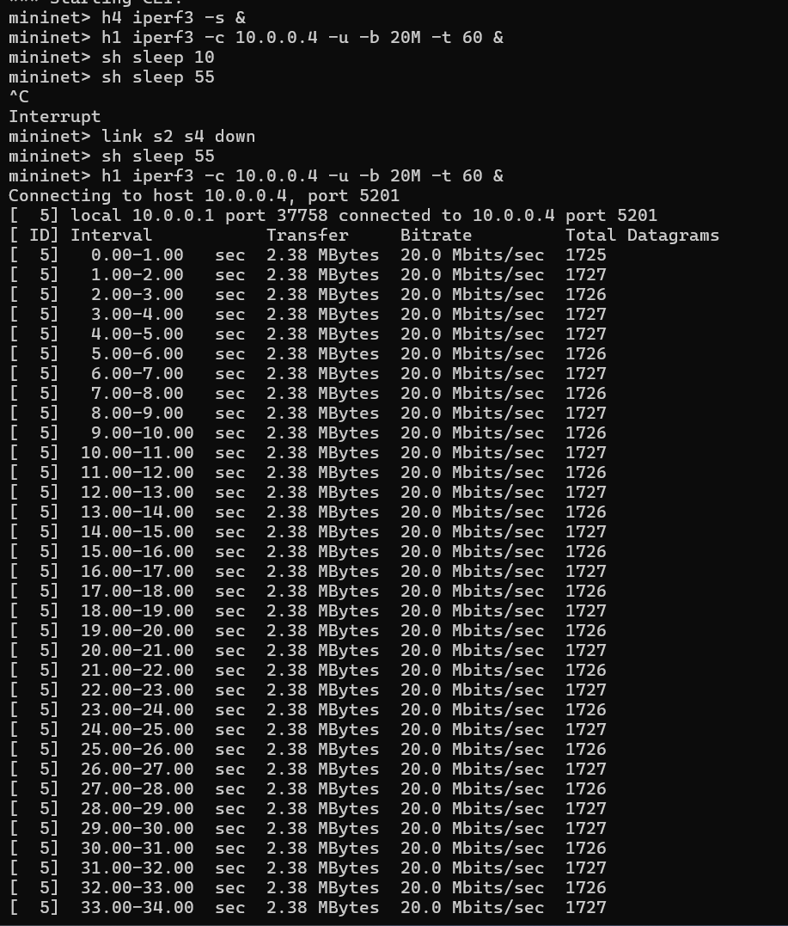
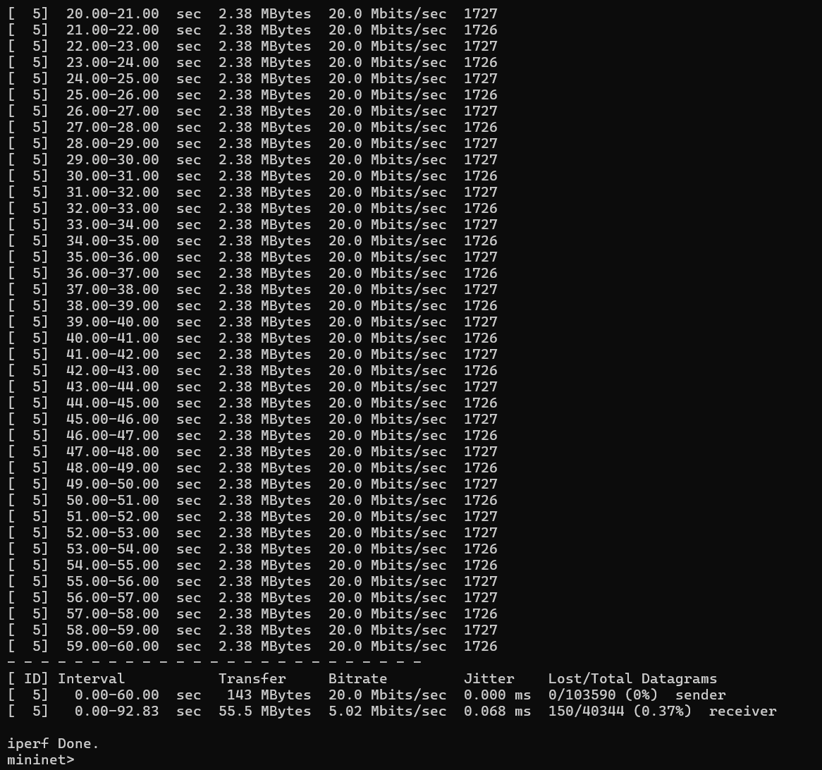
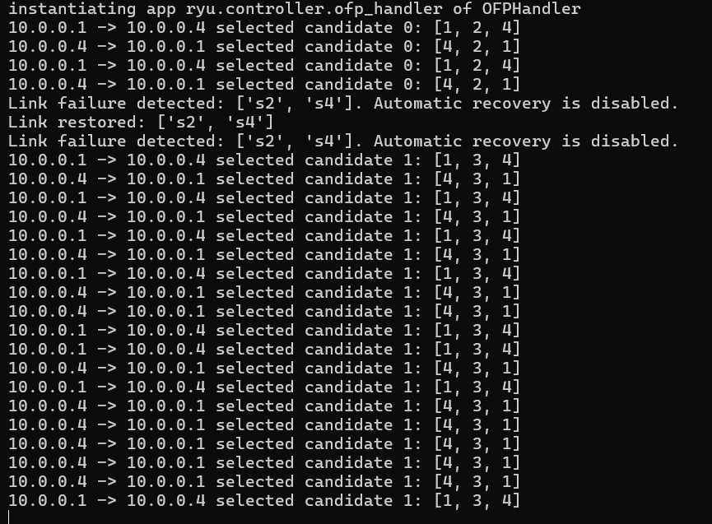
4)Predictive PPO:
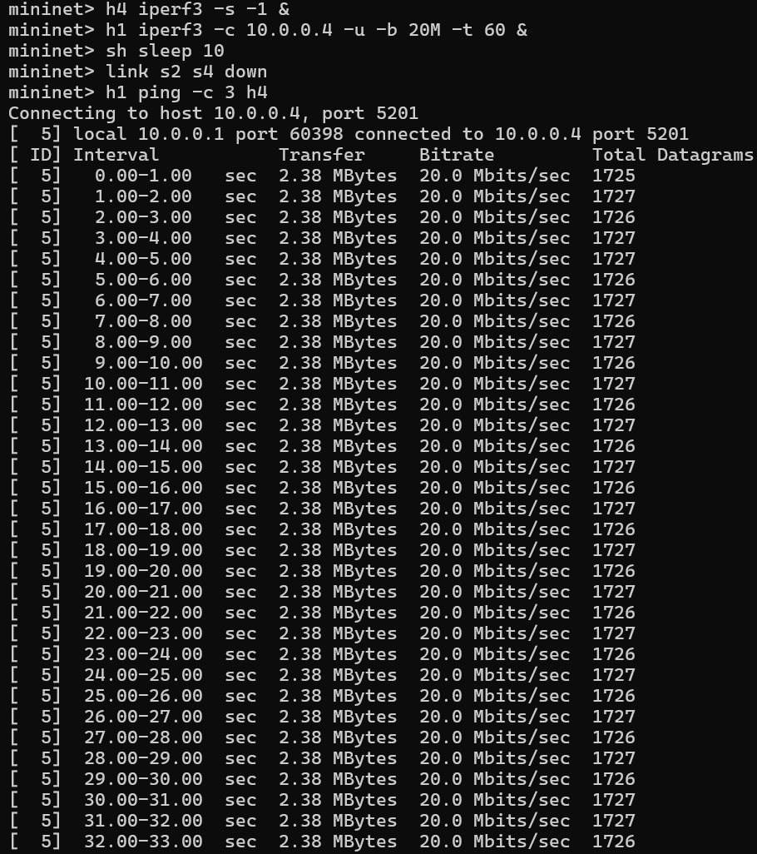
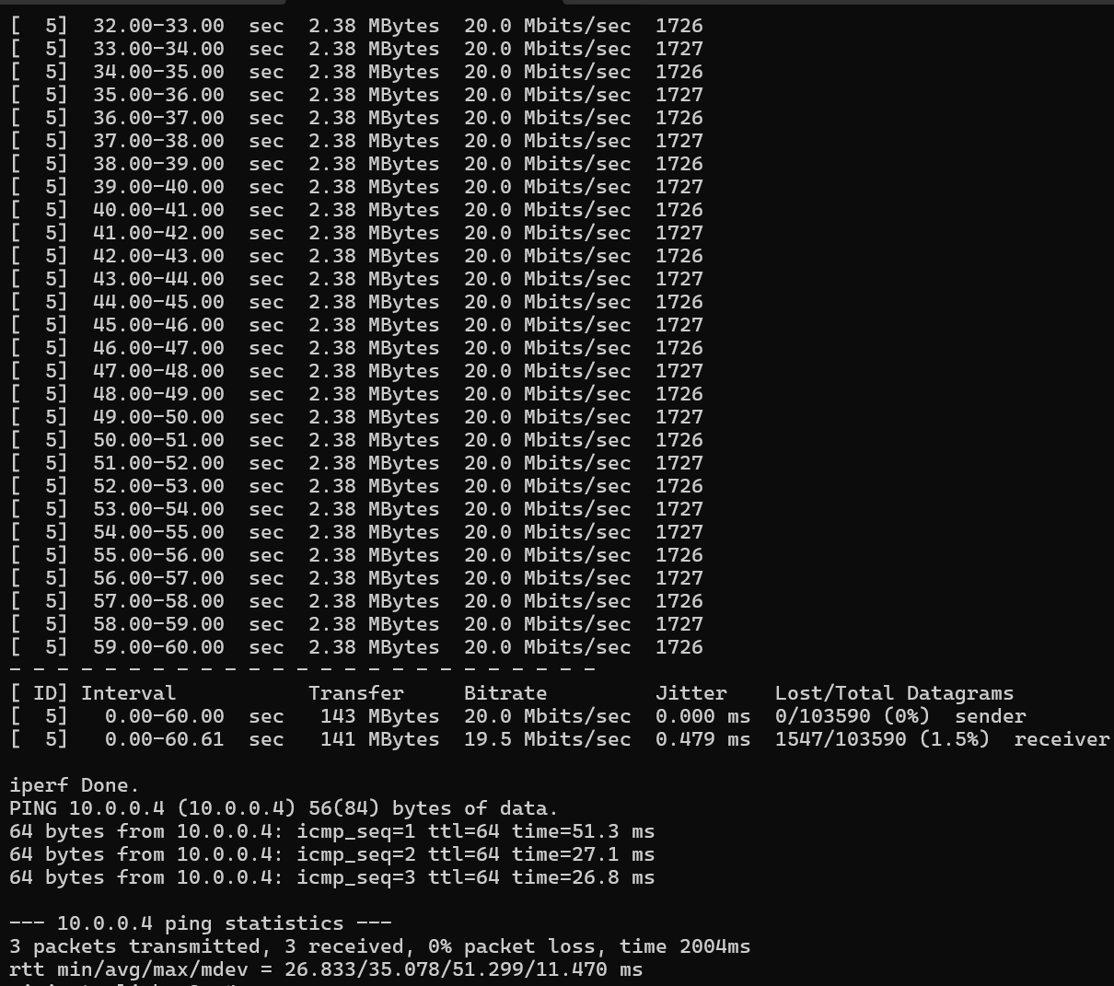
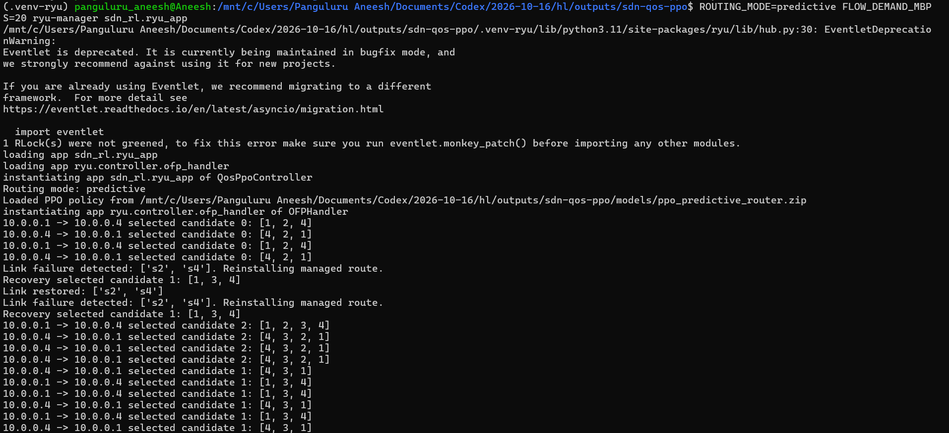

References:
[1] L. Wang, M. Wang, C. Lin, and Y. Zhang, “Accelerating traffic engineering optimization for segment routing: A recommendation perspective,” Computer Networks, vol. 264, Art. no. 111224, 2025. https://doi.org/10.1016/j.comnet.2025.111224
[2] Y. Tian, Z. Wang, X. Yin, X. Shi, J. Yang, and H. Zhang, “Adaptive traffic engineering with segment routing through deep reinforcement learning,” Computer Networks, vol. 267, Art. no. 111356, 2025. https://doi.org/10.1016/j.comnet.2025.111356
[3] Y. Guo, Z. Huang, M. Ding, B. Lin, and H. Luo, “PROM: A persistent routing optimization method based on supervised learning,” Journal of Network and Computer Applications, vol. 242, Art. no. 104223, 2025. https://doi.org/10.1016/j.jnca.2025.104223
[4] W. Zhou, R. Yang, Y. Guo, and H. Luo, “Network traffic feature representation with contrastive learning for traffic engineering in hybrid software-defined networks,” Journal of Network and Computer Applications, vol. 242, Art. no. 104270, 2025. https://doi.org/10.1016/j.jnca.2025.104270
[5] Y. Chen, A. Gu, L. Cui, and L. Lin, “MTEAL: Network routing optimization of SD-WAN traffic engineering integrating multi-dimensional QoS metrics,” Journal of Network and Computer Applications, vol. 242, Art. no. 104272, 2025. https://doi.org/10.1016/j.jnca.2025.104272
[6] Z. Wu, Q. Tang, J. Cao, S. Wen, and B. Li, “Intelligent routing optimization with deep reinforcement learning and Betweenness Centrality Theory in software-defined networks,” Computer Communications, vol. 247, Art. no. 108401, 2026. https://doi.org/10.1016/j.comcom.2025.108401
[7] M. K. Awad, D. H. A. Daqar, D. H. Kablaoui, and E. A. Alrashed, “Knowledge transfer-enabled reinforcement learning for routing in software-defined networks,” Journal of Engineering Research, vol. 14, pp. 2840–2850, 2026. https://doi.org/10.1016/j.jer.2026.03.017
[8] G.-J. Lin, C.-F. Hung, and C.-H. Ke, “A deep reinforcement learning-based bandwidth demand-oriented routing in software-defined networking,” ICT Express, vol. 11, no. 6, pp. 1146–1151, 2025. https://doi.org/10.1016/j.icte.2025.07.009
[9] L. P. Aguirre S., Y. Shen, and M. Guo, “LCA: Deep reinforcement learning-based congestion avoidance routing model in SDN,” Computer Networks, vol. 268, Art. no. 111371, 2025. https://doi.org/10.1016/j.comnet.2025.111371
[10] R. I. Alkanhel, A. Alzaghir, N. D. Tu, A. Muthanna, A. Khakimov, and A. Koucheryavy, “Toward predictive routing in AAV network: A deep learning-based congestion avoidance approach,” IEEE Access, vol. 14, pp. 112202–112218, 2026. https://doi.org/10.1109/ACCESS.2026.3710875

